Distillation is not just discarding data; it is concentrating meaning and optimizing for the LLM.
While distill_cap_alert physically compresses 10KB weather JSON payloads down by 90%, for database records like property and policy, the "distill" functions serve four critical purposes:

1. Semantic Enrichment (Adding Domain Meaning to Dumb Data)
A database stores dumb values like 0 or 1. If an LLM simply receives:
json
{"sewer_backup_endorsed": 0, "overland_water_endorsed": 0}
The LLM has to deduce what 0 means, whether it is good or bad, and whether it requires action.
In

distill_policy_context, it transforms that into:
text
Sewer Backup Endorsement: NO - CRITICAL GAP: Basement sewer backup damage is UNINSURED
Overland Water Endorsement: NO - CRITICAL GAP: Surface overland flood runoff is UNINSURED
This is not discarding—it is semantic enrichment. It forces the LLM's attention to the exact risk implication so it never hallucinates that the homeowner is covered.

2. Token Compression (Syntax Overhead Reduction)
Raw JSON or dictionary representations carry huge syntactic baggage (quotes, curly braces, colons, repeated key names):
Raw JSON (~75 tokens) | Distilled Text (~35 tokens)
json<br>{<br> "dwelling_type": "detached",<br> "roof_type": "asphalt_shingle",<br> "roof_age_years": 4,<br> "basement_type": "finished",<br> "has_sump_pump": 1,<br> "has_backwater_valve": 1<br>}<br> | ```text  Dwelling: detached
By packing related attributes into a compact pipe-delimited (|) format, you cut token consumption in half. Over long multi-turn agent conversations, this reduces latency and cost.
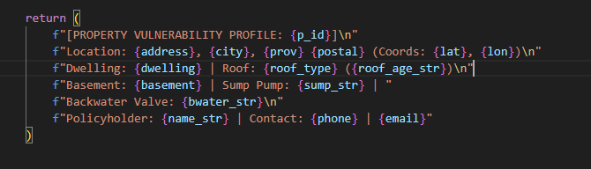

3. filter unnecasry output in json after tool calling
4. organize the information in a way that better understandable. For example Semantic Grouping: It arranges the data into logical categories so downstream models can immediately isolate peril-relevant features:

