Presentation of Data Using Dashboards for Netflix
Justin Hall
University of Wisconsin – La Crosse
DS 780: Data Science and Strategic Decision Making
July 22, 2020

Presentation of Data Using Dashboards for Netflix
In today’s world, data is something that must be treated as an asset. But how companies derive information and value from their data is still something many companies struggle with. Dashboards offer a simple visual representation of data that can be used to gain insights into many different aspects of a business. Furthermore, dashboards can be customized to fit any level of business operations across any possible departments. To be effective at potentially so many levels, dashboards must deliver information that is relevant to the user and their goals while not overwhelming them with a large amount of unnecessary material.

Best Practices for Dashboards
Ideally dashboards provide useful insights using visuals that quickly allow for users to make or support business decisions without any needless distractions. According to Janes, Sillitti, and Succi (2013):
In the 19th century, the term “dashboard” was already being used to refer to a board in front of a carriage that stopped mud from being splashed (dashed) into the vehicle by the horse’s hooves.
In many ways this analogy still holds true for the dashboards created today for businesses. But how do we accomplish this?
First it is necessary to define what type of dashboard we will be creating depending on the users and their needs. Dashboards generally fall under 3 categories: strategic, operational, or analytical. Strategic dashboards are designed to communicate to management about performance and financial information about corporate goals. The data shown may be quantitative or qualitative but is designed to give a quick overview of the health of organization. Operational dashboards track changes that requiring urgent or immediate action. The visuals displayed generally need to be simple, allowing for quick, clear, and simple actions. In comparison to strategic dashboards, operational dashboards need to update more frequently, if possible, in real-time. Analytical dashboards allow for exploration of the data and give the user the ability to drill-down to gain deeper insights. These dashboards can also be used to forecast outcomes by incorporating predictive models (Pappas & Whitman, 2011).
Once the type of dashboard being developed has been identified you must address what needs the user has for the dashboard. This involves defining what the users’ goals are through interviews or by listing requirements on the information necessary to guide them to these goals. This will involve things such as recognizing key performance indicators (KPIs) that are deemed necessary. Careful consideration must be taken to effectively display these KPIs in the most successful way. The key to useful presentation is to show how the data is related and offer ways to gain crucial insights (Wolf, 2016).
After discovering necessary information required to meet the users’ needs it is important to begin to lay out a design for the dashboard. The dashboard layout should not be created ad hoc, careful consideration into the graphs and visualizations created must be done before hand. An effective dashboard gives a user a quick way to achieve their purpose and the display of data needs to facilitate this. Typically, this involves ensuring dashboards are no longer than one page and provide line graphs, bar charts, or scatter plots that are allow users to quickly make comparisons and evaluate key data (Pappas & Whitman, 2011). It is important that you include the business users in this process so that they can give feedback and you can adjust the dashboard to best suit them. This should be an iterative process until both you and the business user agree on a final design. At every iteration consideration should be taken to ensure that the graphics and visuals help to drive a deeper understanding or ignite a need for new information (Wolf, 2016).
Finally, once a dashboard is live you must work to provide proper maintenance for the dashboard. This involves proper documentation of the design choices and any provided data or data models. It is necessary that the parties who will be responsible for the dashboard have all the necessary information to make updates in the future (Wolf, 2016).

Netflix and Current Big Data Use
Netflix is an online streaming platform and DVD rental service. Currently they use big data in nearly every aspect of their business, including content generation, improving user experiences, and marketing. By using data gathered from previous viewing experiences and surveys when signing up, Netflix provides recommendations to their massive viewing library. By analyzing popular movies and movies with high ratings for features they gain insight into what viewers enjoy watching and incorporate those into their own original content. Using data gathered on streaming status, internet provider, and user feedback they help to give users the best possible experience by using predictive algorithms for predictive bitrates to avoid buffering (Macaulay, 2018). The Netflix marketing team also heavily uses big data and the insights gained from A/B testing on a large scale to make decisions. This includes design changes for their website, targeted ads, new member sign-up processes, and even changing color schemes to match local and geographic preferences (Gomez-Uribe & Hunt, 2015). All these things and many other big data projects have helped to propel Netflix into the market leader with over 183 million subscribers (Shapiro, 2020).

Netflix Data Users
A core philosophy at Netflix is ensuring that all information collected is shared openly and deliberately throughout the company and that independent decision making is fostered by employees based on this data (Netflix Culture). This extends to all levels and job titles including the Chief Executive Officer (CEO), the Chief Content Officer (CCO), and Technical Research Analysts.

Chief Executive Officer (CEO). The CEO of a company is responsible for making all or most operational decisions. This may include managing resources in the company such as budgets for various departments. The CEO is also the face of the company and is responsible for communication between the company, customers, and investors. Because of this, CEO’s require access to data that gives insight to the general health of the company (Lafley, 2015). For Netflix, this may include things like current number of subscribers, number of trial accounts converted to full accounts, revenue, net income and operating income, expenses, and departmental budgets like marketing and technology.
Chief Content Officer (CCO). The Netflix Content Officer oversees all creation and acquisition of content for Netflix including global series and movies (Netflix Media Center). The CCO will need to see data on the development of current movies and be able to quickly determine what content is successful. The CCO needs to be able to promptly identify what is popular currently among viewers so that he can use these same insights to help greenlight potential new content. A dashboard designed for the CCO should include things such as the current N-top movies and series. The average viewing time for each movie should be available as well as metadata for the movies, such as current popular directors and casts. It may also be useful to see ratios of current budget vs expenses for content currently being created.
Technical Research Analysts. The technical research group at Netflix helps to improve the customer experience by investigating and troubleshooting customer issues. An analyst in that group would be responsible for handling technical questions for global customers, documenting complex issues, and identify trends in problematic areas and define actionable solutions (Netflix Jobs). A dashboard developed for these analysts will include things like ratios for current number of customer support tickets and a specified threshold or average, average response time, number of escalated issues, and common terms in customer tickets.

Netflix Dashboards
Potential dashboards for each of the three job titles were developed to display the data most relevant to each user. Figure 1displays the CEO dashboard that allows for the CEO to quickly assess the health of the company and address any problem areas. Three KPIs are shown at the top of the dashboard: a subscription count and target for yearly growth, the percentage of trial accounts being converted to full accounts, and the monthly retention rate of current subscribers. Graphs are also shown to give insight into key business measures such as revenue, and net income by department and region. The CEO also has the option to change the date range for each display as well as specify the region when displaying the metrics.
Figure 2 is a potential dashboard for the CCO of Netflix. This dashboard displays data that quickly lets the CCO determine what is popular with viewers and how production of new content is doing. For example, the percentage of Netflix original content vs all content is displayed as are the most watched TV shows and movies, and most searched for actors. Plots of the average watch time per user and budget expenditure for upcoming releases are also shown. The CCO dashboard also offers the ability to specify a time frame as well as region but also include a way to filter for specific genres when displaying the data.
Lastly, Figure 3 shows a possible dashboard for a technical research analyst at Netflix. This dashboard gives quick insight to customer calls and their issues. The analysts can instantly view average wait times, call abandonment, first call resolution (FCR) and average speed of answer (ASA). They can also use heat maps of different regions to gain insights if certain areas are experiencing an above average number of calls. Like the other dashboards the analysts also can filter by time and region to gain more specific insight.

Summary
In conclusion, following the best practices discussed in the above sections, we can be sure that we design dashboards that best help meet the needs of the business users. The effectiveness of the dashboard requires ensuring that the user has immediate access to the data they need while keeping the “mud” out of their eyes. These best practices were used to develop three dashboards for Netflix that would allow each specific business user, with disparate needs to easily view the data necessary for their job. These dashboards can offer a quick way to gain insights into data allowing users to make better business decisions. By continuing to work with the users and make changes we can be sure their effectiveness will only improve.

References
Gomez-Uribe, C., & Hunt, N. (2015). The Netflix Recommender System: Algorithms, Business Value, and Innovation. ACM Transactions on Management Information Systems (TMIS), 6(4), 1-19.
Janes, A., Sillitti, A., & Succi, G. (2013). Effective Dashboard Design. Cutter IT Journal, 26(1). Retrieved July 23, 2020, from https://www.cutter.com/article/effective-dashboard-design-417046
Lafley, A. (2015, July 31). What Only the CEO Can Do. Retrieved August 01, 2020, from https://hbr.org/2009/05/what-only-the-ceo-can-do
Macaulay, T. (2018, September 10). How Netflix moved to the AWS cloud and created its own CDN. Retrieved July 11, 2020, from https://www.computerworld.com/article/3427839/ten-years-on--how-netflix-completed-a-historic-cloud-migration-with-aws.html
Netflix Culture. (n.d.). Retrieved July 10, 2020, from https://jobs.netflix.com/culture
Netflix, Inc. (2019). Annual Report 2019. Retrieved from
https://s22.q4cdn.com/959853165/files/doc_financials/2019/ar/2019-10-K.pdf
Netflix, Inc. (2020). Q2 2020 Financial Statements. Retrieved from
https://www.netflixinvestor.com/financials/financial-statements/default.aspx
Netflix Jobs. (n.d.). Technical Research Analyst. Retrieved August 05, 2020, from https://jobs.netflix.com/jobs/21762290
Netflix Media Center. (n.d.). Management Team. Retrieved August 05, 2020, from https://media.netflix.com/en/management-team
Pappas, L., & Whitman, L. (2011, July 09). Riding the Technology Wave: Effective Dashboard Data Visualization. Retrieved July 24, 2020, from https://doi.org/10.1007/978-3-642-21793-7_29
Reelgood. (n.d.). Most Popular Shows Right Now on Netflix. Retrieved August 01, 2020, from https://reelgood.com/curated/popular-picks/on-netflix
Shapiro, A. (2020, April 22). Netflix Adds 15.8 Million Subscribers In First Quarter. Retrieved July 11, 2020, from https://www.forbes.com/sites/arielshapiro/2020/04/21/netflix-stock-up-5-after-hours-reports-158-million-additional-subscribers/
Wolf, R. (2016). Dashboard Design: Using Metrics to Drive Business Performance. Strategic Finance, 97(12), 20-27.

Figures
Figure 1
CEO Dashboard
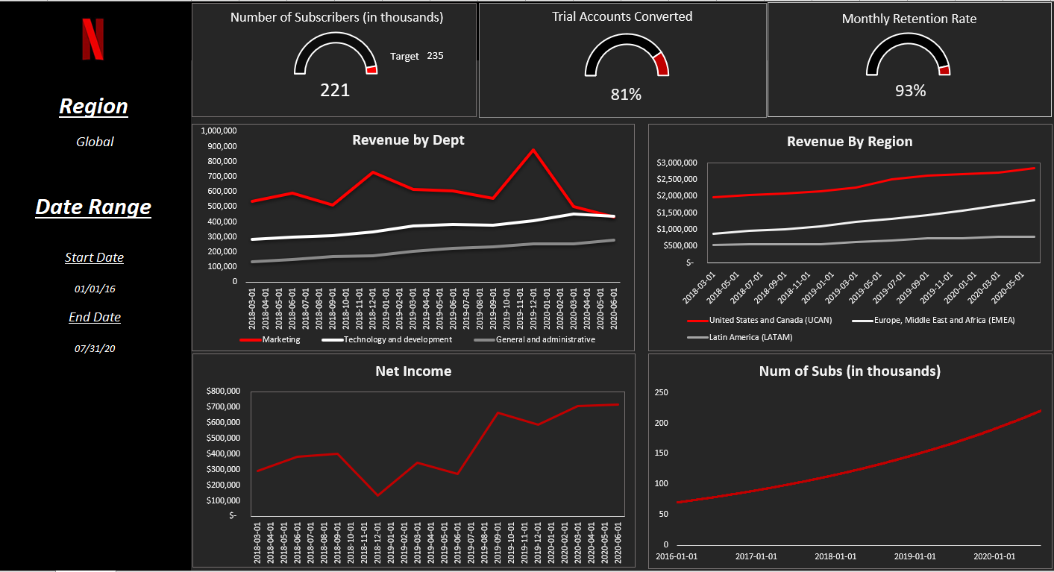
A dashboard designed for the CEO of Netflix to allow them to quickly make decisions about business success. Revenue and net income data gathered from Netflix annual report (2019) and Netflix Q2 Financial report (2020).
Figure 2
CCO Dashboard
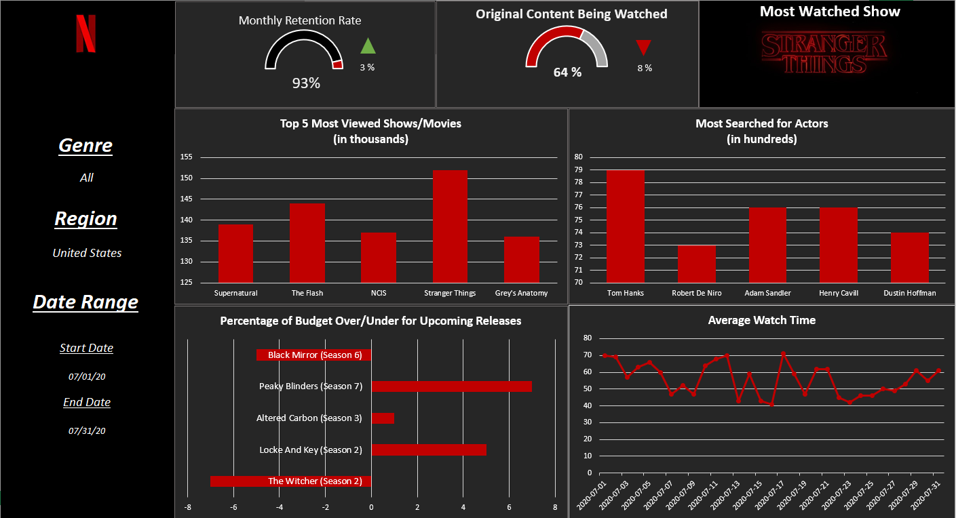
Dashboard designed for use by the CCO, upcoming releases retrieved from Reelgood. Other data was simulated using Excel random formula.

Figure 3
Technical Analyst Dashboard
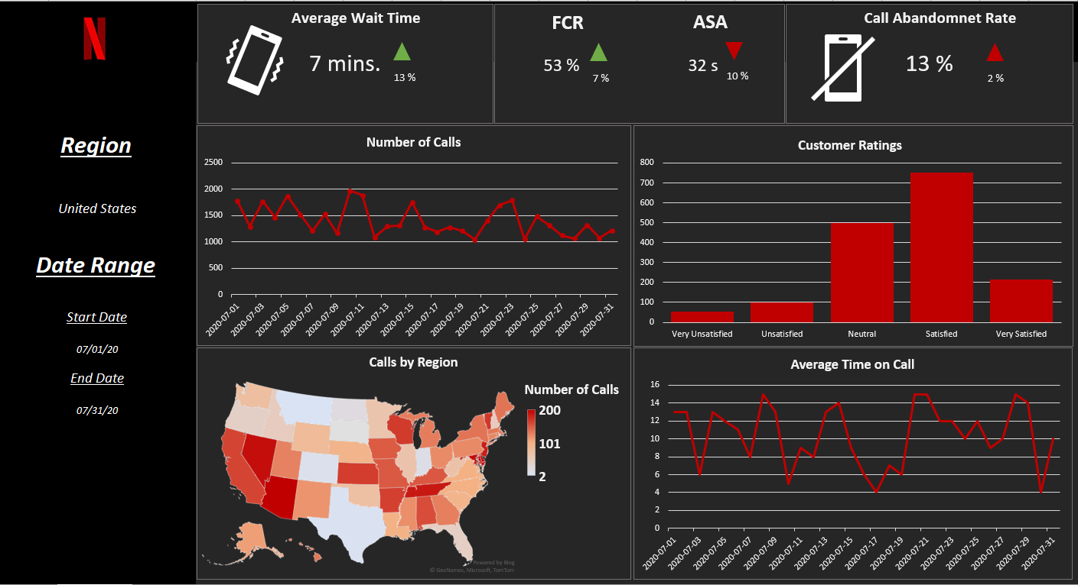
Dashboard designed for a technical analyst role at Netflix. Data was simulated using Excel random formula.

