[The title page contains the title of the report, the names of the authors, the names of the Faculty Mentor and sponsors, the names of the department and university, and the date the report is submitted. Note that this page is considered to be the first page of the front matter (that is, page i; see the General Specifications for Final Reports; however, the number does not appear on the page. Everything on this and the following pages that is between brackets represents instructions or examples and is to be replaced with information unique to your report. Items in italics are instructions, and those not in italics demonstrate the typeface to be used in your inserted text. Material that appears outside of brackets represents text that will appear in the report in that exact form (i.e., both content and formatting).]

[Place Title of Report Here]
[Type the title of the report in 24-point Times New Roman Bold type at the optical center of the page, that is, centered on the page about one-third the length of the page from the top. Use upper and lower case letters. Do not use italics. The title should be informative, casting light on both the project and the design object.]

Submitted To

[Name of Faculty Mentor]
[Name of Sponsor (if applicable)]
[Sponsor’s Affiliation (if applicable)]
[This and the following information should be set in 14-point Times New Roman Bold.]

Prepared By

[Name of Author]
[Name of Author]
[Name of Author]
[Name of Author]
[Name of Author]
[Name of Author]

EE464 Senior Design Project
Electrical and Computer Engineering Department
University of Texas at Austin

[Semester Year]
CONTENTS [Set in bold, all caps]
[Skip a line (press the Enter key twice) after typing a centered heading.]
TABLES iv
FIGURES vi
EXECUTIVE SUMMARY vii
[Skip a line space here.]
1.0 INTRODUCTION [This is a first-level heading. Use bold, all capital letters.] 1
2.0 DESIGN PROBLEM STATEMENT 2
3.0 DESIGN PROBLEM SOLUTION 2
4.0 DESIGN IMPLEMENTATION 4
4.1 Clock Mode 3
4.2 Debug 3
4.3 Program Counter 3
4.4 Memory 3
4.2.1 [Third-Level Heading] [Bold, italicized, initial caps.] 4
4.2.2 [Third-Level Heading] 4
4.5 Register File 3
4.6 Arithmetic Logic Unit 3
5.0 TEST AND EVALUATION 5
6.0 TIME AND COST CONSIDERATIONS 7
7.0 SAFETY AND ETHICAL ASPECTS OF DESIGN 7
8.0 RECOMMENDATIONS 7
9.0 CONCLUSIONS 8
REFERENCES 9
APPENDIX A – [TITLE OF FIRST APPENDIX] [Insert the appendix title.] A-1
APPENDIX B – [TITLE OF SECOND APPENDIX] B-1
[Etc.]

[The table of contents receives the page number ii. If the table extends to a second page (page iii), place the heading “CONTENTS (Continued)” at the top of the second page. Note that you use both decimal numbers and indentation in this table to distinguish the different levels of headings.

Note: The first-level headings shown above are those required for the final report. You can, however, add your own second- and third-level headings to describe your particular project.]
TABLES [Set in bold, all caps]
[Skip a line (press the Enter key twice) after typing the centered heading.]
1 [Title of first table] 7
2 [Title of second table] [etc.]
[Etc.]

[The list of tables follows the table of contents and is also page numbered with a lowercase Roman numeral. Note that the list of tables and the following list of figures are two separate pages.]

FIGURES [Set in bold, all caps]
[Skip a line (press the Enter key twice) after typing the centered heading.]
1 [Title of first figure] 6
2 [Title of second figure] [etc.]
[Etc.]

[The list of figures follows the table of contents and is also page numbered with a lowercase Roman numeral. Note that the list of figures and list of tables are two separate pages.]

EXECUTIVE SUMMARY
[Skip a line (press the Enter key twice) after typing the centered heading.]
[Text

1.0 INTRODUCTION

2.0 DESIGN PROBLEM

3.0 DESIGN SOLUTION

4.0 DESIGN IMPLEMENTATION
why pc went to bus
4.1 Clock Mode

4.2 Debug

4.3 Program Counter
The program counter (PC) consists of four 4-bit binary counters, two 8-bit tristate buffers, three quad 2-input NAND gates, and hex invertering gates. The configuration is shown in Figure n.

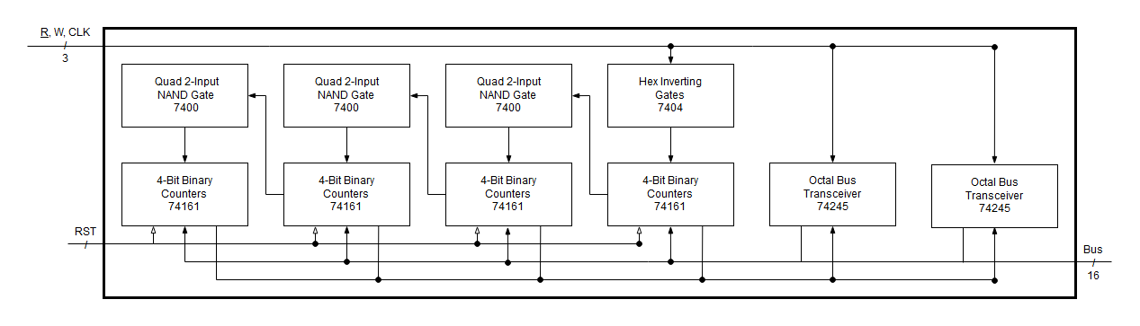
Figure n. Program counter layout.

The 74LS161 binary counter provided an incremented address with each clock pulse. Additionally, the address can be set or reset. All output bits were connected to 74LS245 buffers. All input setting bits were tied to the bus. The active low master reset (MR) signal was connect to a master reset SPST switch. The clock bit, CP, was not directly connected to the system clock. Since four binary counters were connected in series, the first counter would use the clock signal for normal operation, and the remaining counters would use the previous counter’s terminal count output bit (TC). This bit signaled when a counter had counted its’ full range. However, resetting the counters required a clock pulse. Therefore, the counters would need their respective clock or TC signal at certain times, and need to receive a coordinated pulse to reset. This logic was reduced with LogicAid and then converted to a NAND gate equivalent to reduce cost. The 74LS00 quad-NAND gate and the 74LS04 inverter were used to create this multiplexer.

The 74LS245 octal bus transceiver was used to buffer the program counter’s output. Since the buffer was used for outputting to the bus only, the direction bit (DIR) was always set in that direction. Could have used a diff chip… The enable bit (E), was used to control when the PC sends data to the bus. The remaining lines consist of input to output pairs.

4.4 Memory
The memory module contains one 64K x 8 CMOS Sram UM61512A, four 4-bit D-Type Register 74LS173, four octal D-Type latch 74LS373, one octal bus transceiver 74LS245, two dual 4-input AND gate 74LS21, one hex inverting gate 74LS04, and one quad 2-input OR gate 74LS32. The configuration is shown in Figure n.

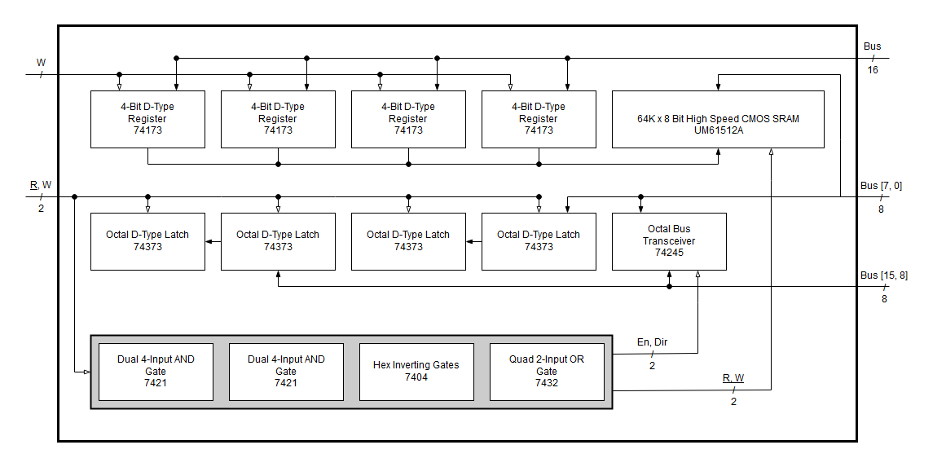
Figure n. Memory layout.

The memory address register (MAR) received a 16 bit address from the bus. This value determined what place in memory was to be accessed. A write enable bit, controlled by the control store, would then allow an address to be sent to memory. The memory data register (MDR) contained four octal D-type latches. However, the latches were connected in series and held identical values—this allow LEDs to be connected to see what values the latch pairs held. Since memory was byte addressable, the high and low bytes of the bus had to be both accessable by the MDR. The octal bus transceiver 74LS245 was configured to allow the high byte to be copied onto the lower byte on the bus. This data path is shown in Figure n in red.
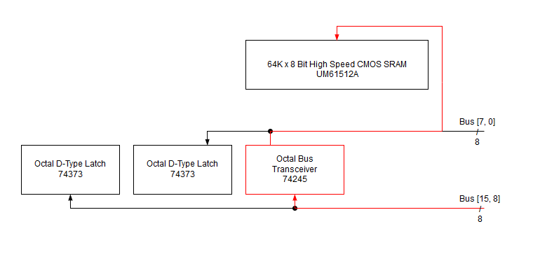
Figure n. High to low byte datapath.

At this point, the control store has to keep track of the following MDR signals: read byte 1, read byte 0, write byte 1, write byte 0; the signals to write to memory are: memory read, memory write, tri-state buffer enable, tri-state buffer direction. However, only certain permuations of these signals are ever used; the truth table, shown in Table n, shows all possible states.

w1 | w0 | r1 | r0 | r mem | w mem | 3s dir | 3s en
0 | 0 | 0 | 0 | 1 | 1 | - | 0 | Mdr to bus
0 | 0 | 0 | 1 | 1 | 0 | 1 | 1 | R1 to mem
0 | 0 | 1 | 0 | 1 | 0 | - | 0 | R0 to mem
0 | 0 | 1 | 1 | 1 | 1 | - | 0 | Default (off)
0 | 1 | 0 | 0 | 1 | 1 | - | 0
0 | 1 | 0 | 1 | 1 | 1 | - | 0
0 | 1 | 1 | 0 | 1 | 1 | - | 0
0 | 1 | 1 | 1 | 0 | 1 | - | 0 | Mem to R0
1 | 0 | 0 | 0 | 1 | 1 | - | 0
1 | 0 | 0 | 1 | 1 | 1 | - | 0
1 | 0 | 1 | 0 | 1 | 1 | - | 0
1 | 0 | 1 | 1 | 0 | 1 | 0 | 1 | Mem to R1
1 | 1 | 0 | 0 | 1 | 1 | - | 0
1 | 1 | 0 | 1 | 1 | 1 | - | 0
1 | 1 | 1 | 0 | 1 | 1 | - | 0
1 | 1 | 1 | 1 | 1 | 1 | - | 0 | Bus to MDR

Table n. Memory logic truth table.

Since the memory and tri-state control signals are dependent on what byte is beign written or read, the number of control lines can be reduced from eight to four. The table was entered into logic aid to find a minimally reduced solution. The LogicAid simplification routine is show in Figure n.

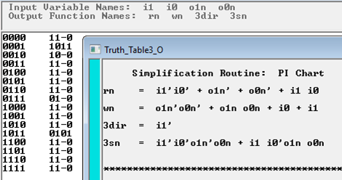
Figure n. Memory logic simplification.

Lastly, these equations were implemented with 4-input AND 74LS21 and 2-input OR 74LS32 to reduce component quantity. This is shown shadowed in grey in the previous Figure n.

4.5 Register File
The 8 by 16bit register file contains eight 4x4 register file 74LS670, four Quad 2-Input NAND gate 74LS00, and a hex inverter 74LS04. The configuration is shown in figure n.

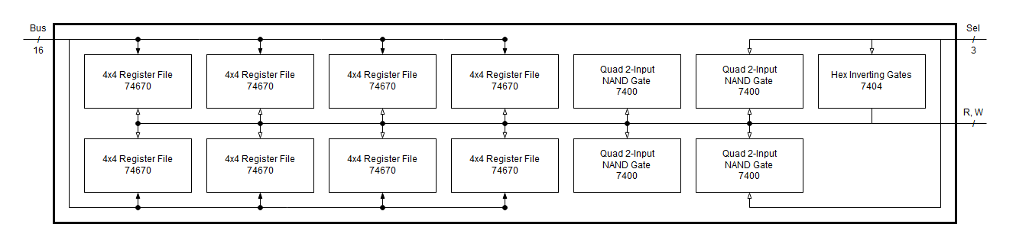
Figure n.

This setup contains two sets of four 74LS670, where each set stores four 16-bit registers. Their inputs and outputs are both tied to the bus. A tri-state buffer is not used, so there is no way to see into a selected register without sending its’ data to the bus. Each set of the four 74LS670 has four control lines: read, write, and two bits to select a register. The 74LS670 allows for simultaneous read and write, but it is not used in the model. To avoid using a total of eight control lines, their logic was reduced to Equations 1 through 4, shown below.

(1)
(2)
(3)
(4)

4.6 Arithmetic Logic Unit

5.0 TEST AND EVALUATION

6.0 TIME AND COST CONSIDERATIONS

7.0 SAFETY AND ETHICAL ASPECTS OF DESIGN

8.0 RECOMMENDATIONS

9.0 CONCLUSION
REFERENCES

[1] [First source reference in IEEE format. First source reference in IEEE format. First source reference in IEEE format. First source reference in IEEE format.]

[2] [Second source reference in IEEE format. Second source reference in IEEE format. Second source reference in IEEE format. Second source reference in IEEE format.]
[Etc.]

[Note that the brackets around each number (unlike the other brackets in this template) are required in a list of references. Each listed reference should be single spaced, with 1-1/2 space between references. This section is a listing of all references of source material. (See the General Specifications for Final Reports.) List the references in the same numbered order that they are cited in the text. Note that this section does not have a decimal number.]

[This page is the title sheet for the first appendix. All appendices must have a title sheet, with the title centered horizontally approximately a third of the way down the page. Be sure to give each appendix a descriptive title. No appendix can appear that has not been referenced in the text, and all appendices must be listed in the table of contents. This page receives the page number A-1, and the numbering system continues with A-2, A-3, etc. on the following pages.]

APPENDIX A – [TITLE OF FIRST APPENDIX]
APPENDIX A – [TITLE OF FIRST APPENDIX]
[Text, figures, tables, or chart. Text, figures, tables, or chart. Text, figures, tables, or chart. Text, figures, tables, or chart. Text, figures, tables, or chart. Text, figures, tables, or chart. Text, figures, tables, or chart. Text, figures, tables, or chart. Text, figures, tables, or chart. Text, figures, tables, or chart. Text, figures, tables, or chart. Text, figures, tables, or chart. Text, figures, tables, or chart. Text, figures, tables, or chart. Text, figures, tables, or chart. Text, figures, tables, or chart. Text, figures, tables, or chart. Text, figures, tables, or chart. Text, figures, tables, or chart. Text, figures, tables, or chart. Text, figures, tables, or chart. Text, figures, tables, or chart. Text, figures, tables, or chart. Text, figures, tables, or chart. Text, figures, tables, or chart. Text, figures, tables, or chart.v Text, figures, tables, or chart. Text, figures, tables, or chart. Text, figures, tables, or chart.]

[Repeat the appendix letter and title on the first page after the title sheet. Place an en dash between the appendix letter and title. There are no other requirements for the appendix. Use the space in this appendix for figures, tables, coding technical details, photographs, sketches, or any other type of data that is too extensive or distracting to place in the main text, even though it is relevant and necessary information.

[Same instructions as for Appendix A. This page is the title sheet for the second appendix. This page receives the page number B-1, and the numbering system continues with B-2, B-3, etc. on following pages.]

APPENDIX B – [TITLE OF SECOND APPENDIX]

APPENDIX B – [TITLE OF SECOND APPENDIX]
[Text, figures, tables, or chart. Text, figures, tables, or chart. Text, figures, tables, or chart. Text, figures, tables, or chart. Text, figures, tables, or chart. Text, figures, tables, or chart. Text, figures, tables, or chart. Text, figures, tables, or chart. Text, figures, tables, or chart. Text, figures, tables, or chart. Text, figures, tables, or chart. Text, figures, tables, or chart. Text, figures, tables, or chart. Text, figures, tables, or chart. Text, figures, tables, or chart. Text, figures, tables, or chart. Text, figures, tables, or chart. Text, figures, tables, or chart. Text, figures, tables, or chart. Text, figures, tables, or chart. Text, figures, tables, or chart. Text, figures, tables, or chart. Text, figures, tables, or chart. Text, figures, tables, or chart. Text, figures, tables, or chart. Text, figures, tables, or chart.v Text, figures, tables, or chart. Text, figures, tables, or chart. Text, figures, tables, or chart.]

[Same instructions as those for the first appendix.]

