$$b3' = a3'a2 a1 a0 + a3 a2'a1 a0$$

$$b2' = a3'a2'a1'a0 + a3'a2'a1 a0'$$

$$b1' = a1$$

$$b1 = a1'$$

$b0' = a0' + a3'a1 + a2 + a3 a1'$

$$b3 = (a3 + a2'+ a1'+ a0') (a3'+ a2 + a1'+ a0')$$

$$= (a3 + a2'+ (a1'+ a0')) (a3'+ a2 + (a1'+ a0'))$$

$$=(a1'+ a0') (a3 + a2') (a3'+ a2)$$

$$=(a1a0)’(a3’a2)’(a3a2’)’$$

$$b2 = (a3 + a2 + a1 + a0') (a3 + a2 + a1'+ a0 )$$

$$= ((a3 + a2) + a1 + a0') ((a3 + a2) + a1'+ a0 )$$

$$= \left(a3 + a2\right)+ (a1 + a0') (a1'+ a0 )$$

$$= \left(a3’a2’\right)’+(a1’a0)’ (a1a0’)’$$

$$= \left({\left(a3’a2’\right)}^{'}’{\left(\left(a1’a0\right)’ \left(a1a0’\right)’\right)}^{'}\right)$$

$$b1 = (a1')$$

$$b0 = (a0) (a3 + a1') (a2') (a3'+ a1 )$$

$$= (a0) (a3’a1)’ (a2') (a3a1’)’$$

$$b3 = (a3 + a2'+ a1'+ a0') (a3'+ a2 + a1'+ a0')$$

$$= (a3 + a2'+ (a1'+ a0')) (a3'+ a2 + (a1'+ a0'))$$

$$=(a1'+ a0') (a3 + a2') (a3'+ a2)$$

$$=(a1a0)’(a3’a2)’(a3a2’)’$$

$$b2 = (a3 + a2 + a1 + a0') (a3 + a2 + a1'+ a0 )$$

$$= ((a3 + a2) + a1 + a0') ((a3 + a2) + a1'+ a0 )$$

$$= \left(a3 + a2\right)+ (a1 + a0') (a1'+ a0 )$$

$$= (a3’a2’)’ (a1’a0)’ (a1a0’)’$$

$$b1 = (a1')$$

$$b0 = (a0) (a3 + a1') (a2') (a3'+ a1 )$$

$$= (a0) (a3’a1)’ (a2') (a3a1’)’$$

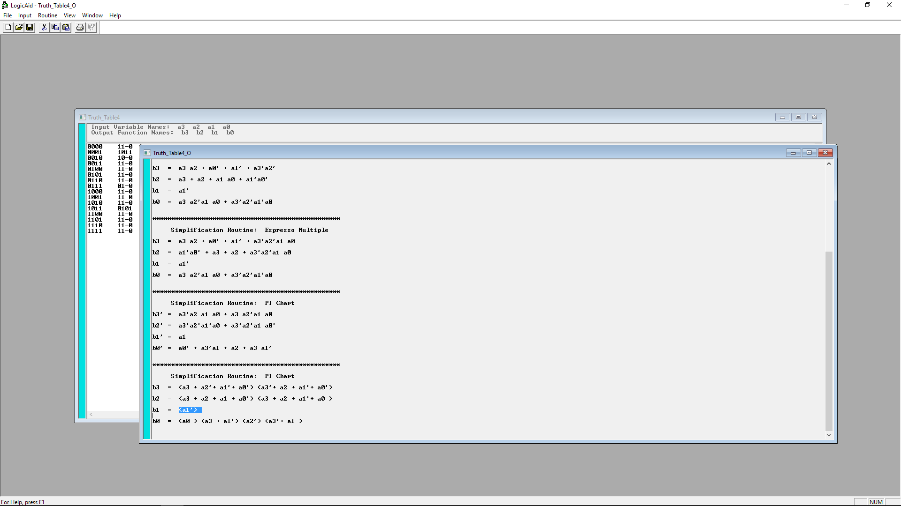

$$b3 =(a1a0)’(a3’a2)’(a3a2’)’$$

$$b2 = (a3’a2’)’ (a1’a0)’ (a1a0’)’$$

$$b1 = (a1')$$

$$b0 = (a0) (a3’a1)’ (a2') (a3a1’)’$$

$$b3 =(c4)’(c2)’(c7)’$$

$$b2 = (c3)’ (c5)’ (c0)’$$

$$b1 = (a1')$$

$$b0 = (a0) (c1)’ (a2') (c6)’$$

$$b3 =(c2)’(c4)’(c7)’$$

$$b2 = (c0)’(c3)’ (c5)’$$

$$b1 = (a1')$$

$$b0 = (a0) (a2') (c1)’ (c6)’$$

$$b3 =(c2)’(c4)’(c7)’$$

3 nand, 1 four and

$$b2 = (c0)’(c3)’ (c5)’$$

3 nand, 1 four and

$$b1 = (a1')$$

$$b0 = (a0) (a2') (c1)’ (c6)’$$

2 nand, 1 four and

inverter

|  |  |  |
| --- | --- | --- |
| a1 | a0' | c0 |
| a1 | a3' | c1 |
| a2 | a3' | c2 |
| a2' | a3' | c3 |
| a1 | a0 | c4 |
| a1' | a0 | c5 |
| a1' | a3 | c6 |
| a2' | a3 | c7 |