Nicholas Hallahan
Sunday, December 8, 2013

GEO 510 OWEB Internship Report
My graduate internship with the Oregon Watershed Enhancement Board was intended to provide experience working as a GIS technician for a state agency. OWEB provides grants statewide for the improvement of watershed related areas throughout the state of Oregon. OWEB grants are funded with a small portion of Oregon Lottery Dollars, federal dollars, and salmon license plate revenue¹. Though the funding and details about the restoration projects are documented online in the Oregon Watershed Restoration Inventory (OWRI), the location and extent of each project needs to be mapped in a spatial database as well. The digitization is done in Esri ArcGIS 10.1 and the data is cataloged in a geodatabase. This file geodatabase is then submitted to the supervisor, Ginger Lofftus, who reviews the submission and merges this database into OWEB's enterprise ArcSDE database. This data is used in-house for analysis and reporting, and it is also available to the public via the Oregon Watershed Restoration Tool² on Oregon Explorer.
For each OWEB grant, two stages in the process need to be mapped: (1) the location point of the work to be done as described in a grant application before approval, and (2) the extent and details of the work done on a completed project. For grant applications, only the center point of the project site is needed, and this is added to the OWEB_grants feature class in the geodatabase. For the completed projects, more detailed digitization is required. Based on the details found in the respondents' supplied maps and documentation as well as the type of restoration activity completed, we digitize points, lines, and polygons representing the details of the projects. These data are digitized into the OWRI feature class in the geodatabase. My internship primarily took place during the summer when we were mapping the results of the restoration projects that took place during 2012, so I primarily was digitizing into the OWRI feature class. Fall and winter term internships will instead focus more on mapping the grant applications for the next year.
Because the work involved in the OWEB internship is predefined, we are able to work from any location as long as we have access to the internet. Documentation for grant proposals are found at the Oregon Watershed Enhancement Board Grant Management System (OGMS), and documentation for completed restoration projects are located at the Oregon Watershed Restoration Inventory (OWRI). We are assigned a list of projects to map by Ginger Lofftus, and this list is provided when logging into the OGMS according to a specified user name and password (provided by Ginger) for OWEB grant applications. For completed restoration projects, Ginger supplies an Excel spreadsheet that lists each project we are to map as well as various details. We then enter the corresponding project_id into OWRI to retrieve the details and map submitted by the respondent. For both OGMS and OWRI, we find and map the project site based on both the information provided on the website as well as the uploaded project files submitted.
Usually the uploaded project files consist of a PDF that contains a map of the project site and the work done. The quality of the provided map varies wildly. Sometimes we are provided with a very vague satellite ortho-image with some unlabeled dots and lines drawn on it. Other times we may receive a rendered CAD drawing of the site or even an occasional hand drawn map. Some maps are well made and provide all of the location and detail we need, and others do not. On occasion, we also receive shapefiles instead of PDFs, and this is usually preferred.
The main challenge digitizing these maps is finding the location of the project site. Sometimes the respondents provide exact GPS or PLSS (Township, Range, and Section) coordinates, and these projects are usually easy to find. At times, however, the provided information is incorrect or missing altogether. In this situation, we search for the site based on either the 8 digit HUC or recognizing features and labels on the provided map and manually find the site. This is not always possible, and in this situation, we simply flag this project as incomplete in the Excel document and state in the comments field that we were unable to find the project site.
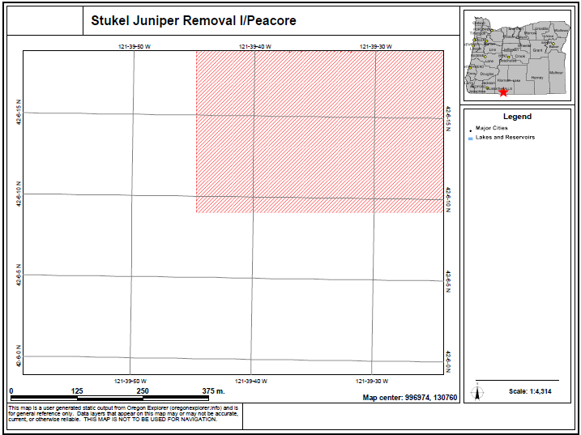Illustration 1: An example of a bogus map that does not provide usable information.
Although receiving a shapefile is the most convenient data we can receive from the respondent, we need to make sure that the mapped geometries adhere to the protocol. The protocol is a document provided by OWEB that defines all of the requirements regarding the content and detail of the data to be entered into the geodatabase. This means that if the provided shapefile includes lines representing all of the streams in a watershed affected by a headgate installation or an irrigation point diversion, we must remove this data and instead insert a point for the headgate or irrigation diversion. Though this is less detailed, the protocol specifies that points are to be used in this situation, and consistency of the data is more important than fine-grained detail. Understanding the priorities of what data to map and at what detail to provide is the most important skill that OWEB needs from us for our digitization endeavors.
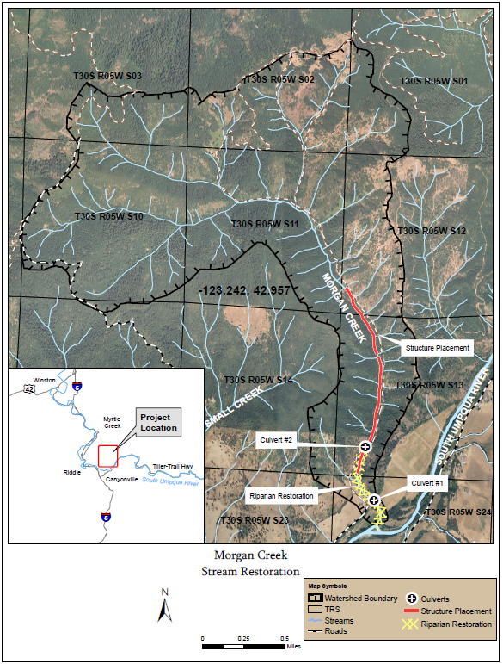Illustration 2: An example of a map with good details and both GPS and PLSS coordinates.
The most challenging stage of the OWEB internship is getting started. It takes some time to properly set up the geodatabase and download the proper reference datasets used to help us find and digitize our project sites. Useful reference basemaps include NAIP_2011_SL orthoimagery streamed from Oregon explorer, the scanned USGS Topographic maps provided by services.arcgisonline.com, as well as the default OpenStreetMap basemap. It is also useful to have the Oregon Counties, Hydrologic Units, and PLSS shapefiles of Oregon to assist with finding project sites. Regarding tracing watershed features, we need the OR_Trans_Public_2012 geodatabase, fish passage barriers, and the wc_oregon hydrography framework. All of these datasets can be found on Oregon Explorer and the Oregon Geospatial Enterprise Office websites.
When beginning the internship, it would sometimes take up to an hour to digitize a given OWRI project, because I was in the process of learning how to digitize in ArcGIS and learning how to do this correctly in the context of the protocol. After a few weeks, however, I became acclimated to the work flow and requirements, and now I can often do a project in 5 – 10 minutes. This improvement came though repetition as well as guidance provided by my supervisors Kuuipo and Ginger. The databases I created , further documentation, and notes useful in this internship is available publicly on my OWEB Github³ repository.
In this repository you will find several Python scripts that I wrote that will help you automate the process of working with your geodatabase. One example is attribute-filler.py. Sometimes you will be provided shapefiles for a project that contain hundreds of points. When you import them into your geodatabase, instead of repetitively filling in the fields for each feature, you can run this script to automatically fill in all of the fields at once. Another useful script I made is filter-out-riparian.py. When copy-pasting the treatment details into the database from OWRI, activities of the activity type “Riparian” would often have descriptions like: “Other riparian vegetation management.” Ginger decided that including the word “riparian” in the description is redundant and requested that I take this word out. Unfortunately, I had done this with dozens of projects, and it would have taken a long time to go through each and manually filter out the word “riparian”. Instead, I wrote a simple Python script that did this for me.
Overall I enjoyed this internship and now know what it takes to do the work of a GIS technician working for a state agency. Though challenging at first, the internship became easy after I became acclimated. It provided me the opportunity to get a glimpse into the upkeep of rural watersheds throughout Oregon, and I learned quite a lot of fun details about the geography of the state in the process. The projects I worked on were spread throughout the state, and I am now familiar with each of the 35 counties of Oregon. Although it is common nowadays to hear about government malfunctioning, OWEB has been a straight-forward agency effectively working towards the upkeep and improvement of the land we live on.

References
1. Oregon Watershed Enhancement Board. 2013. “OWEB: About OWEB.” Dec 8. http://www.healthywatersheds.org/about.html
2. Oregon Explorer. 2013. “Oregon Watershed Restoration Tool.” Dec. 8. http://oe.oregonexplorer.info/RestorationTool/
3. Hallahan, Nicholas. “OWEB Digitization Github Repository.” Dec. 8. https://github.com/hallahan/oweb

