Oregon Watershed Restoration Inventory (OWRI)

**Mapping Protocols**

Updated March 20, 2012

Restoration projects will be mapped based on the type of restoration activity as described below. USGS topographic base maps or current aerial imagery will be used as the primary mapping base layer. Although it is ideal to map all project types to the level of detail and accuracy as described by the protocols, it is only possible to map to the level of detail provided in the respondent’s map.

Maps are submitted by respondents in a variety of file formats and using a multitude of software applications. Guidance for map submission is provided on OWEB’s website and OWEB recommends submitting a map either by using the Oregon Explorer Advanced Mapping Tool or by ESRI shapefile. However, this is not a requirement. Common map file formats include PDF, jpeg, tiff, or shapefile.

Link to map guidance on OWEB website:

<http://www.oregon.gov/OWEB/MONITOR/OWRI_reporting.shtml#Project_Location_Map_Guidance>

Base data for building an .mxd for data entry:

* **Basemaps as ArcGIS Server connections**

1. expand the ‘GIS Servers’ directory, choose 'Add ArcGIS Server' from the list
2. select the option 'Use GIS Services'
3. enter 'http://159.121.100.164/ArcGIS/services' for the Server URL under the Internet option
4. click finish

The connection to the server will now be listed under the GIS Servers list; the imagery (called ‘Imagery_Mosaic2009') is located under the 'Basemaps' folder.

1. Repeat the map services steps above, substituting the following URL in step 3, to add a topographic map service from hosted by ESRI. ArcGIS Online - <http://services.arcgisonline.com/arcgis/services>

* **ArcGIS 10.0 Add ESRI Basemap**

1. Select the ‘Add Data’ button, choose Add Basemap
2. Select Imagery
3. Repeat step 1
4. Select USA Topo Map

* OWRI Dataset (up to 2009) - <http://oregonexplorer.info/EnhancingWatersheds>
* BLM Ground Transportation (roads) - <http://www.blm.gov/or/gis/data-details.php?data=ds000041>
* State of Oregon Spatial Data Library/Alpha List <http://www.oregon.gov/DAS/EISPD/GEO/alphalist.shtml>
  + Oregon Fish Passage Barriers, Source: Oregon Department of Fish and Wildlife
  + Watershed Boundaries Dataset, Source: Hydrography Framework data
  + Watercourses or NHD, Source: Pacific Northwest Hydrography Framework data
  + counties
  + cities
  + quadindex
  + plss

**Step-by-Step Guidance**

1. OWRI submissions are viewed through OWRIO (OWRI Online) by logging in, entering the project number or project id, and reviewing the data via a webpage. A list of projects to be digitized will be provided in Excel.
   1. Login: rimapping, password: rimapping
2. The maps associated with the projects are attached as uploads to the data review webpage, scroll to the very bottom once a project id or project number is entered to view the attachment for the project*.*
3. Open an ArcMap document (.mxd)
4. Begin editing specified feature classes (Editor Toolbar Editor dropdown menu ‘Start Editing’)



1. From the data review webpage and map, identify the project location and activities reported;
   1. Look for a latitude/longitude coordinate on the map provided;
   2. Look for a map center coordinate on the map provided or;
   3. Note the township/range/section (TRS) provided or;
   4. Look for any other location identifying information such as stream names;
   5. Note which activities were reported (e.g., instream, upland, riparian, etc.);
2. If provided, enter a latitude/longitude coordinate using the ‘Go to XY’ button .
   1. If no latitude/longitude coordinate is provided locate the TRS or other identifying information (e.g., stream name, city, etc.) using the map layer attribute tables.
   2. Right click the highlighted feature and select ‘Zoom to Selected Feature’
3. Use a combination of the pan and zoom tool, as needed, to view the project location. 

***Duplication*** *- occasionally projects may get reported to OWRI more than once by a respondent. Once the location of the project is found; if there are other projects nearby that look suspiciously like the features that you are about to map, take note of the project numbers or project ids in the Excel sheet provided for tracking which projects are to be mapped. An OWEB project manager will verify whether or not the projects are actually duplicates.*

1. Open the ‘Create Features Editing Window’ (Editor Toolbar dropdown menu Editing Windows Create Features)
   1. Select the OWRI point, line or polygon feature class.
   2. Select the appropriate Construction Tool
2. Click on the map to create a feature
   1. If OWRI_points is selected, one click will create a point.
   2. If OWRI_lines or OWRI_polygons is selected, multiple clicks will create a line or polygon.
   3. For lines and polygons either double click to finish the sketch, hit F2 or right click and select ‘Finish Sketch’ from the menu.

***OWRI Mapping Protocols by Activity Type*** *- when digitizing from a respondent’s shapefile or map, follow the OWRI mapping protocols below, do not copy the respondents feature exactly unless it follows the correct protocols for the activity reported.*

1. Select the ‘Attributes’ button 
2. Enter the attributes as described below.
3. Save your edits (Editor dropdown menu ‘Save Edits’).

**OWRI Data Review**

Activities versus Treatments – at least one feature per activity should be digitized. It is not necessary to create a feature for each treatment. If one activity type has multiple treatments, the treatments can be summarized in the ‘treatment_comment’ attribute field. For example, a project reported an upland activity that included grazing management, off-channel livestock watering and upland fencing as treatment. Only one polygon should be digitized to encompass the activities UNLESS there are multiple project sites reported. If multiple project sites are reported, one polygon per site would be adequate for this example project.

From the OWRI Online data review page, under the section ‘Treatments and Metrics’ the activities and treatments are listed.

**OWRI Mapping Protocols by Activity Type**

* **Instream projects –** *utilize the trace tool (on the editor tool bar in ArcGIS software) on the most current version of the Oregon Framework dataset, ‘Watercourses’, when appropriate.*

Instream projects will be mapped primarily as lines and secondarily as points, reflecting the placement of the restoration activity. Instream projects should always be mapped as a line if possible. They will be mapped as a line rather than individual points when the restoration activity occupies a linear location, such as several log placements along a stream reach. In certain instances, instream projects will be mapped as points e.g., when the restoration activity occupies a single location such as a single log or boulder structure placement.

* **Instream Flow projects**

Instream Flow project will be mapped primarily as points and secondarily as a line feature, reflecting the placement of the treatment reported. Instream Flow projects will be mapped as a point when the restoration activity is at a single location such as a headgate installation, a point of diversion for instream water lease transfer or a measuring device installation at an irrigation point of diversion. Instream projects will be mapped as a line if the treatment reported is an irrigation system improvement such as a ditch to pipe conversion.

* **Road projects**

Road projects will be mapped primarily as lines and secondarily as points, reflecting the placement of the restoration activity. Road projects will be mapped as a line when the restoration activity occupies a linear location such as a road rocking, road relocation or road vacating project. Road projects will be mapped as a point when the restoration activity occupies a single location such as a non-stream crossing project or drainage improvement project. In that case, each 50-yr peak flow culvert crossing improvement may be mapped as a single point if they are on different roads within the same project or are further apart otherwise one line reflecting multiple crossing improvements along a stretch of road is adequate.

* **Fish Passage/Fish Screen projects -** *utilize the snapping tool (on the editor drop down menu within the editor tool bar in ArcGIS software, also on by default in ArcGIS 10.0) on the most current version of the Oregon Framework dataset, ‘Watercourses’, when appropriate.* **See below for guidance\***.

Fish passage/fish screen projects will only be mapped as points, reflecting the actual, on-the-ground placement of the restoration activity. Examples of fish passage projects include a culvert replaced at a road/stream crossing and a push-up dam removal.

**\***It is important to be as accurate as possible when placing fish passage points so that OWRI data can inform ODFW’s Fish Passage Barriers Dataset.

**Satisfy the following conditions for Fish Passage projects:**

* + 1. The target positional accuracy is 40 feet, best achieved if you work at scales between 1:12,000 and 1:1,200.
    2. Most OWRI Fish Passage projects should be located at a road/stream crossing (e.g., dams may not be at a road crossing), therefore the new point feature should also lay on top of a road/stream crossing either in the aerial imagery, topographic map or the base data layers (i.e., BLM roads, Hydrography Framework ‘Watercourses’). The base map used by the respondent is not always the most accurate data layer to use to precisely place a fish passage point. Use the respondents map to get to the correct location but review the other base layers to determine the most accurate location.
       - Additionally, the respondent may not have precisely reflected the location of the project on the map provided because either the scale used was too small or the base map was not detailed enough (e.g., outdated topographic maps). There are cases where the project location can be inferred from reviewing the aerial imagery compared to the map provided by the respondent (e.g., visible road stream crossings in the aerial photography compared to the topographic map).
    3. Turn on the ODFW Fish Passage Barrier Dataset (OFPBD), if there is a feature from this dataset within 40ft of the location of the restoration activity; place the new OWRI point directly on top of the OFPBD feature.

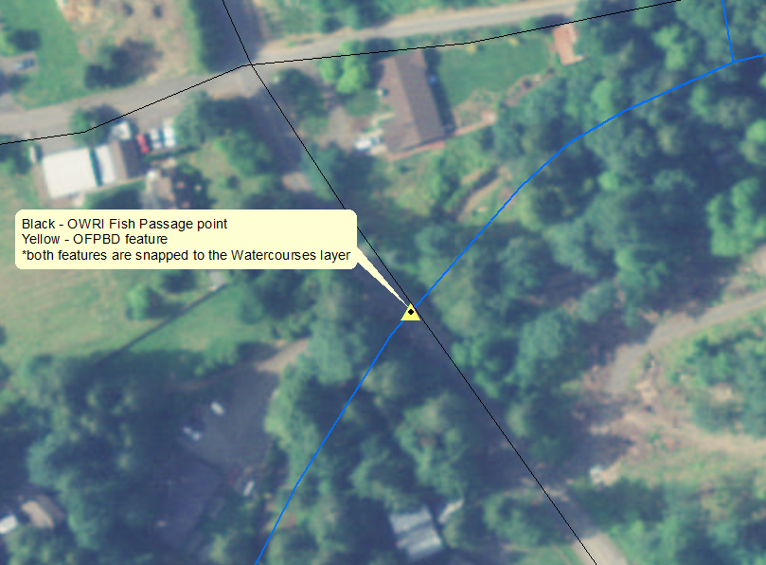

* + 1. If the mapper is not confident on the placement of a fish passage project point, place the point as accurately as possible and note in the project tracking spreadsheet that the project should be reviewed by the OWEB project manager.
* **Riparian projects** - *utilize the trace tool (on the editor tool bar in ArcGIS software) on the most current version of the Oregon Framework dataset, ‘Watercourses’, when appropriate.*

Riparian projects will be mapped as lines reflecting the stream reach affected by the restoration activity, and very rarely mapped as points. They will be mapped as a line when the restoration activity occupies a linear location such as a riparian planting project. Although riparian projects exist adjacent to the stream, riparian projects will be mapped as a line segment directly on top of the stream. In very rare circumstances, such as a chemical application project, the project may be mapped as a point. In these cases, the point will be mapped at the location of the chemical application.

* **Wetland projects**

Wetland projects will be mapped primarily as polygons, secondarily as lines or points, reflecting the placement of the restoration activity. The feature type used will match that of the respondent’s map to preserve the maximum detail provided. They will be mapped as polygons when the restoration activity occupies an area such as a wetland restoration. Wetland projects will be mapped as points if the restoration activity is at a single location such as the position of a dike for a dike removal project.

* **Upland**

Upland projects will be mapped primarily as polygons, secondarily as lines or points, reflecting the placement of the restoration activity. The feature type used will match that of the respondent’s map to preserve the maximum detail provided. Upland projects will be mapped as a point when the restoration activity occupies a single location such as an off-channel livestock watering project. They will be mapped as a line when the restoration activity occupies a linear location such as a ditch to pipeline restoration or cross fencing project. They will be mapped as a polygons when the restoration activity occupies an area such as an upland seeding project.

* **Urban**

Urban projects will be mapped primarily as polygons, secondarily as lines or points, reflecting the placement of the restoration activity. The feature type used will match that of the respondent’s map to preserve the maximum detail provided.

**OWRI Feature Class Attributes**

|  |
| --- |
| **gis_source:** identifies the source of the data for reporting purposes, select the appropriate option. This field combined with the objectID field creates a unique identifier for each site.  point = ‘owri_pt’, line = ‘owri_ln’, polygons = ‘owri_poly’ |
| **ri_project_id**: Enter the OWRI project identifier. The provided project tracking spreadsheet lists this information. |
| **project_nbr**: database identifier, found at the top right hand corner of the hard-copy form in pencil (e.g., 20060634). Alternatively, the project number can be found at the top of the page on the OWRIO data review page after entering the project id (ri_project_id). If this number is null in the OWRIO database, leave it null in the geodatabase. |
| **activity_type**: Enter the type of activity the feature represents - found at the top of each activity page on the hard copy form or refer to the data review webpage under ‘Treatment and Metrics’, the activities reported are under the ‘Activity Type’ column. (e.g., upland, riparian, road, fish passage), choices are provided in a drop down menu. ***NOTE:*** *at least one feature is required for each activity type, even if the features are exact copies. E.g., riparian planting and instream large wood placement occurred on the same stream reach. Create two lines, one for the riparian activity and one for the instream activity (with the appropriate treatment comment, see below).* |
| **treatment_comment**: Enter a brief description of the treatments that occurred. The treatments are reported on the OWRI hard copy form under each activity page. On the OWRIO data review webpage, copy and paste the ‘Treatment’. If the spatial feature represents more than one treatment, briefly summarize all. |
| **mapper**: Enter your name (or the name of the person who created the feature), choices are provided in the drop down menu. |
| **mapper_confidence**: The confidence the mapper has in how accurate the entry is (how well the mapper is able to interpret the data). Enter ‘H‘ for high, ‘M’ for medium or ‘L’ for low. A feature with high confidence is when the mapper is confident they were able to duplicate the location shown on the respondents map. A feature with medium confidence is if the mapper is certain they are within the right TRS or general location but are not confident the activity is located exactly as the respondent’s map portrays. If the mapper has low confidence in placement, flag it for follow-up in the provided project tracking spreadsheet. |
| **origin:** not used currently but kept in the files to make sure data can be appended accurately (was used historically). No data entry required. |
| **point_x/point_y**: The x and y coordinate of the feature in decimal degrees using the Geographic Coordinate System NAD83. Line features will be represented by the midpoint of the line and polygon features will be represented by the centroid of the area. |
| **gis_type**: The feature type for reporting purposes, found in a drop down menu, select the appropriate option.  point = ‘GIS Point Source’, line = ‘GIS Line Midpoint’, polygon = ‘GIS Polygon Centroid’ |
| **analysis_scale**: an attribute required for reporting purposes. All features will be ‘6th Field HUC’ and the option is found in a drop down menu. |
| **origin_date**: Enter the date the feature was digitized. |
| **qaqc_date:** The date the feature was quality checked for accuracy and consistency with mapping protocols. No data entry required, the OWEB project manager does quality checks of the data |
| *Auto-generated/OWEB-generated, mandatory database fields. No data entry is required.*  **ObjectID, shape, shape.area, GlobalID, shape.len, site_id** |