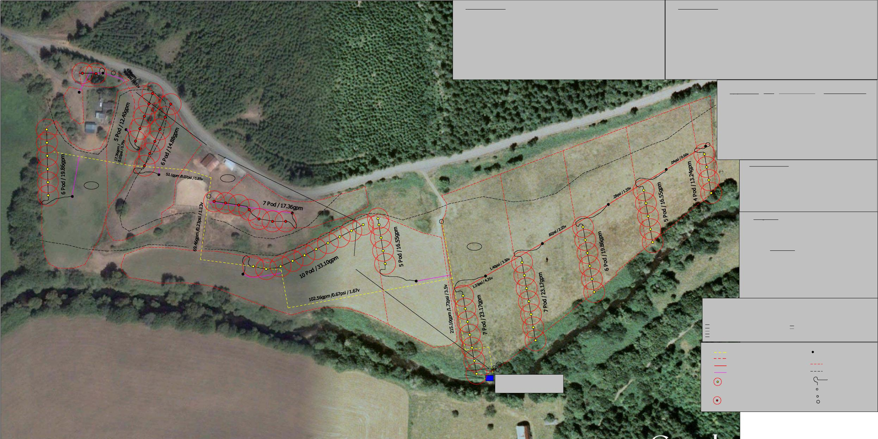

.17 Acres

3.66 Acres

2 Pods / 4.96gpm

48

.25 Acres

A

2.11 Acres

33' Vert.

A

63B

6.80 Acres

1.39 Acres

5.5' Vert.

A

11' Vert.

5' Vert.

10 Day/ 250' Block System Design Gross Application = 3.10" ( 2.33" A.D. / .75eff. @ 10 Day Interval / 1 Moves Per Day / Max. ETc Increase = 0.233" Daily ) (Weather Tec 3.2 FC Noz. @ 45psi = 3.31 gpm )

( 0.128" Application Rate x 24hr = 3.10 " Applied Gross x .75 eff. = 2.33" / .18 Etc = 12.94 Days

Estimated Water Requirement :

Soil Type = (33) Kirkendall, (48)Quosantana

Available Water Capacity @ 0- 24" Profile Combined Average 0.20 In/In

Crop Type = Pasture

Maximum Rooting Depth = 24"

Total Plant Available Water In Root Zone = 4.80" ( 0.20 In/In Average x 24" )

Maximum Daily ETc = 0.18" (Dora Climate Site)

Maximum Soil Water Deficiency = 50% ( Allowable Depletion =4.80"x.50 = 2.40" )

Soil Maximum Irrigation Interval (days) = 13.3 ( 2.40"A.D. / 0.18"ETc )

Gross Application = 3.10" ( 2.33" A.D. / .75eff @ 10 Day Interval, Max Et =.233" )

Application Efficiency = 75%

33

CV P

A

20hp Pump

3phase/ 240v / 100amp Service 58' ASL

13.00 Acre

8 Day/ 200' Block System Design Gross Application = 2.86" ( 2.15" A.D. / .75eff. @ 8 Day Interval / 1 Moves Per Day / Max. ETc Increase = 0.269" Daily ) (Weather Tec 2.5 FC Noz. @ 35psi = 2.48 gpm )

( 0.119" Application Rate x 24hr = 2.86 " Applied Gross x .75 eff. = 2.15" / .18 Etc = 11.94 Days

Estimated Water Requirement :

Soil Type = (63B) Wintley

Available Water Capacity @ 0- 24" Profile Combined Average 0.18 In/In

Crop Type = Pasture

Maximum Rooting Depth = 24"

Total Plant Available Water In Root Zone = 4.32" ( 0.18 In/In Average x 24" )

Maximum Daily ETc = 0.18" (Dora Climate Site)

Maximum Soil Water Deficiency = 50% ( Allowable Depletion =4.32"x.50 = 2.16" )

Soil Maximum Irrigation Interval (days) = 12 ( 2.16"A.D. / 0.18"ETc )

Gross Application = 2.86" ( 2.15" A.D. / .75eff @ 8 Day Interval, Max Et =.269" )

Application Efficiency = 75%

***Key***

***NRCS Constuction Specification References:***

CS-02 Pollution Control

CS-52 Conduit and Pipelines

CS-53 Valves and Meters

CS-62 Pump

CS-113 Excavation and Backfill of Trenches for Conduits and Pipelines

***NRCS Job Class:***

442 Irrigation System Sprinkler, Job Class ( Control Factor #1 = I ) ( Control Factor #2 = l )

430DD Irrigation Water Conveyance,High Pressure,Under Ground Pipeline, Job Class ( Control Factor #1 = l )

533C Pumping Plant for Water Control,Centrifugal Pump,Job Class ( Control Factor #1 = ll ) ( Control Factor #2 = lll )

A

Weather Tec w/ 2.5 FC Nozzle 80' diam.

35 psi = 2.48 gpm

50' x 40' spacing = 0.119"per hr application rate

Weather Tec w/ 3.2 FC Nozzle 80' diam.

45 psi = 3.31 gpm

50' x 50' spacing = 0.128"per hr application rate

Physical Soil Properties:

3" PVC Schd 40 Solvent Weld (1,300 ' )

1. PVC Schd 40 Solvent Weld (1,200')

Map Symbol & Soil Name Depth In. Available Water Capacity In./ In. Basic Sprinkler Intake Rate In. per Hr

1. PVC Schd 40 Solvent Weld (Existing)

5" PVC 160 Solvent Weld (Existing)

33 : Kirkendall 0 - 7 0.19 - 0.21

7 - 42 0.19 - 0.21

48 : Quosantana 0 - 13 0.19 - 0.21

13 - 48 0.19 - 0.21

63B : Wintley 0 - 4 0.19 - 0.21

4 - 47 0.15 - 0.17

24 Hr set x 0.119" hr = 2.86 " Applied ( Gross ) 2.5 FC Noz.

8 Day/Various' Block Interval/Return w/ 1 Move per Day ( 50' x 40' spacing )

Application Rate & Interval :

24 Hr set x 0.128" hr = 3.10 " Applied ( Gross ) 3.2 FC Noz.

10 Day/250' Block Interval/Return w/ 1 Move per Day ( 50' x 50' spacing )

Total K-line "Blocks" = 12 qty

Total K-Line GPM = 215.10

Total Acres Irrigated = 27.38

Total K-line Pods Continues = 70 qty

Intake screen loss = 1.5'

Suction line loss = 0.5'

Check valve loss = 1.6'

Suction Lift ( vert.) = 11.0'

Discharge lift ( vert ) = 43.5'

Mainline loss (2.82 psi) = 6.51 ( PVC / C value used = 150)

K-line leader loss (1.99 psi) = 4.60' ( Poly / C value used = 145 ) 37.55 mm I.D. x 150' K-line 7 pod loss ( 2.2 psi) = 5.08' ( Poly / C value used = 145 ) 37.55 mm I.D.

Sprinkler oper.( 35.0psi ) = 80.85' 2.5 FC Noz. @ 35psi / 2.48gpm (Upper Field)

Design Point:

Pump Selection :

HC 4 x 25 - 75 Franklin 20hp Pump / 6.7" Trim

215 TGPM @ 179' TDH ( 77.49psi ) / 67% eff./ 4.98' NPSHR / 14.4Hpr

215.10 TGPM @

155.14'

10% Margin = 15.5' (6.71 psi)

-------------

170.64 TDH ( 73.87 psi )

***NRCS Material Specification References:***

MS-206 Plastic Pipe MS-218 Valves and Meters

A

P

CV

K-line valve outlet

Soil Type Contour

Working Section

K-line Leader

Air Vent

Check Valve

Pressure Relief

0.50 ( SICL )

N/A ( SIL ) 0.50 ( SICL )

|  |  |  |  |  |
| --- | --- | --- | --- | --- |
| Project :  2011 EQIP Project Farm# **** Tract # **** | | Date : 12/18/10 | Prepared For :Landowner | **Pacific A S stems,Inc.**  **g Y**  93780 Highway 99 South Junction City, Oregon 97448 Phone: 541-998-1983  Tollfree: 888-998-1983 Fax: 541-998-6768  Website: [www.PacAg.com](http://www.PacAg.com) |
| Designer:  Tye Fountain, TSP# 06-5455 (541) 510-1838 Cell [tfountain@pacag.com](mailto:tfountain@pacag.com) | Drawing # Draft | Quote # TBA |
| Last up-date : 10/28/2011 |
| **0' 100'**  Scale : | **200' 300' 400' 500'** |  | |
|  | |