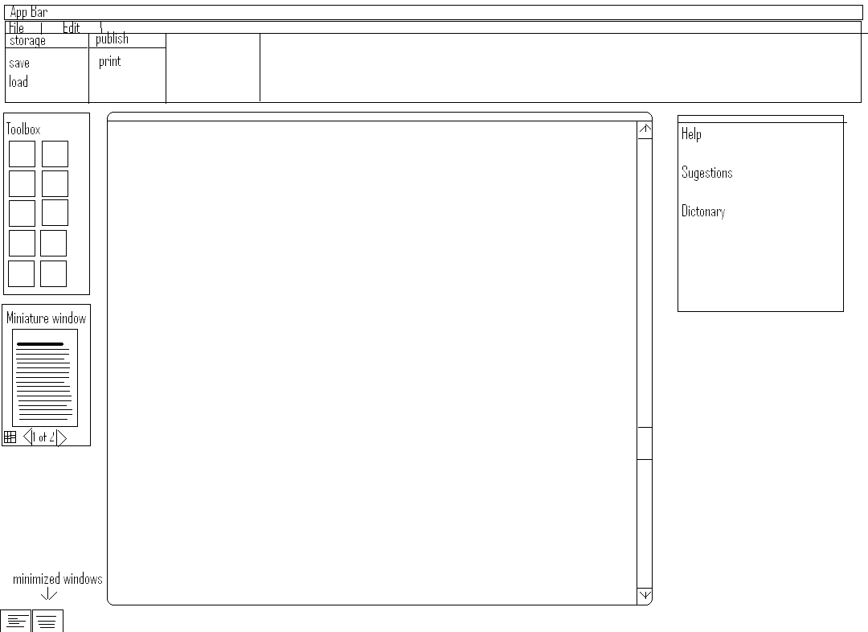
This is my Koffice GUI Mock-up. I will go through the different tools.

App Bar

The App bar displays the app name and document name... very simple

Toolbar (file, edit)

I have always hated not beeing able to find what im looking for in the dropdown toolbar menus. So i thought of a different way making a toolbar menu ... in the picture above we se under the file | edit bar there is a new bar. This bar acts as a dropdown menu. Lets say the file menu is selected. Groups will show up along the bar as storage ... under storage we have save, load, etc. And a publish group for printing and exporting. I havent added all the gruops but if you get the idea of horizontal grouping. And of course if Edit is selected in the toolbar, new groups and options will apear. Hope you got the idea of it!
Toolbox
The toolbox is were we can locate icons as font settings. And tools for vector drawing ... pretty simple nothing new here.
Minuature Window
The minuature window can display any page in your document as a minuature. With out changing page in the work area you can view all your pages.. and if you want to go to a page ... you cold press a goto button or double click.
Another feauture here is to show multiple miniatures like 9 at a time.

Minimized windows
Here you can see other minimized open projects as minatures. Verry simple

The big box in the middle
The big box in the middle is the work area were you can view and edit your document.

The suggestion box
In this box you can se suggestions and seek help in the program .. i thought of a dictonary in this window to...
Abillity to ad new panels under the toolbar would be a nice feature to
That was it hope you like it

