Koffice UI and Functionality Example

by Shapovalov Nikolay, acid_n@mail.ru

1.Synopsis

In modern programs there is no place for working area, it became absolutely not convenient to work with editors. Working area reduce with each new version, squeezing from different directions panels with buttons and the menu. And in fact for creativity so there is no place, a workplace. My idea will consist in clearing the screen of all menus, to hide them. In fact now computers everyone become more powerful and more powerful. Modern technologies allow us to create beautiful, smoothly dropping out, translucent panels on which it is possible to arrange buttons and any leaving menus.
Further I shall try to state vision GUI Koffice in more detail.

2.User Interface
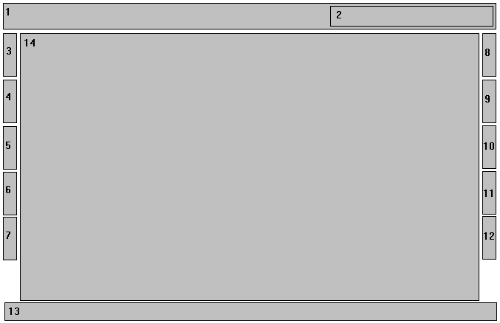
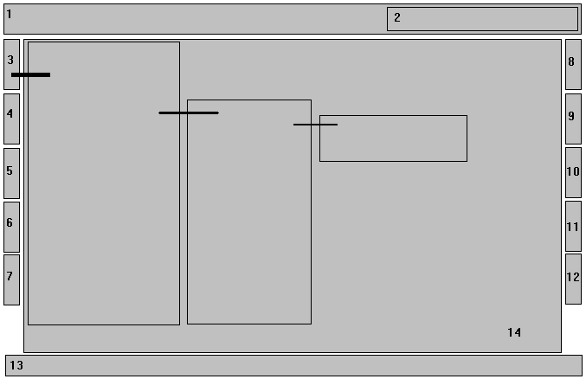

1.Menu Bar.
The basic menu.
Items{Points} of a line of the menu:
File - serves for creation, opening and preservation of the text document. The text can be kept in a various kind.
Editing - serves for editing the text and contains the items{points} connected to work above separate fragments of the text and his{its} objects (to cut out, copy, insert, find, replace, etc.).
The kind - serves for adjustment{option} of working field Koffice: panels of tools, rulers, sectoring of page.
Insert - serves for an insert in the text of various objects (a symbol, figure, a hyperlink, the diagram, the table, etc.).
The format - serves for work with fonts and paragraphs.
Service - serves for adjustment{option} Koffice.
Tables - serves for drawing and formatting of tables.
The window - serves for adjustment{option} of editing of several texts in different windows.
The information{inquiry} - serves for viewing a help material.
As here it is possible to place the standard panel of tools, it serves for performance frequently meeting commands{teams} of various purpose{assignment} (opening and preservation of the document, a seal, work with the buffer of an exchange, a cancellation of actions, creation of tables, columns, etc.).

2. Here I suggest to place the information panel "formatting" (style, the size, a tracing and color which at present is informed are used).

3, 4, 5, 6, 7, 8, 9, 10, 11, 12
Functional panels of tools can be placed on each side working area, as small rectangulars (it is possible like bookmarks) with which it is possible to allocate with different shades or colors. At prompting (or кликом mice, depending on adjustments{options}) on them the mouse from him{it} leaves given (for this or that rectangular) the menu. It is the menu can contain a number{line} of panels with buttons or still leaving menus, depending on functions of this panel. It is possible to make adjusted quantity{amount} of lateral panels, depending on desire of the user. The user can adjust at own discretion both quantity{amount} of panels, and sequence (on functionality) their arrangements, depending on the desire.
In these panels it is possible to enclose a plenty of functions:
Formatting - serves for the task of parameters of the text (style, the size, a tracing, alignment, an interval, color, etc.).
Drawing - serves for work with graphic elements (drawing of lines, figures, inscriptions, the task of color заливки, lines, the text, etc.).
Design and Views - This is new. Design tab when click opens the document for editing. View tab when click opens the document for viewing. This is parallel to the document and view model used in the development of KOffice.
Functionality of Design tab provides a document canvas for user to freely dabble with the document. The toolbar will adapt to the Design tab. Meaning, the icons in the toolbar will correspond to the editing feature of Design tab.
Functionality of View tab provides a readable version of the document. The purpose of this is to create an overlay for purposes like reviews, collaboration, see it in print, etc. View tab in combination of “Author:
KOffice User” is used as a reference for many of the workflow that can be done. For example, when a Koffice User is done writing the document in a peer-to-peer environment, he or she sends the document to another
KOffice User called KOffice User 2. KOffice User 2 uses the View tab to make modification to the document as a reviewer, in addition, with the workflow, KOffice User 2 can approve or vote on the document.

Author – this feature allows the identification of the current author the document. This helps in conjunction with collaboration in a peer to peer or server/client environment. By having an identification more users can participate in the collaborative development of the document.

Workflow visual – the workflow visual maps out the whole process for Design and View tab depending on which tab is selected. For example, if Design tab is selected, the workflow will have series of step like: 1) Create document 2) Save document 3) Apply style 4) Save another version of document 5) Review for accuracy
An example of View tab is selected, the workflow would have the following series: 1) Preview 2) Review 3) Other user comment 4) Merge suggestions 5) Vote on document 6) Secure document 7) Publish document
The above are just examples. The series of steps can be adapted to the user who is writing the document or be a preconfigured series of steps by the developer of Koffice. The whole purpose of the workflow is to help user complete he/she document quickest. Another way the workflow can do is morph the series of steps each time a user select a text in the document canvas. This will bring up a series of steps: 1) Change style 2) Lookup word 3) Research Google for said text.
There is a plurality of possibilities. The main objective is to have a workflow there to help guide user.
Toolbar – toolbar is just the traditional icons based toolbar seen in GIMP or any graphic design application.
Suggestion Box – A user can right click in the document canvas to have the suggestion box popup with something. A user can select a right click and search Google for more content on the search term/terms.
Another use for this is when a user writes something and want to search through his/her previous documents to retrieve it for this is current document. Instead of the user manually going through old documents, the Suggestion Box will do that indexing of all the user’s document to provide that suggestion so the user can insert immediately in the document canvas.
Examples – Examples are style oriented. By reading the tabs, and placements of text in the document canvas, Koffice will provides examples of style user can choose from. Think of templates to present to user when composing a document.
Document Navigation – allow the side by side view of two documents. Allow the opening of multiple documents. This is the area where the documents are organized in such a way for easy retrieval.

13. The panel of a line of a condition - this area, located in the bottom part of a window of the editor in which the various help information on the current condition of the document (with the help of a line of a condition is displayed is possible to carry out fast transition to the set page).

14. Document Canvas.
Where document is edited or review for comments.
Here as rulers (serve for the task of the sizes of page and spaces (at the left and on the right)) settle down.

The further arrangement and formation of panels depends on software developer. To consider all difficulties and problems of creation GUI here practically it is not possible. During creation and editing GUI will arise new ideas and every possible decisions of those or other problems. I hope, programmers Koffice can overcome and create all this really the convenient and beautiful decision.

