**KEY: GREEN = Large values, RED = Small values (linear scale)**

**Total Reimbursement for DRG 292 (Heart Failure)**

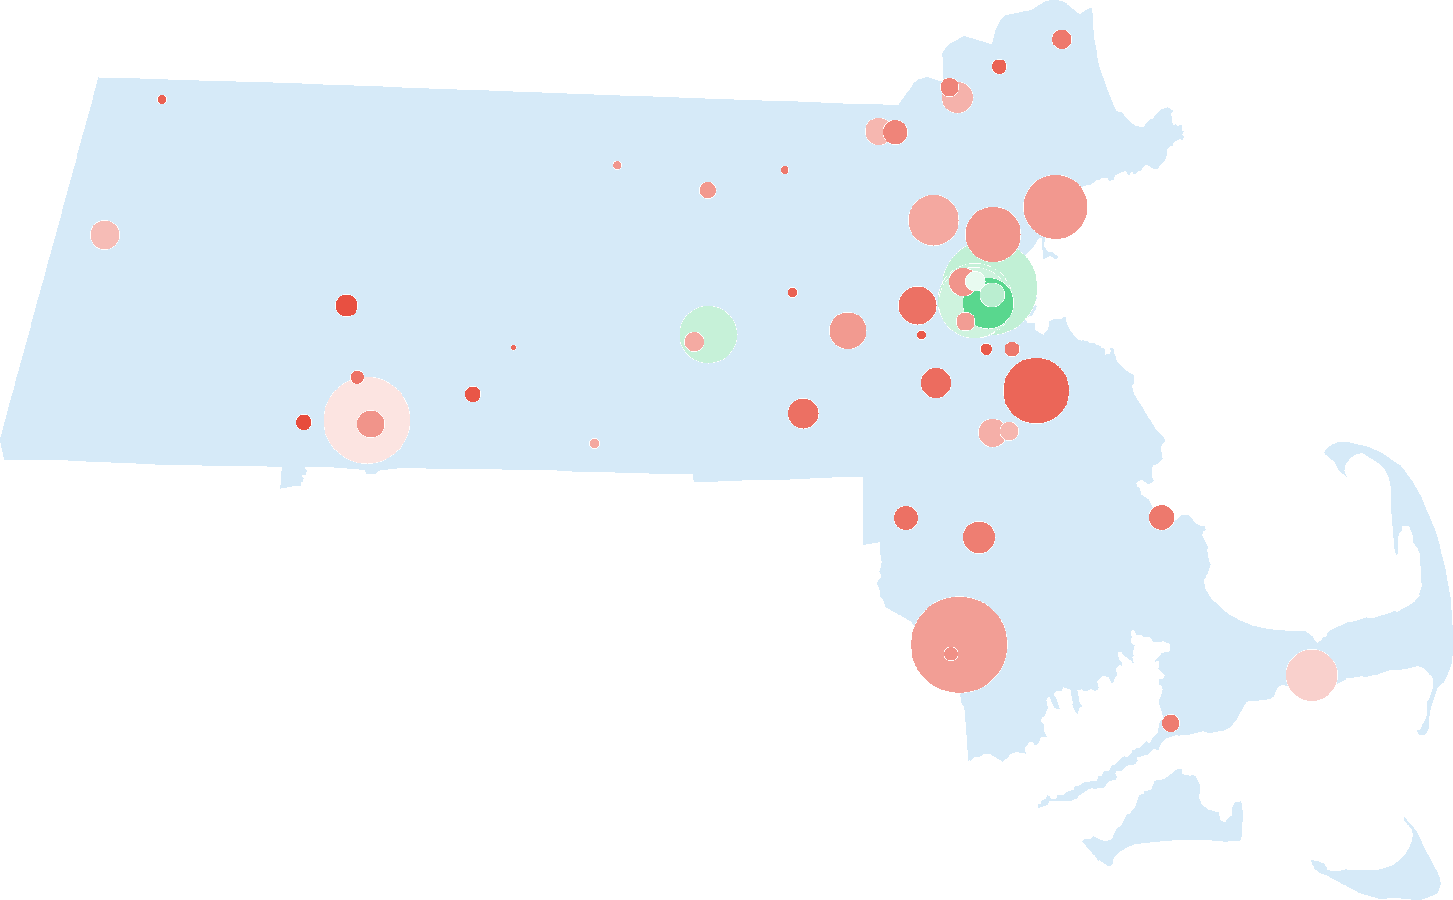

**Charge for DRG 292**

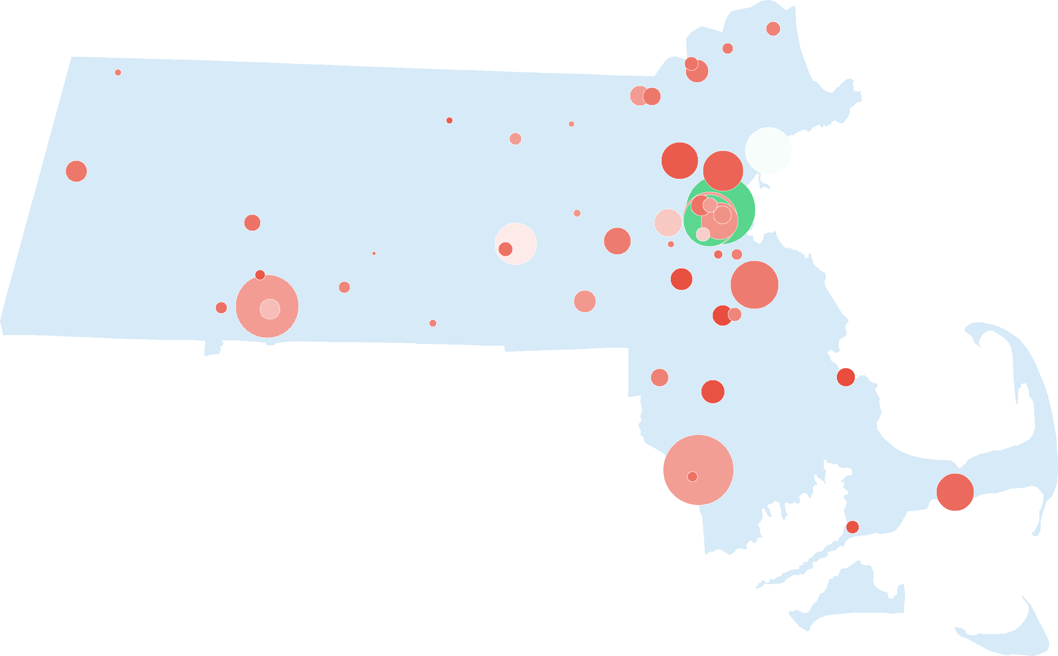

**(Charge – Total Reimbursement) for DRG 292**

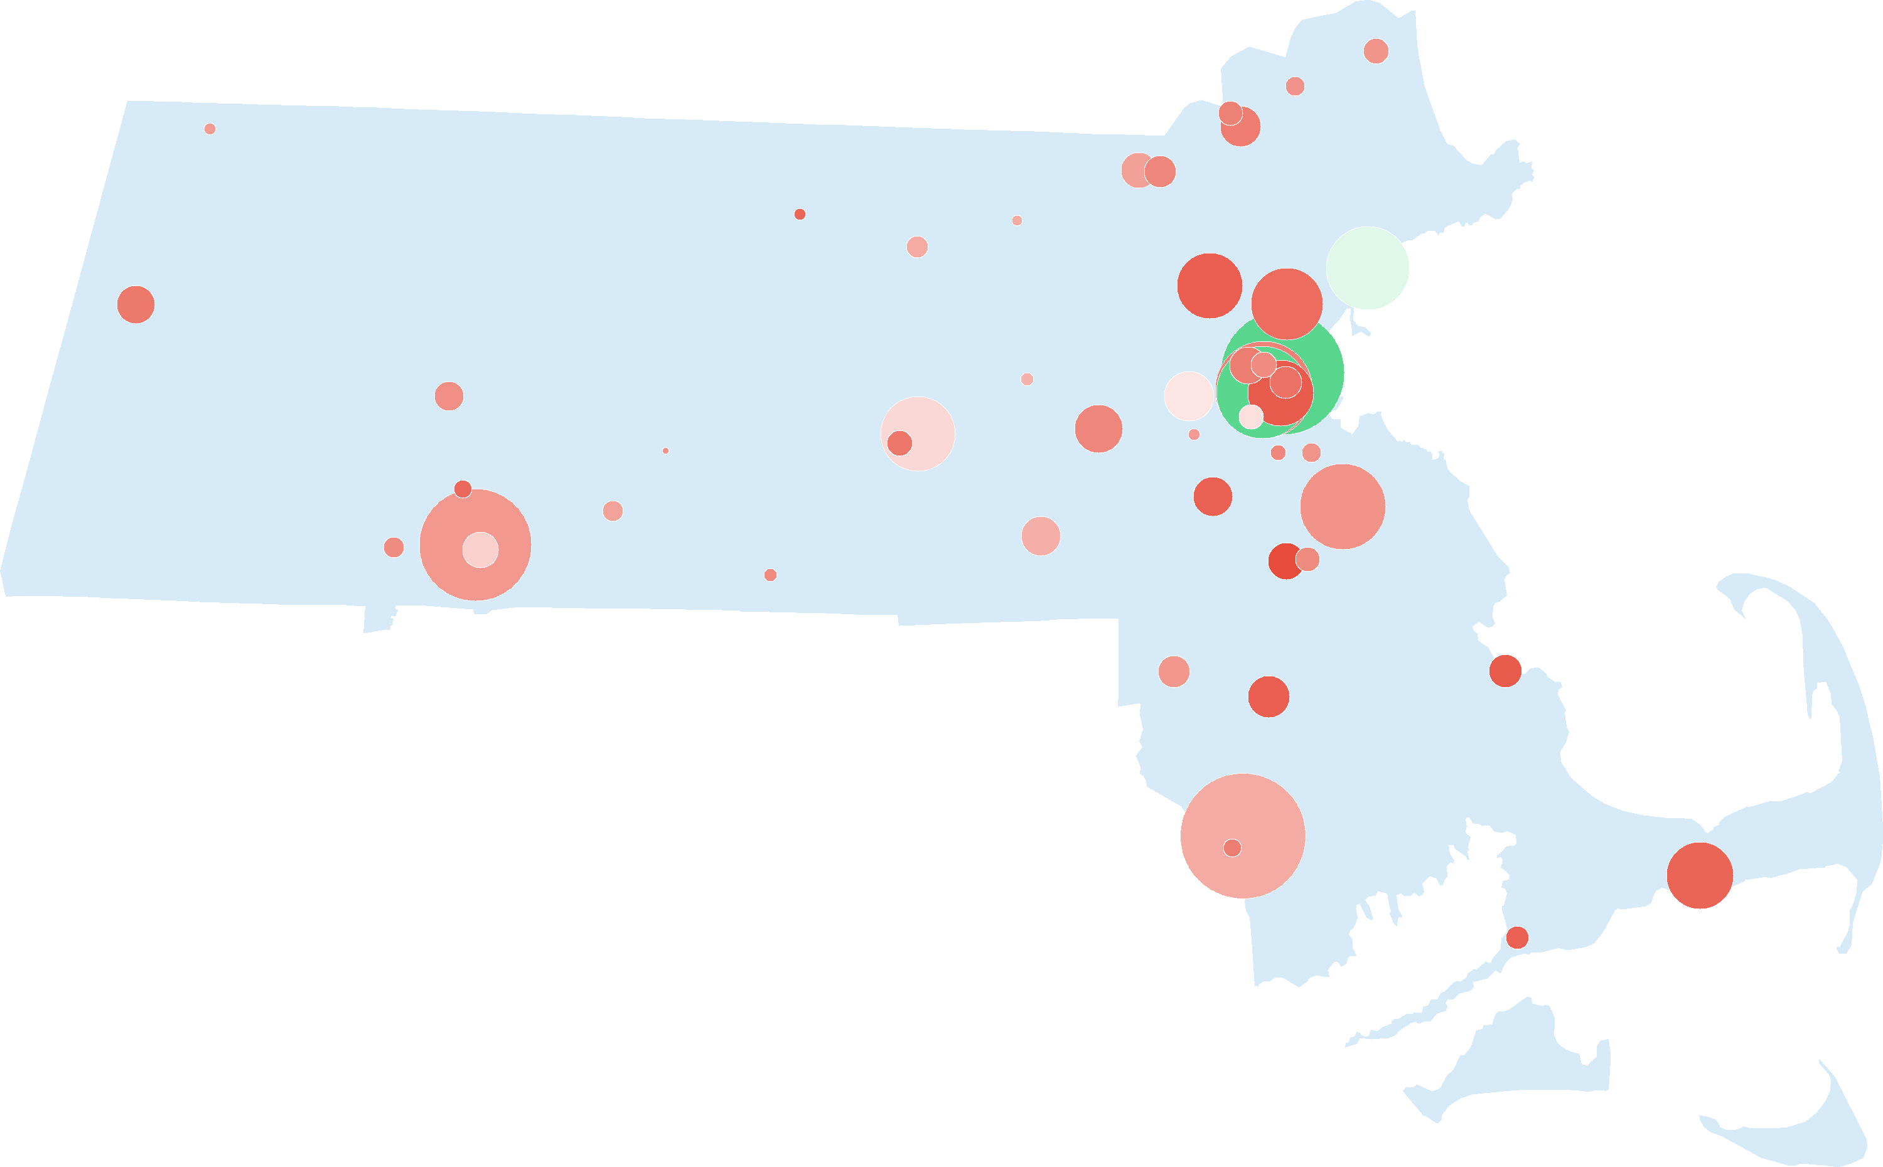

**Medicare Reimbursement for DRG 292**

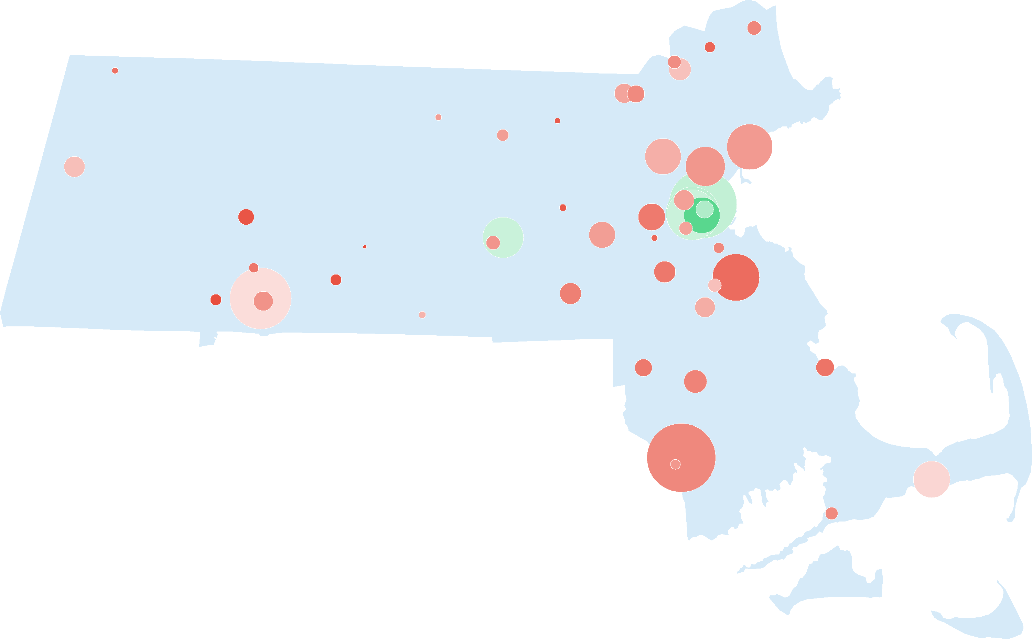

**Medicare Reimbursement for DRG 292**

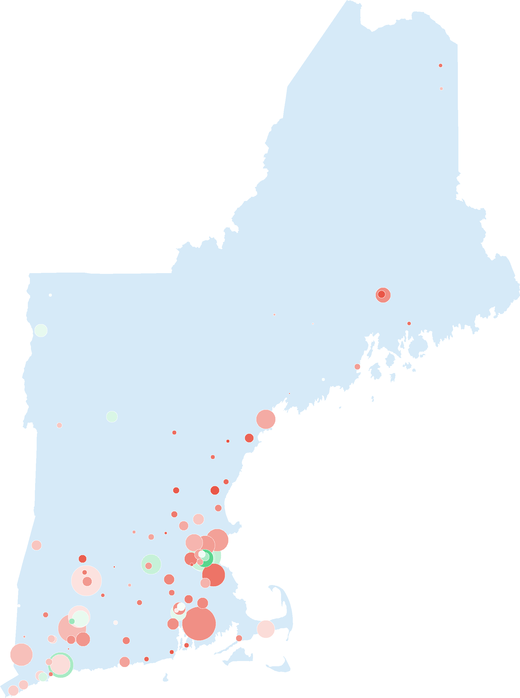

**Medicare Reimbursement for DRG 292**

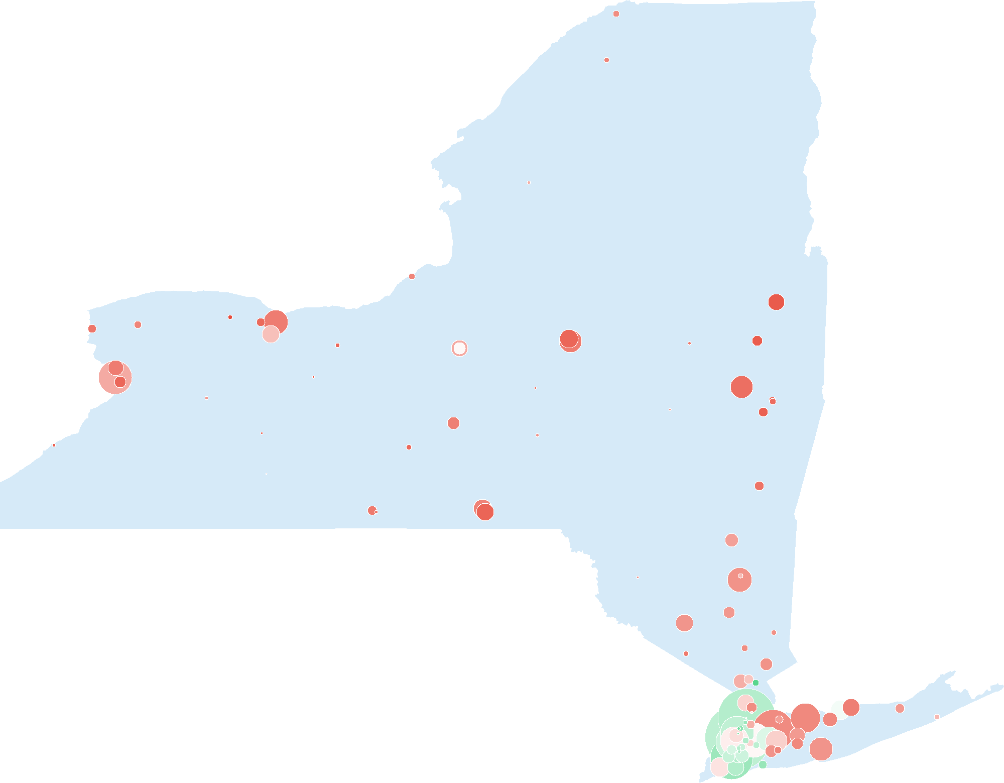

**(Charge – Total Reimbursement) for DRG 292**

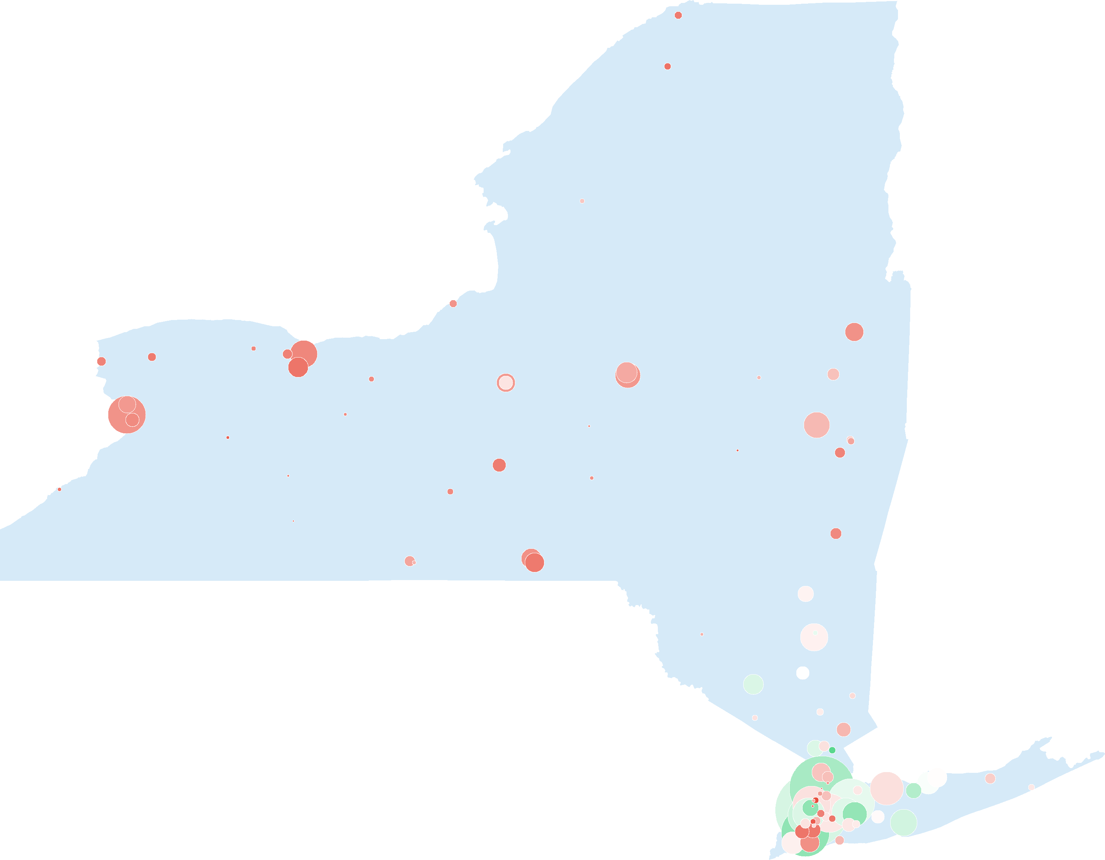

**Medicare Reimbursement for DRG 470 (Join Replacement)**

