Elizabeth Hall

2/6/2019

Spatial & Frequency Filtering Project 1 Write Up

* Spatial Filtering

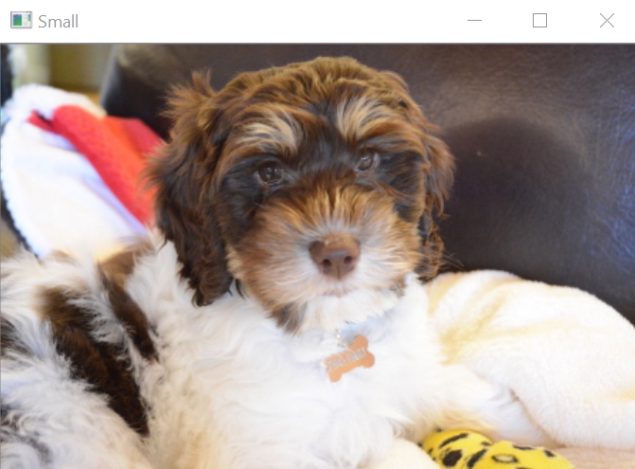

Above is the original photo of the dog that has been resized to half its original size.

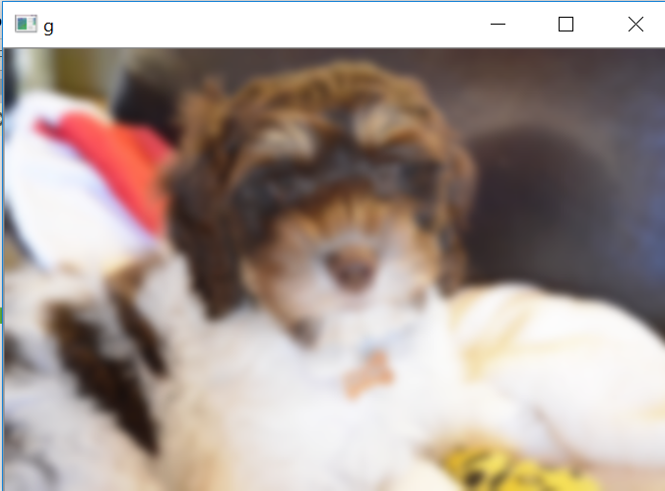

Above is the small dog photo with the gaussian filter, here I made the filter (75,75), meaning that the blur was pretty substantial.

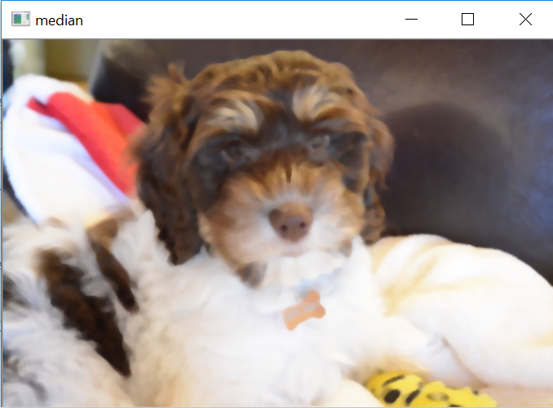

Next I did the median blur effect, which can be seen above. This seemed to not be as intense as the gaussian blur. I did some research and it seems to be because a Gaussian blur is a linear operation, while the median filter appears to be a non-linear operation. Apparently, unlike linear filters, median filters replace the pixel values with the median value available. Also, median blur is best for salt and pepper noise (<https://cs.nyu.edu/~fergus/teaching/vision/3_filtering.pdf>)

The next few images have to do with the Frequency filtering part of this assignment. The first image shows the various intensities of each pixel in a single column of the original image of the dog. This column was taken from the center of the image. As you can see by the graph, the intensity increase dramatically, which makes sense given that at the top of this column the pixels are dark (the dogs dark hair, the dark chair background), and as you move down the column the pixels become very bright (the dog’s fur). I also included the image of the dog when the image was converted to grayscale.

