Your title

Name1, Name2.

1Affiliation, 2Affiliation.

**keywords:** words.

**Correspondence:** Name ([email@email.com](mailto:email@email.com))

# Abstract

Write your abstract

# Introduction

Write your introduction

Examples of some citation formats:

(Darwin 1859)

Bumpus (1898)

(Darwin 1859; Bumpus 1898)

(e.g., Bumpus 1898)

# Methods

In equation (1), and are the mean of the samples. Similarly, and are the sample sizes, and .

# Results

The mean value of group x (127.86) was larger than the mean value of group y (114.25; t: 4.02, p: 2.85^{-4}).

Cross-reference to Fig. 1.

Cross-reference to Table 1.

# Discussion

Write your discussion

# Conclusion

Write your conclusion

# Acknowledgment

# ORCID ids

# References

Bumpus, H. C. 1898. Eleventh lecture. The elimination of the unfit as illustrated by the introduced sparrow, *Passer domesticus*. (A fourth contribution to the study of variation.). Biological Lectures: Woods Hole Marine Biological Laboratory 209–225.

Darwin, C. 1859. The Origin of Species. Penguin, New York.

# Figures

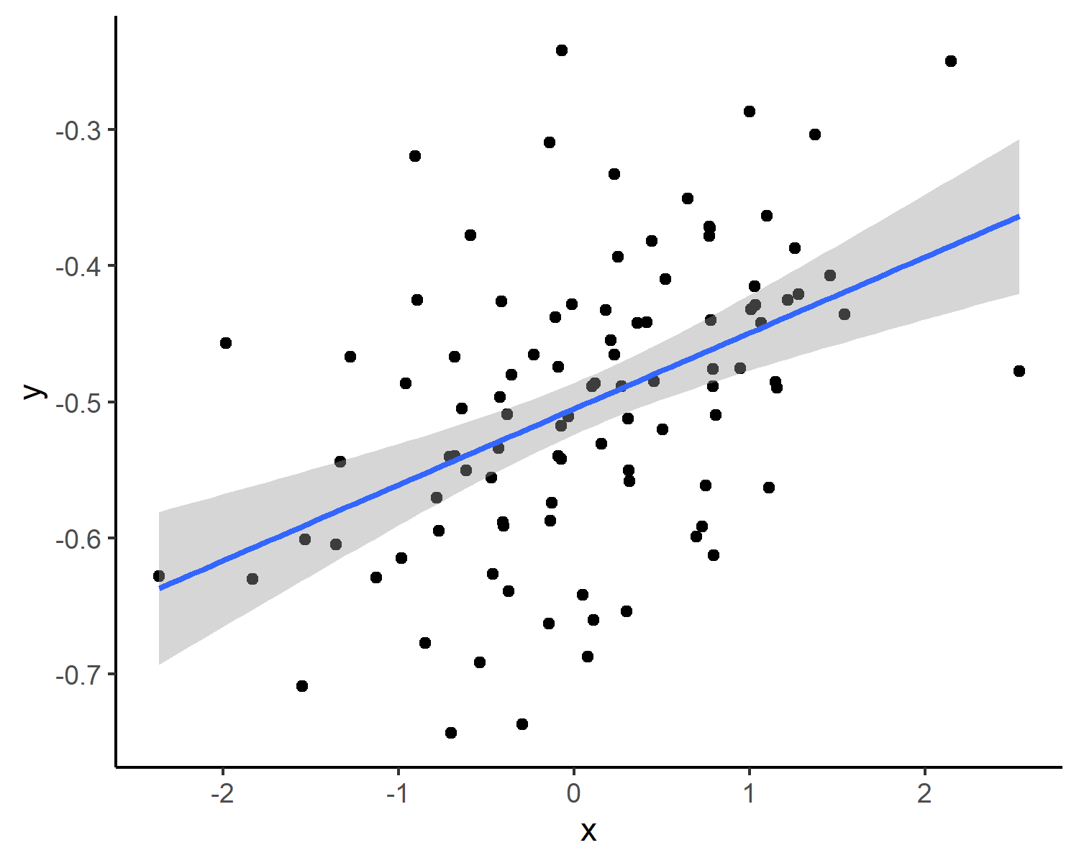

Figure 1: Figure caption

# Tables

Table 1: My table caption

| id | res |
| --- | --- |
| 1 | a |
| 2 | b |
| 3 | c |
| 4 | d |
| 5 | e |

# Supplementaty materials



Figure 2: Figure caption