🍳 | Baked Chicken  Visual Cooking Lab • large picture cues + short directions

FOR STAFF • 30-MINUTE SESSION
Purpose: Practice following a picture-supported recipe safely and independently.
Materials: Ingredients, listed tools, printed guide.
Easy flow: 5 min preview • 15-20 min cook • 5 min cleanup/independence check.

Ingredients + Tools
INGREDIENTS  ☐ Chicken pieces  ☐ Oil  ☐ Seasoning | TOOLS  ☐ Baking dish  ☐ Tongs  ☐ Oven mitt  ☐ Food thermometer if available

Follow the Pictures
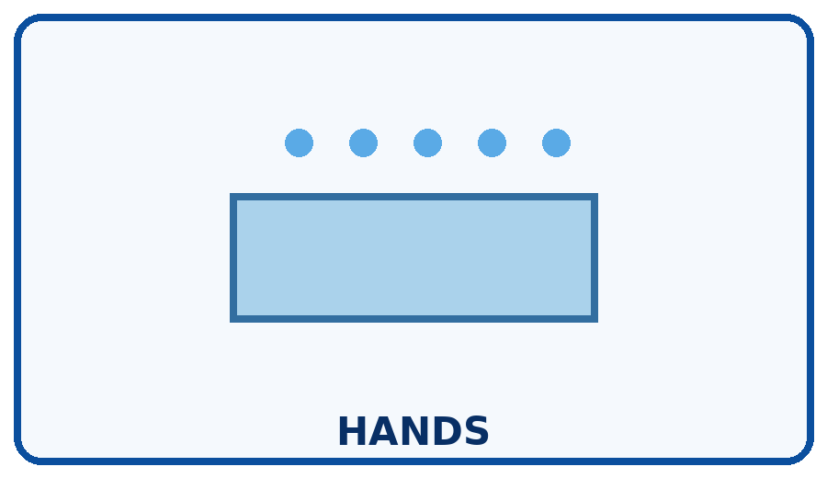 | STEP 1  Wash hands; keep raw chicken away from other foods.
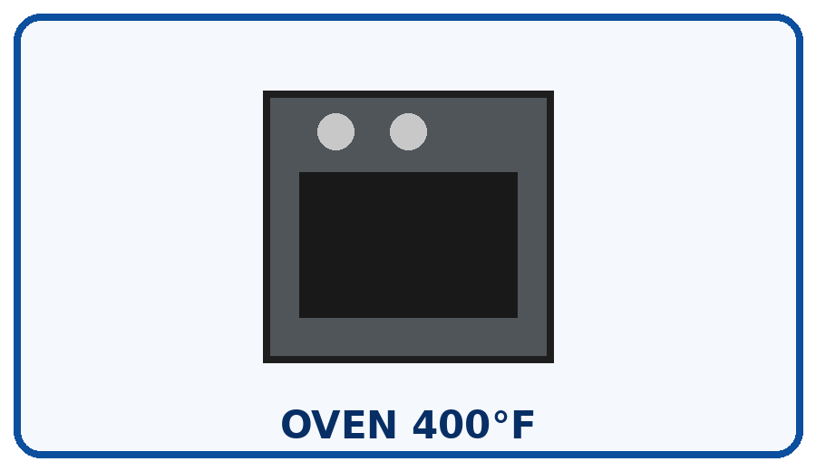 | STEP 2  Preheat oven.
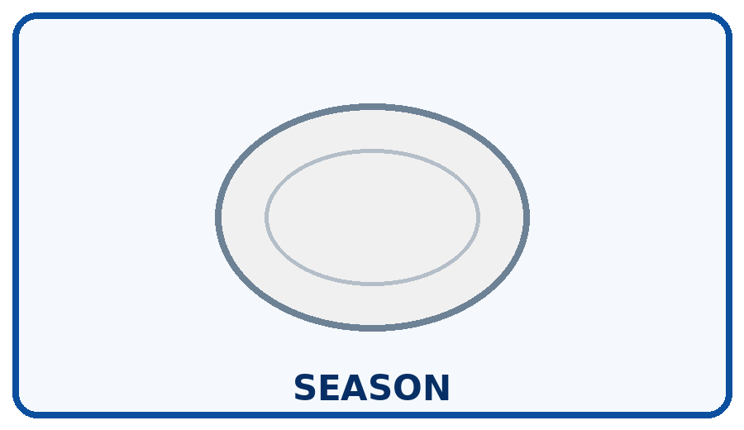 | STEP 3  Place chicken in dish and season.
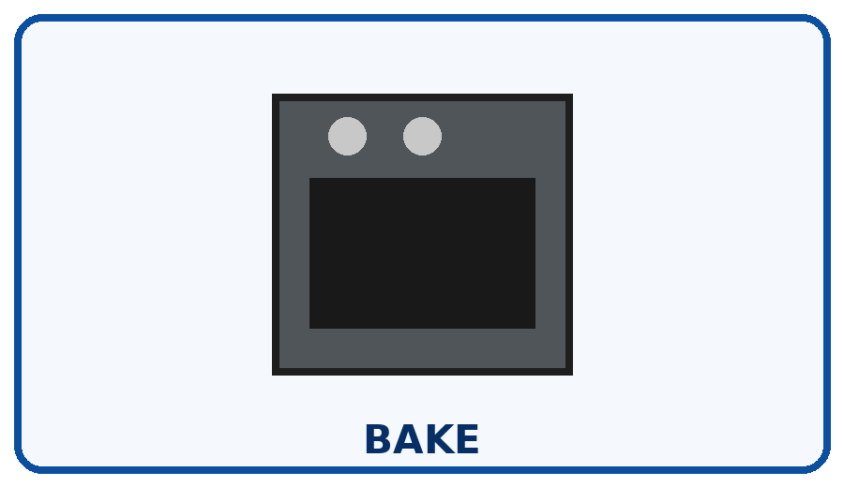 | STEP 4  Bake until fully cooked.
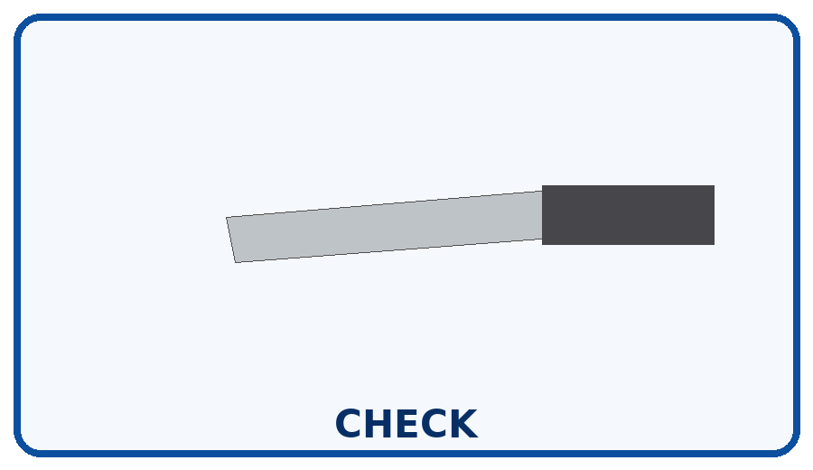 | STEP 5  Use a thermometer when available; poultry should reach 165°F.
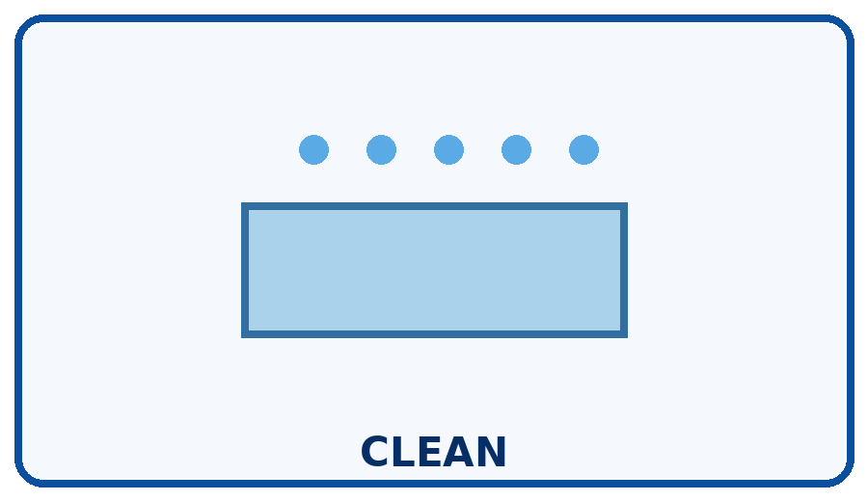 | STEP 6  Wash hands, tools, and surfaces that touched raw chicken.

Independence Check
☐ Did it myself ☐ Needed a reminder ☐ Needed help
One step I can do more independently next time: __________________________________________________________________________

