🍳 | Baked Potato  Visual Cooking Lab • large picture cues + short directions

FOR STAFF • 30-MINUTE SESSION
Purpose: Practice following a picture-supported recipe safely and independently.
Materials: Ingredients, listed tools, printed guide.
Easy flow: 5 min preview • 15-20 min cook • 5 min cleanup/independence check.

Ingredients + Tools
INGREDIENTS  ☐ 1 potato  ☐ Oil (optional)  ☐ Toppings | TOOLS  ☐ Fork  ☐ Baking sheet  ☐ Oven mitt

Follow the Pictures
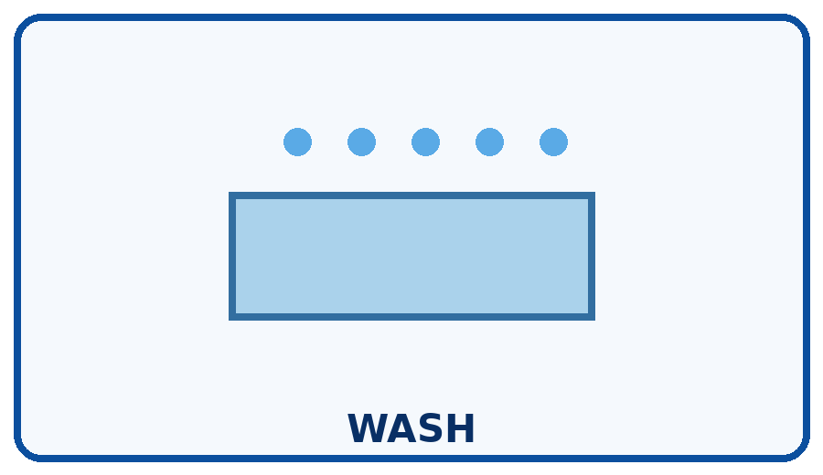 | STEP 1  Wash and scrub the potato.
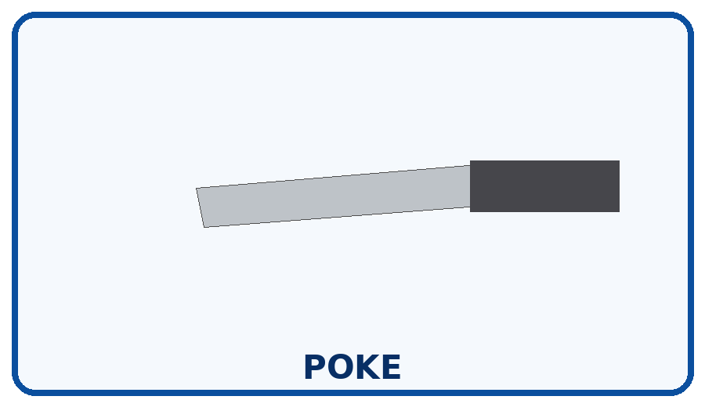 | STEP 2  Poke several holes with a fork.
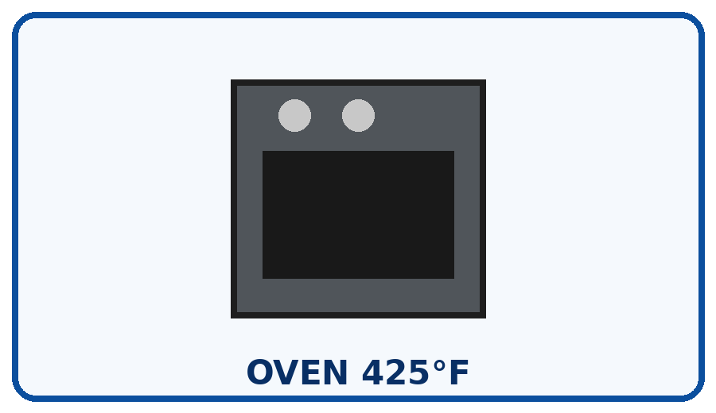 | STEP 3  Bake about 45-60 minutes until soft.
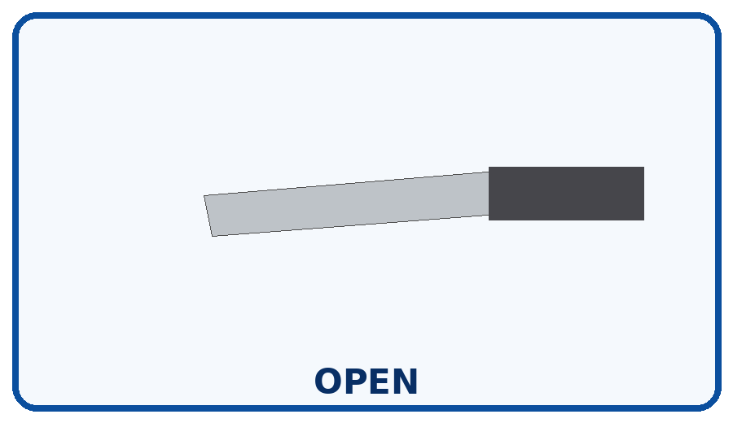 | STEP 4  Cut carefully after cooling a little.
 | STEP 5  Add toppings you like.
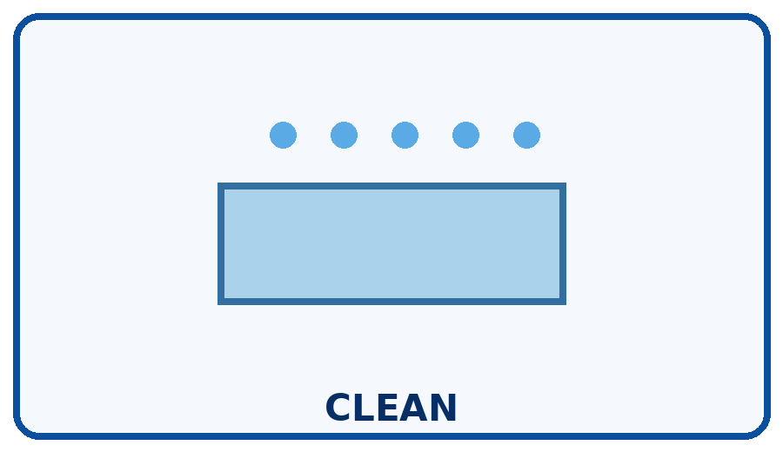 | STEP 6  Turn oven off and clean your area.

Independence Check
☐ Did it myself ☐ Needed a reminder ☐ Needed help
One step I can do more independently next time: __________________________________________________________________________

