🍳 | Chicken & Rice  Visual Cooking Lab • large picture cues + short directions

FOR STAFF • 30-MINUTE SESSION
Purpose: Practice following a picture-supported recipe safely and independently.
Materials: Ingredients, listed tools, printed guide.
Easy flow: 5 min preview • 15-20 min cook • 5 min cleanup/independence check.

Ingredients + Tools
INGREDIENTS  ☐ Cooked chicken  ☐ Cooked rice  ☐ Frozen vegetables  ☐ Seasoning | TOOLS  ☐ Skillet or pot  ☐ Spoon  ☐ Measuring cup

Follow the Pictures
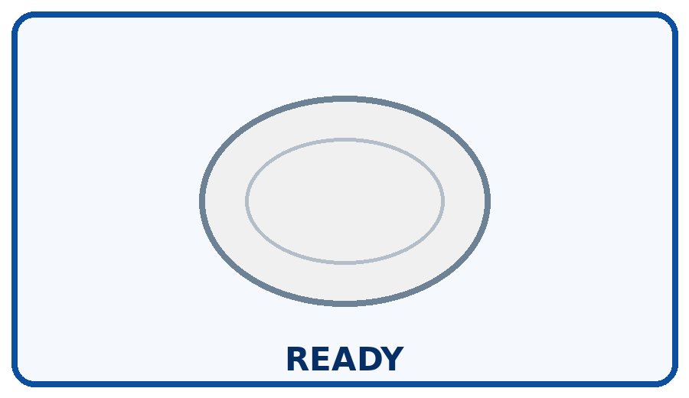 | STEP 1  Use fully cooked chicken.
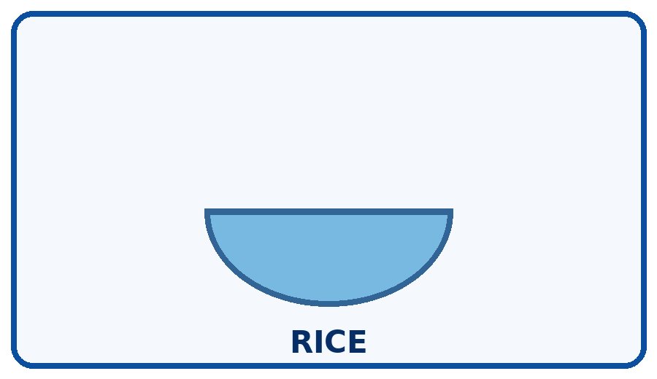 | STEP 2  Measure cooked rice.
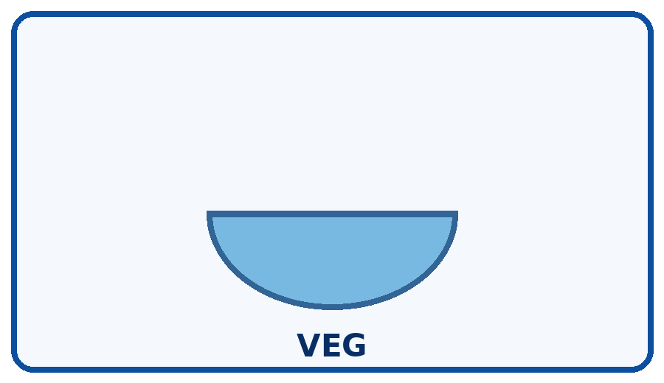 | STEP 3  Add vegetables.
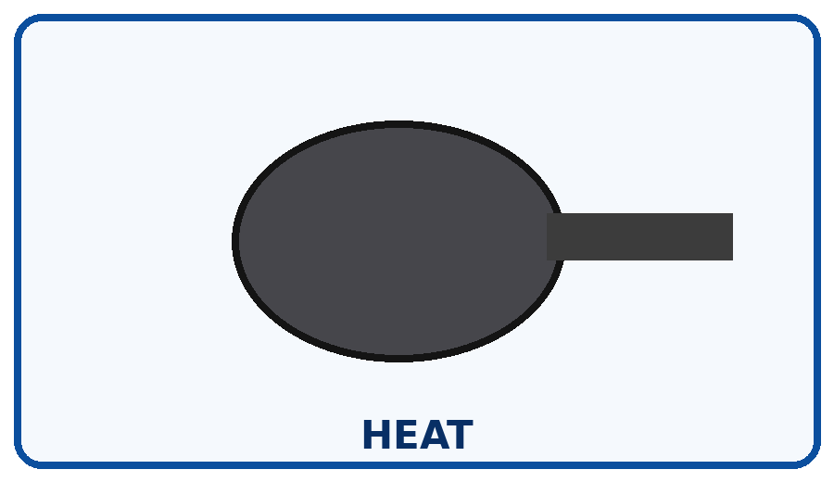 | STEP 4  Heat everything until steaming hot.
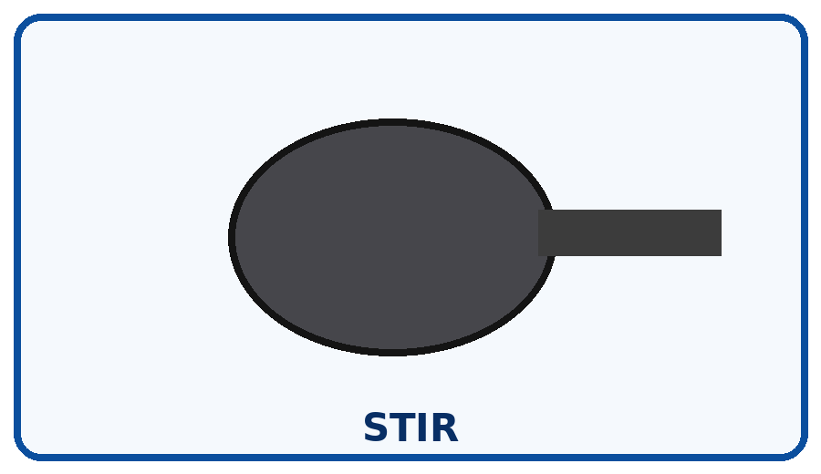 | STEP 5  Stir and season.
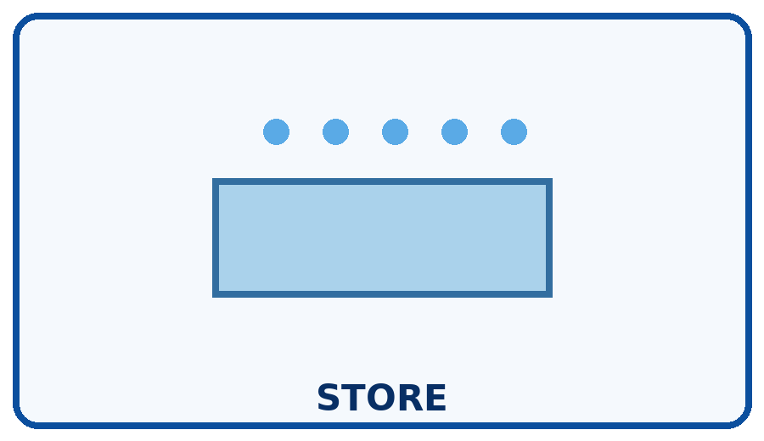 | STEP 6  Refrigerate leftovers promptly.

Independence Check
☐ Did it myself ☐ Needed a reminder ☐ Needed help
One step I can do more independently next time: __________________________________________________________________________

