🍳 | Easy Dessert Parfait  Visual Cooking Lab • large picture cues + short directions

FOR STAFF • 30-MINUTE SESSION
Purpose: Practice following a picture-supported recipe safely and independently.
Materials: Ingredients, listed tools, printed guide.
Easy flow: 5 min preview • 15-20 min cook • 5 min cleanup/independence check.

Ingredients + Tools
INGREDIENTS  ☐ Yogurt or pudding  ☐ Fruit  ☐ Granola or crushed cookies | TOOLS  ☐ Cup or bowl  ☐ Spoon

Follow the Pictures
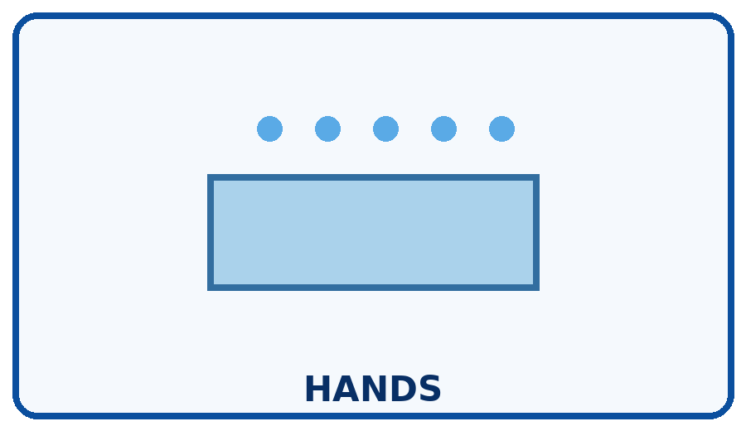 | STEP 1  Wash hands.
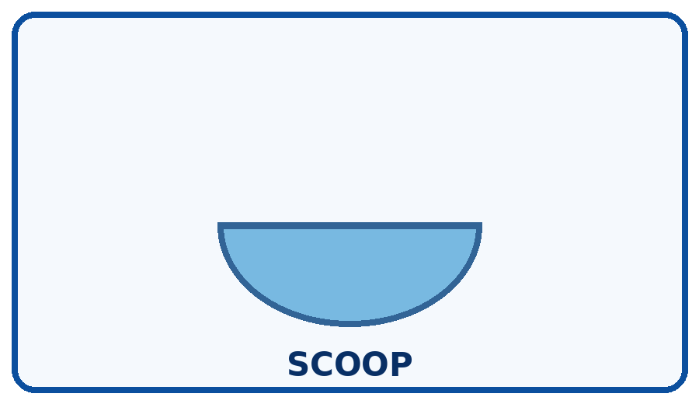 | STEP 2  Add yogurt or pudding.
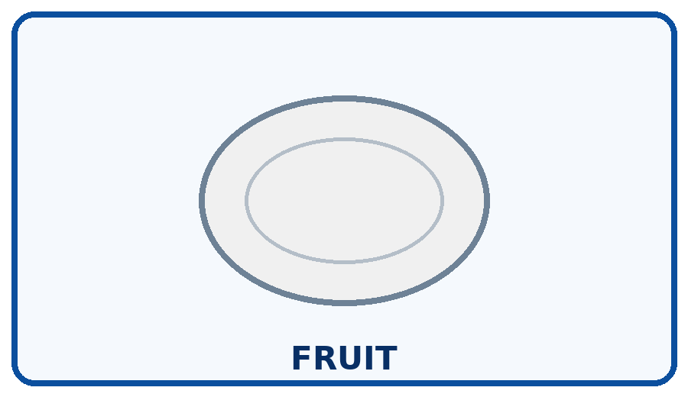 | STEP 3  Add fruit.
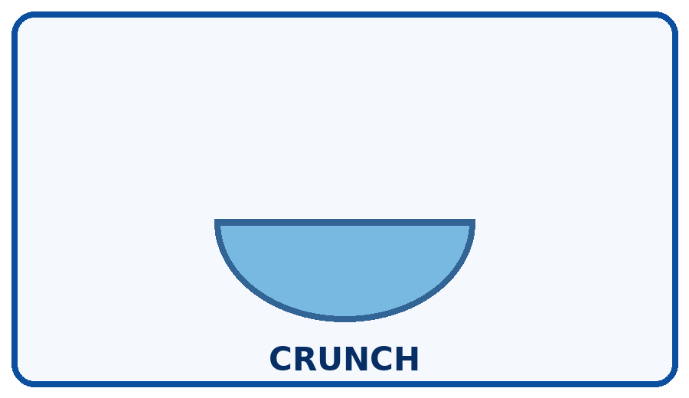 | STEP 4  Add granola or cookie crumbs.
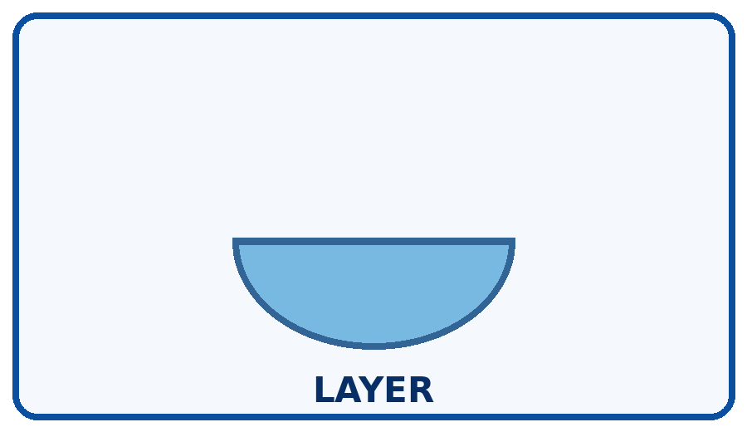 | STEP 5  Repeat layers if you want.
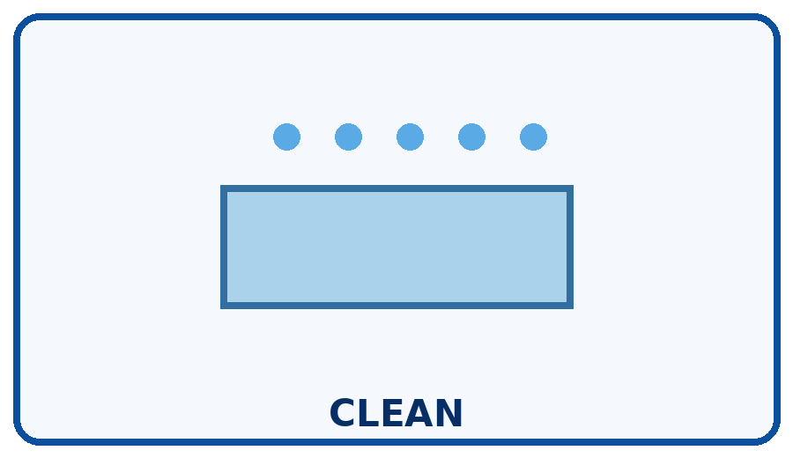 | STEP 6  Refrigerate leftovers and clean up.

Independence Check
☐ Did it myself ☐ Needed a reminder ☐ Needed help
One step I can do more independently next time: __________________________________________________________________________

