🍳 | Pancakes  Visual Cooking Lab • large picture cues + short directions

FOR STAFF • 30-MINUTE SESSION
Purpose: Practice following a picture-supported recipe safely and independently.
Materials: Ingredients, listed tools, printed guide.
Easy flow: 5 min preview • 15-20 min cook • 5 min cleanup/independence check.

Ingredients + Tools
INGREDIENTS  ☐ Pancake mix  ☐ Water or milk  ☐ Oil/spray | TOOLS  ☐ Bowl  ☐ Measuring cup  ☐ Skillet  ☐ Spatula

Follow the Pictures
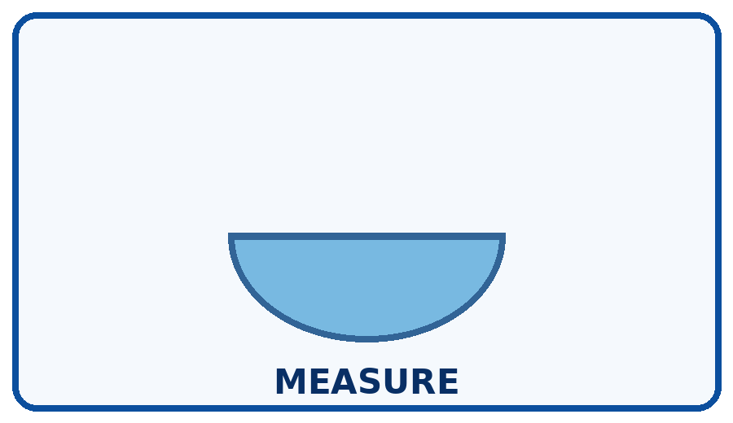 | STEP 1  Measure mix and liquid.
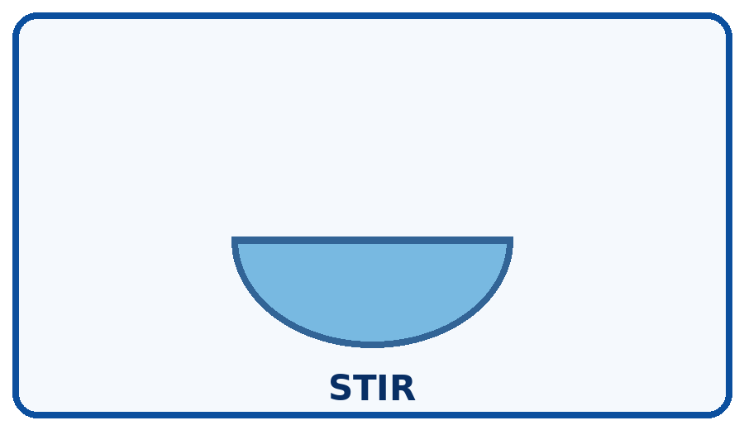 | STEP 2  Stir just until combined.
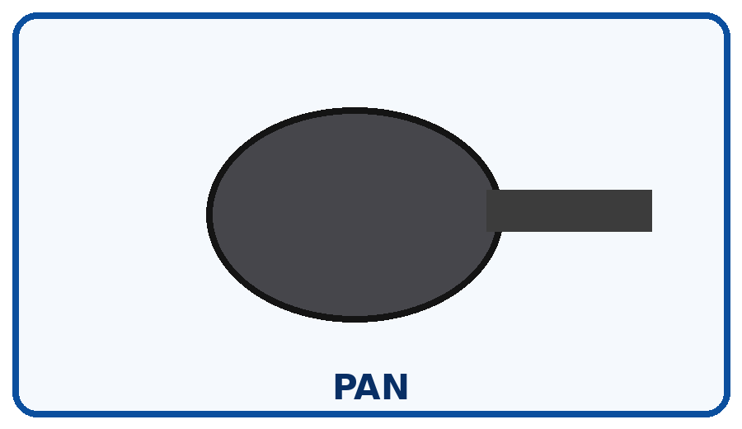 | STEP 3  Warm skillet on medium-low.
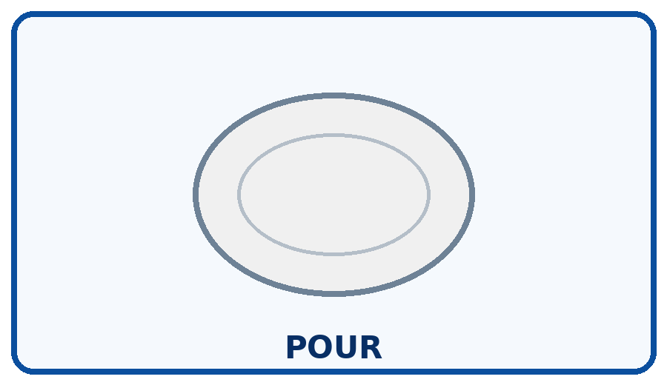 | STEP 4  Pour small circles of batter.
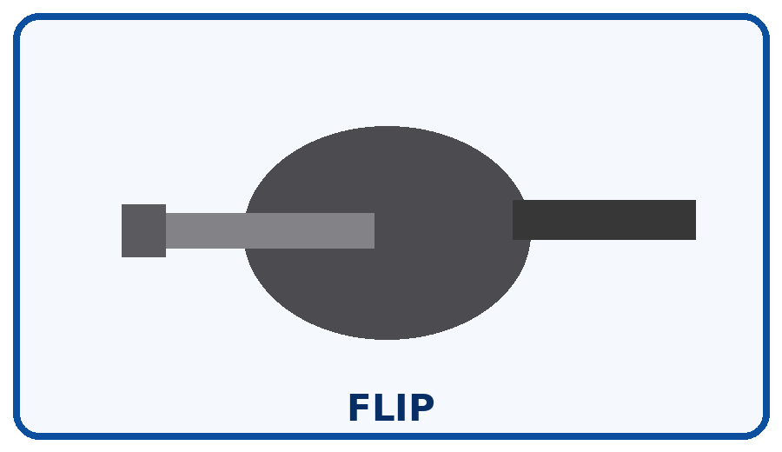 | STEP 5  Flip when bubbles form and edges set.
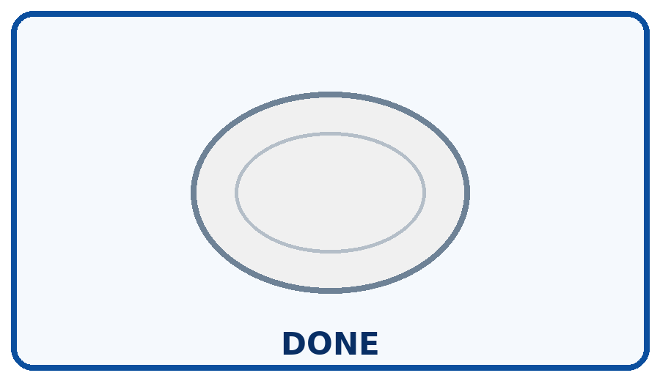 | STEP 6  Cook second side and turn heat off.

Independence Check
☐ Did it myself ☐ Needed a reminder ☐ Needed help
One step I can do more independently next time: __________________________________________________________________________

