🍳 | Spaghetti  Visual Cooking Lab • large picture cues + short directions

FOR STAFF • 30-MINUTE SESSION
Purpose: Practice following a picture-supported recipe safely and independently.
Materials: Ingredients, listed tools, printed guide.
Easy flow: 5 min preview • 15-20 min cook • 5 min cleanup/independence check.

Ingredients + Tools
INGREDIENTS  ☐ Pasta  ☐ Jarred sauce  ☐ Water | TOOLS  ☐ Pot  ☐ Colander  ☐ Spoon

Follow the Pictures
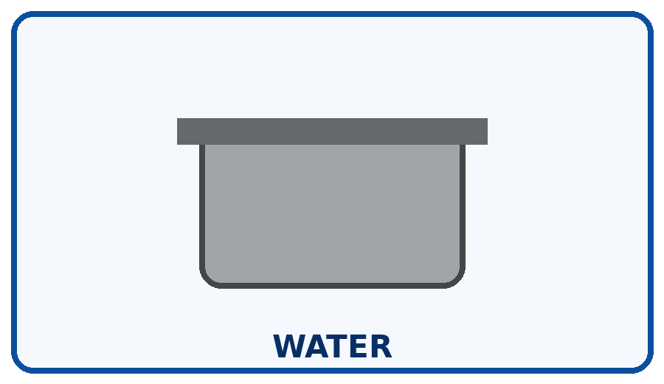 | STEP 1  Fill pot with water and bring to a boil.
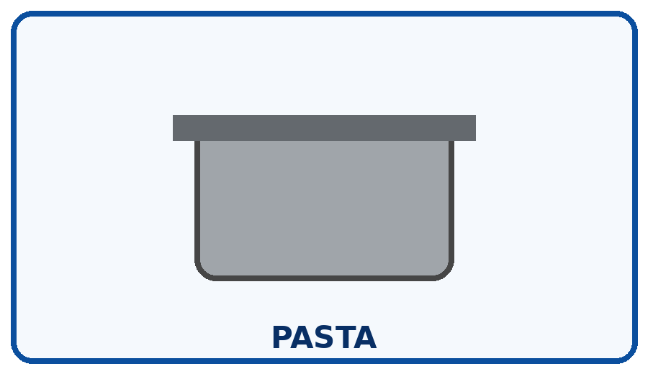 | STEP 2  Add pasta carefully.
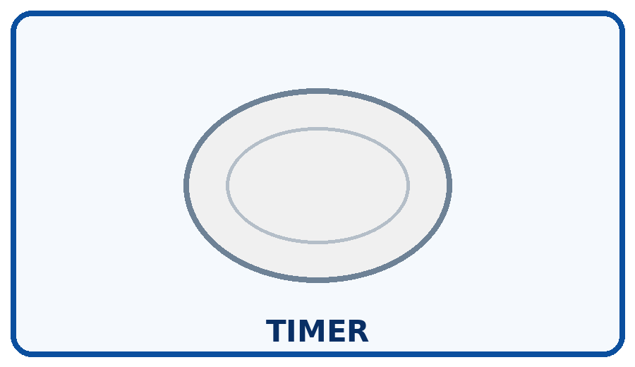 | STEP 3  Cook for the package time.
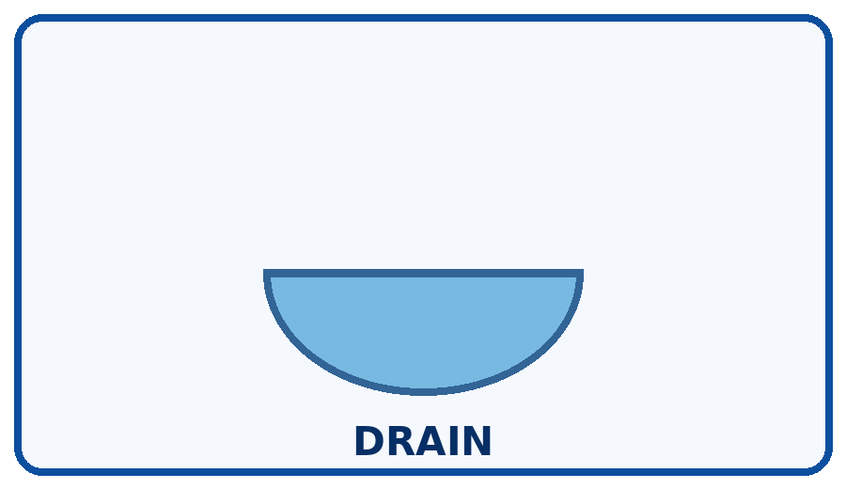 | STEP 4  Drain in a colander away from your face.
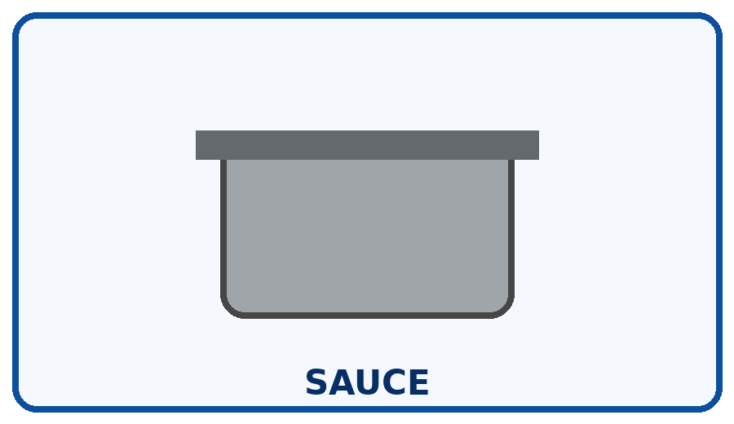 | STEP 5  Warm sauce and combine.
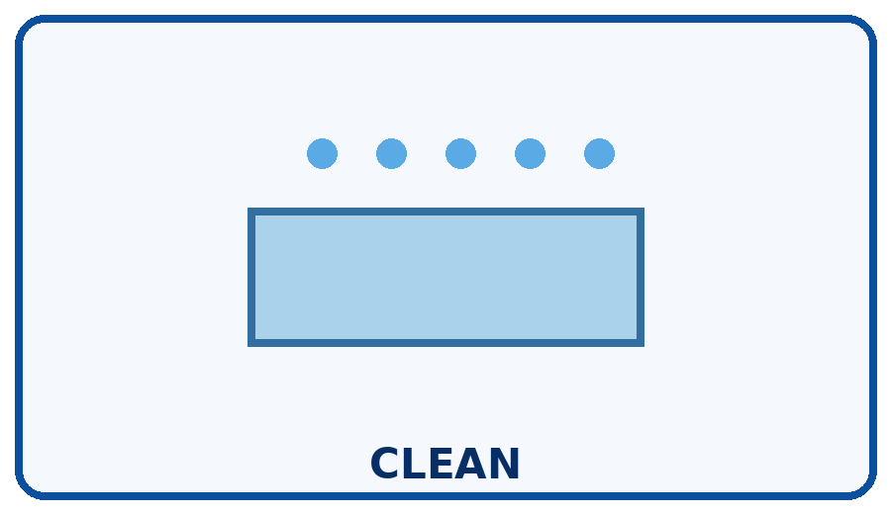 | STEP 6  Turn heat off and clean up.

Independence Check
☐ Did it myself ☐ Needed a reminder ☐ Needed help
One step I can do more independently next time: __________________________________________________________________________

