🍳 | Tacos  Visual Cooking Lab • large picture cues + short directions

FOR STAFF • 30-MINUTE SESSION
Purpose: Practice following a picture-supported recipe safely and independently.
Materials: Ingredients, listed tools, printed guide.
Easy flow: 5 min preview • 15-20 min cook • 5 min cleanup/independence check.

Ingredients + Tools
INGREDIENTS  ☐ Cooked ground meat or beans  ☐ Taco seasoning  ☐ Tortillas  ☐ Toppings | TOOLS  ☐ Skillet  ☐ Spatula  ☐ Spoon

Follow the Pictures
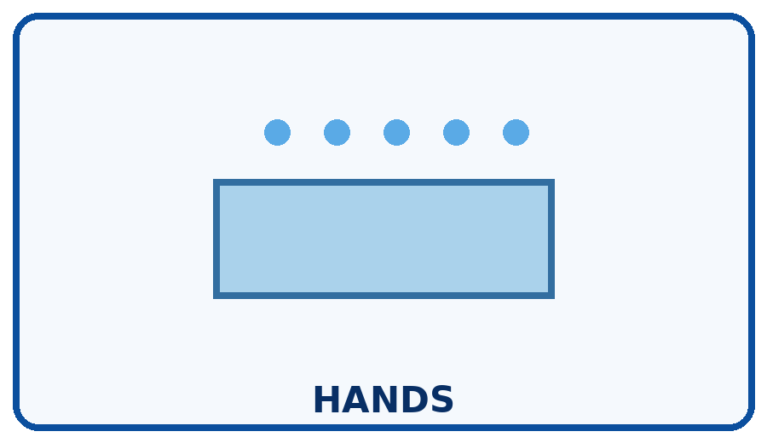 | STEP 1  Wash hands before cooking.
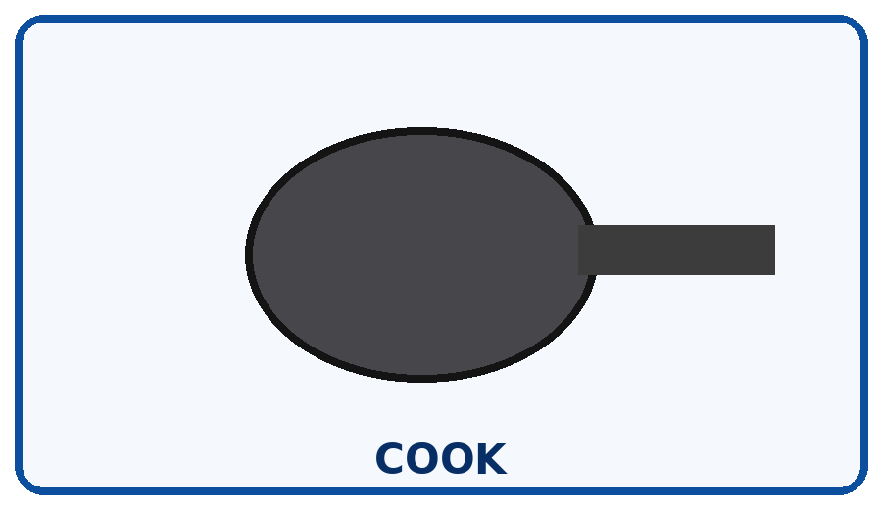 | STEP 2  Cook meat fully or heat beans.
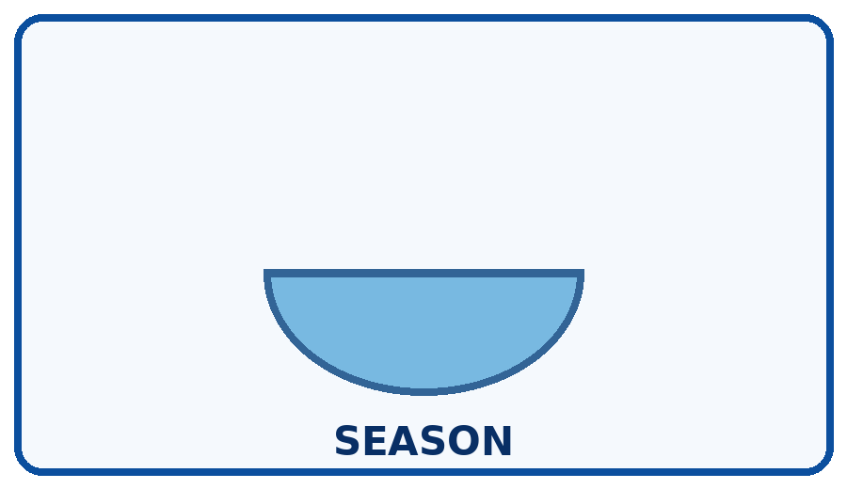 | STEP 3  Add seasoning as directed.
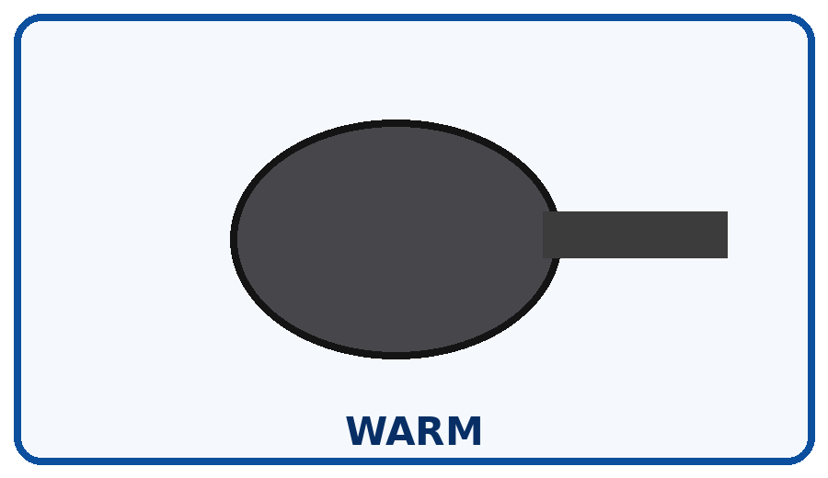 | STEP 4  Warm tortillas safely.
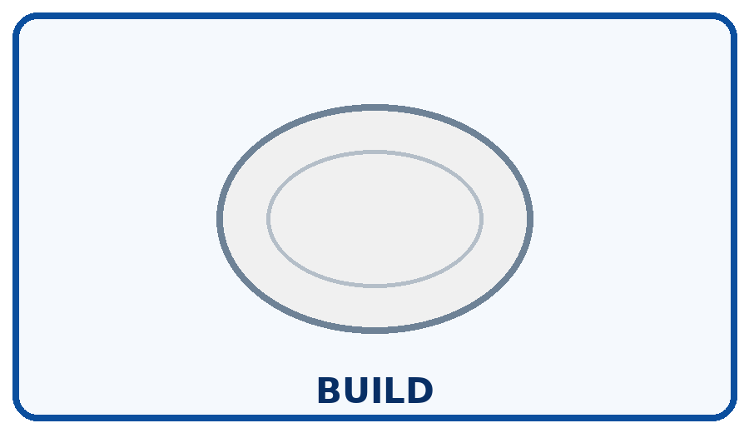 | STEP 5  Add filling and toppings.
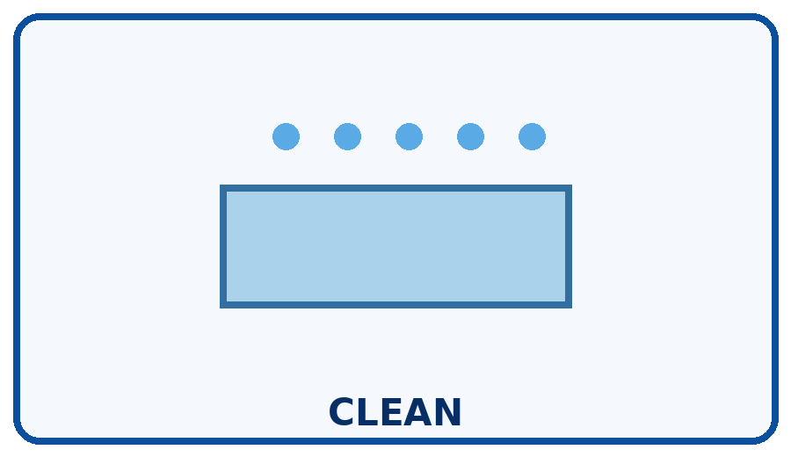 | STEP 6  Refrigerate leftovers and clean up.

Independence Check
☐ Did it myself ☐ Needed a reminder ☐ Needed help
One step I can do more independently next time: __________________________________________________________________________

