**Asynchronous BFS**

**Project Report**

# Distributed Computing

*To the*

# The University of Texas at Dallas



**`** *Submitted by*:

**Maxwell Hall**

**Prashant Prakash**

**Shashank Adidamu**

## The University of Texas at Dallas Dallas – 75252

December, 2015

1. **Setup**

A Connected Graph is built $G=\left(V,E\right)$ with a distinguished source node i. For the shortest paths problem, we also assume that each undirected edge

$\left(i,j\right)$ has a nonnegative real-valued weight, $weight\left(i,j\right)$, known at both the end processes. We assume that the processes do not know the size of diameter of the network and that there are no UIDs.

1. **Algorithm**

The way Asynch BFS can be solved with the modification in Asynch Spanning Tree. If a process i initially identifies one of its neighbors , say j , as its parent , and later obtains information from another neighbor , say k , along a shorter path , then process i can change its parent designation to k. In this case , process i must inform its neighbors about its correction , so that they might also correct their parent designations.

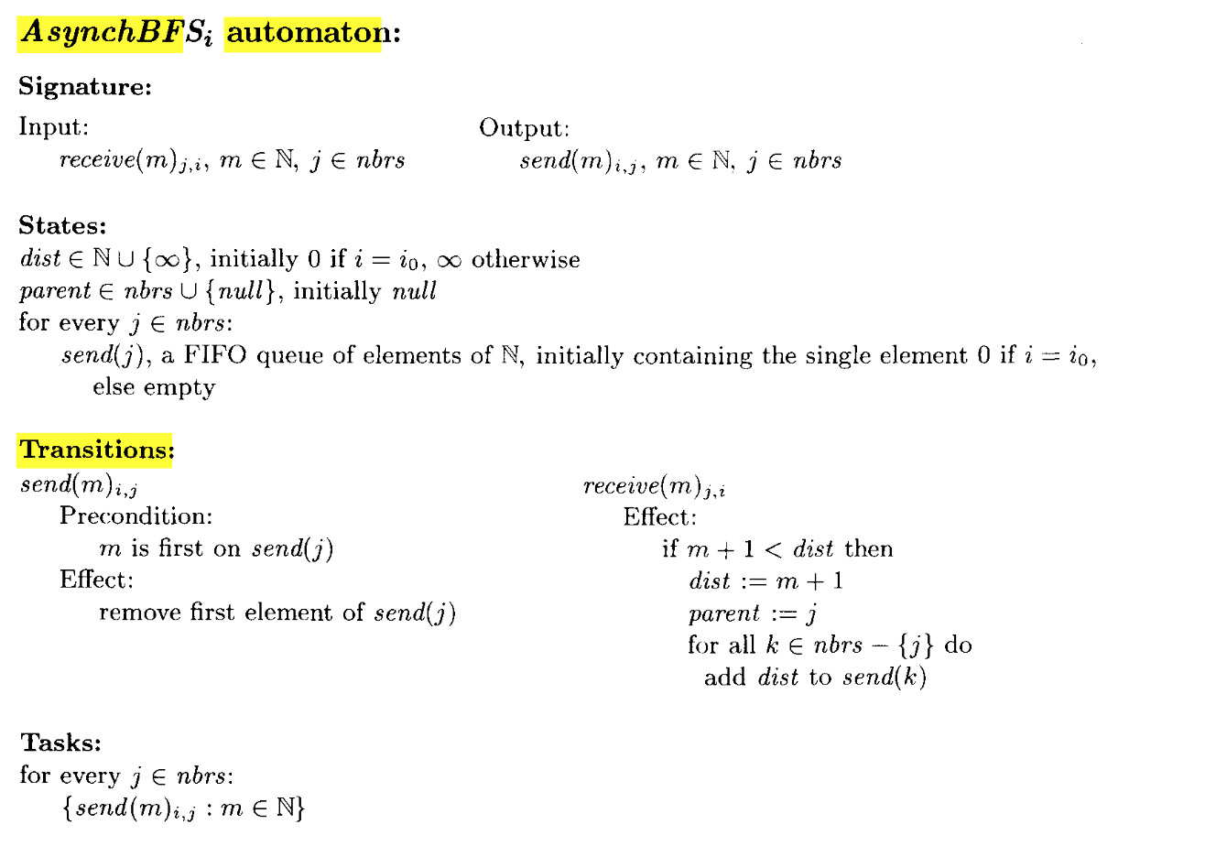

1. **Termination**

For termination we use “Converge Cast” technique. We add acknowledgements for all messages, convergecasting the acknowledgments back to i as in AsynchBcastAck. This enables i to learn when the system has reached a stable state and then to broadcast a signal to all the processes to perform their parent outputs.

1. **System Requirements**

To run this Program “**JAVA 8**” must be available in the system. We are extensively using Java 8 features to solve the problem.

1. **Sample Input and output**

The system takes input from file in the format mentioned below:

Sample Input:

12, 7

1 1 0 1 0 0 0 1 0 0 0 0

1 1 1 0 1 0 0 0 0 0 0 0

0 1 1 0 1 1 0 0 0 0 0 0

1 0 0 1 0 0 1 1 0 0 0 0

0 1 1 0 1 1 0 1 1 0 0 0

0 0 1 0 1 1 0 0 0 0 0 1

0 0 0 1 0 0 1 1 0 1 0 0

1 0 0 1 1 0 1 1 0 0 1 0

0 0 0 0 1 0 0 0 1 0 1 1

0 0 0 0 0 0 1 0 0 1 1 1

0 0 0 0 0 0 0 1 1 1 1 1

0 0 0 0 0 1 0 0 1 1 1 1

Where 12 is the number of Process and 7 is the source Node. The two dimensional matrix is the Adjacency matrix for the graph.

Output:

The root is process 7

Process Parent Distance

1 8 2

2 1 3

3 5 3

4 7 1

5 8 2

6 5 3

7 -1 0

8 7 1

9 5 3

10 7 1

11 8 2

12 10 2

We also print the adjacency list to represent the output graph.

Adjacency List:

NODE 11 adjacency list: 8

NODE 1 adjacency list: 2 8

NODE 12 adjacency list: 10

NODE 2 adjacency list: 1

NODE 3 adjacency list: 5

NODE 4 adjacency list: 7

NODE 5 adjacency list: 3 6 8 9

NODE 6 adjacency list: 5

NODE 7 adjacency list: 4 8 10

NODE 8 adjacency list: 11 1 5 7

NODE 9 adjacency list: 5

NODE 10 adjacency list: 12 7

1. **Challenges**

The major problem we faced are following:

1. We faced problem with basic understanding of Algorithm and various steps involved and understanding each nodes participation in different rounds.
2. We faced problem with implementation of ConvergeCast technique.