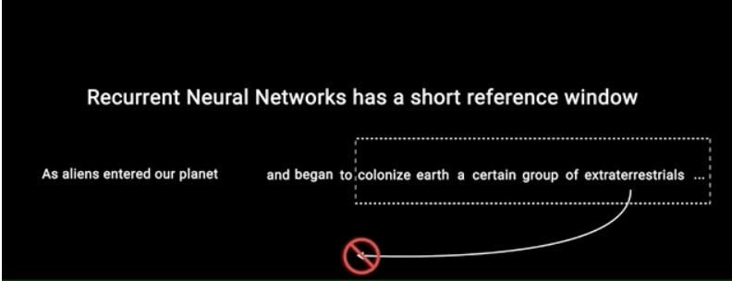

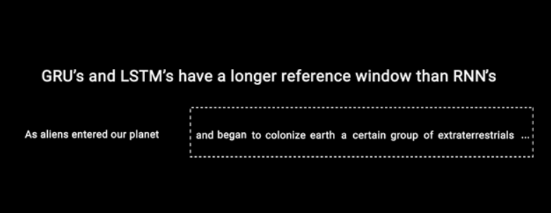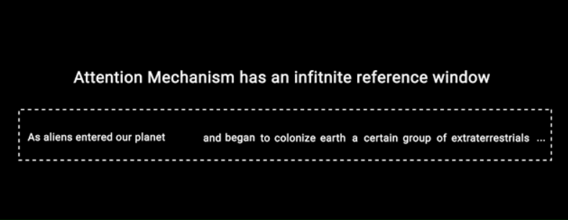

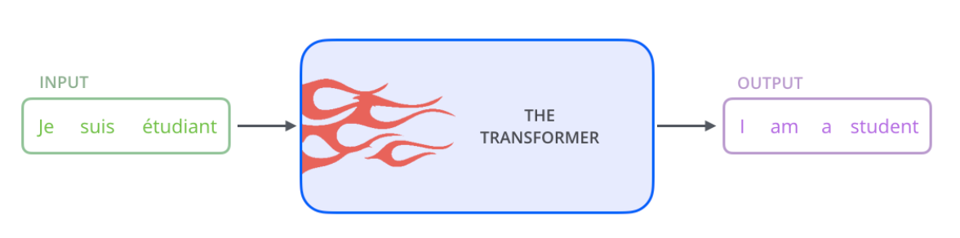

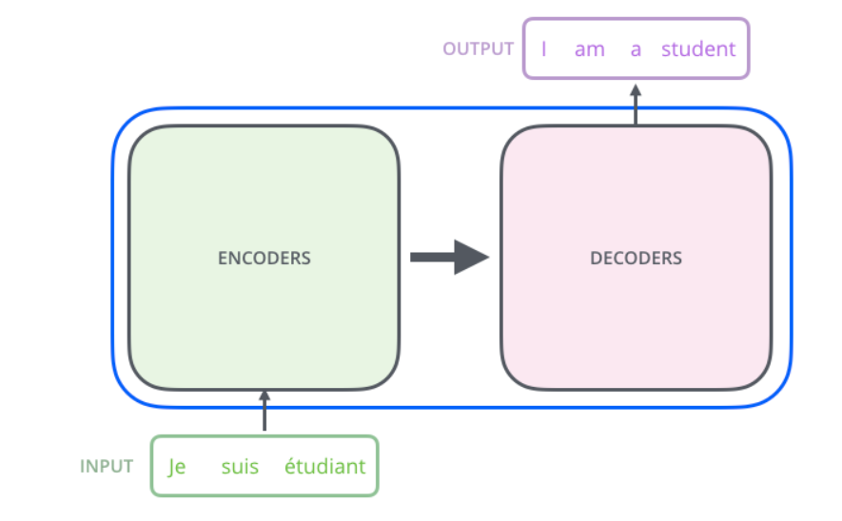

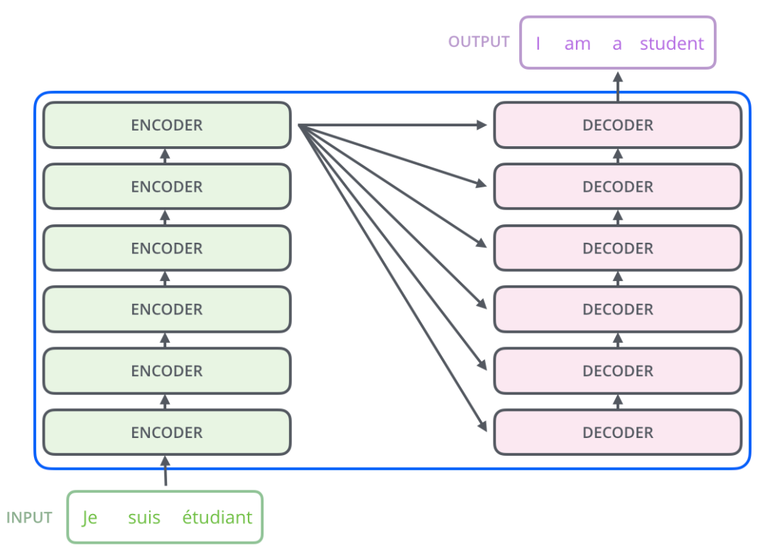

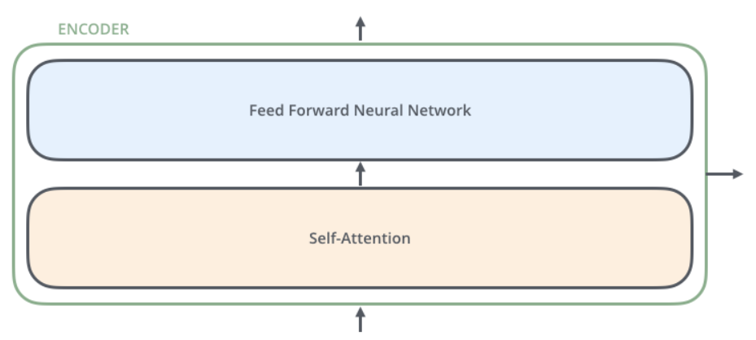

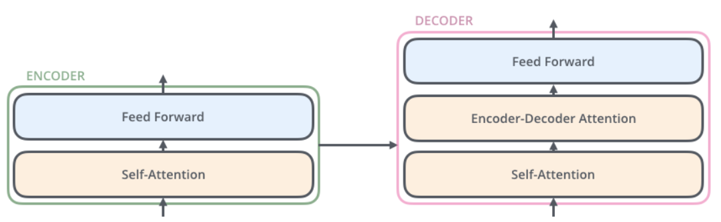

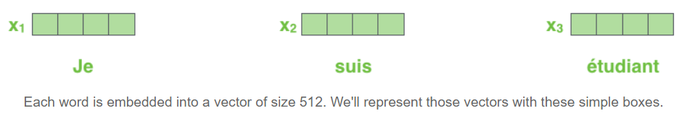

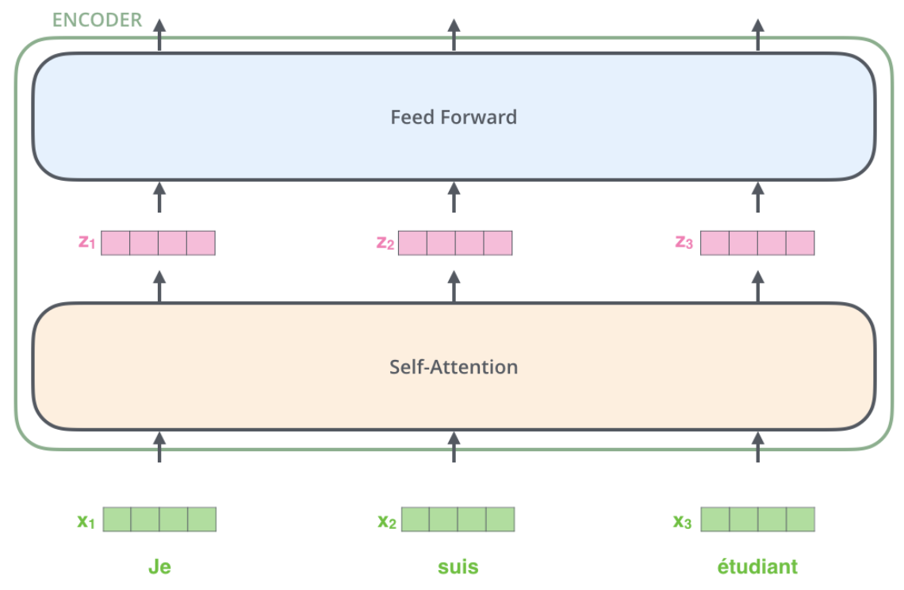

**Self-Attention at a High Level**

Say the following sentence is an input sentence we want to translate:

The animal didn't cross the street because it was too tired

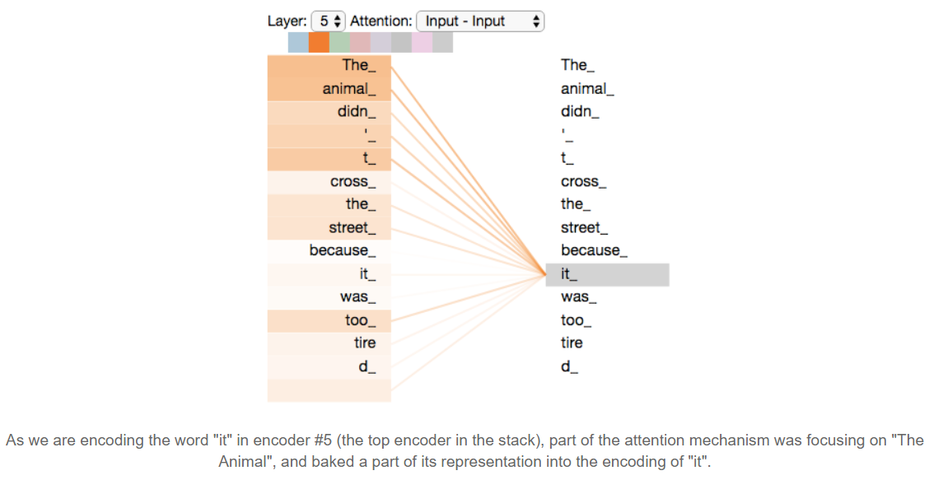

*References:*

[*https://paperswithcode.com/paper/attention-is-all-you-need*](https://paperswithcode.com/paper/attention-is-all-you-need)

[*http://jalammar.github.io/illustrated-transformer/*](http://jalammar.github.io/illustrated-transformer/)

[*https://towardsdatascience.com/illustrated-guide-to-transformers-step-by-step-explanation-f74876522bc0*](https://towardsdatascience.com/illustrated-guide-to-transformers-step-by-step-explanation-f74876522bc0)