Manual Test Plan

1. When run the chess game, it will first ask the user to input the two player’s name. They cannot have the same player name as showing.

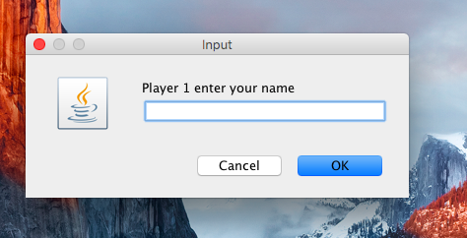

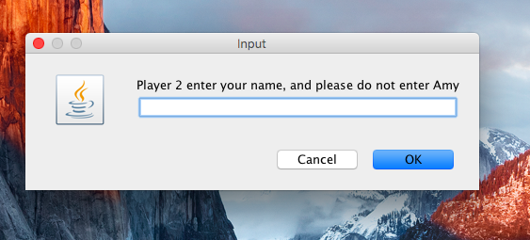

1. After entering the user name, it will tell the user that the white piece will move first, it will only start when the user agree with it as showing

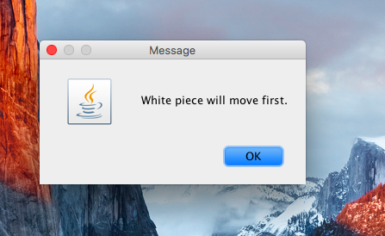

1. After agree with white move first, the game board will show below, which contain the player name and the score, which is 0 for now.

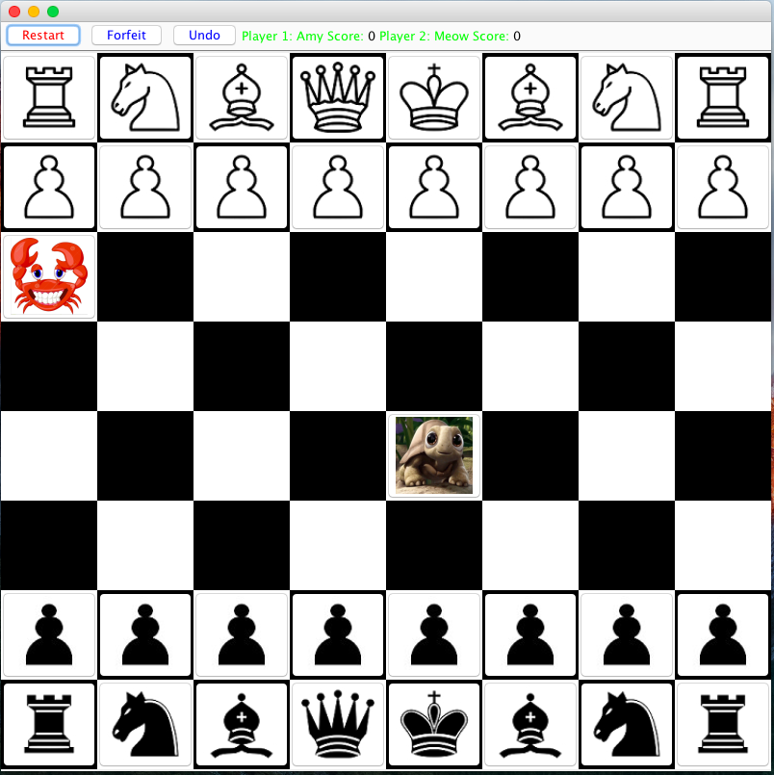

1. After game started, if a user want to restart the game, both of the user has to agree with restarting before it actually restarts, show below:

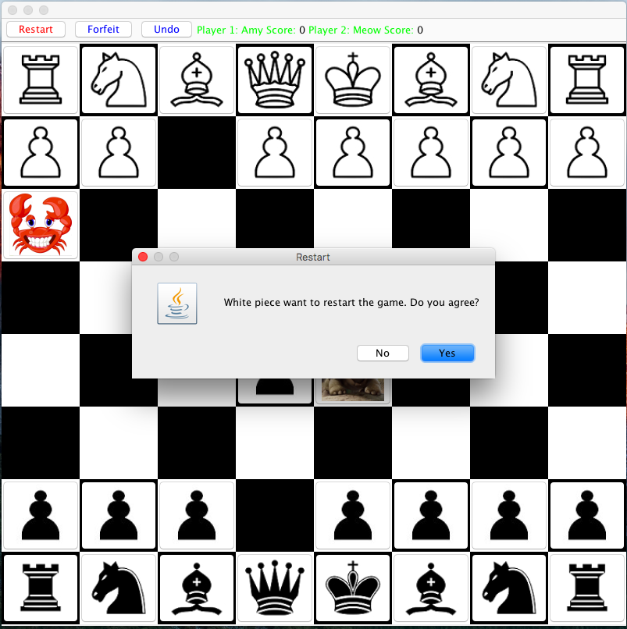

1. A player can only move their own piece, it is not allowed to move other pieces from the opponent. Show below:

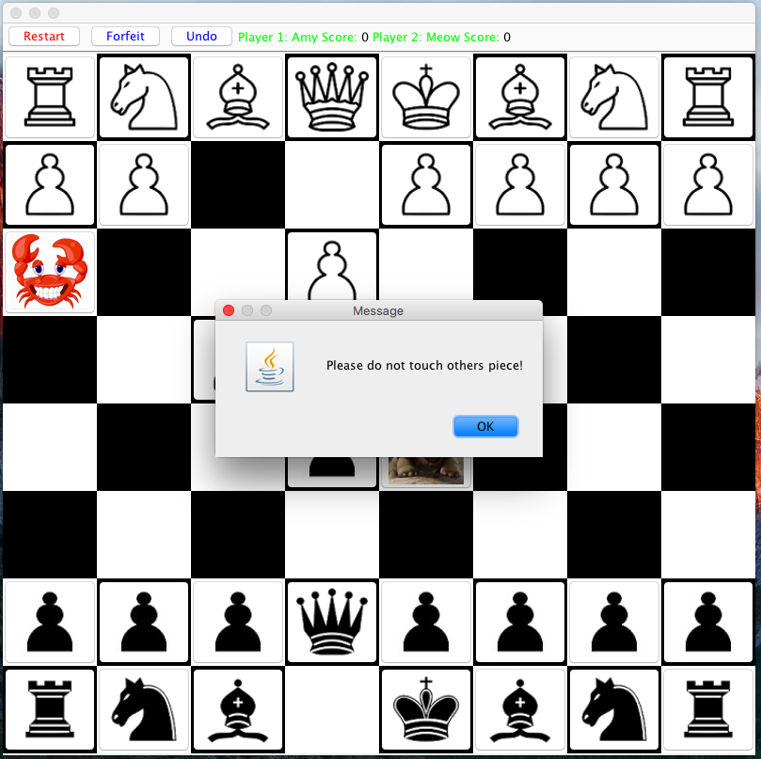

1. The user cannot move the piece illegally, has to follow the rule of Chess game.

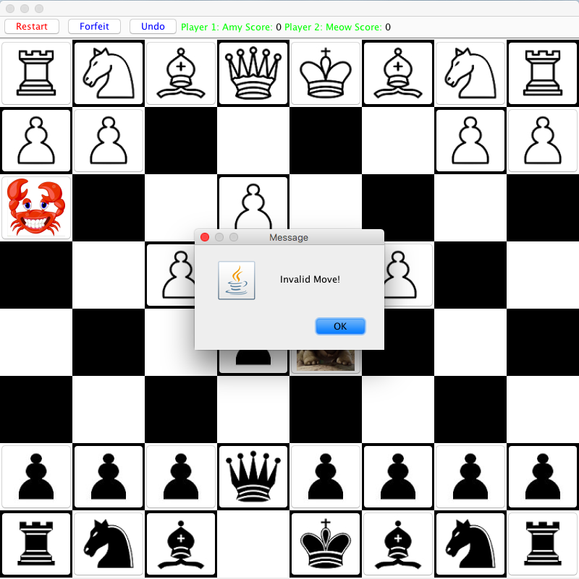

1. Customer piece will follow the basic rule during the game, and the turtle from black piece cannot move at all time, it plays a role as a one time blocker, and the crab plays as a fake pawn, for the first move, it can move whatever steps horizontally it wants, but after that, it will act as a normal pawn. Show below:

