How To Install VirtualBox 6.0 on Ubuntu 18.04 LTS

Oracle VirtualBox 6.0.0 has been released on December 18, 2018. Oracle VirtualBox 6.0 is the latest major release after launched by Oracle team. You can read the ChangeLog to know more about changes in newer version’s of VirtualBox. This tutorial will help you to install VirtualBox on Ubuntu 18.04 LTS Bionic Beaver Linux systems.

Step 1 – Prerequsities
Login to your Ubuntu 18.04 desktop system with sudo privileged user. After login to your system update current packages of the system to the latest version.
sudo apt update
sudo apt upgrade

Step 2 – Setup Apt Repository
Now, import the Oracle public key to your system signed the Debian packages using the following commands.
wget -q https://www.virtualbox.org/download/oracle_vbox_2016.asc -O- | sudo apt-key add -
wget -q https://www.virtualbox.org/download/oracle_vbox.asc -O- | sudo apt-key add -
Then, you need to add Oracle VirtualBox PPA to Ubuntu system. You can do this by running the below command on your system.
sudo add-apt-repository "deb http://download.virtualbox.org/virtualbox/debian bionic contrib"
This command will add an entry to /etc/apt/sources.list at end of the file.

Step 3 – Install VirtualBox on Ubuntu 18.04
After completing the above steps, let’s install VirtualBox using the following commands. If you have already installed an older version of VirtualBox, Below command will update it automatically.
sudo apt update
sudo apt install virtualbox-6.0

Step 4 – Launch VirtualBox
We can use dashboard shortcuts to start VirtualBox or simply run following command from a terminal.
virtualbox
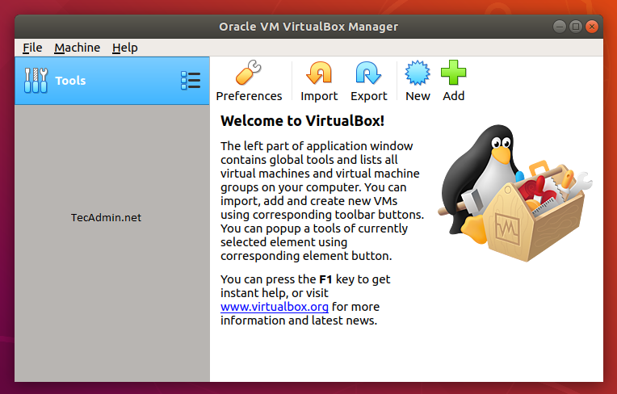

https://tecadmin.net/install-virtualbox-on-ubuntu-18-04/

