Screenshots and screencasts
You can take a picture of your screen (a screenshot) or record a video of what is happening on the screen (a screencast). This is useful if you want to show someone how to do something on the computer, for example. Screenshots and screencasts are just normal picture and video files, so you can email them and share them on the web.

Take a screenshot
- Open Screenshot from the Activities overview.
- In the Screenshot window, select whether to grab the whole screen, the current window, or an area of the screen. Set a delay if you need to select a window or otherwise set up your desktop for the screenshot. Then choose any effects you want.
- Click Take Screenshot.
If you selected Select area to grab, the pointer changes into a crosshair. Click and drag the area you want for the screenshot.
- In the Save Screenshot window, enter a file name and choose a folder, then click Save.
Alternatively, import the screenshot directly into an image-editing application without saving it first. Click Copy to Clipboard then paste the image in the other application, or drag the screenshot thumbnail to the application.

Keyboard shortcuts
Quickly take a screenshot of the desktop, a window, or an area at any time using these global keyboard shortcuts:
- Prt Scrn to take a screenshot of the desktop.
- Alt+Prt Scrn to take a screenshot of a window.
- Shift+Prt Scrn to take a screenshot of an area you select.
When you use a keyboard shortcut, the image is automatically saved in your Pictures folder in your home folder with a file name that begins with Screenshot and includes the date and time it was taken.
If you do not have a Pictures folder, the images will be saved in your home folder instead.
You can also hold down Ctrl with any of the above shortcuts to copy the screenshot image to the clipboard instead of saving it.

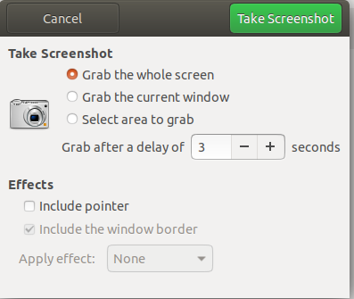

Make a screencast
You can make a video recording of what is happening on your screen:
- Press Ctrl+Alt+Shift+R to start recording what is on your screen.
A red circle is displayed in the top right corner of the screen when the recording is in progress.
- Once you have finished, press Ctrl+Alt+Shift+R again to stop the recording.
- The video is automatically saved in your Videos folder in your home folder, with a file name that starts with Screencast and includes the date and time it was taken.
If you do not have a Videos folder, the videos will be saved in your home folder instead.

