How to Install LibreOffice

How to Uninstall LibreOffice 6.1 via PPA in Ubuntu

You can purge the PPA and downgrade LibreOffice to Ubuntu pre-installed version via command:

sudo apt-get install ppa-purge && sudo ppa-purge ppa:libreoffice/ppa

To simply remove LibreOffice PPA, open Software & Updater and navigate to Other Software tab.

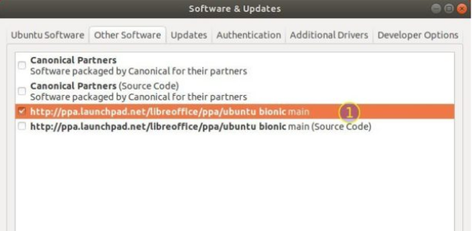

To remove a version of libreOffice as a 6.1.3

sudo apt-get remove libobasis6.1-core*

To install LibreOffice 6.1 snap, simply open Ubuntu Software, search for and install the first ‘libreoffice’
package from Snappy store.

Snap is containerised software package, designed to work securely within most Linux desktop. It bundles
all its dependencies and auto-updates itself.

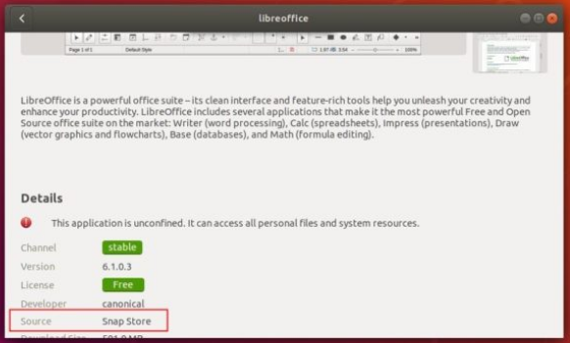

Or open terminal (Ctrl+Alt+T) and run single command to install it:
snap install libreoffice

The snap package co-exists with default Libreoffice package. Other than open it from software
launcher, you can run /snap/bin/libreoffice command to make sure you’re running the snap
version.

How to Install Libreoffice 6.1 via PPA in Ubuntu:

sudo add-apt-repository ppa:libreoffice/ppa

sudo apt-get update

sudo apt-get install libreoffice

