Cannot turn on sharing on ubuntu 18.04

After I turn on the slider, nothing happen. When i exit the window and go back to it, it turned off again. I want to use screen sharing. What do I have to do ? 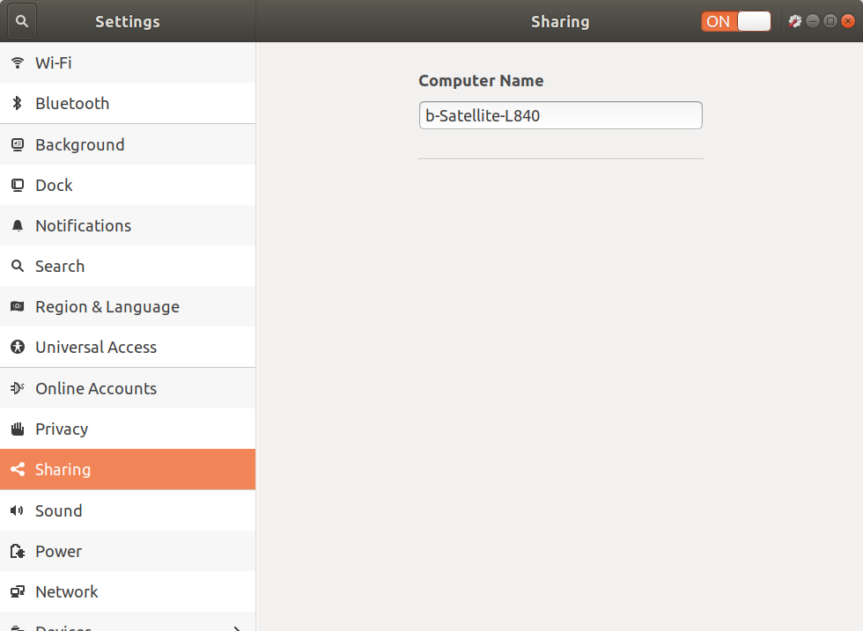

The screen sharing is featured by Vino vnc server, you just have to install it
sudo apt install vino
FYI, The ssh server (too) can be enabled/disabled on this gnome settings section

