Control Flow

If Statements
The if statement in python is same as C language which is used to test a condition.
If condition is true, statement of if block is executed otherwise it is skipped.

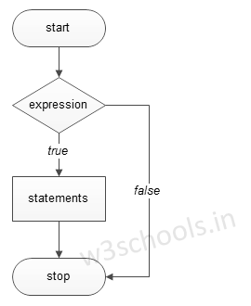

Syntax :

if condition:
statements
Example:

a=10
b=10
if a==b:
print ("Value of a and b are same")

Output:
Value of a and b are same

If Else Statements
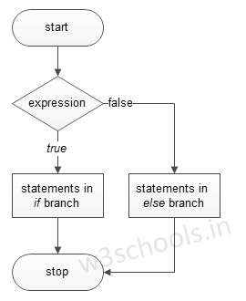

Syntax:
if condition:
True statements
else:
False statements

Example:

year=2000
if year%4==0:
print "Year is Leap year"
else:
print "Year is not Leap year"

Output:
Year is Leap year

Else If Statements
When we need to check for multiple conditions to be true then we use elif Statement.
This statement is like executing a if statement inside a else statement.

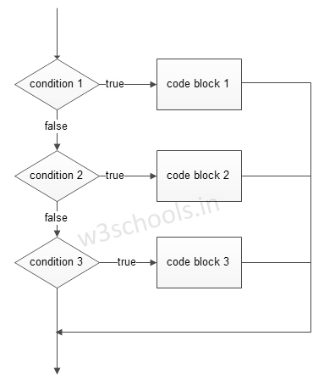

Syntax:

If condition 1:
True statement of condition 1
elif condition 2:
True statement of condition 2
else:
False statement of all conditions

Example:

a=10
if a>=20:
print "Condition is True"
elif a>=15:
print "Checking second value"
else:
print "All Conditions are false"

Output:

All Conditions are false.

For Loop

For Loop

for Loop is used to iterate a variable over a sequence(i.e., list or string) in the order that they appear.

Syntax:

for <variable> in <sequence>:

Output:

1

7

9

Explanation:

Firstly, the first value will be assigned in the variable.
Secondly all the statements in the body of the loop are executed with the same value.
Thirdly, once step second is completed then variable is assigned the next value in the sequence and step second is repeated.
Finally, it continues till all the values in the sequence are assigned in the variable and processed.

Program to display table of Number:

num=2
for a in range (1,6):
print num * a

Output:

2

4

6

8

10

Program to find sum of Natural numbers from 1 to 10.

sum=0
for n in range(1,11):
sum+=n
print sum

Output:

55

Nested Loops

Loops defined within another Loop is called Nested Loop.

When an outer loop contains an inner loop in its body it is called Nested Looping.

Syntax:

for <expression>:
for <expression>:
Body

eg:

for i in range(1,6):
for j in range (1,i+1):
print i,
print

Output:

>>>
1
2 2
3 3 3
4 4 4 4
5 5 5 5 5
>>>

Explanation:

For each value of Outer loop the whole inner loop is executed.

For each value of inner loop the Body is executed each time.

Program to print Pyramid:

for i in range (1,6):
for j in range (5,i-1,-1):
print "*",
print

Output:

>>>
* * * * *
* * * *
* * *
* *
*

While Loop

while Loop is used to execute number of statements or body till the condition passed in while is true. Once the condition is false, the control will come out of the loop.

Syntax:

while <expression>:
Body

Here, body will execute multiple times till the expression passed is true. The Body may be a single statement or multiple statement.

Eg:

a=10
while a>0:
print "Value of a is",a
a=a-2

print "Loop is Completed"

Output:

>>>
Value of a is 10
Value of a is 8
Value of a is 6
Value of a is 4
Value of a is 2
Loop is Completed
>>>

Explanation:

Firstly, the value in the variable is initialized.
Secondly, the condition/expression in the while is evaluated. Consequently if condition is true, the control enters in the body and executes all the statements . If the condition/expression passed results in false then the control exists the body and straight away control goes to next instruction after body of while.
Thirdly, in case condition was true having completed all the statements, the variable is incremented or decremented. Having changed the value of variable step second is followed. This process continues till the expression/condition becomes false.
Finally Rest of code after body is executed.

Program to add digits of a number:

n=153
sum=0
while n>0:
r=n%10
sum+=r
n=n/10
print sum

Output:

>>>
9
>>>

Break

break statement is a jump statement that is used to pass the control to the end of the loop.

When break statement is applied the control points to the line following the body of the loop , hence applying break statement makes the loop to terminate and controls goes to next line pointing after loop body.

Keywords

eg:

for i in [1,2,3,4,5]:
if i==4:
print "Element found"
break
print i,

Output:

>>>
1 2 3 Element found
>>>

Continue Statement

continue Statement is a jump statement that is used to skip the present iteration and forces next iteration of loop to take place. It can be used in while as well as for loop statements.
Continue Statement

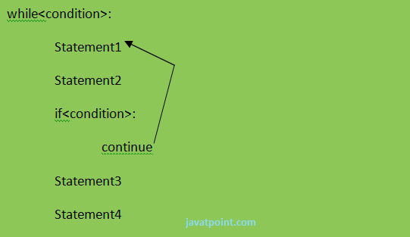
eg:

a=0
while a<=5:
a=a+1
if a%2==0:
continue
print a
print "End of Loop"

Output:

>>>
1
3
5
End of Loop
>>>

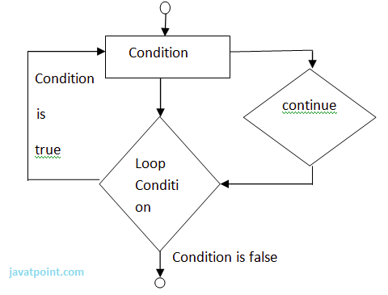

Pass

When you do not want any code to execute, pass Statement is used. It is same as the name refers to. It just makes the control to pass by without executing any code. If we want to bypass any code pass statement can be used.

Syntax:

pass

eg:

for i in [1,2,3,4,5]:
if i==3:
pass
print "Pass when value is",i
print i,

Output:

>>>
1 2 Pass when value is 3
3 4 5
>>>

