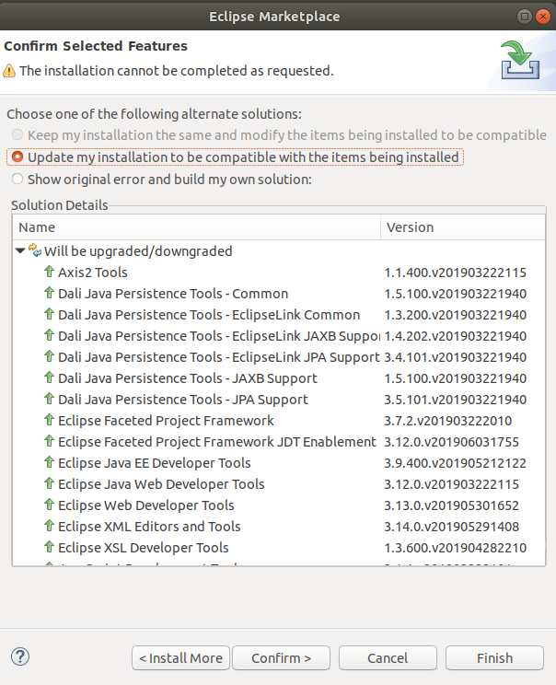

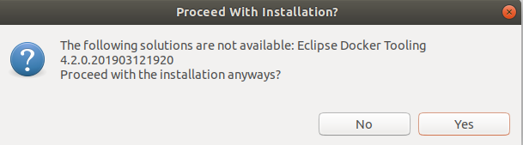

https://download.eclipse.org/linuxtools/update-2019-03-docker

