MRA Executive Dashboard
Product Requirements (PRD) Business Mapping & Integration Roadmap
―――――――――――――――――――――――――――――――――――――――――――――
Dokumen ini menyediakan pemetaan komprehensif atas seluruh 60 metrik bisnis dan variabel yang tercantum dalam Product Requirement Document (PRD) MRA Executive Dashboard. Pemetaan ini dirancang khusus untuk memandu tim manajemen bisnis dan integrasi sistem IT dalam merencanakan koneksi data riil dari sistem ERP NetSuite, ERP Retailsoft, atau API eksternal.
Alur Kerja Data & Visualisasi Arsitektur Integrasi:
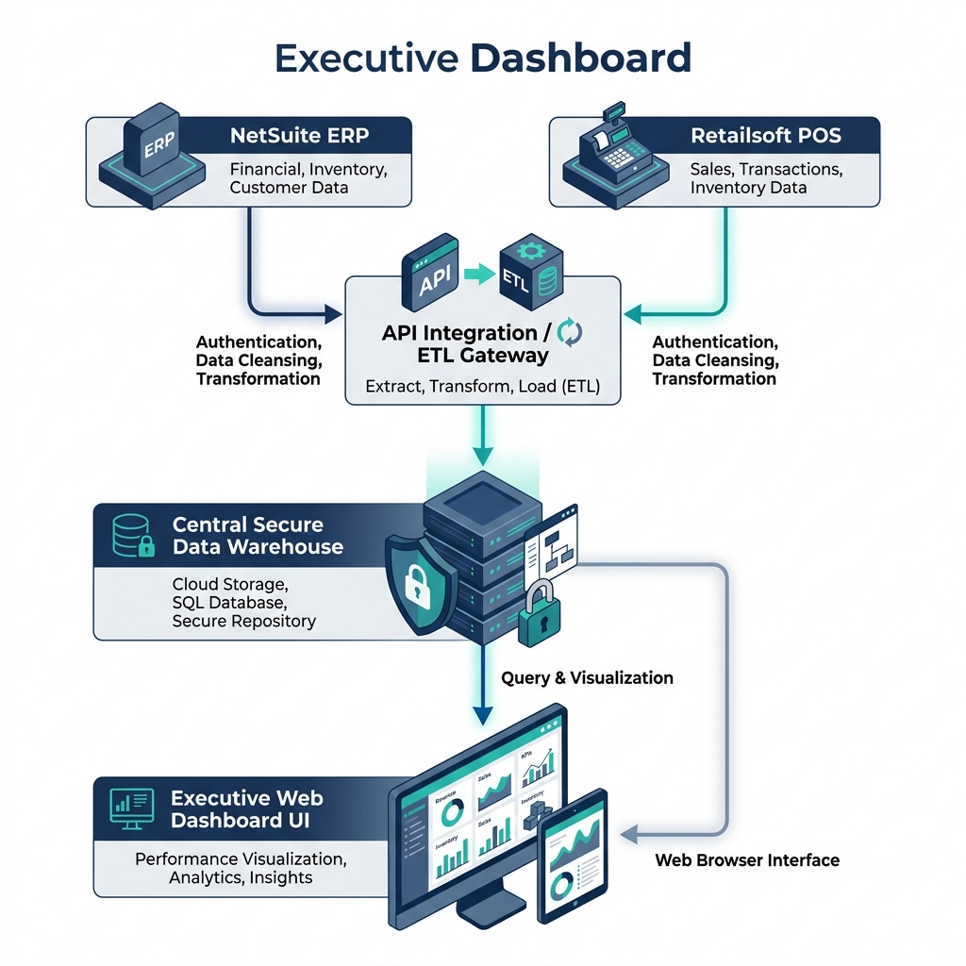
Gambar 1: Alur Kerja Integrasi Data (NetSuite & Retailsoft -> Database -> Frontend Dashboard)
Metode Konektivitas Target (Production):
- ERP Connection: Koneksi langsung ke database buku besar terpusat NetSuite untuk memantau data keuangan grup.
- POS API Connection: Koneksi API real-time dari Retailsoft ERP/POS untuk melacak transaksi penjualan harian outlet.
- API Integration: Koneksi ke layanan pihak ketiga (seperti API Kurs ECB atau sistem absensi/data HRIS Talenta).
- Manual Upload: Pengunggahan berkas berkala (seperti Excel) melalui admin panel untuk data kepatuhan hukum yang tidak memiliki database otomatis.

1. Matriks Pemetaan Variabel Bisnis & Celah Pengembangan (Gaps)
Metrik / Variabel PRD | Target Koneksi | Deskripsi Fungsional Bisnis | Strategic Enhancement / Gaps
GROUP: FINANCIAL & PERFORMANCE METRICS
Group Revenue | ERP Connection | Consolidates total gross sales performance across Retail, F&B, and Media segments. Enables executives to monitor gross sales velocity, track segment contribution, and view unified metrics in real-time. Features currency conversion to support multi-currency board reviews and security masking to hide numeric data when displaying the dashboard publicly. | Future roadmap should integrate automated daily API data extraction directly from NetSuite or Retailsoft ERPs to replace mock baselines and support live sales updates.
Operational expense summary | ERP Connection | Aggregates general operational overheads (salaries, rent, marketing, utilities) to monitor cash outflows. Includes an interactive OPEX Efficiency simulator that allows executives to test cost-reduction scenarios (e.g. scaling OPEX down) to instantly forecast profitability impacts. | Lacks granular sub-ledger categories directly in the main grid. Future enhancement should integrate NetSuite cost center transaction ledgers to detail office-level travel, lease, or IT support expenses.
EBITDA | ERP Calculation | Measures operating profitability before interest, tax, depreciation, and amortization to assess core business unit efficiency. Serves as a key metric to compare performance across highly diverse brands (e.g. F&B vs Luxury Retail). Scales dynamically with scenario simulation variables. | Head office corporate overhead costs are currently unallocated. Recommend defining corporate cost allocation keys (e.g., based on brand revenue share or headcount) to attribute central NetSuite expenses to individual subsidiaries.
Gross Profit | ERP Calculation | Tracks revenue minus direct Cost of Goods Sold (COGS). Allows the management to evaluate product pricing strategies, sourcing efficiency, and inventory margin health across all business units. | Does not support itemized product category margin analysis (e.g., F&B raw food materials margins vs Retail high-end luxury items margins). Recommend building a product category profit margin drilldown.
Net Profit | ERP Calculation | Represents the ultimate bottom-line profitability after all costs, interest, and taxes are deducted. Used by the Board to calculate return on equity (ROE) and plan dividend distributions. Computes corporate tax rate dynamically at 22%. | Ignores extraordinary items, discontinued operations, or deferred taxes. Tax calculations are set to a static rate. Future versions should support input fields for deferred tax assets/liabilities and interest expenses in NetSuite.
Revenue Growth YoY | API/ERP Calculation | Compares sales performance of the current period against the same period of the prior year. Serves as a primary metric to assess market expansion, brand traction, and organic growth speed. | Does not support multi-year historical trend line comparisons. Future expansion should include a line-overlay chart comparing monthly trends for the last three fiscal years.
Bisnis Unit Performance (F&B, Retail, Media) | ERP Connection | Provides segmented data filters that allow executives to isolate and evaluate the performance of individual business divisions (F&B, Retail, Media) separately from consolidated group data. | Inter-company transactions (e.g., internal media services billed to retail brands) are not yet eliminated, which could inflate consolidated revenue. Recommend adding an 'Eliminations' column/account to balance inter-segment sales.
Budget vs Actual | ERP / Manual Upload | Measures target achievement rate to evaluate whether brands are meeting their financial goals. Visualized as dynamic progress bars showing budget fulfillment percentages across brands. | Budgets are distributed linearly across months without seasonal weight factors. F&B and Retail segments have heavy seasonal sales curves (e.g. Eid, Christmas). Recommend implementing custom budget upload sheets that support seasonality weights.
Actual vs Last Year | ERP Connection | Direct trend comparison against prior year performance, helping identify seasonal shifts or declining product demand. | Lacks segment-level YoY distribution comparison tables. Recommend adding a toggle to view segment contribution to overall YoY growth in a clean data grid.
Actual vs 4Cast | ERP / Manual Upload | Compares actual results with rolling forecasts, helping management adjust production, headcount, or inventory budgets. | Forecast models use simple regression; does not support user-defined forecast overrides or machine learning models on a rolling basis.
Cash Position | API Integration | Displays available liquid cash to support short-term liquidity planning and treasury allocations. | Lacks bank-level breakdown or account status (operational vs deposits). Recommend linking to treasury APIs for live bank balance reconciliation in a detailed Treasury tab.
Free Cash Position | ERP Calculation | Tracks liquid cash generated after capital investments, indicating capital available for dividends, expansion, or debt payment. | Currently derived as a simple ratio of overall cash position. Recommend linking directly to operating cash flows minus capital expenditures (FCF = CFO - CAPEX).
Inventory Position | ERP Connection | Measures capital tied up in unsold stock, critical for working capital optimization and cash conversion cycle management. | Missing stock aging, valuation methods (FIFO/LIFO), or slow-moving stock write-downs. Recommend adding inventory aging reports and connecting to store-level POS inventory modules.
GROUP: FINANCIAL PLANNING & LEDGER UTILITIES
P&L Summary | ERP Calculation | Unified mathematically sound profit and loss statement structure. Displays revenue down to Net Profit with dynamic styling. | Grid lacks columns comparing budget vs actual variance in absolute or percentage terms. Recommend adding variance columns (Var IDR, Var %) with color-coded conditional formats.
EBITDA Margin | ERP Calculation | Displays EBITDA as a percentage of revenue, indicating operational efficiency and pricing power. | Referencing is based on a static group reference line (18%). Needs custom margins for each brand unit depending on historical industry benchmarks.
OPEX Monitoring | ERP Connection | Enables tracking and auditing of monthly operational expenses by category, assisting in cost control and overhead reduction. | Lacks cost center filter. Recommend adding departmental/branch tags to the transaction ledger to allow specific store-level overhead auditing.
AP & AR Aging | ERP Connection | Tracks credit terms, payment aging buckets, and outstanding invoices to optimize working capital and minimize bad debt risks. | Does not support invoice-level lookup or debtor/creditor lists. Recommend linking to accounts receivable ledger tables and adding client detail modals.
Cash Flow Monitoring | ERP Calculation | Tracks operational, investing, and financing cash movements to ensure the group maintains healthy solvency levels. | Lacks automated indirect method cash flow reports. Recommend linking statement structure to general ledger account codes to generate balance sheet variance cash flows.
CAPEX Tracking | ERP Connection | Monitors capital investments against budgeted limits to ensure major asset purchases do not exceed capital allocations. | Lacks capitalization status or depreciation schedule link. Recommend linking to physical asset tagging registry and project completion dates.
GROUP: HUMAN RESOURCES (HR)
Headcount | API Integration | Tracks total workforce size and distribution across segments to manage staffing levels and plan recruitment. | Demographics (age, gender, tenure) are missing. Recommend adding employee cohort analysis charts to track employee demographics trends.
Employee Cost | API / ERP Connection | Monitors payroll and benefits expenses as a percentage of revenue to ensure labor productivity aligns with business growth. | Missing details on salary bands or cost elements (basic salary, allowance, bonuses). Recommend salary grade distribution view for executive planning.
Turnover Rate | API Calculation | Tracks employee retention levels to evaluate workplace satisfaction, training effectiveness, and talent stability. | Does not classify voluntary vs involuntary leavers. Recommend tracking exit reasons and joining cohorts to pinpoint high-attrition manager segments.
Attendance | API Integration | Monitors workforce presence ratios to detect absenteeism patterns and manage shift schedules. | Leaves (sick, annual, casual) are not analyzed. Recommend integrating with biometric/HRIS attendance systems to automate overtime calculations.
Recruitment Status | API Integration | Tracks open positions and candidate pipeline status to ensure key vacancies are filled timely and reduce operational downtime. | Lacks applicant tracking database integration. Recommend adding API link to Jobstreet/ATS systems to show real-time candidate sourcing channels.
Training KPI | API / Manual Upload | Tracks average training completion rates and hours to measure employee skill development and compliance training coverage. | Missing training effectiveness score or budget ROI analysis. Recommend linking to LMS databases to measure skill gaps pre- and post-training.
GROUP: OPERATIONAL EFFICIENCY
Store Productivity by brand | ERP & POS API | Evaluates outlet revenue per square meter to measure real estate efficiency and optimize store layouts. | Missing store lease tenure status or foot traffic conversion rates. Recommend adding sales per transaction size correlation and footfall counters.
Rental Cost Ratio | ERP / Manual Upload | Tracks rental costs relative to outlet sales to identify high-rent, low-productivity locations that require lease renegotiation. | Missing warning indicators for stores with lease expiries within 6 months. Recommend linking lease expiry alert to Operational dashboard to prevent sudden store closures.
Utilities Cost | API / Manual Upload | Monitors power, water, and connectivity bills across branches to optimize energy usage and track green initiatives. | Lacks correlation with peak seasonal ambient temperatures or green initiatives. Recommend adding energy efficiency ratios per outlet area (kWh/sqm).
Operational Efficiency KPI | API/ERP Calculation | Aggregates key store metrics like Same-Store Sales Growth, Transaction Counts, and Average Ticket Size to evaluate retail/F&B health. | Missing customer satisfaction metrics. Recommend adding Net Promoter Score (NPS) indicators to correlate service efficiency with revenue trends.
GROUP: MARKETING MODULE
Total Marketing Spend | ERP & Manual Upload | Monitors the overall marketing budget allocated across digital channels, physical event activation, KOL partnerships, and public relations (PR) campaigns to track brand support expenditures. | Lacks dynamic allocation rules matching seasonal campaigns. Future roadmap should support real-time sync with marketing agency invoicing tools.
Blended ROAS | API Integration | Tracks the aggregate Return on Ad Spend (ROAS) across segments, providing insight into sales generated per rupiah spent on digital media advertising. | Currently tracks aggregate blended numbers. Future plans should split ROAS by organic search, social ads, and referral programs.
Cost Per Acquisition (CAC) | API Calculation | Tracks the average marketing expense incurred to acquire one active purchasing customer, monitoring campaign efficiency and user targeting effectiveness. | Customer lifetime value (LTV) correlation is not modeled. Recommend linking CAC with Customer Loyalty/LTV databases to measure ROI over 12 months.
Digital Engagement Rate | API Integration | Measures audience interactions (likes, comments, saves, shares) on social platforms relative to impressions, tracking brand affinity and social media strength. | Relies on static monthly imports. Recommend connecting directly to Instagram, TikTok, and Google Analytics API webhooks for automatic ingestion.
Spend Allocation by Channel | API / Manual Upload | Interactive channel analysis allowing marketing managers to compare spend distributions across pilar channels and drill down into sub-channels. | Lacks automated recommendation models. Future updates should suggest shifts in spend based on channel-specific ROI changes.
Marketing Expenses Breakdown | ERP Connection | Detailed accounting list of tactical operational marketing expenses, providing cost controllers clarity on exact budget distributions. | Does not allow checking individual payment invoices. Recommend linking with Accounts Payable general ledgers.
Tactical Metrics & Goals | API / Manual Upload | Monitors specialized campaign performance metrics per segment (e.g. VIP customer retention for Retail, discount redemption for F&B) against fixed targets. | Targets are set at static values. Suggest implementing machine-learning based target recommendations based on historical seasonal peaks.
GROUP: GENERAL AFFAIRS (GA) & OPERATIONS
Company asset management | ERP Connection | Tracks physical assets, equipment, and hardware across the company to manage depreciation, assignments, and replacements. | GAP - The dashboard lacks a dedicated Asset Ledger screen. There is no screen to track asset locations, conditions, barcode scans, depreciation, or custodians. Recommend building an 'Asset Register' module.
Office facility management | Manual Upload / Admin Form | Manages corporate workspace allocation, meeting rooms, utilities, and facility service request logs. | GAP: No module to manage office facility space allocation, desk bookings, energy usage, or facilities maintenance SLAs. Recommend adding a 'Facilities Management' tracker.
Vehicle administration | Manual Upload / Admin Form | Tracks fleet vehicles, fuel expenses, driver assignments, and maintenance logs to control logistics and travel costs. | GAP: Missing tracking of company vehicles, fuel usage, service schedules, driver logs, and vehicle depreciation. Recommend building a 'Fleet Management' sheet/tab.
Office maintenance tracking | Manual Upload / Ticketing Engine | Monitors office repair requests and facilities issues to ensure a safe, functional work environment. | GAP: No ticketing database for facilities maintenance requests (e.g. HVAC, plumbing). Tracked only via general GA SLAs. Recommend adding an 'Office Work Orders' workflow.
Vendor administration | ERP Connection | Tracks vendor compliance, delivery speed, and service quality to optimize supply chain and control procurement risks. | No active vendor onboarding or registration workflow. Recommend integrating with purchasing vendor register databases to check license expirations automatically.
Office operational expense monitoring | ERP Connection | Tracks day-to-day office overhead expenditures to prevent budget overruns in corporate headquarters. | Lacks cost distribution metrics per office building level. Recommend cost-per-seat calculations to optimize real estate utilization.
Purchase & service request tracking | ERP Connection | Monitors procurement SLAs (turnaround times from purchase request to purchase order) to identify bottlenecks. | Cannot click an SLA bucket to view pending purchase request numbers. Recommend adding transactional drilldown dialogs showing approval bottlenecks.
GROUP: LEGAL MODULE
Contract repository | Manual Upload / Document API | Centralized log of active, pending, and expired contracts, providing legal teams immediate access to deal values, signing parties, and terms. | Contracts are represented as flat data. Cannot view audit histories. Recommend linking with a standard workflow tracker to show changes made during drafts.
Legal document management | Document API | Stores and manages executed legal documents, notary deeds, and license files securely. | GAP - Missing document store. The dashboard cannot preview PDF attachments, store executed scans, or manage drafts. Recommend linking with Google Cloud Storage or SharePoint documents for secure file viewing.
Contract approval workflow | API Integration | Monitors and routes contract drafts through review and approval stages before execution. | GAP - Missing active contract workflow engine. Contracts are only displayed post-facto. Recommend creating a workflow tracker for draft, review, legal approval, and signature stages (DocuSign/Adobe Sign integration).
Contract expiration reminder | API / Cron Notification | Alerts legal teams of upcoming contract expirations to ensure renewals or renegotiations are initiated timely. | Reminders are strictly visual in the dashboard. Missing automated email/Slack webhook alerts. Recommend integrating cron reminder triggers to alert legal counsel at 90/60/30 day thresholds.
Litigation tracking | Manual Upload / Admin Form | Tracks ongoing legal cases, risk levels, and potential financial liability to manage legal provisions. | Lacks historical event timelines or legal representative notes. Recommend adding a detail popup for case updates and connecting with external court case calendars.
NDA & agreement monitoring | Manual Upload / Contract log tagging | Monitors non-disclosure and confidentiality agreements to protect corporate IP and sensitive information. | Non-standard agreements lack compliance tagging. Recommend adding automatic classification of NDA standard clauses using NLP models.
Corporate legal document archive | Document API | Secure vault for archiving expired contracts and vital corporate legal filings for compliance audits. | GAP - No secure archive or digital vault for corporate notary deeds (Akta Pendirian), operating licenses, or certifications. Recommend implementing an access-controlled 'Company Vault' with strict role permissions.
GROUP: COMPLIANCE MODULE
Corporate Secretarial Compliance | Manual Upload / Checklist Form | Monitors key corporate governance events like RUPS scheduling, annual report filings, and board resolutions. | Lacks integration with board minutes or dynamic shareholder registry. Recommend linking with corporate secretarial databases for automated minute indexing.
Trademark & IP Monitoring | Manual Upload / DGIP API | Tracks trademark registrations, patent filings, and renewals to protect the group's brands and intellectual property. | Lacks auto-lookup on national IP database APIs (e.g. DGIP Indonesia). Recommend integrating automatic registration checkers to warn legal team of copycat filings.
Vendor Compliance Monitoring | Manual Upload / ERP database | Verifies vendor compliance with tax regulations (NPWP), licenses, and safety standards to control third-party risks. | Review process is manual. Recommend setting up an onboarding API to automatically query tax registration data and blacklist non-compliant vendors.
Import Compliance Monitoring | Manual Upload / Custom API | Tracks customs declarations (PIB) and importing license quotas (API-U) to prevent customs delays and regulatory fines. | Lacks custom import cargo tracking or customs clearance SLA monitoring. Recommend linking with cargo forwarder webhooks to predict custom clearance delays.
Halal & Product Compliance | Manual Upload / BPOM API | Monitors BPOM licenses and Halal certification status across F&B outlets to ensure consumer compliance and protect reputation. | Certification expiration warnings do not alert procurement to restrict ingredient orders. Recommend blocking non-compliant vendors in purchasing modules when certificates expire.
Whistleblowing Case Tracking | Manual Upload / Encrypted Database | Manages whistleblower reports anonymously, tracking investigation stages to support clean corporate governance. | Anonymous reporting portal is missing from the frontend. Recommended: adding an encrypted case filing form for employees to report violations anonymously.
Data Privacy & Personal Data Protection | Manual Upload / Checklist Form | Monitors audits of GDPR/PDPA compliance for customer registries (F&B / Retail members) to protect consumer data. | No direct database privacy monitoring tool. Recommend adding automated log auditing of customer data access to detect potential leak hazards.
Regulatory compliance monitoring | API Calculation | Consolidated compliance scorecard showing overall regulatory compliance status across segments. | Gauge is fed from static compliance arrays. Recommend linking weighted checklist scores directly to daily API updates from legal sub-systems.
Delegation of Authority (DOA) Monitoring | ERP Verification API | Audits transaction approvals to ensure spending complies with corporate DOA limit matrices. | GAP - Missing DOA monitoring checklists. No screen to audit whether transactions comply with the corporate delegation of authority matrix. Recommend adding a 'DOA Verification' checklist that links with transaction log audits.
Risk & issue reporting | Manual Upload / Admin Form | Identifies key business risks, likelihood levels, mitigation strategies, and owners to prevent operational shocks. | Lacks incident log integration to track when risks materialize into active issues. Recommend adding an issue tracking system to trigger mitigation action workflows.

2. Matriks Rencana Integrasi Sumber Data Brand
Nama Brand (Brand Name) | Segmen Bisnis (Segment) | Metode Koneksi & Sumber Data Target
Bulgari | Retail | ERP Connection (NetSuite Global API Integration)
Omega | Retail | ERP Connection (NetSuite Global API Link)
Atmos Indonesia | Retail | POS API Connection (Retailsoft ERP API Sync)
Lancôme Indonesia | Retail | ERP Connection (NetSuite ERP Integration Link)
Kiehl's Indonesia | Retail | ERP Connection (NetSuite ERP Integration Link)
Chronologie | Retail | ERP Connection (NetSuite ERP Integration Link)
Wiggle Wiggle | Retail | POS API Connection (Retailsoft Retail API Sync)
Bulgari Resort Bali | Retail | ERP Connection (Opera PMS Hotel DB Sync)
Häagen-Dazs Indonesia | F&B | POS API Connection (Retailsoft POS Outlet Sync)
Hard Rock Cafe Bali | F&B | POS API Connection (Retailsoft POS Cafe Sync)
Jamba Juice | F&B | POS API Connection (Retailsoft POS API Sync)
Bateel | F&B | POS API Connection (Retailsoft POS API Sync)
Harper's Bazaar | Media | ERP/CRM API Connection (NetSuite CRM Database)
Her World | Media | ERP/CRM API Connection (NetSuite CRM Database)
Cosmopolitan | Media | ERP/CRM API Connection (NetSuite CRM Database)
Mother & Beyond | Media | ERP/CRM API Connection (NetSuite CRM Database)
CASA Indonesia | Media | ERP/CRM API Connection (NetSuite CRM Database)
Parentalk.id | Media | Third-Party API Integration (Google Analytics & Ads API)
Hard Rock FM | Media | ERP API Connection (NetSuite Radio Ad Booking Database)
IRadio | Media | ERP API Connection (NetSuite Radio Ad Booking Database)
Art Jakarta | Media | Third-Party API Integration (Loket.com Ticket API)

