桂林电子科技大学 2019-2020学年 第1学期
《Java程序设计》实 验 报 告

实验名称 实验四 Java GUI 编程（一）
指导教师意见：

成绩
教 师
签 名

计算机与信息安全 学院 计算机类 专 业
班 第 实 验 小 组
姓 名 奚锐 学 号 1800300636
实 验 日 期 2019 年 11 月 2 日

实验四 JavaGUI编程

实验目的

1、掌握 Java 图形界面程序设计的基本思想和步骤。

2、掌握 JDK 中 AWT 包和 Swing 包的基本使用方法和区别。

3、掌握容器和布局的概念和使用。

4、掌握图形界面程序的界面设计方法和步骤。

实验内容
自己编写所有代码，设计一个程序的界面。该程序的功能要求是：运行之后，界面要求基本如左 图所示。其中界面设计时的顶层容器要求使用 JFrame（或 Frame）， 界面上的“简易计算器”、“运算数一”、“运算数二”、“运算结果” 这些提示标签使用组件 JLabel（或 Label） ，输入运算数和输出运 算结果使用 JTextField（或 TextField），“相加”、“相减”和“全 部清零”使用按钮 JButton（或 Button）。 请注意查阅 JDK 的 API 文档中这些相关的类，看看它们具有哪些构造函数可以用来生成 所需的对象，它们具有哪些方法可以用来进行调用。注意保存好 本次实验代码，下一次实验将会要求实现其事件处理以继续完善。

2、下面的左图和右图分别是 windows 系统中的标准型和科学型计算器的界面截图。打开你使用的微 软公司 Windows 操作系统或 Linux 等其它操作系统中自带的“计算器”软件，观察和参照其界面和功能， 实现一个接近其界面和功能的计算器（标准型或科学型）的界面。并保存好代码，在下一次实验中实现 其事件处理（即运算功能）。

分析与设计
第一题的简易计算器，需要两个text栏进行数据的输入，一个text进行结果的输出，再需要三个对应的label放在三个text上对text内容进行说明。最底部放置三个Jbutton实现计算（相加，相减，清零）功能
第二题的标准计算器，将整个窗体分成两部分上半部分放置一个text显示输入的结果与输出的结果，下半部分放置按钮，包扣数字部分（0-9），符号（+，-，×，÷，（，））等。
代码如下：
简易计算器的界面代码：
<?xml version="1.0" encoding="UTF-8"?>
<form xmlns="http://www.intellij.com/uidesigner/form/" version="1" bind-to-class="CalTwo">
<grid id="27dc6" binding="Main" layout-manager="GridLayoutManager" row-count="9" column-count="2" same-size-horizontally="false" same-size-vertically="false" hgap="-1" vgap="-1">
<margin top="0" left="0" bottom="0" right="0"/>
<constraints>
<xy x="20" y="20" width="500" height="400"/>
</constraints>
<properties/>
<border type="none"/>
<children>
<component id="cad4a" class="javax.swing.JLabel" binding="Tittle">
<constraints>
<grid row="0" column="0" row-span="1" col-span="2" vsize-policy="0" hsize-policy="0" anchor="1" fill="0" indent="0" use-parent-layout="false"/>
</constraints>
<properties>
<text value="简易计算器"/>
</properties>
</component>
<component id="b63b3" class="javax.swing.JTextField" binding="textField1" default-binding="true">
<constraints>
<grid row="6" column="0" row-span="1" col-span="2" vsize-policy="0" hsize-policy="6" anchor="0" fill="0" indent="0" use-parent-layout="false">
<preferred-size width="150" height="-1"/>
</grid>
</constraints>
<properties/>
</component>
<component id="29abe" class="javax.swing.JTextField" binding="textField2" default-binding="true">
<constraints>
<grid row="4" column="0" row-span="1" col-span="2" vsize-policy="0" hsize-policy="0" anchor="0" fill="0" indent="0" use-parent-layout="false">
<preferred-size width="150" height="-1"/>
</grid>
</constraints>
<properties/>
</component>
<component id="5049" class="javax.swing.JTextField" binding="textField3" default-binding="true">
<constraints>
<grid row="2" column="0" row-span="1" col-span="2" vsize-policy="0" hsize-policy="6" anchor="0" fill="0" indent="0" use-parent-layout="false">
<preferred-size width="150" height="-1"/>
</grid>
</constraints>
<properties/>
</component>
<component id="d9de4" class="javax.swing.JButton" binding="toZero">
<constraints>
<grid row="8" column="0" row-span="1" col-span="2" vsize-policy="0" hsize-policy="3" anchor="0" fill="0" indent="1" use-parent-layout="false"/>
</constraints>
<properties>
<text value="清零"/>
</properties>
</component>
<component id="89f49" class="javax.swing.JButton" binding="negButton">
<constraints>
<grid row="7" column="1" row-span="1" col-span="1" vsize-policy="0" hsize-policy="3" anchor="8" fill="0" indent="0" use-parent-layout="false"/>
</constraints>
<properties>
<text value="相减"/>
</properties>
</component>
<component id="5c9d3" class="javax.swing.JButton" binding="addButton">
<constraints>
<grid row="7" column="0" row-span="1" col-span="1" vsize-policy="0" hsize-policy="3" anchor="4" fill="0" indent="0" use-parent-layout="false"/>
</constraints>
<properties>
<text value="相加"/>
</properties>
</component>
<component id="13949" class="javax.swing.JLabel">
<constraints>
<grid row="1" column="0" row-span="1" col-span="1" vsize-policy="0" hsize-policy="0" anchor="0" fill="0" indent="0" use-parent-layout="false"/>
</constraints>
<properties>
<text value="操作数1"/>
</properties>
</component>
<component id="8cc06" class="javax.swing.JLabel">
<constraints>
<grid row="3" column="0" row-span="1" col-span="1" vsize-policy="0" hsize-policy="0" anchor="0" fill="0" indent="0" use-parent-layout="false"/>
</constraints>
<properties>
<text value="操作数2"/>
</properties>
</component>
<component id="69906" class="javax.swing.JLabel">
<constraints>
<grid row="5" column="0" row-span="1" col-span="1" vsize-policy="0" hsize-policy="0" anchor="0" fill="0" indent="0" use-parent-layout="false"/>
</constraints>
<properties>
<text value="结果"/>
</properties>
</component>
</children>
</grid>
</form>
科学计算器的界面代码如下：
<?xml version="1.0" encoding="UTF-8"?>
<form xmlns="http://www.intellij.com/uidesigner/form/" version="1" bind-to-class="helloWorld.contactForm">
<grid id="27dc6" binding="mainPanel" layout-manager="GridLayoutManager" row-count="2" column-count="1" same-size-horizontally="false" same-size-vertically="false" hgap="-1" vgap="-1">
<margin top="0" left="0" bottom="0" right="0"/>
<constraints>
<xy x="20" y="20" width="509" height="380"/>
</constraints>
<properties>
<background color="-327937"/>
</properties>
<border type="none" title-justification="2">
<color color="-4506581"/>
</border>
<children>
<grid id="f72f9" layout-manager="GridLayoutManager" row-count="5" column-count="5" same-size-horizontally="false" same-size-vertically="false" hgap="-1" vgap="-1">
<margin top="0" left="0" bottom="0" right="0"/>
<constraints>
<grid row="1" column="0" row-span="1" col-span="1" vsize-policy="0" hsize-policy="0" anchor="0" fill="3" indent="0" use-parent-layout="false"/>
</constraints>
<properties/>
<border type="etched"/>
<children>
<component id="7859e" class="javax.swing.JButton" binding="a7Button" default-binding="true">
<constraints>
<grid row="1" column="0" row-span="1" col-span="2" vsize-policy="3" hsize-policy="3" anchor="0" fill="3" indent="0" use-parent-layout="false">
<preferred-size width="73" height="50"/>
</grid>
</constraints>
<properties>
<font name="DengXian" size="28" style="1"/>
<hideActionText value="false"/>
<horizontalTextPosition value="0"/>
<text value="7"/>
<verticalTextPosition value="3"/>
</properties>
</component>
<component id="54c2b" class="javax.swing.JButton" binding="a8Button">
<constraints>
<grid row="1" column="2" row-span="1" col-span="1" vsize-policy="3" hsize-policy="3" anchor="0" fill="3" indent="0" use-parent-layout="false">
<preferred-size width="85" height="50"/>
</grid>
</constraints>
<properties>
<font name="DengXian" size="28" style="1"/>
<horizontalTextPosition value="0"/>
<text value="8"/>
</properties>
</component>
<component id="df86c" class="javax.swing.JButton" binding="a9Button">
<constraints>
<grid row="1" column="3" row-span="1" col-span="1" vsize-policy="3" hsize-policy="3" anchor="0" fill="3" indent="0" use-parent-layout="false"/>
</constraints>
<properties>
<font name="DengXian" size="28" style="1"/>
<hideActionText value="false"/>
<horizontalTextPosition value="0"/>
<text value="9"/>
</properties>
</component>
<component id="ec949" class="javax.swing.JButton" binding="a4Button">
<constraints>
<grid row="2" column="0" row-span="1" col-span="2" vsize-policy="3" hsize-policy="3" anchor="0" fill="3" indent="0" use-parent-layout="false">
<preferred-size width="73" height="50"/>
</grid>
</constraints>
<properties>
<font name="DengXian" size="28" style="1"/>
<hideActionText value="false"/>
<horizontalTextPosition value="0"/>
<text value="4"/>
</properties>
</component>
<component id="96201" class="javax.swing.JButton" binding="a5Button">
<constraints>
<grid row="2" column="2" row-span="1" col-span="1" vsize-policy="3" hsize-policy="3" anchor="0" fill="3" indent="0" use-parent-layout="false">
<preferred-size width="85" height="50"/>
</grid>
</constraints>
<properties>
<font name="DengXian" size="28" style="1"/>
<hideActionText value="false"/>
<horizontalTextPosition value="0"/>
<text value="5"/>
</properties>
</component>
<component id="72f79" class="javax.swing.JButton" binding="a6Button">
<constraints>
<grid row="2" column="3" row-span="1" col-span="1" vsize-policy="3" hsize-policy="3" anchor="0" fill="3" indent="0" use-parent-layout="false"/>
</constraints>
<properties>
<font name="DengXian" size="28" style="1"/>
<hideActionText value="false"/>
<horizontalTextPosition value="0"/>
<text value="6"/>
</properties>
</component>
<component id="edba7" class="javax.swing.JButton" binding="a1Button">
<constraints>
<grid row="3" column="0" row-span="1" col-span="2" vsize-policy="3" hsize-policy="3" anchor="0" fill="3" indent="0" use-parent-layout="false">
<preferred-size width="73" height="50"/>
</grid>
</constraints>
<properties>
<font name="DengXian" size="28" style="1"/>
<hideActionText value="false"/>
<horizontalTextPosition value="0"/>
<text value="1"/>
</properties>
</component>
<component id="79e3d" class="javax.swing.JButton" binding="a2Button">
<constraints>
<grid row="3" column="2" row-span="1" col-span="1" vsize-policy="3" hsize-policy="3" anchor="0" fill="3" indent="0" use-parent-layout="false">
<preferred-size width="85" height="50"/>
</grid>
</constraints>
<properties>
<font name="DengXian" size="28" style="1"/>
<hideActionText value="false"/>
<horizontalTextPosition value="0"/>
<text value="2"/>
</properties>
</component>
<component id="f02c7" class="javax.swing.JButton" binding="a3Button">
<constraints>
<grid row="3" column="3" row-span="1" col-span="1" vsize-policy="3" hsize-policy="3" anchor="0" fill="3" indent="0" use-parent-layout="false"/>
</constraints>
<properties>
<font name="DengXian" size="28" style="1"/>
<hideActionText value="false"/>
<horizontalTextPosition value="0"/>
<text value="3"/>
</properties>
</component>
<component id="1f437" class="javax.swing.JButton" binding="cButton">
<constraints>
<grid row="0" column="0" row-span="1" col-span="2" vsize-policy="3" hsize-policy="3" anchor="0" fill="3" indent="0" use-parent-layout="false">
<preferred-size width="73" height="50"/>
</grid>
</constraints>
<properties>
<background color="-12828863"/>
<font name="DengXian" size="28" style="1"/>
<hideActionText value="false"/>
<horizontalTextPosition value="0"/>
<text value="C"/>
</properties>
</component>
<component id="b8b9c" class="javax.swing.JButton" binding="_Button">
<constraints>
<grid row="0" column="2" row-span="1" col-span="1" vsize-policy="3" hsize-policy="3" anchor="0" fill="3" indent="0" use-parent-layout="false">
<preferred-size width="85" height="50"/>
</grid>
</constraints>
<properties>
<font name="DengXian" size="28" style="1"/>
<hideActionText value="false"/>
<horizontalTextPosition value="0"/>
<text value="±"/>
</properties>
</component>
<component id="2d9b9" class="javax.swing.JButton" binding="percentButton">
<constraints>
<grid row="0" column="3" row-span="1" col-span="1" vsize-policy="3" hsize-policy="3" anchor="0" fill="3" indent="0" use-parent-layout="false"/>
</constraints>
<properties>
<font name="DengXian" size="28" style="1"/>
<hideActionText value="false"/>
<horizontalTextPosition value="0"/>
<text value="%"/>
</properties>
</component>
<component id="27a75" class="javax.swing.JButton" binding="dividebutton">
<constraints>
<grid row="0" column="4" row-span="1" col-span="1" vsize-policy="3" hsize-policy="3" anchor="0" fill="3" indent="0" use-parent-layout="false">
<preferred-size width="15" height="50"/>
</grid>
</constraints>
<properties>
<font name="DengXian" size="28" style="1"/>
<hideActionText value="false"/>
<horizontalTextPosition value="0"/>
<text value="÷"/>
</properties>
</component>
<component id="88a39" class="javax.swing.JButton" binding="multyButton">
<constraints>
<grid row="1" column="4" row-span="1" col-span="1" vsize-policy="3" hsize-policy="3" anchor="0" fill="3" indent="0" use-parent-layout="false">
<preferred-size width="15" height="50"/>
</grid>
</constraints>
<properties>
<font name="DengXian" size="28" style="1"/>
<hideActionText value="false"/>
<horizontalTextPosition value="0"/>
<text value="×"/>
</properties>
</component>
<component id="2220" class="javax.swing.JButton" binding="negButton">
<constraints>
<grid row="2" column="4" row-span="1" col-span="1" vsize-policy="3" hsize-policy="3" anchor="0" fill="3" indent="0" use-parent-layout="false">
<preferred-size width="15" height="50"/>
</grid>
</constraints>
<properties>
<font name="DengXian" size="28" style="1"/>
<hideActionText value="false"/>
<horizontalTextPosition value="0"/>
<text value="-"/>
</properties>
</component>
<component id="5b067" class="javax.swing.JButton" binding="addButton">
<constraints>
<grid row="3" column="4" row-span="1" col-span="1" vsize-policy="3" hsize-policy="3" anchor="0" fill="3" indent="0" use-parent-layout="false">
<preferred-size width="15" height="50"/>
</grid>
</constraints>
<properties>
<font name="DengXian" size="28" style="1"/>
<hideActionText value="false"/>
<horizontalTextPosition value="0"/>
<text value="+"/>
</properties>
</component>
<component id="b441f" class="javax.swing.JButton" binding="a0Button">
<constraints>
<grid row="4" column="2" row-span="1" col-span="1" vsize-policy="3" hsize-policy="3" anchor="0" fill="3" indent="0" use-parent-layout="false">
<preferred-size width="85" height="50"/>
</grid>
</constraints>
<properties>
<font name="DengXian" size="28" style="1"/>
<hideActionText value="false"/>
<horizontalTextPosition value="0"/>
<text value="0"/>
</properties>
</component>
<component id="9f592" class="javax.swing.JButton" binding="equalbutton">
<constraints>
<grid row="4" column="4" row-span="1" col-span="1" vsize-policy="3" hsize-policy="3" anchor="0" fill="3" indent="0" use-parent-layout="false">
<preferred-size width="15" height="50"/>
</grid>
</constraints>
<properties>
<font name="DengXian" size="28" style="1"/>
<hideActionText value="false"/>
<horizontalTextPosition value="0"/>
<text value="="/>
</properties>
</component>
<component id="76551" class="javax.swing.JButton" binding="dotbutton">
<constraints>
<grid row="4" column="3" row-span="1" col-span="1" vsize-policy="3" hsize-policy="3" anchor="0" fill="3" indent="0" use-parent-layout="false">
<preferred-size width="73" height="50"/>
</grid>
</constraints>
<properties>
<font name="DengXian" size="28" style="1"/>
<hideActionText value="false"/>
<horizontalTextPosition value="0"/>
<text value="·"/>
</properties>
</component>
<component id="5c762" class="javax.swing.JButton" binding="leftbracket">
<constraints>
<grid row="4" column="0" row-span="1" col-span="1" vsize-policy="0" hsize-policy="0" anchor="0" fill="3" indent="0" use-parent-layout="false">
<preferred-size width="51" height="34"/>
</grid>
</constraints>
<properties>
<font name="DengXian" size="26" style="1"/>
<text value="（"/>
</properties>
</component>
<component id="a719a" class="javax.swing.JButton" binding="rightbracket">
<constraints>
<grid row="4" column="1" row-span="1" col-span="1" vsize-policy="7" hsize-policy="3" anchor="0" fill="3" indent="0" use-parent-layout="false"/>
</constraints>
<properties>
<font name="DengXian" size="26" style="1"/>
<text value="）"/>
<verticalAlignment value="0"/>
</properties>
</component>
</children>
</grid>
<grid id="f8cc1" binding="DisplayPanel" layout-manager="FlowLayout" hgap="5" vgap="5" flow-align="2">
<constraints>
<grid row="0" column="0" row-span="1" col-span="1" vsize-policy="3" hsize-policy="3" anchor="0" fill="3" indent="0" use-parent-layout="false">
<preferred-size width="53" height="73"/>
</grid>
</constraints>
<properties/>
<border type="none"/>
<children>
<component id="d515c" class="javax.swing.JLabel" binding="DisplayText">
<constraints/>
<properties>
<font name="Microsoft Sans Serif" size="72" style="1"/>
<horizontalAlignment value="0"/>
<horizontalTextPosition value="2"/>
<text value="0"/>
<verticalAlignment value="3"/>
<verticalTextPosition value="3"/>
</properties>
</component>
</children>
</grid>
</children>
</grid>
</form>

测试数据及运行结果
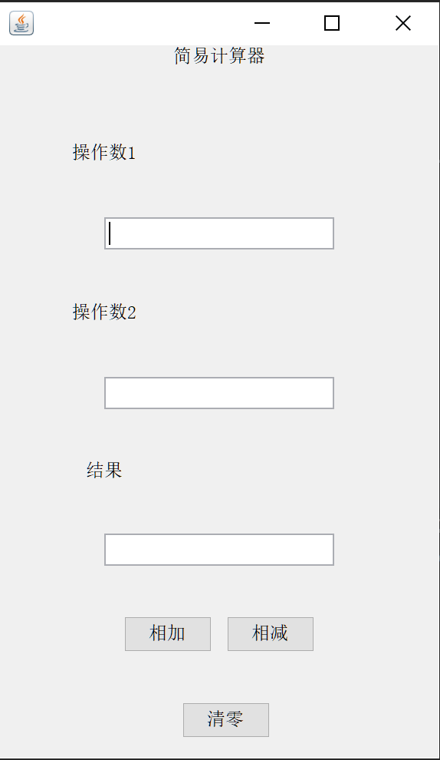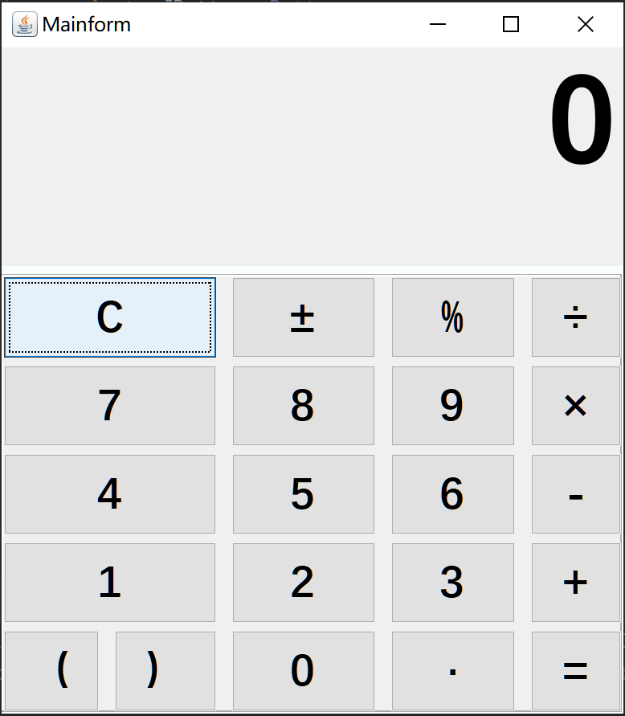

问题与总结
使用代码构建画面可以使程序员较为自由的对自己的界面进行布局但是需要做较多的重复工作且代码量繁杂。
使用图形界面编辑器可以减少大量的画面布局代码，而且可以让布局管理器管理布局和界面缩放，缺点是图形界面编辑器缺少自由度，且对新手不够友好。需要一段时间上手

