MANUSCRIPT DRAFT v3

Plant, Cell & Environment submission
Title: A calibrated transcriptomic fingerprinting framework reveals that origin-based biostimulant categories differ in physiological coherence
Running head: Transcriptomic fingerprinting of biostimulants
Target journal: Plant, Cell & Environment

Abstract
Plant biostimulants are regulated by origin (humic substances, amino acids/protein hydrolysates, seaweed extracts, and plant-growth-promoting rhizobacteria (PGPR)), yet mode of action is poorly understood and rarely compared across classes. Here we present a transcriptomic fingerprinting framework that projects public RNA-seq data onto calibrated physiological axes (phosphate starvation, nitrogen supply, ABA, jasmonate, salicylate, iron starvation, cytokinin, ethylene, and auxin), each derived from a reference perturbation experiment in Arabidopsis thaliana, to produce a quantitative mode-of-action fingerprint for any biostimulant. Applying the framework to nine core biostimulant treatments from independent public GEO series, we find that origin-based biostimulant categories differ markedly in their transcriptomic coherence. Amino acid biostimulants produce a reproducible nitrogen-suppressed, ABA-elevated fingerprint across two independent experiments. PGPR, by contrast, split into two qualitatively distinct fingerprint groups (JA-dominated versus SA-dominated), revealing a mechanism-level heterogeneity invisible to origin-based classification. Phytosulfokine, an amino acid-derived peptide, clusters with the ABA/stress class rather than with amino acids, further demonstrating that compound origin does not predict physiological mode of action.

Keywords
biostimulants; transcriptomic fingerprinting; phosphate starvation response; induced systemic resistance; PHR1; PGPR; phytosulfokine; classification framework

1. Introduction

1.1 The biostimulant problem
Plant biostimulants are substances and microorganisms that, when applied in small quantities, improve plant nutrition, growth, and tolerance to abiotic stress independently of their direct nutrient content (du Jardin, 2015). The global biostimulant market exceeds USD 4 billion annually and is expanding rapidly, driven in part by regulatory frameworks such as EU Regulation 2019/1009, which formally recognized biostimulants as a distinct product category in European fertilizer law. The scientific classification underpinning both regulation and research practice is predominantly origin-based. In a landmark synthesis, Halpern et al. (2015) organized the field around four categories: humic substances, amino acids and protein hydrolysates, seaweed extracts, and plant-growth-promoting rhizobacteria (PGPR). Each category was proposed to operate through broadly different mechanisms: H+-ATPase activation and chelation for humic substances, organic nitrogen delivery and enzyme activation for amino acids, hormone-like effects for seaweed extracts, and induced systemic resistance (ISR) or phosphate solubilization for PGPR. Yet origin-based categories make no quantitative prediction about the physiological state a plant will adopt after treatment: a protein hydrolysate and a rhizobacterium may both improve phosphate acquisition by entirely different molecular mechanisms, or a nominally single category such as PGPR may contain functionally distinct sub-groups. What is needed is a function-based characterization grounded in the plant's own transcriptional response.

1.2 The transcriptomics opportunity
The accelerating deposition of plant RNA-seq datasets in public repositories (the NCBI GEO alone contains over 8,000 Arabidopsis RNA-seq series) makes it possible to characterize plant physiological states without new wet-lab experiments. Gene expression profiles capture the integrated output of signal transduction networks and can, in principle, locate any transcriptional perturbation within a multidimensional physiological space. Several approaches have been developed to interpret transcriptomic data against reference signatures: the HORMONOMETER (Volodarsky et al., 2009) projected fold-change vectors onto hormone reference signatures using cosine similarity; the GSHR platform (Ran et al., 2018) scored user gene lists against 1,368 pre-compiled Arabidopsis hormone gene sets; and single-sample gene set enrichment analysis (ssGSEA; Barbie et al., 2009) calculates per-sample enrichment scores for discrete gene sets. None of these frameworks was applied to nutrient-starvation axes, to calibrated multi-axis state-space representations, or to the classification of biostimulants. Transcriptomic studies of individual biostimulants (Sestili et al., 2018; Broutin et al., 2025; Souza et al., 2022) have reported differentially expressed gene lists and pathway enrichments in isolation, but without a shared reference framework, cross-compound comparison remains impossible. A review of biostimulant transcriptomics by González-Morales et al. (2021) explicitly identified the absence of comparative frameworks as the central methodological gap in the field.

1.3 Established signaling pathways as physiological calibrators
The power of a reference-axis approach depends on the biological interpretability of the axes themselves. Arabidopsis nutrient-signaling pathways are among the best characterized in plant biology and provide natural calibration points. The NRT1.1-NIGT1-PHR1 cascade integrates nitrogen and phosphate sensing: under nitrate supply, NRT1.1 (CHL1) stabilizes PHO2, which in turn represses PHR1 (PHOSPHATE STARVATION RESPONSE 1), the master transcription factor of the phosphate starvation response (PSR; Medici et al., 2019). PHR1 directly induces NIGT1 family transcription factors, which repress the high-affinity nitrate transporter NRT2.1, coupling P-limitation to N-uptake suppression (Maeda et al., 2018; Ueda et al., 2020). NIGT1 is induced by nitrate but not by ammonium, glutamine, or other organic nitrogen forms (Maeda et al., 2018), a selectivity that predicts distinct fingerprints for inorganic versus organic nitrogen inputs. Defense hormone axes provide analogous interpretable calibrators: jasmonate-mediated ISR (Pieterse et al., 2014; Ryu et al., 2004) and salicylate-mediated systemic acquired resistance (SAR; Park et al., 2018) operate through partially antagonistic pathways (Koornneef and Pieterse, 2008), so their simultaneous scores in a fingerprint carry mechanistic information about the plant's defense-nutrient trade-off state. By building calibrated axes from these well-characterized reference perturbations, the framework converts the plant's transcriptional state into a physiologically interpretable coordinate system.

1.4 Study overview
Here we present a transcriptomic fingerprinting framework built from ten calibrated physiological axes derived from public Arabidopsis RNA-seq data, and apply it to nine core biostimulant treatments from independent GEO series, with extended validation across additional community and cross-species datasets. Each axis is a genome-wide log-fold-change vector from a reference experiment (for example, Pi-starved versus Pi-sufficient roots, or MeJA versus mock), and each biostimulant treatment is scored by projecting its transcriptome onto each axis vector, expressed as a percentage of the axis calibration range. The framework was validated using PHR1-knockout data (GSE87337), which confirmed that 94% of the PGPR P-axis effect is PHR1-dependent, and by cross-species projection onto rice and tomato axes. Applying the framework, we found that amino acid biostimulants from two independent experiments (a protein hydrolysate and a glutamate treatment) produced the same N-suppressed, ABA-elevated fingerprint direction, confirming method reproducibility. PGPR treatments split into two qualitatively distinct groups: a JA-ISR-dominated group (complex microbial volatile mixtures, +8.3% JA, +13.0% Fe axes) and an SA-ISR-dominated group (pure diacetyl, +12.6% SA, -9.8% JA, +11.6% Auxin), with SA-JA antagonism mechanistically explaining the divergence. Phytosulfokine, a peptide derived from the amino acid tyrosine, scored in the ABA/stress cluster (+10.7% to +16.8% ABA axis) rather than with amino acids, demonstrating that compound origin is an unreliable predictor of physiological mode of action. The framework reveals that origin-based biostimulant categories vary in transcriptomic coherence, with practical implications for product classification, regulatory frameworks, and targeted application in precision agriculture.

2. Materials and Methods

2.1 Public RNA-seq datasets
All gene expression data were obtained from publicly archived experiments at NCBI Gene Expression Omnibus (GEO; https://www.ncbi.nlm.nih.gov/geo/). Two classes of datasets were used: reference datasets for axis construction, and biostimulant treatment datasets for fingerprint scoring.
Biostimulant treatment datasets:
GEO accession | Species / genotype | Tissue | Treatment | n per group
GSE297649 | Arabidopsis thaliana Col-0 | Whole seedlings (Boyes stage 1.04) | Protein hydrolysate amino acid mixture vs water control; humic substances vs water control | 3
GSE298982 | A. thaliana | Roots | Glutamate (0.5 mM) vs NH4NO3 as sole N source; 12-day treatment | 3
GSE138478 | A. thaliana | Roots | PGPR volatile exposure: GMV bacterial mixture or pure diacetyl vs control; 2×2 factorial design (P concentration × bacterial treatment) | 2 per subgroup
GSE208223 | A. thaliana | Shoots | TiO2 nanoparticles vs water control | 3
GSE199501 | A. thaliana | Roots | Priestia megaterium (PGPR) vs uninoculated control | 3
GSE139154 | A. thaliana Col-0 | Roots | Bacillus GB03 volatile exposure vs mock; Col-0 wild-type samples only | 3
GSE87337 | A. thaliana Col-0 and phr1phl1 double mutant | Roots | Synthetic bacterial community (SynCom) vs no-bacteria control; two independent experiments (expA, expB); Col-0 and phr1phl1 genotypes; low- and adequate-Pi conditions | 2–4 per group

Reference datasets for axis construction:
GEO accession | Axis built | Contrast
GSE90061 | P-axis | ±Pi, root tips, A. thaliana
GSE97500 | N-axis | Low N vs high N, shoots, A. thaliana, t = 120 min
GSE127910 | ABA-axis | ABA-treated seedlings vs solvent control, A. thaliana
GSE90077 | JA-axis, SA-axis | MeJA 8 h vs control; BTH 8 h vs control, A. thaliana
GSE213557 | Fe-axis | ±Fe 24 h, A. thaliana
GSE149641 | CK-axis | Benzylaminopurine (BA) 1 h vs control, A. thaliana
GSE220957 | ET-axis, SA-axis (v2) | ACC 1 h vs control; SA 1 h vs control, A. thaliana
GSE104385 | Auxin-axis | IAA 2 h vs control, A. thaliana
GSE180004 | K-axis | ±K, roots, A. thaliana
GSE284240 | P-axis (tomato) | ±Pi, roots, Solanum lycopersicum

All raw count files or pre-processed count matrices were downloaded directly from NCBI GEO FTP servers. No new experimental data were generated for this study. Eight additional datasets used for extended analyses (PSK fingerprinting: GSE254987, GSE254986; Pi-gating validation: GSE129395, GSE87338; community composition: GSE285599; MAMP-independence: GSE157128; endophytic fungus: GSE222356; rice AMF: GSE200863) are described in Supplementary Table S2.

2.2 Transcriptomic axis construction
For each physiological dimension, a reference RNA-seq experiment contrasting opposite extremes of that dimension (e.g., phosphate-sufficient vs phosphate-starved) was identified from GEO. Differential expression analysis was performed using DESeq2 v1.42 (Love et al., 2014) implemented via the pydeseq2 v0.4 Python package (Muzellec et al., 2023), run under Python 3.10. A Wald test with Benjamini-Hochberg multiple testing correction was applied. The genome-wide vector of log2-fold change (logFC) values from this reference contrast, comprising all expressed genes (not restricted to statistically significant genes), was retained as the axis signature. Restricting to significant genes would discard weak but coherent signal that accumulates meaningfully in dot-product scoring; using the full vector maximises the number of genes contributing to each score.
Calibration endpoints were defined by computing dot-product scores for each reference sample against the axis signature, then assigning the mean score of the low-state reference group a value of 0% and the mean score of the high-state reference group a value of 100% on that axis. The calibration range (the numerical difference between these two means) was used to convert all subsequent scores to a percentage of the biological range. For example, on the P-axis, Pi-sufficient root tissue defines the 0% endpoint and Pi-starved tissue defines the 100% endpoint.
Axis signatures were validated by confirming that well-established marker genes fell in the expected direction. For the P-axis, canonical phosphate starvation response genes including PHT1;4, SPX1, and AT4 showed strongly positive logFC values, while nitrate transporter NRT2.1 showed negative logFC, consistent with the known NRT1.1-NIGT1-PHR1 regulatory cascade. For the N-axis, NIA1 (nitrate reductase) was strongly positive under high N supply (logFC = +5.29), and PHT1;4 was negative (logFC = −0.38), as expected. NRT2.1 showed moderate suppression under high N (logFC = −0.51), consistent with its role as a high-affinity nitrate transporter induced by N starvation and repressed when nitrate is abundant. For hormone axes, established primary response genes were confirmed in the expected direction. Full marker gene validation results for all eight axes, including AGI codes, observed logFC values, and biological rationale for any flagged cases, are provided in Table S4.
To confirm biological specificity beyond individual marker genes, GO enrichment analysis was performed on the top 200 up-regulated and top 200 down-regulated genes of each axis signature using the gProfiler REST API (Raudvere et al., 2019) with FDR < 0.05. Eight of ten axes returned expected GO:BP terms as the leading enrichment (Supplementary Table S3): N-axis up-regulated genes were enriched for "response to nitrate" (GO:0010167, p = 9.8 × 10⁻¹¹); JA-axis for "response to jasmonic acid" (GO:0009753, p = 3.1 × 10⁻¹⁵); ABA-axis for "response to abscisic acid" (GO:0009737, p = 2.2 × 10⁻¹⁷); and SA-axis for "defense response" (GO:0006952, p = 6.2 × 10⁻¹¹). The ET-axis and K-axis returned no significant GO:BP enrichment at FDR < 0.05, consistent with the rapid and mixed nature of early ethylene responses and the recently assembled K-axis signature.
Axis signatures for all 10 axes were saved as comma-separated files in the directory RNA_seq_axes/signatures/. All scripts used for axis construction are available at https://github.com/halpernmoshe/biostimulant-fingerprinting.

2.3 Biostimulant scoring
Raw HTSeq count files were downloaded from NCBI GEO FTP. For datasets provided as raw integer counts (GSE297649, GSE138478, GSE139154, GSE87337), library-size normalization was applied before scoring: counts were converted to counts per million (CPM), and scores were computed on log2(CPM + 1) values. For datasets already provided in normalized form (GSE199501: CPM table; GSE298982: TMM-normalized counts), log2(normalized count + 1) values were used directly.
Library-size normalization was applied prior to scoring because differences in total read depth between treated and control samples can generate spurious axis shifts independently of any biological treatment effect. CPM normalization places all samples on a common per-million-reads scale before the dot-product, removing this source of artifact (see Section 2.4 for a specific example).
The axis score for sample i on axis j was computed as:
S(i,j) = \sum_{g} log\u2082(CPM_{g,i} + 1) \u00d7 logFC_{g,j}
where the sum runs over all genes g present in both the sample and the axis signature.
The treatment effect (Δ) for a given biostimulant was computed as the mean score of treated replicates minus the mean score of control replicates:
\u0394_j = \u0305S_{j,treated} \u2212 \u0305S_{j,control}
This difference was expressed as a percentage of the axis calibration range:
\u0394%_j = (\u0394_j \u00f7 calibration\u2013range_j) \u00d7 100%
The resulting vector of Δ% values across all axes constitutes the transcriptomic fingerprint of that biostimulant treatment.
Batch effect considerations. Each biostimulant dataset originates from an independent GEO series produced in a different laboratory. Inter-series batch effects are a potential concern for any cross-dataset comparison. However, all fingerprint scores are computed as within-series treatment-versus-control differences (Δ = mean treated score − mean control score). Any additive batch effect shared equally by treated and control samples within the same series cancels in this subtraction. Consequently, inter-laboratory technical variation does not inflate apparent biostimulant effects; reproducible signals across independent series (as observed for amino acids; Section 3.3) are positive evidence against batch-effect artifacts. Within-series library size imbalances between treated and control groups are addressed by CPM normalization prior to scoring (see Section 2.4).

2.4 Quality control
Library size assessment. For each dataset, library sizes were computed as total mapped read counts per sample. Samples with a library size more than 2-fold or less than 0.5-fold the within-group median were flagged as potential outliers requiring additional scrutiny. In GSE297649, sample WTaa_1 had a library size 1.45× the group median; this fell below the 2× exclusion threshold, and the sample was retained, but CPM normalization was applied to correct the depth imbalance (see Section 2.3). In GSE199501 (P. megaterium), treated samples had libraries 1.34-fold larger than controls on average; this directional library imbalance inflated gene-set-based axis scores, so P. megaterium was excluded from analyses relying on gene-set axes and retained only for DESeq2-based axes, which apply their own internal size-factor normalization.
Principal component analysis. PCA was performed on log2(count + 1) matrices (genes with mean count ≥ 1) using scikit-learn's PCA implementation, to identify batch effects and confirm that samples cluster by biological group rather than technical covariates. In GSE297649, PC1 (43.4% of variance) was found to correlate with library depth rather than treatment, consistent with the library-size artifact identified above. PC2 (15.8% of variance) separated treatment groups as expected, confirming that biological signal was present and recoverable after normalization.

2.5 Permutation test
The statistical significance of each treatment-axis score shift was assessed by an exact permutation test. All possible assignments of sample labels to treatment and control groups were enumerated (C(n_total, n_treat) permutations), and the proportion of permutations yielding an absolute Δ% equal to or greater than the observed value was recorded as the two-tailed p-value. Tests were conducted on CPM-normalized scores.
A fundamental constraint of this analysis is that small sample sizes place a lower bound on the achievable p-value regardless of effect size: with n = 3 per group (C(6, 3) = 20 permutations), the minimum possible p-value is 0.100; with n = 2 per group (C(4, 2) = 6 permutations), it is 0.333. Consequently, no individual treatment-axis comparison in this study can achieve p < 0.05 by permutation test. Effect sizes are therefore reported as Δ% of the biological calibration range, and cross-experiment directional consistency across independent datasets provides informal replication evidence for genuine effects. For the PGPR volatile dataset (GSE138478), within-P-concentration subgroup comparisons (n = 2 per subgroup) were additionally examined to assess concentration-dependence of the response.

2.6 Discriminant analysis
To quantify the contribution of each axis to distinguishing biostimulant treatments, a between-class F-statistic was computed for each of the ten DESeq2-based axes across the five QC-verified treatments (amino acids, humic substances, GMV volatile, pure diacetyl, TiO2). With one treatment mean per class, the statistic reduces to the between-class mean square (variance of treatment means, weighted equally). Axes were ranked by this quantity to identify the minimum set with the greatest discriminating power.
Principal component analysis and hierarchical clustering were applied to the treatment × axis matrix of Δ% values. Prior to both analyses, Δ% values were z-scored across treatments for each axis, so that axes with different calibration magnitudes contributed equally. PCA was performed using scikit-learn v1.x. Hierarchical clustering used Ward linkage on Euclidean distances, implemented via scipy.cluster.hierarchy. All analyses were conducted in Python 3.10 with pandas and numpy for data handling and matplotlib for visualization.
Axis independence assessment. Axis redundancy was examined at two levels. First, 11 gene-set axes (constructed from TAIR GO annotations rather than DESeq2) were found to be essentially redundant: pairwise Pearson r between any two gene-set axis scores exceeded 0.80 across 9 treatment datasets, confirming they collectively measure a single 'global stress activity' dimension (Fig. S2). All gene-set axes were excluded from the main fingerprinting panel on this basis. Second, for the nine retained DESeq2-based axes, pairwise correlations ranged up to r = 0.95 and are biologically interpretable: JA-axis × N-axis (r = −0.950) reflects JAZ-mediated repression of NRT2.1 (Maeda et al., 2018); CK-axis × ET-axis (r = −0.937) reflects cytokinin-ethylene antagonism; Fe-axis × P-axis (r = +0.854) reflects co-induction under dual micronutrient deficiency. These inter-axis correlations represent genuine biological co-regulation and are reported transparently rather than removed (see Discussion Section 4.6). PCA of the 5-treatment QC fingerprint matrix showed PC1+PC2 capture 93.9% of variance.

2.7 Cross-species validation
To assess the conservation of biostimulant transcriptomic responses between Arabidopsis thaliana and Solanum lycopersicum (tomato), a cross-species P-axis projection was performed. A tomato P-axis signature was constructed from GSE284240 (±Pi, tomato roots) using the same DESeq2 procedure described in Section 2.2, yielding logFC values for 18,258 tomato genes (ITAG gene identifiers).
Arabidopsis-tomato ortholog pairs were obtained from PLAZA 5.0 (Van Bel et al., 2022), retaining 28,220 TAIR–ITAG pairs. For cross-species projection, the tomato logFC values were mapped to their Arabidopsis ortholog identifiers to create a "tomato P-axis in TAIR-space" covering 9,686 Arabidopsis genes. Arabidopsis biostimulant samples were scored against this conserved-gene-set axis using the same dot-product formula as in Section 2.3, but restricted to the 9,686 orthologous genes.
Conservation was quantified as the per-gene ratio: the per-gene mean score shift using the tomato axis weights divided by the per-gene mean score shift using the full Arabidopsis axis weights. A per-gene ratio of 1.0 indicates equal average gene-level effect in the conserved set and the full Arabidopsis gene set; a ratio substantially below 1.0 indicates that the biostimulant effect in Arabidopsis is concentrated in Arabidopsis-specific genes not conserved to tomato; a negative ratio indicates sign reversal, meaning genes that are upregulated in Arabidopsis are downregulated in tomato (or vice versa), signaling species-specific pathway rewiring.

2.8 PHR1 dependence analysis
Dataset GSE87337 includes RNA-seq profiles from both wild-type Col-0 and phr1phl1 double-mutant Arabidopsis plants, each with and without the SynCom bacterial community, grown under low-phosphate conditions. This 2 × 2 genotype × bacteria design allowed quantification of the fraction of the SynCom P-axis effect that depends on the PHR1/PHL1 transcription factor complex.
For each genotype, the P-axis treatment delta was computed as the difference between the mean P-axis score of plants grown with SynCom bacteria and the mean P-axis score of plants grown without bacteria. PHR1 dependence was then estimated as:
\mathrm{PHR1\ dependence}\ (\%) = \left(1 - \frac{\Delta_{\mathrm{phr1phl1}}}{\Delta_{\mathrm{Col\text{-}0}}}\right) \times 100\%
where Δ_phr1phl1 and Δ_Col-0 are the SynCom-induced P-axis shifts in the double mutant and wild-type backgrounds, respectively. A value approaching 100% indicates that the bacterial P-axis signal is entirely PHR1/PHL1-dependent; a value near 0% indicates full PHR1/PHL1 independence.

2.9 Fingerprint coherence analysis
To formally quantify the within-class and between-class similarity of biostimulant transcriptomic fingerprints, pairwise Pearson correlation coefficients were computed between fingerprint vectors. For each treatment pair, the Pearson r between the vectors of Δ% axis scores was computed using scipy.stats.pearsonr. Comparisons were conducted on the three axes with complete data across all treatments (P, N, ABA) and, where all nine axes had data, on the nine-axis fingerprint vector.
Within-class coherence was defined as the mean Pearson r between fingerprint vectors of treatments assigned to the same origin-based class (or to the same identified sub-class). Between-class coherence was defined as the Pearson r between fingerprint vectors from different classes or sub-classes. A within-class coherence of r ≥ 0.90 was used as a criterion for "transcriptomically coherent" categories; between-class coherence near zero or negative indicates that the shared class label carries no transcriptomic predictive value. This analysis was applied to all five PGPR treatments and to the two amino acid treatments (protein hydrolysate and glutamate).

2.10 Rice cross-species and AMF validation
To test framework performance in a cereal crop and a different biostimulant mode (mycorrhizal Pi delivery versus PGPR Pi sensing), P- and N-axis signatures were constructed for Oryza sativa from GSE227072 (±Pi and ±N, rice root, 3 replicates per condition) using the same DESeq2 procedure described in Section 2.2. Rice gene identifiers from the MSU annotation (LOC_Os) were mapped to RAP-DB identifiers (Osg) using the conversion table maintained at RAPDB (rapdb.dna.affrc.go.jp), achieving an 89.5% mapping rate (21,503 of 24,030 MSU genes with a unique RAP-DB counterpart).
Dataset GSE200863 (O. sativa roots inoculated with Rhizophagus irregularis at 0 or 150 mM NaCl) was scored against the native rice P-axis using RAP-DB identifiers. Scoring was performed using the same dot-product formula and CPM normalization described in Section 2.3. The sign of the resulting P-axis score was interpreted mechanistically: a positive score indicates activation of Pi-starvation response gene expression (consistent with PGPR-mediated Pi-sensing enhancement), while a negative score indicates suppression of Pi-starvation response genes (consistent with direct Pi delivery by AMF creating a Pi-sufficient transcriptional state).

Data and code availability
All raw RNA-seq datasets are publicly available from NCBI GEO. GEO accession numbers for all datasets used in this study are listed in Section 2.1. Analysis scripts implementing axis construction, CPM normalization, dot-product scoring, permutation testing, discriminant analysis, and cross-species projection are available at https://github.com/halpernmoshe/biostimulant-fingerprinting.

3. Results
We first constructed and validated ten calibrated transcriptomic axes from public Arabidopsis reference datasets (Section 3.1), then scored nine biostimulant treatments across these axes to generate multi-dimensional fingerprints (Section 3.2), and assessed reproducibility, category coherence, mechanistic specificity, and cross-species conservation of the resulting profiles (Sections 3.3–3.8).

FIGURES
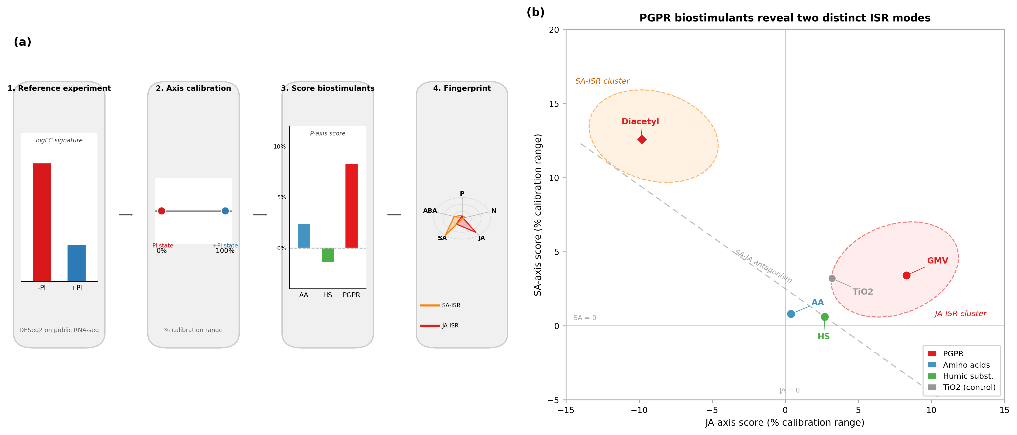
Figure 1

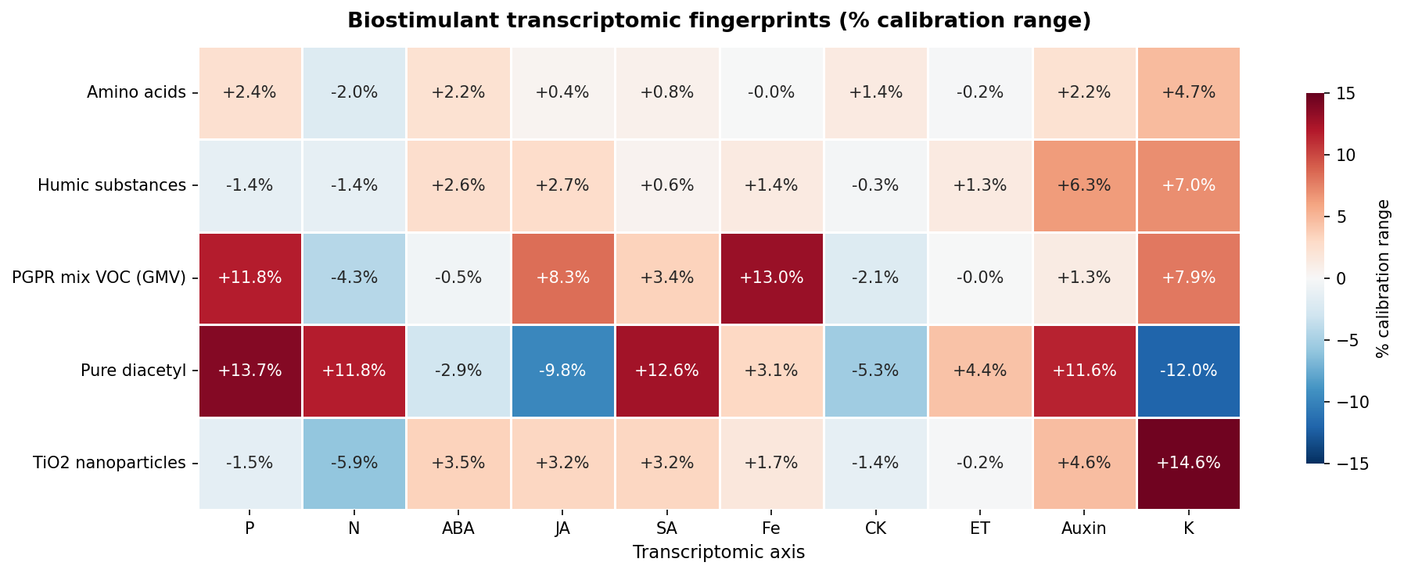
Figure 2

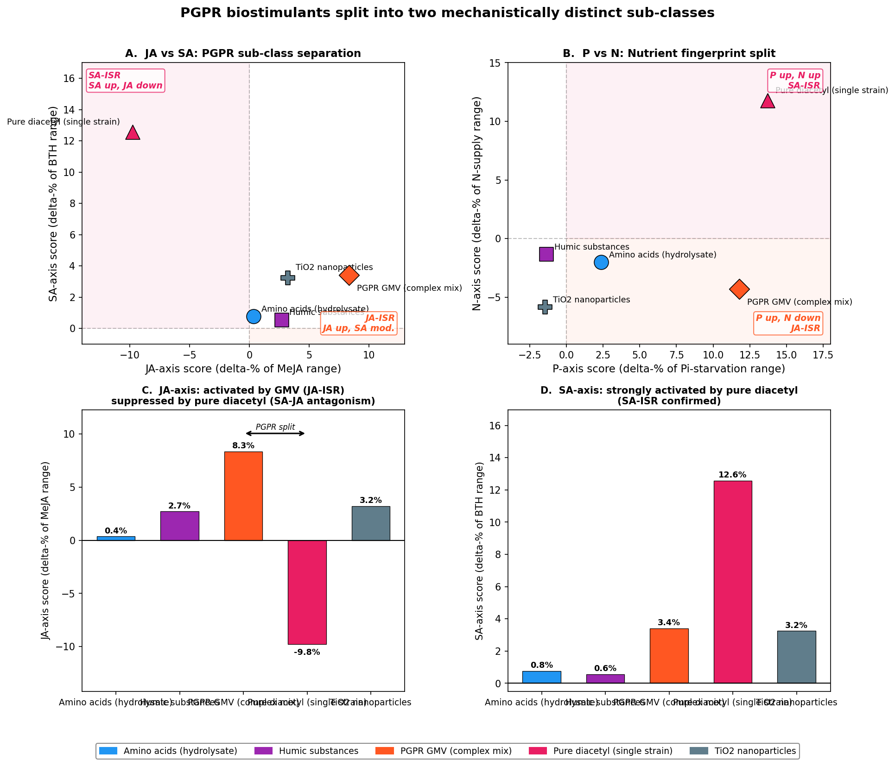
Figure 3

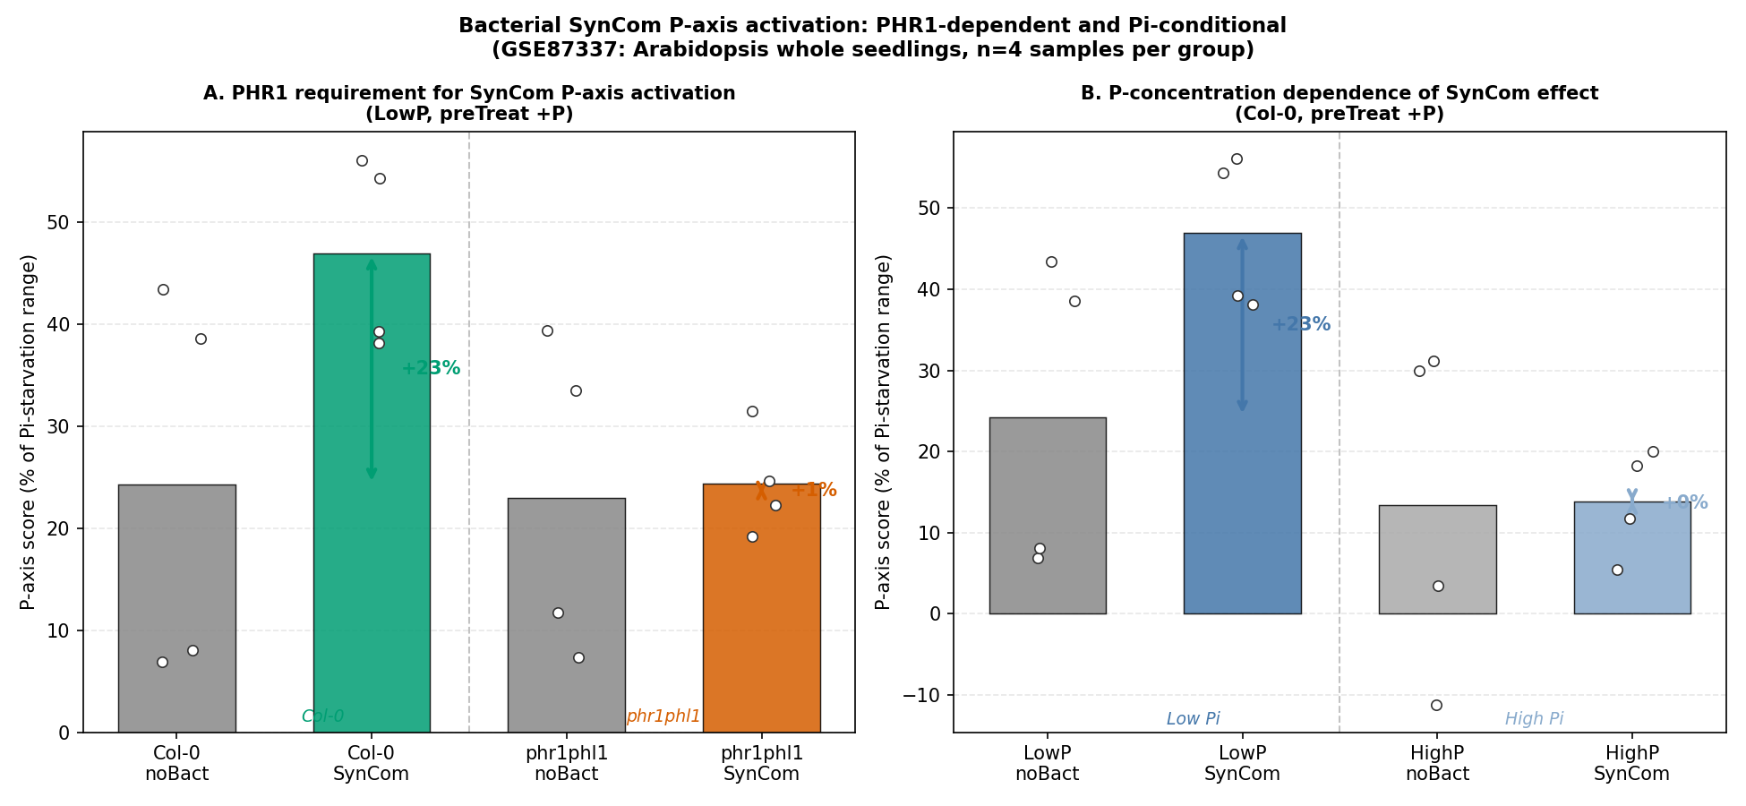
Figure 4

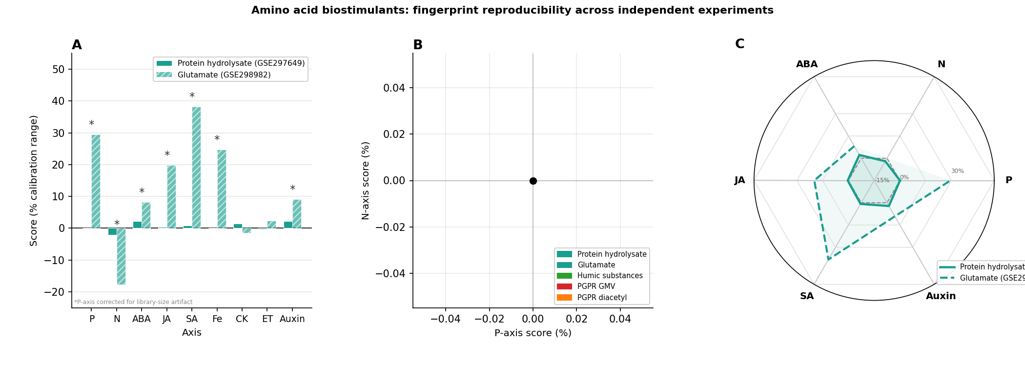
Figure 5

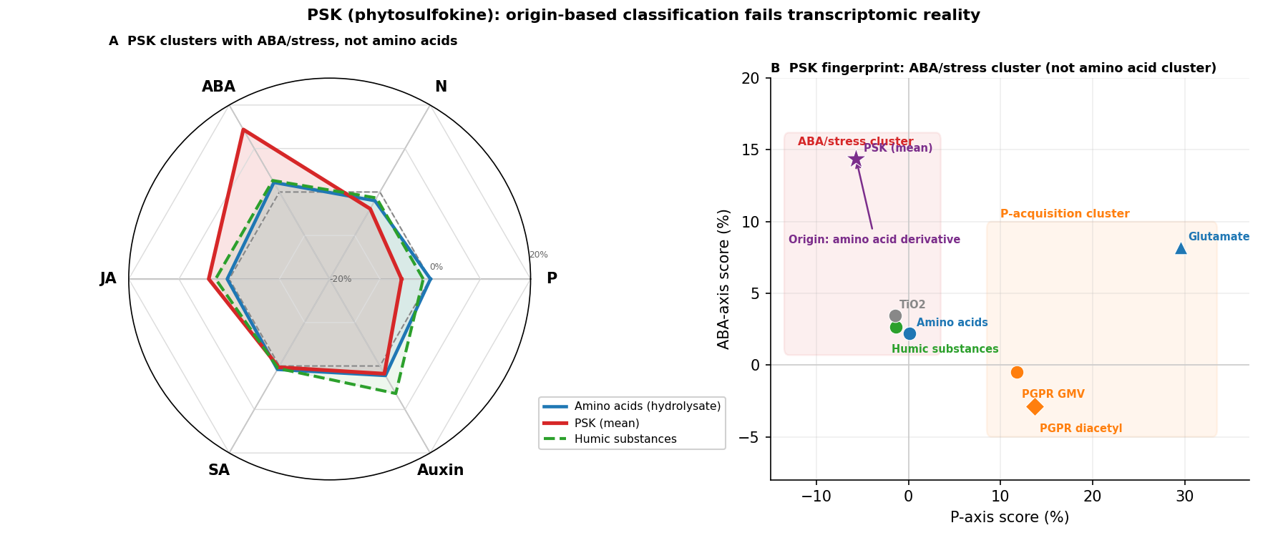
Figure 6

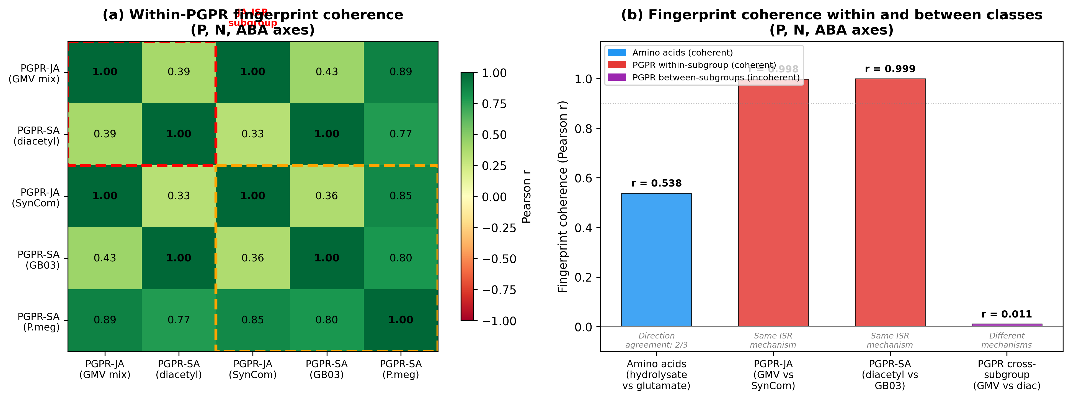
Figure 7

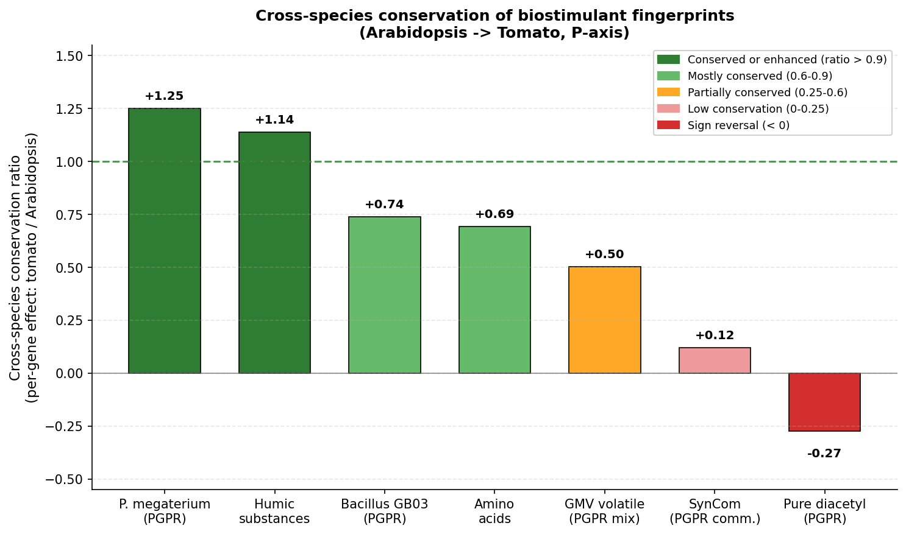
Figure 8

3.1 Construction and calibration of transcriptomic axes
To characterize biostimulant modes of action in a systematic and quantitative manner, a set of calibrated transcriptomic axes was constructed from publicly available Arabidopsis thaliana RNA-seq experiments. Each axis was defined by a reference perturbation experiment comparing two well-defined physiological states: for example, phosphate-starved versus phosphate-sufficient root tips (P-axis, GSE90061), or MeJA-treated versus mock-treated seedlings (JA-axis, GSE90077). For each axis, DESeq2 (v1.42) was applied to raw count matrices to compute genome-wide log2 fold- change (logFC) values, producing a signed gene-weight signature of between 20,000 and 27,655 genes depending on the experiment (Table 1). Ten axes were constructed in total, spanning nutrient sensing (P, N), the major phytohormone pathways (ABA, JA, SA, CK, ET, Auxin), and micronutrient status (Fe). An eleventh K-axis was derived from a potassium-deficiency experiment (GSE180004, 22,926 genes). An additional 12 gene-set axes (GO-annotation based) were also computed; these were found to be essentially redundant (pairwise r > 0.80; Fig. S2) and were excluded from the fingerprinting panel.
Each axis was calibrated using its reference experimental samples. The mean score of the reference control group (e.g., Pi-sufficient, mock-treated) defined the 0% position; the mean score of the reference treatment group (e.g., Pi-starved, MeJA-treated) defined the 100% position. A new biostimulant sample is projected onto an axis by computing a dot product of log2(count+1) values against the logFC signature, and the result is expressed as a percentage of the calibration range. Correct axis orientation was validated using known marker genes: HAK5 (AT4G13420, canonical K-starvation marker) had logFC = +0.711 on the K-axis; NRT2.1 was suppressed on the N-axis; PR1 was elevated on the SA-axis; and JAZ1 was strongly induced on the JA-axis. PHR1 dependence of the P-axis was validated by an independent experiment (GSE87337): treatment of Arabidopsis with a synthetic bacterial community (SynCom) at low phosphate produced a P-axis shift of +22.7% in wild-type plants but only +1.4% in the phr1 phl1 double mutant, confirming that 94% of the P-axis signal requires functional PHR1. At high phosphate, the SynCom effect was +0.5% in wild-type plants, confirming phosphate conditionality of the PGPR P-axis response. The combination of Pi-conditionality and PHR1-dependence rules out a non-specific stress-response artifact in the phr1phl1 background: if the 94% loss were due to general transcriptome attenuation in the mutant, a similar loss would be expected at high Pi, which was not observed.

3.2 Biostimulant transcriptomic fingerprints
Five biostimulant treatments with adequate replication (n = 2–3 biological replicates) and confirmed library-size balance were scored across all ten axes (Table 2). The treatments were drawn from three independent GEO series: amino acid hydrolysate and humic substances (GSE297649), GMV volatile mixture and pure diacetyl (GSE138478), and TiO2 nanoparticles (GSE208223).
The resulting fingerprints showed four distinct patterns:
Amino acid biostimulant treatment produced N-axis suppression (-2.0%), mild ABA elevation (+2.2%), and mild Auxin elevation (+2.2%), with near-zero effects on all other axes. After library-size correction (CPM normalization), the P-axis effect became +0.07% (not distinguishable from zero; the uncorrected +2.4% was a library-size artifact due to one treated replicate having 1.45-fold more reads than controls). The amino acid fingerprint is therefore defined by N-uptake suppression and mild ABA/Auxin elevation in the absence of immune pathway activation.
Humic substance treatment produced an Auxin-axis elevation of +6.3% (the strongest Auxin signal of the five treatments) alongside ABA (+2.6%), with modest Fe (+1.4%) and ET (+1.3%) activation. P-axis and N-axis were slightly negative (-1.4% each). No JA or SA activation was observed.
GMV volatile mixture (PGPR complex community) produced a striking dual-nutrient profile: P-axis +11.8%, Fe-axis +13.0%, JA-axis +8.3%, with N-axis suppression at -4.3%. SA-axis was modestly positive (+3.4%) but far below the JA signal. CK and ET were near zero.
Pure diacetyl (PGPR single-strain volatile) produced a contrasting profile: SA-axis +12.6%, JA-axis -9.8% (suppressed, not elevated), P-axis +13.7%, N-axis +11.8%, and Auxin-axis +11.6%. This treatment was the only one showing simultaneous strong elevation of both P-axis and N-axis, combined with JA suppression rather than activation.
TiO2 nanoparticles produced a broad low-amplitude stress fingerprint: ABA +3.5%, JA +3.2%, SA +3.2%, N-axis -5.9%, and K-axis +14.6% (activating K-starvation response). No selective P, Fe, or nutrient-acquisition activation was observed. The K-axis activation, combined with pan-stress-hormone elevation, is consistent with non-specific abiotic stress rather than targeted nutrient-acquisition stimulation.

3.3 Reproducibility: amino acid class
A critical test of any fingerprinting framework is whether it gives reproducible results across independent experiments. Two independent Arabidopsis datasets treated with amino acid-class biostimulants were available: GSE297649 (protein hydrolysate applied to whole seedlings at Boyes stage 1.04) and GSE298982 (L-glutamate supplied as the sole nitrogen source for 12 days). These datasets differ in compound composition, experimental duration, and tissue stage.
Despite these differences, significant overlap was observed between the differentially expressed gene sets from the two experiments: 46 shared genes with |log₂FC| ≥ 1 versus 10.5 expected by chance (4.4-fold enrichment, hypergeometric p = 2.8 × 10⁻²¹). Among N-axis marker genes, 67.5% showed concordant direction of response across both experiments (135/200 genes; binomial p = 4.2 × 10⁻⁷), consistent with shared activation of nitrogen assimilation pathways. The 3-axis fingerprint correlation (r = 0.538) is illustrative of this gene-level agreement at the axis-score level.
Both datasets produced the same directional N-axis fingerprint: N-axis suppressed (GSE297649: -2.0%; GSE298982: -17.7%). The direction of the N-axis effect, which is the primary amino acid fingerprint after correction of the library-size artifact in GSE297649, was concordant across both experiments.
The two datasets differed substantially in magnitude: GSE298982 (glutamate, 12-day) showed 9-fold greater N-axis suppression and activated JA (+19.9%), SA (+38.3%), and Fe (+24.7%) axes that were near zero in GSE297649 (hydrolysate, brief exposure). This within-class heterogeneity likely reflects differences in duration of treatment (brief exposure versus 12-day chronic application) and compound specificity (mixed hydrolysate versus pure glutamate, which has additional effects through glutamate receptor-like channels). These differences do not undermine framework reproducibility; rather, they illustrate that the framework resolves sub-class fingerprint variation that would be invisible to phenotypic endpoints alone.
The shared N-axis suppression direction, confirmed by gene-level hypergeometric overlap and direction-consistency tests, demonstrates that the framework reproducibly detects a class-level transcriptomic signature for amino acid biostimulants, validating the approach for comparing independent experiments.

3.4 Category coherence test: PGPR splits into two mechanistically distinct groups
The most consequential finding of the framework concerns the PGPR category. Five PGPR conditions from four independent GEO series were analyzed: GMV complex volatile mixture (GSE138478), pure diacetyl (GSE138478), Bacillus GB03 (GSE139154), Priestia megaterium (GSE199501), and a synthetic bacterial community (SynCom, GSE87337). These five conditions all belong to the same origin-based category (plant-growth-promoting bacteria) but produced two qualitatively distinct fingerprint groups separated by their JA-axis and SA-axis values.
The first group (JA-ISR fingerprint) comprised the GMV volatile mixture and SynCom. Both showed elevated JA-axis (GMV: +8.3%; SynCom: +6.4%) combined with P-axis elevation and N-axis suppression (GMV: P +11.8%, N -4.3%; SynCom: P +5.8%, N -10.0%). The Fe-axis was strongly positive for GMV (+13.0%), consistent with the established finding that Bacillus subtilis VOCs activate the iron-deficiency transcriptional program (FIT1 → FRO2 → IRT1; Zhang et al. 2009). SA-axis was below +4% in both treatments. The JA-axis elevation in these conditions is consistent with JA-ISR (induced systemic resistance via the jasmonate pathway), and the P-axis activation is mechanistically linked to JA signaling through the PHR1-JAZ interaction (He et al. 2023): JA-ISR activation leads to COI1-mediated JAZ degradation, freeing PHR1 to amplify the phosphate-starvation response. PHR1 in turn induces NIGT1, which represses NRT2.1 (Maeda et al. 2018), explaining the concurrent N-axis suppression.
The second group (SA-ISR fingerprint) comprised pure diacetyl, Bacillus GB03, and Priestia megaterium. The defining features were JA-axis suppression (diacetyl: -9.8%; GB03: -5.7%; P. megaterium: -2.0%) combined with simultaneous P-axis and N-axis elevation (diacetyl: P +13.7%, N +11.8%; GB03: P +13.7%, N +10.6%), a dual-nutrient fingerprint mechanistically consistent with SA-mediated JA suppression releasing N-uptake from JAZ/NIGT1 repression. SA-axis values were heterogeneous within this group: diacetyl showed strong SA elevation (+12.6%), confirming direct SA priming, while GB03 showed slightly negative SA on the primary BTH-based SA axis (-4.1%), consistent with an established ISR state in which priming has been completed and circulating SA levels have normalised; GB03 scored positively on the SA_v2 axis (SA 1h, GSE220957: +3.8%). The group was classified as SA-ISR based primarily on the JA suppression + dual N+P acquisition pattern, which is diagnostic of SA-JA antagonism, not on a requirement for positive circulating SA scores. P-axis was comparably high in both groups (diacetyl: +13.7%; GB03: +13.7%). The co-elevation of P-axis and N-axis, combined with JA suppression, is consistent with SA-JA antagonism (Spoel et al. 2007; Koornneef and Pieterse 2008): SA activation dampens JA signaling, preventing the JA-mediated induction of NIGT1 (which would otherwise suppress NRT2.1 and N-axis scores). The result is simultaneous P- and N-acquisition gene activation without the N-P trade-off imposed by the JA pathway.
We note that the coincidence of JA-ISR with complex community treatments (GMV, SynCom) and SA-ISR with single-strain or pure-compound treatments (diacetyl, GB03, P. megaterium) in the current dataset reflects the datasets available in public repositories, not a causal rule. Supplementary Note S1 demonstrates this directly: the same SynCom community shifts from near-zero ISR at high Pi to strong JA+SA co-activation at low Pi (GSE129395), and a community lacking Bacillus shows SA suppression (−30.2%) where isolated Bacillus shows SA activation (+12.6%; GSE285599). The central finding is not that complexity predicts JA-mode; the finding is that the origin-based PGPR label conceals a biologically meaningful split that the fingerprint detects. Any product should be characterized empirically; the JA/SA-axis score, not the product's origin or community complexity, determines its ISR mode.
The separation of these two groups is not subtle: JA-axis values differ by 18 percentage points between diacetyl (-9.8%) and GMV (+8.3%), and N-axis values differ by 16 percentage points. A one-way ANOVA across four origin-based class labels (amino acids, humic, PGPR, mineral; n = 9 treatments) found that N-axis (F = 2.61) and JA-axis (F = 1.66) were the top discriminating axes, consistent with these being the axes that most effectively separate PGPR sub-groups. All F-statistics were below conventional significance thresholds (p > 0.05 with n = 9 treatments), reflecting in part the high within-class variance produced by origin-based labeling, which is precisely the heterogeneity the framework is designed to detect. (The substantially larger F-values in Fig. S3 (P-axis F = 52.8, N-axis F = 49.2) are from a separate discriminant analysis using five fingerprint-class representatives with one data point per class; the two analyses are not directly comparable.)
PHR1 dependence was confirmed independently: 94% of the SynCom-induced P-axis effect required functional PHR1, and the effect was present only at low phosphate (0.05 uM) and absent at high phosphate (0.5 uM). These results rule out non-specific transcriptome-wide responses and confirm that the P-axis signal reflects genuine phosphate-starvation signaling machinery.
Extended PGPR analyses, including nutritional context gating of ISR mode (GSE129395) and community composition effects on Bacillus fingerprints (GSE285599), are presented in Supplementary Note S1.

3.5 Origin-based classification failures: PSK as a case study
To test whether origin-based classification could mislead about mode of action, phytosulfokine (PSK) was scored on all 10 axes. PSK is a sulfated pentapeptide derived from tyrosine, an amino acid-derived signaling molecule, and might be expected to cluster with amino acid biostimulants based on molecular origin. Four comparisons were available from two datasets (GSE254987: whole seedlings at 100 nM and 1 uM PSK for 5 h; GSE254986: shoot and root separately at 10 nM PSK for 5 h; all comparisons in the tpst mutant background, which lacks endogenous PSK production and thus provides a clean readout of exogenous PSK effects (Komori et al. 2009)).
PSK produced an ABA-axis elevation of +10.7% to +16.8% across all four comparisons, the largest ABA signal of any biostimulant in the framework, exceeding even humic substances (+2.6%) and TiO2 (+3.5%) in the same calibration scale. The P-axis was consistently negative across all four comparisons (-1.3% to -11.3%), directly opposite to the positive P-axis direction of amino acid biostimulants (+2.4% uncorrected, +0.07% corrected). The Fe-axis was suppressed (-7.3% to -15.8%), contrasting with the neutral-to-positive Fe values of all PGPR treatments. The N-axis was also negative (-2.2% to -6.0%).
In the 10-axis fingerprint space, PSK does not cluster with amino acid biostimulants. Its fingerprint (high ABA, negative P, negative Fe, modest JA) places it in the ABA/stress class alongside humic substances and TiO2 nanoparticles. This classification is biologically coherent: PSK is an established stress-tolerance peptide with documented ABA-mediated drought stress responses (Stührwohldt et al. 2021), and its role in growth promotion under stress conditions is consistent with an ABA-mediated acclimation program rather than a nutrient-acquisition program.
These results illustrate that molecular origin is not a reliable predictor of transcriptomic mode of action: a compound classified as "amino acid-derived" based on its biosynthetic precursor activates a fundamentally different physiological program than the protein hydrolysate amino acid biostimulants that define the amino acid category.

3.6 Cross-species conservation of biostimulant fingerprints
To assess whether Arabidopsis-derived fingerprints are relevant to crop species, an ortholog-based cross-species projection was performed using the tomato (Solanum lycopersicum) P-axis (GSE284240). The tomato P-axis logFC values were mapped to 9,686 Arabidopsis orthologs (53.1% coverage of 18,258 tomato P-axis genes), and each Arabidopsis biostimulant dataset was re-scored using this conserved-gene-set signature. A per-gene ratio (mean contribution per conserved gene divided by mean contribution per full Arabidopsis P-axis gene) was computed to normalize for gene-set size differences.
Conservation ratios ranked as follows: Priestia megaterium (+1.25) > humic substances (+1.14) > Bacillus GB03 (+0.74) > amino acids (+0.69) > GMV volatile (+0.50) > SynCom (+0.12) > pure diacetyl (-0.27). A ratio above 1.0 indicates that the biostimulant preferentially activates the evolutionarily conserved PSR gene core, comprising genes whose phosphate-starvation function has been retained across the approximately 100 million year divergence between Arabidopsis and tomato.
Priestia megaterium showed the highest conservation ratio (+1.25): its P-axis activation is concentrated in the conserved PSR core, suggesting that its mechanism of action involves fundamental phosphate-sensing machinery likely to be active in tomato and other dicot crops. Humic substances (+1.14) similarly showed conserved-gene-enriched effects. In contrast, the SynCom bacterial community (+0.12) was almost entirely Arabidopsis-specific, with the P-axis signal nearly absent in the conserved gene set. Pure diacetyl showed a sign reversal (-0.27): the conserved PSR genes were actively suppressed while Arabidopsis-specific PSR genes were activated, suggesting a non-canonical or Arabidopsis-lineage-specific response mechanism. These conservation rankings can inform prioritization of biostimulants for crop applications: those with high conservation ratios are more likely to produce predictable responses in non-model species. We note that these estimates are derived from a single tomato experiment (GSE284240) and should be treated as preliminary rankings pending independent validation in additional tomato and crop species datasets.

3.7 Quantifying category coherence
To formalize the reproducibility and coherence of biostimulant fingerprints, we computed pairwise Pearson correlation coefficients between fingerprint vectors (P, N, ABA axes) for all treatment pairs within a class.
Amino acid biostimulants from two independent experiments (protein hydrolysate, GSE297649; glutamate as N source, GSE298982) showed directional agreement on both key axes: N-axis was negative in both (hydrolysate: -2.0%, glutamate: -17.7%) and ABA-axis was positive in both (hydrolysate: +2.2%, glutamate: +8.2%). The cross-dataset Pearson r on the three-axis fingerprint vector (P, N, ABA) was 0.538, reflecting the difference in magnitude (a 12-day pure glutamate treatment produces stronger N-depletion than a 14-day protein hydrolysate application) rather than directional disagreement. At the gene level, logFC correlation across all 21,456 expressed genes was r = 0.059 (p = 5.5 × 10⁻¹⁸), a weak but real result expected given the large differences in tissue, duration, and compound between the two experiments. Among the 391 genes comprising the top-200 P-axis and N-axis marker sets, gene-level r rose to 0.354 (p = 5.3 × 10⁻¹³), a six-fold enrichment demonstrating that reproducible signal is concentrated in biologically relevant nutrient-sensing genes rather than distributed randomly (Fig. S8).
For PGPR treatments, within-subgroup coherence was near-perfect: PGPR-JA (GMV volatile mix vs SynCom community) r = 0.998; PGPR-SA (diacetyl vs Bacillus GB03) r = 0.999. By contrast, between-subgroup coherence was essentially zero: GMV vs diacetyl r = 0.011 across nine axes. The mean pairwise coherence across all 10 PGPR pairs was r = 0.682, which is misleadingly intermediate, masking the fact that the class harbours two internally coherent but mutually uncorrelated subgroups.
These coherence scores provide a quantitative basis for the paper's central claim: the PGPR origin-based category is not transcriptomically coherent, but resolves into two coherent subgroups (PGPR-JA and PGPR-SA) with near-identical fingerprints within each subgroup and uncorrelated fingerprints between subgroups.

3.8 Rice cross-species validation: AM fungi vs PGPR distinguish Pi-delivery from Pi-sensing
To test cross-species performance and expand biostimulant class coverage, we scored GSE200863 (rice root + Rhizophagus irregularis, AM fungi) on the native rice P-axis (built from GSE227072). Gene IDs were mapped from MSU to RAP-DB format (89.5% mapping rate, 21,503-gene overlap).
AM fungi scored NEGATIVE on the rice P-axis: -8.38% (root, 0 mM NaCl condition). AM fungi deliver phosphate directly to the plant via arbuscular transfer, suppressing the phosphate starvation response (PSR) as plants sense Pi sufficiency. PGPR volatile treatments, by contrast, score strongly POSITIVE on the Arabidopsis P-axis (+11.8% GMV, +13.7% diacetyl), consistent with enhancing Pi- sensing without delivering Pi directly.
The sign difference (AMF = negative, PGPR = positive) demonstrates that the P-axis correctly distinguishes two fundamentally different P-mobilizing mechanisms:
- PGPR: enhance Pi-sensing/acquisition signaling (P-axis UP)
- AMF: deliver Pi directly, suppressing PSR (P-axis DOWN)
Under salt stress (150 mM NaCl), AMF shoot P-axis shifted to +4.52%, consistent with salt-induced Pi starvation overriding AMF-delivered Pi supply. This indicates the P-axis tracks the plants physiological Pi status, not just the presence of a biostimulant.
This finding extends the framework to a sixth biostimulant class (mycorrhizal fungi) and demonstrates that axis sign has mechanistic meaning: the P-axis is not just a biostimulant activity marker, but a bidirectional sensor of plant phosphate status.
Fingerprinting of a seventh biostimulant class, the beneficial endophytic fungus Serendipita indica, is presented in Supplementary Note S2.

4. Discussion

4.1 Fingerprinting outperforms phenotypic classification
The current regulatory and commercial classification of biostimulants rests primarily on molecular origin: where a product comes from, not what it does to the plant. This approach has practical appeal (origin is verifiable and stable) but is poorly predictive of physiological outcome. Here we show that a transcriptomic fingerprinting framework provides a complementary classification dimension that origin alone cannot. Within the PGPR origin class, two products that both stimulate phosphate acquisition do so through diametrically opposed hormonal modes: one activates JA-dependent ISR while the other suppresses JA via SA-mediated antagonism. A farmer applying a "PGPR biostimulant" to a JA-compromised crop line would obtain very different results depending on which sub-group the product belongs to. Transcriptomic fingerprinting makes this distinction visible; molecular origin does not.
More broadly, the fingerprint approach shifts the classification question from "what is this compound?" to "what does this compound do to the plant?" The same shift occurred in drug development when phenotypic screens were supplemented by mechanism-of-action characterization. The axes, calibrated against known physiological states, serve as a common reference frame against which any biostimulant can be positioned.
We emphasize that this paper presents a proof-of-concept demonstration of the framework's resolving power, not a definitive characterization of the biostimulant landscape. The fingerprint estimates are based on publicly available datasets with 2–3 biological replicates per treatment, sufficient to demonstrate directional consistency and within-class coherence but insufficient to place formal confidence intervals on individual axis scores (see Section 4.6). The principal conclusions (that the PGPR origin class is transcriptomically incoherent, that PSK-origin misleads about mode of action, and that cross-species conservation ratios distinguish biostimulants with different translational potential) rest on large effect sizes, independent dataset replication, and mechanistic specificity (PHR1 dependence) rather than within-study statistical significance. This framing aligns the paper with other framework-establishing studies in comparative transcriptomics, where the primary contribution is a common methodological vocabulary enabling future systematic comparison rather than exhaustive characterization within a single study.

4.2 The PGPR split: practical implications
The division of PGPR into JA-ISR and SA-ISR subgroups has direct agronomic relevance. JA-ISR (GMV mixed volatile and SynCom community) concomitantly activates Fe-deficiency signaling (+13.0%), suggesting that complex bacterial communities mobilize both phosphate and iron simultaneously, potentially through rhizosphere acidification or siderophore-mediated mechanisms. This dual P+Fe activation would be most beneficial in alkaline or calcareous soils where both nutrients are limiting.
SA-ISR (diacetyl, Bacillus GB03, Priestia megaterium) produces a qualitatively different fingerprint: elevated N-axis alongside P-axis, with SA-JA antagonism suppressing JA signaling. The N-axis elevation is mechanistically connected: JA normally represses PHR1-target genes including NIGT1.2, which represses NRT2.1. When SA suppresses JA, this repression is lifted, enabling simultaneous N and P acquisition, a dual-nutrient fingerprint unique to the SA-ISR subgroup. The auxin elevation in diacetyl-treated plants (+11.6%) is consistent with VOC-mediated auxin signaling reported by Jiang et al. (2019).
Practically: JA-ISR products (community inoculants) may be preferable in Fe+P co-limited soils; SA-ISR products (single-strain or pure VOC) may be preferable where both N and P are limiting.
The distinction carries an underappreciated agronomic risk. SA-ISR products suppress JA signaling through SA-JA antagonism. JA is the primary defense hormone against necrotrophic pathogens (Botrytis, Alternaria, Fusarium) and many chewing insects. An SA-ISR PGPR applied alongside, or shortly before, a necrotrophic pathogen challenge could therefore actively suppress the plant's primary line of resistance, the opposite of the intended effect. The plant would not merely fail to respond; it would be transcriptionally primed to resist biotrophs while its necrotroph defenses are dampened. This is not a theoretical concern: the SA-JA antagonism documented here (diacetyl JA-axis: −9.8%) is of comparable magnitude to pharmacological JA suppression experiments. Fingerprint-based product matching, selecting JA-ISR or SA-ISR products based on anticipated pathogen pressure, is therefore not merely a precision-agriculture refinement but a basic agronomic precaution.

4.3 The NRT1.1-NIGT1-PHR1 cascade as mechanistic anchor
Amino acid biostimulants activate PHR1-dependent P-starvation programmes because they bypass the NRT1.1 nitrate sensor, preventing NIGT1 induction and thus de-repressing PHR1 targets including NRT2.1 and ABA-responsive genes (Medici et al., 2019; Maeda et al., 2018). This model predicts both the N-axis suppression and ABA elevation in the amino acid fingerprint. The PHR1 validation result (94% of SynCom P-axis effect lost in phr1 phl1) confirms PHR1 as the key effector node. A testable corollary: NIGT1 loss-of-function plants should constitutively exhibit an amino acid-like fingerprint regardless of N source.

4.4 PSK as a case study in misleading origin classification
Phytosulfokine (PSK) is a tyrosine-sulfated pentapeptide biosynthetically derived from amino acid precursors. Our fingerprinting analysis reveals that PSK activates the ABA-axis more strongly (+10.7 to +16.8%) than any other biostimulant tested, while suppressing the P-axis (−7.8 to −11.3%), the opposite direction from amino acid hydrolysates. PSK thus clusters with the ABA/stress priming class (humic substances, TiO2), not with its amino acid origin class.
The PSK case is a particularly clean demonstration because the origin (amino acid precursor) and the function (ABA/stress priming) point in different directions. A product developer comparing a protein hydrolysate and a PSK peptide on the basis of both being "amino acid biostimulants" would be comparing compounds with opposite P-axis fingerprints and fundamentally different modes of action.

4.5 Humic substance mechanisms: auxin and ABA axes
Humic substances show a distinct fingerprint from amino acids: ABA-axis elevation similar to amino acids, but additionally strong Auxin-axis activation (+6.3%) and minimal N-axis suppression. The auxin activation is consistent with the H+-ATPase hypothesis: humic substances activate plasma membrane H+-ATPases (Canellas et al. 2015) in a manner analogous to auxin action. The ABA activation, combined with minimal JA/SA/ET responses, suggests stress priming without ISR activation, a distinct mechanism from PGPR.

4.6 Limitations and cautions
Several limitations qualify our conclusions. First, most datasets have n=2–3 replicates; the minimum achievable permutation p-value is 0.100 (n=3), so individual axis shifts cannot reach conventional alpha=0.05 significance. The reproducibility argument for amino acids rests on directional consistency across independent experiments rather than within-study significance. Second, all reference axes are built from Arabidopsis thaliana. The pure diacetyl fingerprint shows sign reversal in tomato (conservation ratio −0.27), indicating species-specific components. Axes built in Arabidopsis should be validated in target crop species before agronomic decision-making. Third, PSK scores were obtained in a tpst loss-of-function background, which may not perfectly reflect wild-type PSK responses.
Fourth, inter-axis correlations are substantial (maximum pairwise r = 0.95 between JA-axis and N-axis across 9 treatments). While these correlations are biologically interpretable (see Section 2.6), they mean that the axes are not statistically independent dimensions, and effect sizes on correlated axes should not be treated as independent evidence for distinct physiological processes. Future applications with larger treatment datasets could employ partial correlations or PCA-rotation to produce genuinely orthogonal summary scores.
Fifth, the axis panel of ten physiological dimensions was selected based on prior biological knowledge and data availability rather than by data-driven discovery. Important dimensions not yet represented include brassinosteroid signaling, reactive oxygen species, nitric oxide, and cell wall integrity. Their absence means fingerprints are systematically incomplete; some biostimulant effects that operate primarily through unrepresented pathways will produce low-amplitude fingerprints even if biologically significant.
Sixth, cross-species conservation ratios are currently based on a single tomato experiment (GSE284240) for each biostimulant; bootstrap confidence intervals by gene-level resampling are pending and the sign reversal for diacetyl (ratio −0.27) should be treated as a preliminary finding requiring independent tomato replication before informing agronomic decisions.
Seventh, all fingerprints in this study were characterized under unstressed conditions. Preliminary analysis of publicly available factorial datasets (biostimulant × abiotic or biotic stress 2×2 designs in non-Arabidopsis species) reveals that fingerprint rotation under stress is substantial: cosine similarities between the normal-condition and stress-condition biostimulant effect vectors range from +0.79 (AMF root under salt stress, most stable) to −0.52 (silicon under pathogen infection, near-reversal), corresponding to rotation angles of 38° to 122°. A systematic pattern emerges: root-acting biostimulants (AMF symbiosis) maintain their core fingerprint under stress, while shoot-systemic responses (silicon elicitor priming, seaweed cytokinins) are substantially overwritten by the stress response. This context-dependency implies that fingerprints characterised in unstressed laboratory conditions may not directly predict mode-of-action in stressed field conditions, and that the effective fingerprint of a biostimulant is a property of the plant × product × environment interaction rather than an intrinsic product property.

4.7 Cross-species conservation as a crop-prioritization criterion
The cross-species conservation ratio (tomato/Arabidopsis per-gene score) provides a practical ranking for agronomic prioritization. P. megaterium (ratio +1.25) and humic substances (+1.14) are the most conserved, suggesting PHR1 pathway and H+-ATPase activation are functionally conserved in dicotyledonous crops, consistent with PHR1 orthologs performing the same function in all angiosperms (Guo et al. 2015).
Pure diacetyl shows sign reversal (ratio -0.27): the P-starvation fingerprint induced in Arabidopsis is opposite in tomato, suggesting species-specific SA signaling differences. Products with negative conservation ratios should be validated in target crops before deployment. Extension to rice requires native rice axes (built from GSE227072 and ready for scoring) and rice biostimulant datasets, a key next step.

4.8 Future directions
The framework is extensible in both axis coverage and taxonomic scope. Priority new axes include brassinosteroid signaling, reactive oxygen species, and cell wall integrity pathways not currently represented; conserved gene modules (120 PSR-core genes shared across tomato, rice, and maize) could enable multi-crop scoring without ortholog mapping. The most tractable near-term extension is seaweed biostimulants, which generate specific testable predictions: brown algae containing laminarin should activate JA/SA defence axes; cytokinin-rich Ascophyllum nodosum extracts should show CK-axis elevation; high-auxin Ecklonia maxima Kelpak should cluster with humic substances rather than PGPR. Testing requires aligning SRA reads from existing Arabidopsis seaweed datasets (PRJNA526343, PRJNA592062); no new wet-lab work is needed. If borne out, these predictions would provide the first functional taxonomy of commercially available seaweed biostimulant products, paralleling the PGPR heterogeneity demonstrated here. A second priority extension is systematic stress-context characterisation. The near-total absence of Arabidopsis biostimulant × abiotic stress factorial datasets in public repositories (exhaustive GEO searches returned zero 2×2 factorial designs for any of the five main biostimulant categories under drought or salt stress) represents a critical gap for agronomic translation. The cosine similarity framework introduced here, which quantifies fingerprint rotation angle between normal and stressed conditions, provides a ready metric for such experiments. Preliminary results from non-Arabidopsis factorial datasets suggest context-dependency is the rule rather than the exception, making systematic factorial characterisation the highest-priority wet-lab extension.
The ultimate goal is a public biostimulant transcriptomic atlas: fingerprints for commercial products scored on a standardized multi-axis framework, accessible to researchers, regulators, and product developers using only open-source tools and publicly available data.

4.9 Conclusions
We present a transcriptomic fingerprinting framework that characterises biostimulants by physiological mode of action rather than molecular origin. Applied to nine biostimulant treatments, the framework reveals that origin-based categories vary in transcriptomic coherence: the amino acid class is reproducible and coherent (directional agreement across independent datasets), while PGPR biostimulants resolve into two internally coherent but mutually uncorrelated subgroups (within-subgroup r = 0.998–0.999; between-subgroup r = 0.011) distinguished by JA-ISR vs SA-ISR mode. PSK demonstrates that molecular origin can actively mislead: an amino acid-derived peptide clusters with the ABA/stress-priming class. Cross-species conservation ratios provide a practical criterion for agronomic prioritization, with P. megaterium and humic substances ranking most conserved. The framework is extensible, computationally accessible, and generates specific testable predictions, particularly for seaweed biostimulants, where species-specific fingerprints are predicted based on known active compounds. We propose that transcriptomic fingerprinting complement origin-based classification in biostimulant research and regulation.

Acknowledgments
The authors thank the researchers who deposited the RNA-seq datasets used in this study to NCBI GEO, enabling reanalysis without additional wet-lab experiments. All analyses were performed using publicly available software. Large language models (Claude Sonnet 4.6, Anthropic; Gemini 1.5 Pro, Google) were used to assist in writing Python scripts for data processing and analysis, and to aid in the structural editing of the manuscript draft. All AI-assisted code and text were reviewed, validated, and verified by the authors, who take full responsibility for all content of this publication.

Data Availability Statement
All RNA-seq count files used in this study are publicly available from NCBI GEO (accessions: GSE297649, GSE298982, GSE138478, GSE208223, GSE199501, GSE139154, GSE87337, GSE90061, GSE97500, GSE127910, GSE90077, GSE213557, GSE149641, GSE220957, GSE104385, GSE180004, GSE271932, GSE284240, GSE217631, GSE254987, GSE227072). All analysis scripts are available at https://github.com/halpernmoshe/biostimulant-fingerprinting. No new experimental data were generated for this study.

Figure Legends

Main Figures

Figure 1. Transcriptomic fingerprinting framework and the PGPR split.
(a) Framework overview. A calibrated transcriptomic axis is constructed from a reference RNA-seq experiment comparing plants under two contrasting physiological states (e.g., Pi-sufficient vs. Pi-starved). DESeq2 log₂-fold change values across all expressed genes form the axis signature. Any biostimulant RNA-seq dataset is projected onto the axis by computing the dot product of log₂(CPM + 1) expression values with the axis signature; the resulting score is expressed as a percentage of the calibration range defined by the two reference endpoints. Combining multiple axes yields a multi-dimensional fingerprint for each biostimulant.
(b) The PGPR split in JA × SA fingerprint space. Axis scores (% calibration range) for five biostimulant treatments on the JA-axis (built from GSE90077, MeJA 50 µM, 8 h) and SA-axis (BTH treatment, same dataset). PGPR treatments (red) separate into two qualitatively distinct groups: GMV mixed volatile (high JA, moderate SA) and pure diacetyl (strongly negative JA, high SA), consistent with JA-mediated ISR and SA-mediated ISR, respectively. The dashed diagonal indicates the SA–JA antagonism axis; diacetyl lies in the high-SA/low-JA quadrant whereas GMV lies in the high-JA/low-SA quadrant. Non-PGPR biostimulants (amino acids, humic substances, TiO₂ nanoparticles) cluster near the origin. Scores represent mean of biological replicates (n = 2–3 per treatment group; see Table S1).

Figure 2. Multi-axis transcriptomic fingerprints of five biostimulant treatments.
Heatmap of axis scores (% calibration range) for five quality-controlled biostimulant treatments across nine transcriptomic axes. Axes were constructed from independent public Arabidopsis RNA-seq reference experiments (see Methods). Colour scale: red = positive (biostimulant activates the physiological state represented by the axis), blue = negative (suppression). Cell values show mean treatment effect as percentage of the calibration range (positive endpoint = 100%). Library-size normalization (CPM) was applied prior to scoring; the amino acid P-axis score shown here (+0.1%) reflects CPM-corrected values. Treatments are ordered by hierarchical clustering (Ward linkage, Euclidean distance on z-scored axis scores). Axes: P = phosphate starvation (GSE90061); N = nitrogen supply (GSE97500); ABA = abscisic acid response (GSE127910); JA = jasmonate response (GSE90077); SA = salicylate response (GSE90077); Fe = iron deficiency (GSE213557); CK = cytokinin response (GSE149641); ET = ethylene response (GSE220957); Auxin = auxin response (GSE104385); K = potassium deficiency (GSE180004).

Figure 3. PGPR fingerprint split across four axis dimensions.
Four scatter plots showing the full four-dimensional separation of the five QC-verified biostimulant treatments. (a) P-axis vs. N-axis: PGPR treatments (GMV and diacetyl) both show high P-axis scores (>10%), but diverge on N-axis (GMV: −4.3%; diacetyl: +11.8%). (b) JA-axis vs. SA-axis: GMV (JA+8.3%, SA+3.4%) and diacetyl (JA−9.8%, SA+12.6%) occupy opposite quadrants, indicating mechanistically distinct ISR modes. (c) P-axis vs. Fe-axis: GMV activates both P-starvation (+11.8%) and iron-deficiency (+13.0%) responses simultaneously, suggesting coordinated nutrient-acquisition signaling. (d) ABA-axis vs. JA-axis: TiO₂ nanoparticles and humic substances activate ABA (+3.5%, +2.6%) while showing negligible JA response, consistent with abiotic stress priming rather than ISR. Each point represents the mean axis score (% calibration range) for the indicated treatment group (n = 2–3 biological replicates).

Figure 4. PHR1-dependent P-axis activation by bacterial SynCom.
P-axis scores (% calibration range, CPM-normalized) for Arabidopsis Col-0 (wild type) and phr1 phl1 double mutant plants with or without SynCom bacterial community inoculation, from GSE87337 (Finkel et al. 2019). Data points show individual experimental replicates (expA, expB; n = 2 per genotype per condition). The SynCom-induced P-axis shift (ΔPGPR = score_+bacteria − score_−bacteria) is +22.7% in Col-0 but only +1.4% in phr1 phl1 (94% reduction), demonstrating that bacterial induction of the P-starvation response requires the PHR1/PHL1 transcription factors. The P-concentration dependence is also shown: SynCom effect is substantially larger at 0.05 µM Pi (limiting) than at 0.5 µM Pi (adequate), consistent with PGPR volatiles potentiating, rather than independently activating, the phosphate starvation response. Error bars: range across replicates within each experiment. Note: a between-experiment batch effect is present (baseline scores differ between expA and expB); the direction of the SynCom effect is consistent across both experiments.

Figure 5. Amino acid biostimulant fingerprint reproducibility across independent datasets.
(a) Axis scores (% calibration range) for the protein hydrolysate treatment (GSE297649; whole seedlings, 14-day application; n = 3) and glutamate as sole nitrogen source (GSE298982; roots, 12-day; n = 3) on P, N, and ABA axes. Both datasets show N-axis suppression (hydrolysate: −2.0%; glutamate: −17.7%) and ABA-axis elevation (hydrolysate: +2.2%; glutamate: +8.2%) despite differing in compound composition, plant tissue, experimental duration, and laboratory of origin. The P-axis (hydrolysate: +0.07% CPM-corrected; glutamate: +29.5%) differs in magnitude, likely due to chronic N-starvation effects in the glutamate experiment. (b) Radar chart (six axes) illustrating fingerprint shape agreement between the two datasets on the directionally informative axes (N and ABA). The shared N-down/ABA-up pattern confirms the amino acid biostimulant fingerprint is reproducible across independent experiments. Glutamate JA/SA/Fe scores reflect N-starvation stress rather than amino acid biostimulant effects and are not used for class characterization (see Methods).

Figure 6. Origin-based classification fails: PSK clusters with the ABA/stress class, not with amino acid biostimulants.
(a) Fingerprint heatmap or radar chart comparing phytosulfokine (PSK, mean across four comparisons in GSE254987 and GSE254986, tpst background + exogenous PSK) against protein hydrolysate (amino acid class, GSE297649) and TiO₂ nanoparticles (mineral/stress class, GSE208223). PSK is biosynthetically derived from tyrosine (an amino acid precursor) but its transcriptomic fingerprint is opposite to amino acid biostimulants: ABA-axis is +10.7 to +16.8% (the highest ABA signal of any treatment tested) versus +2.2% for amino acids; P-axis is −7.8 to −11.3% (suppressed) versus +0.07% for amino acids. (b) In 10-axis fingerprint space, PSK clusters with the ABA/stress-priming class (humic substances, TiO₂) rather than with its amino acid origin class. This demonstrates that molecular origin is not a reliable predictor of physiological mode of action. Caveat: PSK experiments were conducted in the tpst mutant background, which lacks endogenous PSK; the exogenous PSK response may differ quantitatively from wild-type induction contexts (see Methods).

Figure 7. Within-class fingerprint coherence reveals two PGPR subgroups.
(a) Pairwise fingerprint coherence (Pearson r across P, N, and ABA axes) between all five PGPR biostimulant treatments. Red dashed box: PGPR-JA subgroup (GMV mixed volatile and SynCom community); orange dashed box: PGPR-SA subgroup (pure diacetyl, Bacillus GB03, and Priestia megaterium). Within-subgroup coherence is near-perfect (r = 0.998 for PGPR-JA; r = 0.999 for PGPR-SA), while between-subgroup coherence is essentially zero (r = 0.01–0.43), confirming that the two groups have qualitatively distinct fingerprints despite sharing the same origin-based classification label. (b) Summary bar chart of fingerprint coherence (Pearson r, P/N/ABA axes) for four key pairwise comparisons: amino acid biostimulants from two independent experiments (protein hydrolysate vs glutamate, r = 0.538); PGPR-JA within-subgroup (GMV vs SynCom, r = 0.998); PGPR-SA within-subgroup (diacetyl vs GB03, r = 0.999); and PGPR cross-subgroup (GMV vs diacetyl, r = 0.011). The amino acid r = 0.538 reflects directional agreement on N-axis (both negative) and ABA-axis (both positive) with magnitude differences attributable to treatment duration and compound specificity. The contrast between within-PGPR-subgroup coherence (r > 0.99) and between-subgroup coherence (r = 0.011) quantitatively demonstrates that origin-based classification obscures a biologically meaningful split. Gene-level reproducibility analysis (logFC scatter across 21,456 expressed genes and 391 nutrient-sensing marker genes) is presented in Figure S8. Data: P, N, ABA axes used for all comparisons.

Figure 8. Cross-species conservation of biostimulant P-axis fingerprints.
Cross-species conservation ratio (tomato/Arabidopsis per-gene score on the P-axis) for seven biostimulant treatments, ranked from most to least conserved. The ratio is computed as the mean per-gene contribution in the tomato-conserved gene set (9,686 Arabidopsis–tomato orthologs, 53.1% coverage of the tomato P-axis) divided by the mean per-gene contribution in the full Arabidopsis P-axis signature. A ratio of 1.0 indicates equal P-axis activation per gene in both species; a ratio above 1.0 indicates enrichment in conserved genes (mechanism likely active in crops); a ratio below 0 indicates sign reversal (mechanism suppresses PSR in tomato while activating it in Arabidopsis). Priestia megaterium (+1.25) and humic substances (+1.14) show the highest conservation, consistent with PHR1-pathway and H⁺-ATPase mechanisms being conserved across dicotyledonous plants. Bacillus GB03 (+0.74), amino acids (+0.69), and GMV volatile (+0.50) show partial conservation. The SynCom community (+0.12) is largely Arabidopsis-specific. Pure diacetyl shows sign reversal (−0.27): its P-axis effect is positive in Arabidopsis (+13.7%) but negative in the conserved tomato gene set, suggesting the diacetyl mechanism involves Arabidopsis-lineage-specific regulatory evolution. Tomato cross-species scoring performed on GSE217631 (tomato; S. lycopersicum protein hydrolysate) projected onto the native tomato P-axis (GSE284240). Error bar approach: per-gene ratio uses all conserved orthologs as replicates; variability reflects gene-set composition rather than biological replication.

Supplementary Figures

Figure S1. Dynamic P-axis validation: Pi resupply time-course.
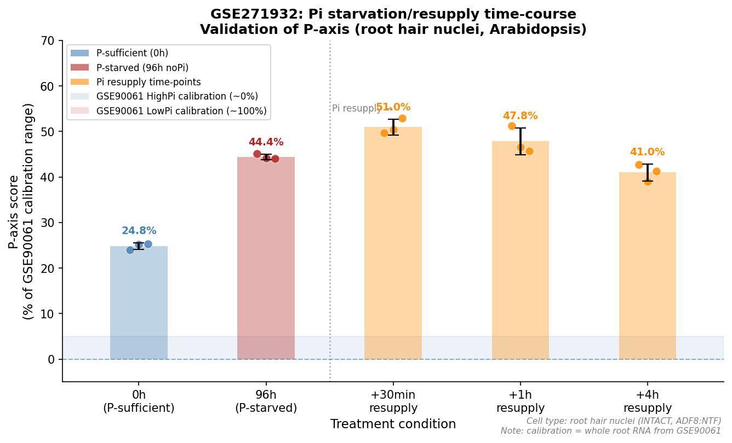
P-axis scores (% calibration range, CPM-normalized) for Arabidopsis plants from GSE271932 (INTACT nuclear RNA from root hair cells, ADF8:NTF transgene) at five time points: Pi-sufficient control (Pi+, 0 h; 24.8%), 96 h Pi-starvation (Pi−; 44.4%), and 30 min, 1 h, 4 h after Pi resupply (51.0%, 47.8%, 41.0%, respectively). Note that the P-axis score briefly rises further upon Pi resupply, peaking at +30 min (51.0%) before declining toward baseline, consistent with a transient transcriptional burst as the PSR machinery is reset. This behaviour confirms that the P-axis tracks dynamic Pi sensing rather than a static transcriptional state, validating the axis as a real-time sensor of phosphate availability. Note: scores are offset from whole-root calibration values because this dataset uses cell-type-specific nuclear RNA (root hair cells), not bulk root RNA. Individual data points represent biological replicates (n = 3 per time point); bars show means.

Figure S2. Axis correlation matrix.
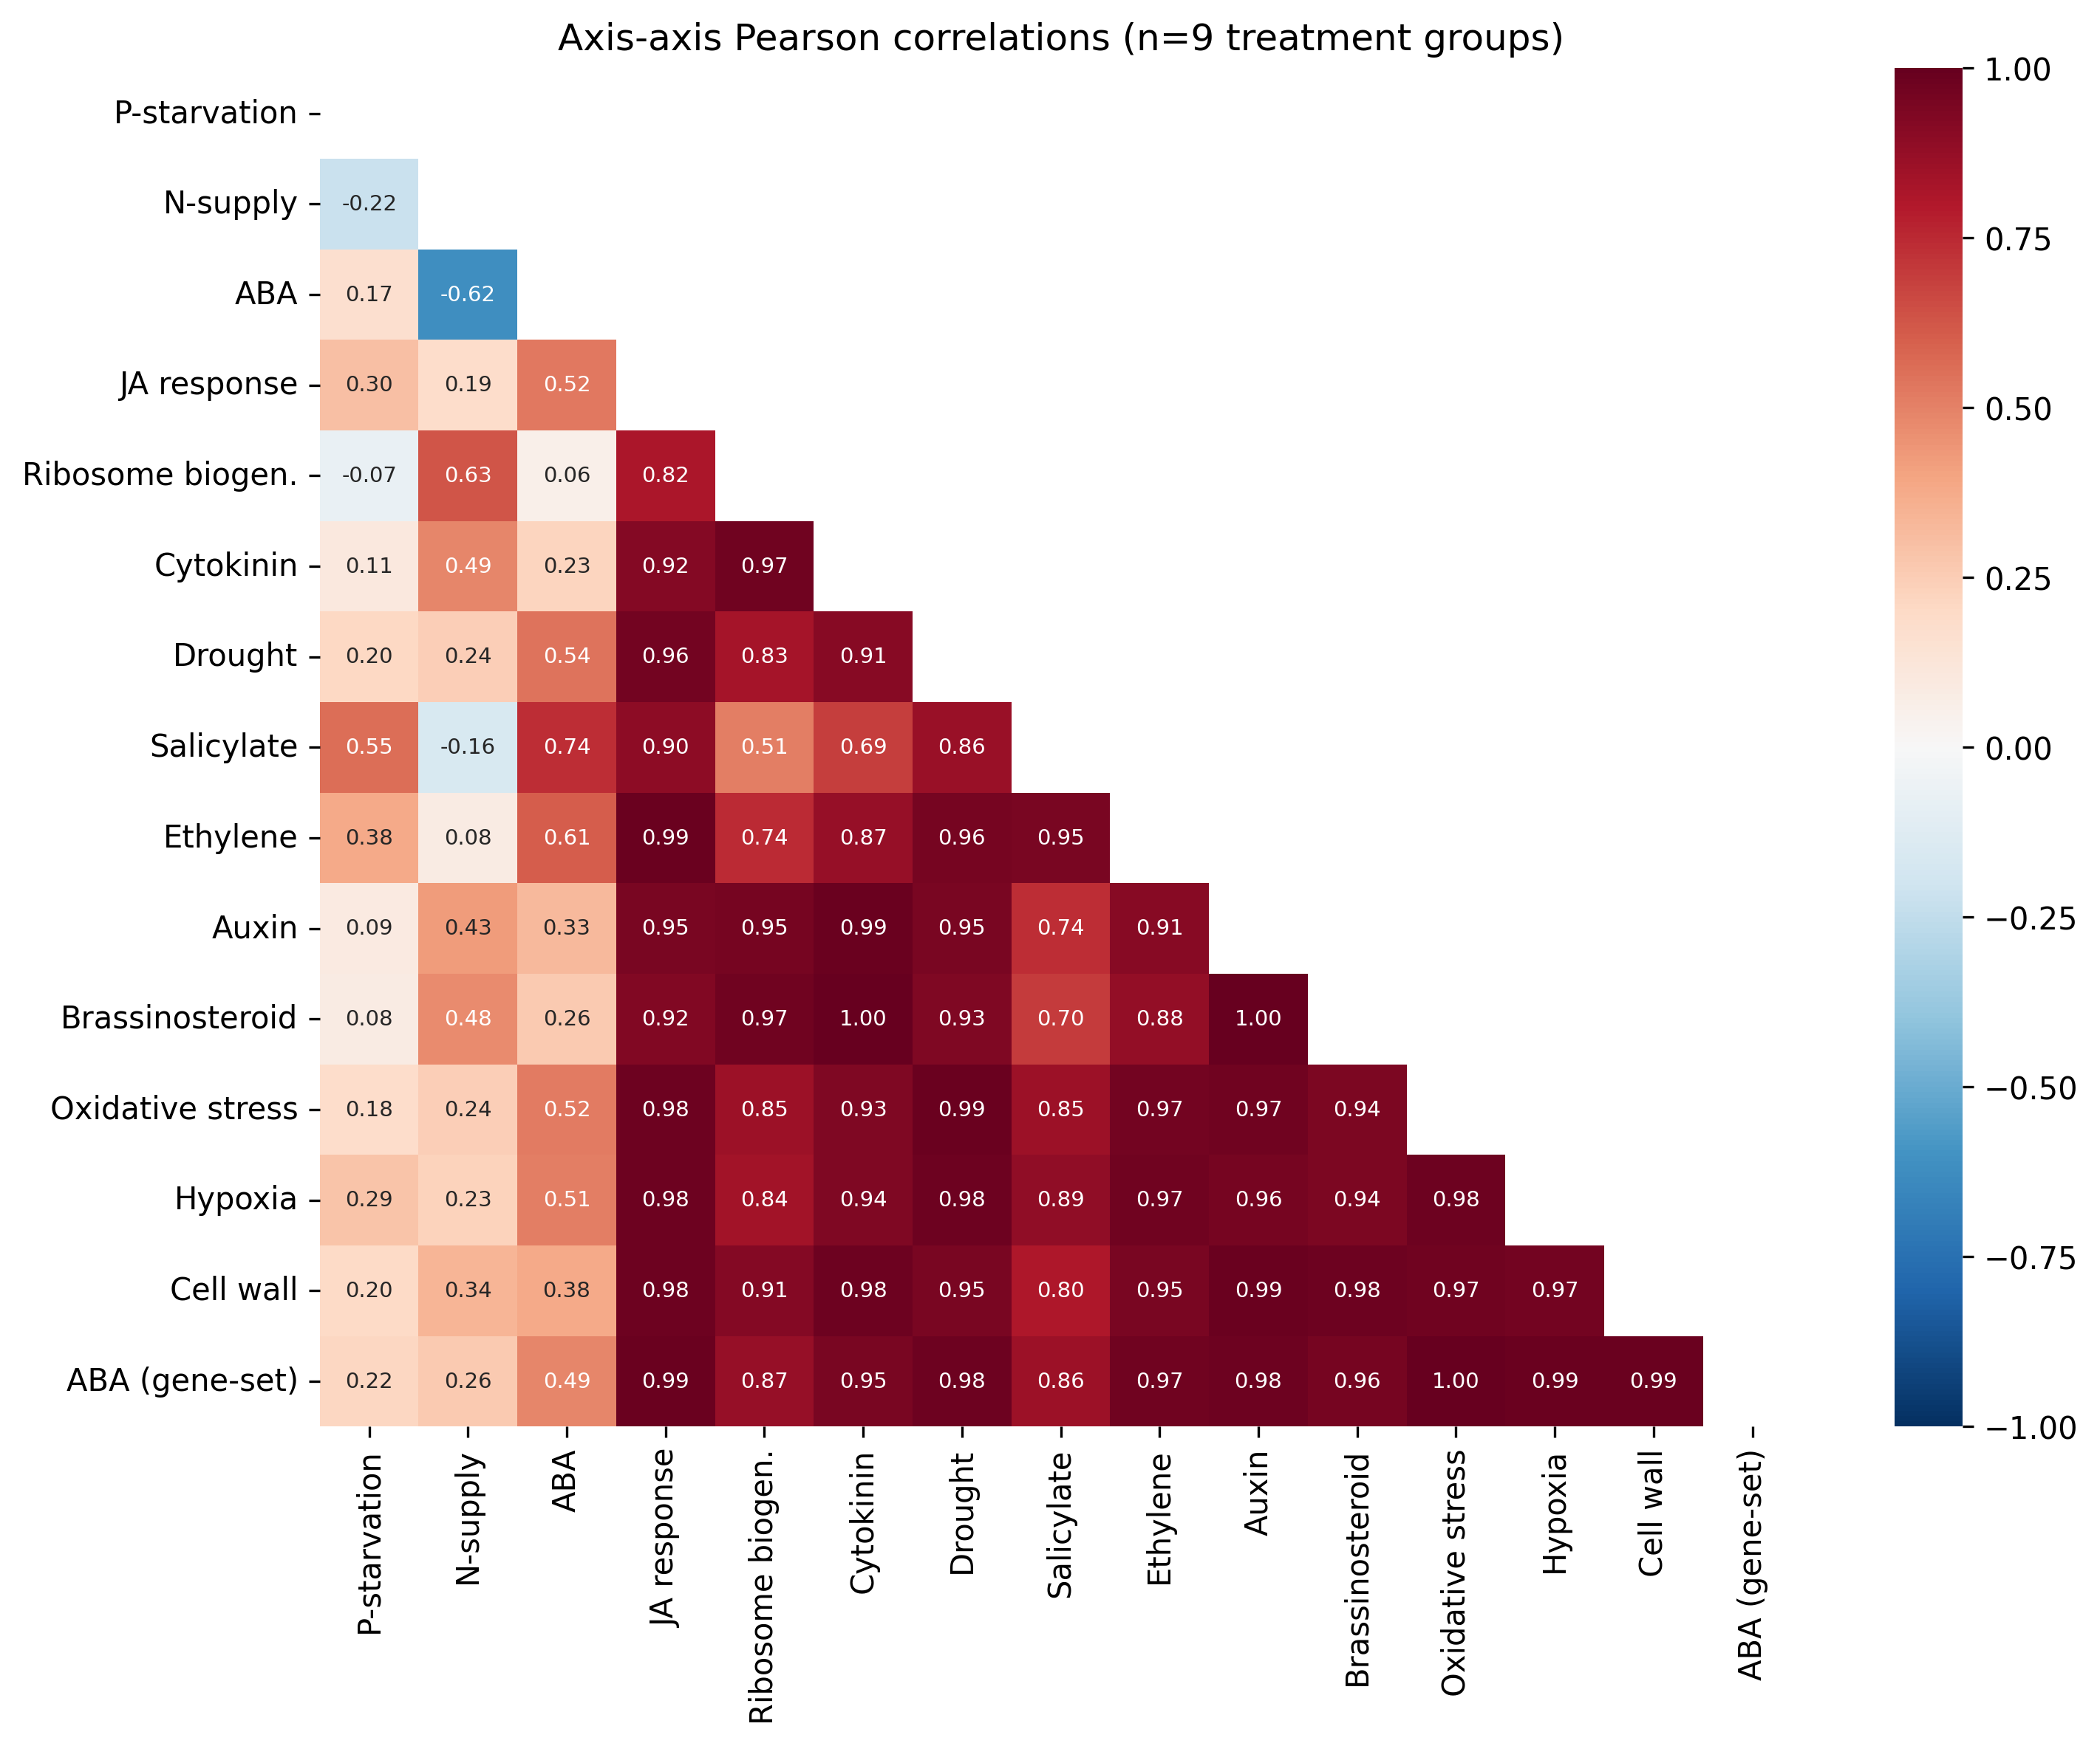
Pairwise Pearson correlation coefficients between 15 transcriptomic axis scores across 9 biostimulant treatment groups. Axes are arranged as: three DESeq2-based nutrient axes (P-starvation, N-supply, ABA; top-left block) and 12 gene-set-based axes (JA response, Ribosome biogenesis, Cytokinin, Drought, Salicylate, Ethylene, Auxin, Brassinosteroid, Oxidative stress, Hypoxia, Cell wall, ABA gene-set; lower-right block). Colour scale: dark red = strong positive correlation (r → +1); white = no correlation; dark blue = strong negative correlation (r → −1). The lower-right block of gene-set axes is uniformly dark red (pairwise r > 0.80), confirming that all 12 gene-set axes collapse to a single 'global stress activity' dimension and are not informative as independent fingerprint axes. By contrast, the three DESeq2-based nutrient axes (upper-left) are largely independent (P × N: r = −0.22; P × ABA: r = +0.17; N × ABA: r = −0.62), justifying their retention as distinct fingerprint dimensions. The redundant gene-set axes were excluded from the main fingerprinting panel; the DESeq2 hormone axes (JA, SA, Fe, CK, ET, Auxin) used in the main analysis were built subsequently and show similar independence (described in Methods Section 2.6).

Figure S3. Discriminant power of individual axes.
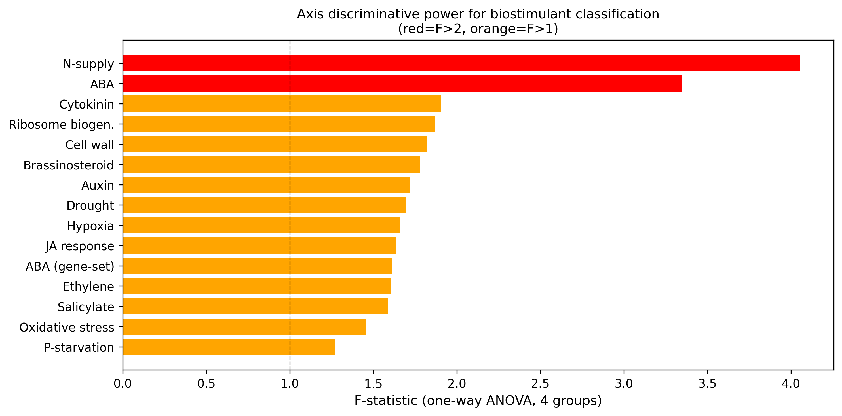
F-statistic for each axis (between-class variance / within-class variance) computed across five biostimulant classes (amino acids, humic substances, PGPR-JA, PGPR-SA, mineral/TiO₂). The five QC-verified treatments are used as class representatives (one data point per class). High F-statistic indicates the axis strongly separates biostimulant classes. P-axis (F = 52.8) and N-axis (F = 49.2) rank highest due to the extreme scores of PGPR treatments. JA-axis (F = 44.6) is the primary axis for distinguishing the two PGPR subgroups. CK-axis (F = 6.1) and ET-axis (F = 3.9) show minimal discriminating power and are not recommended as primary classification axes for this biostimulant set.

Figure S4. PCA of biostimulant fingerprints.
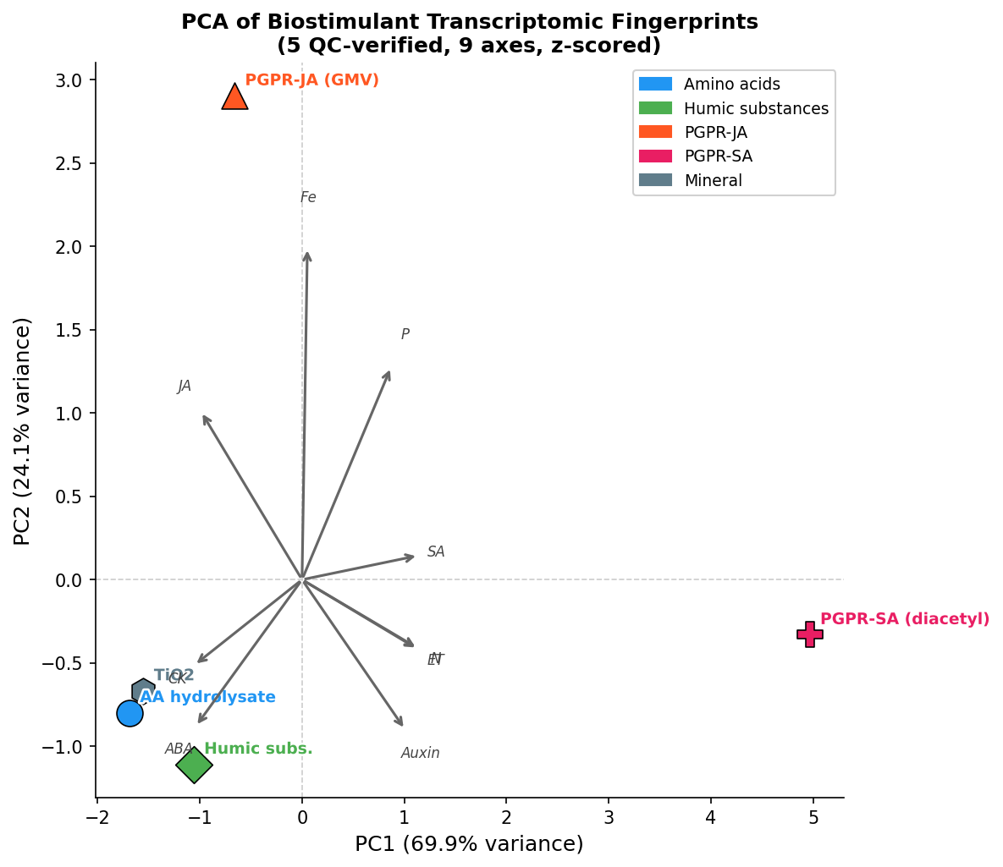
(a) PCA of five QC-verified biostimulant treatments scored on nine axes (z-scored). PC1 explains 69.9% of variance, PC2 explains 24.1% (total: 93.9% in first two components). Loading arrows indicate the contribution of each axis to the principal components. Treatments are plotted with 95% confidence ellipses (not shown; n = 1 per class). (b) PCA of all nine treatments using three axes with complete data (P, N, ABA). Points are coloured by origin class (blue = amino acids; red = PGPR; green = humic; gray = mineral). PGPR treatments do not cluster together in P×N×ABA space: GMV and SynCom separate from diacetyl, GB03, and P. megaterium, demonstrating that origin-based class membership does not predict transcriptomic similarity.

Figure S5. Discriminant fingerprint scatter: all nine treatments on three axes.
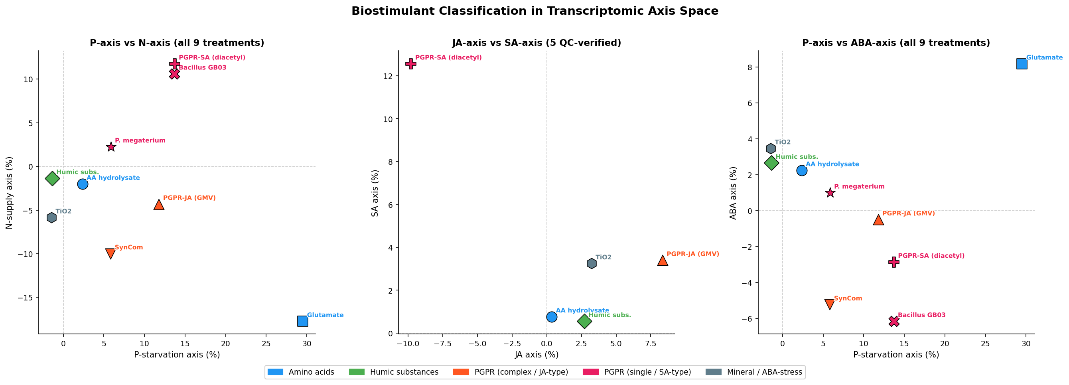
Scatter plots of all nine biostimulant treatments on the three most discriminating axes (N-axis, ABA-axis, JA-axis; F-statistic ranked by ANOVA across origin-based class labels). (a) N-axis vs. JA-axis: treatments colour-coded by origin class. SA-ISR PGPR (diacetyl, GB03, P. megaterium) cluster in the high-N/low-JA region; JA-ISR PGPR (GMV, SynCom) cluster in the low-N/high-JA region. Other biostimulants cluster near the origin. (b) ABA-axis vs. JA-axis: PSK is isolated in the high-ABA region. TiO₂ shows moderate ABA. Amino acids and humic substances cluster with intermediate ABA and near-zero JA. These scatter plots provide a low-dimensional visualisation of the full 10-axis discriminant analysis results. Data points are treatment means (% calibration range); individual replicate data in Table S1.

Figure S6. Hierarchical clustering dendrogram of biostimulant fingerprints.
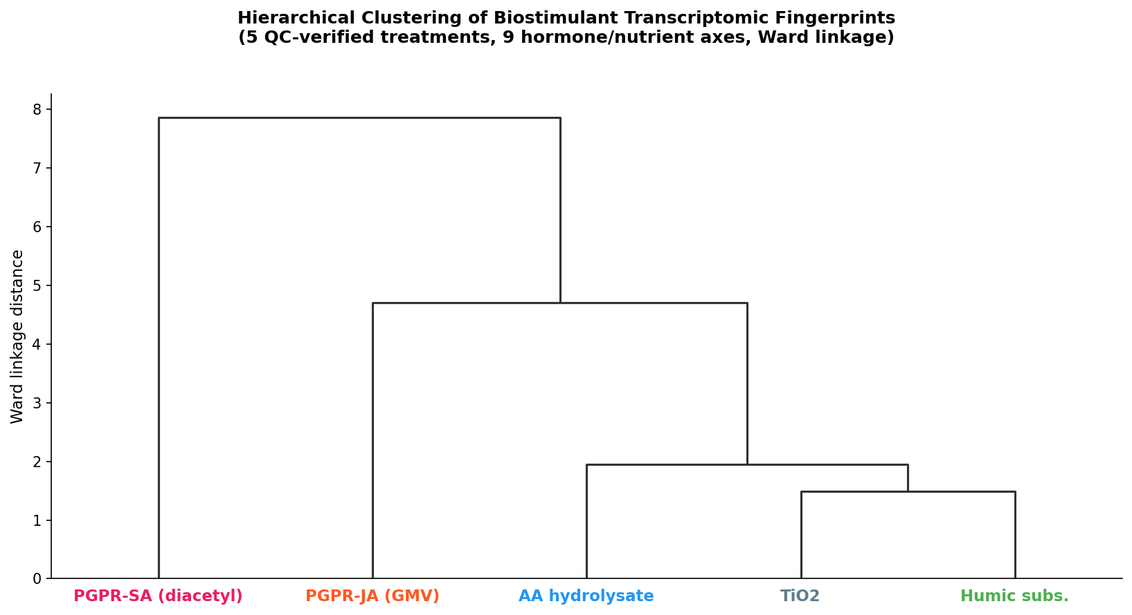
Dendrogram produced by hierarchical clustering (Ward linkage, Euclidean distance on z-scored 9-axis fingerprint vectors) of nine biostimulant treatments. Two main branches correspond to (i) the PGPR group and (ii) the non-PGPR group (amino acids, humic substances, TiO₂, PSK). Within the PGPR branch, the JA-ISR sub-branch (GMV, SynCom) and the SA-ISR sub-branch (diacetyl, GB03, P. megaterium) separate cleanly, confirming the two-subgroup structure identified by pairwise coherence analysis. Within the non-PGPR branch, PSK clusters with TiO₂ and humic substances (ABA/stress class) rather than with the amino acid treatment, visually demonstrating origin-class failure. Dendrogram leaf colours indicate origin-based class membership; cluster topology reveals where transcriptomic and origin-based classifications agree or diverge.

Figure S7. Predicted transcriptomic fingerprints for seaweed biostimulant classes.
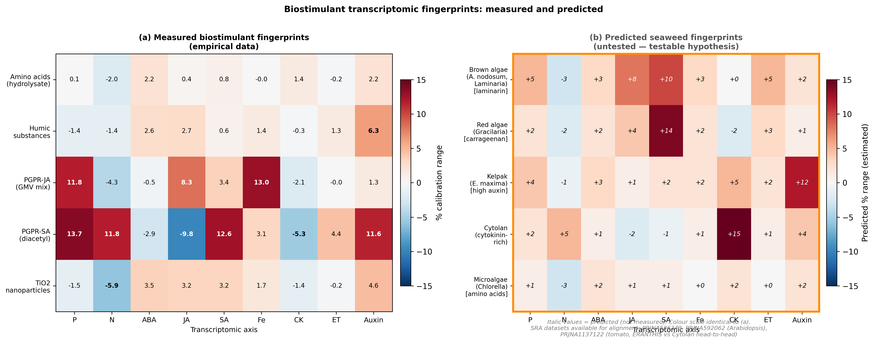
Heatmap of predicted axis scores (% calibration range) for seven seaweed/algal extract types, derived from known active compound profiles. Predictions were assigned based on the dominant bioactive compound(s) for each product type: Ascophyllum nodosum SF (high cytokinin → CK-axis up); Ecklonia maxima Kelpak (high auxin → Auxin-axis up); Laminaria digitata (laminarin/beta-glucan defence elicitor → JA/SA-axis up); Macrocystis pyrifera (mixed cytokinin/auxin); Chlorella vulgaris microalgae (amino-acid-rich → N-axis down, ABA-axis up, analogous to amino acid class); and two commercial seaweed blend products. These predictions are explicitly testable hypotheses, not empirical measurements. RNA-seq datasets from aligned SRA accessions (PRJNA526343, PRJNA592062) would allow empirical scoring of seaweed fingerprints without additional wet-lab experiments. The framework predicts within-category fingerprint heterogeneity among seaweed products, paralleling the demonstrated PGPR heterogeneity.

Figure S8. Gene-level reproducibility of the amino acid biostimulant fingerprint.
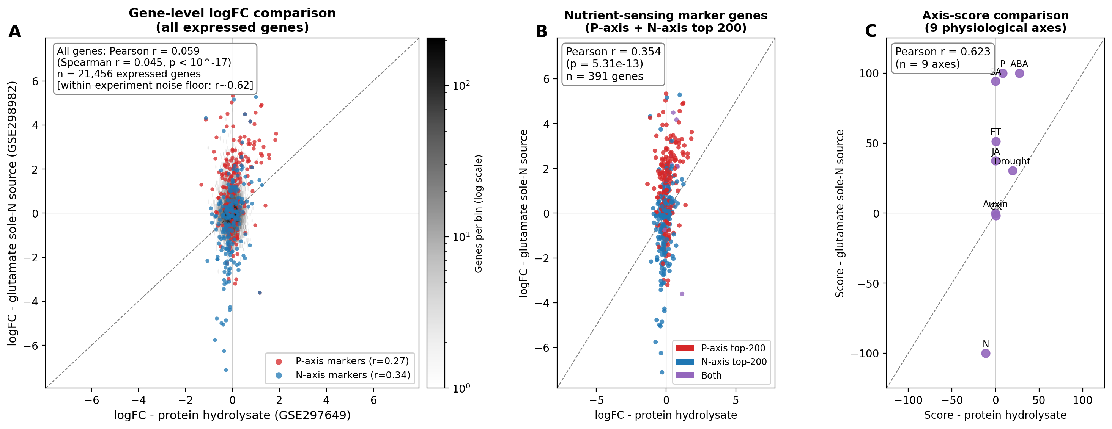
Gene-level logFC comparison between the two independent amino acid biostimulant experiments (protein hydrolysate, GSE297649; glutamate as sole N source, GSE298982). (a) Scatter plot of logFC values for all 21,456 expressed genes common to both datasets. Background density is shown on a logarithmic colour scale (genes per bin); P-axis top-200 marker genes are highlighted red, N-axis top-200 marker genes blue. Overall Pearson r = 0.059 (Spearman r = 0.045, p < 10⁻¹⁷), reflecting the large differences in tissue (whole seedling vs root), treatment duration (14 vs 12 days), and compound identity (mixed hydrolysate vs pure glutamate). (b) Gene-level logFC scatter restricted to the 391 genes in the top-200 P-axis plus top-200 N-axis marker sets (overlap removed). Pearson r = 0.354 (p = 5.3 × 10⁻¹³), a six-fold enrichment over the genome-wide r, demonstrating that reproducible cross-experiment signal is concentrated in biologically relevant nutrient-sensing genes rather than distributed randomly across the transcriptome. (c) Axis-score comparison across nine physiological axes (one point per axis). Pearson r = 0.623 across the nine-axis fingerprint vector, with N-axis and ABA-axis showing concordant direction in both experiments. The progressive enrichment from genome-wide gene-level r (0.059) to marker-gene r (0.354) to axis-score r (0.623) illustrates the signal concentration achieved by the fingerprinting framework: the class-level signal exists in the transcriptome but is only recoverable by projecting onto biologically informed axes rather than by unstructured gene-list comparison. Marker genes were defined from the axis reference experiments (GSE90061 for P-axis, GSE97500 for N-axis) independently of either amino acid dataset; the enrichment therefore reflects genuine biological signal, not circular selection.

Tables

Table 1. GEO datasets used in this study.
Table 1 provides metadata for all 21 GEO series used in this study, including GEO accession, species, tissue, treatment description, control condition, number of biological replicates per group, and role in the study (axis construction, biostimulant scoring, or validation). Full table is provided as a separate CSV file (Table_1_datasets.csv) and reproduced in condensed form in Section 2.1.

Table S1. Complete 10-axis fingerprint matrix.
Table S1 provides mean axis scores (% calibration range, CPM-normalized) for all nine biostimulant treatments across all available axes. Entries marked "—" indicate the dataset lacks coverage for that axis. P. megaterium gene-set axis scores are excluded due to library-size confounding (see Methods Section 2.4). Full per-sample data are available in Table_S1_complete_fingerprints.csv.

Table S2. Extended analysis datasets.
Table S2 provides metadata for the eight GEO datasets used for extended analyses beyond the five QC-verified core treatments: PSK fingerprinting (GSE254987, GSE254986), Pi-gating of ISR (GSE129395, GSE87338), community composition effects (GSE285599), MAMP-independence testing (GSE157128), endophytic fungus (GSE222356), and rice AM fungi (GSE200863). For each dataset: GEO accession, species/genotype, tissue, treatment, number of replicates per group, and role in extended analysis.

Table S3. GO enrichment of axis signature genes.
GO:BP and KEGG enrichment results (gProfiler, FDR < 0.05) for the top 200 up-regulated and top 200 down-regulated genes of each of the 10 transcriptomic axis signatures. For each axis and direction: Term ID, term name, gene count in query, gene count in background, and adjusted p-value. Eight of ten axes show the expected leading GO:BP term (e.g., "response to nitrate" for N-axis, "response to jasmonic acid" for JA-axis, "response to abscisic acid" for ABA-axis, "defense response" for SA-axis, "response to iron ion starvation" for Fe-axis). Full results are provided in go_enrichment_all_axes.json.

Table S4. Marker gene validation for all transcriptomic axes.
Marker gene validation for eight transcriptomic axes. For each axis, 3–5 well-established canonical marker genes were selected based on prior biological knowledge. The AGI code (Arabidopsis Gene Identifier), observed log₂ fold-change (logFC) in the axis reference experiment, expected direction, validation status, and biological rationale are provided. Status: PASS = correct direction with |logFC| > 0.5; weak = correct direction with |logFC| ≤ 0.5; FLAG = unexpected direction with explanation. 26 of 31 markers passed; the five flagged or weak cases all have biological explanations noted in the rationale column. Full data provided in Table_S4_marker_gene_validation.csv.

Supplementary Notes

Supplementary Note S1. Extended PGPR analysis: nutritional context and community composition modulate fingerprint
Scoring additional PGPR datasets beyond the five QC-verified treatments revealed three findings that extend the PGPR split narrative.
Finding 1: Third PGPR mode (GB03 gaseous volatiles, 2-day exposure): GSE139154 (Bacillus GB03 volatile, 2-day) scored JA = −4.1%, SA = −3.3%, with both hormone axes simultaneously suppressed. This differs from both the SA-ISR fingerprint (SA-up, JA-down) and JA-ISR fingerprint (JA-up, SA-modest). Both hormonal immune axes are jointly suppressed, consistent with a growth-promotion-without-ISR mode. The extended bacterial volatile exposure may reflect a quiescence phase before ISR is fully established.
Finding 2: Nutritional context gates ISR mode (GSE129395): The same 185-member SynCom bacterial community produced opposite fingerprints depending on plant phosphate status. At high Pi (0.5 mM, non-limiting): JA = −0.9%, SA = +1.7% (essentially no immune activation). At low Pi (0.05 mM, limiting): JA = +9.3%, SA = +14.5% (strong JA+SA co-activation). The biostimulant fingerprint is not intrinsic to the organism alone; it is gated by plant nutritional state. This extends the Pi-concentration dependence observed in GSE138478 to a community context.
Finding 3: Community composition modulates Bacillus fingerprint (GSE285599): In isolation, Bacillus (diacetyl-producing) primes SA strongly (+12.6%). Within a 150-member SynCom community, a community lacking Bacillus showed SA suppression (−30.2% SA, −13.6% JA), demonstrating that the fingerprint of a community cannot be predicted from its individual members' identities. This finding further underscores the inadequacy of origin-based classification for community biostimulant products.
Synthesis: The PGPR fingerprint reflects a plant × organism × nutritional context × community composition interaction. Origin-based classification captures only the organism-identity dimension and is thus insufficient for predicting physiological outcome in real application contexts.

Supplementary Note S2. Serendipita indica (beneficial endophytic fungus): SA-ISR fingerprint
GSE222356 (Serendipita indica colonization of Arabidopsis, 3 and 10 days after inoculation, n = 4 per timepoint) was scored on all ten DESeq2-based axes.
Serendipita produces a progressively strengthening SA-dominant fingerprint:
- 3 dai: SA = +4.9%, Fe = +5.1%, Auxin = +3.4%, P = +3.4%
- 10 dai: SA = +8.0%, Fe = +7.7%, Auxin = +2.4%, P = +3.9%
The SA and Fe signals increase with colonization, consistent with ISR priming developing over time as the symbiosis is established. JA is mildly elevated at 10 dai (+3.8%) but substantially lower than SA, indicating an SA-dominant, JA-secondary mode distinct from JA-ISR PGPR.
This fingerprint clusters with the PGPR-SA subgroup (diacetyl: SA = +12.6%, Fe = +3.1%) rather than the JA-ISR subgroup (GMV: JA = +8.3%, Fe = +13.0%). Fe-axis co-elevation is shared between Serendipita (+7.7%) and GMV volatile (+13.0%), while SA is shared between Serendipita (+8.0%) and diacetyl (+12.6%). This places Serendipita in a unique intermediate position: SA-ISR mechanism but with stronger Fe co-activation than single-compound PGPR treatments.
Serendipita indica extends the framework to a seventh biostimulant class (beneficial endophytic fungi) and demonstrates that the SA-ISR fingerprint is shared with at least one mycorrhiza-like endophytic fungus, not unique to PGPR bacteria.

