### List of Use Case

###### <Shift Shift Manager> View Customer

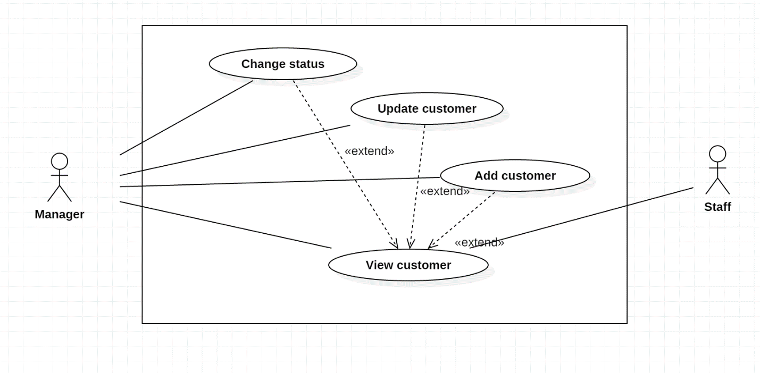Figure1: <Shift Manager> View customer

|  |  |  |  |
| --- | --- | --- | --- |
| USE CASE – IMS001 | | | |
| Use Case No. | IMS001 | **Use Case Version** | 2.0 |
| Use Case Name | View Customer | | |
| Author | Cao Hồng Nam | | |
| Date | 18/01/2016 | **Priority** | medium |
| Actor:   * Shift Manager.   Summary:   * This use case allows Shift Manager and staff to view customer information.   Goal:   * View customers information.   Triggers:   * Shift Manager, Staff clicks on “View customer” link on the panel.   Preconditions:   * Shift Manager and Staff must login into the system with role Shift Manager and Staff.   Post Conditions:   * Success: All data will be saving successfully and show success message   - Fail: System shows error message.  Main Success Scenario:   |  |  |  | | --- | --- | --- | | Step | Actor Action | System Response | | 1 | Shift Manager or Staff clicks on “View customer” link on the panel. | Navigate to View customer information page which contains:   * User name: label * Full name: label * Phone: label * Email: label * Address: label * Sever name: link * Indentification: label |   Alternatives Scenario: N/A.  Exceptions:   |  |  |  | | --- | --- | --- | | No | Actor Action | System Response | | 1 | Connect to database fail | Show message “Error, please try again!” |   Relationships:   * extend to Change Status, Update Customer, Add Customer (Shift Manager clicks View Customer link in View Customer Page)   Business Rules: N/A. | | | |

Table1: Use case IMS001 - <Shift Manager> View customer.

###### <Shift Manager> Add Customer

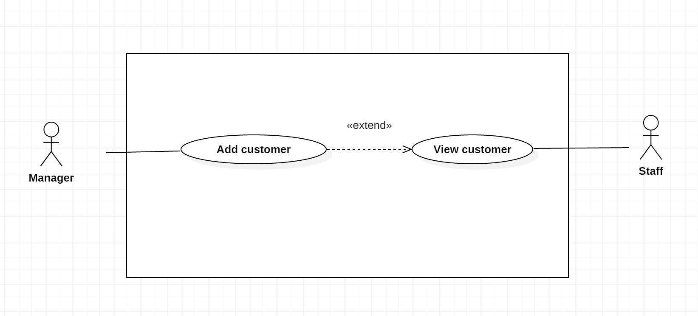*Figure2: <Shift Manager> Add customer*

|  |  |  |  |
| --- | --- | --- | --- |
| USE CASE – IMS002 | | | |
| Use Case No. | IMS002 | **Use Case Version** | 2.0 |
| Use Case Name | Add Customer | | |
| Author | Cao Hồng Nam | | |
| Date | 18/01/2016 | **Priority** | medium |
| Actor:   * Shift Manager.   Summary:   * This use case allows user to add customer information.   Goal:   * Add customer information.   Triggers:   * Shift Manager clicks on “Add customer” link on the panel.   Preconditions:   * Shift Manager must login into the system with role Shift Manager.   Post Conditions:   * Success: All data will be saving successfully and show success message   - Fail: System shows error message.  Main Success Scenario:   |  |  |  | | --- | --- | --- | | Step | Actor Action | System Response | | 1 | Shift Manager goes to add customer view. | System display view with following information:   * User name: free text input, required. * Full name: free text input, required. * Phone: free text input, required. * Email: free text input, required. * Address: free text input, required. * Sever name: free text input, required. * Indentification: free text input, required. | | 2 | Shift Manager fills out the form. | * After Shift Manager finish one field, system will show error message (if need) next to that field. Therefore, Shift Manager knows which field has typed wrong and need to input again. | | 3 | Shift Manager sends add customer command. | * Validate data. * If data valid, system creates new customer. * System shows successful message to Shift Manager. |   Alternatives Scenario:   |  |  |  | | --- | --- | --- | | No | Actor Action | System Response | | 1 | Shift Manager clicks “Clear data” button. | Clear all data input. |   Exceptions:   |  |  |  | | --- | --- | --- | | No | Actor Action | System Response | | 1 | Connect to database fail | Show message “Error, please try again!” |   Relationships:   * extend to View Customer (Shift Manager clicks Add Customer link in View Customer Page)   Business Rules:   * An email address must be validated by this regular expression:   /^([a-z0-9_\.-]+)@([\da-z\.-]+)\.([a-z\.]{2,6})$/   * An email must be unique among staff. No two customer share same email address. * Password must be encrypted before send to server. * Password must be encrypted before save to database. | | | |

Table2: Use case IMS002 - <Shift Manager> Add customer.

###### <Shift Manager> Update customer

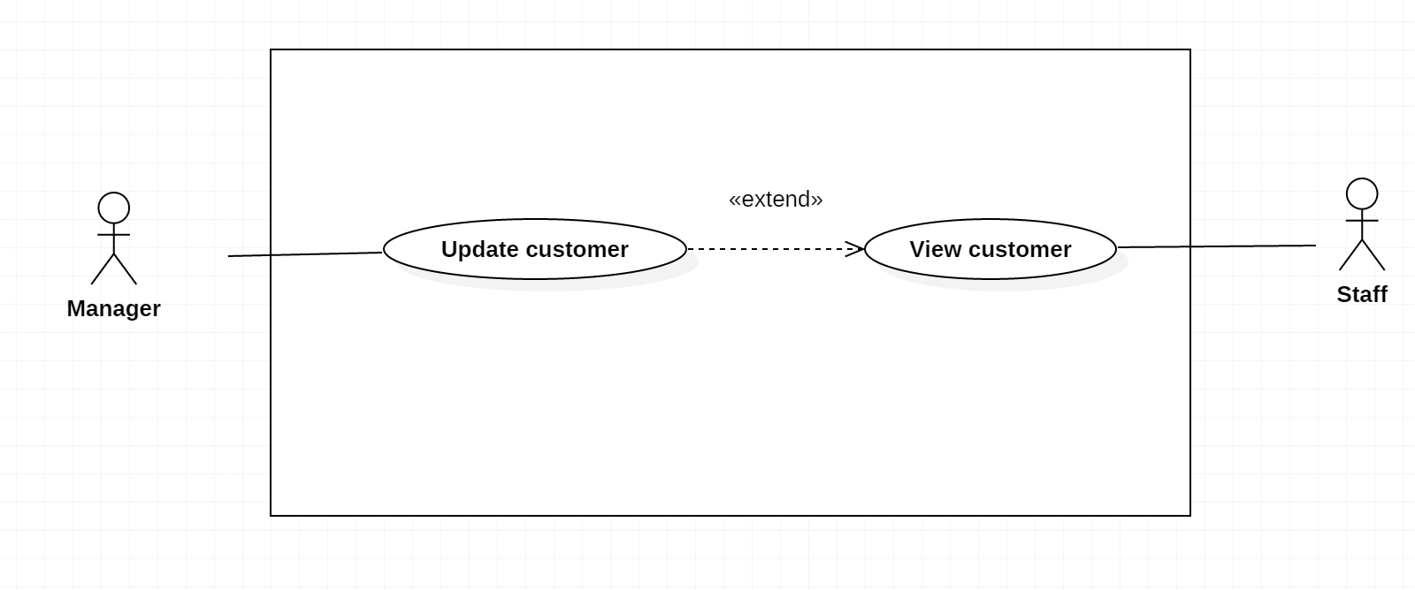*Figure3: <Shift Manager> update customer*

|  |  |  |  |
| --- | --- | --- | --- |
| USE CASE – IMS003 | | | |
| Use Case No. | IMS003 | **Use Case Version** | 2.0 |
| Use Case Name | Update Customer | | |
| Author | Cao Hồng Nam | | |
| Date | 18/01/2016 | **Priority** | medium |
| Actor:   * Shift Manager.   Summary:   * This use case allows Shift Manager to update customer information.   Goal:   * Update customer information.   Triggers:   * Shift Manager clicks on “Update customer” link on the panel.   Preconditions:   * Shift Manager must login into the system with role Shift Manager.   Post Conditions:   * Success: All data will be saving successfully and show success message   - Fail: System shows error message.  Main Success Scenario:   |  |  |  | | --- | --- | --- | | Step | Actor Action | System Response | | 1 | Shift Manager goes to update customer information view. | System display view with following information:   * User name: free text input, required. * Full name: free text input, required. * Phone: free text input, required. * Email: free text input, required. * Address: free text input, required. * Sever name: free text input, required. * Indentification: free text input, required. | | 2 | Shift Manager selects field | This field will be changed to editable mode. | | 3 | Shift Manager inputs value. | After Shift Manager finish one field, system will show error message (if need) next to that field. Therefore, Shift Manager knows which field has typed wrong and need to input again. | | 4 | Shift Manager sends update customer command. | * Validate data. * If data valid, system update new customer information to storage. * System show successful message to Shift Manager. |   Alternatives Scenario:   |  |  |  | | --- | --- | --- | | Step | Cause | System Response | | 1 | Customer cannot be updated. | System will show message that this new staff cannot be updated. |   Exceptions:   |  |  |  | | --- | --- | --- | | No | Actor Action | System Response | | 1 | Connect to database fail | Show message “Error, please try again!” |   Relationships:   * extend to View Customer (Shift Manager clicks Update Customer link in View Customer Page)   Business Rules:   * An email address must be validated by this regular expression:   /^([a-z0-9_\.-]+)@([\da-z\.-]+)\.([a-z\.]{2,6})$/   * Password must be encrypted before send to server. * Password must be encrypted before save to database. | | | |

Table3: Use case IMS003 - <Shift Manager> update customer.

###### <Shift Manager> Change Status

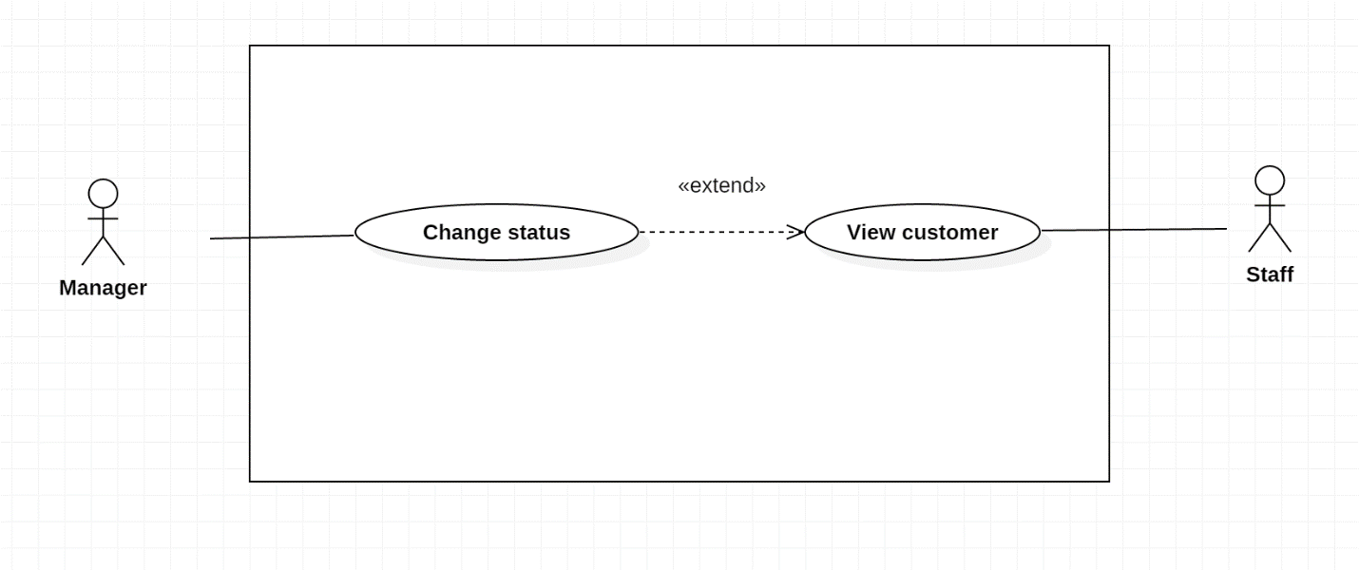*Figure4: <Shift Manager> change status*

|  |  |  |  |
| --- | --- | --- | --- |
| USE CASE – IMS004 | | | |
| Use Case No. | IMS004 | **Use Case Version** | 2.0 |
| Use Case Name | Change status | | |
| Author | Cao Hồng Nam | | |
| Date | 18/01/2016 | **Priority** | medium |
| Actor:   * Shift Manager.   Summary:   * This use case allows Shift Manager to change status for customer information.   Goal:   * Change Status information.   Triggers:   * Shift Manager clicks on “Change status” link on the panel.   Preconditions:   * Shift Manager must login into the system with role Shift Manager.   Post Conditions:   * Success: All data will be saving successfully and show success message   - Fail: System shows error message.  Main Success Scenario:   |  |  |  | | --- | --- | --- | | Step | Actor Action | System Response | | 1 | Shift Manager clicks on “Change status” at each customer in Shift Manager Page. | The system will display the table of customer with column Status which can edit. | | 2 | Shift Manager clicks on “Save” button in Shift Manager Page. | The new status will be saved into database and the new status will be displayed on server table. |   Alternatives Scenario:   * extend to View Customer (Shift Manager clicks Change Status link in View Customer Page)   Exceptions:   |  |  |  | | --- | --- | --- | | No | Actor Action | System Response | | 1 | Connect to database fail | Show message “Error, please try again!” |   Relationships:   * extend to View Customer (Shift Manager clicks Change Status link in View Customer Page)   Business Rules:   * Only Shift Manager can change status for customer (active, deactivate). | | | |

Table4: Use case IMS004 - <Shift Manager> change status.

###### <Shift Manager> View Staff

*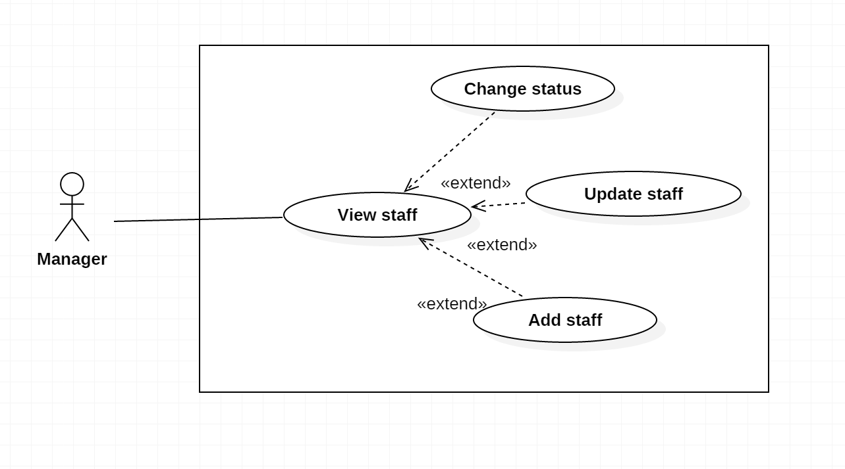Figure5: <Shift Manager> view staff*

|  |  |  |  |
| --- | --- | --- | --- |
| USE CASE – IMS005 | | | |
| Use Case No. | IMS005 | **Use Case Version** | 2.0 |
| Use Case Name | View Staff | | |
| Author | Cao Hồng Nam | | |
| Date | 18/01/2016 | **Priority** | medium |
| Actor:   * Shift Manager.   Summary:   * This use case allows Shift Manager to view staff information.   Goal:   * View staff information.   Triggers:   * Shift Manager clicks on “View staff” link on the panel.   Preconditions:   * Shift Manager must login into the system with role Shift Manager.   Post Conditions:   * Success: All data will be saving successfully and show success message   - Fail: System shows error message.  Main Success Scenario:   |  |  |  | | --- | --- | --- | | Step | Actor Action | System Response | | 1 | Shift Manager clicks on “View Staff” link on the panel. | Navigate to View staff information page which contains:   * User name: label * Full name: label * Phone: label * Email: label * Address: label * Indentification: label |   Alternatives Scenario: N/A.  Exceptions:   |  |  |  | | --- | --- | --- | | No | Actor Action | System Response | | 1 | Connect to database fail | Show message “Error, please try again!” |   Relationships:   * extend to Change Status, Add Staff (Shift Manager clicks View Staff link in View Staff Page)   Business Rules: N/A. | | | |

Table5: Use case IMS005 - <Shift Manager> view staff.

###### <Shift Manager > Add Staff

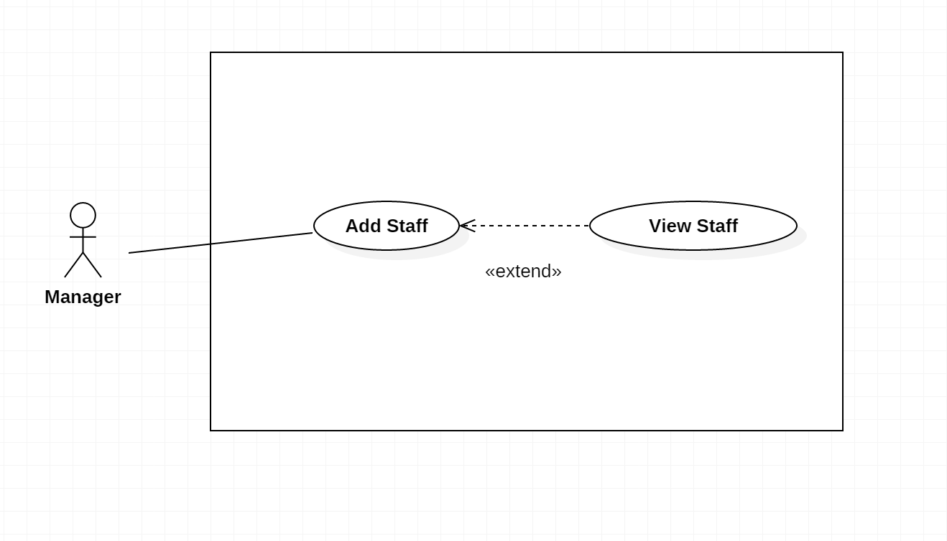

*Figure6: <Shift Manager> add staff*

|  |  |  |  |
| --- | --- | --- | --- |
| USE CASE – IMS006 | | | |
| Use Case No. | IMS006 | **Use Case Version** | 2.0 |
| Use Case Name | Add Staff | | |
| Author | Cao Hồng Nam | | |
| Date | 18/01/2016 | **Priority** | medium |
| Actor:   * Shift Manager.   Summary:   * This use case allows Shift Manager to add staff information.   Goal:   * Add staff information.   Triggers:   * Shift Manager clicks on “Add staff” link on the panel.   Preconditions:   * Shift Manager must login into the system with role Shift Manager.   Post Conditions:   * Success: All data will be saving successfully and show success message   - Fail: System shows error message.  Main Success Scenario:   |  |  |  | | --- | --- | --- | | Step | Actor Action | System Response | | 1 | Shift Manager goes to add staff view. | System display view with following information:   * User name: free text input, required. * Full name: free text input, required. * Phone: free text input, required. * Email: free text input, required. * Address: free text input, required. * Indentification: free text input, required. | | 2 | Shift Manager fills out the form. | * After Shift Manager finish one field, system will show error message (if need) next to that field. Therefore, Shift Manager knows which field has typed wrong and need to input again. | | 3 | Shift Manager sends add staff command. | * Validate data. * If data valid, system creates new staff. * System shows successful message to Shift Manager. |   Alternatives Scenario:   |  |  |  | | --- | --- | --- | | No | Actor Action | System Response | | 1 | Shift Manager clicks “Clear data” button. | Clear all data input. |   Exceptions:   |  |  |  | | --- | --- | --- | | No | Actor Action | System Response | | 1 | Connect to database fail | Show message “Error, please try again!” |   Relationships:   * extend to View Staff (Shift Manager clicks Add Staff link in View Staff Page)   Business Rules:   * An email address must be validated by this regular expression:   /^([a-z0-9_\.-]+)@([\da-z\.-]+)\.([a-z\.]{2,6})$/   * An email must be unique among staff. No two staffs share same email address. * Password must be encrypted before send to server. * Password must be encrypted before save to database. | | | |

Table6: Use case IMS006 - <Shift Manager> add staff.

###### <Shift Manager> Update Staff

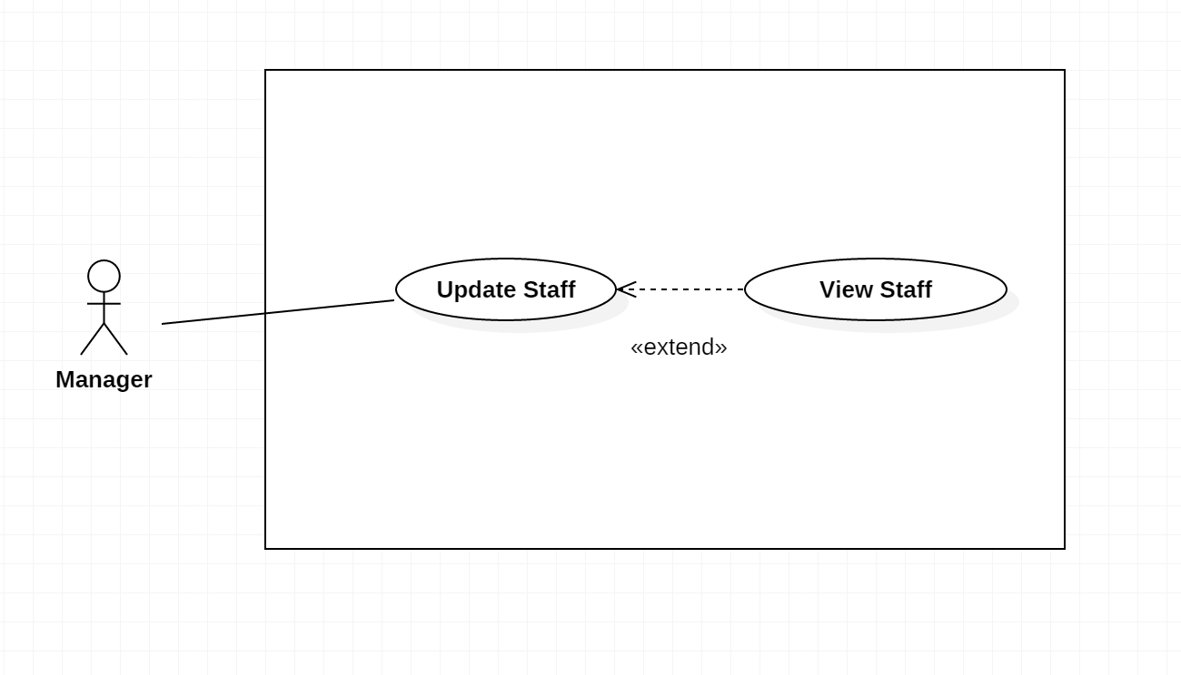

*Figure7: <Shift Manager> update staff*

|  |  |  |  |
| --- | --- | --- | --- |
| USE CASE – IMS007 | | | |
| Use Case No. | IMS007 | **Use Case Version** | 2.0 |
| Use Case Name | Update Staff | | |
| Author | Cao Hồng Nam | | |
| Date | 18/01/2016 | **Priority** | medium |
| Actor:   * Shift Manager.   Summary:   * This use case allows Shift Manager to update staff information.   Goal:   * Update staff information.   Triggers:   * Shift Manager clicks on “Update Staff” link on the panel.   Preconditions:   * Shift Manager must login into the system with role Shift Manager.   Post Conditions:   * Success: All data will be saving successfully and show success message   - Fail: System shows error message.  Main Success Scenario:   |  |  |  | | --- | --- | --- | | Step | Actor Action | System Response | | 1 | Shift Manager goes to update staff information view. | System display view with following information:   * User name: free text input, required. * Full name: free text input, required. * Phone: free text input, required. * Email: free text input, required. * Address: free text input, required. * Indentification: free text input, required. | | 2 | Shift Manager selects field | This field will be changed to editable mode. | | 3 | Shift Manager inputs value. | After Shift Manager finish one field, system will show error message (if need) next to that field. Therefore, Shift Manager knows which field has typed wrong and need to input again. | | 4 | Shift Manager sends update staff command. | * Validate data. * If data valid, system update new customer information to storage. * System show successful message to Shift Manager. |   Alternatives Scenario:   |  |  |  | | --- | --- | --- | | Step | Cause | System Response | | 1 | Customer cannot be updated. | System will show message that this new staff cannot be updated. |   Exceptions:   |  |  |  | | --- | --- | --- | | No | Actor Action | System Response | | 1 | Connect to database fail | Show message “Error, please try again!” |   Relationships:   * extend to View Staff (Shift Manager clicks Update Staff link in View Staff Page).   Business Rules:   * An email address must be validated by this regular expression:   /^([a-z0-9_\.-]+)@([\da-z\.-]+)\.([a-z\.]{2,6})$/   * Password must be encrypted before send to server. * Password must be encrypted before save to database. | | | |

Table7: Use case IMS007 - <Shift Manager> update staff.

###### <Shift Manager> Change Status

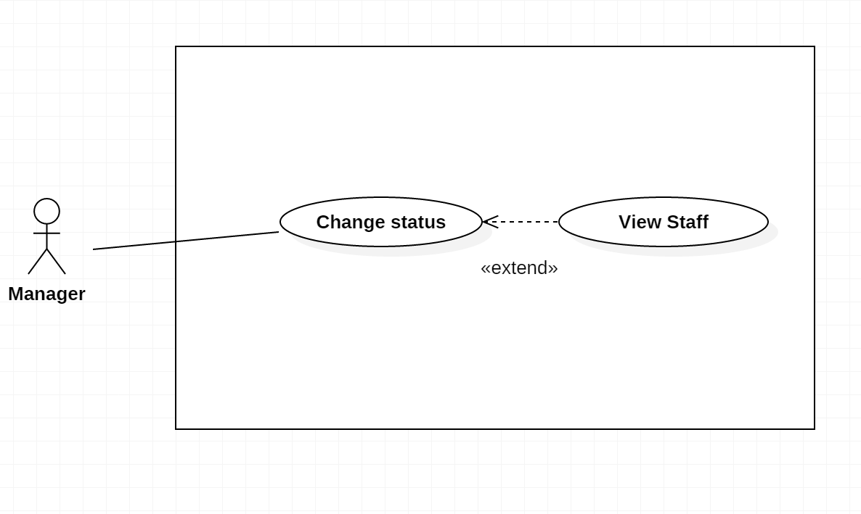*Figure8: <Shift Manager> change status*

|  |  |  |  |
| --- | --- | --- | --- |
| USE CASE – IMS008 | | | |
| Use Case No. | IMS008 | **Use Case Version** | 2.0 |
| Use Case Name | Change status | | |
| Author | Cao Hồng Nam | | |
| Date | 18/01/2016 | **Priority** | medium |
| Actor:   * Shift Manager.   Summary:   * This use case allows Shift Manager to change status for staff.   Goal:   * Change Status information.   Triggers:   * Shift Manager clicks on “Change Status” link on the panel.   Preconditions:   * Shift Manager must login into the system with role Shift Manager.   Post Conditions:   * Success: All data will be saving successfully and show success message   - Fail: System shows error message.  Main Success Scenario:   |  |  |  | | --- | --- | --- | | Step | Actor Action | System Response | | 1 | Shift Manager clicks on “Change status” at each staff in Shift Manager Page. | The system will display the table of staff with column Status which can edit. | | 2 | Shift Manager clicks on “Save” button in Shift Manager Page. | The new status will be saved into database and the new status will be displayed on server table. |   Alternatives Scenario: N/A  Exceptions:   |  |  |  | | --- | --- | --- | | No | Actor Action | System Response | | 1 | Connect to database fail | Show message “Error, please try again!” |   Relationships:   * extend to View Staff (Shift Manager clicks Change Status link in View Staff Page)   Business Rules:   * When checkbox “Internal Notify” is checked, customer can’t see the added announcement. | | | |

Table8: Use case IMS008 - <Shift Manager> change status.

###### < Authenticated user > Login

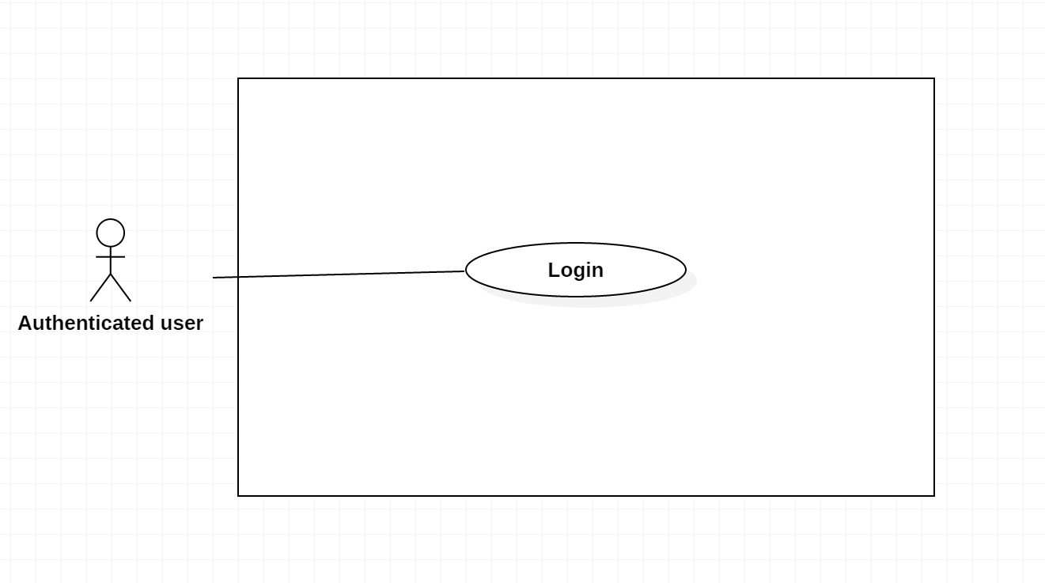*Figure9: <Authenticated user > login*

|  |  |  |  |
| --- | --- | --- | --- |
| USE CASE – IMS009 | | | |
| Use Case No. | IMS009 | **Use Case Version** | 2.0 |
| Use Case Name | Login | | |
| Author | Cao Hồng Nam | | |
| Date | 18/01/2016 | **Priority** | medium |
| Actor:   * Authenticated user.   Summary:   * This use case allows Authenticated user to login.   Goal:   * Login.   Triggers:   * Authenticated user clicks on “Login” link on the panel.   Preconditions:   * Authenticated user must login into the system with role Authenticated user.   Post Conditions:   * Success: All data will be saving successfully and show success message   - Fail: System shows error message.  Main Success Scenario:   |  |  |  | | --- | --- | --- | | Step | Actor Action | System Response | | 1 | Authenticated user goes to login view. | System requires identity information from Authenticated user:   * Authenticated user code: free text input. * Password: free text input. | | 2 | Authenticated user inputs information. |  | | 3 | Authenticated user sends login command to system. | If Authenticated user login successfully, Authenticated user will login system with login account role.  If login fail, system show error message “Invalid username or password”. |   Alternative Scenario: N/A  Exceptions:   |  |  |  | | --- | --- | --- | | No | Actor Action | System Response | | 1 | Connect to database fail | Show message “Error, please try again!” |   Relationships: N/A.  Business Rules:   * Password field displayed “*”. * Encrypt password before being send to server. * After Authenticated user login to system successfully, Authenticated user will have redirected to specified view based on their role on the system: staff or admin. * If role is “Shift Manager”, the system will display to Shift Manager view.   If role is “Staff”, the system will display to Staff Dashboard view | | | |

Table9: Use case IMS009 - <Authenticated> login.

###### < Authenticated user> Logout

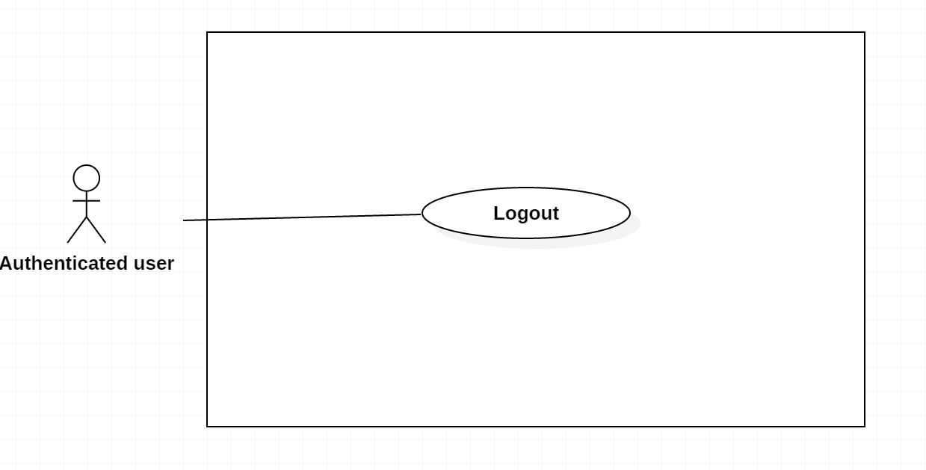*Figure10: < Authenticated user > logout*

|  |  |  |  |
| --- | --- | --- | --- |
| USE CASE – IMS010 | | | |
| Use Case No. | IMS010 | **Use Case Version** | 2.0 |
| Use Case Name | Logout | | |
| Author | Cao Hồng Nam | | |
| Date | 18/01/2016 | **Priority** | medium |
| Actor:   * Authenticated user.   Summary:   * This use case allows Authenticated user to logout.   Goal:   * Logout.   Triggers:   * Authenticated user clicks on “Logout” link on the panel.   Preconditions:   * Authenticated user must login into the system with role Authenticated user.   Post Conditions:   * Success: All data will be saving successfully and show success message   - Fail: System shows error message.  Main Success Scenario:   |  |  |  | | --- | --- | --- | | Step | Actor Action | System Response | | 1 | Authenticated user sends logout command. | Authenticated user exits from system. |   Alternative Scenario: N/A  Exceptions:   |  |  |  | | --- | --- | --- | | No | Actor Action | System Response | | 1 | Connect to database fail | Show message “Error, please try again!” |   Relationships: N/A.  Business Rules: | | | |

Table10: Use case IMS010 - < Authenticated > logout.

###### < Authenticated user> Change Password

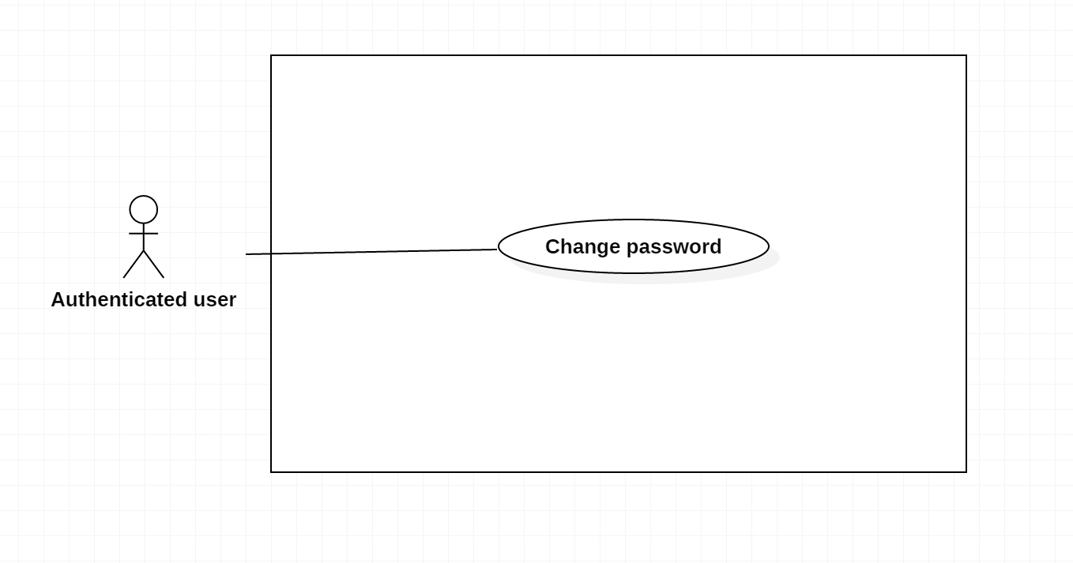*Figure11: < Authenticated user > change password*

|  |  |  |  |
| --- | --- | --- | --- |
| USE CASE – IMS011 | | | |
| Use Case No. | IMS011 | **Use Case Version** | 2.0 |
| Use Case Name | Change Password | | |
| Author | Cao Hồng Nam | | |
| Date | 18/01/2016 | **Priority** | medium |
| Actor:   * Authenticated user.   Summary:   * This use case allows Authenticated user to change password.   Goal:   * Change password.   Triggers:   * Authenticated user clicks on “Change Password” link on the panel.   Preconditions:   * Authenticated user must login into the system with role Authenticated user.   Post Conditions:   * Success: All data will be saving successfully and show success message   - Fail: System shows error message.  Main Success Scenario:   |  |  |  | | --- | --- | --- | | Step | Actor Action | System Response | | 1 | Authenticated user clicks on “Change Password” link on the panel. | Navigate to View customer information page which contains:   * Change Password |   Alternatives Scenario: N/A.  Exceptions:   |  |  |  | | --- | --- | --- | | No | Actor Action | System Response | | 1 | Connect to database fail | Show message “Error, please try again!” |   Relationships: N/A.  Business Rules:   * Password field displayed “*”. * Encrypt password before being send to server. | | | |

Table11: Use case IMS011 - < Authenticated > change password.

###### <Authenticated> View Profile

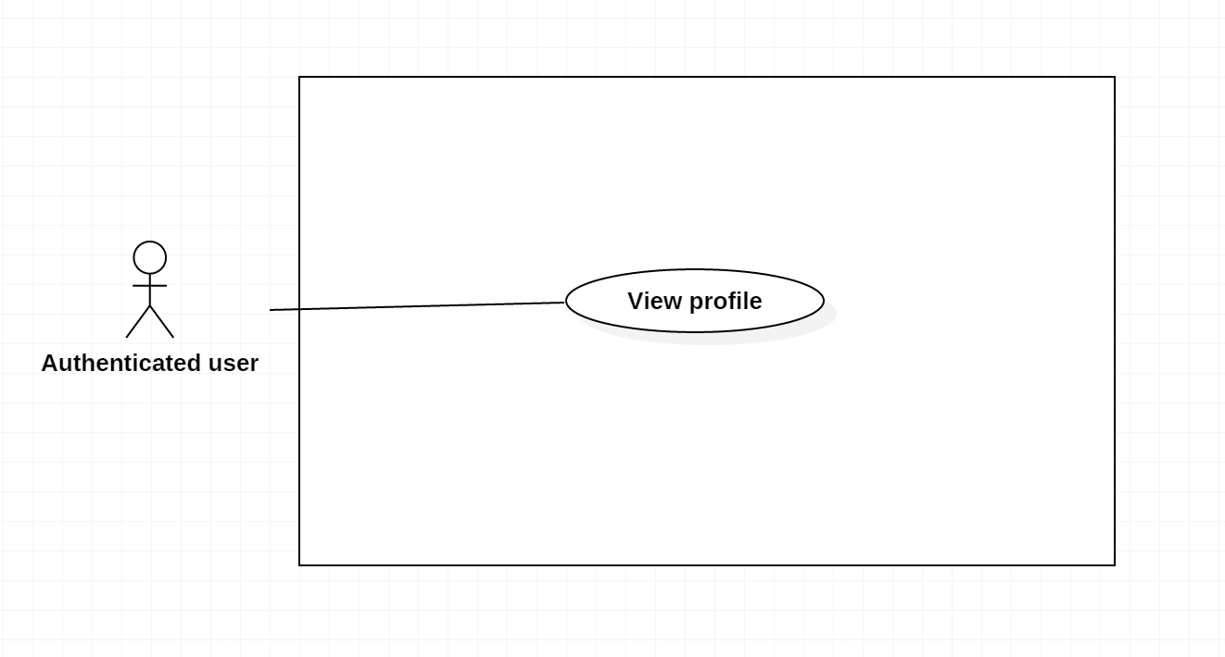*Figure12: < Authenticated user > view profile*

|  |  |  |  |
| --- | --- | --- | --- |
| USE CASE – IMS012 | | | |
| Use Case No. | IMS012 | **Use Case Version** | 2.0 |
| Use Case Name | View Profile | | |
| Author | Cao Hồng Nam | | |
| Date | 18/01/2016 | **Priority** | medium |
| Actor:   * Authenticated user.   Summary:   * This use case allows Authenticated user to view profile information.   Goal:   * View profile information.   Triggers:   * Authenticated user clicks on “View Profile” link on the panel.   Preconditions:   * Authenticated user must login into the system with role Authenticated user.   Post Conditions:   * Success: All data will be saving successfully and show success message   - Fail: System shows error message.  Main Success Scenario:   |  |  |  | | --- | --- | --- | | Step | Actor Action | System Response | | 1 | Authenticated user clicks on “View Profile” link on the panel. | Navigate to View customer information page which contains:   * User name: label * Full name: label * Phone: label * Email: label * Address: label * Sever name: link * Indentification: label |   Alternatives Scenario: N/A.  Exceptions:   |  |  |  | | --- | --- | --- | | No | Actor Action | System Response | | 1 | Connect to database fail | Show message “Error, please try again!” |   Relationships: N/A.  Business Rules:   * Shift Manager, headshift can see profile customer and staff. * Staff can’t see profile of Shift Manager. * Customer can see only customer profile | | | |

Table12: Use case IMS012 - < Authenticated > view profile.

###### < Authenticated > View Notification

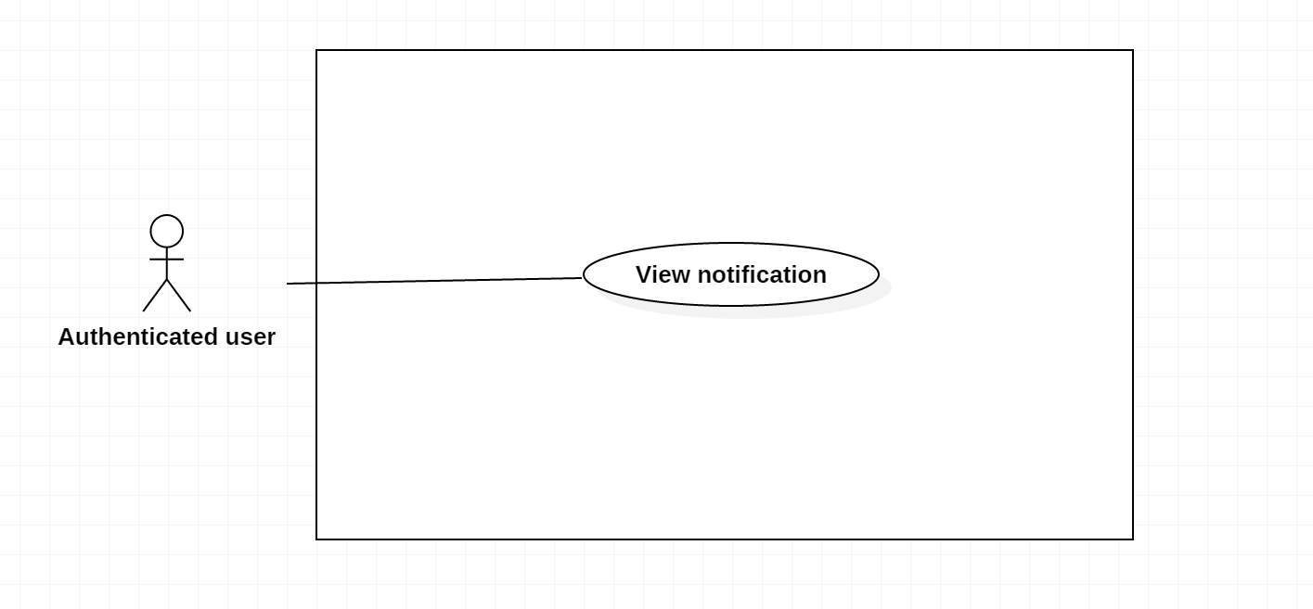*Figure13: < Authenticated user > view notification*

|  |  |  |  |
| --- | --- | --- | --- |
| USE CASE – IMS013 | | | |
| Use Case No. | IMS013 | **Use Case Version** | 2.0 |
| Use Case Name | View Notification | | |
| Author | Cao Hồng Nam | | |
| Date | 18/01/2016 | **Priority** | medium |
| Actor:   * Authenticated user.   Summary:   * This use case allows Authenticated user to view notification information.   Goal:   * View Notification information.   Triggers:   * Authenticated user clicks on “View Notification” link on the panel.   Preconditions:   * Authenticated user must login into the system with role Authenticated user.   Post Conditions:   * Success: All data will be saving successfully and show success message   - Fail: System shows error message.  Main Success Scenario:   |  |  |  | | --- | --- | --- | | Step | Actor Action | System Response | | 1 | Authenticated user clicks on “View Notification” link on the panel. | Navigate to View Notification information page which contains:   * Appointment of customer |   Alternatives Scenario: N/A.  Exceptions:   |  |  |  | | --- | --- | --- | | No | Actor Action | System Response | | 1 | Connect to database fail | Show message “Error, please try again!” |   Relationships: N/A.  Business Rules:  - Shift Manager, staff, headshift, customer can view notification of all request  - If user is headshift or Shift Manager, he/she can make a notification for staff.   * When staff make a request for system, all people can see notification. | | | |

Table13: Use case IMS013 - < Authenticated > view notification.

###### < Authenticated > View Report

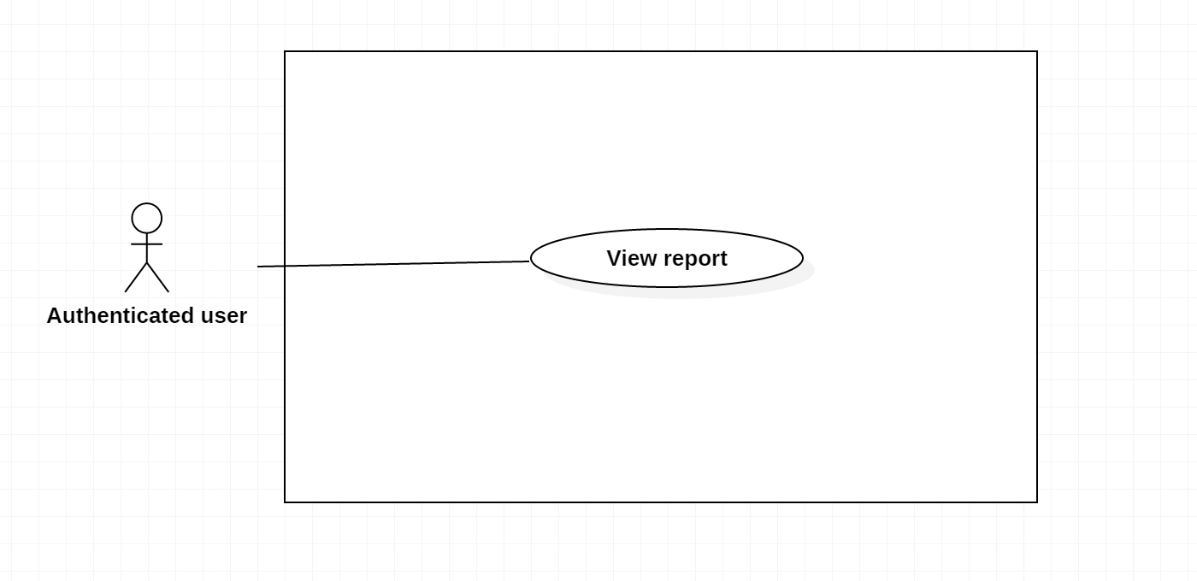*Figure14: < Authenticated user > view report*

|  |  |  |  |
| --- | --- | --- | --- |
| USE CASE – IMS014 | | | |
| Use Case No. | IMS014 | **Use Case Version** | 2.0 |
| Use Case Name | View Report | | |
| Author | Cao Hồng Nam | | |
| Date | 18/01/2016 | **Priority** | medium |
| Actor:   * Authenticated user.   Summary:   * This use case allows Authenticated user to view report information.   Goal:   * View Report information.   Triggers:   * Authenticated user clicks on “View Report” link on the panel.   Preconditions:   * Authenticated user must login into the system with role Authenticated user.   Post Conditions:   * Success: All data will be saving successfully and show success message   - Fail: System shows error message.  Main Success Scenario:   |  |  |  | | --- | --- | --- | | Step | Actor Action | System Response | | 1 | Authenticated user clicks on “View Report” link on the panel. | Navigate to View Report information page which contains:   * Report all activity of Customer, Sever. |   Alternatives Scenario: N/A.  Exceptions:   |  |  |  | | --- | --- | --- | | No | Actor Action | System Response | | 1 | Connect to database fail | Show message “Error, please try again!” |   Relationships: N/A.  Business Rules:  - Shift Manager can view report of all staff, while staff can only view the report of the customer.  - If Authenticated user is headshift or Shift Manager, he/she can choose the staff to view report | | | |

Table14: Use case IMS014 - < Authenticated > view report.

###### < Authenticated > Search

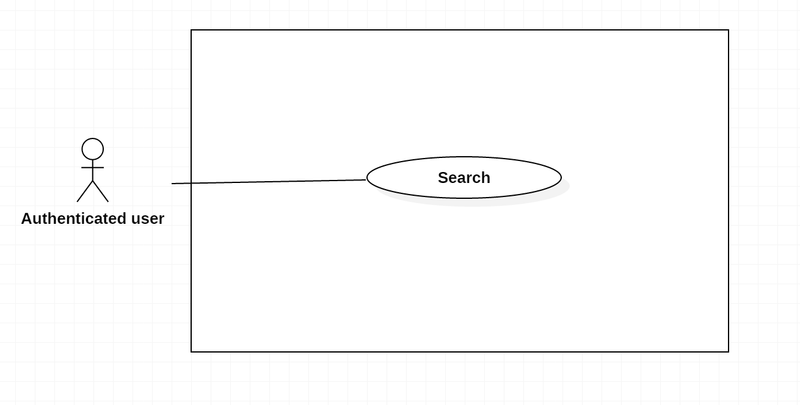*Figure15: < Authenticated user> search*

|  |  |  |  |
| --- | --- | --- | --- |
| USE CASE – IMS015 | | | |
| Use Case No. | IMS015 | **Use Case Version** | 2.0 |
| Use Case Name | Search | | |
| Author | Cao Hồng Nam | | |
| Date | 18/01/2016 | **Priority** | medium |
| Actor:   * Authenticated user.   Summary:   * This use case allows Authenticated user to search information.   Goal:   * View Search information.   Triggers:   * Authenticated user clicks on “Search” link on the panel.   Preconditions:   * Authenticated user must login into the system with role Authenticated user.   Post Conditions:   * Success: All data will be saving successfully and show success message   - Fail: System shows error message.  Main Success Scenario:   |  |  |  | | --- | --- | --- | | Step | Actor Action | System Response | | 1 | Authenticated user clicks on “Search” link on the panel. | Navigate to View Report information page which contains:   * Information of Sever, IP, Customer. |   Alternatives Scenario: N/A.  Exceptions:   |  |  |  | | --- | --- | --- | | No | Actor Action | System Response | | 1 | Connect to database fail | Show message “Error, please try again!” |   Relationships: N/A.  Business Rules:   * Custommer can search your sever and IP. | | | |

Table15: Use case IMS015 - < Authenticated > search.

## Software System Attribute

### Usability

#### Graphic User Interface

* Using language should be English.

#### Usability

* All users should need less than one training week to interact with website.

#### Installation

* Customer can deploy successfully and learn to configure, maintain the system within one day of training.
* The attached manual guide must be clear. User can read and do themselves without developer’s help.

### Reliability

* Calculating average grade (score) and classifying academic result should base on the rules of Data center.

### Availability

* The website should be available 24 hours per day, 7 days per week.

### Security

* Only user who has account can access into System.
* Each role of user has a specific permission to interact with system.
* System always checks authorization before process user’s request.

### Maintainability

* Code is easy to maintain and upgrade.

### Portability

* The system can be deployed into many type of servers those have IIS server.

### Performance

* Response time of almost functions should be less than 2s.