# 

# 

# **Software Requirement Specification**

## User Requirement Specification

### Customer requirement

### Staff requirement

## System Requirement Specification

### External Interface Requirement

#### User interface

#### Hardware Interface

#### Software Interface

#### Communication Protocol

### System Overview Use Case

### List of Use Case

##### <Shift Head> Overview Use Case

Figure 5: <Shift Head> Overview Use Case

###### <Shift Head> Write note

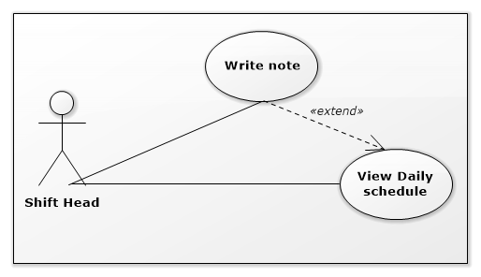

Figure 8 <Shift Head> Write note

|  |  |  |  |
| --- | --- | --- | --- |
| USE CASE – IMS001 | | | |
| Use Case No. | IMS001 | **Use Case Version** | 2.0 |
| Use Case Name | Write note | | |
| Author | Huỳnh Lâm Hà Tiên | | |
| Date | 18/01/2016 | **Priority** | Normal |
| Actor:   * Shift Head   Summary:   * This use case allows Shift Head to write note about customer’s arrival for the next shift.   Goal:   * Creating note about customer’s arrival for the next shift.   Triggers:   * Shift head clicks “Write note for the next shift” link on the Daily Schedule Page.   Precondition:   * The Shift Head must login to the system with Shift Head role at right shift.   Post Conditions:   * Success: The note of this shift will be created. * Fail: Nothing will be created. Show message error with specified content.   Main Success Scenario:   |  |  |  | | --- | --- | --- | | Step | Actor Action | System Response | | 1 | Shift head clicks “Write note for the next shift” link on the Daily Schedule Page. | The popup contains blank note will be showed. | | 2 | Shift head inputs data and clicks “Submit note” button | The note of this shift will be created. |   Alternative Scenario:   |  |  |  | | --- | --- | --- | | Step | Actor Action | System Response | | 1 | Shift head clicks “Write note for the next shift” link on the Daily Schedule Page. | The popup contains blank note will be showed. | | 2 | Shift head inputs data and clicks “Cancel” button | Return to Daily Schedule Page. |   Exceptions:   |  |  |  | | --- | --- | --- | | Step | Cause | System Response | | 1 | The note is blank | Show message error: “The note is blank. Please input data!” |  |  |  |  | | --- | --- | --- | | No | Actor Action | System Response | | 1 | Connect to database fail | Show message “Error, please try again!” |   Relationships: Extend to View daily Schedule.  Business Rules:   * The time when the note was created and the created Shift Head must be saved into database. * If the Shift Head login to the system at different people’s shift, the link “Write note for the next shift” is disabled. | | | |

Table 19: Use case IMS001 - <Shift Head> Write note

###### <Shift Head> Assign task

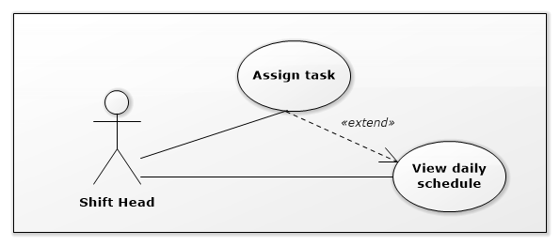

Figure 8 <Shift Head> Assign task

|  |  |  |  |
| --- | --- | --- | --- |
| USE CASE – IMS002 | | | |
| Use Case No. | IMS002 | **Use Case Version** | 2.0 |
| Use Case Name | Assign task | | |
| Author | Huỳnh Lâm Hà Tiên | | |
| Date | 18/01/2016 | **Priority** | Normal |
| Actor:   * Shift Head   Summary:   * This use case allows Shift Head to assign task for Staff.   Goal:   * Assign task for Staff when Shift Head is busy.   Triggers:   * Shift head clicks “Assign task” on event at Daily Schedule Page.   Precondition:   * The Shift Head must login to the system with Shift Head role at his/her right shift.   Post Conditions:   * Success: This task will be assigned to corresponding Staff. Staff will have notification about this assignment. * Fail: Show message error with specified content.   Main Success Scenario:   |  |  |  | | --- | --- | --- | | Step | Actor Action | System Response | | 1 | Shift head clicks “Assign task” on event at Daily Schedule Page. | The list Staff of the same shift will be display. | | 2 | Shift head select one Staff to assign and click “OK” button. | This task will be assign for corresponding Staff.  Staff will have notification about this assignment. |   Alternative Scenario:   |  |  |  | | --- | --- | --- | | Step | Actor Action | System Response | | 1 | Shift head clicks “Assign task” on event at Daily Schedule Page. | The list Staff of the same shift will be display. | | 2 | Shift head select one Staff to assign and click “Cancel” button. | Return to Daily Schedule Page. |   Exceptions:   |  |  |  | | --- | --- | --- | | No | Actor Action | System Response | | 1 | Connect to database fail | Show message “Error, please try again!” |  |  |  |  | | --- | --- | --- | | No | Actor Action | System Response | | 1 | Connect to the Internet fail | Show message “Error, please try again!” |   Relationships: Extend to View daily Schedule.  Business Rules:   * The assigned time, the assigned Shift Head and the Staff who was assigned must be saved into database. * If the Shift Head login to the system at different people’s shift, the button “Assign” is disabled. * The Shift Head can assign task for only the Staff of the same shift. | | | |

Table 19: Use case IMS002 - <Shift Head> Assign task

###### <Shift Head> View request

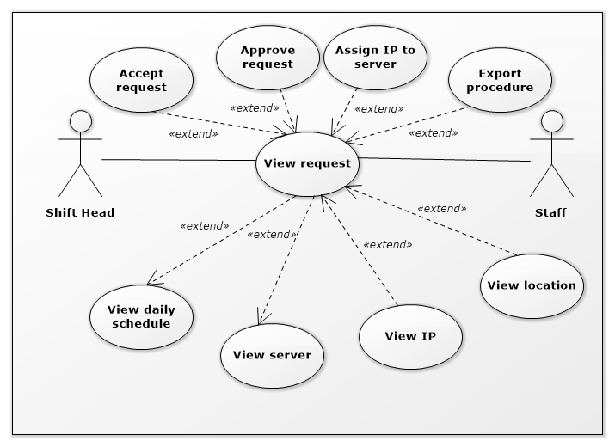

Figure 8 <Shift Head> View request

|  |  |  |  |
| --- | --- | --- | --- |
| USE CASE – IMS003 | | | |
| Use Case No. | IMS003 | **Use Case Version** | 2.0 |
| Use Case Name | View request | | |
| Author | Huỳnh Lâm Hà Tiên | | |
| Date | 18/01/2016 | **Priority** | Normal |
| Actor:   * Shift Head   Summary:   * This use case allows Shift Head to view request from customer.   Goal:   * View request.   Triggers:   * Shift head clicks on each event at Daily Schedule Page or clicks on each request at Server Page.   Precondition:   * The Shift Head must login to the system with Shift Head role.   Post Conditions:   * Success: Request page will be displayed. * Fail: Show message error with specified content.   Main Success Scenario:   |  |  |  | | --- | --- | --- | | Step | Actor Action | System Response | | 1 | Shift head clicks on each event at Daily Schedule Page or clicks on each request at Server Page. | The Request Page will be displayed. |   Alternative Scenario: N/A.  Exceptions:   |  |  |  | | --- | --- | --- | | No | Actor Action | System Response | | 1 | Connect to database fail | Show message “Error, please try again!” |   Relationships:   * Extend to View daily Schedule. * Extend to View server. * Extended by Accept request. * Extended by Approve request. * Extended by Export procedure. * Extended by Assign IP to server. * Extended by View IP. * Extended by View location.   Business Rules:   * When the server has request from customer, that request’s link will be displayed in Server Table. * Shift Head who does not login in right shift, all buttons and check boxes in Request Page will be disabled. | | | |

Table 19: Use case IMS003 - <Shift Head> View request

###### <Shift Head> Accept request

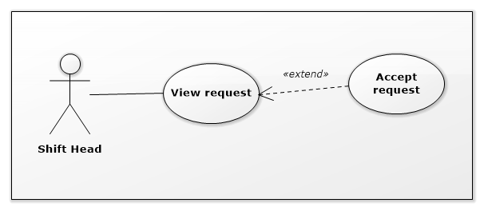

Figure 25 <Shift Head> Accept request

|  |  |  |  |
| --- | --- | --- | --- |
| USE CASE – IMS004 | | | |
| Use Case No. | IMS004 | **Use Case Version** | 2.0 |
| Use Case Name | Accept request | | |
| Author | Huỳnh Lâm Hà Tiên | | |
| Date | 19/01/2016 | **Priority** | medium |
| Actor:   * Shift Head.   Summary:   * This use case allows Shift Head to accept request from customer.   Goal:   * By current system notifications, shift head can accept customer’s requests to manage customer’s arrival.   Triggers:   * Shift head clicks “Accept” button on request page which is showed after clicking notification.   Preconditions:   * The Shift Head must login to the system at his/her right shift. * Having request from customer at Shift Head’s current shift.   Post Conditions:   * Success: A message will be showed “Accept successfully, an email was sent to customer” * Fail: Show message error with specified content.   Main Success Scenario:   |  |  |  | | --- | --- | --- | | Step | Actor Action | System Response | | 1 | Shift Head clicks on notifications. | Request Page will be showed. | | 2 | Shift Head clicks on “Accept” button on Request Page. | Show message: “Are you sure to accept this request?” | | 3 | Shift Head clicks on “OK” | * The status of this request in database will be changed to “Accepted” * An email about the appointment will be sent to customer. |   Alternative Scenario:   |  |  |  | | --- | --- | --- | | Step | Actor Action | System Response | | 1 | Shift Head clicks on notifications. | Request Page will be showed. | | 2 | Shift Head clicks on “Accept” button on Request Page. | Show message: “Are you sure to accept this request?” | | 3 | Shift Head clicks on “Cancel” | Return to Request Page |   Exceptions:   |  |  |  | | --- | --- | --- | | No | Actor Action | System Response | | 1 | Connect to Internet fail | Show message “Cannot send email to customer, please connect to the Internet and try again!” |   Relationships: Extend to View request.  Business Rules:   * When Shift Head accepts request, system will record the accepted Shift Head, the time when accepted, and the status of this request will be changed to “Accepted”. * If the Shift Head login to the system at different people’s shift, the button “Accept” is disabled. | | | |

Table 20: Use case IMS004 - <Shift Head> Accept request

###### <Shift Head> Confirm Arrival

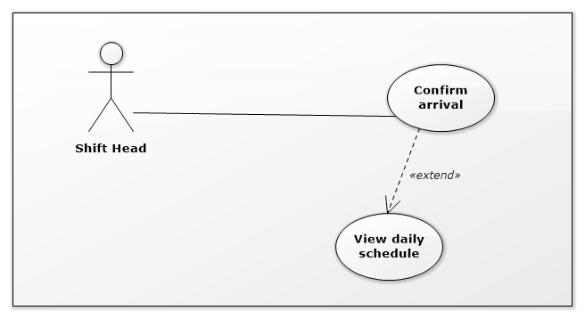

Figure 9: <Shift Head> Confirm Arrival

|  |  |  |  |
| --- | --- | --- | --- |
| USE CASE – IMS005 | | | |
| Use Case No. | IMS005 | **Use Case Version** | 2.0 |
| Use Case Name | Confirm Arrival | | |
| Author | Huỳnh Lâm Hà Tiên | | |
| Date | 19/01/2016 | **Priority** | medium |
| Actor:   * Shift Head.   Summary:   * This use case allows Shift Head to confirm the customer’s arrival at data center following the received request.   Goal:   * System can record the time when customer arrive and the time when customer leave, then data center can control the customer’s arrival day by day.   Triggers:   * On daily schedule, Shift Head ticks on the check box “Arrived” when customer arrived data center.   Preconditions:   * The shift head must login to the system at his/her right shift.   Post Conditions:   * Success: Detail of customer’s arrival include time, the confirmed Shift Head will be saved to database. * Fail: Show message error with specified content.   Main Success Scenario:   |  |  |  | | --- | --- | --- | | Step | Actor Action | System Response | | 1 | On daily schedule, Shift Head ticks on the check box “Arrived” when customer arrived data center and clicks on “Save” button. | The time when customer arrived and the confirmed Shift Head will be saved to database. |   Alternative Scenario: N/A.  Exceptions:   |  |  |  | | --- | --- | --- | | No | Actor Action | System Response | | 1 | Connect to database fail | Show message “Error, please try again!” |   Relationships: Extend to View daily Schedule.  Business Rules:   * The check box “Arrived” will be disabled when it was ticked and the Shift Head clicked “Save” button. * If the Shift Head logins to the system at different people’s shift, the check box “Arrived” are disabled. | | | |

Table 21: Use case IMS005 - <Shift Head> Confirm Arrival

###### <Shift Head> View daily schedule

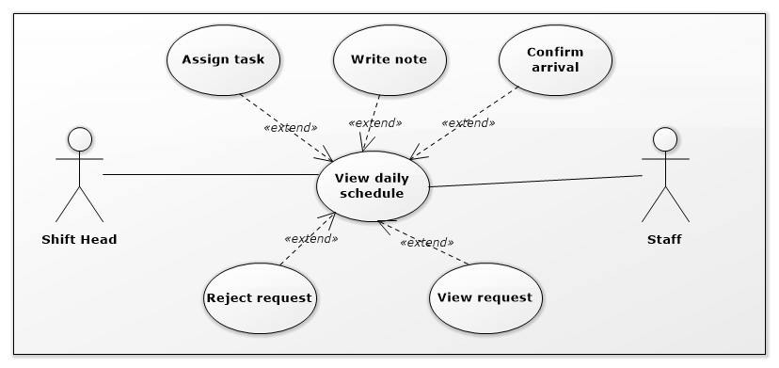

Figure 10: <Shift Head>View daily schedule

|  |  |  |  |
| --- | --- | --- | --- |
| USE CASE – IMS006 | | | |
| Use Case No. | IMS006 | **Use Case Version** | 2.0 |
| Use Case Name | View daily schedule | | |
| Author | Huỳnh Lâm Hà Tiên | | |
| Date | 18/01/2016 | **Priority** | medium |
| Actor:   * Shift Head.   Summary:   * This use case allows Shift Head to view all of the today’s appointments and note from previous shift.   Goal:   * System provides schedule which helps Shift Head to control the appointments with customers.   Triggers:   * When Shift Head login to the system, the page contains daily schedule and the note of previous shift will be showed.   Preconditions:   * The Shift Head must login to the system with Shift Head role.   Post Conditions:   * Success: The daily schedule and note will be showed. * Fail: N/A   Main Success Scenario:   |  |  |  | | --- | --- | --- | | Step | Actor Action | System Response | | 1 | Shift Head login to the system | The page contains daily schedule and note will be showed. |   Alternative Scenario:   |  |  |  | | --- | --- | --- | | Step | Actor Action | System Response | | 1 | Shift Head login to the system and today does not have any customer’s arrival. | A message will be showed “Today does not have any appointment!” |   Exceptions: N/A  Relationships:   * Extended by Write note. * Extended by Confirm Arrival. * Extended by Assign task. * Extended by View request. * Extended by Reject request.   Business Rules:   * The customer link in daily schedule will be showed when today has appointments. | | | |

Table 22: Use case IMS006 - <Shift Head> View daily schedule

###### <Shift Head> View server

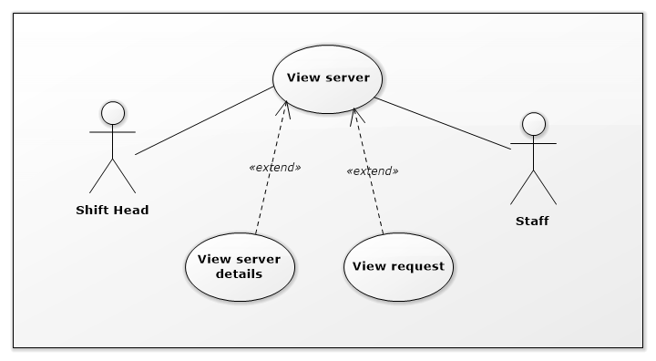

Figure 11: <Shift Head> View server

|  |  |  |  |
| --- | --- | --- | --- |
| USE CASE – IMS007 | | | |
| Use Case No. | IMS007 | **Use Case Version** | 2.0 |
| Use Case Name | View server | | |
| Author | Huỳnh Lâm Hà Tiên | | |
| Date | 20/01/2016 | **Priority** | medium |
| Actor:   * Shift Head.   Summary:   * This use case allows Shift Head to view list all server information of customers.   Goal:   * View server information.   Triggers:   * Shift Head clicks on “View server” link on the panel.   Preconditions:   * Shift Head must login into the system with role Shift Head.   Post Conditions:   * Success: Server information will be showed. * Fail: Server information will not be showed. Show error message with specified content.   Main Success Scenario:   |  |  |  | | --- | --- | --- | | Step | Actor Action | System Response | | 1 | Shift Head clicks on “View server” link on the panel. | Navigate to View server information page which contains:   * Customer name: link * Server name: link * Default IP: label * Status: label * Location: link * Request: link |   Alternative Scenario: N/A.  Exceptions:   |  |  |  | | --- | --- | --- | | No | Actor Action | System Response | | 1 | Connect to database fail | Show message “Error, please try again!” |   Relationships:   * Extended by View server details. * Extended by View request.   Business Rules:   * Request link will be showed when server has request from customer. | | | |

Table 23: Use case IMS007 - <Shift Head> View server

###### <Shift Head> Change server status

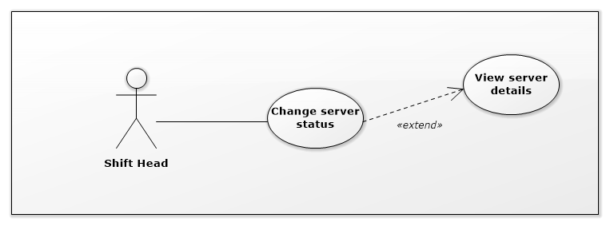

Figure 19: <Shift Head> Change server status

|  |  |  |  |
| --- | --- | --- | --- |
| USE CASE – IMS008 | | | |
| Use Case No. | IMS008 | **Use Case Version** | 2.0 |
| Use Case Name | Change server status | | |
| Author | Huỳnh Lâm Hà Tiên | | |
| Date | 19/01/2016 | **Priority** | medium |
| Actor:   * Shift Head.   Summary:   * This use case allows Shift Head to change status of each server.   Goal:   * Change status of server.   Triggers:   * Shift Head clicks on “Change status” at Server Detail Page.   Preconditions:   * Shift Head must login into the system with role Shift Head.   Post Conditions:   * Success: The status of server will be changed. * Fail: The status of server will not be changed. Show error message with specified content.   Main Success Scenario:   |  |  |  | | --- | --- | --- | | Step | Actor Action | System Response | | 1 | Shift Head clicks on “Change status” at Server Detail Page. | The system will display the table of servers with column Status which can edit. | | 2 | Shift Head clicks on “Save” button in Server Page. | The new status will be saved into database and the new status will be displayed on server detail page. |   Alternatives Scenario: N/A  Exceptions:   |  |  |  | | --- | --- | --- | | No | Cause | System Response | | 1 | Cannot connect to database. | Show message: “Error, please try again!” |   Relationships: N/A.  Business Rules:   * The status of server is only changed to “Deactivate” by Shift Head. | | | |

*Table 29: Use case IMS008 - <Shift Head> Change server status*

###### <Shift Head> Approve request Add New Server

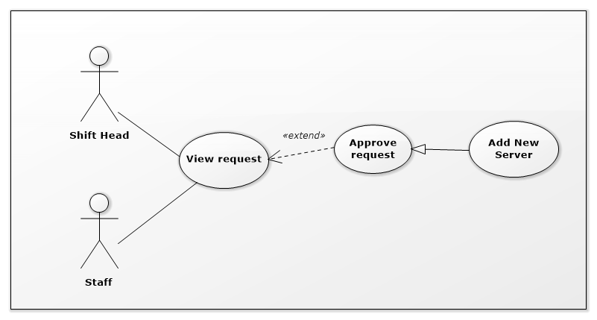

Figure 15: <Shift Head> Approve request Add New Server

|  |  |  |  |
| --- | --- | --- | --- |
| USE CASE – IMS009 | | | |
| Use Case No. | IMS009 | **Use Case Version** | 2.0 |
| Use Case Name | Approve request Add New Server | | |
| Author | Huỳnh Lâm Hà Tiên | | |
| Date | 21/01/2016 | **Priority** | medium |
| Actor:   * Shift Head.   Summary:   * This use case allows Shift Head to approve request Add New Server when that request was done in reality.   Goal:   * Approve request Add New Server which was done in reality.   Triggers:   * Shift Head clicks on “Request” and select “Request Add New Server” link at Request Column of Server Table.   Preconditions:   * Shift Head must login into the system with role Shift Head. * The request was sent to data center by customer.   Post Conditions:   * Success:   The new information of New Server includes Default IP, Location, Registered Date will be saved into database.  The status of this New Server will be changed into database.  The status of Approve Request will be changed into database and the approved time, approved Shift Head will be saved into database.   * Fail: Show message with specified content.   Main Success Scenario:   |  |  |  | | --- | --- | --- | | Step | Actor Action | System Response | | 1 | Shift Head clicks on “Request” link at Request Column of Server Table. | The system will display list of request of that server. | | 2 | Shift Head select request Add New Server | The page of request Add New Server will be displayed. | | 3 | Shift Head clicks on “Add IP” | The picked up IP Address Popup will be displayed. | | 4 | Shift Head searches suitable IP Address, select it and clicks “OK” button. | Return to Request Add New Server Page and the selected IP Address will be display on field “Default IP” | | 5 | Shift Head clicks on “Add location” | The picked up Location Popup will be displayed. | | 6 | Shift Head selects suitable location and clicks “OK” button. | Return to Request Add New Server Page and the selected location will be display on field “Location” | | 7 | Shift Head clicks on “Approve” button | * System will save new information of this server into database. * System will change status of this server into database. * System will save the approved time, approved Shift Head into database. |   Alternatives Scenario:   |  |  |  | | --- | --- | --- | | Step | Actor Action | System Response | | 1 | Shift Head clicks on “Request” link at Request Column of Server Table. | The system will display list of request of that server. | | 2 | Shift Head select request Add New Server | The page of request Add New Server will be displayed. | | 3 | Shift Head clicks on “Cancel” button on Request Add New Server Page. | Return to Server Page. |   Exceptions:   |  |  |  | | --- | --- | --- | | Step | Cause | System Response | | 1 | Connect to database fail. | System will show message: “Error, please try again!” |   Relationships: Extend to View request  Business Rules:   * When Shift Head clicked on “Approve” button, that request will disappear out of the list of server request on Server Page and the status of request will change to “Done”. | | | |

Table 26: Use case IMS009 - <Shift Head> Approve request Add New Server

###### <Shift Head> Approve request Upgrade Server

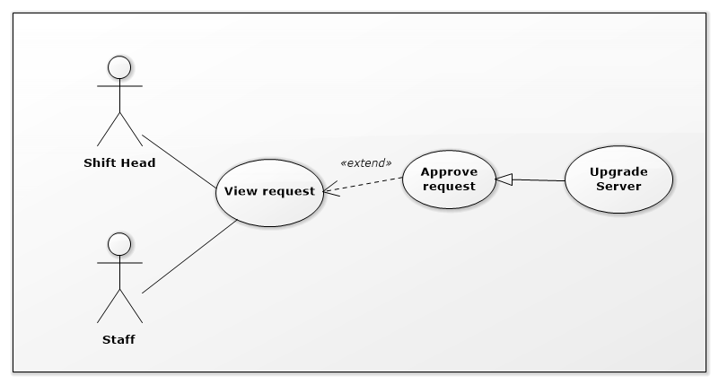

Figure 15: <Shift Head> Approve request Upgrade Server

|  |  |  |  |
| --- | --- | --- | --- |
| USE CASE – IMS010 | | | |
| Use Case No. | IMS010 | **Use Case Version** | 2.0 |
| Use Case Name | Approve request Upgrade Server | | |
| Author | Huỳnh Lâm Hà Tiên | | |
| Date | 22/01/2016 | **Priority** | medium |
| Actor:   * Shift Head.   Summary:   * This use case allows Shift Head to approve request Upgrade Server when that request was done in reality.   Goal:   * Approve request Upgrade Server which was done in reality.   Triggers:   * Shift Head clicks on “Request” and select “Request Upgrade Server” link at Request Column of Server Table.   Preconditions:   * Shift Head must login into the system with role Shift Head. * The request was sent to data center by customer.   Post Conditions:   * Success:   The Upgrade Time of this server will be saved into database.  The status of this Server’s attributes will be changed into database.  The status of Approve Request will be changed into database and the approved time, approved Shift Head will be saved into database.   * Fail: Show message with specified content.   Main Success Scenario:   |  |  |  | | --- | --- | --- | | Step | Actor Action | System Response | | 1 | Shift Head clicks on “Request” link at Request Column of Server Table. | The system will display list of request of that server. | | 2 | Shift Head select request Upgrade Server | The page of request Upgrade Server will be displayed. | | 3 | Shift Head clicks on “Approve” button | * The system will save Upgrade Time of this server into database. * The system will change the status of this Server’s attributes into database. * The system will change the status of Approve Request into database and save the approved time, approved Shift Head into database. |   Alternatives Scenario:   |  |  |  | | --- | --- | --- | | Step | Actor Action | System Response | | 1 | Shift Head clicks on “Request” link at Request Column of Server Table. | The system will display list of request of that server. | | 2 | Shift Head select request Upgrade Server | The page of request Upgrade Server will be displayed. | | 3 | Shift Head clicks on “Cancel” button | Return to Server Page. |   Exceptions:   |  |  |  | | --- | --- | --- | | Step | Cause | System Response | | 1 | Connect to database fail. | System will show message: “Error, please try again!” |   Relationships:   * Extend to View request.   Business Rules:   * When Shift Head clicked on “Approve” button, that request will disappear out of the list of server request on Server Page and the status of request will change to “Done”. | | | |

Table 26: Use case IMS0010 - <Shift Head> Approve request Upgrade Server

###### <Shift Head> Approve request Change IP Address

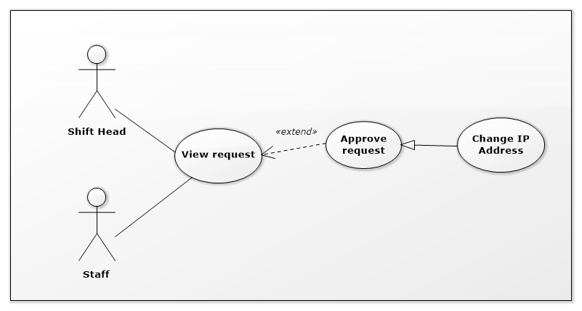

Figure 15: <Shift Head> Approve request Change IP Address

|  |  |  |  |
| --- | --- | --- | --- |
| USE CASE – IMS011 | | | |
| Use Case No. | IMS011 | **Use Case Version** | 2.0 |
| Use Case Name | Approve request Change IP Address | | |
| Author | Huỳnh Lâm Hà Tiên | | |
| Date | 22/01/2016 | **Priority** | medium |
| Actor:   * Shift Head.   Summary:   * This use case allows Shift Head to approve request Change IP Address when that request was done.   Goal:   * Approve request Change IP Address Server which was done.   Triggers:   * Shift Head clicks on “Request” and select “Request Change IP Address” link at Request Column of Server Table.   Preconditions:   * Shift Head must login into the system with role Shift Head. * The request was sent to data center by customer.   Post Conditions:   * Success:   The Changed Time and the information about Assign IP Address will be saved into database.  The status of involved IP Addresses will be changed into database.  The status of Approve Request will be changed into database and the approved time, approved Shift Head will be saved into database.   * Fail: Show message with specified content.   Main Success Scenario:   |  |  |  | | --- | --- | --- | | Step | Actor Action | System Response | | 1 | Shift Head clicks on “Request” link at Request Column of Server Table. | The system will display list of request of that server. | | 2 | Shift Head select request Change IP Address | The page of request Change IP Address will be displayed. | | 3 | Shift Head clicks on “Approve” button | System will save Changed Time and the information about Assign IP Address into database.  System will change the status of involved IP Addresses into database.  System will change the status of Approve Request into database and save the approved time, approved Shift Head into database. |   Alternatives Scenario:   |  |  |  | | --- | --- | --- | | Step | Actor Action | System Response | | 1 | Shift Head clicks on “Request” link at Request Column of Server Table. | The system will display list of request of that server. | | 2 | Shift Head select request Change IP Address | The page of request Change IP Address will be displayed. | | 3 | Shift Head clicks on “Cancel” button | Return to Server Page. |   Exceptions:   |  |  |  | | --- | --- | --- | | Step | Cause | System Response | | 1 | Connect to database fail. | System will show message: “Error, please try again!” |   Relationships:   * Extend to View request.   Business Rules:   * When Shift Head clicked on “Approve” button, that request will disappear out of the list of server request on Server Page and the status of request will change to “Done”. | | | |

Table 26: Use case IMS011 - <Shift Head> Approve request Change IP Address

###### <Shift Head> Approve request Assign IP Address

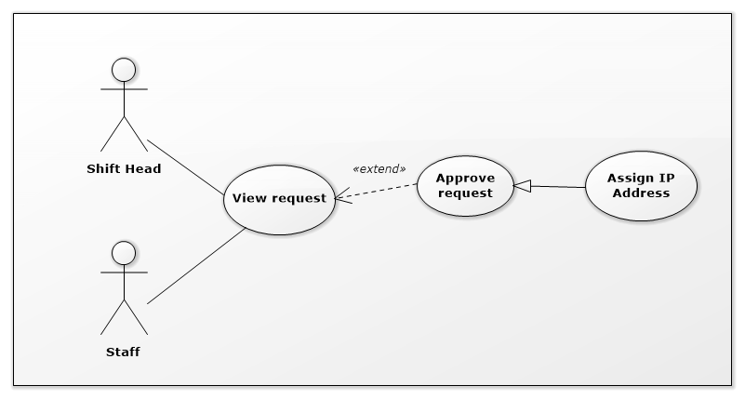

Figure 15: <Shift Head> Approve request Assign IP Address

|  |  |  |  |
| --- | --- | --- | --- |
| USE CASE – IMS012 | | | |
| Use Case No. | IMS012 | **Use Case Version** | 2.0 |
| Use Case Name | Approve request Assign IP Address | | |
| Author | Huỳnh Lâm Hà Tiên | | |
| Date | 22/01/2016 | **Priority** | medium |
| Actor:   * Shift Head.   Summary:   * This use case allows Shift Head to approve request Assign IP Address when that request was done.   Goal:   * Approve request Assign IP Address Server which was done.   Triggers:   * Shift Head clicks on “Request” and select “Request Assign IP Address” link at Request Column of Server Table.   Preconditions:   * Shift Head must login into the system with role Shift Head. * The request was sent to data center by customer.   Post Conditions:   * Success:   The Assigned Time and the information about Assign IP Address will be saved into database.  The status of involved IP Addresses will be changed into database.  The status of Approve Request will be changed into database and the approved time, approved Shift Head will be saved into database.   * Fail: Show message with specified content.   Main Success Scenario:   |  |  |  | | --- | --- | --- | | Step | Actor Action | System Response | | 1 | Shift Head clicks on “Request” link at Request Column of Server Table. | The system will display list of request of that server. | | 2 | Shift Head select request Assign IP Address | The page of request Assign IP Address will be displayed. | | 3 | Shift Head clicks on “Approve” button | System will save Assigned Time and the information about Assign IP Address into database.  System will change the status of involved IP Addresses into database.  System will change the status of Approve Request into database and save the approved time, approved Shift Head into database. |   Alternatives Scenario:   |  |  |  | | --- | --- | --- | | Step | Actor Action | System Response | | 1 | Shift Head clicks on “Request” link at Request Column of Server Table. | The system will display list of request of that server. | | 2 | Shift Head select request Assign IP Address | The page of request Assign IP Address will be displayed. | | 3 | Shift Head clicks on “Cancel” button | Return to Server Page. |   Exceptions:   |  |  |  | | --- | --- | --- | | Step | Cause | System Response | | 1 | Connect to database fail. | System will show message: “Error, please try again!” |   Relationships:   * Extend to View request.   Business Rules:   * When Shift Head clicked on “Approve” button, that request will disappear out of the list of server request on Server Page and the status of request will change to “Done”. | | | |

*Table 26: Use case IMS012 - <Shift Head> Approve request Assign IP Address*

###### <Shift Head> Approve request Return IP Address

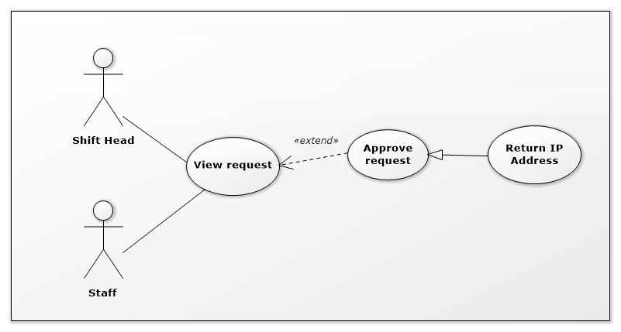

Figure 15: <Shift Head> Approve request Return IP Address

|  |  |  |  |
| --- | --- | --- | --- |
| USE CASE – IMS013 | | | |
| Use Case No. | IMS013 | **Use Case Version** | 2.0 |
| Use Case Name | Approve request Return IP Address | | |
| Author | Huỳnh Lâm Hà Tiên | | |
| Date | 22/01/2016 | **Priority** | medium |
| Actor:   * Shift Head.   Summary:   * This use case allows Shift Head to approve request Return IP Address when that request was done.   Goal:   * Approve request Return IP Address Server which was done.   Triggers:   * Shift Head clicks on “Request” and select “Request Return IP Address” link at Request Column of Server Table.   Preconditions:   * Shift Head must login into the system with role Shift Head. * The request was sent to data center by customer.   Post Conditions:   * Success:   The Returned Time and the information about Return IP Address will be saved into database.  The status of involved IP Addresses will be changed into database.  The status of Approve Request will be changed into database and the approved time, approved Shift Head will be saved into database.   * Fail: Show message with specified content.   Main Success Scenario:   |  |  |  | | --- | --- | --- | | Step | Actor Action | System Response | | 1 | Shift Head clicks on “Request” link at Request Column of Server Table. | The system will display list of request of that server. | | 2 | Shift Head select request Return IP Address | The page of request Return IP Address will be displayed. | | 3 | Shift Head clicks on “Approve” button | System will save Returned Time and the information about Return IP Address into database.  System will change the status of involved IP Addresses into database.  System will change the status of Approve Request into database and save the approved time, approved Shift Head into database. |   Alternatives Scenario:   |  |  |  | | --- | --- | --- | | Step | Actor Action | System Response | | 1 | Shift Head clicks on “Request” link at Request Column of Server Table. | The system will display list of request of that server. | | 2 | Shift Head select request Return IP Address | The page of request Return IP Address will be displayed. | | 3 | Shift Head clicks on “Cancel” button | Return to Server Page. |   Exceptions:   |  |  |  | | --- | --- | --- | | Step | Cause | System Response | | 1 | Connect to database fail. | System will show message: “Error, please try again!” |   Relationships:   * Extend to View request.   Business Rules:   * When Shift Head clicked on “Approve” button, that request will disappear out of the list of server request on Server Page and the status of request will change to “Done”. | | | |

*Table 26: Use case IMS013 - <Shift Head> Approve request Return IP Address*

###### <Shift Head> Export procedure

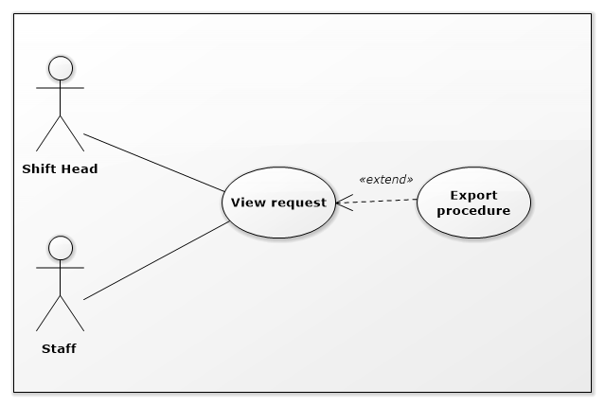

Figure 15: <Shift Head> Export procedure

|  |  |  |  |
| --- | --- | --- | --- |
| USE CASE – IMS014 | | | |
| Use Case No. | IMS014 | **Use Case Version** | 2.0 |
| Use Case Name | Export procedure | | |
| Author | Huỳnh Lâm Hà Tiên | | |
| Date | 23/01/2016 | **Priority** | medium |
| Actor:   * Shift Head.   Summary:   * This use case allows Shift Head to export procedure for customer after approve request.   Goal:   * Export procedure for customer after approve request.   Triggers:   * Shift Head clicks on “Export procedure” button on Request Page.   Preconditions:   * Shift Head must login into the system with role Shift Head. * The request must be already approved.   Post Conditions:   * Success: Export file word corresponding to request content. * Fail: Show message with specified content.   Main Success Scenario:   |  |  |  | | --- | --- | --- | | Step | Actor Action | System Response | | 1 | Shift Head clicks on “Export procedure” button on Request Page. | The system will fill the request information in the procedure and print out for customer. |   Alternatives Scenario: N/A.  Exceptions:   |  |  |  | | --- | --- | --- | | Step | Cause | System Response | | 1 | Connect to database fail. | System will show message: “Error, please try again!” |   Relationships:   * Extend to View request.   Business Rules:   * File procedure is only exported when the request was approved. | | | |

*Table 26: Use case IMS014 - <Shift Head> Export procedure*

###### <Shift Head> View server details

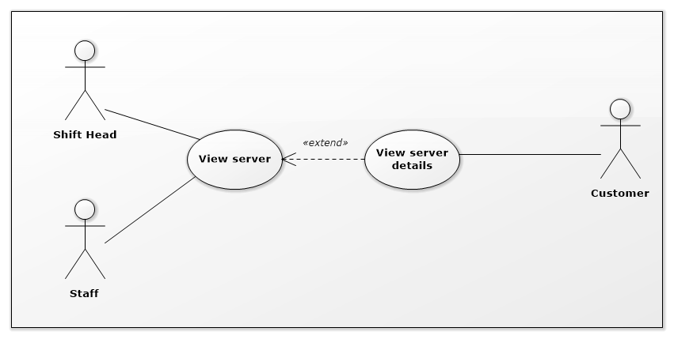

Figure 11: <Shift Head> View server details

|  |  |  |  |
| --- | --- | --- | --- |
| USE CASE – IMS015 | | | |
| Use Case No. | IMS015 | **Use Case Version** | 2.0 |
| Use Case Name | View server details | | |
| Author | Huỳnh Lâm Hà Tiên | | |
| Date | 23/01/2016 | **Priority** | medium |
| Actor:   * Shift Head.   Summary:   * This use case allows Shift Head to view each server information of customers.   Goal:   * View each server information.   Triggers:   * Shift Head clicks on “Server name” link on the Server Table.   Preconditions:   * Shift Head must login into the system with role Shift Head.   Post Conditions:   * Success: Server detail will be showed. * Fail: Server detail will not be showed. Show error message with specified content.   Main Success Scenario:   |  |  |  | | --- | --- | --- | | Step | Actor Action | System Response | | 1 | Shift Head clicks on Server Name link on the panel. | Navigate to Server Detail Page. |   Alternative Scenario: N/A.  Exceptions:   |  |  |  | | --- | --- | --- | | No | Actor Action | System Response | | 1 | Connect to database fail | Show message “Error, please try again!” |   Relationships:   * Extended to View server.   Business Rules: N/A. | | | |

Table 23: Use case IMS015 - <Shift Head> View server details

###### <Shift Head> Assign IP to server

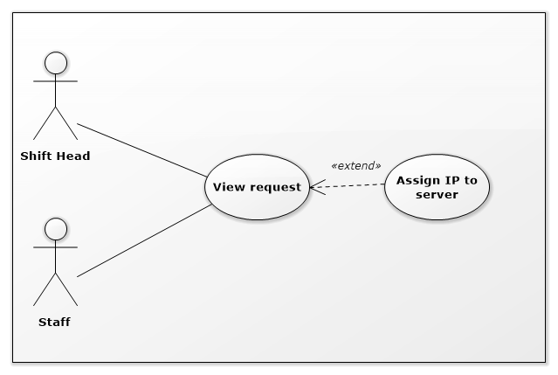

Figure 11: <Shift Head> Assign IP to server

|  |  |  |  |
| --- | --- | --- | --- |
| USE CASE – IMS016 | | | |
| Use Case No. | IMS016 | **Use Case Version** | 2.0 |
| Use Case Name | Assign IP to server | | |
| Author | Huỳnh Lâm Hà Tiên | | |
| Date | 23/01/2016 | **Priority** | medium |
| Actor:   * Shift Head.   Summary:   * This use case allows Shift Head to assign IP Address for server.   Goal:   * Assign IP Address for server.   Triggers:   * Shift Head clicks on “Assign IP Address” link on the Request Page (Request Change IP Address and Request Assign IP Address).   Preconditions:   * Shift Head must login into the system with role Shift Head.   Post Conditions:   * Success: Assigned IP Address will be displayed on Request Page. * Fail: N/A.   Main Success Scenario:   |  |  |  | | --- | --- | --- | | Step | Actor Action | System Response | | 1 | Shift Head clicks on “Assign IP Address” link on the Request Page | Navigate to Assign IP Address Page. | | 2 | Shift Head selects suitable IP Addresses and clicks “Save” button. | Assigned IP Address will be displayed on Request Page. |   Alternative Scenario:   |  |  |  | | --- | --- | --- | | Step | Actor Action | System Response | | 1 | Shift Head clicks on “Assign IP Address” link on the Request Page | Navigate to Assign IP Address Page. | | 2 | Shift Head clicks “Cancel” button. | Return to Request Page. |   Exceptions: N/A.  Relationships:   * Extended to View request.   Business Rules:   * The list IP Addresses which can assign must be same region with server’s current IP Addresses. | | | |

*Table 23: Use case IMS016 - <Shift Head> Assign IP to server.*

###### <Shift Head> Reject request Add New Server

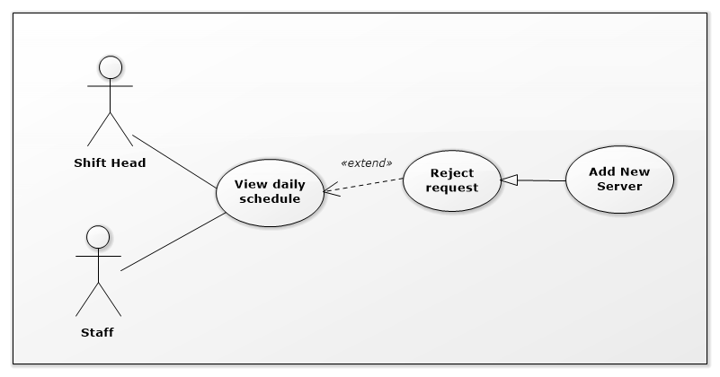

Figure 19: <Shift Head> Reject request Add New Server

|  |  |  |  |
| --- | --- | --- | --- |
| USE CASE – IMS017 | | | |
| Use Case No. | IMS017 | **Use Case Version** | 2.0 |
| Use Case Name | Reject request Add New Server | | |
| Author | Huỳnh Lâm Hà Tiên | | |
| Date | 23/01/2016 | **Priority** | medium |
| Actor:   * Shift Head.   Summary:   * This use case allows Shift Head to reject request Add New Server which was sent by customer.   Goal:   * Reject request Add New Server which was sent by customer.   Triggers:   * Shift Head clicks on “Reject” button on each event on daily schedule.   Preconditions:   * Shift Head must login into the system with role Shift Head in right shift.   Post Conditions:   * Success:   Customer will receive notification about reject request.  At the same time, the new server information which customer sent will be deleted out of database.  The status of this request in database will be changed.   * Fail: Show error message with specified content.   Main Success Scenario:   |  |  |  | | --- | --- | --- | | Step | Actor Action | System Response | | 1 | Shift Head clicks on “Reject” button on each event on daily schedule. | System will show message “Are you sure to reject this request?” | | 2 | Shift Head clicks on “OK” button | * The new server information which customer sent will be deleted out of database. * The status of this request in database will be changed. * Customer will receive notification about reject request. |   Alternatives Scenario:   |  |  |  | | --- | --- | --- | | Step | Actor Action | System Response | | 1 | Shift Head clicks on “Reject” button on each event on daily schedule. | System will show message “Are you sure to reject this request?” | | 2 | Customer clicks on “Cancel” button | Return to Daily Schedule. |   Exceptions:   |  |  |  | | --- | --- | --- | | No | Cause | System Response | | 1 | Connect to Internet fail | Show message “Cannot send request, please connect to the Internet!” |   Relationships: Extend to View daily schedule.  Business Rules:   * The system only deletes the information of new server which customer sent, does not delete different information of this request. | | | |

*Table 29: Use case IMS017 - <Shift Head> Reject request Add New Server*

###### <Shift Head> Reject request Upgrade Server

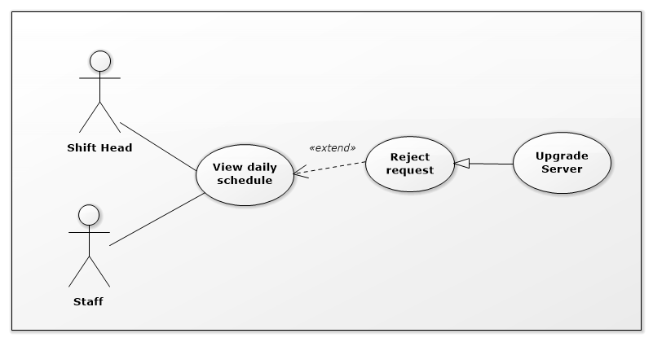

Figure 19: <Shift Head> Reject request Upgrade Server

|  |  |  |  |
| --- | --- | --- | --- |
| USE CASE – IMS018 | | | |
| Use Case No. | IMS018 | **Use Case Version** | 2.0 |
| Use Case Name | Reject request Upgrade Server | | |
| Author | Huỳnh Lâm Hà Tiên | | |
| Date | 23/01/2016 | **Priority** | medium |
| Actor:   * Shift Head.   Summary:   * This use case allows Shift Head to reject request Upgrade Server which was sent by customer.   Goal:   * Reject request Upgrade Server which was sent by customer.   Triggers:   * Shift Head clicks on “Reject” button on each event on daily schedule.   Preconditions:   * Shift Head must login into the system with role Shift Head.   Post Conditions:   * Success:   Customer will receive notification about reject request.  At the same time, the upgrade information of server which customer sent will be deleted out of database.  The status of this request in database will be changed.   * Fail: Show error message with specified content.   Main Success Scenario:   |  |  |  | | --- | --- | --- | | Step | Actor Action | System Response | | 1 | Shift Head clicks on “Reject” button on each event on daily schedule. | System will show message “Are you sure to reject this request?” | | 2 | Shift Head clicks on “OK” button | * The upgrade information of server which customer sent will be deleted out of database. * The status of this request in database will be changed. * Customer will receive notification about reject request. |   Alternatives Scenario:   |  |  |  | | --- | --- | --- | | Step | Actor Action | System Response | | 1 | Shift Head clicks on “Reject” button on each event on daily schedule. | System will show message “Are you sure to reject this request?” | | 2 | Shift Head clicks on “Cancel” button | Return to Daily Schedule. |   Exceptions:   |  |  |  | | --- | --- | --- | | No | Cause | System Response | | 1 | Connect to Internet fail | Show message “Cannot send request, please connect to the Internet!” |   Relationships: Extend to View daily schedule.  Business Rules:   * The system only deletes the upgrade information of server which customer sent, does not delete different information of this request. | | | |

*Table 29: Use case IMS018 - <Shift Head> Reject request Add New Server*

###### <Shift Head> Reject request Change IP Address

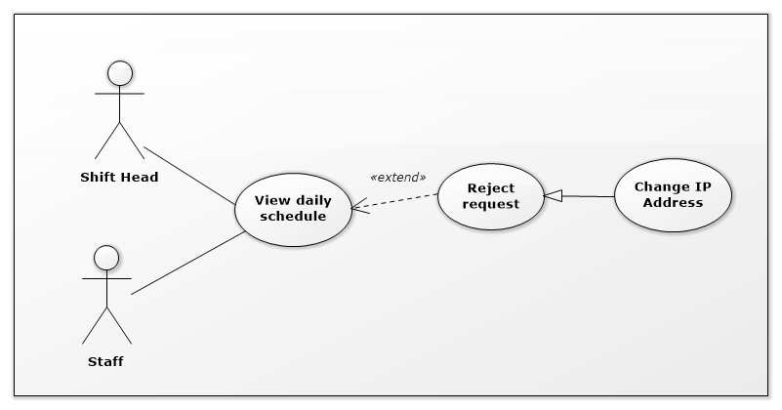

Figure 19: <Shift Head> Reject request Change IP Address

|  |  |  |  |
| --- | --- | --- | --- |
| USE CASE – IMS019 | | | |
| Use Case No. | IMS019 | **Use Case Version** | 2.0 |
| Use Case Name | Reject request Change IP Address | | |
| Author | Huỳnh Lâm Hà Tiên | | |
| Date | 23/01/2016 | **Priority** | medium |
| Actor:   * Shift Head.   Summary:   * This use case allows Shift Head to reject request Change IP Address which was sent by customer.   Goal:   * Reject request Change IP Address which was sent by customer.   Triggers:   * Shift Head clicks on “Reject” button on each event on daily schedule.   Preconditions:   * Shift Head must login into the system with role Shift Head in right shift.   Post Conditions:   * Success:   Customer will receive notification about reject request.  At the same time, the data of change IP Address which customer sent will be deleted out of database.  The status of this request in database will be changed.   * Fail: Show error message with specified content.   Main Success Scenario:   |  |  |  | | --- | --- | --- | | Step | Actor Action | System Response | | 1 | Shift Head clicks on “Reject” button on each event on daily schedule. | System will show message “Are you sure to reject this request?” | | 2 | Shift Head clicks on “OK” button | * The data of change IP Address which customer sent will be deleted out of database. * The status of this request in database will be changed. * Customer will receive notification about reject request. |   Alternatives Scenario:   |  |  |  | | --- | --- | --- | | Step | Actor Action | System Response | | 1 | Shift Head clicks on “Reject” button on each event on daily schedule. | System will show message “Are you sure to reject this request?” | | 2 | Shift Head clicks on “Cancel” button | Return to Daily Schedule. |   Exceptions:   |  |  |  | | --- | --- | --- | | No | Cause | System Response | | 1 | Connect to Internet fail | Show message “Cannot send request, please connect to the Internet!” |   Relationships: Extend to View daily schedule.  Business Rules:   * The system only deletes the data of change IP Address which customer sent, does not delete different information of this request. | | | |

*Table 29: Use case IMS019 - <Shift Head> Reject request Change IP Address*

###### <Shift Head> Reject request Assign IP Address

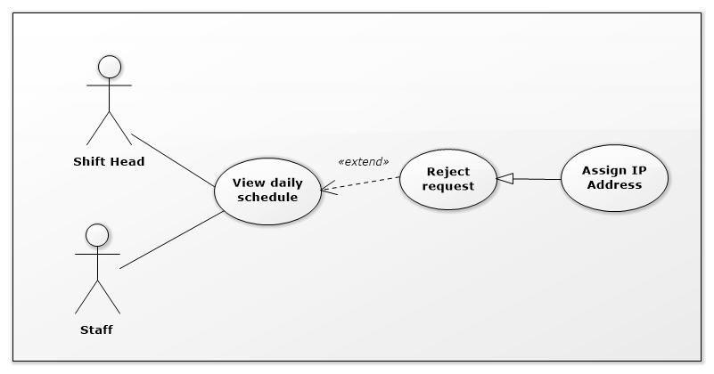

Figure 19: <Shift Head> Reject request Assign IP Address

|  |  |  |  |
| --- | --- | --- | --- |
| USE CASE – IMS020 | | | |
| Use Case No. | IMS020 | **Use Case Version** | 2.0 |
| Use Case Name | Reject request Assign IP Address | | |
| Author | Huỳnh Lâm Hà Tiên | | |
| Date | 23/01/2016 | **Priority** | medium |
| Actor:   * Shift Head.   Summary:   * This use case allows Shift Head to reject request Assign IP Address which was sent by customer.   Goal:   * Reject request Assign IP Address which was sent by customer.   Triggers:   * Shift Head clicks on “Reject” button on each event on daily schedule.   Preconditions:   * Shift Head must login into the system with role Shift Head in right shift.   Post Conditions:   * Success:   Customer will receive notification about reject request.  At the same time, the data of assign IP Address which customer sent will be deleted out of database.  The status of this request in database will be changed.   * Fail: Show error message with specified content.   Main Success Scenario:   |  |  |  | | --- | --- | --- | | Step | Actor Action | System Response | | 1 | Shift Head clicks on “Reject” button on each event on daily schedule. | System will show message “Are you sure to reject this request?” | | 2 | Shift Head clicks on “OK” button | * The data of assign IP Address which customer sent will be deleted out of database. * The status of this request in database will be changed. * Customer will receive notification about reject request. |   Alternatives Scenario:   |  |  |  | | --- | --- | --- | | Step | Actor Action | System Response | | 1 | Shift Head clicks on “Reject” button on each event on daily schedule. | System will show message “Are you sure to reject this request?” | | 2 | Shift Head clicks on “Reject” button | Return to Daily Schedule. |   Exceptions:   |  |  |  | | --- | --- | --- | | No | Cause | System Response | | 1 | Connect to Internet fail | Show message “Cannot send request, please connect to the Internet!” |   Relationships: Extend to View daily schedule.  Business Rules:   * The system only deletes the data of assign IP Address which customer sent, does not delete different information of this request. | | | |

*Table 29: Use case IMS020 - <Shift Head> Reject request Assign IP Address*

###### <Shift Head> Reject request Return IP Address

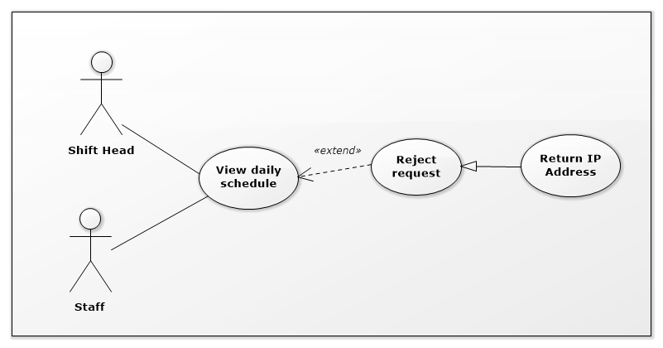

Figure 19: <Shift Head> Reject request Return IP Address

|  |  |  |  |
| --- | --- | --- | --- |
| USE CASE – IMS021 | | | |
| Use Case No. | IMS021 | **Use Case Version** | 2.0 |
| Use Case Name | Reject request Return IP Address | | |
| Author | Huỳnh Lâm Hà Tiên | | |
| Date | 23/01/2016 | **Priority** | medium |
| Actor:   * Shift Head.   Summary:   * This use case allows Shift Head to Reject request Return IP Address which was sent by customer.   Goal:   * Reject request Return IP Address which was sent by customer.   Triggers:   * Shift Head clicks on “Reject” button on each event on daily schedule.   Preconditions:   * Shift Head must login into the system with role Shift Head in right shift.   Post Conditions:   * Success:   Customer will receive notification about reject request.  At the same time, the data of return IP Address which customer sent will be deleted out of database.  The status of this request in database will be changed.   * Fail: Show error message with specified content.   Main Success Scenario:   |  |  |  | | --- | --- | --- | | Step | Actor Action | System Response | | 1 | Shift Head clicks on “Reject” button on each event on daily schedule. | System will show message “Are you sure to reject this request?” | | 2 | Shift Head clicks on “OK” button | * The data of return IP Address which customer sent will be deleted out of database. * The status of this request in database will be changed. * Customer will receive notification about reject request. |   Alternatives Scenario:   |  |  |  | | --- | --- | --- | | Step | Actor Action | System Response | | 1 | Shift Head clicks on “Reject” button on each event on daily schedule. | System will show message “Are you sure to reject this request?” | | 2 | Shift Head clicks on “Cancel” button | Return to Daily Schedule. |   Exceptions:   |  |  |  | | --- | --- | --- | | No | Cause | System Response | | 1 | Connect to Internet fail | Show message “Cannot send request, please connect to the Internet!” |   Relationships: Extend to View daily schedule.  Business Rules:   * The system only deletes the data of return IP Address which customer sent, does not delete different information of this request. | | | |

*Table 29: Use case IMS021 - <Shift Head> Reject request Return IP Address*

##### <Customer> Overview Use Case

.

Figure 17: <Customer> Customer Overview Use Case

###### <Customer> View server details

**

Figure 18: <Customer> View server details

|  |  |  |  |
| --- | --- | --- | --- |
| USE CASE – IMS010 | | | |
| Use Case No. | IMS010 | **Use Case Version** | 2.0 |
| Use Case Name | View server details | | |
| Author | Huỳnh Lâm Hà Tiên | | |
| Date | 23/01/2016 | **Priority** | medium |
| Actor:   * Customer.   Summary:   * This use case allows customer to view his/her server information.   Goal:   * View server information.   Triggers:   * Customer clicks on “View server” link on the panel.   Preconditions:   * Customer must login into the system with role Customer.   Post Conditions:   * Success: Server information will be showed. * Fail: Server information will not be showed. Show error message with specified content.   Main Success Scenario:   |  |  |  | | --- | --- | --- | | Step | Actor Action | System Response | | 1 | Customer clicks on “View server” link on the panel. | Navigate to View server information page which contains:   * Server name: link * Default IP: label * Status: label * Registered Date: label |   Alternatives Scenario: N/A.  Exceptions:   |  |  |  | | --- | --- | --- | | No | Actor Action | System Response | | 1 | Connect to database fail | Show message “Error, please try again!” |   Relationships: N/A.  Business Rules: N/A. | | | |

Table 28: Use case IMS010 - <Customer> View server details

###### <Customer> View Request History

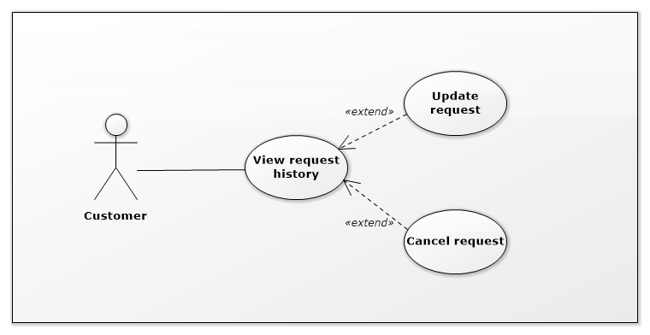

Figure 19: <Customer> View Request History

|  |  |  |  |
| --- | --- | --- | --- |
| USE CASE – IMS011 | | | |
| Use Case No. | IMS011 | **Use Case Version** | 2.0 |
| Use Case Name | View Request History | | |
| Author | Huỳnh Lâm Hà Tiên | | |
| Date | 23/01/2016 | **Priority** | medium |
| Actor:   * Customer.   Summary:   * This use case allows customers to view history of their requests.   Goal:   * Customer can view history of requests.   Triggers:   * Customer logins into the system, the History of requests will be displayed.   Preconditions:   * Customer must login into the system with role Customer.   Post Conditions:   * Success: List of history of requests will be displayed. * Fail: Show error message with specified content.   Main Success Scenario:   |  |  |  | | --- | --- | --- | | Step | Actor Action | System Response | | 1 | Customer logins into the system. | List of history of requests will be displayed. |   Alternatives Scenario: N/A.  Exceptions:   |  |  |  | | --- | --- | --- | | No | Cause | System Response | | 1 | Connect to database fail | Show message “Error, please try again!” |   Relationships:   * Extended by Update request. * Included by Cancel request.   Business Rules:   * List of history of requests will be displayed in order of time. | | | |

Table 29: Use case IMS011 - <Customer> View Request History

###### <Customer> Add server

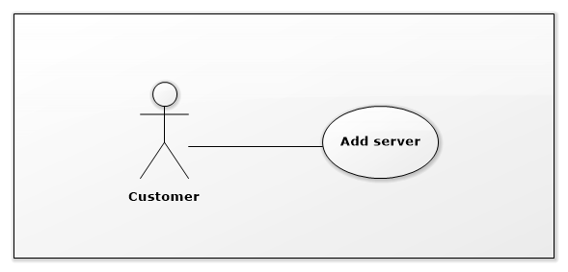

Figure 19: <Customer> Add server

|  |  |  |  |
| --- | --- | --- | --- |
| USE CASE – IMS011 | | | |
| Use Case No. | IMS011 | **Use Case Version** | 2.0 |
| Use Case Name | Add server | | |
| Author | Huỳnh Lâm Hà Tiên | | |
| Date | 23/01/2016 | **Priority** | medium |
| Actor:   * Customer.   Summary:   * This use case allows customer to add new server into data center.   Goal:   * Add information of new server quickly.   Triggers:   * Customer clicks on “Make request” on the panel and select “Add New Server”   Preconditions:   * Customer must login into the system with role Customer.   Post Conditions:   * Success: Request will be sent to data center, Shift Head will receive notification. At the same time, the data about appointment and new server will be saved into database. * Fail: Show error message with specified content.   Main Success Scenario:   |  |  |  | | --- | --- | --- | | Step | Actor Action | System Response | | 1 | Customer clicks on “Make request” on the panel and select “Add New Server” | System will display Request Add New Server Popup | | 2 | Input data in fields of Request Add New Server Popup and clicks on “Send” button | System will send request to data center:   * The information about appointment and the data of new server will be saved into database. * The Head Shift who is in shift will have notification. |   Alternatives Scenario:   |  |  |  | | --- | --- | --- | | Step | Actor Action | System Response | | 1 | Customer clicks on “Make request” and select “Add New Server”. | System will display Request Add New Server Popup. | | 2 | Input data in fields of request page and clicks on “Cancel” button. | Return to Request History Page. |   Exceptions:   |  |  |  | | --- | --- | --- | | No | Cause | System Response | | 1 | Connect to Internet fail | Show message “Cannot send request, please connect to the Internet!” |   Relationships: N/A.  Business Rules:   * Customer can add one or more new servers in one request. | | | |

Table 29: Use case IMS011 - <Customer> Add server

###### <Customer> Return IP

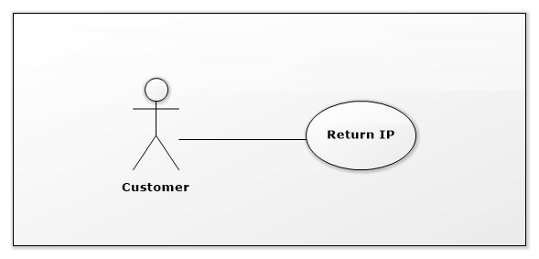

Figure 19: <Customer> Return IP

|  |  |  |  |
| --- | --- | --- | --- |
| USE CASE – IMS011 | | | |
| Use Case No. | IMS011 | **Use Case Version** | 2.0 |
| Use Case Name | Return IP | | |
| Author | Huỳnh Lâm Hà Tiên | | |
| Date | 23/01/2016 | **Priority** | medium |
| Actor:   * Customer.   Summary:   * This use case allows customer to return IP Address for data center.   Goal:   * Return IP Address for data center quickly.   Triggers:   * Customer clicks on “Make request” on the panel and select “Return IP Address”   Preconditions:   * Customer must login into the system with role Customer.   Post Conditions:   * Success: Request will be sent to data center, Shift Head will receive notification. At the same time, the data about IP Address which want to return will be saved into database. * Fail: Show error message with specified content.   Main Success Scenario:   |  |  |  | | --- | --- | --- | | Step | Actor Action | System Response | | 1 | Customer clicks on “Make request” on the panel and select “Return IP Address” | System will display Request Return IP Address Popup | | 2 | Input data in fields of Request Return IP Address Popup and clicks on “Send” button | System will send request to data center:   * The information about IP Address which want to return will be saved into database. * The Head Shift who is in shift will have notification. |   Alternatives Scenario:   |  |  |  | | --- | --- | --- | | Step | Actor Action | System Response | | 1 | Customer clicks on “Make request” and select “Return IP Address”. | System will display Request Return IP Address Popup. | | 2 | Input data in fields of Request Return IP Address Popup and clicks on “Cancel” button. | Return to Request History Page. |   Exceptions:   |  |  |  | | --- | --- | --- | | No | Cause | System Response | | 1 | Connect to Internet fail | Show message “Cannot send request, please connect to the Internet!” |   Relationships:  Business Rules:   * Customer can request to return one or more IP Addresses for data center in one request. | | | |

Table 29: Use case IMS011 - <Customer> Return IP

###### <Customer> Update request Add New Server

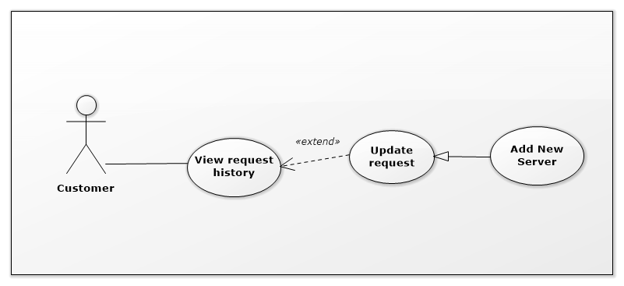

Figure 19: <Customer> Update request Add New Server

|  |  |  |  |
| --- | --- | --- | --- |
| USE CASE – IMS011 | | | |
| Use Case No. | IMS011 | **Use Case Version** | 2.0 |
| Use Case Name | Update request Add New Server | | |
| Author | Huỳnh Lâm Hà Tiên | | |
| Date | 23/01/2016 | **Priority** | medium |
| Actor:   * Customer.   Summary:   * This use case allows customer to update request Add New Server which was sent.   Goal:   * Update request Add New Server which was sent.   Triggers:   * On Request History Page, customer select request Add New Server which want to update. * Edit data in Request Add New Server Popup and clicks on “Update” button.   Preconditions:   * Customer must login into the system with role Customer. * The request which want to update was sent to data center.   Post Conditions:   * Success: Shift Head will receive notification about update request. At the same time, the data about appointment or server which customer changed will be updated into database. * Fail: Show error message with specified content.   Main Success Scenario:   |  |  |  | | --- | --- | --- | | Step | Actor Action | System Response | | 1 | On Request History Page, customer clicks on request Add New Server which want to update. | System will display Request Add New Server Popup with content was created in the past. | | 2 | Customer clicks on “Update” button | System will display Request Add New Server Popup with fields can edit. | | 3 | Customer update information and clicks on “Send” button | * The data about appointment or server which customer changed will be updated into database. * Shift Head will receive notification about update request. |   Alternatives Scenario:   |  |  |  | | --- | --- | --- | | Step | Actor Action | System Response | | 1 | Customer clicks on request which want to update on Request History Page. | System will display Request Add New Server Popup with content was created in the past. | | 2 | Customer clicks on “Update” button | System will display Request Add New Server Popup with fields can edit. | | 3 | Customer update information and clicks on “Cancel” button | Return to Request Add New Server Popup with original content. |   Exceptions:   |  |  |  | | --- | --- | --- | | No | Cause | System Response | | 1 | Connect to Internet fail | Show message “Cannot send request, please connect to the Internet!” |   Relationships: Extend to View request history.  Business Rules:   * Update request is performed same although it was approved by Shift Head or not. | | | |

Table 29: Use case IMS011 - <Customer> Update request Add New Server

###### <Customer> Update request Upgrade Server

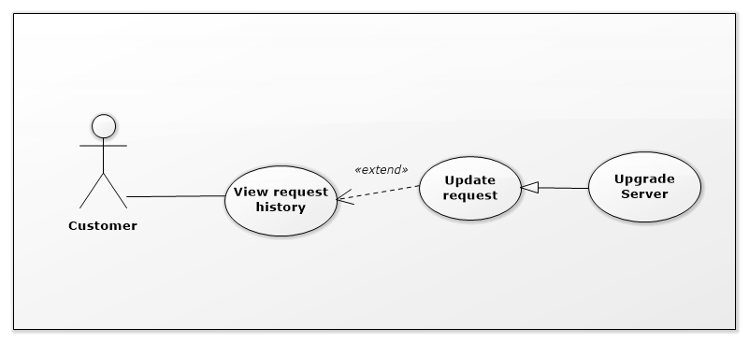

Figure 19: <Customer> Update request Update Server

|  |  |  |  |
| --- | --- | --- | --- |
| USE CASE – IMS011 | | | |
| Use Case No. | IMS011 | **Use Case Version** | 2.0 |
| Use Case Name | Update request Upgrade Server | | |
| Author | Huỳnh Lâm Hà Tiên | | |
| Date | 23/01/2016 | **Priority** | medium |
| Actor:   * Customer.   Summary:   * This use case allows customer to update request Upgrade Server which was sent.   Goal:   * Update request Upgrade Server which was sent.   Triggers:   * On Request History Page, customer select request Upgrade Server which want to update * Edit data in Request Upgrade Server Popup and clicks on “Update” button.   Preconditions:   * Customer must login into the system with role Customer. * The request which want to update was sent to data center.   Post Conditions:   * Success: Shift Head will receive notification about update request. At the same time, the data about appointment or upgrade content of server which customer changed will be updated into database. * Fail: Show error message with specified content.   Main Success Scenario:   |  |  |  | | --- | --- | --- | | Step | Actor Action | System Response | | 1 | On Request History Page, customer clicks on request Upgrade Server which want to update. | System will display Request Upgrade Server Popup with content was created in the past. | | 2 | Customer clicks on “Update” button | System will display Request Upgrade Server Popup with fields can edit. | | 3 | Customer update information and clicks on “Send” button | * The data about appointment or upgrade content of server which customer changed will be updated into database. * Shift Head will receive notification about update request. |   Alternatives Scenario:   |  |  |  | | --- | --- | --- | | Step | Actor Action | System Response | | 1 | On Request History Page, customer clicks on request Upgrade Server which want to update. | System will display Request Upgrade Server Popup with content was created in the past. | | 2 | Customer clicks on “Update” button | System will display Request Upgrade Server Popup with fields can edit. | | 3 | Customer update information and clicks on “Cancel” button | Return to Request Upgrade Server Popup with original content. |   Exceptions:   |  |  |  | | --- | --- | --- | | No | Cause | System Response | | 1 | Connect to Internet fail | Show message “Cannot send request, please connect to the Internet!” |   Relationships: Extend to View request history.  Business Rules:   * Update request is performed same although it was approved by Shift Head or not. | | | |

Table 29: Use case IMS011 - <Customer> Update request Upgrade Server

###### <Customer> Update request Change IP Address

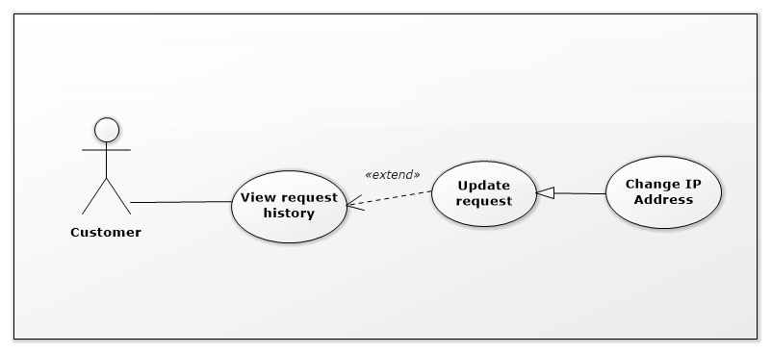

Figure 19: <Customer> Update request Change IP Address

|  |  |  |  |
| --- | --- | --- | --- |
| USE CASE – IMS011 | | | |
| Use Case No. | IMS011 | **Use Case Version** | 2.0 |
| Use Case Name | Update request Change IP Address | | |
| Author | Huỳnh Lâm Hà Tiên | | |
| Date | 23/01/2016 | **Priority** | medium |
| Actor:   * Customer.   Summary:   * This use case allows customer to update request Change IP Address which was sent.   Goal:   * Update request Change IP Address which was sent.   Triggers:   * On Request History Page, customer select request Change IP Address which want to update * Edit data in Request Change IP Address Popup and clicks on “Update” button.   Preconditions:   * Customer must login into the system with role Customer. * The request which want to update was sent to data center.   Post Conditions:   * Success: Shift Head will receive notification about update request. At the same time, the data about change IP Address in the request which customer changed will be updated into database. * Fail: Show error message with specified content.   Main Success Scenario:   |  |  |  | | --- | --- | --- | | Step | Actor Action | System Response | | 1 | On Request History Page, customer clicks on request Change IP Address which want to update. | System will display Request Change IP Address Popup with content was created in the past. | | 2 | Customer clicks on “Update” button | System will display Request Change IP Address Popup with fields can edit. | | 3 | Customer update information and clicks on “Send” button | * The data about change IP Address in the request which customer changed will be updated into database. * Shift Head will receive notification about update request. |   Alternatives Scenario:   |  |  |  | | --- | --- | --- | | Step | Actor Action | System Response | | 1 | On Request History Page, customer clicks on request Change IP Address which want to update. | System will display Request Change IP Address Popup with content was created in the past. | | 2 | Customer clicks on “Update” button | System will display Request Change IP Address Popup with fields can edit. | | 3 | Customer update information and clicks on “Cancel” button | Return to Request Change IP Address Popup with original content. |   Exceptions:   |  |  |  | | --- | --- | --- | | No | Cause | System Response | | 1 | Connect to Internet fail | Show message “Cannot send request, please connect to the Internet!” |   Relationships: Extend to View request history.  Business Rules:   * Update request is performed same although it was approved by Shift Head or not. | | | |

Table 29: Use case IMS011 - <Customer> Update request Change IP Address

###### <Customer> Update request Assign IP Address

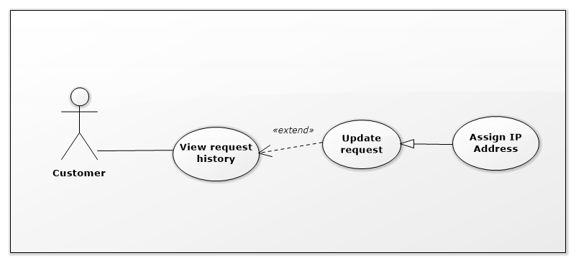

Figure 19: <Customer> Update request Assign IP Address

|  |  |  |  |
| --- | --- | --- | --- |
| USE CASE – IMS011 | | | |
| Use Case No. | IMS011 | **Use Case Version** | 2.0 |
| Use Case Name | Update request Assign IP Address | | |
| Author | Huỳnh Lâm Hà Tiên | | |
| Date | 23/01/2016 | **Priority** | medium |
| Actor:   * Customer.   Summary:   * This use case allows customer to update request Assign IP Address which was sent.   Goal:   * Update request Assign IP Address which was sent.   Triggers:   * On Request History Page, customer select request Assign IP Address which want to update * Edit data in Request Assign IP Address Popup and clicks on “Update” button.   Preconditions:   * Customer must login into the system with role Customer. * The request which want to update was sent to data center.   Post Conditions:   * Success: Shift Head will receive notification about update request. At the same time, the data about assign IP Address in the request which customer changed will be updated into database. * Fail: Show error message with specified content.   Main Success Scenario:   |  |  |  | | --- | --- | --- | | Step | Actor Action | System Response | | 1 | On Request History Page, customer clicks on request Assign IP Address which want to update. | System will display Request Assign IP Address Popup with content was created in the past. | | 2 | Customer clicks on “Update” button | System will display Request Assign IP Address Popup with fields can edit. | | 3 | Customer update information and clicks on “Send” button | * The data about assign IP Address in the request which customer changed will be updated into database. * Shift Head will receive notification about update request. |   Alternatives Scenario:   |  |  |  | | --- | --- | --- | | Step | Actor Action | System Response | | 1 | On Request History Page, customer clicks on request Assign IP Address which want to update. | System will display Request Assign IP Address Popup with content was created in the past. | | 2 | Customer clicks on “Update” button | System will display Request Assign IP Address Popup with fields can edit. | | 3 | Customer update information and clicks on “Cancel” button | Return to Request Assign IP Address Popup with original content. |   Exceptions:   |  |  |  | | --- | --- | --- | | No | Cause | System Response | | 1 | Connect to Internet fail | Show message “Cannot send request, please connect to the Internet!” |   Relationships: Extend to View request history.  Business Rules:   * Update request is performed same although it was approved by Shift Head or not. | | | |

Table 29: Use case IMS011 - <Customer> Update request Assign IP Address

###### <Customer> Update request Return IP Address

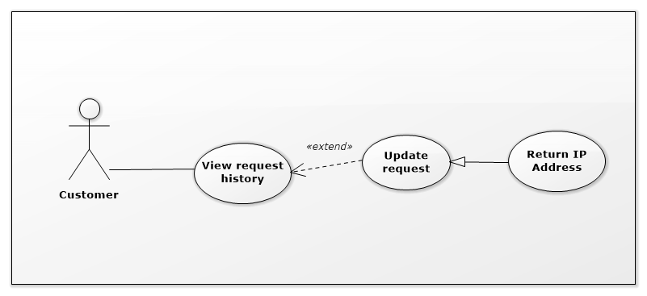

Figure 19: <Customer> Update request Return IP Address

|  |  |  |  |
| --- | --- | --- | --- |
| USE CASE – IMS011 | | | |
| Use Case No. | IMS011 | **Use Case Version** | 2.0 |
| Use Case Name | Update request Return IP Address | | |
| Author | Huỳnh Lâm Hà Tiên | | |
| Date | 23/01/2016 | **Priority** | medium |
| Actor:   * Customer.   Summary:   * This use case allows customer to update request Return IP Address which was sent.   Goal:   * Update request Return IP Address which was sent.   Triggers:   * On Request History Page, customer select request Return IP Address which want to update * Edit data in Request Return IP Address Popup and clicks on “Update” button.   Preconditions:   * Customer must login into the system with role Customer. * The request which want to update was sent to data center.   Post Conditions:   * Success: Shift Head will receive notification about update request. At the same time, the data about return IP Address in the request which customer changed will be updated into database. * Fail: Show error message with specified content.   Main Success Scenario:   |  |  |  | | --- | --- | --- | | Step | Actor Action | System Response | | 1 | On Request History Page, customer clicks on request Return IP Address which want to update. | System will display Request Return IP Address Popup with content was created in the past. | | 2 | Customer clicks on “Update” button | System will display Request Return IP Address Popup with fields can edit. | | 3 | Customer update information and clicks on “Send” button | * The data about return IP Address in the request which customer changed will be updated into database. * Shift Head will receive notification about update request. |   Alternatives Scenario:   |  |  |  | | --- | --- | --- | | Step | Actor Action | System Response | | 1 | On Request History Page, customer clicks on request Return IP Address which want to update. | System will display Request Return IP Address Popup with content was created in the past. | | 2 | Customer clicks on “Update” button | System will display Request Return IP Address Popup with fields can edit. | | 3 | Customer update information and clicks on “Cancel” button | Return to Request Return IP Address Popup with original content. |   Exceptions:   |  |  |  | | --- | --- | --- | | No | Cause | System Response | | 1 | Connect to Internet fail | Show message “Cannot send request, please connect to the Internet!” |   Relationships: Extend to View request history.  Business Rules:   * Update request is performed same although it was approved by Shift Head or not. | | | |

*Table 29: Use case IMS011 - <Customer> Update request Return IP Address*

###### <Customer> Cancel request Add New Server

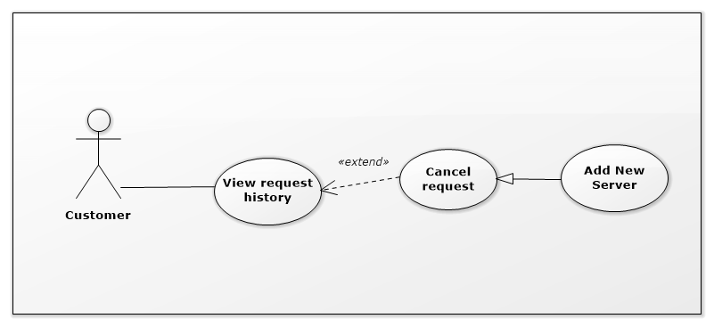

Figure 19: <Customer> Cancel request Add New Server

|  |  |  |  |
| --- | --- | --- | --- |
| USE CASE – IMS011 | | | |
| Use Case No. | IMS011 | **Use Case Version** | 2.0 |
| Use Case Name | Cancel request Add New Server | | |
| Author | Huỳnh Lâm Hà Tiên | | |
| Date | 24/01/2016 | **Priority** | medium |
| Actor:   * Customer.   Summary:   * This use case allows customer to cancel request Add New Server which was sent.   Goal:   * Cancel request Add New Server which was sent.   Triggers:   * On Request History Page, customer select request Add New Server which want to cancel. * Customer clicks on “Cancel Request” button on Request Add New Server Popup.   Preconditions:   * Customer must login into the system with role Customer. * The request which want to cancel was sent to data center.   Post Conditions:   * Success:   Shift Head will receive notification about cancel request.  At the same time, the new server information which customer sent will be deleted out of database.  The status of this request in database will be changed.   * Fail: Show error message with specified content.   Main Success Scenario:   |  |  |  | | --- | --- | --- | | Step | Actor Action | System Response | | 1 | On Request History Page, customer clicks on request Add New Server which want to cancel. | System will display Request Add New Server Popup with content was created in the past. | | 2 | Customer clicks on “Cancel Request” button | System will show message “Are you sure to cancel this request?” | | 3 | Customer clicks on “OK” button | * The new server information which customer sent will be deleted out of database. * The status of this request in database will be changed. * Shift Head will receive notification about cancel request. |   Alternatives Scenario:   |  |  |  | | --- | --- | --- | | Step | Actor Action | System Response | | 1 | On Request History Page, customer clicks on request Add New Server which want to cancel. | System will display Request Add New Server Popup with content was created in the past. | | 2 | Customer clicks on “Cancel Request” button | System will show message “Are you sure to cancel this request?” | | 3 | Customer clicks on “Cancel” button | Return to Request Add New Server Popup with original content. |   Exceptions:   |  |  |  | | --- | --- | --- | | No | Cause | System Response | | 1 | Connect to Internet fail | Show message “Cannot send request, please connect to the Internet!” |   Relationships: Extend to View request history.  Business Rules:   * The system only deletes the information of new server which customer sent, does not delete different information of this request. | | | |

*Table 29: Use case IMS011 - <Customer> Cancel request Add New Server*

###### <Customer> Cancel request Upgrade Server

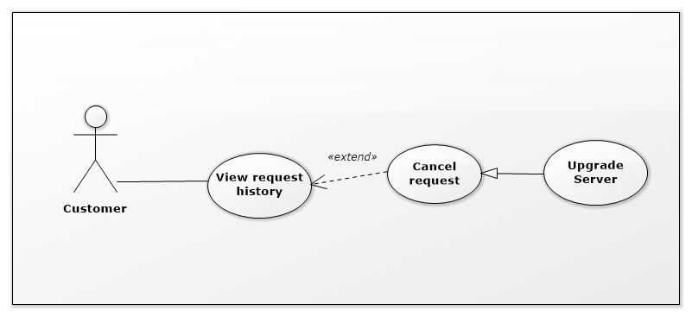

Figure 19: <Customer> Cancel request Upgrade Server

|  |  |  |  |
| --- | --- | --- | --- |
| USE CASE – IMS011 | | | |
| Use Case No. | IMS011 | **Use Case Version** | 2.0 |
| Use Case Name | Cancel request Upgrade Server | | |
| Author | Huỳnh Lâm Hà Tiên | | |
| Date | 24/01/2016 | **Priority** | medium |
| Actor:   * Customer.   Summary:   * This use case allows customer to cancel request Upgrade Server which was sent.   Goal:   * Cancel request Upgrade Server which was sent.   Triggers:   * On Request History Page, customer select request Upgrade Server which want to cancel. * Customer clicks on “Cancel Request” button on Request Upgrade Server Popup.   Preconditions:   * Customer must login into the system with role Customer. * The request which want to cancel was sent to data center.   Post Conditions:   * Success:   Shift Head will receive notification about cancel request.  At the same time, the upgrade information of server which customer sent will be deleted out of database.  The status of this request in database will be changed.   * Fail: Show error message with specified content.   Main Success Scenario:   |  |  |  | | --- | --- | --- | | Step | Actor Action | System Response | | 1 | On Request History Page, customer clicks on request Upgrade Server which want to cancel. | System will display Request Upgrade Server Popup with content was created in the past. | | 2 | Customer clicks on “Cancel Request” button | System will show message “Are you sure to cancel this request?” | | 3 | Customer clicks on “OK” button | * The upgrade information of server which customer sent will be deleted out of database. * The status of this request in database will be changed. * Shift Head will receive notification about cancel request. |   Alternatives Scenario:   |  |  |  | | --- | --- | --- | | Step | Actor Action | System Response | | 1 | On Request History Page, customer clicks on request Upgrade Server which want to cancel. | System will display Request Upgrade Server Popup with content was created in the past. | | 2 | Customer clicks on “Cancel Request” button | System will show message “Are you sure to cancel this request?” | | 3 | Customer clicks on “Cancel” button | Return to Request Upgrade Server Popup with original content. |   Exceptions: Extend to View request history.   |  |  |  | | --- | --- | --- | | No | Cause | System Response | | 1 | Connect to Internet fail | Show message “Cannot send request, please connect to the Internet!” |   Relationships:  Business Rules:   * The system only deletes the upgrade information of server which customer sent, does not delete different information of this request. | | | |

*Table 29: Use case IMS011 - <Customer> Cancel request Add New Server*

###### <Customer> Cancel request Change IP Address

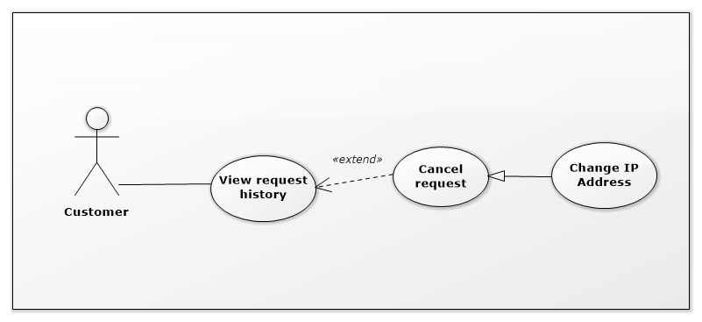

Figure 19: <Customer> Cancel request Change IP Address

|  |  |  |  |
| --- | --- | --- | --- |
| USE CASE – IMS011 | | | |
| Use Case No. | IMS011 | **Use Case Version** | 2.0 |
| Use Case Name | Cancel request Change IP Address | | |
| Author | Huỳnh Lâm Hà Tiên | | |
| Date | 24/01/2016 | **Priority** | medium |
| Actor:   * Customer.   Summary:   * This use case allows customer to cancel request Change IP Address which was sent.   Goal:   * Cancel request Change IP Address which was sent.   Triggers:   * On Request History Page, customer select request Change IP Address which want to cancel. * Customer clicks on “Cancel Request” button on Request Change IP Address Popup.   Preconditions:   * Customer must login into the system with role Customer. * The request which want to cancel was sent to data center.   Post Conditions:   * Success:   Shift Head will receive notification about cancel request.  At the same time, the data of change IP Address which customer sent will be deleted out of database.  The status of this request in database will be changed.   * Fail: Show error message with specified content.   Main Success Scenario:   |  |  |  | | --- | --- | --- | | Step | Actor Action | System Response | | 1 | On Request History Page, customer clicks on request Change IP Status which want to cancel. | System will display Request Change IP Address Popup with content was created in the past. | | 2 | Customer clicks on “Cancel Request” button | System will show message “Are you sure to cancel this request?” | | 3 | Customer clicks on “OK” button | * The data of change IP Address which customer sent will be deleted out of database. * The status of this request in database will be changed. * Shift Head will receive notification about cancel request. |   Alternatives Scenario:   |  |  |  | | --- | --- | --- | | Step | Actor Action | System Response | | 1 | On Request History Page, customer clicks on request Change IP Address which want to cancel. | System will display Request Change IP Address Popup with content was created in the past. | | 2 | Customer clicks on “Cancel Request” button | System will show message “Are you sure to cancel this request?” | | 3 | Customer clicks on “Cancel” button | Return to Request Change IP Address Popup with original content. |   Exceptions:   |  |  |  | | --- | --- | --- | | No | Cause | System Response | | 1 | Connect to Internet fail | Show message “Cannot send request, please connect to the Internet!” |   Relationships: Extend to View request history.  Business Rules:   * The system only deletes the data of change IP Address which customer sent, does not delete different information of this request. | | | |

*Table 29: Use case IMS011 - <Customer> Cancel request Change IP Address*

###### <Customer> Cancel request Assign IP Address

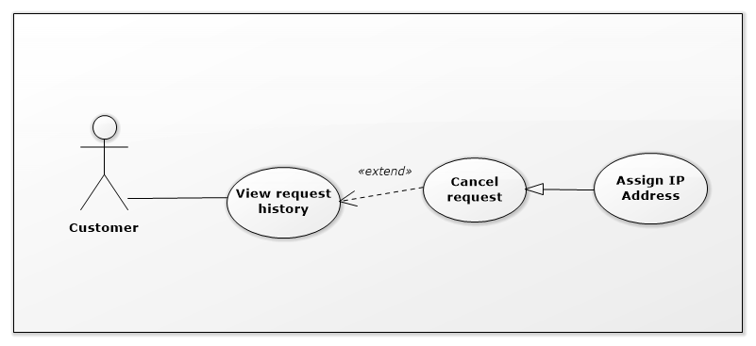

Figure 19: <Customer> Cancel request Assign IP Address

|  |  |  |  |
| --- | --- | --- | --- |
| USE CASE – IMS011 | | | |
| Use Case No. | IMS011 | **Use Case Version** | 2.0 |
| Use Case Name | Cancel request Assign IP Address | | |
| Author | Huỳnh Lâm Hà Tiên | | |
| Date | 24/01/2016 | **Priority** | medium |
| Actor:   * Customer.   Summary:   * This use case allows customer to cancel request Assign IP Address which was sent.   Goal:   * Cancel request Assign IP Address which was sent.   Triggers:   * On Request History Page, customer select request Assign IP Address which want to cancel. * Customer clicks on “Cancel Request” button on Request Assign IP Address Popup.   Preconditions:   * Customer must login into the system with role Customer. * The request which want to cancel was sent to data center.   Post Conditions:   * Success:   Shift Head will receive notification about cancel request.  At the same time, the data of assign IP Address which customer sent will be deleted out of database.  The status of this request in database will be changed.   * Fail: Show error message with specified content.   Main Success Scenario:   |  |  |  | | --- | --- | --- | | Step | Actor Action | System Response | | 1 | On Request History Page, customer clicks on request Assign IP Status which want to cancel. | System will display Request Assign IP Address Popup with content was created in the past. | | 2 | Customer clicks on “Cancel Request” button | System will show message “Are you sure to cancel this request?” | | 3 | Customer clicks on “OK” button | * The data of assign IP Address which customer sent will be deleted out of database. * The status of this request in database will be changed. * Shift Head will receive notification about cancel request. |   Alternatives Scenario:   |  |  |  | | --- | --- | --- | | Step | Actor Action | System Response | | 1 | On Request History Page, customer clicks on request Assign IP Address which want to cancel. | System will display Request Assign IP Address Popup with content was created in the past. | | 2 | Customer clicks on “Cancel Request” button | System will show message “Are you sure to cancel this request?” | | 3 | Customer clicks on “Cancel” button | Return to Request Assign IP Address Popup with original content. |   Exceptions:   |  |  |  | | --- | --- | --- | | No | Cause | System Response | | 1 | Connect to Internet fail | Show message “Cannot send request, please connect to the Internet!” |   Relationships: Extend to View request history.  Business Rules:   * The system only deletes the data of assign IP Address which customer sent, does not delete different information of this request. | | | |

*Table 29: Use case IMS011 - <Customer> Cancel request Assign IP Address*

###### <Customer> Cancel request Return IP Address

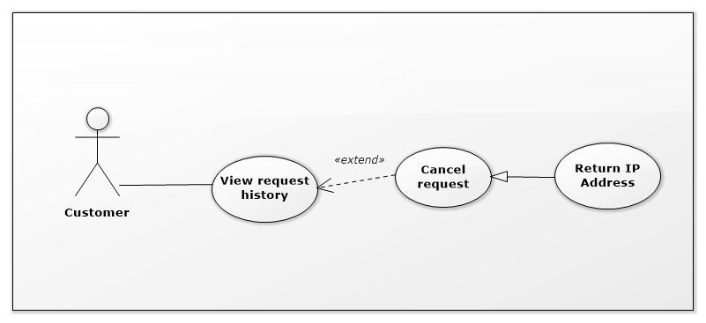

Figure 19: <Customer> Cancel request Return IP Address

|  |  |  |  |
| --- | --- | --- | --- |
| USE CASE – IMS011 | | | |
| Use Case No. | IMS011 | **Use Case Version** | 2.0 |
| Use Case Name | Cancel request Return IP Address | | |
| Author | Huỳnh Lâm Hà Tiên | | |
| Date | 24/01/2016 | **Priority** | medium |
| Actor:   * Customer.   Summary:   * This use case allows customer to cancel request Return IP Address which was sent.   Goal:   * Cancel request Return IP Address which was sent.   Triggers:   * On Request History Page, customer select request Return IP Address which want to cancel. * Customer clicks on “Cancel Request” button on Request Return IP Address Popup.   Preconditions:   * Customer must login into the system with role Customer. * The request which want to cancel was sent to data center.   Post Conditions:   * Success:   Shift Head will receive notification about cancel request.  At the same time, the data of return IP Address which customer sent will be deleted out of database.  The status of this request in database will be changed.   * Fail: Show error message with specified content.   Main Success Scenario:   |  |  |  | | --- | --- | --- | | Step | Actor Action | System Response | | 1 | On Request History Page, customer clicks on request Return IP Status which want to cancel. | System will display Request Return IP Address Popup with content was created in the past. | | 2 | Customer clicks on “Cancel Request” button | System will show message “Are you sure to cancel this request?” | | 3 | Customer clicks on “OK” button | * The data of return IP Address which customer sent will be deleted out of database. * The status of this request in database will be changed. * Shift Head will receive notification about cancel request. |   Alternatives Scenario:   |  |  |  | | --- | --- | --- | | Step | Actor Action | System Response | | 1 | On Request History Page, customer clicks on request Return IP Address which want to cancel. | System will display Request Return IP Address Popup with content was created in the past. | | 2 | Customer clicks on “Cancel Request” button | System will show message “Are you sure to cancel this request?” | | 3 | Customer clicks on “Cancel” button | Return to Request Return IP Address Popup with original content. |   Exceptions:   |  |  |  | | --- | --- | --- | | No | Cause | System Response | | 1 | Connect to Internet fail | Show message “Cannot send request, please connect to the Internet!” |   Relationships: Extend to View request history.  Business Rules:   * The system only deletes the data of return IP Address which customer sent, does not delete different information of this request. | | | |

*Table 29: Use case IMS011 - <Customer> Cancel request Return IP Address*

##### <Staff> Overview Use Case

Figure 13: <Staff> Overview Use Case

###### <Staff> View request



Figure 8 <Staff> View request

|  |  |  |  |
| --- | --- | --- | --- |
| USE CASE – IMS003 | | | |
| Use Case No. | IMS003 | **Use Case Version** | 2.0 |
| Use Case Name | View request | | |
| Author | Huỳnh Lâm Hà Tiên | | |
| Date | 23/01/2016 | **Priority** | Normal |
| Actor:   * Staff   Summary:   * This use case allows Staff to view request from customer.   Goal:   * View request.   Triggers:   * Staff clicks on each event at Daily Schedule Page or clicks on each request at Server Page.   Precondition:   * The Staff must login to the system with Staff role.   Post Conditions:   * Success: Request page will be displayed. * Fail: Show message error with specified content.   Main Success Scenario:   |  |  |  | | --- | --- | --- | | Step | Actor Action | System Response | | 1 | Staff clicks on each event at Daily Schedule Page or clicks on each request at Server Page. | The Request Page will be displayed. |   Alternative Scenario: N/A.  Exceptions:   |  |  |  | | --- | --- | --- | | No | Actor Action | System Response | | 1 | Connect to database fail | Show message “Error, please try again!” |   Relationships:   * Extend to View daily Schedule. * Extend to View server. * Extended by Accept request. * Extended by Approve request. * Extended by Export procedure. * Extended by Assign IP to server. * Extended by View IP. * Extended by View location.   Business Rules:   * When the server has request from customer, that request’s link will be displayed in Server Table. * Staff who does not login in right shift or was not assigned this task, all buttons and check boxes in Request Page will be disabled. | | | |

Table 19: Use case IMS003 - <Staff> View request

###### <Staff> View server



Figure 14: <Staff> View server

|  |  |  |  |
| --- | --- | --- | --- |
| USE CASE – IMS012 | | | |
| Use Case No. | IMS012 | **Use Case Version** | 2.0 |
| Use Case Name | View server | | |
| Author | Huỳnh Lâm Hà Tiên | | |
| Date | 23/01/2016 | **Priority** | medium |
| Actor:   * Staff.   Summary:   * This use case allows Staff to view list all server information of customers.   Goal:   * View server information.   Triggers:   * Staff clicks on “View server” link on the panel.   Preconditions:   * Staff must login into the system with role Staff.   Post Conditions:   * Success: Server information will be showed. * Fail: Server information will not be showed. Show error message with specified content.   Main Success Scenario:   |  |  |  | | --- | --- | --- | | Step | Actor Action | System Response | | 1 | Staff clicks on “View server” link on the panel. | Navigate to View server information page which contains:   * Customer name: link * Server name: link * Default IP Address: label * Status: label * Location: label * Request: label |   Alternative Scenario: N/A.  Exceptions:   |  |  |  | | --- | --- | --- | | No | Actor Action | System Response | | 1 | Connect to database fail | Show message “Error, please try again!” |   Relationships:   * Extended by View server details. * Extended by View request.   Business Rules:   * Staff is just viewed server information and Staff cannot edit anything with server information. * If Staff was assigned request, that request on Server table will become link. | | | |

Table 23: Use case IMS012 - <Staff> View server

###### <Staff> View daily schedule



Figure 14: <Staff> View daily schedule

|  |  |  |  |
| --- | --- | --- | --- |
| USE CASE – IMS013 | | | |
| Use Case No. | IMS013 | **Use Case Version** | 2.0 |
| Use Case Name | View daily schedule | | |
| Author | Huỳnh Lâm Hà Tiên | | |
| Date | 24/01/2016 | **Priority** | medium |
| Actor:   * Staff.   Summary:   * This use case allows Staff to view all of the today’s appointments and note from previous shift.   Goal:   * System provides schedule which helps Staff to view the appointments with customers.   Triggers:   * When Staff login to the system, the page contains daily schedule and the note of previous shift will be showed.   Preconditions:   * The Staff must login to the system with Staff role.   Post Conditions:   * Success: The daily schedule and note will be showed. * Fail: N/A   Main Success Scenario:   |  |  |  | | --- | --- | --- | | Step | Actor Action | System Response | | 1 | Staff login to the system | The page contains daily schedule will be showed. |   Alternative Scenario:   |  |  |  | | --- | --- | --- | | Step | Actor Action | System Response | | 1 | Staff login to the system and today does not have any customer’s arrival. | A message will be showed “Today does not have any appointment!” |   Exceptions: N/A  Relationships:   * Extended by Write note. * Extended by Confirm Arrival. * Extended by Assign task. * Extended by View request. * Extended by Reject request.   Business Rules:   * The customer link in daily schedule will be showed when today has appointments. * The link of “Write note for the next shift” will be disabled when Staff views Daily Schedule Page. | | | |

Table 22: Use case IMS013 - <Staff> View daily schedule

###### <Staff> Confirm Arrival

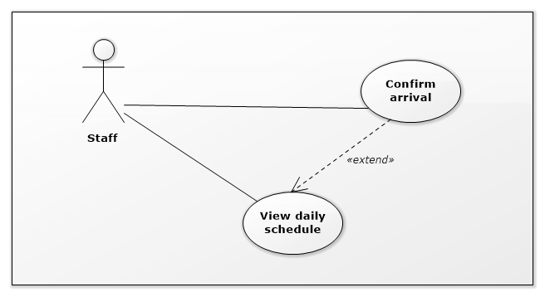

Figure 9: <Staff> Confirm Arrival

|  |  |  |  |
| --- | --- | --- | --- |
| USE CASE – IMS005 | | | |
| Use Case No. | IMS005 | **Use Case Version** | 2.0 |
| Use Case Name | Confirm Arrival | | |
| Author | Huỳnh Lâm Hà Tiên | | |
| Date | 24/01/2016 | **Priority** | medium |
| Actor:   * Staff.   Summary:   * This use case allows Staff to confirm the customer’s arrival at data center following the received request.   Goal:   * System can record the time when customer arrive and the time when customer leave, then data center can control the customer’s arrival day by day.   Triggers:   * On daily schedule, Staff ticks on the check box “Arrived” when customer arrived data center.   Preconditions:   * The Staff must login to the system at his/her right shift. * The Staff was assigned this task.   Post Conditions:   * Success: Detail of customer’s arrival include time, the confirmed Staff will be saved to database. * Fail: Show message error with specified content.   Main Success Scenario:   |  |  |  | | --- | --- | --- | | Step | Actor Action | System Response | | 1 | On daily schedule, Staff ticks on the check box “Arrived” when customer arrived data center and clicks on “Save” button. | The time when customer arrived and the confirmed Staff will be saved to database. |   Alternative Scenario: N/A.  Exceptions:   |  |  |  | | --- | --- | --- | | No | Actor Action | System Response | | 1 | Connect to database fail | Show message “Error, please try again!” |   Relationships: Extend to View daily Schedule.  Business Rules:   * The check box “Arrived” will be disabled when it was ticked and the Staff clicked “Save” button. * If the Staff was not assigned this task, the check box “Arrived” are disabled. | | | |

Table 21: Use case IMS005 - <Staff> Confirm Arrival

###### <Staff> Approve request Add New Server



Figure 15: <Staff> Approve request Add New Server

|  |  |  |  |
| --- | --- | --- | --- |
| USE CASE – IMS009 | | | |
| Use Case No. | IMS009 | **Use Case Version** | 2.0 |
| Use Case Name | Approve request Add New Server | | |
| Author | Huỳnh Lâm Hà Tiên | | |
| Date | 24/01/2016 | **Priority** | medium |
| Actor:   * Staff.   Summary:   * This use case allows Staff to approve request Add New Server when that request was done in reality.   Goal:   * Approve request Add New Server which was done in reality.   Triggers:   * Staff clicks on “Request” and select “Request Add New Server” link at Request Column of Server Table.   Preconditions:   * Staff must login into the system with role Staff in right shift. * Staff is assigned to confirm this request by Shift Head.   Post Conditions:   * Success:   The new information of New Server includes Default IP, Location, Registered Date will be saved into database.  The status of this New Server will be changed into database.  The status of Approve Request will be changed into database and the approved time, approved Staff will be saved into database.   * Fail: Show message with specified content.   Main Success Scenario:   |  |  |  | | --- | --- | --- | | Step | Actor Action | System Response | | 1 | Staff clicks on “Request” link at Request Column of Server Table. | The system will display list of request of that server. | | 2 | Staff select request Add New Server | The page of request Add New Server will be displayed. | | 3 | Staff clicks on “Add IP” | The picked up IP Address Popup will be displayed. | | 4 | Staff searches suitable IP Address, select it and clicks “OK” button. | Return to Request Add New Server Page and the selected IP Address will be display on field “Default IP” | | 5 | Staff clicks on “Add location” | The picked up Location Popup will be displayed. | | 6 | Staff selects suitable location and clicks “OK” button. | Return to Request Add New Server Page and the selected location will be display on field “Location” | | 7 | Staff clicks on “Approve” button | * System will save new information of this server into database. * System will change status of this server into database. * System will save the approved time, approved Staff into database. |   Alternatives Scenario:   |  |  |  | | --- | --- | --- | | Step | Actor Action | System Response | | 1 | Staff clicks on “Request” link at Request Column of Server Table. | The system will display list of request of that server. | | 2 | Staff select request Add New Server | The page of request Add New Server will be displayed. | | 3 | Staff clicks on “Cancel” button on Request Add New Server Page. | Return to Server Page. |   Exceptions:   |  |  |  | | --- | --- | --- | | Step | Cause | System Response | | 1 | Connect to database fail. | System will show message: “Error, please try again!” |   Relationships:   * Extend to View request.   Business Rules:   * When Staff clicked on “Approve” button, that request will disappear out of the list of server request on Server Page. | | | |

Table 26: Use case IMS009 - <Staff> Approve request Add New Server

###### <Staff> Approve request Upgrade Server



Figure 15: <Staff> Approve request Upgrade Server

|  |  |  |  |
| --- | --- | --- | --- |
| USE CASE – IMS009 | | | |
| Use Case No. | IMS009 | **Use Case Version** | 2.0 |
| Use Case Name | Approve request Upgrade Server | | |
| Author | Huỳnh Lâm Hà Tiên | | |
| Date | 24/01/2016 | **Priority** | medium |
| Actor:   * Staff.   Summary:   * This use case allows Staff to approve request Upgrade Server when that request was done in reality.   Goal:   * Approve request Upgrade Server which was done in reality.   Triggers:   * Staff clicks on “Request” and select “Request Upgrade Server” link at Request Column of Server Table.   Preconditions:   * Staff must login into the system with role Staff in right shift. * Staff is assigned to confirm this request by Shift Head.   Post Conditions:   * Success:   The Upgrade Time of this server will be saved into database.  The status of this Server’s attributes will be changed into database.  The status of Approve Request will be changed into database and the approved time, approved Staff will be saved into database.   * Fail: Show message with specified content.   Main Success Scenario:   |  |  |  | | --- | --- | --- | | Step | Actor Action | System Response | | 1 | Staff clicks on “Request” link at Request Column of Server Table. | The system will display list of request of that server. | | 2 | Staff select request Upgrade Server | The page of request Upgrade Server will be displayed. | | 3 | Staff clicks on “Approve” button | * The system will save Upgrade Time of this server into database. * The system will change the status of this Server’s attributes into database. * The system will change the status of Approve Request into database and save the approved time, approved Staff into database. |   Alternatives Scenario:   |  |  |  | | --- | --- | --- | | Step | Actor Action | System Response | | 1 | Staff clicks on “Request” link at Request Column of Server Table. | The system will display list of request of that server. | | 2 | Staff select request Upgrade Server | The page of request Upgrade Server will be displayed. | | 3 | Staff clicks on “Cancel” button | Return to Server Page. |   Exceptions:   |  |  |  | | --- | --- | --- | | Step | Cause | System Response | | 1 | Connect to database fail. | System will show message: “Error, please try again!” |   Relationships:   * Extend to View request.   Business Rules:   * When Staff clicked on “Approve” button, that request will disappear out of the list of server request on Server Page. | | | |

Table 26: Use case IMS009 - <Staff> Approve request Upgrade Server

###### <Staff> Approve request Change IP Address



Figure 15: <Staff> Approve request Change IP Address

|  |  |  |  |
| --- | --- | --- | --- |
| USE CASE – IMS009 | | | |
| Use Case No. | IMS009 | **Use Case Version** | 2.0 |
| Use Case Name | Approve request Change IP Address | | |
| Author | Huỳnh Lâm Hà Tiên | | |
| Date | 24/01/2016 | **Priority** | medium |
| Actor:   * Staff.   Summary:   * This use case allows Staff to approve request Change IP Address when that request was done.   Goal:   * Approve request Change IP Address Server which was done.   Triggers:   * Staff clicks on “Request” and select “Request Change IP Address” link at Request Column of Server Table.   Preconditions:   * Staff must login into the system with role Staff in right shift. * Staff is assigned to confirm this request by Shift Head.   Post Conditions:   * Success:   The Changed Time and the information about Assign IP Address will be saved into database.  The status of involved IP Addresses will be changed into database.  The status of Approve Request will be changed into database and the approved time, approved Staff will be saved into database.   * Fail: Show message with specified content.   Main Success Scenario:   |  |  |  | | --- | --- | --- | | Step | Actor Action | System Response | | 1 | Staff clicks on “Request” link at Request Column of Server Table. | The system will display list of request of that server. | | 2 | Staff select request Change IP Address | The page of request Change IP Address will be displayed. | | 3 | Staff clicks on “Approve” button | System will save Changed Time and the information about Assign IP Address into database.  System will change the status of involved IP Addresses into database.  System will change the status of Approve Request into database and save the approved time, approved Staff into database. |   Alternatives Scenario:   |  |  |  | | --- | --- | --- | | Step | Actor Action | System Response | | 1 | Staff clicks on “Request” link at Request Column of Server Table. | The system will display list of request of that server. | | 2 | Staff select request Change IP Address | The page of request Change IP Address will be displayed. | | 3 | Staff clicks on “Cancel” button | Return to Server Page. |   Exceptions:   |  |  |  | | --- | --- | --- | | Step | Cause | System Response | | 1 | Connect to database fail. | System will show message: “Error, please try again!” |   Relationships:   * Extend to View request.   Business Rules:   * When Staff clicked on “Approve” button, that request will disappear out of the list of server request on Server Page. | | | |

Table 26: Use case IMS009 - <Staff> Approve request Change IP Address

###### <Staff> Approve request Assign IP Address



Figure 15: <Staff> Approve request Assign IP Address

|  |  |  |  |
| --- | --- | --- | --- |
| USE CASE – IMS009 | | | |
| Use Case No. | IMS009 | **Use Case Version** | 2.0 |
| Use Case Name | Approve request Assign IP Address | | |
| Author | Huỳnh Lâm Hà Tiên | | |
| Date | 23/01/2016 | **Priority** | medium |
| Actor:   * Staff.   Summary:   * This use case allows Staff to approve request Assign IP Address when that request was done.   Goal:   * Approve request Assign IP Address Server which was done.   Triggers:   * Staff clicks on “Request” and select “Request Assign IP Address” link at Request Column of Server Table.   Preconditions:   * Staff must login into the system with role Staff in right shift. * Staff is assigned to confirm this request by Shift Head.   Post Conditions:   * Success:   The Assigned Time and the information about Assign IP Address will be saved into database.  The status of involved IP Addresses will be changed into database.  The status of Approve Request will be changed into database and the approved time, approved Staff will be saved into database.   * Fail: Show message with specified content.   Main Success Scenario:   |  |  |  | | --- | --- | --- | | Step | Actor Action | System Response | | 1 | Staff clicks on “Request” link at Request Column of Server Table. | The system will display list of request of that server. | | 2 | Staff select request Assign IP Address | The page of request Assign IP Address will be displayed. | | 3 | Staff clicks on “Approve” button | System will save Assigned Time and the information about Assign IP Address into database.  System will change the status of involved IP Addresses into database.  System will change the status of Approve Request into database and save the approved time, approved Staff into database. |   Alternatives Scenario:   |  |  |  | | --- | --- | --- | | Step | Actor Action | System Response | | 1 | Staff clicks on “Request” link at Request Column of Server Table. | The system will display list of request of that server. | | 2 | Staff select request Assign IP Address | The page of request Assign IP Address will be displayed. | | 3 | Staff clicks on “Cancel” button | Return to Server Page. |   Exceptions:   |  |  |  | | --- | --- | --- | | Step | Cause | System Response | | 1 | Connect to database fail. | System will show message: “Error, please try again!” |   Relationships:   * Extend to View request.   Business Rules:   * When Staff clicked on “Approve” button, that request will disappear out of the list of server request on Server Page. | | | |

*Table 26: Use case IMS009 - <Staff> Approve request Assign IP Address*

###### <Staff> Approve request Return IP Address



Figure 15: <Staff> Approve request Return IP Address

|  |  |  |  |
| --- | --- | --- | --- |
| USE CASE – IMS009 | | | |
| Use Case No. | IMS009 | **Use Case Version** | 2.0 |
| Use Case Name | Approve request Return IP Address | | |
| Author | Huỳnh Lâm Hà Tiên | | |
| Date | 23/01/2016 | **Priority** | medium |
| Actor:   * Staff.   Summary:   * This use case allows Staff to approve request Return IP Address when that request was done.   Goal:   * Approve request Return IP Address Server which was done.   Triggers:   * Staff clicks on “Request” and select “Request Return IP Address” link at Request Column of Server Table.   Preconditions:   * Staff must login into the system with role Staff in right shift. * Staff is assigned to confirm this request by Shift Head.   Post Conditions:   * Success:   The Returned Time and the information about Return IP Address will be saved into database.  The status of involved IP Addresses will be changed into database.  The status of Approve Request will be changed into database and the approved time, approved Staff will be saved into database.   * Fail: Show message with specified content.   Main Success Scenario:   |  |  |  | | --- | --- | --- | | Step | Actor Action | System Response | | 1 | Staff clicks on “Request” link at Request Column of Server Table. | The system will display list of request of that server. | | 2 | Staff select request Return IP Address | The page of request Return IP Address will be displayed. | | 3 | Staff clicks on “Approve” button | System will save Returned Time and the information about Return IP Address into database.  System will change the status of involved IP Addresses into database.  System will change the status of Approve Request into database and save the approved time, approved Staff into database. |   Alternatives Scenario:   |  |  |  | | --- | --- | --- | | Step | Actor Action | System Response | | 1 | Staff clicks on “Request” link at Request Column of Server Table. | The system will display list of request of that server. | | 2 | Staff select request Return IP Address | The page of request Return IP Address will be displayed. | | 3 | Staff clicks on “Cancel” button | Return to Server Page. |   Exceptions:   |  |  |  | | --- | --- | --- | | Step | Cause | System Response | | 1 | Connect to database fail. | System will show message: “Error, please try again!” |   Relationships:   * Extend to View request.   Business Rules:   * When Staff clicked on “Approve” button, that request will disappear out of the list of server request on Server Page. | | | |

*Table 26: Use case IMS009 - <Staff> Approve request Return IP Address*

###### <Staff> Export procedure



Figure 15: <Staff> Export procedure

|  |  |  |  |
| --- | --- | --- | --- |
| USE CASE – IMS014 | | | |
| Use Case No. | IMS014 | **Use Case Version** | 2.0 |
| Use Case Name | Export procedure | | |
| Author | Huỳnh Lâm Hà Tiên | | |
| Date | 23/01/2016 | **Priority** | medium |
| Actor:   * Staff   Summary:   * This use case allows Staff to export procedure for customer after approve request.   Goal:   * Export procedure for customer after approve request.   Triggers:   * Staff clicks on “Export procedure” button on Request Page.   Preconditions:   * Staff must login into the system with role Staff. * The request must be already approved. * The Staff was assigned this task by Shift Head.   Post Conditions:   * Success: Export file word corresponding to request content. * Fail: Show message with specified content.   Main Success Scenario:   |  |  |  | | --- | --- | --- | | Step | Actor Action | System Response | | 1 | Staff clicks on “Export procedure” button on Request Page. | The system will fill the request information in the procedure and print out for customer. |   Alternatives Scenario: N/A.  Exceptions:   |  |  |  | | --- | --- | --- | | Step | Cause | System Response | | 1 | Connect to database fail. | System will show message: “Error, please try again!” |   Relationships:   * Extend to View request.   Business Rules:   * File procedure is only exported when the request was approved. | | | |

*Table 26: Use case IMS013 - <Staff> Export procedure*

###### <Staff> View server details



Figure 11: <Staff> View server details

|  |  |  |  |
| --- | --- | --- | --- |
| USE CASE – IMS007 | | | |
| Use Case No. | IMS007 | **Use Case Version** | 2.0 |
| Use Case Name | View server details | | |
| Author | Huỳnh Lâm Hà Tiên | | |
| Date | 22/01/2016 | **Priority** | medium |
| Actor:   * Staff.   Summary:   * This use case allows Staff to view each server information of customers.   Goal:   * View each server information.   Triggers:   * Staff clicks on “Server name” link on the Server Table.   Preconditions:   * Staff must login into the system with role Staff.   Post Conditions:   * Success: Server detail will be showed. * Fail: Server detail will not be showed. Show error message with specified content.   Main Success Scenario:   |  |  |  | | --- | --- | --- | | Step | Actor Action | System Response | | 1 | Staff clicks on Server Name link on the panel. | Navigate to Server Detail Page. |   Alternative Scenario: N/A.  Exceptions:   |  |  |  | | --- | --- | --- | | No | Actor Action | System Response | | 1 | Connect to database fail | Show message “Error, please try again!” |   Relationships:   * Extended to View server.   Business Rules: N/A. | | | |

Table 23: Use case IMS007 - <Staff> View server details

###### <Staff> Assign IP to server



Figure 11: <Staff> Assign IP to server

|  |  |  |  |
| --- | --- | --- | --- |
| USE CASE – IMS007 | | | |
| Use Case No. | IMS007 | **Use Case Version** | 2.0 |
| Use Case Name | Assign IP to server | | |
| Author | Huỳnh Lâm Hà Tiên | | |
| Date | 22/01/2016 | **Priority** | medium |
| Actor:   * Staff.   Summary:   * This use case allows Staff to assign IP Address for server.   Goal:   * Assign IP Address for server.   Triggers:   * Staff clicks on “Assign IP Address” link on the Request Page (Request Change IP Address and Request Assign IP Address).   Preconditions:   * Staff must login into the system with role Staff. * Staff was assigned this task.   Post Conditions:   * Success: Assigned IP Address will be displayed on Request Page. * Fail: N/A.   Main Success Scenario:   |  |  |  | | --- | --- | --- | | Step | Actor Action | System Response | | 1 | Staff clicks on “Assign IP Address” link on the Request Page | Navigate to Assign IP Address Page. | | 2 | Staff selects suitable IP Addresses and clicks “Save” button. | Assigned IP Address will be displayed on Request Page. |   Alternative Scenario:   |  |  |  | | --- | --- | --- | | Step | Actor Action | System Response | | 1 | Staff clicks on “Assign IP Address” link on the Request Page | Navigate to Assign IP Address Page. | | 2 | Staff clicks “Cancel” button. | Return to Request Page. |   Exceptions: N/A.  Relationships:   * Extended to View request.   Business Rules:   * The list IP Addresses which can assign must be same region with server’s current IP Addresses. | | | |

*Table 23: Use case IMS007 - <Staff> Assign IP to server.*

###### <Staff> Reject request Add New Server



Figure 19: <Staff> Reject request Add New Server

|  |  |  |  |
| --- | --- | --- | --- |
| USE CASE – IMS011 | | | |
| Use Case No. | IMS011 | **Use Case Version** | 2.0 |
| Use Case Name | Reject request Add New Server | | |
| Author | Huỳnh Lâm Hà Tiên | | |
| Date | 22/01/2016 | **Priority** | medium |
| Actor:   * Staff.   Summary:   * This use case allows Staff to reject request Add New Server which was sent by customer.   Goal:   * Reject request Add New Server which was sent by customer.   Triggers:   * Staff clicks on “Reject” button on each event on daily schedule.   Preconditions:   * Staff must login into the system with role Staff. * Staff was assigned this task.   Post Conditions:   * Success:   Customer will receive notification about reject request.  At the same time, the new server information which customer sent will be deleted out of database.  The status of this request in database will be changed.   * Fail: Show error message with specified content.   Main Success Scenario:   |  |  |  | | --- | --- | --- | | Step | Actor Action | System Response | | 1 | Staff clicks on “Reject” button on each event on daily schedule. | System will show message “Are you sure to reject this request?” | | 2 | Staff clicks on “OK” button | * The new server information which customer sent will be deleted out of database. * The status of this request in database will be changed. * Customer will receive notification about reject request. |   Alternatives Scenario:   |  |  |  | | --- | --- | --- | | Step | Actor Action | System Response | | 1 | Staff clicks on “Reject” button on each event on daily schedule. | System will show message “Are you sure to reject this request?” | | 2 | Staff clicks on “Cancel” button | Return to Daily Schedule. |   Exceptions:   |  |  |  | | --- | --- | --- | | No | Cause | System Response | | 1 | Connect to Internet fail | Show message “Cannot send request, please connect to the Internet!” |   Relationships: Extend to View daily schedule.  Business Rules:   * The system only deletes the information of new server which customer sent, does not delete different information of this request. | | | |

*Table 29: Use case IMS011 - < Staff > Reject request Add New Server*

###### <Staff> Reject request Upgrade Server



Figure 19: <Staff> Reject request Upgrade Server

|  |  |  |  |
| --- | --- | --- | --- |
| USE CASE – IMS011 | | | |
| Use Case No. | IMS011 | **Use Case Version** | 2.0 |
| Use Case Name | Reject request Upgrade Server | | |
| Author | Huỳnh Lâm Hà Tiên | | |
| Date | 22/01/2016 | **Priority** | medium |
| Actor:   * Staff.   Summary:   * This use case allows Staff to reject request Upgrade Server which was sent by customer.   Goal:   * Reject request Upgrade Server which was sent by customer.   Triggers:   * Staff clicks on “Reject” button on each event on daily schedule.   Preconditions:   * Staff must login into the system with role Staff. * Staff was assigned this task.   Post Conditions:   * Success:   Customer will receive notification about reject request.  At the same time, the upgrade information of server which customer sent will be deleted out of database.  The status of this request in database will be changed.   * Fail: Show error message with specified content.   Main Success Scenario:   |  |  |  | | --- | --- | --- | | Step | Actor Action | System Response | | 1 | Staffclicks on “Reject” button on each event on daily schedule. | System will show message “Are you sure to reject this request?” | | 2 | Staffclicks on “OK” button | * The upgrade information of server which customer sent will be deleted out of database. * The status of this request in database will be changed. * Customer will receive notification about reject request. |   Alternatives Scenario:   |  |  |  | | --- | --- | --- | | Step | Actor Action | System Response | | 1 | Staffclicks on “Reject” button on each event on daily schedule. | System will show message “Are you sure to reject this request?” | | 2 | Staff clicks on “Cancel” button | Return to Daily Schedule. |   Exceptions:   |  |  |  | | --- | --- | --- | | No | Cause | System Response | | 1 | Connect to Internet fail | Show message “Cannot send request, please connect to the Internet!” |   Relationships: Extend to View daily schedule.  Business Rules:   * The system only deletes the upgrade information of server which customer sent, does not delete different information of this request. | | | |

*Table 29: Use case IMS011 - <Staff> Reject request Add New Server*

###### <Staff> Reject request Change IP Address



Figure 19: <Staff> Reject request Change IP Address

|  |  |  |  |
| --- | --- | --- | --- |
| USE CASE – IMS011 | | | |
| Use Case No. | IMS011 | **Use Case Version** | 2.0 |
| Use Case Name | Reject request Change IP Address | | |
| Author | Huỳnh Lâm Hà Tiên | | |
| Date | 22/01/2016 | **Priority** | medium |
| Actor:   * Staff.   Summary:   * This use case allows Staff to reject request Change IP Address which was sent by customer.   Goal:   * Reject request Change IP Address which was sent by customer.   Triggers:   * Staff clicks on “Reject” button on each event on daily schedule.   Preconditions:   * Staff must login into the system with role Staff. * Staff was assigned this task.   Post Conditions:   * Success:   Customer will receive notification about reject request.  At the same time, the data of change IP Address which customer sent will be deleted out of database.  The status of this request in database will be changed.   * Fail: Show error message with specified content.   Main Success Scenario:   |  |  |  | | --- | --- | --- | | Step | Actor Action | System Response | | 1 | Staff clicks on “Reject” button on each event on daily schedule. | System will show message “Are you sure to reject this request?” | | 2 | Staff clicks on “OK” button | * The data of change IP Address which customer sent will be deleted out of database. * The status of this request in database will be changed. * Customer will receive notification about reject request. |   Alternatives Scenario:   |  |  |  | | --- | --- | --- | | Step | Actor Action | System Response | | 1 | Staff clicks on “Reject” button on each event on daily schedule. | System will show message “Are you sure to reject this request?” | | 2 | Staff clicks on “Cancel” button | Return to Daily Schedule. |   Exceptions:   |  |  |  | | --- | --- | --- | | No | Cause | System Response | | 1 | Connect to Internet fail | Show message “Cannot send request, please connect to the Internet!” |   Relationships: Extend to View daily schedule.  Business Rules:   * The system only deletes the data of change IP Address which customer sent, does not delete different information of this request. | | | |

*Table 29: Use case IMS011 - <Staff> Reject request Change IP Address*

###### <Staff> Reject request Assign IP Address



Figure 19: <Staff> Reject request Assign IP Address

|  |  |  |  |
| --- | --- | --- | --- |
| USE CASE – IMS011 | | | |
| Use Case No. | IMS011 | **Use Case Version** | 2.0 |
| Use Case Name | Reject request Assign IP Address | | |
| Author | Huỳnh Lâm Hà Tiên | | |
| Date | 22/01/2016 | **Priority** | medium |
| Actor:   * Staff.   Summary:   * This use case allows Staff to reject request Assign IP Address which was sent by customer.   Goal:   * Reject request Assign IP Address which was sent by customer.   Triggers:   * Staff clicks on “Reject” button on each event on daily schedule.   Preconditions:   * Staff must login into the system with role Staff. * Staff was assigned this task.   Post Conditions:   * Success:   Customer will receive notification about reject request.  At the same time, the data of assign IP Address which customer sent will be deleted out of database.  The status of this request in database will be changed.   * Fail: Show error message with specified content.   Main Success Scenario:   |  |  |  | | --- | --- | --- | | Step | Actor Action | System Response | | 1 | Staff clicks on “Reject” button on each event on daily schedule. | System will show message “Are you sure to reject this request?” | | 2 | Staff clicks on “OK” button | * The data of assign IP Address which customer sent will be deleted out of database. * The status of this request in database will be changed. * Customer will receive notification about reject request. |   Alternatives Scenario:   |  |  |  | | --- | --- | --- | | Step | Actor Action | System Response | | 1 | Staff clicks on “Reject” button on each event on daily schedule. | System will show message “Are you sure to reject this request?” | | 2 | Staff clicks on “Reject” button | Return to Daily Schedule. |   Exceptions:   |  |  |  | | --- | --- | --- | | No | Cause | System Response | | 1 | Connect to Internet fail | Show message “Cannot send request, please connect to the Internet!” |   Relationships: Extend to View daily schedule.  Business Rules:   * The system only deletes the data of assign IP Address which customer sent, does not delete different information of this request. | | | |

*Table 29: Use case IMS011 - <Staff> Reject request Assign IP Address*

###### <Staff> Reject request Return IP Address



Figure 19: <Staff> Reject request Return IP Address

|  |  |  |  |
| --- | --- | --- | --- |
| USE CASE – IMS011 | | | |
| Use Case No. | IMS011 | **Use Case Version** | 2.0 |
| Use Case Name | Reject request Return IP Address | | |
| Author | Huỳnh Lâm Hà Tiên | | |
| Date | 22/01/2016 | **Priority** | medium |
| Actor:   * Staff.   Summary:   * This use case allows Staff to Reject request Return IP Address which was sent by customer.   Goal:   * Reject request Return IP Address which was sent by customer.   Triggers:   * Staff clicks on “Reject” button on each event on daily schedule.   Preconditions:   * Staff must login into the system with role Staff. * Staff was assigned this task.   Post Conditions:   * Success:   Customer will receive notification about reject request.  At the same time, the data of return IP Address which customer sent will be deleted out of database.  The status of this request in database will be changed.   * Fail: Show error message with specified content.   Main Success Scenario:   |  |  |  | | --- | --- | --- | | Step | Actor Action | System Response | | 1 | Staff clicks on “Reject” button on each event on daily schedule. | System will show message “Are you sure to reject this request?” | | 2 | Staff clicks on “OK” button | * The data of return IP Address which customer sent will be deleted out of database. * The status of this request in database will be changed. * Customer will receive notification about reject request. |   Alternatives Scenario:   |  |  |  | | --- | --- | --- | | Step | Actor Action | System Response | | 1 | Staff clicks on “Reject” button on each event on daily schedule. | System will show message “Are you sure to reject this request?” | | 2 | Staff clicks on “Cancel” button | Return to Daily Schedule. |   Exceptions:   |  |  |  | | --- | --- | --- | | No | Cause | System Response | | 1 | Connect to Internet fail | Show message “Cannot send request, please connect to the Internet!” |   Relationships: Extend to View daily schedule.  Business Rules:   * The system only deletes the data of return IP Address which customer sent, does not delete different information of this request. | | | |

*Table 29: Use case IMS011 - <Staff> Reject request Return IP Address*

## Software System Attribute

### Usability

#### Graphic User Interface

#### Usability

#### Installation

### Reliability

### Availability

* N/A

### Security

### Maintainability

### Portability

### Performance

## Conceptual Diagram

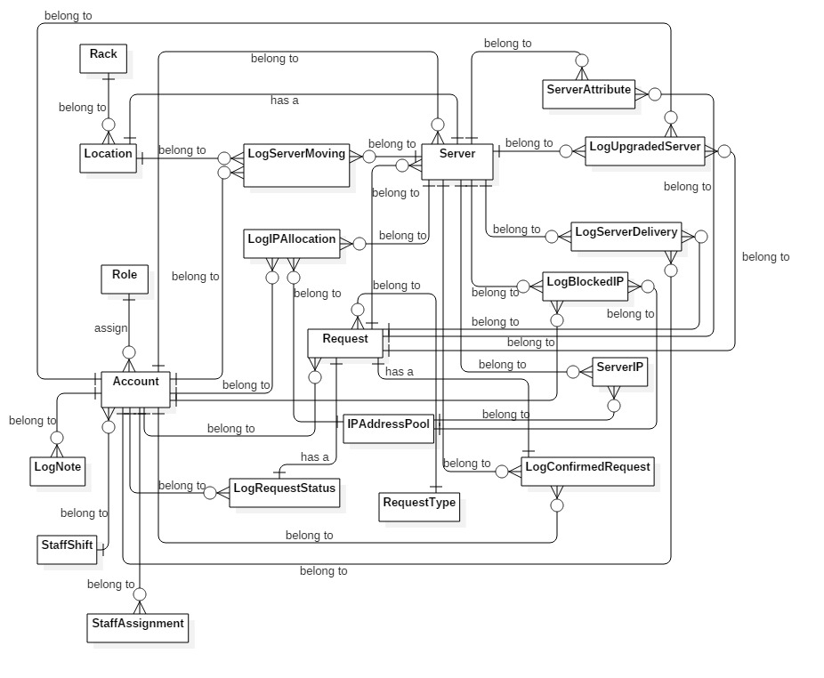

**Figure 34: Conceptual Diagram**

Data dictionary:

|  |  |
| --- | --- |
| **Entity dictionary** | |
| **Entity Name** | **Description** |
| Server | Describe the customer’s server in data center. |
| ServerAttribute | Describe Option Attributes which customer can add depend on server. |
| Location | Describe all location in data center. |
| Rack | Describe all racks which are putting in data center. |
| LogServerMoving | Describe the history of each time when server was moved. |
| LogUpgradedServer | Describe the history of each time when server was upgraded. |
| LogBlockedIP | Describe the history of each time when IP Address was blocked. |
| Role | Describe all roles in the system. |
| LogIPAllocation | Describe the history of each time when IP Address was allocated for server. |
| LogServerDelivery | Describe the history of each time when IP Address was carried in or carried out data center. |
| ServerIP | Describe all of current IP Addresses of each server. |
| Request | Describe content of each request which was sent by customer. |
| Account | Describe all user’s accounts in the system. |
| LogNote | Describe all note which was wrote by previous shift for the next shift. |
| LogRequestStatus | Describe status of each request. |
| IPAddressPool | Describe all IP Addresses which data center is keeping. |
| RequestType | Describe all type of request. |
| LogConfirmedRequest | Describe request information when request was confirmed. |
| StaffShift | Describe shift group information. |
| StaffAssignment | Describe the assignment information when a request was assigned Staff by Shift Head. |

Table 37: Data dictionary