# 

# 

# **Software Requirement Specification**

## User Requirement Specification

### Shift Head requirement

* A group has one shift head and two staff. Shift head has higher authority of using the system than staff. Shift head can use the following functions:
  + View request detail
  + Accept request
  + Process request
  + Reject request
  + View server detail
  + View IP Address
  + View list location
  + View report
  + View daily schedule
  + Add IP Address
  + Add rack
  + Change server’s location
  + Receive notification (customer’s request status, unfinished task)
  + Export procedure
  + Assign task
  + Reassign task
  + Write note about “Pending” and “Processing” requests
  + View profile
  + Change password

### Staff requirement

* Staff is a person who supports shift head to observe data centre’s information. Staff can only view data and be able to process a request if assigned. These are some functions staff can use:
  + View request detail
  + Process request (if assigned)
  + Reject request (if assigned)
  + View server detail
  + View IP Address
  + View list location
  + View report
  + View daily schedule
  + Add IP Address
  + Add rack
  + Change server’s location
  + Receive notification (task only)
  + Export procedure (if assigned)
  + View profile
  + Change password

### Shift Manager requirement

* There’s only one manager who takes charge in managing this system. He is super user who can use more functions than shift head as below:
  + Create customer account
  + Update customer account
  + Create staff account
  + Update staff account
  + Deactivate account
  + Configure system

### Customer requirement

* Customer is a person who owns servers and want to keep it in a good condition. Customer interacts with the system when he wants to make a request or observe his server’s information. With customer role, the system will support some functions as below:
  + Create request “Add server”, “Bring Server Away”, “Assign IP Address”, “Change IP Address”, “Return IP Address”, “Rent Rack”, Return Rack”
  + Cancel request
  + View request history
  + View his server’s information
  + View profile
  + Change password

## System Requirement Specification

### External Interface Requirement

#### User interface

* General requirement for graphics user interface of website is the GUI should be simple, clear, intuitive, and reminiscent.
* Some design principle will be taken into consideration:
* UI for business web applications - Janko Jovanovic [Ref: Appendix 1]
* Ten principles of effective web design – Vitaly Friedman [Ref: Appendix 2]

#### Hardware Interface

* N/A

#### Software Interface

* Chromes (version 41.0.2272.118), Firefox (version 37.0.1) with resolution (1024 x 768) or bigger and must support JavaScript and HTML5.

#### Communication Protocol

* Using HTTP/HTTPS and SMTP protocol.

### System Overview Use Case

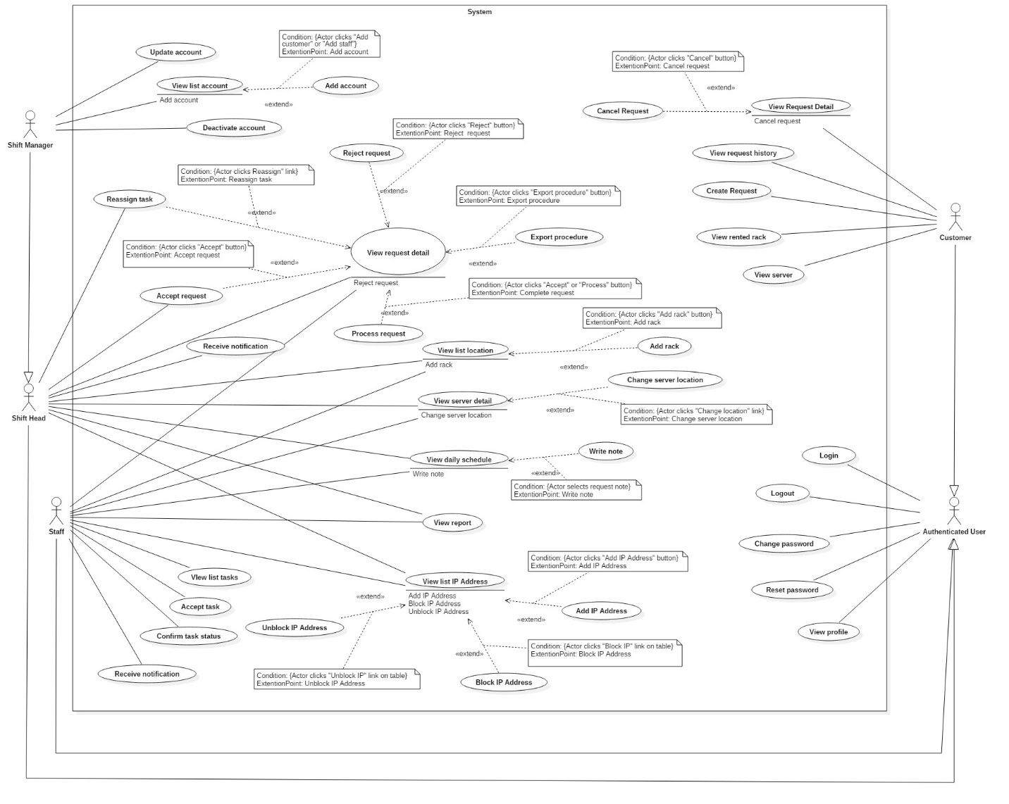

### List of Use Case

##### <Shift Head> Overview Use Case

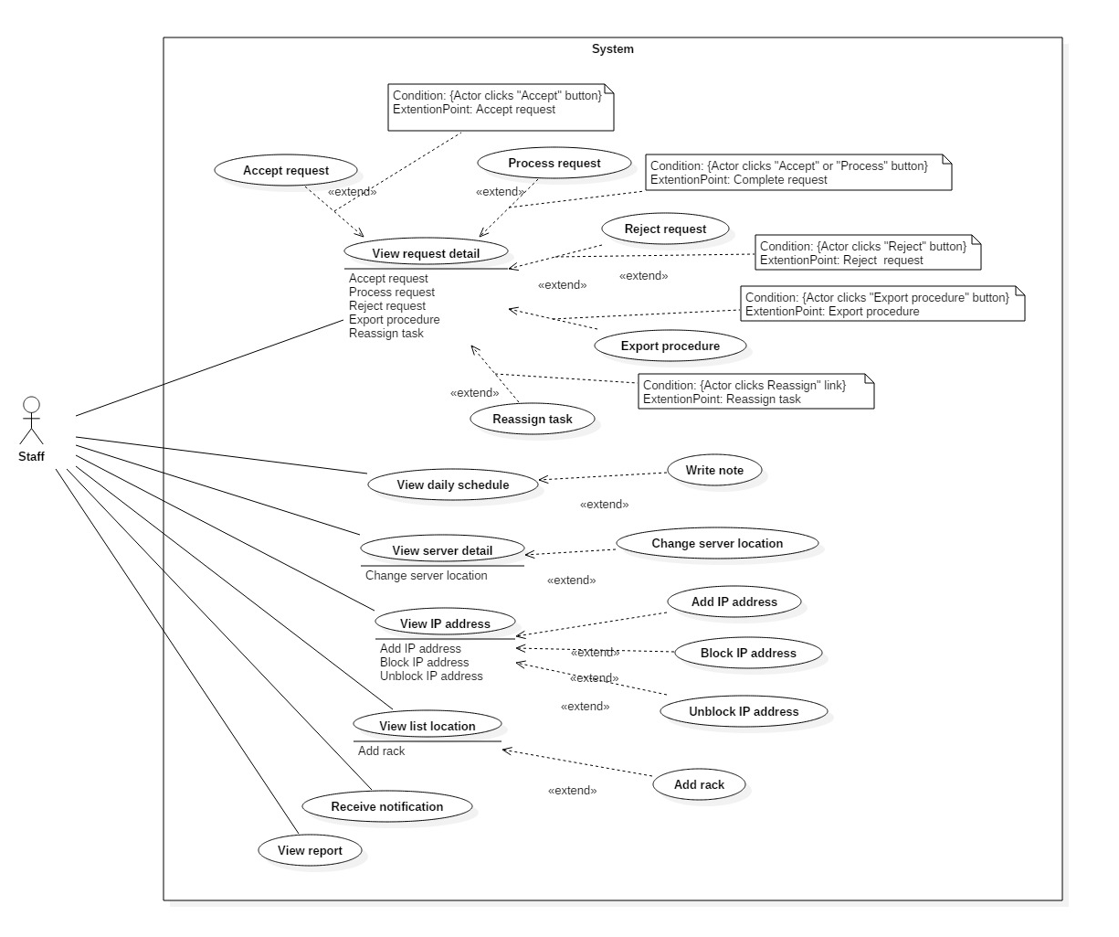Figure 5: <Shift Head> Overview Use Case

###### <Shift Head> View request detail

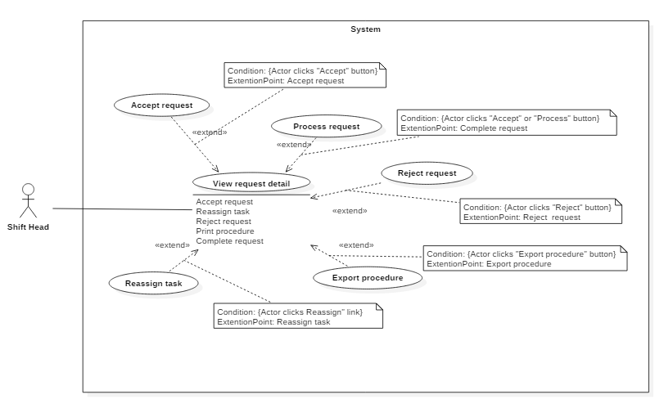

Figure 8 <Shift Head> View request detail

|  |  |  |  |
| --- | --- | --- | --- |
| USE CASE – IMS001 | | | |
| Use Case No. | IMS001 | **Use Case Version** | 2.0 |
| Use Case Name | Write note | | |
| Author | Huỳnh Lâm Hà Tiên | | |
| Date | 18/01/2016 | **Priority** | Normal |
| Actor:   * Shift Head   Summary:   * This use case allows Shift Head to write note about customer’s arrival for the next shift.   Goal:   * Creating note about customer’s arrival for the next shift.   Triggers:   * Shift head clicks “Write note for the next shift” link on the Daily Schedule Page.   Precondition:   * The Shift Head must login to the system with Shift Head role at right shift.   Post Conditions:   * Success: The note of this shift will be created. * Fail: Nothing will be created. Show message error with specified content.   Main Success Scenario:   |  |  |  | | --- | --- | --- | | Step | Actor Action | System Response | | 1 | Shift head clicks “Write note for the next shift” link on the Daily Schedule Page. | The popup contains blank note will be showed. | | 2 | Shift head inputs data and clicks “Submit note” button | The note of this shift will be created. |   Alternative Scenario:   |  |  |  | | --- | --- | --- | | Step | Actor Action | System Response | | 1 | Shift head clicks “Write note for the next shift” link on the Daily Schedule Page. | The popup contains blank note will be showed. | | 2 | Shift head inputs data and clicks “Cancel” button | Return to Daily Schedule Page. |   Exceptions:   |  |  |  | | --- | --- | --- | | Step | Cause | System Response | | 1 | The note is blank | Show message error: “The note is blank. Please input data!” |  |  |  |  | | --- | --- | --- | | No | Actor Action | System Response | | 1 | Connect to database fail | Show message “Error, please try again!” |   Relationships: Extend to View daily Schedule.  Business Rules:   * The time when the note was created and the created Shift Head must be saved into database. * If the Shift Head login to the system at different people’s shift, the link “Write note for the next shift” is disabled. | | | |

Table 19: Use case IMS001 - <Shift Head> Write note

###### <Shift Head> Accept request “Add Server”

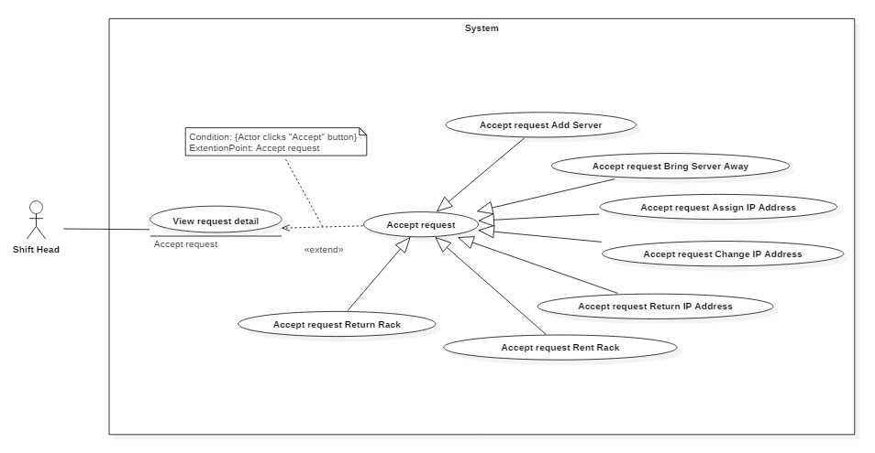

Figure 8 <Shift Head> Accept request “Add Server”

|  |  |  |  |
| --- | --- | --- | --- |
| USE CASE – IMS004 | | | |
| Use Case No. | IMS004 | **Use Case Version** | 2.0 |
| Use Case Name | Accept request “Add Server” | | |
| Author | Lê Thị Thu Hà | | |
| Date | 19/01/2016 | **Priority** | medium |
| Actor:   * Shift Head.   Summary:   * This use case allows Shift Head to accept request “Add Server” from customer.   Goal:   * Request status changes from “Pending” to “Waiting”, button “Process” will appear to ready when customer arrives. After “Accept” button is clicked, customer will immediately receive notification from this system and also via email.   Triggers:   * Shift head clicks “Accept” button on request detail page.   Preconditions:   * User logins will Shift Head role. * Request status is “Pending”.   Post Conditions:   * Success: System shows message “Success! You’ve ACCEPTED Request Add Server.” * Fail: System shows error message.   Main Success Scenario:   |  |  |  | | --- | --- | --- | | Step | Actor Action | System Response | | 1 | Shift Head clicks on not-viewed notification on the header panel. | Navigated to “Add Server” request detail page. | | 2 | Shift Head checks request detail and clicks on “Accept” button at the bottom of the page. | * System shows message “Success! You’ve ACCEPTED Request Add Server.” * Request status changes to “Waiting” * Assignee drop down list and “Process” button are showed. * Changed request status is notified to customer via both system and email. |   Alternative Scenario: N/A.  Exceptions:   |  |  |  | | --- | --- | --- | | No | Actor Action | System Response | | 1 | Connect to Internet fail | Show message “Cannot send email to customer, please connect to the Internet and try again!” |   Relationships: Extend to View request detail detail.  Business Rules:   * When Shift Head accepts the request, system will log the time when he changed the request status from “Pending” to “Waiting”. * Four shift heads of data center can be able to click on the “Accept” button of a request anytime. But as the rule, only the one who is responsible for confirming request at current shift is authorized. Unauthorized person will be discovered by log system. | | | |

Table 19: Use case IMS002 - <Shift Head> Accept request “Add Server”

###### <Shift Head> Accept request “Bring Server Away”

Figure 8 <Shift Head> Assign task

|  |  |  |  |
| --- | --- | --- | --- |
| USE CASE – IMS004 | | | |
| Use Case No. | IMS004 | **Use Case Version** | 2.0 |
| Use Case Name | Accept request “Bring Server Away” | | |
| Author | Lê Thị Thu Hà | | |
| Date | 19/01/2016 | **Priority** | medium |
| Actor:   * Shift Head.   Summary:   * This use case allows Shift Head to accept request “Bring Server Away” from customer.   Goal:   * Request status changes from “Pending” to “Waiting”, button “Process” will appear to ready when customer arrives. After “Accept” button is clicked, customer will immediately receive notification from this system and also via email.   Triggers:   * Shift head clicks “Accept” button on request detail page.   Preconditions:   * User logins will Shift Head role. * Request status is “Pending”.   Post Conditions:   * Success: System shows message “Success! You’ve ACCEPTED Request Bring Server Away.” * Fail: System shows error message.   Main Success Scenario:   |  |  |  | | --- | --- | --- | | Step | Actor Action | System Response | | 1 | Shift Head clicks on not-viewed notification on the header panel. | Navigated to “Bring Server Away” request detail page. | | 2 | Shift Head checks request detail and clicks on “Accept” button at the bottom of the page. | * System shows message “Success! You’ve ACCEPTED Request Bring Server Away.” * Request status changes to “Waiting” * Assignee drop down list and “Process” button are showed. * Changed request status is notified to customer via both system and email. |   Alternative Scenario: N/A.  Exceptions:   |  |  |  | | --- | --- | --- | | No | Actor Action | System Response | | 1 | Connect to Internet fail | Show message “Cannot send email to customer, please connect to the Internet and try again!” |   Relationships: Extend to View request detail detail.  Business Rules:   * When Shift Head accepts the request, system will log the time when he changed the request status from “Pending” to “Waiting”. * Four shift heads of data center can be able to click on the “Accept” button of a request anytime. But as the rule, only the one who is responsible for confirming request at current shift is authorized. Unauthorized person will be discovered by log system. | | | |

Table 19: Use case IMS002 - <Shift Head> Assign task

###### <Shift Head> Accept request “Assign IP Address”

Figure 8 <Shift Head> Assign task

Table 19: Use case IMS002 - <Shift Head> Assign task

|  |  |  |  |
| --- | --- | --- | --- |
| USE CASE – IMS004 | | | |
| Use Case No. | IMS004 | **Use Case Version** | 2.0 |
| Use Case Name | Accept request “Assign IP Address” | | |
| Author | Lê Thị Thu Hà | | |
| Date | 19/01/2016 | **Priority** | medium |
| Actor:   * Shift Head.   Summary:   * This use case allows Shift Head to accept request “Assign IP Address” from customer.   Goal:   * Request status changes from “Pending” to “Processing”, button “Complete” will appear right that. After “Accept” button is clicked, customer will immediately receive notification from this system and also via email.   Triggers:   * Shift head clicks “Accept” button on request detail page.   Preconditions:   * User logins will Shift Head role. * Request status is “Pending”.   Post Conditions:   * Success: System shows message “Success! You’ve ACCEPTED Request Assign IP Address.” * Fail: System shows error message.   Main Success Scenario:   |  |  |  | | --- | --- | --- | | Step | Actor Action | System Response | | 1 | Shift Head clicks on not-viewed notification on the header panel. | Navigated to “Assign IP Address” request detail page. | | 2 | Shift Head checks request detail and clicks on “Accept” button at the bottom of the page without reselect assignee. | * System shows message “Success! You’ve ACCEPTED Request Assign IP Address.” * Request status changes to “Processing” * “Complete” button is replaced for “Accept” button * Shift head is default assignee. * Changed request status is notified to customer via both system and email. |   Alternative Scenario:   |  |  |  | | --- | --- | --- | | Step | Actor Action | System Response | | 1 | Shift Head clicks on not-viewed notification on the header panel. | Navigated to “Assign IP Address” request detail page. | | 2 | * Shift Head selects who will process this request * Shift Head checks request detail and clicks on “Accept” button at the bottom of the page. | * System shows message “Success! You’ve ACCEPTED Request Assign IP Address.” * Request status changes to “Processing” * “Complete” button is replaced for “Accept” button * Selected member will take charge in processing this request * Changed request status is notified to customer via both system and email. |   Exceptions:   |  |  |  | | --- | --- | --- | | No | Actor Action | System Response | | 1 | Connect to Internet fail | Show message “Cannot send email to customer, please connect to the Internet and try again!” |   Relationships: Extend to View request detail detail.  Business Rules:   * When Shift Head accepts the request, system will log the time when he changed the request status from “Pending” to “Processing”. * Four shift heads of data center can be able to click on the “Accept” button of a request anytime. But as the rule, only the one who is responsible for confirming request at current shift is authorized. Unauthorized person will be discovered by log system. * If Shift Head is busy and can’t process the request or assign it to another staff, Shift Manager will take over it | | | |

###### <Shift Head> Accept request “Change IP Address”

Figure 8 <Shift Head> Assign task

|  |  |  |  |
| --- | --- | --- | --- |
| USE CASE – IMS004 | | | |
| Use Case No. | IMS004 | **Use Case Version** | 2.0 |
| Use Case Name | Accept request “Change IP Address” | | |
| Author | Lê Thị Thu Hà | | |
| Date | 19/01/2016 | **Priority** | medium |
| Actor:   * Shift Head.   Summary:   * This use case allows Shift Head to accept request “Change IP Address” from customer.   Goal:   * Request status changes from “Pending” to “Processing”, button “Complete” will appear right that. After “Accept” button is clicked, customer will immediately receive notification from this system and also via email.   Triggers:   * Shift head clicks “Accept” button on request detail page.   Preconditions:   * User logins will Shift Head role. * Request status is “Pending”.   Post Conditions:   * Success: System shows message “Success! You’ve ACCEPTED Request Change IP Address.” * Fail: System shows error message.   Main Success Scenario:   |  |  |  | | --- | --- | --- | | Step | Actor Action | System Response | | 1 | Shift Head clicks on not-viewed notification on the header panel. | Navigated to “Change IP Address” request detail page. | | 2 | Shift Head checks request detail and clicks on “Accept” button at the bottom of the page without reselect assignee. | * System shows message “Success! You’ve ACCEPTED Request Change IP Address.” * Request status changes to “Processing” * “Complete” button is replaced for “Accept” button * Shift head is default assignee. * Changed request status is notified to customer via both system and email. |   Alternative Scenario:   |  |  |  | | --- | --- | --- | | Step | Actor Action | System Response | | 1 | Shift Head clicks on not-viewed notification on the header panel. | Navigated to “Change IP Address” request detail page. | | 2 | * Shift Head selects who will process this request * Shift Head checks request detail and clicks on “Accept” button at the bottom of the page. | * System shows message “Success! You’ve ACCEPTED Request Change IP Address.” * Request status changes to “Processing” * “Complete” button is replaced for “Accept” button * Selected member will take charge in processing this request * Changed request status is notified to customer via both system and email. |   Exceptions:   |  |  |  | | --- | --- | --- | | No | Actor Action | System Response | | 1 | Connect to Internet fail | Show message “Cannot send email to customer, please connect to the Internet and try again!” |   Relationships: Extend to View request detail detail.  Business Rules:   * When Shift Head accepts the request, system will log the time when he changed the request status from “Pending” to “Processing”. * Four shift heads of data center can be able to click on the “Accept” button of a request anytime. But as the rule, only the one who is responsible for confirming request at current shift is authorized. Unauthorized person will be discovered by log system. * If Shift Head is busy and can’t process the request or assign it to another staff, Shift Manager will take over it | | | |

Table 19: Use case IMS002 - <Shift Head> Assign task

###### <Shift Head> Accept request “Return IP Address”

Figure 8 <Shift Head> Return IP Address

|  |  |  |  |
| --- | --- | --- | --- |
| USE CASE – IMS004 | | | |
| Use Case No. | IMS004 | **Use Case Version** | 2.0 |
| Use Case Name | Accept request “Return IP Address” | | |
| Author | Lê Thị Thu Hà | | |
| Date | 19/01/2016 | **Priority** | medium |
| Actor:   * Shift Head.   Summary:   * This use case allows Shift Head to accept request “Return IP Address” from customer.   Goal:   * Request status changes from “Pending” to “Processing”, button “Complete” will appear right that. After “Accept” button is clicked, customer will immediately receive notification from this system and also via email.   Triggers:   * Shift head clicks “Accept” button on request detail page.   Preconditions:   * User logins will Shift Head role. * Request status is “Pending”.   Post Conditions:   * Success: System shows message “Success! You’ve ACCEPTED Request Return IP Address.” * Fail: System shows error message.   Main Success Scenario:   |  |  |  | | --- | --- | --- | | Step | Actor Action | System Response | | 1 | Shift Head clicks on not-viewed notification on the header panel. | Navigated to “Return IP Address” request detail page. | | 2 | Shift Head checks request detail and clicks on “Accept” button at the bottom of the page without reselect assignee. | * System shows message “Success! You’ve ACCEPTED Request Return IP Address.” * Request status changes to “Processing” * “Complete” button is replaced for “Accept” button * Shift head is default assignee. * Changed request status is notified to customer via both system and email. |   Alternative Scenario:   |  |  |  | | --- | --- | --- | | Step | Actor Action | System Response | | 1 | Shift Head clicks on not-viewed notification on the header panel. | Navigated to “Return IP Address” request detail page. | | 2 | * Shift Head selects who will process this request * Shift Head checks request detail and clicks on “Accept” button at the bottom of the page. | * System shows message “Success! You’ve ACCEPTED Request Return IP Address.” * Request status changes to “Processing” * “Complete” button is replaced for “Accept” button * Selected member will take charge in processing this request * Changed request status is notified to customer via both system and email. |   Exceptions:   |  |  |  | | --- | --- | --- | | No | Actor Action | System Response | | 1 | Connect to Internet fail | Show message “Cannot send email to customer, please connect to the Internet and try again!” |   Relationships: Extend to View request detail detail.  Business Rules:   * When Shift Head accepts the request, system will log the time when he changed the request status from “Pending” to “Processing”. * Four shift heads of data center can be able to click on the “Accept” button of a request anytime. But as the rule, only the one who is responsible for confirming request at current shift is authorized. Unauthorized person will be discovered by log system. * If Shift Head is busy and can’t process the request or assign it to another staff, Shift Manager will take over it | | | |

Table 19: Use case IMS002 - <Shift Head> Return IP Address

###### <Shift Head> Accept request “Rent Rack”

Figure 8 <Shift Head> Accept request “Rent Rack”

|  |  |  |  |
| --- | --- | --- | --- |
| USE CASE – IMS004 | | | |
| Use Case No. | IMS004 | **Use Case Version** | 2.0 |
| Use Case Name | Accept request “Rent Rack” | | |
| Author | Lê Thị Thu Hà | | |
| Date | 19/01/2016 | **Priority** | medium |
| Actor:   * Shift Head.   Summary:   * This use case allows Shift Head to accept request “Rent Rack” from customer.   Goal:   * Request status changes from “Pending” to “Processing”, button “Complete” will appear right that. After “Accept” button is clicked, customer will immediately receive notification from this system and also via email.   Triggers:   * Shift head clicks “Accept” button on request detail page.   Preconditions:   * User logins will Shift Head role. * Request status is “Pending”.   Post Conditions:   * Success: System shows message “Success! You’ve ACCEPTED Request Rent Rack.” * Fail: System shows error message.   Main Success Scenario:   |  |  |  | | --- | --- | --- | | Step | Actor Action | System Response | | 1 | Shift Head clicks on not-viewed notification on the header panel. | Navigated to “Rent Rack” request detail page. | | 2 | Shift Head checks request detail and clicks on “Accept” button at the bottom of the page without reselect assignee. | * System shows message “Success! You’ve ACCEPTED Request Rent Rack.” * Request status changes to “Processing” * “Complete” button is replaced for “Accept” button * Shift head is default assignee. * Changed request status is notified to customer via both system and email. |   Alternative Scenario:   |  |  |  | | --- | --- | --- | | Step | Actor Action | System Response | | 1 | Shift Head clicks on not-viewed notification on the header panel. | Navigated to “Rent Rack” request detail page. | | 2 | * Shift Head selects who will process this request * Shift Head checks request detail and clicks on “Accept” button at the bottom of the page. | * System shows message “Success! You’ve ACCEPTED Request Rent Rack.” * Request status changes to “Processing” * “Complete” button is replaced for “Accept” button * Selected member will take charge in processing this request * Changed request status is notified to customer via both system and email. |   Exceptions:   |  |  |  | | --- | --- | --- | | No | Actor Action | System Response | | 1 | Connect to Internet fail | Show message “Cannot send email to customer, please connect to the Internet and try again!” |   Relationships: Extend to View request detail detail.  Business Rules:   * When Shift Head accepts the request, system will log the time when he changed the request status from “Pending” to “Processing”. * Four shift heads of data center can be able to click on the “Accept” button of a request anytime. But as the rule, only the one who is responsible for confirming request at current shift is authorized. Unauthorized person will be discovered by log system. * If Shift Head is busy and can’t process the request or assign it to another staff, Shift Manager will take over it | | | |

Table 19: Use case IMS002 - <Shift Head> Accept request “Rent Rack”

###### <Shift Head> Accept request “Return Rack”

Figure 8 <Shift Head> Accept request “Return Rack”

|  |  |  |  |
| --- | --- | --- | --- |
| USE CASE – IMS004 | | | |
| Use Case No. | IMS004 | **Use Case Version** | 2.0 |
| Use Case Name | Accept request “Return Rack” | | |
| Author | Lê Thị Thu Hà | | |
| Date | 19/01/2016 | **Priority** | medium |
| Actor:   * Shift Head.   Summary:   * This use case allows Shift Head to accept request “Return Rack” from customer.   Goal:   * Request status changes from “Pending” to “Processing”, button “Complete” will appear right that. After “Accept” button is clicked, customer will immediately receive notification from this system and also via email.   Triggers:   * Shift head clicks “Accept” button on request detail page.   Preconditions:   * User logins will Shift Head role. * Request status is “Pending”.   Post Conditions:   * Success: System shows message “Success! You’ve ACCEPTED Request Return Rack.” * Fail: System shows error message.   Main Success Scenario:   |  |  |  | | --- | --- | --- | | Step | Actor Action | System Response | | 1 | Shift Head clicks on not-viewed notification on the header panel. | Navigated to “Return Rack” request detail page. | | 2 | Shift Head checks request detail and clicks on “Accept” button at the bottom of the page without reselect assignee. | * System shows message “Success! You’ve ACCEPTED Request Return Rack.” * Request status changes to “Processing” * “Complete” button is replaced for “Accept” button * Shift head is default assignee. * Changed request status is notified to customer via both system and email. |   Alternative Scenario:   |  |  |  | | --- | --- | --- | | Step | Actor Action | System Response | | 1 | Shift Head clicks on not-viewed notification on the header panel. | Navigated to “Return Rack” request detail page. | | 2 | * Shift Head selects who will process this request * Shift Head checks request detail and clicks on “Accept” button at the bottom of the page. | * System shows message “Success! You’ve ACCEPTED Request Return Rack.” * Request status changes to “Processing” * “Complete” button is replaced for “Accept” button * Selected member will take charge in processing this request * Changed request status is notified to customer via both system and email. |   Exceptions:   |  |  |  | | --- | --- | --- | | No | Actor Action | System Response | | 1 | Connect to Internet fail | Show message “Cannot send email to customer, please connect to the Internet and try again!” |   Relationships: Extend to View request detail detail.  Business Rules:   * When Shift Head accepts the request, system will log the time when he changed the request status from “Pending” to “Processing”. * Four shift heads of data center can be able to click on the “Accept” button of a request anytime. But as the rule, only the one who is responsible for confirming request at current shift is authorized. Unauthorized person will be discovered by log system. * If Shift Head is busy and can’t process the request or assign it to another staff, Shift Manager will take over it | | | |

Table 19: Use case IMS002 - <Shift Head> Accept request “Return Rack”

###### <Shift Head> Process request “Add Server”

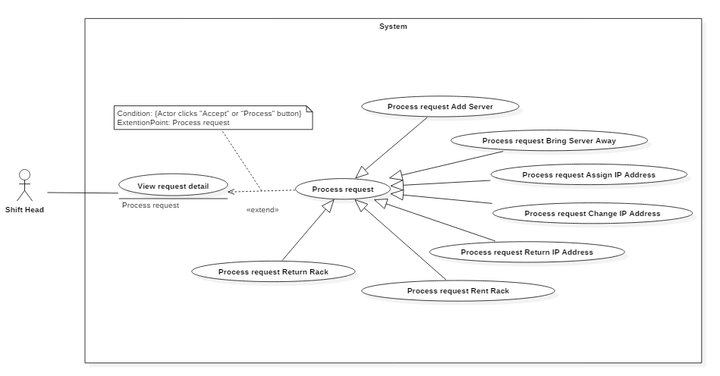Figure 8 <Shift Head> Process request “Add Server”

|  |  |  |  |
| --- | --- | --- | --- |
| USE CASE – IMS009 | | | |
| Use Case No. | IMS009 | **Use Case Version** | 2.0 |
| Use Case Name | Process request “Add Server” | | |
| Author | Huỳnh Lâm Hà Tiên | | |
| Date | 21/01/2016 | **Priority** | medium |
| Actor:   * Shift Head.   Summary:   * This use case allows Shift Head to process request “Add Server”, recording customer officially brought his servers into the data center. Furthermore, necessary information as Default IP Address and Server Location are also processed in this phase.   Goal:   * Complete the request with “Done” status. Customer’s servers are already placed in a rack of data center.   Triggers:   * Shift Head accesses to the appropriate request detail page.   Preconditions:   * Shift Head must login into the system with role Shift Head. * The request was sent to data center by customer.   Post Conditions:   * Success: Server status will be changed from “Waiting” to “Running”. Request status is updated to “Done”. Notification will be sent automatically to customer via system and also email * Fail: System shows error message   Main Success Scenario:   |  |  |  | | --- | --- | --- | | Step | Actor Action | System Response | | 1 | Shift Head clicks on not-viewed notification on the header panel. | The system will display “Add Server” request detail | | 2 | Shift Head clicks on “Add IP” | The picked up IP Address Popup will be displayed. | | 3 | Shift Head searches suitable IP Address, select it and clicks “OK” button. | Return to Request Add New Server Page and the selected IP Address will be display on field “Default IP” | | 4 | Shift Head clicks on “Add location” | The picked up Location Popup will be displayed. | | 5 | Shift Head selects suitable location and clicks “OK” button. | Return to Request Add New Server Page and the selected location will be display on field “Location” | | 6 | Shift Head clicks on “Complete” button | * System will save new information of this server into database. * System will change status of this server(s) to “Running” * System will log who processed the request at this time |   Alternatives Scenario: N/A  Exceptions:   |  |  |  | | --- | --- | --- | | Step | Cause | System Response | | 1 | Shift Head not assign default IP to server | System will show message: “You must assign default IP Address to server.” | | 2 | Shift Head not assign location to server | System will show message: “You must assign location to server.” | | 3 | Connect to Internet fail | Show message “Cannot send email to customer, please connect to the Internet and try again!” |   Relationships: Extend to View request detail  Business Rules:   * When customer want to entrust his servers to datacenter, he must input server configuration by himself using the “Add Server” request. * After finishing setting up servers, then Shift Head will assign Default IP Address to each server and decide where to place the servers to data center. * In data center, Default IP is an identity of server. On each server will be tagged Default IP | | | |

Table 19: Use case IMS003 - <Shift Head> Process request “Add Server”

###### <Shift Head> Process request “Bring Server Away”

Figure 8 <Shift Head> View request

|  |  |  |  |
| --- | --- | --- | --- |
| USE CASE – IMS009 | | | |
| Use Case No. | IMS009 | **Use Case Version** | 2.0 |
| Use Case Name | Process request “Bring Server Away” | | |
| Author | Huỳnh Lâm Hà Tiên | | |
| Date | 21/01/2016 | **Priority** | medium |
| Actor:   * Shift Head.   Summary:   * This use case allows Shift Head to process request “Bring Server Away”, he can check server’s information before customer brings their servers away.   Goal:   * Complete the request with “Done” status. Server status changed to “Deactivate” and all information related to this server such as IP Address, location,.. will be set to “Available”   Triggers:   * Shift Head accesses to the appropriate request detail page.   Preconditions:   * Shift Head must login into the system with role Shift Head. * The request was sent to data center by customer.   Post Conditions:   * Success: Server status will be changed from “Running” to “Deactivate”. Request status is updated to “Done”. Notification will be sent automatically to customer via both IMS system and email * Fail: System shows error message   Main Success Scenario:   |  |  |  | | --- | --- | --- | | Step | Actor Action | System Response | | 1 | Shift Head clicks on not-viewed notification on the header panel. | The system will display “Bring Server Away” request detail | | 2 | Shift Head clicks on “Complete” button | * System will change server status to “Deactivate”. * IP Address and location related to this server will be reset to “Available” * Request status changed to “Done” * System will log who processed the request at this time |   Alternatives Scenario: N/A  Exceptions:   |  |  |  | | --- | --- | --- | | No | Actor Action | System Response | | 1 | Connect to Internet fail | Show message “Cannot send email to customer, please connect to the Internet and try again!” |   Relationships: Extend to View request detail detail  Business Rules:   * This system doesn’t handle whether customer paid enough money before he finishes the service at data center. Shift Head will confirm with sale man beforehand. | | | |

Table 19: Use case IMS003 - <Shift Head> Process request “Bring Server Away”

###### <Shift Head> Process request “Assign IP Address”



Figure 8 <Shift Head> View request

|  |  |  |  |
| --- | --- | --- | --- |
| USE CASE – IMS009 | | | |
| Use Case No. | IMS009 | **Use Case Version** | 2.0 |
| Use Case Name | Process request “Assign IP Address” | | |
| Author | Huỳnh Lâm Hà Tiên | | |
| Date | 21/01/2016 | **Priority** | medium |
| Actor:   * Shift Head.   Summary:   * This use case allows Shift Head to process request “Assign IP Address”, he can select which IP Address to assign to requested server. The number of IP Address is allocated by customer.   Goal:   * Complete the request with “Done” status. New IP Addresses are assigned to appointed server   Triggers:   * Shift Head accesses to the appropriate request detail page.   Preconditions:   * Shift Head must login into the system with role Shift Head. * The request was sent to data center by customer.   Post Conditions:   * Success: Assigned IP Address will be changed its status from “Available” to “Used”. Request status is updated to “Done”. Notification will be sent automatically to customer via both IMS system and email * Fail: System shows error message   Main Success Scenario:   |  |  |  | | --- | --- | --- | | Step | Actor Action | System Response | | 1 | Shift Head clicks on not-viewed notification on the header panel. | The system will display “Assign IP Address” request detail | | 2 | Shift Head checks request detail and necessary action for this request | IP Address will be randomly selected by the system, and the number of it is equals to the number appointed by customer. | | 3 | Shift Head clicks on “Complete” button | * System will change IP Address status to “Used”. * New IP Address is assign to appropriate server * Request status changed to “Done” * System will log who processed the request at this time |   Alternatives Scenario:   |  |  |  | | --- | --- | --- | | Step | Actor Action | System Response | | 1 | Shift Head clicks on not-viewed notification on the header panel. | The system will display “Assign IP Address” request detail | | 2 | Shift Head selects available IP Address to assign |  | | 3 | Shift Head clicks on “Complete” button | * System will change IP Address status to “Used”. * New IP Address is assign to appropriate server * Request status changed to “Done” * System will log who processed the request at this time |   Exceptions:   |  |  |  | | --- | --- | --- | | No | Actor Action | System Response | | 1 | Shift Head assigns the number of IP Address more or less than customer requirement | System shows message “You need to choose the number of IP Address as customer requirement. Please try again.” | | 2 | Number of available IP Addresses is less than customer requirement | System shows message “Number of available IP Address is less than required number. Please confirm with customer to change IP range.” | | 3 | Connect to Internet fail | Show message “Cannot send email to customer, please connect to the Internet and try again!” |   Relationships: Extend to View request detail detail  Business Rules:   * This system doesn’t handle whether customer paid enough money before he finishes the service at data center. Shift Head will confirm with sale man beforehand. | | | |

Table 19: Use case IMS003 - <Shift Head> Process request “Assign IP Address”

###### <Shift Head> Process request “Change IP Address”



Figure 8 <Shift Head> Process request “Change IP Address”

|  |  |  |  |
| --- | --- | --- | --- |
| USE CASE – IMS009 | | | |
| Use Case No. | IMS009 | **Use Case Version** | 2.0 |
| Use Case Name | Process request “Change IP Address” | | |
| Author | Huỳnh Lâm Hà Tiên | | |
| Date | 21/01/2016 | **Priority** | medium |
| Actor:   * Shift Head.   Summary:   * This use case allows Shift Head to process request “Change IP Address”, he will change selected IP Addresses to the new ones that are in the same range.   Goal:   * Complete the request with “Done” status. New IP Addresses are assigned to appointed server. Old IP Addresses will be changed status to “Available”.   Triggers:   * Shift Head accesses to the appropriate request detail page.   Preconditions:   * Shift Head must login into the system with role Shift Head. * The request was sent to data center by customer.   Post Conditions:   * Success: Assigned IP Address will be changed its status from “Available” to “Used”. Old IP Addresses will be changed status to “Available”. Notification will be sent automatically to customer via both IMS system and email * Fail: System shows error message   Main Success Scenario:   |  |  |  | | --- | --- | --- | | Step | Actor Action | System Response | | 1 | Shift Head clicks on not-viewed notification on the header panel. | The system will display “Change IP Address” request detail | | 2 | Shift Head selects IP Address to assign for each IP Address that customer wants to change. |  | | 3 | Shift Head clicks on “Complete” button | * System will change new IP Address status to “Used”. * System will change old IP Address status to “Available”. * Request status changed to “Done” * System will log who processed the request at this time |   Alternatives Scenario: N/A.  Exceptions:   |  |  |  | | --- | --- | --- | | No | Actor Action | System Response | | 1 | Shift Head forgot to select new IP Address from drop down list | System shows message “You need to select new IP Address. Please try again.” | | 2 | Number of available IP Addresses is less than customer requirement | System shows message “Number of available IP Address is less than required number. Please confirm with customer to change IP range.” | | 3 | Connect to Internet fail | Show message “Cannot send email to customer, please connect to the Internet and try again!” |   Relationships: Extend to View request detail  Business Rules:   * This system doesn’t handle whether customer paid enough money before he finishes the service at data center. Shift Head will confirm with sale man beforehand. | | | |

Table 19: Use case IMS003 - <Shift Head> Process request “Change IP Address”

###### <Shift Head> Process request “Return IP Address”

Figure 8 <Shift Head> Process request “Return IP Address”

|  |  |  |  |
| --- | --- | --- | --- |
| USE CASE – IMS009 | | | |
| Use Case No. | IMS009 | **Use Case Version** | 2.0 |
| Use Case Name | Process request “Return IP Address” | | |
| Author | Huỳnh Lâm Hà Tiên | | |
| Date | 21/01/2016 | **Priority** | medium |
| Actor:   * Shift Head.   Summary:   * This use case allows Shift Head to process request “Return IP Address”, he will approve IP Addresses that customer wants to return to data center.   Goal:   * Complete the request with “Done” status. IP Addresses will be returned to data center with status “Available”   Triggers:   * Shift Head accesses to the appropriate request detail page.   Preconditions:   * Shift Head must login into the system with role Shift Head. * The request was sent to data center by customer.   Post Conditions:   * Success: IP Address will be changed its status from “Used” to “Available”. Request status is updated to “Done”. Notification will be sent automatically to customer via both IMS system and email * Fail: System shows error message   Main Success Scenario:   |  |  |  | | --- | --- | --- | | Step | Actor Action | System Response | | 1 | Shift Head clicks on not-viewed notification on the header panel. | The system will display “Return IP Address” request detail | | 2 | Shift Head checks request detail |  | | 3 | Shift Head clicks on “Complete” button | * System will change IP Address status to “Available”. * Request status changed to “Done” * System will log who processed the request at this time |   Alternatives Scenario: N/A.  Exceptions:   |  |  |  | | --- | --- | --- | | No | Actor Action | System Response | | 1 | Connect to Internet fail | Show message “Cannot send email to customer, please connect to the Internet and try again!” |   Relationships: Extend to View request detail detail  Business Rules:   * This system doesn’t handle whether customer paid enough money before he finishes the service at data center. Shift Head will confirm with sale man beforehand. | | | |

Table 19: Use case IMS003 - <Shift Head> Process request “Return IP Address”

###### <Shift Head> Process request “Rent Rack”

Figure 8 <Shift Head> Process request “Rent Rack”

|  |  |  |  |
| --- | --- | --- | --- |
| USE CASE – IMS009 | | | |
| Use Case No. | IMS009 | **Use Case Version** | 2.0 |
| Use Case Name | Process request “Rent Rack” | | |
| Author | Huỳnh Lâm Hà Tiên | | |
| Date | 21/01/2016 | **Priority** | medium |
| Actor:   * Shift Head.   Summary:   * This use case allows Shift Head to process request “Rent Rack”, he will select rack for customer to rent.   Goal:   * Complete the request with “Done” status. Rack status will be changed to “Rented”   Triggers:   * Shift Head accesses to the appropriate request detail page.   Preconditions:   * Shift Head must login into the system with role Shift Head. * The request was sent to data center by customer.   Post Conditions:   * Success: Rack status will be changed from “Available” to “Rented”. Request status is updated to “Done”. Notification will be sent automatically to customer via both IMS system and email * Fail: System shows error message   Main Success Scenario:   |  |  |  | | --- | --- | --- | | Step | Actor Action | System Response | | 1 | Shift Head clicks on not-viewed notification on the header panel. | The system will display “Rent Rack” request detail | | 2 | Shift Head selects number of racks as customer requirement |  | | 3 | Shift Head clicks on “Complete” button | * System will change rack status to “Rented”. * Request status changed to “Done” * System will log who processed the request at this time |   Alternatives Scenario:   |  |  |  | | --- | --- | --- | | Step | Actor Action | System Response | | 1 | Shift Head clicks on not-viewed notification on the header panel. | The system will display “Rent Rack” request detail | | 2 | Shift Head selects alphabet letter that ruled as the first character of rack name. | The system will return appropriate racks with the first letter as selected. | | 3 | Shift Head selects number of racks as customer requirement |  | | 3 | Shift Head clicks on “Complete” button | * System will change rack status to “Rented”. * Request status changed to “Done” * System will log who processed the request at this time |   Exceptions:   |  |  |  | | --- | --- | --- | | No | Actor Action | System Response | | 1 | Shift Head forgot to select rack | System shows message “You need to select rack for rent. Please try again.” | | 2 | Shift Head selected the number of racks that is different from customer requirement | System shows message “Please select the number of racks equal to customer requirement.” | | 3 | Available racks are less than customer requirement | System shows message “Available racks are not enough for rent. Please add more racks to the system.” | | 4 | Connect to Internet fail | Show message “Cannot send email to customer, please connect to the Internet and try again!” |   Relationships: Extend to View request detail detail  Business Rules:   * This system doesn’t handle whether customer paid enough money before he finishes the service at data center. Shift Head will confirm with sale man beforehand. | | | |

Table 19: Use case IMS003 - <Shift Head> Process request “Rent Rack”

###### <Shift Head> Process request “Return Rack”

Figure 8 <Shift Head> Process request “Return Rack”

|  |  |  |  |
| --- | --- | --- | --- |
| USE CASE – IMS009 | | | |
| Use Case No. | IMS009 | **Use Case Version** | 2.0 |
| Use Case Name | Process request “Return Rack” | | |
| Author | Huỳnh Lâm Hà Tiên | | |
| Date | 21/01/2016 | **Priority** | medium |
| Actor:   * Shift Head.   Summary:   * This use case allows Shift Head to process request “Return Rack”.   Goal:   * Complete the request with “Done” status. Rack status will be changed to “Available”.   Triggers:   * Shift Head accesses to the appropriate request detail page.   Preconditions:   * Shift Head must login into the system with role Shift Head. * The request was sent to data center by customer.   Post Conditions:   * Success: Rack status will be changed from “Returning” to “Available”. Request status is updated to “Done”. Notification will be sent automatically to customer via both IMS system and email * Fail: System shows error message   Main Success Scenario:   |  |  |  | | --- | --- | --- | | Step | Actor Action | System Response | | 1 | Shift Head clicks on not-viewed notification on the header panel. | The system will display “Return Rack” request detail | | 2 | Shift Head checks request detail |  | | 3 | Shift Head clicks on “Complete” button | * System will change rack status to “Available”. * Request status changed to “Done” * System will log who processed the request at this time |   Alternatives Scenario: N/A.  Exceptions:   |  |  |  | | --- | --- | --- | | No | Actor Action | System Response | | 1 | Connect to Internet fail | Show message “Cannot send email to customer, please connect to the Internet and try again!” |   Relationships: Extend to View request detail detail  Business Rules:   * This system doesn’t handle whether customer paid enough money before he finishes the service at data center. Shift Head will confirm with sale man beforehand. | | | |

Table 19: Use case IMS003 - <Shift Head> Process request “Return Rack”

###### <Shift Head> Reject request “Add Server”

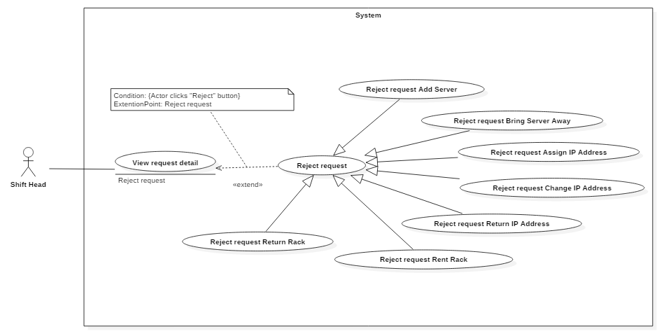 Figure 25 <Shift Head> Reject request “Add Server”

|  |  |  |  |
| --- | --- | --- | --- |
| USE CASE – IMS017 | | | |
| Use Case No. | IMS017 | **Use Case Version** | 2.0 |
| Use Case Name | Reject request “Add Server” | | |
| Author | Huỳnh Lâm Hà Tiên | | |
| Date | 23/01/2016 | **Priority** | medium |
| Actor:   * Shift Head.   Summary:   * This use case allows Shift Head to reject request “Add Server”.   Goal:   * Reject request “Add Server” which was sent by customer.   Triggers:   * Shift Head accesses to the appropriate request detail page.   Preconditions:   * Shift Head must login into the system with role Shift Head. * The request was sent to data center by customer.   Post Conditions:   * Success:   Customer will receive notification about reject request.  Request status will be changed to “Rejected”.  Server information will be removed from database.   * Fail: Show error message with specified content.   Main Success Scenario:   |  |  |  | | --- | --- | --- | | Step | Actor Action | System Response | | 1 | Shift Head clicks on not-viewed notification on the header panel. | The system will display “Add Server” request detail | | 2 | Shift Head clicks on “Reject” button | System shows pop-up to confirm | | 3 | Shift Head clicks “OK” button | * The new server information which customer sent will be deleted from database. * Request status will be changed to “Rejected”. * Customer will receive notification via both IMS system and email. |   Alternatives Scenario:   |  |  |  | | --- | --- | --- | | Step | Actor Action | System Response | | 1 | Shift Head clicks on not-viewed notification on the header panel. | The system will display “Add Server” request detail | | 2 | Shift Head clicks on “Reject” button | System shows pop-up to confirm | | 3 | Shift Head clicks “Cancel” button | “Add Server” request detail displays again. |   Exceptions:   |  |  |  | | --- | --- | --- | | No | Cause | System Response | | 1 | Connect to Internet fail | Show message “Cannot send request, please connect to the Internet!” |   Relationships: Extend to View request detail.  Business Rules:   * “Reject” button appears when request status is “Pending”, “Waiting” or “Processing” * The system only deletes the information of new server which customer sent, does not delete different information of this request. | | | |

Table 20: Use case IMS004 - <Shift Head> Reject request “Add Server”

###### <Shift Head> Reject request “Bring Server Away”

 Figure 25 <Shift Head> Reject request “Bring Server Away”

|  |  |  |  |
| --- | --- | --- | --- |
| USE CASE – IMS017 | | | |
| Use Case No. | IMS017 | **Use Case Version** | 2.0 |
| Use Case Name | Reject request “Bring Server Away” | | |
| Author | Huỳnh Lâm Hà Tiên | | |
| Date | 23/01/2016 | **Priority** | medium |
| Actor:   * Shift Head.   Summary:   * This use case allows Shift Head to reject request “Bring Server Away”.   Goal:   * Reject request “Bring Server Away” successfully.   Triggers:   * Shift Head accesses to the appropriate request detail page.   Preconditions:   * Shift Head must login into the system with role Shift Head. * The request was sent to data center by customer.   Post Conditions:   * Success:   Customer will receive notification about reject request.  Request status will be changed to “Rejected”.  Server information will be removed from database.   * Fail: Show error message with specified content.   Main Success Scenario:   |  |  |  | | --- | --- | --- | | Step | Actor Action | System Response | | 1 | Shift Head clicks on not-viewed notification on the header panel. | The system will display “Bring Server Away” request detail | | 2 | Shift Head clicks on “Reject” button | System shows pop-up to confirm | | 3 | Shift Head clicks “OK” button | * Servers that customer wants to bring away will be changed its status from “Bringing away” to “Running” * Request status will be changed to “Rejected”. * Customer will receive notification via both IMS system and email. |   Alternatives Scenario:   |  |  |  | | --- | --- | --- | | Step | Actor Action | System Response | | 1 | Shift Head clicks on not-viewed notification on the header panel. | The system will display “Bring Server Away” request detail | | 2 | Shift Head clicks on “Reject” button | System shows pop-up to confirm | | 3 | Shift Head clicks “Cancel” button | “Bring Server Away” request detail displays again. |   Exceptions:   |  |  |  | | --- | --- | --- | | No | Cause | System Response | | 1 | Connect to Internet fail | Show message “Cannot send request, please connect to the Internet!” |   Relationships: Extend to View request detail.  Business Rules:   * “Reject” button appears when request status is “Pending”, “Waiting” or “Processing” * The system only deletes the information of new server which customer sent, does not delete different information of this request. | | | |

Table 20: Use case IMS004 - <Shift Head> Reject request “Bring Server Away”

###### <Shift Head> Reject request “Add IP Address”

 Figure 25 <Shift Head> Reject request “Assign IP Address”

|  |  |  |  |
| --- | --- | --- | --- |
| USE CASE – IMS017 | | | |
| Use Case No. | IMS017 | **Use Case Version** | 2.0 |
| Use Case Name | Reject request “Assign IP Address” | | |
| Author | Huỳnh Lâm Hà Tiên | | |
| Date | 23/01/2016 | **Priority** | medium |
| Actor:   * Shift Head.   Summary:   * This use case allows Shift Head to reject request “Assign IP Address”.   Goal:   * Reject request “Assign IP Address” successfully.   Triggers:   * Shift Head accesses to the appropriate request detail page.   Preconditions:   * Shift Head must login into the system with role Shift Head. * The request was sent to data center by customer.   Post Conditions:   * Success:   Customer will receive notification about reject request.  Request status will be changed to “Rejected”.  Server information will be removed from database.   * Fail: Show error message with specified content.   Main Success Scenario:   |  |  |  | | --- | --- | --- | | Step | Actor Action | System Response | | 1 | Shift Head clicks on not-viewed notification on the header panel. | The system will display “Assign IP Address” request detail | | 2 | Shift Head clicks on “Reject” button | System shows pop-up to confirm | | 3 | Shift Head clicks “OK” button | * Request status will be changed to “Rejected”. * Customer will receive notification via both IMS system and email. |   Alternatives Scenario:   |  |  |  | | --- | --- | --- | | Step | Actor Action | System Response | | 1 | Shift Head clicks on not-viewed notification on the header panel. | The system will display “Assign IP Address” request detail | | 2 | Shift Head clicks on “Reject” button | System shows pop-up to confirm | | 3 | Shift Head clicks “Cancel” button | “Assign IP Address” request detail displays again. |   Exceptions:   |  |  |  | | --- | --- | --- | | No | Cause | System Response | | 1 | Connect to Internet fail | Show message “Cannot send request, please connect to the Internet!” |   Relationships: Extend to View request detail.  Business Rules:   * “Reject” button appears when request status is “Pending”” or “Processing” * The system only deletes the information of new server which customer sent, does not delete different information of this request. | | | |

Table 20: Use case IMS004 - <Shift Head> Accept request

###### <Shift Head> Reject request “Change IP Address”

Figure 25 <Shift Head> Reject request “Change IP Address”

|  |  |  |  |
| --- | --- | --- | --- |
| USE CASE – IMS017 | | | |
| Use Case No. | IMS017 | **Use Case Version** | 2.0 |
| Use Case Name | Reject request “Change IP Address” | | |
| Author | Huỳnh Lâm Hà Tiên | | |
| Date | 23/01/2016 | **Priority** | medium |
| Actor:   * Shift Head.   Summary:   * This use case allows Shift Head to reject request “Change IP Address”.   Goal:   * Reject request “Change IP Address” successfully.   Triggers:   * Shift Head accesses to the appropriate request detail page.   Preconditions:   * Shift Head must login into the system with role Shift Head. * The request was sent to data center by customer.   Post Conditions:   * Success:   Customer will receive notification about reject request.  Request status will be changed to “Rejected”.  Server information will be removed from database.   * Fail: Show error message with specified content.   Main Success Scenario:   |  |  |  | | --- | --- | --- | | Step | Actor Action | System Response | | 1 | Shift Head clicks on not-viewed notification on the header panel. | The system will display “Change IP Address” request detail | | 2 | Shift Head clicks on “Reject” button | System shows pop-up to confirm | | 3 | Shift Head clicks “OK” button | * Request status will be changed to “Rejected”. * Customer will receive notification via both IMS system and email. |   Alternatives Scenario:   |  |  |  | | --- | --- | --- | | Step | Actor Action | System Response | | 1 | Shift Head clicks on not-viewed notification on the header panel. | The system will display “Change IP Address” request detail | | 2 | Shift Head clicks on “Reject” button | System shows pop-up to confirm | | 3 | Shift Head clicks “Cancel” button | “Change IP Address” request detail displays again. |   Exceptions:   |  |  |  | | --- | --- | --- | | No | Cause | System Response | | 1 | Connect to Internet fail | Show message “Cannot send request, please connect to the Internet!” |   Relationships: Extend to View request detail.  Business Rules:   * “Reject” button appears when request status is “Pending”” or “Processing” * The system only deletes the information of new server which customer sent, does not delete different information of this request. | | | |

Table 20: Use case IMS004 - <Shift Head> Reject request “Change IP Address”

###### <Shift Head> Reject request “Return IP Address”

 Figure 25 <Shift Head> Reject request “Return IP Address”

|  |  |  |  |
| --- | --- | --- | --- |
| USE CASE – IMS017 | | | |
| Use Case No. | IMS017 | **Use Case Version** | 2.0 |
| Use Case Name | Reject request “Return IP Address” | | |
| Author | Huỳnh Lâm Hà Tiên | | |
| Date | 23/01/2016 | **Priority** | medium |
| Actor:   * Shift Head.   Summary:   * This use case allows Shift Head to reject request “Return IP Address”.   Goal:   * Reject request “Return IP Address” successfully.   Triggers:   * Shift Head accesses to the appropriate request detail page.   Preconditions:   * Shift Head must login into the system with role Shift Head. * The request was sent to data center by customer.   Post Conditions:   * Success:   Customer will receive notification about reject request.  Request status will be changed to “Rejected”.  Server information will be removed from database.   * Fail: Show error message with specified content.   Main Success Scenario:   |  |  |  | | --- | --- | --- | | Step | Actor Action | System Response | | 1 | Shift Head clicks on not-viewed notification on the header panel. | The system will display “Return IP Address” request detail | | 2 | Shift Head clicks on “Reject” button | System shows pop-up to confirm | | 3 | Shift Head clicks “OK” button | * Request status will be changed to “Rejected”. * Customer will receive notification via both IMS system and email. |   Alternatives Scenario:   |  |  |  | | --- | --- | --- | | Step | Actor Action | System Response | | 1 | Shift Head clicks on not-viewed notification on the header panel. | The system will display “Return IP Address” request detail | | 2 | Shift Head clicks on “Reject” button | System shows pop-up to confirm | | 3 | Shift Head clicks “Cancel” button | “Change IP Address” request detail displays again. |   Exceptions:   |  |  |  | | --- | --- | --- | | No | Cause | System Response | | 1 | Connect to Internet fail | Show message “Cannot send request, please connect to the Internet!” |   Relationships: Extend to View request detail.  Business Rules:   * “Reject” button appears when request status is “Pending”” or “Processing” * The system only deletes the information of new server which customer sent, does not delete different information of this request. | | | |

Table 20: Use case IMS004 - <Shift Head> Reject request “Return IP Address”

###### <Shift Head> Reject request “Rent Rack”

 Figure 25 <Shift Head> Reject request “Rent Rack”

|  |  |  |  |
| --- | --- | --- | --- |
| USE CASE – IMS017 | | | |
| Use Case No. | IMS017 | **Use Case Version** | 2.0 |
| Use Case Name | Reject request “Rent Rack” | | |
| Author | Huỳnh Lâm Hà Tiên | | |
| Date | 23/01/2016 | **Priority** | medium |
| Actor:   * Shift Head.   Summary:   * This use case allows Shift Head to reject request “Rent Rack”.   Goal:   * Reject request “Rent Rack” successfully.   Triggers:   * Shift Head accesses to the appropriate request detail page.   Preconditions:   * Shift Head must login into the system with role Shift Head. * The request was sent to data center by customer.   Post Conditions:   * Success:   Customer will receive notification about reject request.  Request status will be changed to “Rejected”.  Server information will be removed from database.   * Fail: Show error message with specified content.   Main Success Scenario:   |  |  |  | | --- | --- | --- | | Step | Actor Action | System Response | | 1 | Shift Head clicks on not-viewed notification on the header panel. | The system will display “Rent Rack” request detail | | 2 | Shift Head clicks on “Reject” button | System shows pop-up to confirm | | 3 | Shift Head clicks “OK” button | * Request status will be changed to “Rejected”. * Customer will receive notification via both IMS system and email. |   Alternatives Scenario:   |  |  |  | | --- | --- | --- | | Step | Actor Action | System Response | | 1 | Shift Head clicks on not-viewed notification on the header panel. | The system will display “Return IP Address” request detail | | 2 | Shift Head clicks on “Reject” button | System shows pop-up to confirm | | 3 | Shift Head clicks “Cancel” button | “Rent Rack” request detail displays again. |   Exceptions:   |  |  |  | | --- | --- | --- | | No | Cause | System Response | | 1 | Connect to Internet fail | Show message “Cannot send request, please connect to the Internet!” |   Relationships: Extend to View request detail.  Business Rules:   * “Reject” button appears when request status is “Pending”” or “Processing” * The system only deletes the information of new server which customer sent, does not delete different information of this request. | | | |

Table 20: Use case IMS004 - <Shift Head> Reject request “Rent Rack”

###### <Shift Head> Reject request “Return Rack”

 Figure 25 <Shift Head> Reject request “Return Rack”

|  |  |  |  |
| --- | --- | --- | --- |
| USE CASE – IMS017 | | | |
| Use Case No. | IMS017 | **Use Case Version** | 2.0 |
| Use Case Name | Reject request “Return Rack” | | |
| Author | Huỳnh Lâm Hà Tiên | | |
| Date | 23/01/2016 | **Priority** | medium |
| Actor:   * Shift Head.   Summary:   * This use case allows Shift Head to reject request “Return Rack”.   Goal:   * Reject request “Return Rack” successfully.   Triggers:   * Shift Head accesses to the appropriate request detail page.   Preconditions:   * Shift Head must login into the system with role Shift Head. * The request was sent to data center by customer.   Post Conditions:   * Success:   Customer will receive notification about reject request.  Request status will be changed to “Rejected”.  Server information will be removed from database.   * Fail: Show error message with specified content.   Main Success Scenario:   |  |  |  | | --- | --- | --- | | Step | Actor Action | System Response | | 1 | Shift Head clicks on not-viewed notification on the header panel. | The system will display “Return Rack” request detail | | 2 | Shift Head clicks on “Reject” button | System shows pop-up to confirm | | 3 | Shift Head clicks “OK” button | * Request status will be changed to “Rejected”. * Customer will receive notification via both IMS system and email. |   Alternatives Scenario:   |  |  |  | | --- | --- | --- | | Step | Actor Action | System Response | | 1 | Shift Head clicks on not-viewed notification on the header panel. | The system will display “Return Rack” request detail | | 2 | Shift Head clicks on “Reject” button | System shows pop-up to confirm | | 3 | Shift Head clicks “Cancel” button | “Return Rack” request detail displays again. |   Exceptions:   |  |  |  | | --- | --- | --- | | No | Cause | System Response | | 1 | Connect to Internet fail | Show message “Cannot send request, please connect to the Internet!” |   Relationships: Extend to View request detail.  Business Rules:   * “Reject” button appears when request status is “Pending”” or “Processing” * The system only deletes the information of new server which customer sent, does not delete different information of this request. | | | |

Table 20: Use case IMS004 - <Shift Head> Reject request “Return Rack”

###### <Shift Head> Export procedure

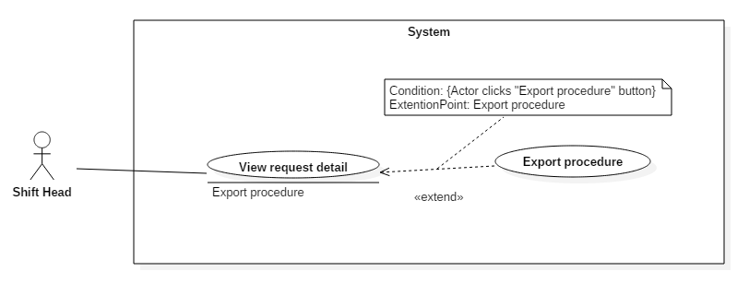 Figure 11: <Shift Head> Export Procedure

|  |  |  |  |
| --- | --- | --- | --- |
| USE CASE – IMS014 | | | |
| Use Case No. | IMS014 | **Use Case Version** | 2.0 |
| Use Case Name | Export procedure | | |
| Author | Huỳnh Lâm Hà Tiên | | |
| Date | 23/01/2016 | **Priority** | medium |
| Actor:   * Shift Head.   Summary:   * This use case allows Shift Head to export procedure after completing request “Add Server”   Goal:   * Export procedure successfully and hand it to customer   Triggers:   * Shift Head clicks on “Export procedure” button on “Add Server” request detail page   Preconditions:   * Shift Head must login into the system with role Shift Head. * The request must be already completed.   Post Conditions:   * Success: Export file word corresponding to request content. * Fail: Show message with specified content.   Main Success Scenario:   |  |  |  | | --- | --- | --- | | Step | Actor Action | System Response | | 1 | Shift Head clicks on “Export procedure” button. | The system will fill the request information in the procedure and export file word. |   Alternatives Scenario: N/A.  Exceptions:   |  |  |  | | --- | --- | --- | | Step | Cause | System Response | | 1 | Template file is not placed in the right folder | System will show message: “Export file is not successful. Please try again.” |   Relationships:   * Extend to View request detail.   Business Rules:   * File procedure is only exported when the request was completed. * Staff can export procedure more than one time. All the action will be logged. | | | |

*Table 23: Use case IMS016 - <Shift Head> Assign IP to server.*

###### <Shift Head> Reassign task

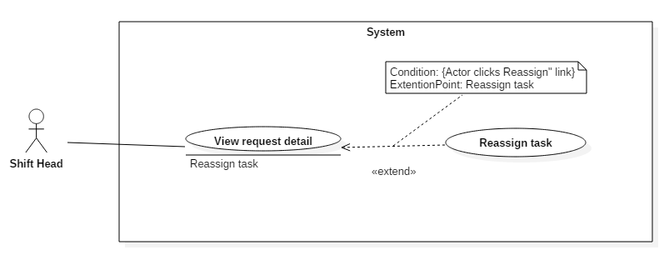 Figure 19: <Shift Head> Reassign task

|  |  |  |  |
| --- | --- | --- | --- |
| USE CASE – IMS002 | | | |
| Use Case No. | IMS002 | **Use Case Version** | 2.0 |
| Use Case Name | Reassign task | | |
| Author | Huỳnh Lâm Hà Tiên | | |
| Date | 18/01/2016 | **Priority** | Normal |
| Actor:   * Shift Head   Summary:   * This use case allows Shift Head to reassign task that was assigned but still not be accepted by staff.   Goal:   * Reassign task successfully.   Triggers:   * Shift head clicks “Reassign task” link on request detail page.   Precondition:   * Shift Head must login into the system with role Shift Head. * The request was sent to data center by customer. * Request is already assigned.   Post Conditions:   * Success: This task will be assigned to corresponding Staff. Staff will have notification about this assignment. * Fail: Show message error with specified content.   Main Success Scenario:   |  |  |  | | --- | --- | --- | | Step | Actor Action | System Response | | 1 | Shift head clicks “Reassign task” link on request detail page | Pop-up will display and show info:   * Assigned staff * Task status * Drop down list: includes name of member in current group. | | 2 | Shift Head selects himself in the drop down list | * Shift Head will be able to process this request. * If pre-assigned staff is not shift head, he will receive notification about his task status * Shift Head won’t receive notification about task. |   Alternative Scenario:   |  |  |  | | --- | --- | --- | | Step | Actor Action | System Response | | 1 | Shift head clicks “Reassign task” link on request detail page | Pop-up will display and show info:   * Assigned staff * Task status * Drop down list: includes name of member in current group. | | 2 | Shift Head selects another staff in the drop down list | * Selected staff will be able to process this request. * If pre-assigned staff is not shift head, he will receive notification about his task status * New-assigned staff will receive notification about new task. |   Exceptions: N/A.  Relationships: Extend to View request detail.  Business Rules:   * Shift Head can only assign task for members in the same group. * If Shift Head assigns task for himself, he won’t receive notification related to task * Shift Head can reassign task until assigned staff clicks “Accept task”. * One request is just edited by one person. | | | |

*Table 29: Use case IMS018 - <Shift Head> Reassign task*

###### <Shift Head> View daily schedule

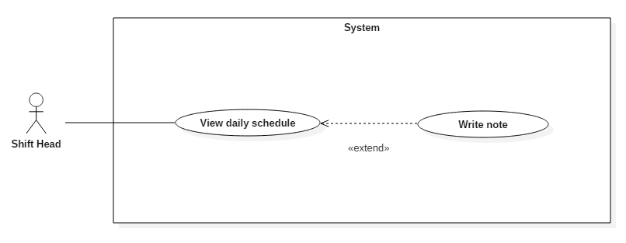 Figure 15: <Shift Head> View daily schedule

|  |  |  |  |
| --- | --- | --- | --- |
| USE CASE – IMS006 | | | |
| Use Case No. | IMS006 | **Use Case Version** | 2.0 |
| Use Case Name | View daily schedule | | |
| Author | Huỳnh Lâm Hà Tiên | | |
| Date | 18/01/2016 | **Priority** | medium |
| Actor:   * Shift Head.   Summary:   * This use case allows Shift Head to view all of the today’s appointments and note from previous shift.   Goal:   * System provides schedule which helps Shift Head to control the appointments with customers.   Triggers:   * When Shift Head login to the system, the page contains daily schedule and the note of previous shift will be showed.   Preconditions:   * The Shift Head must login to the system with Shift Head role.   Post Conditions:   * Success: The daily schedule and note will be showed. * Fail: N/A   Main Success Scenario:   |  |  |  | | --- | --- | --- | | Step | Actor Action | System Response | | 1 | Shift Head login to the system | The page contains daily schedule and note will be showed. |   Alternative Scenario:   |  |  |  | | --- | --- | --- | | Step | Actor Action | System Response | | 1 | Shift Head login to the system and today does not have any customer’s arrival. | A message will be showed “Today does not have any appointment!” |   Exceptions: N/A  Relationships:   * Extended by Write note.   Business Rules:   * The customer link in daily schedule will be showed when today has appointments. | | | |

Table 26: Use case IMS011 - <Shift Head> View daily schedule

###### <Shift Head> Write note

 Figure 19: <Shift Head> Write note

|  |  |  |  |
| --- | --- | --- | --- |
| USE CASE – IMS001 | | | |
| Use Case No. | IMS001 | **Use Case Version** | 2.0 |
| Use Case Name | Write note | | |
| Author | Huỳnh Lâm Hà Tiên | | |
| Date | 18/01/2016 | **Priority** | Normal |
| Actor:   * Shift Head   Summary:   * This use case allows Shift Head to write note about customer’s arrival for the next shift.   Goal:   * Creating note about customer’s arrival for the next shift.   Triggers:   * Shift head clicks “Write note for the next shift” link on the Daily Schedule Page.   Precondition:   * The Shift Head must login to the system with Shift Head role at right shift.   Post Conditions:   * Success: The note of this shift will be created. * Fail: Nothing will be created. Show message error with specified content.   Main Success Scenario:   |  |  |  | | --- | --- | --- | | Step | Actor Action | System Response | | 1 | Shift head clicks “Write note for the next shift” link on the Daily Schedule Page. | The popup contains blank note will be showed. | | 2 | Shift head inputs data and clicks “Submit note” button | The note of this shift will be created. |   Alternative Scenario:   |  |  |  | | --- | --- | --- | | Step | Actor Action | System Response | | 1 | Shift head clicks “Write note for the next shift” link on the Daily Schedule Page. | The popup contains blank note will be showed. | | 2 | Shift head inputs data and clicks “Cancel” button | Return to Daily Schedule Page. |   Exceptions:   |  |  |  | | --- | --- | --- | | Step | Cause | System Response | | 1 | The note is blank | Show message error: “The note is blank. Please input data!” |   Relationships: Extend to View daily Schedule.  Business Rules:   * The time when the note was created and the created Shift Head must be saved into database. * If the Shift Head login to the system at different people’s shift, the link “Write note for the next shift” is disabled. | | | |

*Table 29: Use case IMS019 - <Shift Head> Write note*

###### <Shift Head> View server detail

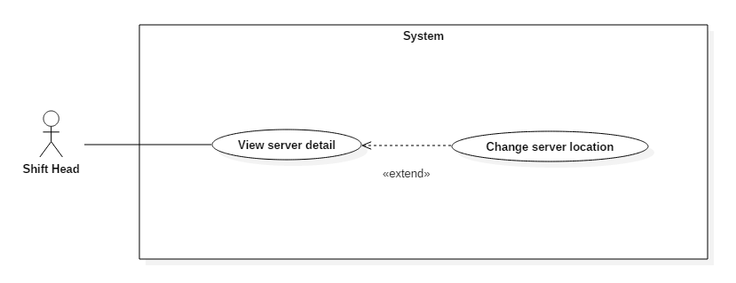  
 Figure 10: <Shift Head> View server detail

|  |  |  |  |
| --- | --- | --- | --- |
| USE CASE – IMS015 | | | |
| Use Case No. | IMS015 | **Use Case Version** | 2.0 |
| Use Case Name | View server detail | | |
| Author | Huỳnh Lâm Hà Tiên | | |
| Date | 23/01/2016 | **Priority** | medium |
| Actor:   * Shift Head.   Summary:   * This use case allows Shift Head to view each server information of customers.   Goal:   * View each server information.   Triggers:   * Shift Head clicks a row in the Server Table.   Preconditions:   * Shift Head must login into the system with role Shift Head.   Post Conditions:   * Success: Server detail will be showed. * Fail: Server detail will not be showed. Show error message with specified content.   Main Success Scenario:   |  |  |  | | --- | --- | --- | | Step | Actor Action | System Response | | 1 | Shift Head clicks a row on Server Table in Server Index page | Navigate to Server Detail Page. |   Alternative Scenario: N/A.  Exceptions: N/A.  Relationships: Extended to Change Server Location.  Business Rules: N/A. | | | |

Table 22: Use case IMS006 - <Shift Head> View server detail

###### <Shift Head> Change server location

 Figure 15: <Shift Head> Change server location

|  |  |  |  |
| --- | --- | --- | --- |
| USE CASE – IMS016 | | | |
| Use Case No. | IMS016 | **Use Case Version** | 2.0 |
| Use Case Name | Change server location | | |
| Author | Lê Thị Thu Hà | | |
| Date | 23/01/2016 | **Priority** | medium |
| Actor:   * Shift Head.   Summary:   * This use case allows Shift Head to change location of server in data center   Goal:   * Change location of server successfully.   Triggers:   * Shift Head clicks on “Change location” link in “Server Detail” page   Preconditions:   * Shift Head must login into the system with role Shift Head.   Post Conditions:   * Success: New location of server is updated successfully. * Fail: N/A.   Main Success Scenario:   |  |  |  | | --- | --- | --- | | Step | Actor Action | System Response | | 1 | Shift Head clicks on “Change location” link in “Server Detail” page | Navigate to “Change Location” page to select available location | | 2 | Shift Head selects suitable location and clicks “Save” button. | Redirect to the previous “Server Detail” page. “Location” field will be updated |   Alternative Scenario:   |  |  |  | | --- | --- | --- | | Step | Actor Action | System Response | | 1 | Shift Head clicks on “Change location” link in “Server Detail” page | Navigate to “Change Location” page to select available location | | 2 | Shift Head clicks “Cancel” button. | Return to Request Page. |   Exceptions: N/A.  Relationships:   * Extended to View server detail.   Business Rules:   * Shift Head makes sure that information saved in the system is the same with reality * All members in data center can update server location. Action will be logged. | | | |

*Table 26: Use case IMS014 - <Shift Head> Change server location*

###### <Shift Head> View IP address

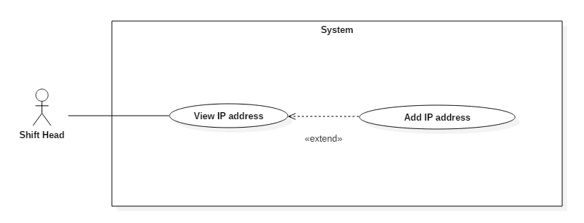 Figure 11: <Shift Head> View IP Address

|  |  |  |  |
| --- | --- | --- | --- |
| USE CASE – IMS012 | | | |
| Use Case No. | IMS020 | **Use Case Version** | 2.0 |
| Use Case Name | View IP Address | | |
| Author | Lê Thị Thu Hà | | |
| Date | 23/01/2016 | **Priority** | medium |
| Actor:   * Shift Head.   Summary:   * This use case allows Shift Head to view all IP address in the center   Goal:   * View and Search all IP Address in the system.   Triggers:   * Shift Head clicks “IP Address” tab on the Sidebar   Preconditions:   * Shift Head must login into the system with role Shift Head.   Post Conditions:   * Success: IP address information will be showed. * Fail: IP address information will not be showed. Show error message with specified content.   Main Success Scenario:   |  |  |  | | --- | --- | --- | | Step | Actor Action | System Response | | 1 | Shift Head clicks “IP Address” tab on the Sidebar | Navigate to View IP information page which contains:   * IP Address: label * Status: link * Gateway: label * Subnet mask: label * Status duration: label |   Alternative Scenario: N/A.  Exceptions: N/A.  Relationships: Extend to Add IP Address.  Business Rules:   * The first, the last IP address and gateway are special IP addresses. It cannot be able to use. | | | |

Table 23: Use case IMS007 - <Shift Head> View IP Address

###### <Shift Head> Add IP address

 Figure 15: <Shift Head> Add IP Address

|  |  |  |  |
| --- | --- | --- | --- |
| USE CASE – IMS011 | | | |
| Use Case No. | IMS011 | **Use Case Version** | 2.0 |
| Use Case Name | Add IP Address | | |
| Author | Lê Thị Thu Hà | | |
| Date | 23/01/2016 | **Priority** | medium |
| Actor:   * Shift Head.   Summary:   * This use case allows Shift Head to add range of IP address to the pool   Goal:   * Add information of IP address quickly.   Triggers:   * Shift Head clicks on “Add IP Address” on “IP Address” page   Preconditions:   * Shift Head must login into the system with role Shift Head.   Post Conditions:   * Success: Shift Head enter the IP address, and the system automatically generate other IP address in the range. Shift Head click “Save” to save all of generated IP addresses to database * Fail: Show error message with specified content.   Main Success Scenario:   |  |  |  | | --- | --- | --- | | Step | Actor Action | System Response | | 1 | Shift Head clicks on “Add IP Address” on “IP Address” page | System will display Add IP Address pop-up | | 2 | Input IP address and default gateway | After entering IP address range, system automatically return the subnet mask code | | 3 | Click “OK” | System generates all of IP address in the same range and return to previous “IP address” page |   Alternatives Scenario:   |  |  |  | | --- | --- | --- | | Step | Actor Action | System Response | | 1 | Shift Head clicks on “Add IP Address” on “IP Address” page | System will display Add IP Address pop-up | | 2 | Input IP address and default gateway | After entering IP address range, system automatically return the subnet mask code | | 3 | Click “Cancel” | Return to view “IP Address” without changed information |   Exceptions: N/A.  Relationships: N/A.  Business Rules: N/A. | | | |

*Table 26: Use case IMS012 - <Shift Head> Add IP Address*

###### <Shift Head> Block IP address

 Figure 15: <Shift Head> Block IP Address

|  |  |  |  |
| --- | --- | --- | --- |
| USE CASE – IMS008 | | | |
| Use Case No. | IMS008 | **Use Case Version** | 2.0 |
| Use Case Name | Block IP Address | | |
| Author | Lê Thị Thu Hà | | |
| Date | 23/01/2016 | **Priority** | medium |
| Actor:   * Shift Head.   Summary:   * This use case allows Shift Head to change IP address status from “Available” to “Blocked”   Goal:   * Change IP address status to “Blocked”. It can’t be used to assign until unblocked.   Triggers:   * Shift Head clicks “Block” link on a row on the table in “IP Address” page.   Preconditions:   * Shift Head must login into the system with role Shift Head.   Post Conditions:   * Success: The status of IP address will be changed to “Blocked”. * Fail: The status of IP address will not be changed. Show error message with specified content.   Main Success Scenario:   |  |  |  | | --- | --- | --- | | Step | Actor Action | System Response | | 1 | Shift Head clicks “Block” link on a row on the table in “IP Address” page. | Confirmation pop-up will display | | 2 | Click “OK” | Return to previous page with updated status of selected IP address. |   Alternatives Scenario:   |  |  |  | | --- | --- | --- | | Step | Actor Action | System Response | | 1 | Shift Head clicks “Block” link on a row on the table in “IP Address” page. | Confirmation pop-up will display | | 2 | Click “Cancel” | Return to previous page with nothing changed. |   Exceptions: N/A.  Relationships: N/A.  Business Rules:   * Only “blocked” status is able to be updated manually | | | |

*Table 26: Use case IMS012 - <Shift Head> Block IP Address*

###### <Shift Head> Unblock IP address

 Figure 15: <Shift Head> Unblock IP Address

|  |  |  |  |
| --- | --- | --- | --- |
| USE CASE – IMS008 | | | |
| Use Case No. | IMS008 | **Use Case Version** | 2.0 |
| Use Case Name | Unblock IP Address | | |
| Author | Lê Thị Thu Hà | | |
| Date | 23/01/2016 | **Priority** | medium |
| Actor:   * Shift Head.   Summary:   * This use case allows Shift Head to change IP address status from “Blocked” to “Available”   Goal:   * Selected IP address status will be changed to “Available”.   Triggers:   * Shift Head clicks “Unblock” link on a row on the table in “IP Address” page.   Preconditions:   * Shift Head must login into the system with role Shift Head.   Post Conditions:   * Success: The status of IP address will be changed to “Available”. * Fail: The status of IP address will not be changed. Show error message with specified content.   Main Success Scenario:   |  |  |  | | --- | --- | --- | | Step | Actor Action | System Response | | 1 | Shift Head clicks “Unblock” link on a row on the table in “IP Address” page. | Confirmation pop-up will display | | 2 | Click “OK” | Return to previous page with updated status of selected IP address. |   Alternatives Scenario:   |  |  |  | | --- | --- | --- | | Step | Actor Action | System Response | | 1 | Shift Head clicks “Unblock” link on a row on the table in “IP Address” page. | Confirmation pop-up will display | | 2 | Click “Cancel” | Return to previous page with nothing changed. |   Exceptions: N/A.  Relationships: N/A.  Business Rules:   * Only “Blocked” status is able to be updated manually | | | |

*Table 26: Use case IMS012 - <Shift Head> Unblock IP Address*

###### <Shift Head> View list location

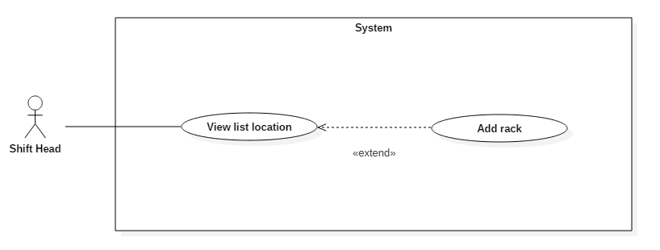 Figure 15: <Shift Head> Approve request Add New Server

|  |  |  |  |
| --- | --- | --- | --- |
| USE CASE – IMS012 | | | |
| Use Case No. | IMS021 | **Use Case Version** | 2.0 |
| Use Case Name | View list location | | |
| Author | Lê Thị Thu Hà | | |
| Date | 23/01/2016 | **Priority** | medium |
| Actor:   * Shift Head.   Summary:   * This use case allows Shift Head to view list all server location of the system   Goal:   * View location   Triggers:   * Shift Head clicks on “View location” link on the panel.   Preconditions:   * Shift Head must login into the system with role Shift Head.   Post Conditions:   * Success: All location information will be showed. * Fail: All location information will not be showed. Show error message with specified content.   Main Success Scenario:   |  |  |  | | --- | --- | --- | | Step | Actor Action | System Response | | 1 | Shift Head clicks on “View location” link on the panel. | Navigate to View location information page which contains:   * Location on the rack represented as a table * Default IP address of server on the rack: label |   Alternative Scenario: N/A.  Exceptions:   |  |  |  | | --- | --- | --- | | No | Actor Action | System Response | | 1 | Connect to database fail | Show message “Error, please try again!” |   Relationships:   * Extended by View request.   Business Rules:   * Shift Head can view and update location information | | | |

Table 26: Use case IMS009 - <Shift Head> Approve request Add New Server

###### <Shift Head> Add rack

 Figure 15: <Shift Head> Approve request Return IP Address

|  |  |  |  |
| --- | --- | --- | --- |
| USE CASE – IMS011 | | | |
| Use Case No. | IMS011 | **Use Case Version** | 2.0 |
| Use Case Name | Add location | | |
| Author | Lê Thị Thu Hà | | |
| Date | 23/01/2016 | **Priority** | medium |
| Actor:   * Shift Head.   Summary:   * This use case allows Shift Head add new rack information to database.   Goal:   * Add new location to the center quickly and easily manage   Triggers:   * Shift Head clicks on “Add location” on View location page   Preconditions:   * Shift Head must login into the system with role Shift Head.   Post Conditions:   * Success: Shift Head add new location successfully * Fail: Show error message with specified content.   Main Success Scenario:   |  |  |  | | --- | --- | --- | | Step | Actor Action | System Response | | 1 | Customer clicks on “Add location” on view location page | System will display Add location Popup | | 2 | Input data in fields Popup and clicks on “Save” button | System will automatically generate 42 location by each rack added and save to database |   Alternatives Scenario: N/A  Exceptions:   |  |  |  | | --- | --- | --- | | No | Cause | System Response | | 1 | Cannot connect to database. | Show message: “Error, please try again!” |   Relationships: N/A.  Business Rules:   * Only shift head can add new location. * Rack name is ruled by the data center | | | |

*Table 26: Use case IMS013 - <Shift Head> Approve request Return IP Address*

###### <Shift Head> Receive notification

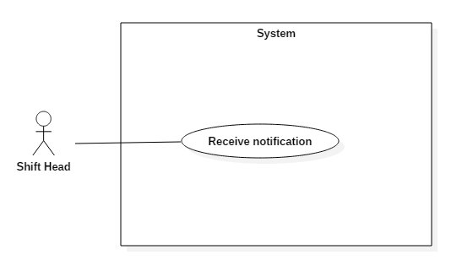 Figure 11: <Shift Head> View server details

|  |  |  |  |
| --- | --- | --- | --- |
| USE CASE – IMS015 | | | |
| Use Case No. | IMS015 | **Use Case Version** | 2.0 |
| Use Case Name | View server details | | |
| Author | Huỳnh Lâm Hà Tiên | | |
| Date | 23/01/2016 | **Priority** | medium |
| Actor:   * Shift Head.   Summary:   * This use case allows Shift Head to view each server information of customers.   Goal:   * View each server information.   Triggers:   * Shift Head clicks on “Server name” link on the Server Table.   Preconditions:   * Shift Head must login into the system with role Shift Head.   Post Conditions:   * Success: Server detail will be showed. * Fail: Server detail will not be showed. Show error message with specified content.   Main Success Scenario:   |  |  |  | | --- | --- | --- | | Step | Actor Action | System Response | | 1 | Shift Head clicks on Server Name link on the panel. | Navigate to Server Detail Page. |   Alternative Scenario: N/A.  Exceptions:   |  |  |  | | --- | --- | --- | | No | Actor Action | System Response | | 1 | Connect to database fail | Show message “Error, please try again!” |   Relationships:   * Extended to View server.   Business Rules: N/A. | | | |

Table 23: Use case IMS015 - <Shift Head> View server details

###### <Shift Head> View report Blocked IP Address

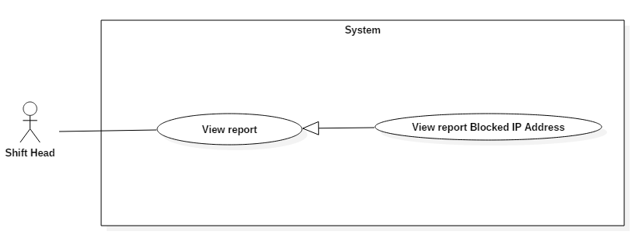 Figure 15: <Shift Head> Approve request Upgrade Server

|  |  |  |  |
| --- | --- | --- | --- |
| USE CASE – IMS014 | | | |
| Use Case No. | IMS014 | **Use Case Version** | 2.0 |
| Use Case Name | View Report | | |
| Author | Cao Hồng Nam | | |
| Date | 18/01/2016 | **Priority** | medium |
| Actor:   * Authenticated user.   Summary:   * This use case allows Authenticated user to view report information.   Goal:   * View Report information.   Triggers:   * Authenticated user clicks on “View Report” link on the panel.   Preconditions:   * Authenticated user must login into the system with role Authenticated user.   Post Conditions:   * Success: All data will be saving successfully and show success message   - Fail: System shows error message.  Main Success Scenario:   |  |  |  | | --- | --- | --- | | Step | Actor Action | System Response | | 1 | Authenticated user clicks on “View Report” link on the panel. | Navigate to View Report information page which contains:   * Report all activity of Customer, Sever. |   Alternatives Scenario: N/A.  Exceptions:   |  |  |  | | --- | --- | --- | | No | Actor Action | System Response | | 1 | Connect to database fail | Show message “Error, please try again!” |   Relationships: N/A.  Business Rules:  - Shift Manager can view report of all staff, while staff can only view the report of the customer.  - If Authenticated user is headshift or Shift Manager, he/she can choose the staff to view report | | | |

Table 26: Use case IMS0010 - <Shift Head> Approve request Upgrade Server

##### <Staff> Overview Use Case

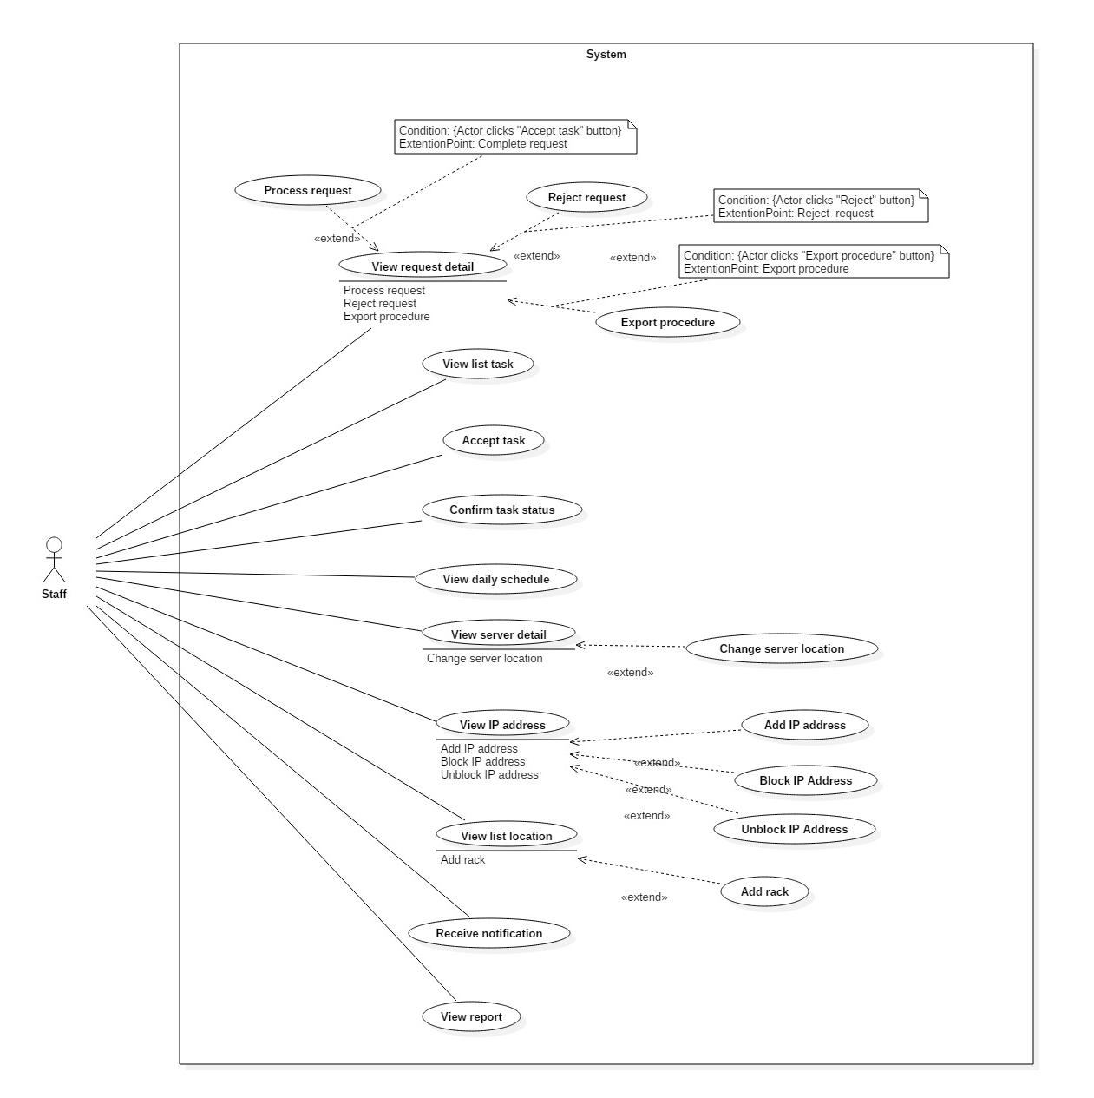

Figure 13: <Staff> Overview Use Case

###### <Staff> View request detail

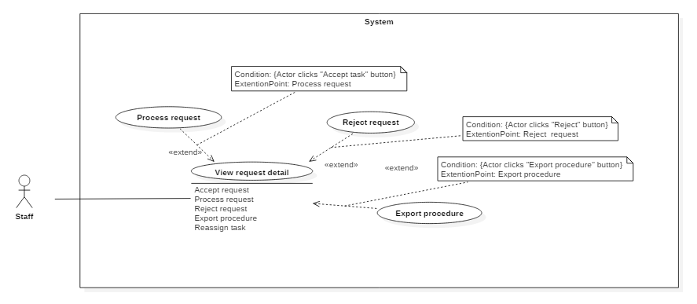

Figure 8 <Staff> View request

|  |  |  |  |
| --- | --- | --- | --- |
| USE CASE – IMS003 | | | |
| Use Case No. | IMS003 | **Use Case Version** | 2.0 |
| Use Case Name | View request | | |
| Author | Huỳnh Lâm Hà Tiên | | |
| Date | 23/01/2016 | **Priority** | Normal |
| Actor:   * Staff   Summary:   * This use case allows Staff to view request from customer.   Goal:   * View request.   Triggers:   * Staff clicks on each event at Daily Schedule Page or clicks on each request at Server Page.   Precondition:   * The Staff must login to the system with Staff role.   Post Conditions:   * Success: Request page will be displayed. * Fail: Show message error with specified content.   Main Success Scenario:   |  |  |  | | --- | --- | --- | | Step | Actor Action | System Response | | 1 | Staff clicks on each event at Daily Schedule Page or clicks on each request at Server Page. | The Request Page will be displayed. |   Alternative Scenario: N/A.  Exceptions:   |  |  |  | | --- | --- | --- | | No | Actor Action | System Response | | 1 | Connect to database fail | Show message “Error, please try again!” |   Relationships:   * Extend to View daily Schedule. * Extend to View server. * Extended by Accept request. * Extended by Approve request. * Extended by Export procedure. * Extended by Assign IP to server. * Extended by View IP. * Extended by View location.   Business Rules:   * When the server has request from customer, that request’s link will be displayed in Server Table. * Staff who does not login in right shift or was not assigned this task, all buttons and check boxes in Request Page will be disabled. | | | |

Table 19: Use case IMS003 - <Staff> View request

###### <Staff> Process request “Add Server”

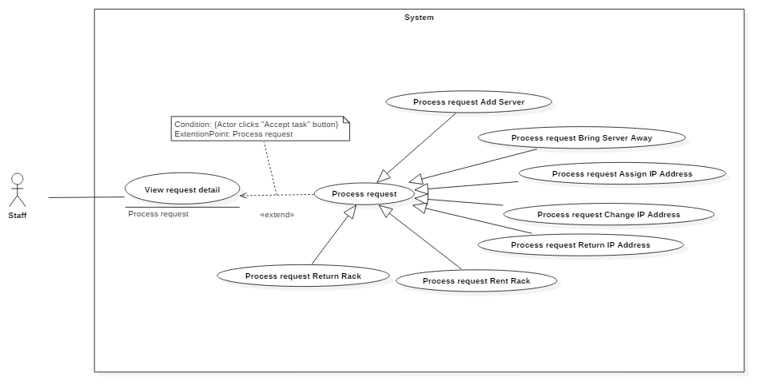 Figure 15: <Staff> Approve request Add New Server

|  |  |  |  |
| --- | --- | --- | --- |
| USE CASE – IMS009 | | | |
| Use Case No. | IMS009 | **Use Case Version** | 2.0 |
| Use Case Name | Approve request Add New Server | | |
| Author | Huỳnh Lâm Hà Tiên | | |
| Date | 24/01/2016 | **Priority** | medium |
| Actor:   * Staff.   Summary:   * This use case allows Staff to approve request Add New Server when that request was done in reality.   Goal:   * Approve request Add New Server which was done in reality.   Triggers:   * Staff clicks on “Request” and select “Request Add New Server” link at Request Column of Server Table.   Preconditions:   * Staff must login into the system with role Staff in right shift. * Staff is assigned to confirm this request by Shift Head.   Post Conditions:   * Success:   The new information of New Server includes Default IP, Location, Registered Date will be saved into database.  The status of this New Server will be changed into database.  The status of Approve Request will be changed into database and the approved time, approved Staff will be saved into database.   * Fail: Show message with specified content.   Main Success Scenario:   |  |  |  | | --- | --- | --- | | Step | Actor Action | System Response | | 1 | Staff clicks on “Request” link at Request Column of Server Table. | The system will display list of request of that server. | | 2 | Staff select request Add New Server | The page of request Add New Server will be displayed. | | 3 | Staff clicks on “Add IP” | The picked up IP Address Popup will be displayed. | | 4 | Staff searches suitable IP Address, select it and clicks “OK” button. | Return to Request Add New Server Page and the selected IP Address will be display on field “Default IP” | | 5 | Staff clicks on “Add location” | The picked up Location Popup will be displayed. | | 6 | Staff selects suitable location and clicks “OK” button. | Return to Request Add New Server Page and the selected location will be display on field “Location” | | 7 | Staff clicks on “Approve” button | * System will save new information of this server into database. * System will change status of this server into database. * System will save the approved time, approved Staff into database. |   Alternatives Scenario:   |  |  |  | | --- | --- | --- | | Step | Actor Action | System Response | | 1 | Staff clicks on “Request” link at Request Column of Server Table. | The system will display list of request of that server. | | 2 | Staff select request Add New Server | The page of request Add New Server will be displayed. | | 3 | Staff clicks on “Cancel” button on Request Add New Server Page. | Return to Server Page. |   Exceptions:   |  |  |  | | --- | --- | --- | | Step | Cause | System Response | | 1 | Connect to database fail. | System will show message: “Error, please try again!” |   Relationships:   * Extend to View request detail.   Business Rules:   * When Staff clicked on “Approve” button, that request will disappear out of the list of server request on Server Page. | | | |

Table 26: Use case IMS009 - <Staff> Approve request Add New Server

###### <Staff> Process request “Bring Server Away”

 Figure 15: <Staff> Approve request Add New Server

|  |  |  |  |
| --- | --- | --- | --- |
| USE CASE – IMS009 | | | |
| Use Case No. | IMS009 | **Use Case Version** | 2.0 |
| Use Case Name | Approve request Add New Server | | |
| Author | Huỳnh Lâm Hà Tiên | | |
| Date | 24/01/2016 | **Priority** | medium |
| Actor:   * Staff.   Summary:   * This use case allows Staff to approve request Add New Server when that request was done in reality.   Goal:   * Approve request Add New Server which was done in reality.   Triggers:   * Staff clicks on “Request” and select “Request Add New Server” link at Request Column of Server Table.   Preconditions:   * Staff must login into the system with role Staff in right shift. * Staff is assigned to confirm this request by Shift Head.   Post Conditions:   * Success:   The new information of New Server includes Default IP, Location, Registered Date will be saved into database.  The status of this New Server will be changed into database.  The status of Approve Request will be changed into database and the approved time, approved Staff will be saved into database.   * Fail: Show message with specified content.   Main Success Scenario:   |  |  |  | | --- | --- | --- | | Step | Actor Action | System Response | | 1 | Staff clicks on “Request” link at Request Column of Server Table. | The system will display list of request of that server. | | 2 | Staff select request Add New Server | The page of request Add New Server will be displayed. | | 3 | Staff clicks on “Add IP” | The picked up IP Address Popup will be displayed. | | 4 | Staff searches suitable IP Address, select it and clicks “OK” button. | Return to Request Add New Server Page and the selected IP Address will be display on field “Default IP” | | 5 | Staff clicks on “Add location” | The picked up Location Popup will be displayed. | | 6 | Staff selects suitable location and clicks “OK” button. | Return to Request Add New Server Page and the selected location will be display on field “Location” | | 7 | Staff clicks on “Approve” button | * System will save new information of this server into database. * System will change status of this server into database. * System will save the approved time, approved Staff into database. |   Alternatives Scenario:   |  |  |  | | --- | --- | --- | | Step | Actor Action | System Response | | 1 | Staff clicks on “Request” link at Request Column of Server Table. | The system will display list of request of that server. | | 2 | Staff select request Add New Server | The page of request Add New Server will be displayed. | | 3 | Staff clicks on “Cancel” button on Request Add New Server Page. | Return to Server Page. |   Exceptions:   |  |  |  | | --- | --- | --- | | Step | Cause | System Response | | 1 | Connect to database fail. | System will show message: “Error, please try again!” |   Relationships:   * Extend to View request detail.   Business Rules:   * When Staff clicked on “Approve” button, that request will disappear out of the list of server request on Server Page. | | | |

Table 26: Use case IMS009 - <Staff> Approve request Add New Server

###### <Staff> Process request “Assign IP Address”

 Figure 15: <Staff> Approve request Assign IP Address

|  |  |  |  |
| --- | --- | --- | --- |
| USE CASE – IMS009 | | | |
| Use Case No. | IMS009 | **Use Case Version** | 2.0 |
| Use Case Name | Approve request Assign IP Address | | |
| Author | Huỳnh Lâm Hà Tiên | | |
| Date | 23/01/2016 | **Priority** | medium |
| Actor:   * Staff.   Summary:   * This use case allows Staff to approve request Assign IP Address when that request was done.   Goal:   * Approve request Assign IP Address Server which was done.   Triggers:   * Staff clicks on “Request” and select “Request Assign IP Address” link at Request Column of Server Table.   Preconditions:   * Staff must login into the system with role Staff in right shift. * Staff is assigned to confirm this request by Shift Head.   Post Conditions:   * Success:   The Assigned Time and the information about Assign IP Address will be saved into database.  The status of involved IP Addresses will be changed into database.  The status of Approve Request will be changed into database and the approved time, approved Staff will be saved into database.   * Fail: Show message with specified content.   Main Success Scenario:   |  |  |  | | --- | --- | --- | | Step | Actor Action | System Response | | 1 | Staff clicks on “Request” link at Request Column of Server Table. | The system will display list of request of that server. | | 2 | Staff select request Assign IP Address | The page of request Assign IP Address will be displayed. | | 3 | Staff clicks on “Approve” button | System will save Assigned Time and the information about Assign IP Address into database.  System will change the status of involved IP Addresses into database.  System will change the status of Approve Request into database and save the approved time, approved Staff into database. |   Alternatives Scenario:   |  |  |  | | --- | --- | --- | | Step | Actor Action | System Response | | 1 | Staff clicks on “Request” link at Request Column of Server Table. | The system will display list of request of that server. | | 2 | Staff select request Assign IP Address | The page of request Assign IP Address will be displayed. | | 3 | Staff clicks on “Cancel” button | Return to Server Page. |   Exceptions:   |  |  |  | | --- | --- | --- | | Step | Cause | System Response | | 1 | Connect to database fail. | System will show message: “Error, please try again!” |   Relationships:   * Extend to View request detail.   Business Rules:   * When Staff clicked on “Approve” button, that request will disappear out of the list of server request on Server Page. | | | |

*Table 26: Use case IMS009 - <Staff> Approve request Assign IP Address*

###### <Staff> Process request “Change IP Address”



Figure 15: <Staff> Approve request Change IP Address

|  |  |  |  |
| --- | --- | --- | --- |
| USE CASE – IMS009 | | | |
| Use Case No. | IMS009 | **Use Case Version** | 2.0 |
| Use Case Name | Approve request Change IP Address | | |
| Author | Huỳnh Lâm Hà Tiên | | |
| Date | 24/01/2016 | **Priority** | medium |
| Actor:   * Staff.   Summary:   * This use case allows Staff to approve request Change IP Address when that request was done.   Goal:   * Approve request Change IP Address Server which was done.   Triggers:   * Staff clicks on “Request” and select “Request Change IP Address” link at Request Column of Server Table.   Preconditions:   * Staff must login into the system with role Staff in right shift. * Staff is assigned to confirm this request by Shift Head.   Post Conditions:   * Success:   The Changed Time and the information about Assign IP Address will be saved into database.  The status of involved IP Addresses will be changed into database.  The status of Approve Request will be changed into database and the approved time, approved Staff will be saved into database.   * Fail: Show message with specified content.   Main Success Scenario:   |  |  |  | | --- | --- | --- | | Step | Actor Action | System Response | | 1 | Staff clicks on “Request” link at Request Column of Server Table. | The system will display list of request of that server. | | 2 | Staff select request Change IP Address | The page of request Change IP Address will be displayed. | | 3 | Staff clicks on “Approve” button | System will save Changed Time and the information about Assign IP Address into database.  System will change the status of involved IP Addresses into database.  System will change the status of Approve Request into database and save the approved time, approved Staff into database. |   Alternatives Scenario:   |  |  |  | | --- | --- | --- | | Step | Actor Action | System Response | | 1 | Staff clicks on “Request” link at Request Column of Server Table. | The system will display list of request of that server. | | 2 | Staff select request Change IP Address | The page of request Change IP Address will be displayed. | | 3 | Staff clicks on “Cancel” button | Return to Server Page. |   Exceptions:   |  |  |  | | --- | --- | --- | | Step | Cause | System Response | | 1 | Connect to database fail. | System will show message: “Error, please try again!” |   Relationships:   * Extend to View request detail.   Business Rules:   * When Staff clicked on “Approve” button, that request will disappear out of the list of server request on Server Page. | | | |

Table 26: Use case IMS009 - <Staff> Approve request Change IP Address

###### <Staff> Process request “Return IP Address”



Figure 15: <Staff> Approve request Return IP Address

|  |  |  |  |
| --- | --- | --- | --- |
| USE CASE – IMS009 | | | |
| Use Case No. | IMS009 | **Use Case Version** | 2.0 |
| Use Case Name | Approve request Return IP Address | | |
| Author | Huỳnh Lâm Hà Tiên | | |
| Date | 23/01/2016 | **Priority** | medium |
| Actor:   * Staff.   Summary:   * This use case allows Staff to approve request Return IP Address when that request was done.   Goal:   * Approve request Return IP Address Server which was done.   Triggers:   * Staff clicks on “Request” and select “Request Return IP Address” link at Request Column of Server Table.   Preconditions:   * Staff must login into the system with role Staff in right shift. * Staff is assigned to confirm this request by Shift Head.   Post Conditions:   * Success:   The Returned Time and the information about Return IP Address will be saved into database.  The status of involved IP Addresses will be changed into database.  The status of Approve Request will be changed into database and the approved time, approved Staff will be saved into database.   * Fail: Show message with specified content.   Main Success Scenario:   |  |  |  | | --- | --- | --- | | Step | Actor Action | System Response | | 1 | Staff clicks on “Request” link at Request Column of Server Table. | The system will display list of request of that server. | | 2 | Staff select request Return IP Address | The page of request Return IP Address will be displayed. | | 3 | Staff clicks on “Approve” button | System will save Returned Time and the information about Return IP Address into database.  System will change the status of involved IP Addresses into database.  System will change the status of Approve Request into database and save the approved time, approved Staff into database. |   Alternatives Scenario:   |  |  |  | | --- | --- | --- | | Step | Actor Action | System Response | | 1 | Staff clicks on “Request” link at Request Column of Server Table. | The system will display list of request of that server. | | 2 | Staff select request Return IP Address | The page of request Return IP Address will be displayed. | | 3 | Staff clicks on “Cancel” button | Return to Server Page. |   Exceptions:   |  |  |  | | --- | --- | --- | | Step | Cause | System Response | | 1 | Connect to database fail. | System will show message: “Error, please try again!” |   Relationships:   * Extend to View request detail.   Business Rules:   * When Staff clicked on “Approve” button, that request will disappear out of the list of server request on Server Page. | | | |

*Table 26: Use case IMS009 - <Staff> Approve request Return IP Address*

###### <Staff> Process request “Rent Rack”



Figure 15: <Staff> Approve request Upgrade Server

|  |  |  |  |
| --- | --- | --- | --- |
| USE CASE – IMS009 | | | |
| Use Case No. | IMS009 | **Use Case Version** | 2.0 |
| Use Case Name | Approve request Upgrade Server | | |
| Author | Huỳnh Lâm Hà Tiên | | |
| Date | 24/01/2016 | **Priority** | medium |
| Actor:   * Staff.   Summary:   * This use case allows Staff to approve request Upgrade Server when that request was done in reality.   Goal:   * Approve request Upgrade Server which was done in reality.   Triggers:   * Staff clicks on “Request” and select “Request Upgrade Server” link at Request Column of Server Table.   Preconditions:   * Staff must login into the system with role Staff in right shift. * Staff is assigned to confirm this request by Shift Head.   Post Conditions:   * Success:   The Upgrade Time of this server will be saved into database.  The status of this Server’s attributes will be changed into database.  The status of Approve Request will be changed into database and the approved time, approved Staff will be saved into database.   * Fail: Show message with specified content.   Main Success Scenario:   |  |  |  | | --- | --- | --- | | Step | Actor Action | System Response | | 1 | Staff clicks on “Request” link at Request Column of Server Table. | The system will display list of request of that server. | | 2 | Staff select request Upgrade Server | The page of request Upgrade Server will be displayed. | | 3 | Staff clicks on “Approve” button | * The system will save Upgrade Time of this server into database. * The system will change the status of this Server’s attributes into database. * The system will change the status of Approve Request into database and save the approved time, approved Staff into database. |   Alternatives Scenario:   |  |  |  | | --- | --- | --- | | Step | Actor Action | System Response | | 1 | Staff clicks on “Request” link at Request Column of Server Table. | The system will display list of request of that server. | | 2 | Staff select request Upgrade Server | The page of request Upgrade Server will be displayed. | | 3 | Staff clicks on “Cancel” button | Return to Server Page. |   Exceptions:   |  |  |  | | --- | --- | --- | | Step | Cause | System Response | | 1 | Connect to database fail. | System will show message: “Error, please try again!” |   Relationships:   * Extend to View request detail.   Business Rules:   * When Staff clicked on “Approve” button, that request will disappear out of the list of server request on Server Page. | | | |

Table 26: Use case IMS009 - <Staff> Approve request Upgrade Server

###### <Staff> Process request “Return Rack”

 Figure 15: <Staff> Approve request Upgrade Server

|  |  |  |  |
| --- | --- | --- | --- |
| USE CASE – IMS009 | | | |
| Use Case No. | IMS009 | **Use Case Version** | 2.0 |
| Use Case Name | Approve request Upgrade Server | | |
| Author | Huỳnh Lâm Hà Tiên | | |
| Date | 24/01/2016 | **Priority** | medium |
| Actor:   * Staff.   Summary:   * This use case allows Staff to approve request Upgrade Server when that request was done in reality.   Goal:   * Approve request Upgrade Server which was done in reality.   Triggers:   * Staff clicks on “Request” and select “Request Upgrade Server” link at Request Column of Server Table.   Preconditions:   * Staff must login into the system with role Staff in right shift. * Staff is assigned to confirm this request by Shift Head.   Post Conditions:   * Success:   The Upgrade Time of this server will be saved into database.  The status of this Server’s attributes will be changed into database.  The status of Approve Request will be changed into database and the approved time, approved Staff will be saved into database.   * Fail: Show message with specified content.   Main Success Scenario:   |  |  |  | | --- | --- | --- | | Step | Actor Action | System Response | | 1 | Staff clicks on “Request” link at Request Column of Server Table. | The system will display list of request of that server. | | 2 | Staff select request Upgrade Server | The page of request Upgrade Server will be displayed. | | 3 | Staff clicks on “Approve” button | * The system will save Upgrade Time of this server into database. * The system will change the status of this Server’s attributes into database. * The system will change the status of Approve Request into database and save the approved time, approved Staff into database. |   Alternatives Scenario:   |  |  |  | | --- | --- | --- | | Step | Actor Action | System Response | | 1 | Staff clicks on “Request” link at Request Column of Server Table. | The system will display list of request of that server. | | 2 | Staff select request Upgrade Server | The page of request Upgrade Server will be displayed. | | 3 | Staff clicks on “Cancel” button | Return to Server Page. |   Exceptions:   |  |  |  | | --- | --- | --- | | Step | Cause | System Response | | 1 | Connect to database fail. | System will show message: “Error, please try again!” |   Relationships:   * Extend to View request detail.   Business Rules:   * When Staff clicked on “Approve” button, that request will disappear out of the list of server request on Server Page. | | | |

Table 26: Use case IMS009 - <Staff> Approve request Upgrade Server

###### <Staff> Reject request “Add Server”

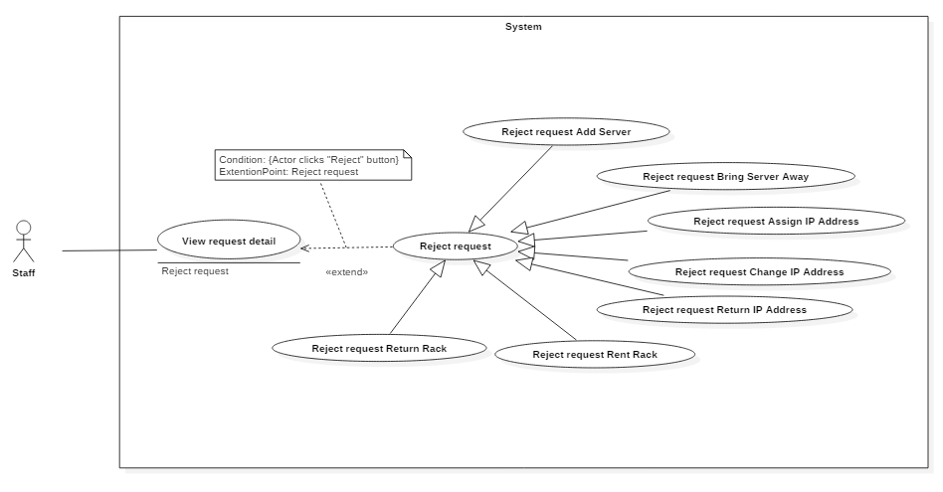 Figure 19: <Staff> Reject request Add New Server

|  |  |  |  |
| --- | --- | --- | --- |
| USE CASE – IMS011 | | | |
| Use Case No. | IMS011 | **Use Case Version** | 2.0 |
| Use Case Name | Reject request Add New Server | | |
| Author | Huỳnh Lâm Hà Tiên | | |
| Date | 22/01/2016 | **Priority** | medium |
| Actor:   * Staff.   Summary:   * This use case allows Staff to reject request Add New Server which was sent by customer.   Goal:   * Reject request Add New Server which was sent by customer.   Triggers:   * Staff clicks on “Reject” button on each event on daily schedule.   Preconditions:   * Staff must login into the system with role Staff. * Staff was assigned this task.   Post Conditions:   * Success:   Customer will receive notification about reject request.  At the same time, the new server information which customer sent will be deleted out of database.  The status of this request in database will be changed.   * Fail: Show error message with specified content.   Main Success Scenario:   |  |  |  | | --- | --- | --- | | Step | Actor Action | System Response | | 1 | Staff clicks on “Reject” button on each event on daily schedule. | System will show message “Are you sure to reject this request?” | | 2 | Staff clicks on “OK” button | * The new server information which customer sent will be deleted out of database. * The status of this request in database will be changed. * Customer will receive notification about reject request. |   Alternatives Scenario:   |  |  |  | | --- | --- | --- | | Step | Actor Action | System Response | | 1 | Staff clicks on “Reject” button on each event on daily schedule. | System will show message “Are you sure to reject this request?” | | 2 | Staff clicks on “Cancel” button | Return to Daily Schedule. |   Exceptions:   |  |  |  | | --- | --- | --- | | No | Cause | System Response | | 1 | Connect to Internet fail | Show message “Cannot send request, please connect to the Internet!” |   Relationships: Extend to View daily schedule.  Business Rules:   * The system only deletes the information of new server which customer sent, does not delete different information of this request. | | | |

*Table 29: Use case IMS011 - < Staff > Reject request Add New Server*

###### <Staff> Reject request “Bring Server Away”

 Figure 19: <Staff> Reject request Add New Server

|  |  |  |  |
| --- | --- | --- | --- |
| USE CASE – IMS011 | | | |
| Use Case No. | IMS011 | **Use Case Version** | 2.0 |
| Use Case Name | Reject request Add New Server | | |
| Author | Huỳnh Lâm Hà Tiên | | |
| Date | 22/01/2016 | **Priority** | medium |
| Actor:   * Staff.   Summary:   * This use case allows Staff to reject request Add New Server which was sent by customer.   Goal:   * Reject request Add New Server which was sent by customer.   Triggers:   * Staff clicks on “Reject” button on each event on daily schedule.   Preconditions:   * Staff must login into the system with role Staff. * Staff was assigned this task.   Post Conditions:   * Success:   Customer will receive notification about reject request.  At the same time, the new server information which customer sent will be deleted out of database.  The status of this request in database will be changed.   * Fail: Show error message with specified content.   Main Success Scenario:   |  |  |  | | --- | --- | --- | | Step | Actor Action | System Response | | 1 | Staff clicks on “Reject” button on each event on daily schedule. | System will show message “Are you sure to reject this request?” | | 2 | Staff clicks on “OK” button | * The new server information which customer sent will be deleted out of database. * The status of this request in database will be changed. * Customer will receive notification about reject request. |   Alternatives Scenario:   |  |  |  | | --- | --- | --- | | Step | Actor Action | System Response | | 1 | Staff clicks on “Reject” button on each event on daily schedule. | System will show message “Are you sure to reject this request?” | | 2 | Staff clicks on “Cancel” button | Return to Daily Schedule. |   Exceptions:   |  |  |  | | --- | --- | --- | | No | Cause | System Response | | 1 | Connect to Internet fail | Show message “Cannot send request, please connect to the Internet!” |   Relationships: Extend to View daily schedule.  Business Rules:   * The system only deletes the information of new server which customer sent, does not delete different information of this request. | | | |

*Table 29: Use case IMS011 - < Staff > Reject request Add New Server*

###### <Staff> Reject request “Assign IP Address”

 Figure 19: <Staff> Reject request Assign IP Address

|  |  |  |  |
| --- | --- | --- | --- |
| USE CASE – IMS011 | | | |
| Use Case No. | IMS011 | **Use Case Version** | 2.0 |
| Use Case Name | Reject request Assign IP Address | | |
| Author | Huỳnh Lâm Hà Tiên | | |
| Date | 22/01/2016 | **Priority** | medium |
| Actor:   * Staff.   Summary:   * This use case allows Staff to reject request Assign IP Address which was sent by customer.   Goal:   * Reject request Assign IP Address which was sent by customer.   Triggers:   * Staff clicks on “Reject” button on each event on daily schedule.   Preconditions:   * Staff must login into the system with role Staff. * Staff was assigned this task.   Post Conditions:   * Success:   Customer will receive notification about reject request.  At the same time, the data of assign IP Address which customer sent will be deleted out of database.  The status of this request in database will be changed.   * Fail: Show error message with specified content.   Main Success Scenario:   |  |  |  | | --- | --- | --- | | Step | Actor Action | System Response | | 1 | Staff clicks on “Reject” button on each event on daily schedule. | System will show message “Are you sure to reject this request?” | | 2 | Staff clicks on “OK” button | * The data of assign IP Address which customer sent will be deleted out of database. * The status of this request in database will be changed. * Customer will receive notification about reject request. |   Alternatives Scenario:   |  |  |  | | --- | --- | --- | | Step | Actor Action | System Response | | 1 | Staff clicks on “Reject” button on each event on daily schedule. | System will show message “Are you sure to reject this request?” | | 2 | Staff clicks on “Reject” button | Return to Daily Schedule. |   Exceptions:   |  |  |  | | --- | --- | --- | | No | Cause | System Response | | 1 | Connect to Internet fail | Show message “Cannot send request, please connect to the Internet!” |   Relationships: Extend to View daily schedule.  Business Rules:   * The system only deletes the data of assign IP Address which customer sent, does not delete different information of this request. | | | |

*Table 29: Use case IMS011 - <Staff> Reject request Assign IP Address*

###### <Staff> Reject request “Change IP Address”

 Figure 19: <Staff> Reject request Change IP Address

|  |  |  |  |
| --- | --- | --- | --- |
| USE CASE – IMS011 | | | |
| Use Case No. | IMS011 | **Use Case Version** | 2.0 |
| Use Case Name | Reject request Change IP Address | | |
| Author | Huỳnh Lâm Hà Tiên | | |
| Date | 22/01/2016 | **Priority** | medium |
| Actor:   * Staff.   Summary:   * This use case allows Staff to reject request Change IP Address which was sent by customer.   Goal:   * Reject request Change IP Address which was sent by customer.   Triggers:   * Staff clicks on “Reject” button on each event on daily schedule.   Preconditions:   * Staff must login into the system with role Staff. * Staff was assigned this task.   Post Conditions:   * Success:   Customer will receive notification about reject request.  At the same time, the data of change IP Address which customer sent will be deleted out of database.  The status of this request in database will be changed.   * Fail: Show error message with specified content.   Main Success Scenario:   |  |  |  | | --- | --- | --- | | Step | Actor Action | System Response | | 1 | Staff clicks on “Reject” button on each event on daily schedule. | System will show message “Are you sure to reject this request?” | | 2 | Staff clicks on “OK” button | * The data of change IP Address which customer sent will be deleted out of database. * The status of this request in database will be changed. * Customer will receive notification about reject request. |   Alternatives Scenario:   |  |  |  | | --- | --- | --- | | Step | Actor Action | System Response | | 1 | Staff clicks on “Reject” button on each event on daily schedule. | System will show message “Are you sure to reject this request?” | | 2 | Staff clicks on “Cancel” button | Return to Daily Schedule. |   Exceptions:   |  |  |  | | --- | --- | --- | | No | Cause | System Response | | 1 | Connect to Internet fail | Show message “Cannot send request, please connect to the Internet!” |   Relationships: Extend to View daily schedule.  Business Rules:   * The system only deletes the data of change IP Address which customer sent, does not delete different information of this request. | | | |

*Table 29: Use case IMS011 - <Staff> Reject request Change IP Address*

###### <Staff> Reject request “Return IP Address”

 Figure 19: <Staff> Reject request Return IP Address

|  |  |  |  |
| --- | --- | --- | --- |
| USE CASE – IMS011 | | | |
| Use Case No. | IMS011 | **Use Case Version** | 2.0 |
| Use Case Name | Reject request Return IP Address | | |
| Author | Huỳnh Lâm Hà Tiên | | |
| Date | 22/01/2016 | **Priority** | medium |
| Actor:   * Staff.   Summary:   * This use case allows Staff to Reject request Return IP Address which was sent by customer.   Goal:   * Reject request Return IP Address which was sent by customer.   Triggers:   * Staff clicks on “Reject” button on each event on daily schedule.   Preconditions:   * Staff must login into the system with role Staff. * Staff was assigned this task.   Post Conditions:   * Success:   Customer will receive notification about reject request.  At the same time, the data of return IP Address which customer sent will be deleted out of database.  The status of this request in database will be changed.   * Fail: Show error message with specified content.   Main Success Scenario:   |  |  |  | | --- | --- | --- | | Step | Actor Action | System Response | | 1 | Staff clicks on “Reject” button on each event on daily schedule. | System will show message “Are you sure to reject this request?” | | 2 | Staff clicks on “OK” button | * The data of return IP Address which customer sent will be deleted out of database. * The status of this request in database will be changed. * Customer will receive notification about reject request. |   Alternatives Scenario:   |  |  |  | | --- | --- | --- | | Step | Actor Action | System Response | | 1 | Staff clicks on “Reject” button on each event on daily schedule. | System will show message “Are you sure to reject this request?” | | 2 | Staff clicks on “Cancel” button | Return to Daily Schedule. |   Exceptions:   |  |  |  | | --- | --- | --- | | No | Cause | System Response | | 1 | Connect to Internet fail | Show message “Cannot send request, please connect to the Internet!” |   Relationships: Extend to View daily schedule.  Business Rules:   * The system only deletes the data of return IP Address which customer sent, does not delete different information of this request. | | | |

*Table 29: Use case IMS011 - <Staff> Reject request Return IP Address*

###### <Staff> Reject request “Rent Rack”

 Figure 19: <Staff> Reject request Upgrade Server

|  |  |  |  |
| --- | --- | --- | --- |
| USE CASE – IMS011 | | | |
| Use Case No. | IMS011 | **Use Case Version** | 2.0 |
| Use Case Name | Reject request Upgrade Server | | |
| Author | Huỳnh Lâm Hà Tiên | | |
| Date | 22/01/2016 | **Priority** | medium |
| Actor:   * Staff.   Summary:   * This use case allows Staff to reject request Upgrade Server which was sent by customer.   Goal:   * Reject request Upgrade Server which was sent by customer.   Triggers:   * Staff clicks on “Reject” button on each event on daily schedule.   Preconditions:   * Staff must login into the system with role Staff. * Staff was assigned this task.   Post Conditions:   * Success:   Customer will receive notification about reject request.  At the same time, the upgrade information of server which customer sent will be deleted out of database.  The status of this request in database will be changed.   * Fail: Show error message with specified content.   Main Success Scenario:   |  |  |  | | --- | --- | --- | | Step | Actor Action | System Response | | 1 | Staffclicks on “Reject” button on each event on daily schedule. | System will show message “Are you sure to reject this request?” | | 2 | Staffclicks on “OK” button | * The upgrade information of server which customer sent will be deleted out of database. * The status of this request in database will be changed. * Customer will receive notification about reject request. |   Alternatives Scenario:   |  |  |  | | --- | --- | --- | | Step | Actor Action | System Response | | 1 | Staffclicks on “Reject” button on each event on daily schedule. | System will show message “Are you sure to reject this request?” | | 2 | Staff clicks on “Cancel” button | Return to Daily Schedule. |   Exceptions:   |  |  |  | | --- | --- | --- | | No | Cause | System Response | | 1 | Connect to Internet fail | Show message “Cannot send request, please connect to the Internet!” |   Relationships: Extend to View daily schedule.  Business Rules:   * The system only deletes the upgrade information of server which customer sent, does not delete different information of this request. | | | |

*Table 29: Use case IMS011 - <Staff> Reject request Add New Server*

###### <Staff> Reject request “Return Rack”

 Figure 19: <Staff> Reject request Upgrade Server

|  |  |  |  |
| --- | --- | --- | --- |
| USE CASE – IMS011 | | | |
| Use Case No. | IMS011 | **Use Case Version** | 2.0 |
| Use Case Name | Reject request Upgrade Server | | |
| Author | Huỳnh Lâm Hà Tiên | | |
| Date | 22/01/2016 | **Priority** | medium |
| Actor:   * Staff.   Summary:   * This use case allows Staff to reject request Upgrade Server which was sent by customer.   Goal:   * Reject request Upgrade Server which was sent by customer.   Triggers:   * Staff clicks on “Reject” button on each event on daily schedule.   Preconditions:   * Staff must login into the system with role Staff. * Staff was assigned this task.   Post Conditions:   * Success:   Customer will receive notification about reject request.  At the same time, the upgrade information of server which customer sent will be deleted out of database.  The status of this request in database will be changed.   * Fail: Show error message with specified content.   Main Success Scenario:   |  |  |  | | --- | --- | --- | | Step | Actor Action | System Response | | 1 | Staffclicks on “Reject” button on each event on daily schedule. | System will show message “Are you sure to reject this request?” | | 2 | Staffclicks on “OK” button | * The upgrade information of server which customer sent will be deleted out of database. * The status of this request in database will be changed. * Customer will receive notification about reject request. |   Alternatives Scenario:   |  |  |  | | --- | --- | --- | | Step | Actor Action | System Response | | 1 | Staffclicks on “Reject” button on each event on daily schedule. | System will show message “Are you sure to reject this request?” | | 2 | Staff clicks on “Cancel” button | Return to Daily Schedule. |   Exceptions:   |  |  |  | | --- | --- | --- | | No | Cause | System Response | | 1 | Connect to Internet fail | Show message “Cannot send request, please connect to the Internet!” |   Relationships: Extend to View daily schedule.  Business Rules:   * The system only deletes the upgrade information of server which customer sent, does not delete different information of this request. | | | |

*Table 29: Use case IMS011 - <Staff> Reject request Add New Server*

###### <Staff> Export procedure

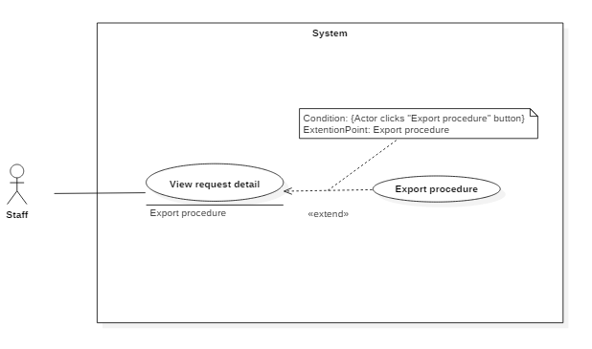 Figure 19: <Staff> Reject request Upgrade Server

|  |  |  |  |
| --- | --- | --- | --- |
| USE CASE – IMS011 | | | |
| Use Case No. | IMS011 | **Use Case Version** | 2.0 |
| Use Case Name | Reject request Upgrade Server | | |
| Author | Huỳnh Lâm Hà Tiên | | |
| Date | 22/01/2016 | **Priority** | medium |
| Actor:   * Staff.   Summary:   * This use case allows Staff to reject request Upgrade Server which was sent by customer.   Goal:   * Reject request Upgrade Server which was sent by customer.   Triggers:   * Staff clicks on “Reject” button on each event on daily schedule.   Preconditions:   * Staff must login into the system with role Staff. * Staff was assigned this task.   Post Conditions:   * Success:   Customer will receive notification about reject request.  At the same time, the upgrade information of server which customer sent will be deleted out of database.  The status of this request in database will be changed.   * Fail: Show error message with specified content.   Main Success Scenario:   |  |  |  | | --- | --- | --- | | Step | Actor Action | System Response | | 1 | Staffclicks on “Reject” button on each event on daily schedule. | System will show message “Are you sure to reject this request?” | | 2 | Staffclicks on “OK” button | * The upgrade information of server which customer sent will be deleted out of database. * The status of this request in database will be changed. * Customer will receive notification about reject request. |   Alternatives Scenario:   |  |  |  | | --- | --- | --- | | Step | Actor Action | System Response | | 1 | Staffclicks on “Reject” button on each event on daily schedule. | System will show message “Are you sure to reject this request?” | | 2 | Staff clicks on “Cancel” button | Return to Daily Schedule. |   Exceptions:   |  |  |  | | --- | --- | --- | | No | Cause | System Response | | 1 | Connect to Internet fail | Show message “Cannot send request, please connect to the Internet!” |   Relationships: Extend to View daily schedule.  Business Rules:   * The system only deletes the upgrade information of server which customer sent, does not delete different information of this request. | | | |

*Table 29: Use case IMS011 - <Staff> Reject request Add New Server*

###### <Staff> View list task

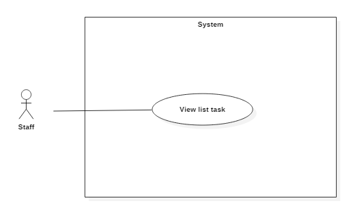 Figure 19: <Staff> Reject request Upgrade Server

|  |  |  |  |
| --- | --- | --- | --- |
| USE CASE – IMS011 | | | |
| Use Case No. | IMS011 | **Use Case Version** | 2.0 |
| Use Case Name | Reject request Upgrade Server | | |
| Author | Huỳnh Lâm Hà Tiên | | |
| Date | 22/01/2016 | **Priority** | medium |
| Actor:   * Staff.   Summary:   * This use case allows Staff to reject request Upgrade Server which was sent by customer.   Goal:   * Reject request Upgrade Server which was sent by customer.   Triggers:   * Staff clicks on “Reject” button on each event on daily schedule.   Preconditions:   * Staff must login into the system with role Staff. * Staff was assigned this task.   Post Conditions:   * Success:   Customer will receive notification about reject request.  At the same time, the upgrade information of server which customer sent will be deleted out of database.  The status of this request in database will be changed.   * Fail: Show error message with specified content.   Main Success Scenario:   |  |  |  | | --- | --- | --- | | Step | Actor Action | System Response | | 1 | Staffclicks on “Reject” button on each event on daily schedule. | System will show message “Are you sure to reject this request?” | | 2 | Staffclicks on “OK” button | * The upgrade information of server which customer sent will be deleted out of database. * The status of this request in database will be changed. * Customer will receive notification about reject request. |   Alternatives Scenario:   |  |  |  | | --- | --- | --- | | Step | Actor Action | System Response | | 1 | Staffclicks on “Reject” button on each event on daily schedule. | System will show message “Are you sure to reject this request?” | | 2 | Staff clicks on “Cancel” button | Return to Daily Schedule. |   Exceptions:   |  |  |  | | --- | --- | --- | | No | Cause | System Response | | 1 | Connect to Internet fail | Show message “Cannot send request, please connect to the Internet!” |   Relationships: Extend to View daily schedule.  Business Rules:   * The system only deletes the upgrade information of server which customer sent, does not delete different information of this request. | | | |

*Table 29: Use case IMS011 - <Staff> Reject request Add New Server*

###### <Staff> Accept task

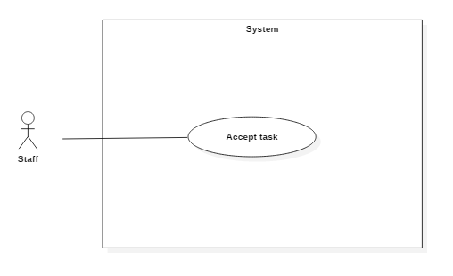

Figure 19: <Staff> Reject request Upgrade Server

|  |  |  |  |
| --- | --- | --- | --- |
| USE CASE – IMS011 | | | |
| Use Case No. | IMS011 | **Use Case Version** | 2.0 |
| Use Case Name | Reject request Upgrade Server | | |
| Author | Huỳnh Lâm Hà Tiên | | |
| Date | 22/01/2016 | **Priority** | medium |
| Actor:   * Staff.   Summary:   * This use case allows Staff to reject request Upgrade Server which was sent by customer.   Goal:   * Reject request Upgrade Server which was sent by customer.   Triggers:   * Staff clicks on “Reject” button on each event on daily schedule.   Preconditions:   * Staff must login into the system with role Staff. * Staff was assigned this task.   Post Conditions:   * Success:   Customer will receive notification about reject request.  At the same time, the upgrade information of server which customer sent will be deleted out of database.  The status of this request in database will be changed.   * Fail: Show error message with specified content.   Main Success Scenario:   |  |  |  | | --- | --- | --- | | Step | Actor Action | System Response | | 1 | Staffclicks on “Reject” button on each event on daily schedule. | System will show message “Are you sure to reject this request?” | | 2 | Staffclicks on “OK” button | * The upgrade information of server which customer sent will be deleted out of database. * The status of this request in database will be changed. * Customer will receive notification about reject request. |   Alternatives Scenario:   |  |  |  | | --- | --- | --- | | Step | Actor Action | System Response | | 1 | Staffclicks on “Reject” button on each event on daily schedule. | System will show message “Are you sure to reject this request?” | | 2 | Staff clicks on “Cancel” button | Return to Daily Schedule. |   Exceptions:   |  |  |  | | --- | --- | --- | | No | Cause | System Response | | 1 | Connect to Internet fail | Show message “Cannot send request, please connect to the Internet!” |   Relationships: Extend to View daily schedule.  Business Rules:   * The system only deletes the upgrade information of server which customer sent, does not delete different information of this request. | | | |

*Table 29: Use case IMS011 - <Staff> Reject request Add New Server*

###### <Staff> Confirm task status

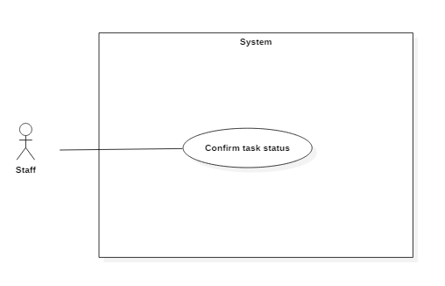

Figure 19: <Staff> Reject request Upgrade Server

|  |  |  |  |
| --- | --- | --- | --- |
| USE CASE – IMS011 | | | |
| Use Case No. | IMS011 | **Use Case Version** | 2.0 |
| Use Case Name | Reject request Upgrade Server | | |
| Author | Huỳnh Lâm Hà Tiên | | |
| Date | 22/01/2016 | **Priority** | medium |
| Actor:   * Staff.   Summary:   * This use case allows Staff to reject request Upgrade Server which was sent by customer.   Goal:   * Reject request Upgrade Server which was sent by customer.   Triggers:   * Staff clicks on “Reject” button on each event on daily schedule.   Preconditions:   * Staff must login into the system with role Staff. * Staff was assigned this task.   Post Conditions:   * Success:   Customer will receive notification about reject request.  At the same time, the upgrade information of server which customer sent will be deleted out of database.  The status of this request in database will be changed.   * Fail: Show error message with specified content.   Main Success Scenario:   |  |  |  | | --- | --- | --- | | Step | Actor Action | System Response | | 1 | Staffclicks on “Reject” button on each event on daily schedule. | System will show message “Are you sure to reject this request?” | | 2 | Staffclicks on “OK” button | * The upgrade information of server which customer sent will be deleted out of database. * The status of this request in database will be changed. * Customer will receive notification about reject request. |   Alternatives Scenario:   |  |  |  | | --- | --- | --- | | Step | Actor Action | System Response | | 1 | Staffclicks on “Reject” button on each event on daily schedule. | System will show message “Are you sure to reject this request?” | | 2 | Staff clicks on “Cancel” button | Return to Daily Schedule. |   Exceptions:   |  |  |  | | --- | --- | --- | | No | Cause | System Response | | 1 | Connect to Internet fail | Show message “Cannot send request, please connect to the Internet!” |   Relationships: Extend to View daily schedule.  Business Rules:   * The system only deletes the upgrade information of server which customer sent, does not delete different information of this request. | | | |

*Table 29: Use case IMS011 - <Staff> Reject request Add New Server*

###### <Staff> View daily schedule

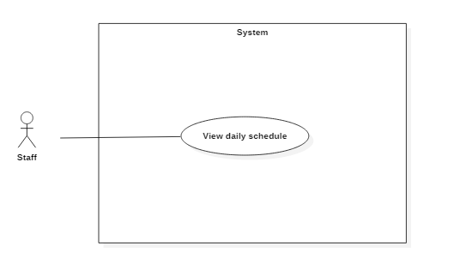

Figure 14: <Staff> View daily schedule

|  |  |  |  |
| --- | --- | --- | --- |
| USE CASE – IMS013 | | | |
| Use Case No. | IMS013 | **Use Case Version** | 2.0 |
| Use Case Name | View daily schedule | | |
| Author | Huỳnh Lâm Hà Tiên | | |
| Date | 24/01/2016 | **Priority** | medium |
| Actor:   * Staff.   Summary:   * This use case allows Staff to view all of the today’s appointments and note from previous shift.   Goal:   * System provides schedule which helps Staff to view the appointments with customers.   Triggers:   * When Staff login to the system, the page contains daily schedule and the note of previous shift will be showed.   Preconditions:   * The Staff must login to the system with Staff role.   Post Conditions:   * Success: The daily schedule and note will be showed. * Fail: N/A   Main Success Scenario:   |  |  |  | | --- | --- | --- | | Step | Actor Action | System Response | | 1 | Staff login to the system | The page contains daily schedule will be showed. |   Alternative Scenario:   |  |  |  | | --- | --- | --- | | Step | Actor Action | System Response | | 1 | Staff login to the system and today does not have any customer’s arrival. | A message will be showed “Today does not have any appointment!” |   Exceptions: N/A  Relationships:   * Extended by Write note. * Extended by Confirm Arrival. * Extended by Assign task. * Extended by View request. * Extended by Reject request.   Business Rules:   * The customer link in daily schedule will be showed when today has appointments. * The link of “Write note for the next shift” will be disabled when Staff views Daily Schedule Page. | | | |

Table 22: Use case IMS013 - <Staff> View daily schedule

###### <Staff> View server detail

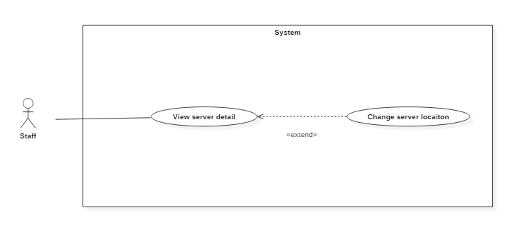 Figure 14: <Staff> View server

|  |  |  |  |
| --- | --- | --- | --- |
| USE CASE – IMS012 | | | |
| Use Case No. | IMS012 | **Use Case Version** | 2.0 |
| Use Case Name | View server | | |
| Author | Huỳnh Lâm Hà Tiên | | |
| Date | 23/01/2016 | **Priority** | medium |
| Actor:   * Staff.   Summary:   * This use case allows Staff to view list all server information of customers.   Goal:   * View server information.   Triggers:   * Staff clicks on “View server” link on the panel.   Preconditions:   * Staff must login into the system with role Staff.   Post Conditions:   * Success: Server information will be showed. * Fail: Server information will not be showed. Show error message with specified content.   Main Success Scenario:   |  |  |  | | --- | --- | --- | | Step | Actor Action | System Response | | 1 | Staff clicks on “View server” link on the panel. | Navigate to View server information page which contains:   * Customer name: link * Server name: link * Default IP Address: label * Status: label * Location: label * Request: label |   Alternative Scenario: N/A.  Exceptions:   |  |  |  | | --- | --- | --- | | No | Actor Action | System Response | | 1 | Connect to database fail | Show message “Error, please try again!” |   Relationships:   * Extended by View server details. * Extended by View request.   Business Rules:   * Staff is just viewed server information and Staff cannot edit anything with server information. * If Staff was assigned request, that request on Server table will become link. | | | |

Table 23: Use case IMS012 - <Staff> View server

###### <Staff> Change server location

 Figure 14: <Staff> View server

|  |  |  |  |
| --- | --- | --- | --- |
| USE CASE – IMS012 | | | |
| Use Case No. | IMS012 | **Use Case Version** | 2.0 |
| Use Case Name | View server | | |
| Author | Huỳnh Lâm Hà Tiên | | |
| Date | 23/01/2016 | **Priority** | medium |
| Actor:   * Staff.   Summary:   * This use case allows Staff to view list all server information of customers.   Goal:   * View server information.   Triggers:   * Staff clicks on “View server” link on the panel.   Preconditions:   * Staff must login into the system with role Staff.   Post Conditions:   * Success: Server information will be showed. * Fail: Server information will not be showed. Show error message with specified content.   Main Success Scenario:   |  |  |  | | --- | --- | --- | | Step | Actor Action | System Response | | 1 | Staff clicks on “View server” link on the panel. | Navigate to View server information page which contains:   * Customer name: link * Server name: link * Default IP Address: label * Status: label * Location: label * Request: label |   Alternative Scenario: N/A.  Exceptions:   |  |  |  | | --- | --- | --- | | No | Actor Action | System Response | | 1 | Connect to database fail | Show message “Error, please try again!” |   Relationships:   * Extended by View server details. * Extended by View request.   Business Rules:   * Staff is just viewed server information and Staff cannot edit anything with server information. * If Staff was assigned request, that request on Server table will become link. | | | |

Table 23: Use case IMS012 - <Staff> View server

###### <Staff> View list IP

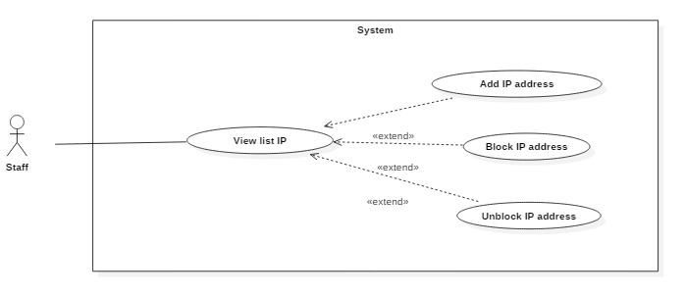Figure 20: <Staff> View list IP

|  |  |  |  |
| --- | --- | --- | --- |
| USE CASE – IMS012 | | | |
| Use Case No. | IMS020 | **Use Case Version** | 2.0 |
| Use Case Name | View list IP | | |
| Author | Lê Thị Thu Hà | | |
| Date | 23/01/2016 | **Priority** | medium |
| Actor:   * Staff.   Summary:   * This use case allows Staff to view list of all IP address in the center   Goal:   * View IP address information.   Triggers:   * Staff clicks on “View IP” link on the panel.   Preconditions:   * Staff must login into the system with role Staff.   Post Conditions:   * Success: IP address information will be showed. * Fail: IP address information will not be showed. Show error message with specified content.   Main Success Scenario:   |  |  |  | | --- | --- | --- | | Step | Actor Action | System Response | | 1 | Staff clicks on “View IP” link on the panel. | Navigate to View IP information page which contains:   * IP Address: label * Status: link * Gateway: label * Subnet mask: label * Status duration: label |   Alternative Scenario: N/A.  Exceptions:   |  |  |  | | --- | --- | --- | | No | Actor Action | System Response | | 1 | Connect to database fail | Show message “Error, please try again!” |   Relationships:   * Extended by View request.   Business Rules:   * Staff is just viewed IP information and Staff cannot edit anything with server information. | | | |

Table 30: Use case IMS020 - <Staff> View IP

###### <Staff> Add IP address

 Figure 11: <Staff> Assign IP to server

|  |  |  |  |
| --- | --- | --- | --- |
| USE CASE – IMS007 | | | |
| Use Case No. | IMS007 | **Use Case Version** | 2.0 |
| Use Case Name | Assign IP to server | | |
| Author | Huỳnh Lâm Hà Tiên | | |
| Date | 22/01/2016 | **Priority** | medium |
| Actor:   * Staff.   Summary:   * This use case allows Staff to assign IP Address for server.   Goal:   * Assign IP Address for server.   Triggers:   * Staff clicks on “Assign IP Address” link on the Request Page (Request Change IP Address and Request Assign IP Address).   Preconditions:   * Staff must login into the system with role Staff. * Staff was assigned this task.   Post Conditions:   * Success: Assigned IP Address will be displayed on Request Page. * Fail: N/A.   Main Success Scenario:   |  |  |  | | --- | --- | --- | | Step | Actor Action | System Response | | 1 | Staff clicks on “Assign IP Address” link on the Request Page | Navigate to Assign IP Address Page. | | 2 | Staff selects suitable IP Addresses and clicks “Save” button. | Assigned IP Address will be displayed on Request Page. |   Alternative Scenario:   |  |  |  | | --- | --- | --- | | Step | Actor Action | System Response | | 1 | Staff clicks on “Assign IP Address” link on the Request Page | Navigate to Assign IP Address Page. | | 2 | Staff clicks “Cancel” button. | Return to Request Page. |   Exceptions: N/A.  Relationships:   * Extended to View request.   Business Rules:   * The list IP Addresses which can assign must be same region with server’s current IP Addresses. | | | |

*Table 23: Use case IMS007 - <Staff> Assign IP to server.*

###### <Staff> Block IP address

Figure 11: <Staff> Assign IP to server

|  |  |  |  |
| --- | --- | --- | --- |
| USE CASE – IMS007 | | | |
| Use Case No. | IMS007 | **Use Case Version** | 2.0 |
| Use Case Name | Assign IP to server | | |
| Author | Huỳnh Lâm Hà Tiên | | |
| Date | 22/01/2016 | **Priority** | medium |
| Actor:   * Staff.   Summary:   * This use case allows Staff to assign IP Address for server.   Goal:   * Assign IP Address for server.   Triggers:   * Staff clicks on “Assign IP Address” link on the Request Page (Request Change IP Address and Request Assign IP Address).   Preconditions:   * Staff must login into the system with role Staff. * Staff was assigned this task.   Post Conditions:   * Success: Assigned IP Address will be displayed on Request Page. * Fail: N/A.   Main Success Scenario:   |  |  |  | | --- | --- | --- | | Step | Actor Action | System Response | | 1 | Staff clicks on “Assign IP Address” link on the Request Page | Navigate to Assign IP Address Page. | | 2 | Staff selects suitable IP Addresses and clicks “Save” button. | Assigned IP Address will be displayed on Request Page. |   Alternative Scenario:   |  |  |  | | --- | --- | --- | | Step | Actor Action | System Response | | 1 | Staff clicks on “Assign IP Address” link on the Request Page | Navigate to Assign IP Address Page. | | 2 | Staff clicks “Cancel” button. | Return to Request Page. |   Exceptions: N/A.  Relationships:   * Extended to View request.   Business Rules:   * The list IP Addresses which can assign must be same region with server’s current IP Addresses. | | | |

*Table 23: Use case IMS007 - <Staff> Assign IP to server.*

###### <Staff> Unblock IP address

 Figure 11: <Staff> Assign IP to server

|  |  |  |  |
| --- | --- | --- | --- |
| USE CASE – IMS007 | | | |
| Use Case No. | IMS007 | **Use Case Version** | 2.0 |
| Use Case Name | Assign IP to server | | |
| Author | Huỳnh Lâm Hà Tiên | | |
| Date | 22/01/2016 | **Priority** | medium |
| Actor:   * Staff.   Summary:   * This use case allows Staff to assign IP Address for server.   Goal:   * Assign IP Address for server.   Triggers:   * Staff clicks on “Assign IP Address” link on the Request Page (Request Change IP Address and Request Assign IP Address).   Preconditions:   * Staff must login into the system with role Staff. * Staff was assigned this task.   Post Conditions:   * Success: Assigned IP Address will be displayed on Request Page. * Fail: N/A.   Main Success Scenario:   |  |  |  | | --- | --- | --- | | Step | Actor Action | System Response | | 1 | Staff clicks on “Assign IP Address” link on the Request Page | Navigate to Assign IP Address Page. | | 2 | Staff selects suitable IP Addresses and clicks “Save” button. | Assigned IP Address will be displayed on Request Page. |   Alternative Scenario:   |  |  |  | | --- | --- | --- | | Step | Actor Action | System Response | | 1 | Staff clicks on “Assign IP Address” link on the Request Page | Navigate to Assign IP Address Page. | | 2 | Staff clicks “Cancel” button. | Return to Request Page. |   Exceptions: N/A.  Relationships:   * Extended to View request.   Business Rules:   * The list IP Addresses which can assign must be same region with server’s current IP Addresses. | | | |

*Table 23: Use case IMS007 - <Staff> Assign IP to server.*

###### <Staff> View list location

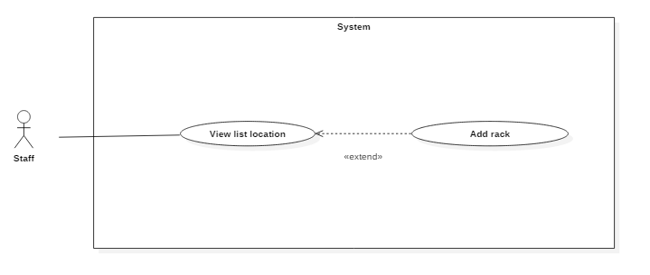Figure 21: <Staff> View list location

|  |  |  |  |
| --- | --- | --- | --- |
| USE CASE – IMS012 | | | |
| Use Case No. | IMS021 | **Use Case Version** | 2.0 |
| Use Case Name | View list location | | |
| Author | Lê Thị Thu Hà | | |
| Date | 23/01/2016 | **Priority** | medium |
| Actor:   * Staff.   Summary:   * This use case allows Staff to view list all server location of the system   Goal:   * View location   Triggers:   * Staff clicks on “View location” link on the panel.   Preconditions:   * Staff must login into the system with role Staff.   Post Conditions:   * Success: All location information will be showed. * Fail: All location information will not be showed. Show error message with specified content.   Main Success Scenario:   |  |  |  | | --- | --- | --- | | Step | Actor Action | System Response | | 1 | Staff clicks on “View location” link on the panel. | Navigate to View location information page which contains:   * Location on the rack represented as a table * Default IP address of server on the rack: label |   Alternative Scenario: N/A.  Exceptions:   |  |  |  | | --- | --- | --- | | No | Actor Action | System Response | | 1 | Connect to database fail | Show message “Error, please try again!” |   Relationships:   * Extended by View request.   Business Rules:   * Staff is just viewed location and Staff cannot edit anything with location information. | | | |

Table 32: Use case IMS021 - <Staff> View list location

###### <Staff> Add rack



Figure 9: <Staff> Confirm Arrival

|  |  |  |  |
| --- | --- | --- | --- |
| USE CASE – IMS005 | | | |
| Use Case No. | IMS005 | **Use Case Version** | 2.0 |
| Use Case Name | Confirm Arrival | | |
| Author | Huỳnh Lâm Hà Tiên | | |
| Date | 24/01/2016 | **Priority** | medium |
| Actor:   * Staff.   Summary:   * This use case allows Staff to confirm the customer’s arrival at data center following the received request.   Goal:   * System can record the time when customer arrive and the time when customer leave, then data center can control the customer’s arrival day by day.   Triggers:   * On daily schedule, Staff ticks on the check box “Arrived” when customer arrived data center.   Preconditions:   * The Staff must login to the system at his/her right shift. * The Staff was assigned this task.   Post Conditions:   * Success: Detail of customer’s arrival include time, the confirmed Staff will be saved to database. * Fail: Show message error with specified content.   Main Success Scenario:   |  |  |  | | --- | --- | --- | | Step | Actor Action | System Response | | 1 | On daily schedule, Staff ticks on the check box “Arrived” when customer arrived data center and clicks on “Save” button. | The time when customer arrived and the confirmed Staff will be saved to database. |   Alternative Scenario: N/A.  Exceptions:   |  |  |  | | --- | --- | --- | | No | Actor Action | System Response | | 1 | Connect to database fail | Show message “Error, please try again!” |   Relationships: Extend to View daily Schedule.  Business Rules:   * The check box “Arrived” will be disabled when it was ticked and the Staff clicked “Save” button. * If the Staff was not assigned this task, the check box “Arrived” are disabled. | | | |

Table 21: Use case IMS005 - <Staff> Confirm Arrival

###### <Staff> Receive notification

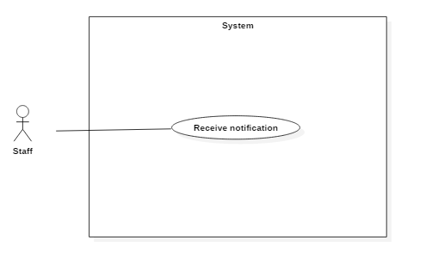

Figure 15: <Staff> Export procedure

|  |  |  |  |
| --- | --- | --- | --- |
| USE CASE – IMS014 | | | |
| Use Case No. | IMS014 | **Use Case Version** | 2.0 |
| Use Case Name | Export procedure | | |
| Author | Huỳnh Lâm Hà Tiên | | |
| Date | 23/01/2016 | **Priority** | medium |
| Actor:   * Staff   Summary:   * This use case allows Staff to export procedure for customer after approve request.   Goal:   * Export procedure for customer after approve request.   Triggers:   * Staff clicks on “Export procedure” button on Request Page.   Preconditions:   * Staff must login into the system with role Staff. * The request must be already approved. * The Staff was assigned this task by Shift Head.   Post Conditions:   * Success: Export file word corresponding to request content. * Fail: Show message with specified content.   Main Success Scenario:   |  |  |  | | --- | --- | --- | | Step | Actor Action | System Response | | 1 | Staff clicks on “Export procedure” button on Request Page. | The system will fill the request information in the procedure and print out for customer. |   Alternatives Scenario: N/A.  Exceptions:   |  |  |  | | --- | --- | --- | | Step | Cause | System Response | | 1 | Connect to database fail. | System will show message: “Error, please try again!” |   Relationships:   * Extend to View request detail.   Business Rules:   * File procedure is only exported when the request was approved. | | | |

*Table 26: Use case IMS013 - <Staff> Export procedure*

###### <Staff> View report Blocked IP Address

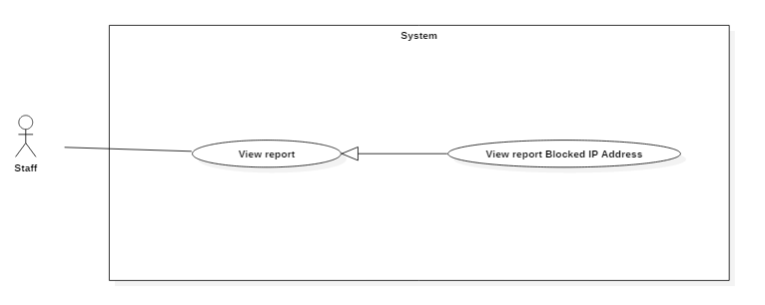 Figure 11: <Staff> View server details

|  |  |  |  |
| --- | --- | --- | --- |
| USE CASE – IMS007 | | | |
| Use Case No. | IMS007 | **Use Case Version** | 2.0 |
| Use Case Name | View server details | | |
| Author | Huỳnh Lâm Hà Tiên | | |
| Date | 22/01/2016 | **Priority** | medium |
| Actor:   * Staff.   Summary:   * This use case allows Staff to view each server information of customers.   Goal:   * View each server information.   Triggers:   * Staff clicks on “Server name” link on the Server Table.   Preconditions:   * Staff must login into the system with role Staff.   Post Conditions:   * Success: Server detail will be showed. * Fail: Server detail will not be showed. Show error message with specified content.   Main Success Scenario:   |  |  |  | | --- | --- | --- | | Step | Actor Action | System Response | | 1 | Staff clicks on Server Name link on the panel. | Navigate to Server Detail Page. |   Alternative Scenario: N/A.  Exceptions:   |  |  |  | | --- | --- | --- | | No | Actor Action | System Response | | 1 | Connect to database fail | Show message “Error, please try again!” |   Relationships:   * Extended to View server.   Business Rules: N/A. | | | |

Table 23: Use case IMS007 - <Staff> View server details

##### <Customer> Overview Use Case

. 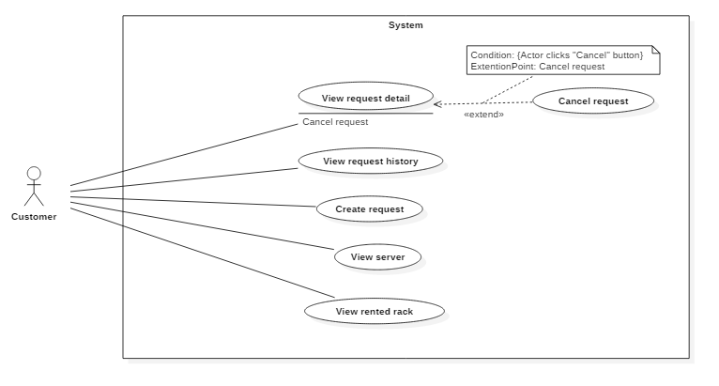Figure 17: <Customer> Customer Overview Use Case

###### <Customer> View request detail

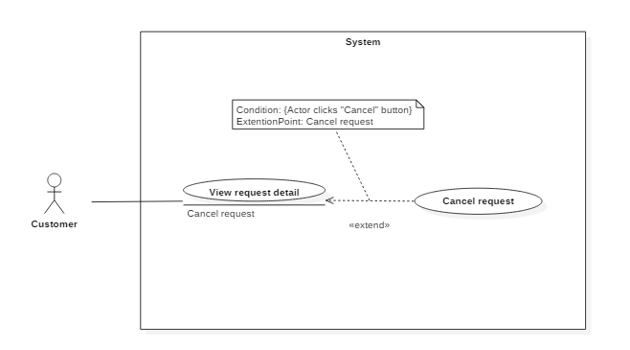 Figure 18: <Customer> View server details

|  |  |  |  |
| --- | --- | --- | --- |
| USE CASE – IMS010 | | | |
| Use Case No. | IMS010 | **Use Case Version** | 2.0 |
| Use Case Name | View server details | | |
| Author | Huỳnh Lâm Hà Tiên | | |
| Date | 23/01/2016 | **Priority** | medium |
| Actor:   * Customer.   Summary:   * This use case allows customer to view his/her server information.   Goal:   * View server information.   Triggers:   * Customer clicks on “View server” link on the panel.   Preconditions:   * Customer must login into the system with role Customer.   Post Conditions:   * Success: Server information will be showed. * Fail: Server information will not be showed. Show error message with specified content.   Main Success Scenario:   |  |  |  | | --- | --- | --- | | Step | Actor Action | System Response | | 1 | Customer clicks on “View server” link on the panel. | Navigate to View server information page which contains:   * Server name: link * Default IP: label * Status: label * Registered Date: label |   Alternatives Scenario: N/A.  Exceptions:   |  |  |  | | --- | --- | --- | | No | Actor Action | System Response | | 1 | Connect to database fail | Show message “Error, please try again!” |   Relationships: N/A.  Business Rules: N/A. | | | |

Table 28: Use case IMS010 - <Customer> View server details

###### <Customer> View Request History

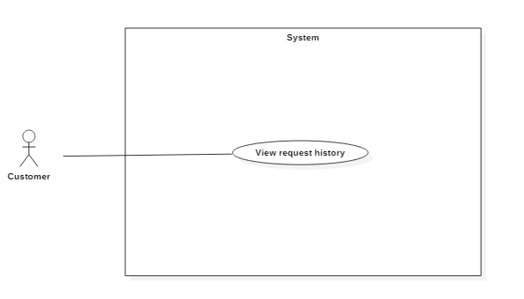 Figure 19: <Customer> View Request History

|  |  |  |  |
| --- | --- | --- | --- |
| USE CASE – IMS011 | | | |
| Use Case No. | IMS011 | **Use Case Version** | 2.0 |
| Use Case Name | View Request History | | |
| Author | Huỳnh Lâm Hà Tiên | | |
| Date | 23/01/2016 | **Priority** | medium |
| Actor:   * Customer.   Summary:   * This use case allows customers to view history of their requests.   Goal:   * Customer can view history of requests.   Triggers:   * Customer logins into the system, the History of requests will be displayed.   Preconditions:   * Customer must login into the system with role Customer.   Post Conditions:   * Success: List of history of requests will be displayed. * Fail: Show error message with specified content.   Main Success Scenario:   |  |  |  | | --- | --- | --- | | Step | Actor Action | System Response | | 1 | Customer logins into the system. | List of history of requests will be displayed. |   Alternatives Scenario: N/A.  Exceptions:   |  |  |  | | --- | --- | --- | | No | Cause | System Response | | 1 | Connect to database fail | Show message “Error, please try again!” |   Relationships:   * Extended by Update request. * Included by Cancel request.   Business Rules:   * List of history of requests will be displayed in order of time. | | | |

Table 29: Use case IMS011 - <Customer> View Request History

###### <Customer> Create request “Add Server”

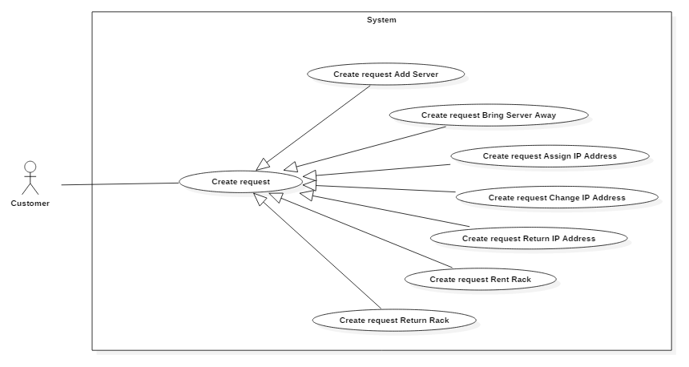

Figure 19: <Customer> Add server

|  |  |  |  |
| --- | --- | --- | --- |
| USE CASE – IMS011 | | | |
| Use Case No. | IMS011 | **Use Case Version** | 2.0 |
| Use Case Name | Add server | | |
| Author | Huỳnh Lâm Hà Tiên | | |
| Date | 23/01/2016 | **Priority** | medium |
| Actor:   * Customer.   Summary:   * This use case allows customer to add new server into data center.   Goal:   * Add information of new server quickly.   Triggers:   * Customer clicks on “Make request” on the panel and select “Add New Server”   Preconditions:   * Customer must login into the system with role Customer.   Post Conditions:   * Success: Request will be sent to data center, Shift Head will receive notification. At the same time, the data about appointment and new server will be saved into database. * Fail: Show error message with specified content.   Main Success Scenario:   |  |  |  | | --- | --- | --- | | Step | Actor Action | System Response | | 1 | Customer clicks on “Make request” on the panel and select “Add New Server” | System will display Request Add New Server Popup | | 2 | Input data in fields of Request Add New Server Popup and clicks on “Send” button | System will send request to data center:   * The information about appointment and the data of new server will be saved into database. * The Head Shift who is in shift will have notification. |   Alternatives Scenario:   |  |  |  | | --- | --- | --- | | Step | Actor Action | System Response | | 1 | Customer clicks on “Make request” and select “Add New Server”. | System will display Request Add New Server Popup. | | 2 | Input data in fields of request page and clicks on “Cancel” button. | Return to Request History Page. |   Exceptions:   |  |  |  | | --- | --- | --- | | No | Cause | System Response | | 1 | Connect to Internet fail | Show message “Cannot send request, please connect to the Internet!” |   Relationships: N/A.  Business Rules:   * Customer can add one or more new servers in one request. | | | |

Table 29: Use case IMS011 - <Customer> Add server

###### <Customer> Create request “Bring Server Away”

 Figure 19: <Customer> Update request Update Server

|  |  |  |  |
| --- | --- | --- | --- |
| USE CASE – IMS011 | | | |
| Use Case No. | IMS011 | **Use Case Version** | 2.0 |
| Use Case Name | Update request Upgrade Server | | |
| Author | Huỳnh Lâm Hà Tiên | | |
| Date | 23/01/2016 | **Priority** | medium |
| Actor:   * Customer.   Summary:   * This use case allows customer to update request Upgrade Server which was sent.   Goal:   * Update request Upgrade Server which was sent.   Triggers:   * On Request History Page, customer select request Upgrade Server which want to update * Edit data in Request Upgrade Server Popup and clicks on “Update” button.   Preconditions:   * Customer must login into the system with role Customer. * The request which want to update was sent to data center.   Post Conditions:   * Success: Shift Head will receive notification about update request. At the same time, the data about appointment or upgrade content of server which customer changed will be updated into database. * Fail: Show error message with specified content.   Main Success Scenario:   |  |  |  | | --- | --- | --- | | Step | Actor Action | System Response | | 1 | On Request History Page, customer clicks on request Upgrade Server which want to update. | System will display Request Upgrade Server Popup with content was created in the past. | | 2 | Customer clicks on “Update” button | System will display Request Upgrade Server Popup with fields can edit. | | 3 | Customer update information and clicks on “Send” button | * The data about appointment or upgrade content of server which customer changed will be updated into database. * Shift Head will receive notification about update request. |   Alternatives Scenario:   |  |  |  | | --- | --- | --- | | Step | Actor Action | System Response | | 1 | On Request History Page, customer clicks on request Upgrade Server which want to update. | System will display Request Upgrade Server Popup with content was created in the past. | | 2 | Customer clicks on “Update” button | System will display Request Upgrade Server Popup with fields can edit. | | 3 | Customer update information and clicks on “Cancel” button | Return to Request Upgrade Server Popup with original content. |   Exceptions:   |  |  |  | | --- | --- | --- | | No | Cause | System Response | | 1 | Connect to Internet fail | Show message “Cannot send request, please connect to the Internet!” |   Relationships: Extend to View request detail history.  Business Rules:   * Update request is performed same although it was approved by Shift Head or not. | | | |

Table 29: Use case IMS011 - <Customer> Update request Upgrade Server

###### <Customer> Create request “Assign IP Address”

 Figure 19: <Customer> Update request Assign IP Address

|  |  |  |  |
| --- | --- | --- | --- |
| USE CASE – IMS011 | | | |
| Use Case No. | IMS011 | **Use Case Version** | 2.0 |
| Use Case Name | Update request Assign IP Address | | |
| Author | Huỳnh Lâm Hà Tiên | | |
| Date | 23/01/2016 | **Priority** | medium |
| Actor:   * Customer.   Summary:   * This use case allows customer to update request Assign IP Address which was sent.   Goal:   * Update request Assign IP Address which was sent.   Triggers:   * On Request History Page, customer select request Assign IP Address which want to update * Edit data in Request Assign IP Address Popup and clicks on “Update” button.   Preconditions:   * Customer must login into the system with role Customer. * The request which want to update was sent to data center.   Post Conditions:   * Success: Shift Head will receive notification about update request. At the same time, the data about assign IP Address in the request which customer changed will be updated into database. * Fail: Show error message with specified content.   Main Success Scenario:   |  |  |  | | --- | --- | --- | | Step | Actor Action | System Response | | 1 | On Request History Page, customer clicks on request Assign IP Address which want to update. | System will display Request Assign IP Address Popup with content was created in the past. | | 2 | Customer clicks on “Update” button | System will display Request Assign IP Address Popup with fields can edit. | | 3 | Customer update information and clicks on “Send” button | * The data about assign IP Address in the request which customer changed will be updated into database. * Shift Head will receive notification about update request. |   Alternatives Scenario:   |  |  |  | | --- | --- | --- | | Step | Actor Action | System Response | | 1 | On Request History Page, customer clicks on request Assign IP Address which want to update. | System will display Request Assign IP Address Popup with content was created in the past. | | 2 | Customer clicks on “Update” button | System will display Request Assign IP Address Popup with fields can edit. | | 3 | Customer update information and clicks on “Cancel” button | Return to Request Assign IP Address Popup with original content. |   Exceptions:   |  |  |  | | --- | --- | --- | | No | Cause | System Response | | 1 | Connect to Internet fail | Show message “Cannot send request, please connect to the Internet!” |   Relationships: Extend to View request detail history.  Business Rules:   * Update request is performed same although it was approved by Shift Head or not. | | | |

Table 29: Use case IMS011 - <Customer> Update request Assign IP Address

###### <Customer> Create request “Change IP Address”

 Figure 19: <Customer> Update request Change IP Address

|  |  |  |  |
| --- | --- | --- | --- |
| USE CASE – IMS011 | | | |
| Use Case No. | IMS011 | **Use Case Version** | 2.0 |
| Use Case Name | Update request Change IP Address | | |
| Author | Huỳnh Lâm Hà Tiên | | |
| Date | 23/01/2016 | **Priority** | medium |
| Actor:   * Customer.   Summary:   * This use case allows customer to update request Change IP Address which was sent.   Goal:   * Update request Change IP Address which was sent.   Triggers:   * On Request History Page, customer select request Change IP Address which want to update * Edit data in Request Change IP Address Popup and clicks on “Update” button.   Preconditions:   * Customer must login into the system with role Customer. * The request which want to update was sent to data center.   Post Conditions:   * Success: Shift Head will receive notification about update request. At the same time, the data about change IP Address in the request which customer changed will be updated into database. * Fail: Show error message with specified content.   Main Success Scenario:   |  |  |  | | --- | --- | --- | | Step | Actor Action | System Response | | 1 | On Request History Page, customer clicks on request Change IP Address which want to update. | System will display Request Change IP Address Popup with content was created in the past. | | 2 | Customer clicks on “Update” button | System will display Request Change IP Address Popup with fields can edit. | | 3 | Customer update information and clicks on “Send” button | * The data about change IP Address in the request which customer changed will be updated into database. * Shift Head will receive notification about update request. |   Alternatives Scenario:   |  |  |  | | --- | --- | --- | | Step | Actor Action | System Response | | 1 | On Request History Page, customer clicks on request Change IP Address which want to update. | System will display Request Change IP Address Popup with content was created in the past. | | 2 | Customer clicks on “Update” button | System will display Request Change IP Address Popup with fields can edit. | | 3 | Customer update information and clicks on “Cancel” button | Return to Request Change IP Address Popup with original content. |   Exceptions:   |  |  |  | | --- | --- | --- | | No | Cause | System Response | | 1 | Connect to Internet fail | Show message “Cannot send request, please connect to the Internet!” |   Relationships: Extend to View request detail history.  Business Rules:   * Update request is performed same although it was approved by Shift Head or not. | | | |

Table 29: Use case IMS011 - <Customer> Update request Change IP Address

###### <Customer> Create request “Return IP Address”

 Figure 19: <Customer> Update request Return IP Address

|  |  |  |  |
| --- | --- | --- | --- |
| USE CASE – IMS011 | | | |
| Use Case No. | IMS011 | **Use Case Version** | 2.0 |
| Use Case Name | Update request Return IP Address | | |
| Author | Huỳnh Lâm Hà Tiên | | |
| Date | 23/01/2016 | **Priority** | medium |
| Actor:   * Customer.   Summary:   * This use case allows customer to update request Return IP Address which was sent.   Goal:   * Update request Return IP Address which was sent.   Triggers:   * On Request History Page, customer select request Return IP Address which want to update * Edit data in Request Return IP Address Popup and clicks on “Update” button.   Preconditions:   * Customer must login into the system with role Customer. * The request which want to update was sent to data center.   Post Conditions:   * Success: Shift Head will receive notification about update request. At the same time, the data about return IP Address in the request which customer changed will be updated into database. * Fail: Show error message with specified content.   Main Success Scenario:   |  |  |  | | --- | --- | --- | | Step | Actor Action | System Response | | 1 | On Request History Page, customer clicks on request Return IP Address which want to update. | System will display Request Return IP Address Popup with content was created in the past. | | 2 | Customer clicks on “Update” button | System will display Request Return IP Address Popup with fields can edit. | | 3 | Customer update information and clicks on “Send” button | * The data about return IP Address in the request which customer changed will be updated into database. * Shift Head will receive notification about update request. |   Alternatives Scenario:   |  |  |  | | --- | --- | --- | | Step | Actor Action | System Response | | 1 | On Request History Page, customer clicks on request Return IP Address which want to update. | System will display Request Return IP Address Popup with content was created in the past. | | 2 | Customer clicks on “Update” button | System will display Request Return IP Address Popup with fields can edit. | | 3 | Customer update information and clicks on “Cancel” button | Return to Request Return IP Address Popup with original content. |   Exceptions:   |  |  |  | | --- | --- | --- | | No | Cause | System Response | | 1 | Connect to Internet fail | Show message “Cannot send request, please connect to the Internet!” |   Relationships: Extend to View request detail history.  Business Rules:   * Update request is performed same although it was approved by Shift Head or not. | | | |

*Table 29: Use case IMS011 - <Customer> Update request Return IP Address*

###### <Customer> Create request “Rent Rack”

 Figure 19: <Customer> Update request Add New Server

|  |  |  |  |
| --- | --- | --- | --- |
| USE CASE – IMS011 | | | |
| Use Case No. | IMS011 | **Use Case Version** | 2.0 |
| Use Case Name | Update request Add New Server | | |
| Author | Huỳnh Lâm Hà Tiên | | |
| Date | 23/01/2016 | **Priority** | medium |
| Actor:   * Customer.   Summary:   * This use case allows customer to update request Add New Server which was sent.   Goal:   * Update request Add New Server which was sent.   Triggers:   * On Request History Page, customer select request Add New Server which want to update. * Edit data in Request Add New Server Popup and clicks on “Update” button.   Preconditions:   * Customer must login into the system with role Customer. * The request which want to update was sent to data center.   Post Conditions:   * Success: Shift Head will receive notification about update request. At the same time, the data about appointment or server which customer changed will be updated into database. * Fail: Show error message with specified content.   Main Success Scenario:   |  |  |  | | --- | --- | --- | | Step | Actor Action | System Response | | 1 | On Request History Page, customer clicks on request Add New Server which want to update. | System will display Request Add New Server Popup with content was created in the past. | | 2 | Customer clicks on “Update” button | System will display Request Add New Server Popup with fields can edit. | | 3 | Customer update information and clicks on “Send” button | * The data about appointment or server which customer changed will be updated into database. * Shift Head will receive notification about update request. |   Alternatives Scenario:   |  |  |  | | --- | --- | --- | | Step | Actor Action | System Response | | 1 | Customer clicks on request which want to update on Request History Page. | System will display Request Add New Server Popup with content was created in the past. | | 2 | Customer clicks on “Update” button | System will display Request Add New Server Popup with fields can edit. | | 3 | Customer update information and clicks on “Cancel” button | Return to Request Add New Server Popup with original content. |   Exceptions:   |  |  |  | | --- | --- | --- | | No | Cause | System Response | | 1 | Connect to Internet fail | Show message “Cannot send request, please connect to the Internet!” |   Relationships: Extend to View request detail history.  Business Rules:   * Update request is performed same although it was approved by Shift Head or not. | | | |

Table 29: Use case IMS011 - <Customer> Update request Add New Server

###### <Customer> Create request “Return Rack”

 Figure 19: <Customer> Update request Add New Server

|  |  |  |  |
| --- | --- | --- | --- |
| USE CASE – IMS011 | | | |
| Use Case No. | IMS011 | **Use Case Version** | 2.0 |
| Use Case Name | Update request Add New Server | | |
| Author | Huỳnh Lâm Hà Tiên | | |
| Date | 23/01/2016 | **Priority** | medium |
| Actor:   * Customer.   Summary:   * This use case allows customer to update request Add New Server which was sent.   Goal:   * Update request Add New Server which was sent.   Triggers:   * On Request History Page, customer select request Add New Server which want to update. * Edit data in Request Add New Server Popup and clicks on “Update” button.   Preconditions:   * Customer must login into the system with role Customer. * The request which want to update was sent to data center.   Post Conditions:   * Success: Shift Head will receive notification about update request. At the same time, the data about appointment or server which customer changed will be updated into database. * Fail: Show error message with specified content.   Main Success Scenario:   |  |  |  | | --- | --- | --- | | Step | Actor Action | System Response | | 1 | On Request History Page, customer clicks on request Add New Server which want to update. | System will display Request Add New Server Popup with content was created in the past. | | 2 | Customer clicks on “Update” button | System will display Request Add New Server Popup with fields can edit. | | 3 | Customer update information and clicks on “Send” button | * The data about appointment or server which customer changed will be updated into database. * Shift Head will receive notification about update request. |   Alternatives Scenario:   |  |  |  | | --- | --- | --- | | Step | Actor Action | System Response | | 1 | Customer clicks on request which want to update on Request History Page. | System will display Request Add New Server Popup with content was created in the past. | | 2 | Customer clicks on “Update” button | System will display Request Add New Server Popup with fields can edit. | | 3 | Customer update information and clicks on “Cancel” button | Return to Request Add New Server Popup with original content. |   Exceptions:   |  |  |  | | --- | --- | --- | | No | Cause | System Response | | 1 | Connect to Internet fail | Show message “Cannot send request, please connect to the Internet!” |   Relationships: Extend to View request detail history.  Business Rules:   * Update request is performed same although it was approved by Shift Head or not. | | | |

Table 29: Use case IMS011 - <Customer> Update request Add New Server

###### <Customer> Cancel request “Add Server”

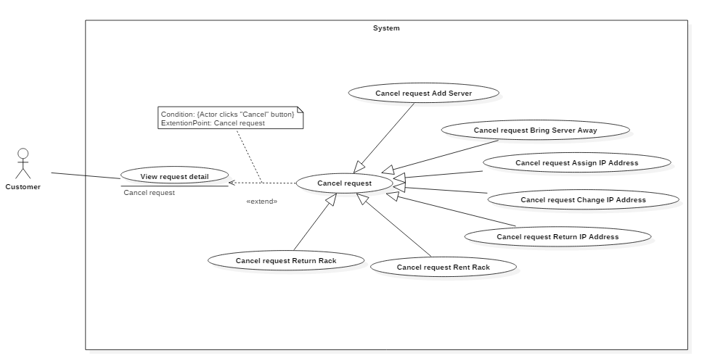 Figure 19: <Customer> Cancel request Add New Server

|  |  |  |  |
| --- | --- | --- | --- |
| USE CASE – IMS011 | | | |
| Use Case No. | IMS011 | **Use Case Version** | 2.0 |
| Use Case Name | Cancel request Add New Server | | |
| Author | Huỳnh Lâm Hà Tiên | | |
| Date | 24/01/2016 | **Priority** | medium |
| Actor:   * Customer.   Summary:   * This use case allows customer to cancel request Add New Server which was sent.   Goal:   * Cancel request Add New Server which was sent.   Triggers:   * On Request History Page, customer select request Add New Server which want to cancel. * Customer clicks on “Cancel Request” button on Request Add New Server Popup.   Preconditions:   * Customer must login into the system with role Customer. * The request which want to cancel was sent to data center.   Post Conditions:   * Success:   Shift Head will receive notification about cancel request.  At the same time, the new server information which customer sent will be deleted out of database.  The status of this request in database will be changed.   * Fail: Show error message with specified content.   Main Success Scenario:   |  |  |  | | --- | --- | --- | | Step | Actor Action | System Response | | 1 | On Request History Page, customer clicks on request Add New Server which want to cancel. | System will display Request Add New Server Popup with content was created in the past. | | 2 | Customer clicks on “Cancel Request” button | System will show message “Are you sure to cancel this request?” | | 3 | Customer clicks on “OK” button | * The new server information which customer sent will be deleted out of database. * The status of this request in database will be changed. * Shift Head will receive notification about cancel request. |   Alternatives Scenario:   |  |  |  | | --- | --- | --- | | Step | Actor Action | System Response | | 1 | On Request History Page, customer clicks on request Add New Server which want to cancel. | System will display Request Add New Server Popup with content was created in the past. | | 2 | Customer clicks on “Cancel Request” button | System will show message “Are you sure to cancel this request?” | | 3 | Customer clicks on “Cancel” button | Return to Request Add New Server Popup with original content. |   Exceptions:   |  |  |  | | --- | --- | --- | | No | Cause | System Response | | 1 | Connect to Internet fail | Show message “Cannot send request, please connect to the Internet!” |   Relationships: Extend to View request detail history.  Business Rules:   * The system only deletes the information of new server which customer sent, does not delete different information of this request. | | | |

*Table 29: Use case IMS011 - <Customer> Cancel request Add New Server*

###### <Customer> Cancel request “Bring Server Away”

 Figure 19: <Customer> Cancel request Upgrade Server

|  |  |  |  |
| --- | --- | --- | --- |
| USE CASE – IMS011 | | | |
| Use Case No. | IMS011 | **Use Case Version** | 2.0 |
| Use Case Name | Cancel request Upgrade Server | | |
| Author | Huỳnh Lâm Hà Tiên | | |
| Date | 24/01/2016 | **Priority** | medium |
| Actor:   * Customer.   Summary:   * This use case allows customer to cancel request Upgrade Server which was sent.   Goal:   * Cancel request Upgrade Server which was sent.   Triggers:   * On Request History Page, customer select request Upgrade Server which want to cancel. * Customer clicks on “Cancel Request” button on Request Upgrade Server Popup.   Preconditions:   * Customer must login into the system with role Customer. * The request which want to cancel was sent to data center.   Post Conditions:   * Success:   Shift Head will receive notification about cancel request.  At the same time, the upgrade information of server which customer sent will be deleted out of database.  The status of this request in database will be changed.   * Fail: Show error message with specified content.   Main Success Scenario:   |  |  |  | | --- | --- | --- | | Step | Actor Action | System Response | | 1 | On Request History Page, customer clicks on request Upgrade Server which want to cancel. | System will display Request Upgrade Server Popup with content was created in the past. | | 2 | Customer clicks on “Cancel Request” button | System will show message “Are you sure to cancel this request?” | | 3 | Customer clicks on “OK” button | * The upgrade information of server which customer sent will be deleted out of database. * The status of this request in database will be changed. * Shift Head will receive notification about cancel request. |   Alternatives Scenario:   |  |  |  | | --- | --- | --- | | Step | Actor Action | System Response | | 1 | On Request History Page, customer clicks on request Upgrade Server which want to cancel. | System will display Request Upgrade Server Popup with content was created in the past. | | 2 | Customer clicks on “Cancel Request” button | System will show message “Are you sure to cancel this request?” | | 3 | Customer clicks on “Cancel” button | Return to Request Upgrade Server Popup with original content. |   Exceptions: Extend to View request detail history.   |  |  |  | | --- | --- | --- | | No | Cause | System Response | | 1 | Connect to Internet fail | Show message “Cannot send request, please connect to the Internet!” |   Relationships:  Business Rules:   * The system only deletes the upgrade information of server which customer sent, does not delete different information of this request. | | | |

*Table 29: Use case IMS011 - <Customer> Cancel request Add New Server*

###### <Customer> Cancel request “Assign IP Address”

 Figure 19: <Customer> Cancel request Assign IP Address

|  |  |  |  |
| --- | --- | --- | --- |
| USE CASE – IMS011 | | | |
| Use Case No. | IMS011 | **Use Case Version** | 2.0 |
| Use Case Name | Cancel request Assign IP Address | | |
| Author | Huỳnh Lâm Hà Tiên | | |
| Date | 24/01/2016 | **Priority** | medium |
| Actor:   * Customer.   Summary:   * This use case allows customer to cancel request Assign IP Address which was sent.   Goal:   * Cancel request Assign IP Address which was sent.   Triggers:   * On Request History Page, customer select request Assign IP Address which want to cancel. * Customer clicks on “Cancel Request” button on Request Assign IP Address Popup.   Preconditions:   * Customer must login into the system with role Customer. * The request which want to cancel was sent to data center.   Post Conditions:   * Success:   Shift Head will receive notification about cancel request.  At the same time, the data of assign IP Address which customer sent will be deleted out of database.  The status of this request in database will be changed.   * Fail: Show error message with specified content.   Main Success Scenario:   |  |  |  | | --- | --- | --- | | Step | Actor Action | System Response | | 1 | On Request History Page, customer clicks on request Assign IP Status which want to cancel. | System will display Request Assign IP Address Popup with content was created in the past. | | 2 | Customer clicks on “Cancel Request” button | System will show message “Are you sure to cancel this request?” | | 3 | Customer clicks on “OK” button | * The data of assign IP Address which customer sent will be deleted out of database. * The status of this request in database will be changed. * Shift Head will receive notification about cancel request. |   Alternatives Scenario:   |  |  |  | | --- | --- | --- | | Step | Actor Action | System Response | | 1 | On Request History Page, customer clicks on request Assign IP Address which want to cancel. | System will display Request Assign IP Address Popup with content was created in the past. | | 2 | Customer clicks on “Cancel Request” button | System will show message “Are you sure to cancel this request?” | | 3 | Customer clicks on “Cancel” button | Return to Request Assign IP Address Popup with original content. |   Exceptions:   |  |  |  | | --- | --- | --- | | No | Cause | System Response | | 1 | Connect to Internet fail | Show message “Cannot send request, please connect to the Internet!” |   Relationships: Extend to View request detail history.  Business Rules:   * The system only deletes the data of assign IP Address which customer sent, does not delete different information of this request. | | | |

*Table 29: Use case IMS011 - <Customer> Cancel request Assign IP Address*

###### <Customer> Cancel request “Change IP Address”

Figure 19: <Customer> Cancel request Change IP Address

|  |  |  |  |
| --- | --- | --- | --- |
| USE CASE – IMS011 | | | |
| Use Case No. | IMS011 | **Use Case Version** | 2.0 |
| Use Case Name | Cancel request Change IP Address | | |
| Author | Huỳnh Lâm Hà Tiên | | |
| Date | 24/01/2016 | **Priority** | medium |
| Actor:   * Customer.   Summary:   * This use case allows customer to cancel request Change IP Address which was sent.   Goal:   * Cancel request Change IP Address which was sent.   Triggers:   * On Request History Page, customer select request Change IP Address which want to cancel. * Customer clicks on “Cancel Request” button on Request Change IP Address Popup.   Preconditions:   * Customer must login into the system with role Customer. * The request which want to cancel was sent to data center.   Post Conditions:   * Success:   Shift Head will receive notification about cancel request.  At the same time, the data of change IP Address which customer sent will be deleted out of database.  The status of this request in database will be changed.   * Fail: Show error message with specified content.   Main Success Scenario:   |  |  |  | | --- | --- | --- | | Step | Actor Action | System Response | | 1 | On Request History Page, customer clicks on request Change IP Status which want to cancel. | System will display Request Change IP Address Popup with content was created in the past. | | 2 | Customer clicks on “Cancel Request” button | System will show message “Are you sure to cancel this request?” | | 3 | Customer clicks on “OK” button | * The data of change IP Address which customer sent will be deleted out of database. * The status of this request in database will be changed. * Shift Head will receive notification about cancel request. |   Alternatives Scenario:   |  |  |  | | --- | --- | --- | | Step | Actor Action | System Response | | 1 | On Request History Page, customer clicks on request Change IP Address which want to cancel. | System will display Request Change IP Address Popup with content was created in the past. | | 2 | Customer clicks on “Cancel Request” button | System will show message “Are you sure to cancel this request?” | | 3 | Customer clicks on “Cancel” button | Return to Request Change IP Address Popup with original content. |   Exceptions:   |  |  |  | | --- | --- | --- | | No | Cause | System Response | | 1 | Connect to Internet fail | Show message “Cannot send request, please connect to the Internet!” |   Relationships: Extend to View request detail history.  Business Rules:   * The system only deletes the data of change IP Address which customer sent, does not delete different information of this request. | | | |

*Table 29: Use case IMS011 - <Customer> Cancel request Change IP Address*

###### <Customer> Cancel request “Return IP Address”

 Figure 19: <Customer> Cancel request Return IP Address

|  |  |  |  |
| --- | --- | --- | --- |
| USE CASE – IMS011 | | | |
| Use Case No. | IMS011 | **Use Case Version** | 2.0 |
| Use Case Name | Cancel request Return IP Address | | |
| Author | Huỳnh Lâm Hà Tiên | | |
| Date | 24/01/2016 | **Priority** | medium |
| Actor:   * Customer.   Summary:   * This use case allows customer to cancel request Return IP Address which was sent.   Goal:   * Cancel request Return IP Address which was sent.   Triggers:   * On Request History Page, customer select request Return IP Address which want to cancel. * Customer clicks on “Cancel Request” button on Request Return IP Address Popup.   Preconditions:   * Customer must login into the system with role Customer. * The request which want to cancel was sent to data center.   Post Conditions:   * Success:   Shift Head will receive notification about cancel request.  At the same time, the data of return IP Address which customer sent will be deleted out of database.  The status of this request in database will be changed.   * Fail: Show error message with specified content.   Main Success Scenario:   |  |  |  | | --- | --- | --- | | Step | Actor Action | System Response | | 1 | On Request History Page, customer clicks on request Return IP Status which want to cancel. | System will display Request Return IP Address Popup with content was created in the past. | | 2 | Customer clicks on “Cancel Request” button | System will show message “Are you sure to cancel this request?” | | 3 | Customer clicks on “OK” button | * The data of return IP Address which customer sent will be deleted out of database. * The status of this request in database will be changed. * Shift Head will receive notification about cancel request. |   Alternatives Scenario:   |  |  |  | | --- | --- | --- | | Step | Actor Action | System Response | | 1 | On Request History Page, customer clicks on request Return IP Address which want to cancel. | System will display Request Return IP Address Popup with content was created in the past. | | 2 | Customer clicks on “Cancel Request” button | System will show message “Are you sure to cancel this request?” | | 3 | Customer clicks on “Cancel” button | Return to Request Return IP Address Popup with original content. |   Exceptions:   |  |  |  | | --- | --- | --- | | No | Cause | System Response | | 1 | Connect to Internet fail | Show message “Cannot send request, please connect to the Internet!” |   Relationships: Extend to View request detail history.  Business Rules:   * The system only deletes the data of return IP Address which customer sent, does not delete different information of this request. | | | |

*Table 29: Use case IMS011 - <Customer> Cancel request Return IP Address*

###### <Customer> Cancel request “Rent Rack”

 Figure 19: <Customer> Return IP

|  |  |  |  |
| --- | --- | --- | --- |
| USE CASE – IMS011 | | | |
| Use Case No. | IMS011 | **Use Case Version** | 2.0 |
| Use Case Name | Return IP | | |
| Author | Huỳnh Lâm Hà Tiên | | |
| Date | 23/01/2016 | **Priority** | medium |
| Actor:   * Customer.   Summary:   * This use case allows customer to return IP Address for data center.   Goal:   * Return IP Address for data center quickly.   Triggers:   * Customer clicks on “Make request” on the panel and select “Return IP Address”   Preconditions:   * Customer must login into the system with role Customer.   Post Conditions:   * Success: Request will be sent to data center, Shift Head will receive notification. At the same time, the data about IP Address which want to return will be saved into database. * Fail: Show error message with specified content.   Main Success Scenario:   |  |  |  | | --- | --- | --- | | Step | Actor Action | System Response | | 1 | Customer clicks on “Make request” on the panel and select “Return IP Address” | System will display Request Return IP Address Popup | | 2 | Input data in fields of Request Return IP Address Popup and clicks on “Send” button | System will send request to data center:   * The information about IP Address which want to return will be saved into database. * The Head Shift who is in shift will have notification. |   Alternatives Scenario:   |  |  |  | | --- | --- | --- | | Step | Actor Action | System Response | | 1 | Customer clicks on “Make request” and select “Return IP Address”. | System will display Request Return IP Address Popup. | | 2 | Input data in fields of Request Return IP Address Popup and clicks on “Cancel” button. | Return to Request History Page. |   Exceptions:   |  |  |  | | --- | --- | --- | | No | Cause | System Response | | 1 | Connect to Internet fail | Show message “Cannot send request, please connect to the Internet!” |   Relationships:  Business Rules:   * Customer can request to return one or more IP Addresses for data center in one request. | | | |

Table 29: Use case IMS011 - <Customer> Return IP

###### <Customer> Cancel request “Return Rack”

 Figure 19: <Customer> Return IP

|  |  |  |  |
| --- | --- | --- | --- |
| USE CASE – IMS011 | | | |
| Use Case No. | IMS011 | **Use Case Version** | 2.0 |
| Use Case Name | Return IP | | |
| Author | Huỳnh Lâm Hà Tiên | | |
| Date | 23/01/2016 | **Priority** | medium |
| Actor:   * Customer.   Summary:   * This use case allows customer to return IP Address for data center.   Goal:   * Return IP Address for data center quickly.   Triggers:   * Customer clicks on “Make request” on the panel and select “Return IP Address”   Preconditions:   * Customer must login into the system with role Customer.   Post Conditions:   * Success: Request will be sent to data center, Shift Head will receive notification. At the same time, the data about IP Address which want to return will be saved into database. * Fail: Show error message with specified content.   Main Success Scenario:   |  |  |  | | --- | --- | --- | | Step | Actor Action | System Response | | 1 | Customer clicks on “Make request” on the panel and select “Return IP Address” | System will display Request Return IP Address Popup | | 2 | Input data in fields of Request Return IP Address Popup and clicks on “Send” button | System will send request to data center:   * The information about IP Address which want to return will be saved into database. * The Head Shift who is in shift will have notification. |   Alternatives Scenario:   |  |  |  | | --- | --- | --- | | Step | Actor Action | System Response | | 1 | Customer clicks on “Make request” and select “Return IP Address”. | System will display Request Return IP Address Popup. | | 2 | Input data in fields of Request Return IP Address Popup and clicks on “Cancel” button. | Return to Request History Page. |   Exceptions:   |  |  |  | | --- | --- | --- | | No | Cause | System Response | | 1 | Connect to Internet fail | Show message “Cannot send request, please connect to the Internet!” |   Relationships:  Business Rules:   * Customer can request to return one or more IP Addresses for data center in one request. | | | |

Table 29: Use case IMS011 - <Customer> Return IP

###### <Customer> View server

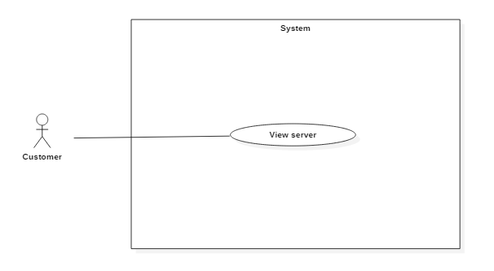 Figure 19: <Customer> Return IP

|  |  |  |  |
| --- | --- | --- | --- |
| USE CASE – IMS011 | | | |
| Use Case No. | IMS011 | **Use Case Version** | 2.0 |
| Use Case Name | Return IP | | |
| Author | Huỳnh Lâm Hà Tiên | | |
| Date | 23/01/2016 | **Priority** | medium |
| Actor:   * Customer.   Summary:   * This use case allows customer to return IP Address for data center.   Goal:   * Return IP Address for data center quickly.   Triggers:   * Customer clicks on “Make request” on the panel and select “Return IP Address”   Preconditions:   * Customer must login into the system with role Customer.   Post Conditions:   * Success: Request will be sent to data center, Shift Head will receive notification. At the same time, the data about IP Address which want to return will be saved into database. * Fail: Show error message with specified content.   Main Success Scenario:   |  |  |  | | --- | --- | --- | | Step | Actor Action | System Response | | 1 | Customer clicks on “Make request” on the panel and select “Return IP Address” | System will display Request Return IP Address Popup | | 2 | Input data in fields of Request Return IP Address Popup and clicks on “Send” button | System will send request to data center:   * The information about IP Address which want to return will be saved into database. * The Head Shift who is in shift will have notification. |   Alternatives Scenario:   |  |  |  | | --- | --- | --- | | Step | Actor Action | System Response | | 1 | Customer clicks on “Make request” and select “Return IP Address”. | System will display Request Return IP Address Popup. | | 2 | Input data in fields of Request Return IP Address Popup and clicks on “Cancel” button. | Return to Request History Page. |   Exceptions:   |  |  |  | | --- | --- | --- | | No | Cause | System Response | | 1 | Connect to Internet fail | Show message “Cannot send request, please connect to the Internet!” |   Relationships:  Business Rules:   * Customer can request to return one or more IP Addresses for data center in one request. | | | |

Table 29: Use case IMS011 - <Customer> Return IP

###### <Customer> View rented rack

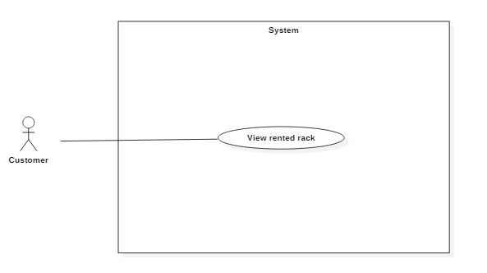 Figure 19: <Customer> Return IP

|  |  |  |  |
| --- | --- | --- | --- |
| USE CASE – IMS011 | | | |
| Use Case No. | IMS011 | **Use Case Version** | 2.0 |
| Use Case Name | Return IP | | |
| Author | Huỳnh Lâm Hà Tiên | | |
| Date | 23/01/2016 | **Priority** | medium |
| Actor:   * Customer.   Summary:   * This use case allows customer to return IP Address for data center.   Goal:   * Return IP Address for data center quickly.   Triggers:   * Customer clicks on “Make request” on the panel and select “Return IP Address”   Preconditions:   * Customer must login into the system with role Customer.   Post Conditions:   * Success: Request will be sent to data center, Shift Head will receive notification. At the same time, the data about IP Address which want to return will be saved into database. * Fail: Show error message with specified content.   Main Success Scenario:   |  |  |  | | --- | --- | --- | | Step | Actor Action | System Response | | 1 | Customer clicks on “Make request” on the panel and select “Return IP Address” | System will display Request Return IP Address Popup | | 2 | Input data in fields of Request Return IP Address Popup and clicks on “Send” button | System will send request to data center:   * The information about IP Address which want to return will be saved into database. * The Head Shift who is in shift will have notification. |   Alternatives Scenario:   |  |  |  | | --- | --- | --- | | Step | Actor Action | System Response | | 1 | Customer clicks on “Make request” and select “Return IP Address”. | System will display Request Return IP Address Popup. | | 2 | Input data in fields of Request Return IP Address Popup and clicks on “Cancel” button. | Return to Request History Page. |   Exceptions:   |  |  |  | | --- | --- | --- | | No | Cause | System Response | | 1 | Connect to Internet fail | Show message “Cannot send request, please connect to the Internet!” |   Relationships:  Business Rules:   * Customer can request to return one or more IP Addresses for data center in one request. | | | |

Table 29: Use case IMS011 - <Customer> Return IP

##### <Shift Manager> Overview Use Case

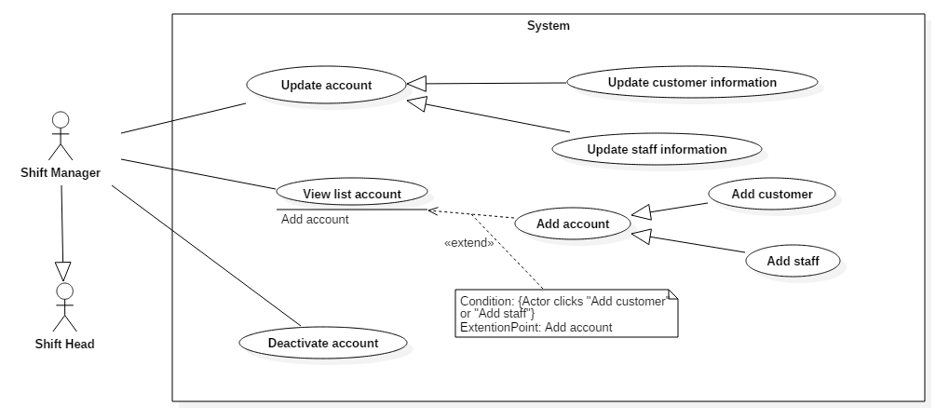

Figure1: <Shift Manager> View customer

|  |  |  |  |
| --- | --- | --- | --- |
| USE CASE – IMS001 | | | |
| Use Case No. | IMS001 | **Use Case Version** | 2.0 |
| Use Case Name | View Customer | | |
| Author | Cao Hồng Nam | | |
| Date | 18/01/2016 | **Priority** | medium |
| Actor:   * Shift Manager.   Summary:   * This use case allows Shift Manager and staff to view customer information.   Goal:   * View customers information.   Triggers:   * Shift Manager, Staff clicks on “View customer” link on the panel.   Preconditions:   * Shift Manager and Staff must login into the system with role Shift Manager and Staff.   Post Conditions:   * Success: All data will be saving successfully and show success message   - Fail: System shows error message.  Main Success Scenario:   |  |  |  | | --- | --- | --- | | Step | Actor Action | System Response | | 1 | Shift Manager or Staff clicks on “View customer” link on the panel. | Navigate to View customer information page which contains:   * User name: label * Full name: label * Phone: label * Email: label * Address: label * Sever name: link * Indentification: label |   Alternatives Scenario: N/A.  Exceptions:   |  |  |  | | --- | --- | --- | | No | Actor Action | System Response | | 1 | Connect to database fail | Show message “Error, please try again!” |   Relationships:   * extend to Change Status, Update Customer, Add Customer (Shift Manager clicks View Customer link in View Customer Page)   Business Rules: N/A. | | | |

Table1: Use case IMS001 - <Shift Manager> View customer.

###### <Shift Manager> Add Customer

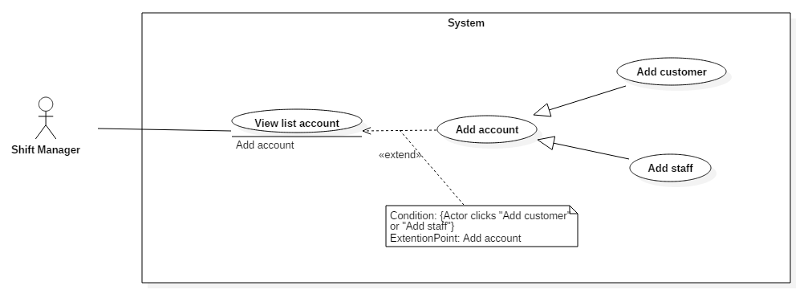*Figure2: <Shift Manager> Add customer*

|  |  |  |  |
| --- | --- | --- | --- |
| USE CASE – IMS002 | | | |
| Use Case No. | IMS002 | **Use Case Version** | 2.0 |
| Use Case Name | Add Customer | | |
| Author | Cao Hồng Nam | | |
| Date | 18/01/2016 | **Priority** | medium |
| Actor:   * Shift Manager.   Summary:   * This use case allows user to add customer information.   Goal:   * Add customer information.   Triggers:   * Shift Manager clicks on “Add customer” link on the panel.   Preconditions:   * Shift Manager must login into the system with role Shift Manager.   Post Conditions:   * Success: All data will be saving successfully and show success message   - Fail: System shows error message.  Main Success Scenario:   |  |  |  | | --- | --- | --- | | Step | Actor Action | System Response | | 1 | Shift Manager goes to add customer view. | System display view with following information:   * User name: free text input, required. * Full name: free text input, required. * Phone: free text input, required. * Email: free text input, required. * Address: free text input, required. * Sever name: free text input, required. * Indentification: free text input, required. | | 2 | Shift Manager fills out the form. | * After Shift Manager finish one field, system will show error message (if need) next to that field. Therefore, Shift Manager knows which field has typed wrong and need to input again. | | 3 | Shift Manager sends add customer command. | * Validate data. * If data valid, system creates new customer. * System shows successful message to Shift Manager. |   Alternatives Scenario:   |  |  |  | | --- | --- | --- | | No | Actor Action | System Response | | 1 | Shift Manager clicks “Clear data” button. | Clear all data input. |   Exceptions:   |  |  |  | | --- | --- | --- | | No | Actor Action | System Response | | 1 | Connect to database fail | Show message “Error, please try again!” |   Relationships:   * extend to View Customer (Shift Manager clicks Add Customer link in View Customer Page)   Business Rules:   * An email address must be validated by this regular expression:   /^([a-z0-9_\.-]+)@([\da-z\.-]+)\.([a-z\.]{2,6})$/   * An email must be unique among staff. No two customer share same email address. * Password must be encrypted before send to server. * Password must be encrypted before save to database. | | | |

Table2: Use case IMS002 - <Shift Manager> Add customer.

###### <Shift Manager> Update customer

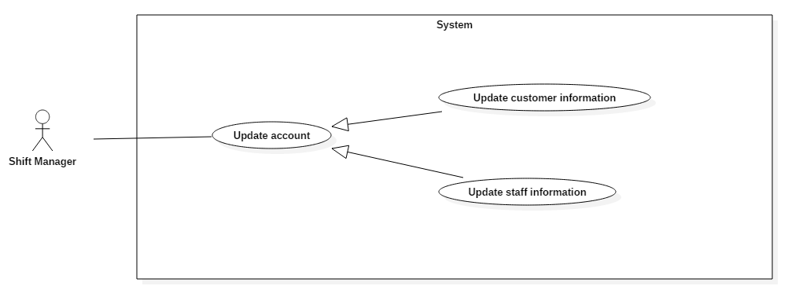*Figure3: <Shift Manager> update customer*

|  |  |  |  |
| --- | --- | --- | --- |
| USE CASE – IMS003 | | | |
| Use Case No. | IMS003 | **Use Case Version** | 2.0 |
| Use Case Name | Update Customer | | |
| Author | Cao Hồng Nam | | |
| Date | 18/01/2016 | **Priority** | medium |
| Actor:   * Shift Manager.   Summary:   * This use case allows Shift Manager to update customer information.   Goal:   * Update customer information.   Triggers:   * Shift Manager clicks on “Update customer” link on the panel.   Preconditions:   * Shift Manager must login into the system with role Shift Manager.   Post Conditions:   * Success: All data will be saving successfully and show success message   - Fail: System shows error message.  Main Success Scenario:   |  |  |  | | --- | --- | --- | | Step | Actor Action | System Response | | 1 | Shift Manager goes to update customer information view. | System display view with following information:   * User name: free text input, required. * Full name: free text input, required. * Phone: free text input, required. * Email: free text input, required. * Address: free text input, required. * Sever name: free text input, required. * Indentification: free text input, required. | | 2 | Shift Manager selects field | This field will be changed to editable mode. | | 3 | Shift Manager inputs value. | After Shift Manager finish one field, system will show error message (if need) next to that field. Therefore, Shift Manager knows which field has typed wrong and need to input again. | | 4 | Shift Manager sends update customer command. | * Validate data. * If data valid, system update new customer information to storage. * System show successful message to Shift Manager. |   Alternatives Scenario:   |  |  |  | | --- | --- | --- | | Step | Cause | System Response | | 1 | Customer cannot be updated. | System will show message that this new staff cannot be updated. |   Exceptions:   |  |  |  | | --- | --- | --- | | No | Actor Action | System Response | | 1 | Connect to database fail | Show message “Error, please try again!” |   Relationships:   * extend to View Customer (Shift Manager clicks Update Customer link in View Customer Page)   Business Rules:   * An email address must be validated by this regular expression:   /^([a-z0-9_\.-]+)@([\da-z\.-]+)\.([a-z\.]{2,6})$/   * Password must be encrypted before send to server. * Password must be encrypted before save to database. | | | |

Table3: Use case IMS003 - <Shift Manager> update customer.

###### <Shift Manager> View list account

*Figure5: <Shift Manager> view staff*

|  |  |  |  |
| --- | --- | --- | --- |
| USE CASE – IMS005 | | | |
| Use Case No. | IMS005 | **Use Case Version** | 2.0 |
| Use Case Name | View Staff | | |
| Author | Cao Hồng Nam | | |
| Date | 18/01/2016 | **Priority** | medium |
| Actor:   * Shift Manager.   Summary:   * This use case allows Shift Manager to view staff information.   Goal:   * View staff information.   Triggers:   * Shift Manager clicks on “View staff” link on the panel.   Preconditions:   * Shift Manager must login into the system with role Shift Manager.   Post Conditions:   * Success: All data will be saving successfully and show success message   - Fail: System shows error message.  Main Success Scenario:   |  |  |  | | --- | --- | --- | | Step | Actor Action | System Response | | 1 | Shift Manager clicks on “View Staff” link on the panel. | Navigate to View staff information page which contains:   * User name: label * Full name: label * Phone: label * Email: label * Address: label * Indentification: label |   Alternatives Scenario: N/A.  Exceptions:   |  |  |  | | --- | --- | --- | | No | Actor Action | System Response | | 1 | Connect to database fail | Show message “Error, please try again!” |   Relationships:   * extend to Change Status, Add Staff (Shift Manager clicks View Staff link in View Staff Page)   Business Rules: N/A. | | | |

Table5: Use case IMS005 - <Shift Manager> view staff.

###### <Shift Manager> Add Staff

*Figure6: <Shift Manager> add staff*

|  |  |  |  |
| --- | --- | --- | --- |
| USE CASE – IMS006 | | | |
| Use Case No. | IMS006 | **Use Case Version** | 2.0 |
| Use Case Name | Add Staff | | |
| Author | Cao Hồng Nam | | |
| Date | 18/01/2016 | **Priority** | medium |
| Actor:   * Shift Manager.   Summary:   * This use case allows Shift Manager to add staff information.   Goal:   * Add staff information.   Triggers:   * Shift Manager clicks on “Add staff” link on the panel.   Preconditions:   * Shift Manager must login into the system with role Shift Manager.   Post Conditions:   * Success: All data will be saving successfully and show success message   - Fail: System shows error message.  Main Success Scenario:   |  |  |  | | --- | --- | --- | | Step | Actor Action | System Response | | 1 | Shift Manager goes to add staff view. | System display view with following information:   * User name: free text input, required. * Full name: free text input, required. * Phone: free text input, required. * Email: free text input, required. * Address: free text input, required. * Indentification: free text input, required. | | 2 | Shift Manager fills out the form. | * After Shift Manager finish one field, system will show error message (if need) next to that field. Therefore, Shift Manager knows which field has typed wrong and need to input again. | | 3 | Shift Manager sends add staff command. | * Validate data. * If data valid, system creates new staff. * System shows successful message to Shift Manager. |   Alternatives Scenario:   |  |  |  | | --- | --- | --- | | No | Actor Action | System Response | | 1 | Shift Manager clicks “Clear data” button. | Clear all data input. |   Exceptions:   |  |  |  | | --- | --- | --- | | No | Actor Action | System Response | | 1 | Connect to database fail | Show message “Error, please try again!” |   Relationships:   * extend to View Staff (Shift Manager clicks Add Staff link in View Staff Page)   Business Rules:   * An email address must be validated by this regular expression:   /^([a-z0-9_\.-]+)@([\da-z\.-]+)\.([a-z\.]{2,6})$/   * An email must be unique among staff. No two staffs share same email address. * Password must be encrypted before send to server. * Password must be encrypted before save to database. | | | |

Table6: Use case IMS006 - <Shift Manager> add staff.

###### <Shift Manager> Update Staff

*Figure7: <Shift Manager> update staff*

|  |  |  |  |
| --- | --- | --- | --- |
| USE CASE – IMS007 | | | |
| Use Case No. | IMS007 | **Use Case Version** | 2.0 |
| Use Case Name | Update Staff | | |
| Author | Cao Hồng Nam | | |
| Date | 18/01/2016 | **Priority** | medium |
| Actor:   * Shift Manager.   Summary:   * This use case allows Shift Manager to update staff information.   Goal:   * Update staff information.   Triggers:   * Shift Manager clicks on “Update Staff” link on the panel.   Preconditions:   * Shift Manager must login into the system with role Shift Manager.   Post Conditions:   * Success: All data will be saving successfully and show success message   - Fail: System shows error message.  Main Success Scenario:   |  |  |  | | --- | --- | --- | | Step | Actor Action | System Response | | 1 | Shift Manager goes to update staff information view. | System display view with following information:   * User name: free text input, required. * Full name: free text input, required. * Phone: free text input, required. * Email: free text input, required. * Address: free text input, required. * Indentification: free text input, required. | | 2 | Shift Manager selects field | This field will be changed to editable mode. | | 3 | Shift Manager inputs value. | After Shift Manager finish one field, system will show error message (if need) next to that field. Therefore, Shift Manager knows which field has typed wrong and need to input again. | | 4 | Shift Manager sends update staff command. | * Validate data. * If data valid, system update new customer information to storage. * System show successful message to Shift Manager. |   Alternatives Scenario:   |  |  |  | | --- | --- | --- | | Step | Cause | System Response | | 1 | Customer cannot be updated. | System will show message that this new staff cannot be updated. |   Exceptions:   |  |  |  | | --- | --- | --- | | No | Actor Action | System Response | | 1 | Connect to database fail | Show message “Error, please try again!” |   Relationships:   * extend to View Staff (Shift Manager clicks Update Staff link in View Staff Page).   Business Rules:   * An email address must be validated by this regular expression:   /^([a-z0-9_\.-]+)@([\da-z\.-]+)\.([a-z\.]{2,6})$/   * Password must be encrypted before send to server. * Password must be encrypted before save to database. | | | |

Table7: Use case IMS007 - <Shift Manager> update staff.

###### <Shift Manager> Deactivate account

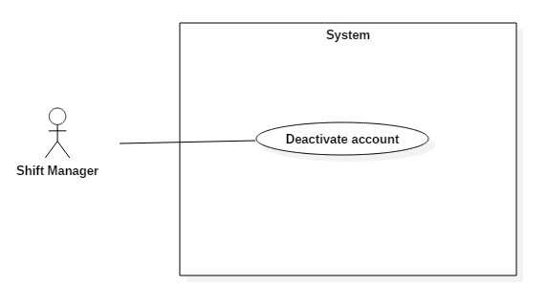

*Figure8: <Shift Manager> change status*

|  |  |  |  |
| --- | --- | --- | --- |
| USE CASE – IMS008 | | | |
| Use Case No. | IMS008 | **Use Case Version** | 2.0 |
| Use Case Name | Change status | | |
| Author | Cao Hồng Nam | | |
| Date | 18/01/2016 | **Priority** | medium |
| Actor:   * Shift Manager.   Summary:   * This use case allows Shift Manager to change status for staff.   Goal:   * Change Status information.   Triggers:   * Shift Manager clicks on “Change Status” link on the panel.   Preconditions:   * Shift Manager must login into the system with role Shift Manager.   Post Conditions:   * Success: All data will be saving successfully and show success message   - Fail: System shows error message.  Main Success Scenario:   |  |  |  | | --- | --- | --- | | Step | Actor Action | System Response | | 1 | Shift Manager clicks on “Change status” at each staff in Shift Manager Page. | The system will display the table of staff with column Status which can edit. | | 2 | Shift Manager clicks on “Save” button in Shift Manager Page. | The new status will be saved into database and the new status will be displayed on server table. |   Alternatives Scenario: N/A  Exceptions:   |  |  |  | | --- | --- | --- | | No | Actor Action | System Response | | 1 | Connect to database fail | Show message “Error, please try again!” |   Relationships:   * extend to View Staff (Shift Manager clicks Change Status link in View Staff Page)   Business Rules:   * When checkbox “Internal Notify” is checked, customer can’t see the added announcement. | | | |

Table8: Use case IMS008 - <Shift Manager> change status.

##### <Authenticated User> Overview Use Case

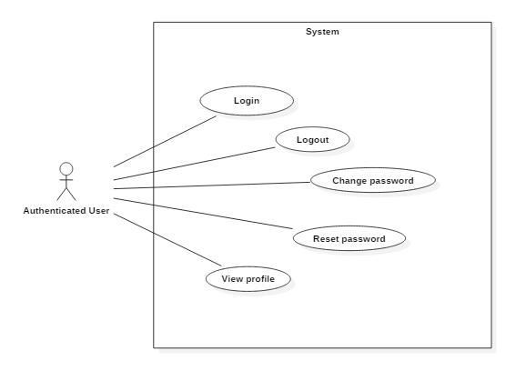

###### <Authenticated User> Login

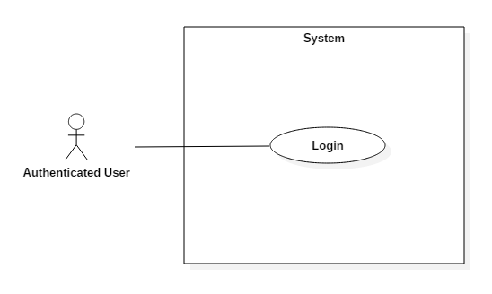

*Figure9: <Authenticated User > login*

|  |  |  |  |
| --- | --- | --- | --- |
| USE CASE – IMS009 | | | |
| Use Case No. | IMS009 | **Use Case Version** | 2.0 |
| Use Case Name | Login | | |
| Author | Lê Thị Thu Hà | | |
| Date | 18/01/2016 | **Priority** | Normal |
| Actor:   * Authenticated user.   Summary:   * This use case allows authenticated user to login.   Goal:   * Authenticated user can login to the system.   Triggers:   * Authenticated user clicks on “Login” button   Preconditions:   * Authenticated user must login into the system with role shift manager, shift head, staff or customer.   Post Conditions:   * Success: User logins successfully and redirected to home page   - Fail: System shows error message.  Main Success Scenario:   |  |  |  | | --- | --- | --- | | Step | Actor Action | System Response | | 1 | Authenticated user goes to login view. | System requires identity information from Authenticated user:   * Authenticated user code: free text input. * Password: free text input. | | 2 | Authenticated user inputs information. |  | | 3 | Authenticated user sends login command to system. | If authenticated user logins successfully, he will login system his role.  If he logins fail, system shows error message “Invalid username or password”. |   Alternative Scenario: N/A  Exceptions:   |  |  |  | | --- | --- | --- | | No | Actor Action | System Response | | 1 | Authenticated user not inputs to “Username” field | System shows error message “Username is required.” | | 2 | Authenticated user not inputs to “Password” field | System shows error message “Password is required.” | | 3 | Authenticated user inputs wrong username | System shows error “Username or Password is incorrect. Please try again!” | | 4 | Authenticated user inputs wrong password | System shows error “Username or Password is incorrect. Please try again!” | | 5 | Account is deactivated | System shows error message “Your account is deactivated. Please contact to the administrator for more detail.” |   Relationships: N/A.  Business Rules:   * Only active account can be able to login into the system * Password field displayed “*”. * Encrypt password before being send to server. * After authenticated user login to system successfully, he will been redirected to specified view based on their role on the system: shift manager/shift head/staff or customer. * If role is “Shift Manager”, ”Shift Head” or ”Staff”, the system will display to dashboard view. * If role is “Staff”, the system will display to Staff Dashboard view | | | |

Table9: Use case IMS009 - <Authenticated User> Login.

###### <Authenticated User> Logout

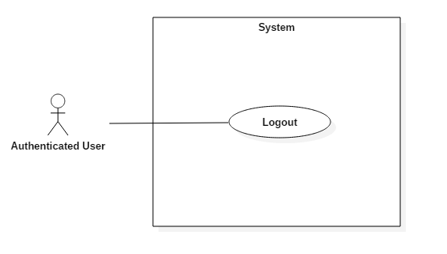*Figure10: < Authenticated User > Logout*

|  |  |  |  |
| --- | --- | --- | --- |
| USE CASE – IMS010 | | | |
| Use Case No. | IMS010 | **Use Case Version** | 2.0 |
| Use Case Name | Logout | | |
| Author | Lê Thị Thu Hà | | |
| Date | 18/01/2016 | **Priority** | Normal |
| Actor:   * Authenticated user.   Summary:   * This use case allows authenticated user to logout.   Goal:   * Logout.   Triggers:   * Authenticated user clicks on “Logout” button on the top of the website.   Preconditions:   * Authenticated user must login into the system with authenticated role.   Post Conditions:   * Success: User logout successfully and cannot access to the website until he login again.   - Fail: N/A.  Main Success Scenario:   |  |  |  | | --- | --- | --- | | Step | Actor Action | System Response | | 1 | Authenticated user sends logout command. | Authenticated user exits from system. |   Alternative Scenario: N/A  Exceptions: N/A  Relationships: N/A.  Business Rules: N/A | | | |
|  | | | |

Table10: Use case IMS010 - < Authenticated User> Logout.

###### <Authenticated User> Change Password

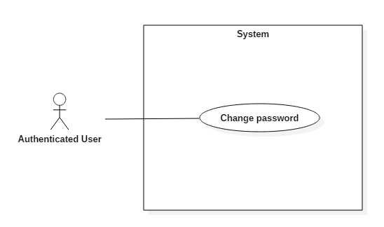

*Figure11: < Authenticated User > Change password*

|  |  |  |  |
| --- | --- | --- | --- |
| USE CASE – IMS011 | | | |
| Use Case No. | IMS011 | **Use Case Version** | 2.0 |
| Use Case Name | Change Password | | |
| Author | Lê Thị Thu Hà | | |
| Date | 18/01/2016 | **Priority** | Normal |
| Actor:   * Authenticated user.   Summary:   * This use case allows authenticated user to change password.   Goal:   * Change password successfully.   Triggers:   * Authenticated user clicks on “Change Password” link on “View Profile” page.   Preconditions:   * Authenticated user must login into the system with authenticated role.   Post Conditions:  - Success: All data will be saving successfully and show success message “Success! You’ve changed your password.”  - Fail: System shows error message.  Main Success Scenario:   |  |  |  | | --- | --- | --- | | Step | Actor Action | System Response | | 1 | Authenticated user clicks on “Change Password” link on “View Profile” page | Navigate to “Change Password” view | | 2 | Authenticated user inputs old password, new password and confirm again the new password |  | | 3 | Authenticated user sends login command to system. | If authenticated user logins successfully, current page will be redirected to previous “View Profile” page.  If he logins fail, system shows error message. |   Alternatives Scenario: N/A.  Exceptions:   |  |  |  | | --- | --- | --- | | No | Actor Action | System Response | | 1 | If authenticated user not inputs to “Password” field | System shows error “Password is required.” | | 2 | If authenticated user not inputs to “New Password” field | System shows error “New Password is required.” | | 3 | If authenticated user not inputs to “Confirm Password” field | System shows error “Confirm Password is required.” | | 4 | If authenticated user inputs wrong value to “Password” field | System shows error “Your password is wrong. Please try again!” | | 5 | If value of “New Password” and “Confirm Password” are different | System shows error “Confirmation is incorrect. Please try again!” |   Relationships: N/A.  Business Rules:   * “Password”, “New Password” and “Confirm Password” field displayed “*”. * Encrypt password before being send to server. | | | |
|  | | | |

Table11: Use case IMS011 - < Authenticated User> Change password.

###### <Authenticated User> Reset password

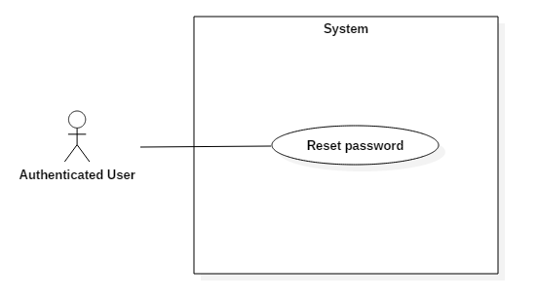

*Figure14: < Authenticated User > Reset password*

|  |  |  |  |
| --- | --- | --- | --- |
| USE CASE – IMS014 | | | |
| Use Case No. | IMS014 | **Use Case Version** | 2.0 |
| Use Case Name | Reset password | | |
| Author | Lê Thị Thu Hà | | |
| Date | 18/01/2016 | **Priority** | Normal |
| Actor:   * Authenticated user.   Summary:   * This use case allows authenticated user reset his password.   Goal:   * Reset password successfully and receive new password via email.   Triggers:   * Authenticated user clicks on “Reset password” link on login page.   Preconditions:   * User forgets his password.   Post Conditions:   * Success: System shows success message, and then customer can get new random password via his email.   - Fail: System shows error message.  Main Success Scenario:   |  |  |  | | --- | --- | --- | | Step | Actor Action | System Response | | 1 | Authenticated user clicks on “Reset password” link on login page | System shows success message “New password is sent to your email. Please check it.” |   Alternatives Scenario: N/A.  Exceptions: N/A.  Relationships: N/A.  Business Rules:   * Registered email of customer must be valid to be able to receive new password. If not, he has to contact directly to shift manager to update his email and get new password. * No one can reset password but the owner. New random password is only allocated via email. | | | |

Table14: Use case IMS014 - < Authenticated User> Reset password.

###### <Authenticated User> View profile

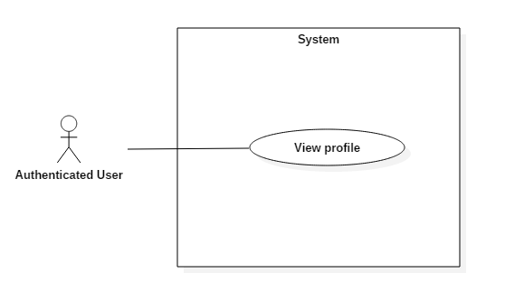

*Figure12: < Authenticated User > View profile*

|  |  |  |  |
| --- | --- | --- | --- |
| USE CASE – IMS012 | | | |
| Use Case No. | IMS012 | **Use Case Version** | 2.0 |
| Use Case Name | View Profile | | |
| Author | Lê Thị Thu Hà | | |
| Date | 18/01/2016 | **Priority** | Normal |
| Actor:   * Authenticated user.   Summary:   * This use case allows authenticated user to view his profile.   Goal:   * View personal information such as Phone, Email, Address and so on.   Triggers:   * Authenticated user clicks on “View Profile” button on scrolled-down panel on the top right of the website.   Preconditions:   * Authenticated user must login into the system with authenticated role.   Post Conditions:   * Success: User can enter to the “View Profile” page   - Fail: System shows error message.  Main Success Scenario:   |  |  |  | | --- | --- | --- | | Step | Actor Action | System Response | | 1 | Authenticated user clicks on “View Profile” button | Navigate to “View Profile” page which contains:   * User name: label * Full name: label * Status: label * Phone: label * Email: label * Address: label * Identification: label * Edit Profile: button * Change Password: button |   Alternatives Scenario: N/A.  Exceptions:   |  |  |  | | --- | --- | --- | | No | Actor Action | System Response | | 1 | Connect to database fail | System shows message “Error happened. Try to connect again!” |   Relationships: N/A.  Business Rules:   * Each user can see his profile. * Shift manager is allowed to see and edit profile of all account in the system. * Shift head and staff can only see profile of customer. * No one can change password but the owner | | | |

Table12: Use case IMS012 - < Authenticated User> View profile.

## Software System Attribute

### Usability

#### Graphic User Interface

* Using language should be English.

#### Usability

* All users should need less than one training week to interact with website.

#### Installation

* Customer can deploy successfully and learn to configure, maintain the system within one day of training.
* The attached manual guide must be clear. User can read and do themselves without developer’s help.

### Reliability

* Information related to customer such as server’s upgraded information will be saved by each interaction

### Availability

* The website should be available 24 hours per day, 7 days per week.

### Security

* Only user who has account can access into System.
* Each role of user has a specific permission to interact with system.
* System always checks authorization before process user’s request.

### Maintainability

* Code is easy to maintain and upgrade.

### Portability

* The system can be deployed into many type of servers those have IIS server.

### Performance

* Response time of almost functions should be less than 2s.

## Conceptual Diagram

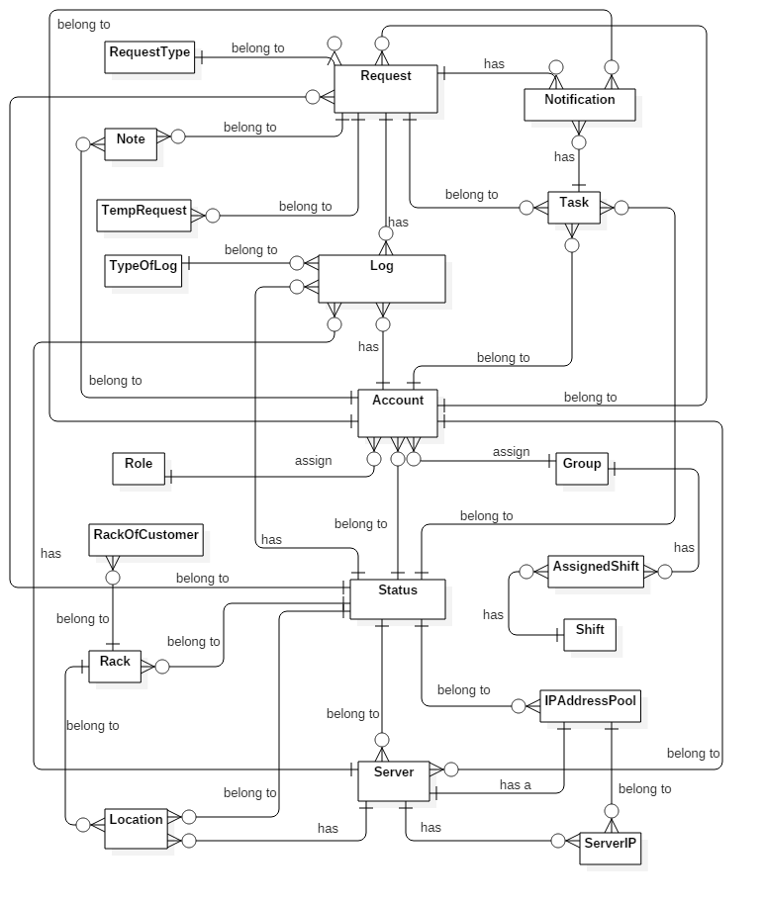

**Figure 34: Conceptual Diagram**

Data dictionary:

|  |  |
| --- | --- |
| **Entity dictionary** | |
| **Entity Name** | **Description** |
| Server | Describe the customer’s server in data center. |
| Status | Describe all of statuses of objects in data center. |
| Location | Describe all location in data center. |
| Rack | Describe all racks which are putting in data center. |
| Log | Describe all logs about object’s changes in data center. |
| Role | Describe all roles in the system. |
| ServerIP | Describe all of current IP Addresses of server. |
| Request | Describe content of each request which was sent by customer. |
| Account | Describe all user’s accounts in the system. |
| Note | Describe all note which was wrote by previous shift for the next shift. |
| TempRequest | Describe temporary detail of all requests. |
| IPAddressPool | Describe all IP Addresses which data center is keeping. |
| RequestType | Describe all types of request. |
| TypeOfLog | Describe all types of log. |
| Group | Describe all shift group of data center. |
| AssignedShift | Describe which group is in which shift each day. |
| Shift | Describe started time and ended time of each shift group. |
| RackOfCustomer | Describe all racks which was rent by customer. |
| Notification | Describe all contents of each notification. |
| Task | Describe all contents of each task. |

Table 37: Data dictionary