# 

# 

# **Software Requirement Specification**

## User Requirement Specification

### Shift Head requirement

* Shift head is the one who mainly use this system with almost essential operations

### Staff requirement

* Staff is a person who works with shift head in the same shift. Staff can only view data on the website except assigned task by shift head.
* When customer request arrives, all of staff have account in the system will receive a notification

### Shift Manager requirement

* Shift manager is the one whose role is all.
* Shift manager is not mainly the one who uses the system frequently. They use the system to manage account information or view the reports

### Customer requirement

* Customer who wants to entrust their server to data center will be granted an account to use this system
* Customer can create request related to their servers
* Customer receives notification content different from system staff’s one
* Customer can view report related to their servers

## System Requirement Specification

### External Interface Requirement

#### User interface

* General requirement for graphics user interface of website is the GUI should be simple, clear, intuitive, and reminiscent.
* Some design principle will be taken into consideration:
* UI for business web applications - Janko Jovanovic [Ref: Appendix 1]
* Ten principles of effective web design – Vitaly Friedman [Ref: Appendix 2]

#### Hardware Interface

* N/A

#### Software Interface

* Chromes (version 41.0.2272.118), Firefox (version 37.0.1) with resolution (1024 x 768) or bigger and must support JavaScript and HTML5.

#### Communication Protocol

* Using HTTP/HTTPS and SMTP protocol.

### System Overview Use Case

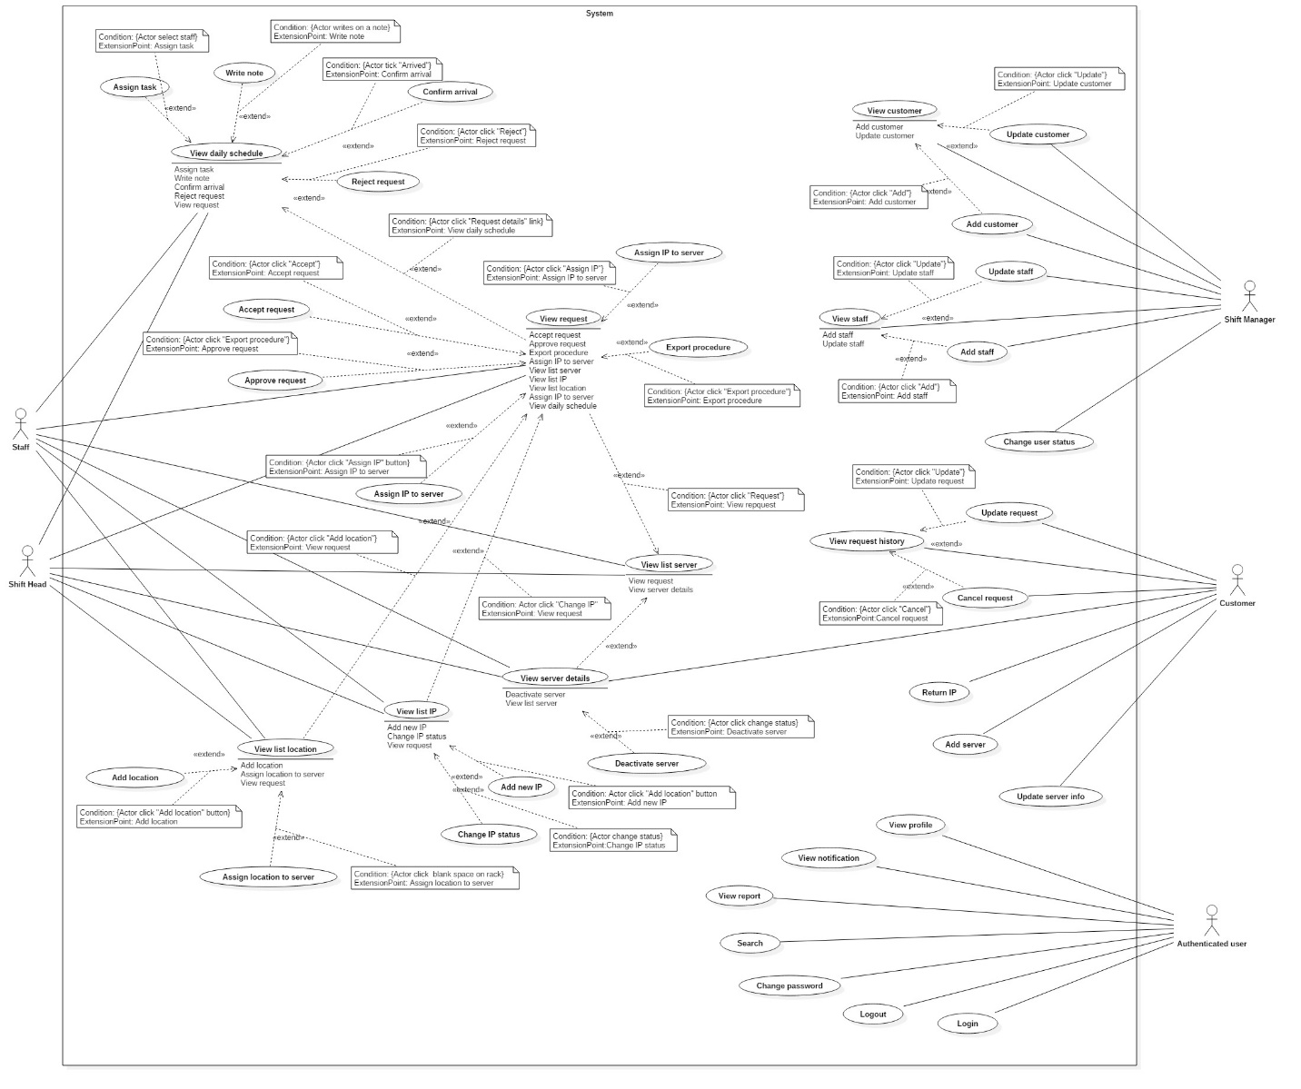

### List of Use Case

## Software System Attribute

### Usability

#### Graphic User Interface

* Using language should be English.

#### Usability

* All users should need less than one training week to interact with website.

#### Installation

* Customer can deploy successfully and learn to configure, maintain the system within one day of training.
* The attached manual guide must be clear. User can read and do themselves without developer’s help.

### Reliability

* Information related to customer such as server’s upgraded information will be saved by each interaction

### Availability

* The website should be available 24 hours per day, 7 days per week.

### Security

* Only user who has account can access into System.
* Each role of user has a specific permission to interact with system.
* System always checks authorization before process user’s request.

### Maintainability

* Code is easy to maintain and upgrade.

### Portability

* The system can be deployed into many type of servers those have IIS server.

### Performance

* Response time of almost functions should be less than 2s.

## Conceptual Diagram

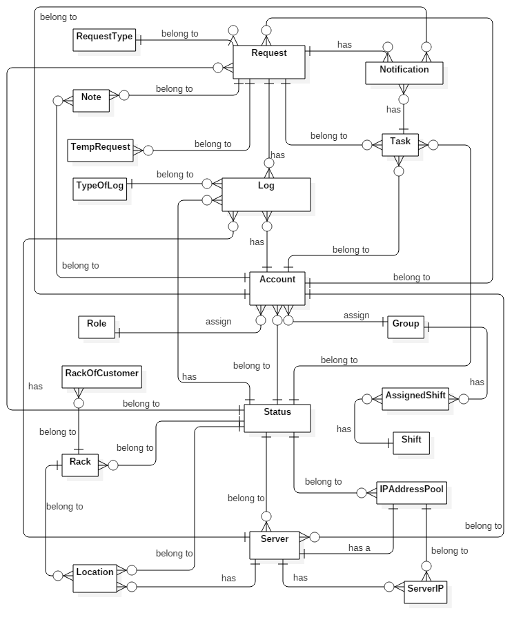

**Figure 34: Conceptual Diagram**

Data dictionary:

|  |  |
| --- | --- |
| **Entity dictionary** | |
| **Entity Name** | **Description** |
| Server | Describe the customer’s server in data center. |
| Status | Describe all of statuses of objects in data center. |
| Location | Describe all location in data center. |
| Rack | Describe all racks which are putting in data center. |
| Log | Describe all logs about object’s changes in data center. |
| Role | Describe all roles in the system. |
| ServerIP | Describe all of current IP Addresses of server. |
| Request | Describe content of each request which was sent by customer. |
| Account | Describe all user’s accounts in the system. |
| Note | Describe all note which was wrote by previous shift for the next shift. |
| TempRequest | Describe temporary detail of all requests. |
| IPAddressPool | Describe all IP Addresses which data center is keeping. |
| RequestType | Describe all types of request. |
| TypeOfLog | Describe all types of log. |
| Group | Describe all shift group of data center. |
| AssignedShift | Describe which group is in which shift each day. |
| Shift | Describe started time and ended time of each shift group. |
| RackOfCustomer | Describe all racks which was rent by customer. |
| Notification | Describe all contents of each notification. |
| Task | Describe all contents of each task. |

Table 37: Data dictionary