This page is intentionally left blank

**

**CAPSTONE PROJECT REGISTER**

Class: Duration time: from 04/01/2016 To ..….…./20…..

(\*) Profession: Ngo Dang Ha An Specialty: <IS> <JS>

X

(\*) Kinds of person make registers: Lecturer Students

X

1. Register information for supervisor (if have)

|  |  |  |  |  |
| --- | --- | --- | --- | --- |
|  | **Full name** | **Phone** | **E-Mail** | **Title** |
| Supervisor 1 | Ngô Đăng Hà An |  | anndh@fpt.edu.vn | Mr. |

2. Register information for students (if have)

|  |  |  |  |  |  |
| --- | --- | --- | --- | --- | --- |
|  | **Full name** | **Student code** | **Phone** | **E-mail** | **Role in Group** |
| Student 1 |  |  |  |  |  |
| Student 2 |  |  |  |  |  |
| Student 3 |  |  |  |  |  |

3. Register content of Capstone Project

(\*) 3.1. Capstone Project name:

English: Build an Information Management System for a datacenter

Vietnamese: Xây dựng hệ thống quản lý thông tin của một trung tâm dữ liệu

Abbreviation:IMS

(\*) 3.2. Main proposal content (including result and product)

1. Theory and practice (document):

Datacenters are physical or virtual infrastructure used by enterprises to house computer, server and networking systems and components for the company's information technology (IT) needs, which typically involve storing, processing and serving large amounts of mission-critical data to clients in client/server architecture.

**Information Management System** of a datacenter (**IMS**) supports staffs to perform tasks includes:

* Customer information management
* Server Information management
* Server placement management
* IP address allocation management
* Usage history of IP address reporting

1. Program: **IMS** has the following functions:
   1. Manage customer information:
      1. Add/Update/Active or Deactivate customer information
      2. Record time customer go into datacenter
   2. Manage server information:
      1. Add/Edit/Search/Delete configuration of a server
      2. Record history of a server: carry on/out server room
      3. Create report of server delivery
      4. Record time server which was upgraded configuration.
   3. Manage placement of server:
      1. Add/ Update/ Search/ Delete location of server on a rack
      2. Add network configuration of server
      3. Record time server is moved from a rack to a rack
      4. Create report of server moving.
   4. Manage IP address allocation:
      1. Add new IP address
      2. Update usage status of IP address
      3. Record IP address assigned to server. IP assignment can be done manually or automatically
      4. Search available/ unavailable IP addresses
   5. Report usage history of IP address.
      1. Report blocked IP address
      2. Report free IP address
      3. Statistic IP addresses being used by customers

**-Technology:**

Programming Language: C# ( or Java)

Database: SQL Server (mySQL)

1. Other products:

N/A

4. Other comment (propose all relative thing if have)

N/A

|  |  |
| --- | --- |
| **Supervisor (If have)**  *(Sign and full name)* | Ha noi, date …… ………. /20 …..  **On behalf of Registers**  *(Sign and full name)* |

Table of Contents

[Table of Contents 5](#_Toc448258671)

[List of Tables 7](#_Toc448258672)

[List of Figures 8](#_Toc448258673)

[Definitions, Acronyms, and Abbreviations 9](#_Toc448258674)

[A. Introduction 10](#_Toc448258675)

[1. Project Information 10](#_Toc448258676)

[2. Introduction 10](#_Toc448258677)

[3. Current Situation 10](#_Toc448258678)

[4. Problem Definition 10](#_Toc448258679)

[5. Proposed Solution 11](#_Toc448258680)

[5.1. Feature functions 11](#_Toc448258681)

[5.2. Advantages and disadvantages 12](#_Toc448258682)

[B. Software Project Management Plan 12](#_Toc448258683)

[1. Project organization 12](#_Toc448258684)

[1.1. Software Process Model 12](#_Toc448258685)

[C. Software Requirement Specification 13](#_Toc448258686)

[1. User Requirement Specification 13](#_Toc448258687)

[1.1. Shift Head requirement 13](#_Toc448258688)

[1.2. Staff requirement 13](#_Toc448258689)

[1.3. Shift Manager requirement 14](#_Toc448258690)

[1.4. Customer requirement 14](#_Toc448258691)

[2. System Requirement Specification 15](#_Toc448258692)

[2.1. System Overview Use Case 15](#_Toc448258693)

[3. Conceptual Diagram 16](#_Toc448258694)

[D. Software Design Description 18](#_Toc448258695)

[1. System Architecture Design 18](#_Toc448258696)

[2. Component Diagram 19](#_Toc448258697)

[3. Detailed Description 20](#_Toc448258698)

[3.1. Class Diagram 20](#_Toc448258699)

[3.2. Interactive Diagram 22](#_Toc448258700)

[4. Database Design 26](#_Toc448258701)

[6.1 Entity relationship diagram 26](#_Toc448258702)

[6.2. Physical Diagram 27](#_Toc448258703)

[5. Algorithms 28](#_Toc448258704)

[7.1 Generate AssignedShift 28](#_Toc448258705)

[7.2 Generate IP Address Range 29](#_Toc448258706)

[7.3 Find list of available Racks 31](#_Toc448258707)

[7.4 State machine diagram for Request Offline Status 34](#_Toc448258708)

[7.5 State machine diagram for Request Online Status 34](#_Toc448258709)

[7.6 State machine diagram for Task Status 35](#_Toc448258710)

[7.7 State machine diagram for Server Status 35](#_Toc448258711)

[E. Tasksheet 36](#_Toc448258712)

List of Tables

[Table 1: Definitions, Acronyms, and Abbreviations 9](#_Toc448258646)

[Table 2: Data dictionary 17](#_Toc448258647)

[Table 3: Component Dictionary 19](#_Toc448258648)

List of Figures

[Figure 1: Sashimi Waterfall Model 12](#_Toc448258653)

[Figure 2: System Overview Use Case 15](#_Toc448258654)

[Figure 3: Conceptual Diagram 16](#_Toc448258655)

[Figure 4: System architecture design 18](#_Toc448258656)

[Figure 5 : Component Diagram 19](#_Toc448258657)

[Figure 6 : Class Diagram 21](#_Toc448258658)

[Figure 7: Sequence Diagram <Customer> Add server 22](#_Toc448258659)

[Figure 8: Sequence Diagram<Shift Head> Complete request Add New Server 24](#_Toc448258660)

[Figure 9: Sequence Diagram <Shift Head> Add New IP 25](#_Toc448258661)

[Figure 10 : Entity relationship diagram 26](#_Toc448258662)

[Figure 11 : Physical diagram 27](#_Toc448258663)

[Figure 12: Flowchart of Generate IP Address Range 29](#_Toc448258664)

[Figure 13: Flowchart of Generate IP Address Range 31](#_Toc448258665)

[Figure 14: Flowchart of Find list of available Racks 33](#_Toc448258666)

[Figure 15: State Machine Diagram for Request Offline Status 34](#_Toc448258667)

[Figure 16: State Machine Diagram for Request Online Status 34](#_Toc448258668)

[Figure 17: State Machine Diagram for Staff Status 35](#_Toc448258669)

[Figure 18: State Machine Diagram for Server Status 35](#_Toc448258670)

Definitions, Acronyms, and Abbreviations

|  |  |
| --- | --- |
| Name | Definition |
| IMS | Information Management System |

Table 1: Definitions, Acronyms, and Abbreviations

# Introduction

## Project Information

* + Project name: **Build a Information Management System for a datacenter**
  + Project Code: **IMS**
  + Product Type: **Web Application**
  + Start Date: **4th January, 2016**
  + End Date: 27**th April, 2016**

## Introduction

In the “Information technology age”, the need of using servers as data storage, hosting website or even to archive useful softwares. Normally, people prefer rental server or entrusting their servers in datacenter. One of the reasons is because the cost to buy and maintain server is so expensive, and other related matters such as space, power, cooling, bandwidth, and physical security(copy data, computer burglary,..). In order to cut down amount of expenses, the individuals or companies often entrust their servers or rent servers at the prestigious datacenter.

Datacenter is the place that has good condition to run and maintain server. In current situation, some datacenters are still facing many difficulties. For instance, customer information, sever configuration or IP address mostly managed by Excel or Word. It causes a lot of time and efforts not only for staff in datacenter, but also the customer.

## Current Situation

Management of a huge system as datacenter is really a big deal. There are not only 24/24 server monitoring, but also manage and maintain other infrastructure such as network, temperature, cables and so on. Manually managing will take a lot of time and efforts, even more human errors. It will be annoying to customer if their server information is tracked incorrectly. They would be in trouble with lots of nonsensical procedure. Or when IP address of a server is changed, staff has to find the server’s location to change the IP tag on it. It must take time to find the location even in a small datacenter.

## Problem Definition

Below are disadvantages of current situation:

* Customer-related and server-related information can be lost.
* Must have a large storage to save information.
* Waste lots of time of datacenter’s staff and customers.
* Waste lots of efforts of datacenter’s staff and customers.
* Sometimes cause conflict between datacenter’s staff and customers.
* Cause dissatisfaction to the customers when they use datacenter’s service.
* Very difficult to manage information when too many servers are entrusted.
* Unprofessional process, losing trust with customers.
* Need many staff to manage.

## Proposed Solution

The solution of these problems is to build a website named “Information Management System for a datacenter”. This website can help the staff of datacenter to search and handle customer information, server information, server placement, and IP address allocation faster and easier. Information can be stored and accessed quickly and safely.

IMS has following functions:

### Feature functions

* **Create request**:
  + Customer can send request for their need instead of contacting by phone.
  + Request status will be tracked and notified by both email and the IMS system.
  + Customer can manage his current and old requests by the system.
  + Customer also can observe his servers and retal IP addresses, racks.
* **Customer information management**:
* Only shift manager can create and update customer’s information. If customer stops using datacenter’s service, shift manager will deactivate his account.
* **Server information management**:
* Customer can be able to view their server’s information and related information such as IP addresses or location just in one page.
* Staff and customer can easily find server and its current status.
* **Server location management**:
  + - * + Staff can add rack (where server is placed, a rack has 42 location) to the system.
        + Staff can change server location if necessary.
        + By searching for server, its current location will be showed to help staff find the physical server faster.
        + The system also remind staff whether server can be able to placed in a particular rack.
* **IP address management**:
* Staff can add new range of IP address into the system.
* They also can block or unblock IP address if necessary.
* Search available/unavailable IP address quickly.
* **Blocked IP address report**
* This system can help staff to create report of blocked IP address.
* **Task assignment**:
  + Shift head can assign task (process request) to another staff if he’s busy.
  + Staff will confirm his work afterwards.

### Advantages and disadvantages

* Advantages:
* Support staff managing information easier and faster, save time and reduce effort of staff.
* Customer can view information of their servers immediately by this system.
* Reduce conflicts, satisfy customer by meeting their need.
* Avoid mistakes by human as much as possible.
* Can create report to make a fast decision.
* Disadvantages:
* Initially, it takes time to input information into the system.
* The staff must spend time to learn how to use the system and practice to use expertly.
* A few problems can be happen and the system cannot cover all of the functions.

# Software Project Management Plan

## Project organization

### Software Process Model

Project is developed under Sashimi Waterfall Model.

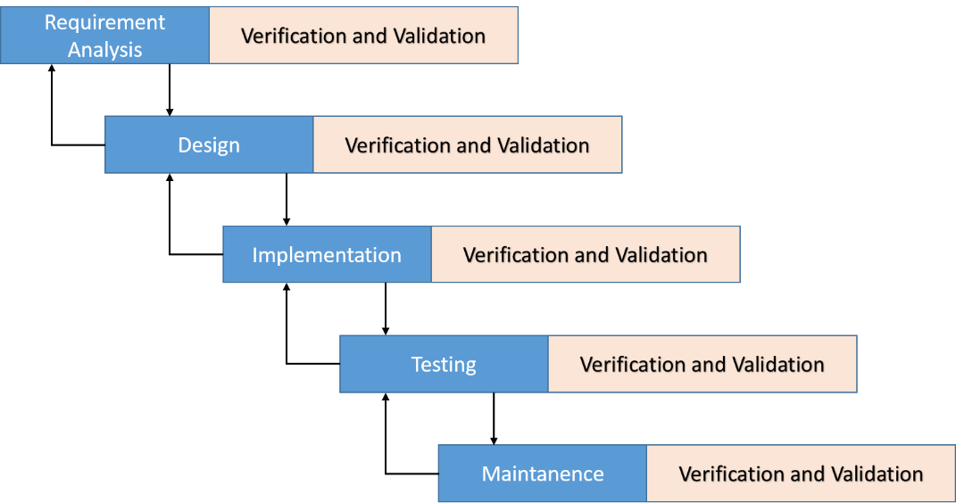

Figure 1: Sashimi Waterfall Model

For more information: <http://www.waterfall-model.com/sashimi-waterfall-model/>

The purpose of applying Sashimi Waterfall model for IMS-datacenter is because of:

* Requirements of the project may be made clearly and difficult to change.
* In current phrase, if the error which in previous phrase or the update occur, we can return and fix it.

# Software Requirement Specification

## User Requirement Specification

### Shift Head requirement

* A group has one shift head and two staff. Shift head has higher authority of using the system than staff. Shift head can use the following functions:
  + View request detail
  + Accept request
  + Process request
  + Reject request
  + View server detail
  + View IP Address
  + View list location
  + View report
  + View daily schedule
  + Add IP Address
  + Add rack
  + Change server’s location
  + Receive notification (customer’s request status, unfinished task)
  + Export procedure
  + Assign task
  + Reassign task
  + Write note about “Pending” and “Processing” requests
  + View profile
  + Change password

### Staff requirement

* Staff is a person who supports shift head to observe data centre’s information. Staff can only view data and be able to process a request if assigned. These are some functions staff can use:
  + View request detail
  + Process request (if assigned)
  + Reject request (if assigned)
  + View server detail
  + View IP Address
  + View list location
  + View report
  + View daily schedule
  + Add IP Address
  + Add rack
  + Change server’s location
  + Receive task
  + Export procedure (if assigned)
  + View profile
  + Change password

### Shift Manager requirement

* There’s only one manager who takes charge in managing this system. He is super user who can use more functions than shift head as below:
  + Create customer account
  + Update customer account
  + Create staff account
  + Update staff account
  + Deactivate account
  + Configure system

### Customer requirement

* Customer is a person who owns servers and want to keep it in a good condition. Customer interacts with the system when he wants to make a request or observe his server’s information. With customer role, the system will support some functions as below:
  + Create request “Add server”, “Bring Server Away”, “Assign IP Address”, “Change IP Address”, “Return IP Address”, “Rent Rack”, Return Rack”
  + Cancel request
  + View request history
  + View his server’s information
  + View his rented racks
  + View profile
  + Change password

## System Requirement Specification

### E:\new place\Document\SRS\IMS_Usecase_20160411.jpgSystem Overview Use Case

*Figure 2: System Overview Use Case*

## Conceptual Diagram

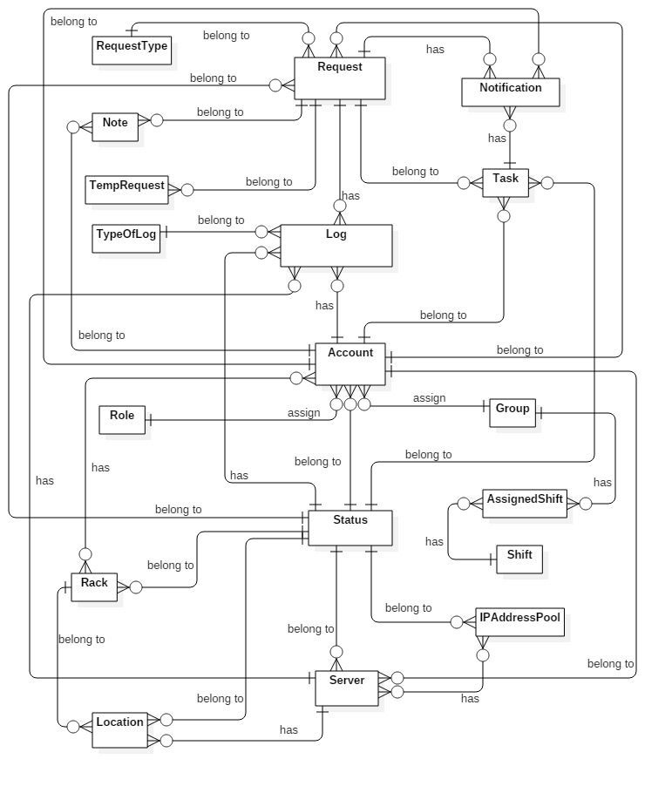

Figure 3: Conceptual Diagram

**Data Dictionary**

|  |  |
| --- | --- |
| Entity Data dictionary: describe all content of all entities | |
| Entity Name | **Description** |
| Server | Contain the server information in datacenter. |
| Status | Contain all of statuses of objects in datacenter. |
| Location | Contain all location information in datacenter. |
| Rack | Contain all racks information which are putting in datacenter. |
| Log | Contain all logs about object’s changes in datacenter. |
| Role | Contain all roles in the system. |
| Request | Contain all request content which was sent by customer. |
| Account | Contain all user information in the system. |
| Note | Contain all note which was wrote by previous shift for the next shift. |
| TempRequest | Contain temporary detail of all requests. |
| IPAddressPool | Contain all IP Addresses information which datacenter is keeping. |
| RequestType | Contain all types of request. |
| TypeOfLog | Contain all types of log. |
| Group | Contain all shift group of datacenter. |
| AssignedShift | Contain which group is in which shift each day. |
| Shift | Contain started time and ended time of each shift group. |
| Notification | Contain all notification information. |
| Task | Contain all contents of each task. |

Table 2: Data dictionary

# Software Design Description

## System Architecture Design

Figure 4: System architecture design

We use MVC architecture style to develop IMS web. Specifically, customized it as convenient and suitable as possible to meet the customer’s requirement.

Controller: Receive requests from clients and transfers to Business to handle request then use processed result from Business to render View and return view to clients.

View: handles for display data from Model. The creation of View is under control of Controller.

Model: is generated by mapping database table by Entity Framework 6, Model is used like a data transfer object between the system and database.

Business: Handles the business logic of the system.

## Component Diagram

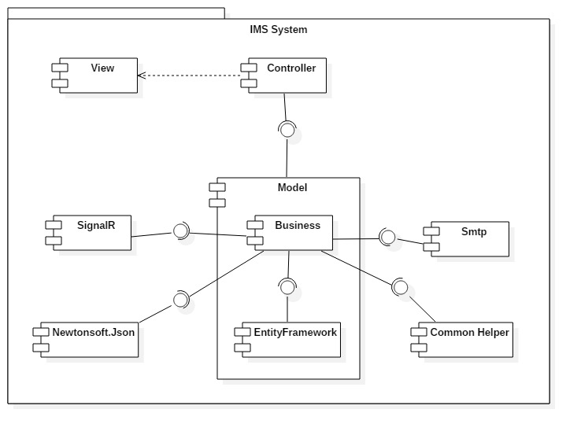

Figure 5 : Component Diagram

|  |  |
| --- | --- |
| Component Dictionary: Describes components | |
| Controller | Contain all controllers in the system. |
| View | Contain all views in the system. |
| Business | Contain all business logic processing in the system. |
| Model | Entity Framework 6 mapping models. |
| Smtp | Component is used to send asynchronous emails. |
| EntityFramework | Component is used to map database table, generate Model. |
| SignalR | Library which is used to add notification, a sort of "real-time" web functionality to ASP.NET application. |
| Newtonsoft.Json | A popular high-performance JSON framework for .NET. |
| Common Helper | Contain common libraries which are used to develop the system. |

Table 3: Component Dictionary

## Detailed Description

### Class Diagram

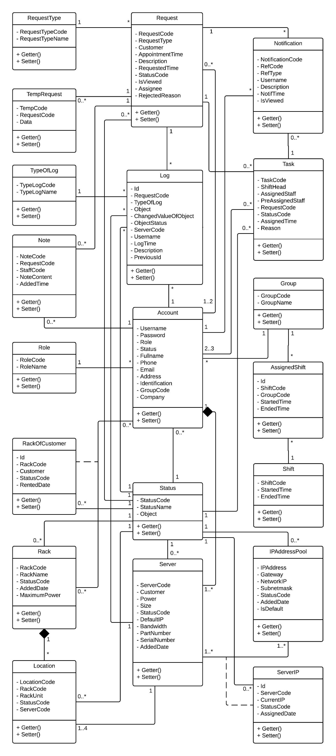

Figure 6 : Class Diagram

### 

### Interactive Diagram

#### <Customer> Add server

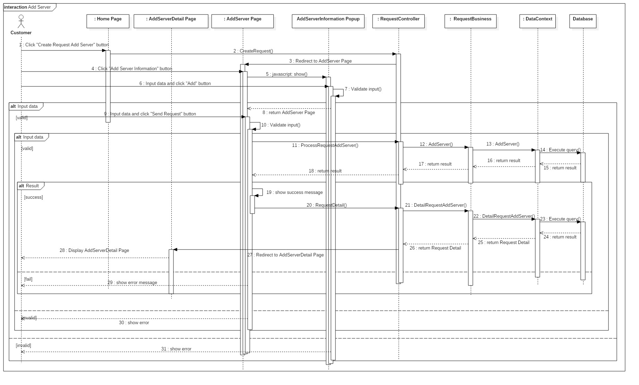**Summary:** This diagram shows how the customer add new server into datacenter.

*Figure 7: Sequence Diagram <Customer> Add server*

#### <Shift Head> Complete request Add Server

**Summary:** This diagram shows how Shift Head approve the request Add New Server

**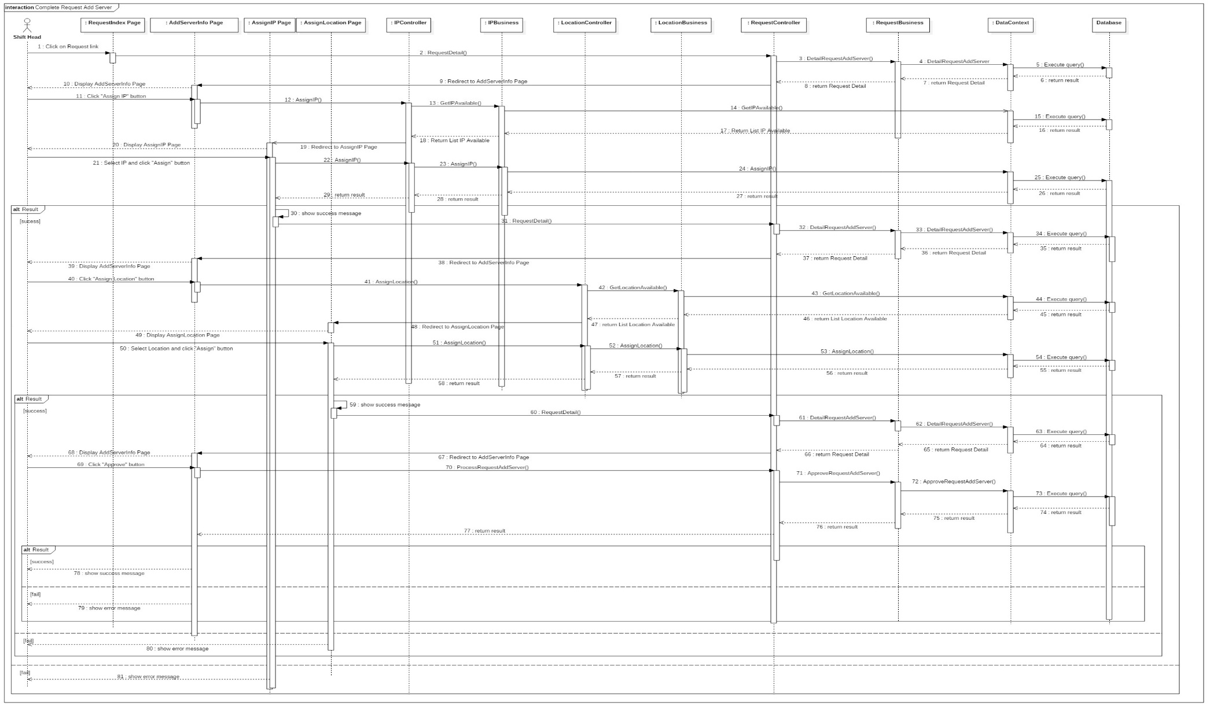**

*Figure 8: Sequence Diagram<Shift Head> Complete request Add New Server*

#### <Shift Head> Add New IP

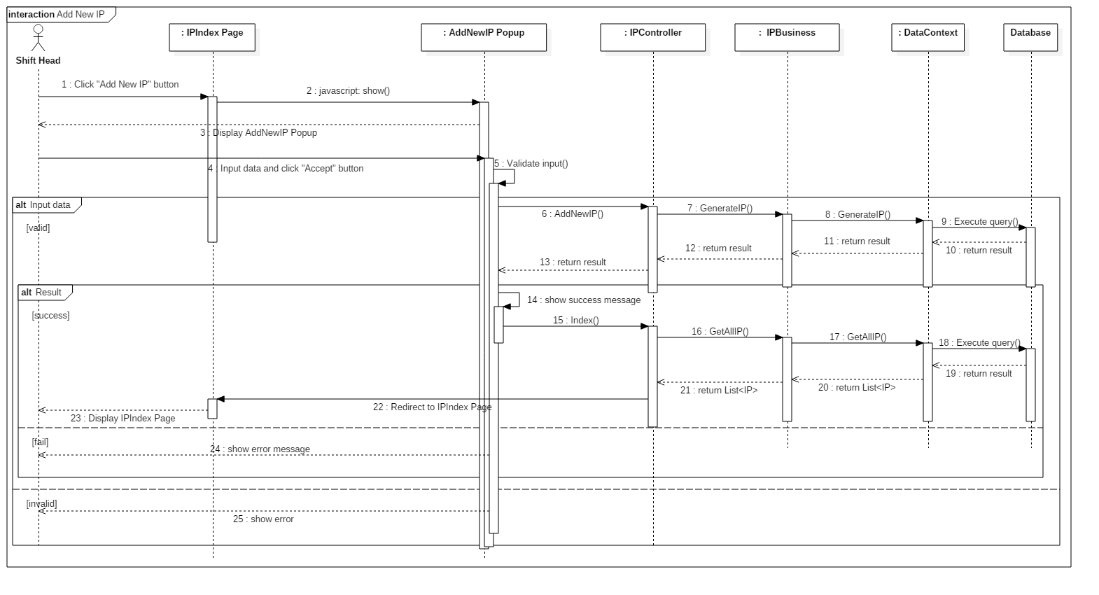 **Summary:** This diagram shows how Shift Head add new IP into datacenter

*Figure 9: Sequence Diagram <Shift Head> Add New IP*

## Database Design

### Entity relationship diagram

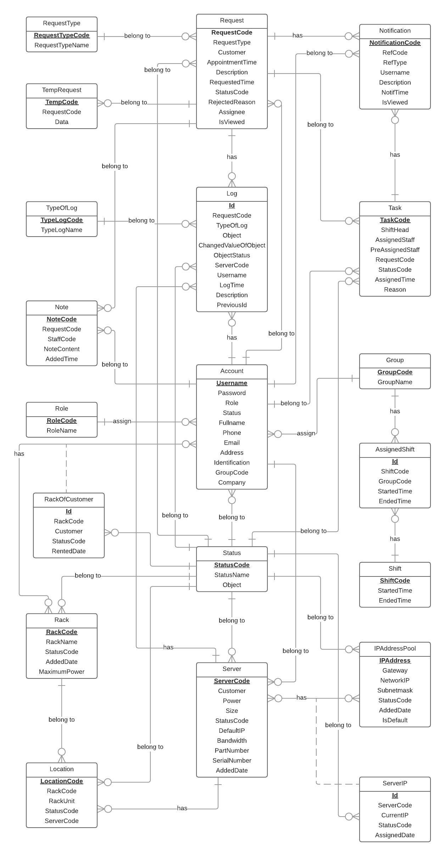

Figure 10 : Entity relationship diagram

### 6.2. Physical Diagram



Figure 11 : Physical diagram

## Algorithms

### Generate AssignedShift

#### Problem definition

* User need to know which group will work on which shift. Therefore, the system must save list Assigned Shift. Every 24 hours, the system will check once and generate AssignedShift if necessary.

#### Attribute definition

* AssignedShift: includes list of Assigned Shift Information; Shift: includes list of Shifts in 1 day; Group: includes list of Groups in datacenter
* Each Assigned Shift in list AssignedShift includes attributes: ShiftCode, GroupCode, StartTime, EndTime.

#### Solution

* Step 1: Every 24 hours, system will check once to generate.

Get LastDate = AssignedShift[LastIndex].StartTime.Date

* Step 2: If LastDate in table AssignedShift of database minus today < 3, system will generate for next 28 days from the day after LastDate 1 day.
* Step 3: Add list into AssignedShift of database.

#### Complexity

* The complexity of this algorithm is define the start date and the end date to generate list of AssignedShift

#### Flowchart

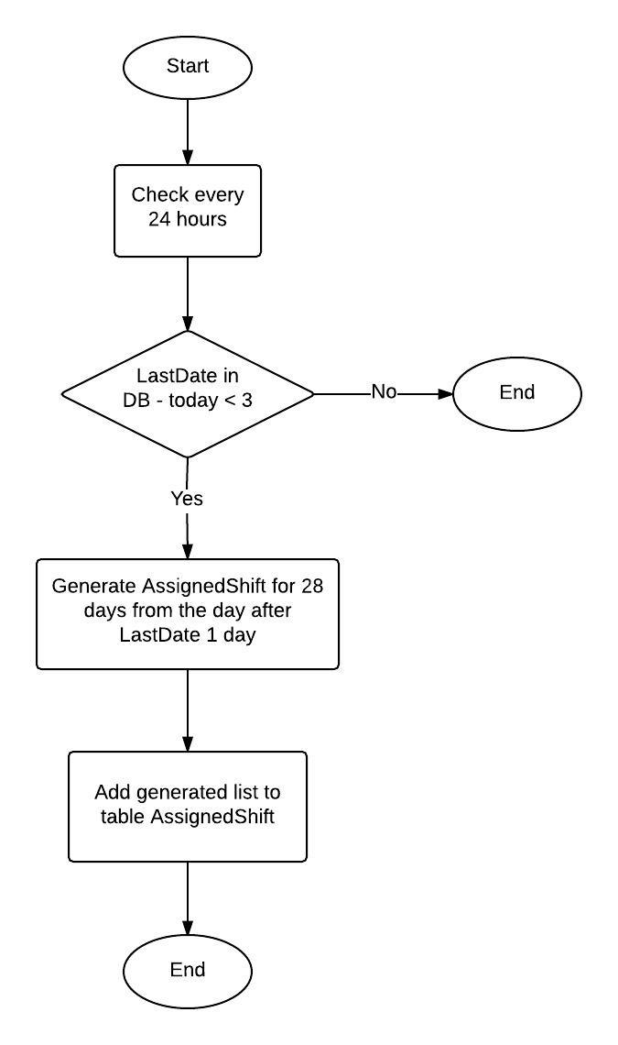

Figure 12: Flowchart of Generate IP Address Range

### Generate IP Address Range

#### Problem definition

* User request to add new IP Address Range. After user inputs information include: IP Address in a range, netmask of that range, the condition for gateway; the system will generate new IP Address Range automatically and add into IPAddressPool.

#### Attribute definition

* IPAddressPool: includes list of IP Addresses in datacenter
* Each IP Address of list IP Addresses include attributes: IPAddress, Gateway, NetworkIP, Subnetmask, Staff, RegisteredDate, StatusCode, IsDefault

#### Solution

* Step 1: By the Netmask, find out the Subnetmask of Range.
* Step 2: With inputted Netmask, find the number of ranges and base number of head IP Addresses.
* Step 3: Find all head IP Addresses of all ranges.

headIP[i] = base number \* i (0 ≤ i < number of ranges)

* Step 4: Base on inputted IP Address, find out the head IP Address of this range.
* Step 5: From the head IP Address of range, define all IP Addresses of this range.
* Step 6: From list of IP Addresses, define Gateway following condition and define NetworkIP.
* Step 7: Add list IP Addresses to IPAddressPool.

#### Complexity

* The complexity of this algorithm is define the range which user want to generate because for each netmask may have one or more range.

#### Flowchart

Figure 13: Flowchart of Generate IP Address Range

### Find list of available Racks

#### Problem definition

* When user want to assign location for new server or change location of server, the system will show list of available racks for user select location.

#### Attribute definition

* AvailableLocation: includes list locations of available racks.
* Each Location of list AvailableLocation include attributes: LocationCode, RackName, RackUnit, ServerCode.

#### Solution

* Step 1: Get list location of each rack
* Step 2: Calculate sum of the power which was used in rack
* Step 3: Find racks which have (rack power – sum used power) > server power
* Step 4: From list available racks about power, find the max size of blank space of each rack.
* Step 6: Find list racks which have max size > size of server
* Step 7: Get list locations of available racks.

#### Complexity

* The complexity of this algorithm is define racks which have size of blank space bigger than size of server.

#### Flowchart

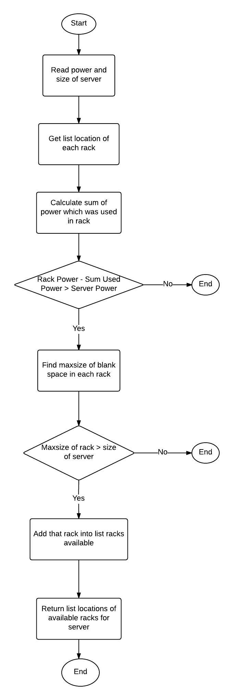

Figure 14: Flowchart of Find list of available Racks

### State machine diagram for Request Offline Status

Figure 15: State Machine Diagram for Request Offline Status

### State machine diagram for Request Online Status

*Figure 16: State Machine Diagram for Request Online Status*

### State machine diagram for Task Status

*Figure 17: State Machine Diagram for Staff Status*

### State machine diagram for Server Status

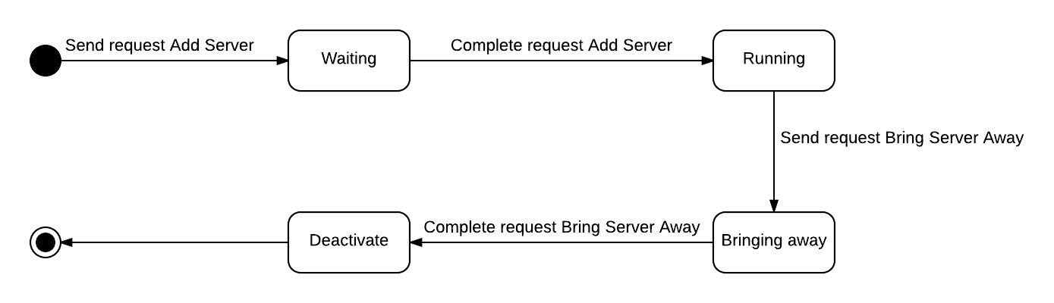

Figure 18: State Machine Diagram for Server Status

# Tasksheet

|  |  |  |  |  |  |  |
| --- | --- | --- | --- | --- | --- | --- |
| **No.** | **Product Deliverables** | **Task** | **Lê Thị Thu Hà** | **Huỳnh Lâm Hà Tiên** | **Unit** | **Size** |
| 1 | Report1 - Introduction | Project Information | **O** |  |  |  |
| Introduction | **O** |  |  |  |
| Curent Situation | **O** |  |  |  |
| Problem Definition |  | **O** |  |  |
| Proposed Solution |  | **O** |  |  |
| Function Requirements |  | **O** |  |  |
| Role and Responsibility | **O** |  |  |  |
| Review and Merger document | **O** |  |  |  |
| 2 | Report2- Software Project Management Plan | Problem Definition | **O** |  |  |  |
| Project organization | **O** |  |  |  |
| Project management plan |  | **O** |  |  |
| Coding Convention |  | **O** |  |  |
| Review and Merger document | **O** |  |  |  |
| 3 | Report 3- Software Requirement Specification | **User Requirement Specification** |  |  |  |  |
| Customer requirement | **O** |  |  |  |
| Shift head requirement | **O** |  |  |  |
| Shift manager requirement | **O** |  |  |  |
| Staff requirement | **O** |  |  |  |
| **System Requirement Specification** |  |  |  |  |
| External Interface Requirements |  | **O** |  |  |
| **Funtional Requirement** |  |  |  |  |
| System Overview Usecase | **O** |  |  |  |
| List Of Use Case |  |  |  |  |
| Create requests | **O** |  |  |  |
| Accept requests | **O** |  |  |  |
| Process requests | **O** |  |  |  |
| Cancel requests | **O** |  |  |  |
| Reject requests | **O** |  |  |  |
| Assign task | **O** |  |  |  |
| Reassign task | **O** |  |  |  |
| Confirm task status | **O** |  |  |  |
| Receive notification | **O** |  |  |  |
| Add IP address |  | **O** |  |  |
| Block/Unblock IP address |  | **O** |  |  |
| View report block IP address |  | **O** |  |  |
| Add rack |  | **O** |  |  |
| View daily schedule |  | **O** |  |  |
| Write note |  | **O** |  |  |
| Change server location |  | **O** |  |  |
| Change password |  | **O** |  |  |
| Manage account (CRUD) |  | **O** |  |  |
| **Non-fuctional Requirement** |  | **O** |  |  |
| Usability |  |  |  |  |
| Reliability |  |  |  |  |
| ... |  |  |  |  |
| Conceptual diagram |  | **O** |  |  |
| Review and Merger document | **O** |  |  |  |
|  |  | System Architectural Design |  | **O** |  |  |
| Component Diagram |  | **O** |  |  |
| **Detail Desciptions** |  |  |  |  |
| **Class diagram** | **O** |  |  |  |
| Class diagram explanation | **O** |  |  |  |
| **Sequence Diagram** |  |  |  |  |
| <Customer> Create request "Add Server" | **O** |  |  |  |
| <Customer> Cancel request "Add Server" | **O** |  |  |  |
| <Customer> Create request "Return IP Address" | **O** |  |  |  |
| <Customer> Create request "Rent Rack" | **O** |  |  |  |
| <Shift head> Complete request "Assign IP Address" | **O** |  |  |  |
| <Shift head> Complete request "Add server" | **O** |  |  |  |
| <Shift head> Complete request "Change IP Address" | **O** |  |  |  |
| <Shift head> Complete request "Rent Rack" | **O** |  |  |  |
| <Shift head> Reject request "Assign IP Address" | **O** |  |  |  |
| <Shift head> Reject request "Add server" | **O** |  |  |  |
| <Shift head> Reassign task | **O** |  |  |  |
| <Shift head> Write note |  | **O** |  |  |
| <Shift head> Add new IP address |  | **O** |  |  |
| <Shift head> Add new rack |  | **O** |  |  |
| <Shift head> Approve change IP request |  | **O** |  |  |
| <Shift head> Export procedure |  | **O** |  |  |
| <Shift head> Block IP address |  | **O** |  |  |
| <Shift head> Deactivate IP range |  | **O** |  |  |
| <Shift manager> Adds new staff |  | **O** |  |  |
| <Shift manager> Deactivate account |  | **O** |  |  |
| <Shift manager> Edit staff profile |  | **O** |  |  |
| **User interface** |  |  |  |  |
| **Logical Database design** |  |  |  |  |
| Logical Diagram |  | **O** |  |  |
| Data Dictionary |  | **O** |  |  |
| **Algorithms** |  |  |  |  |
| Generate assigned shift |  | **O** |  |  |
| Generate IP address range |  | **O** |  |  |
| Find list of available racks |  | **O** |  |  |
| State machine diagram for offline request status | **O** |  |  |  |
| State machine diagram for online request status | **O** |  |  |  |
| State machine diagram for offline task status |  | **O** |  |  |
| State machine diagram for offline server status |  | **O** |  |  |
| Review and Merger document | **O** |  |  |  |
| 5 | Report 5 - Software Implementation and Test Document | **Physical Database** |  |  |  |  |
| Diagram | **O** |  |  |  |
| Data Dictionary |  | **O** |  |  |
| **Setup Environment** | **O** |  | 1 | 4 |
| **Shift Head Module** |  |  |  |  |
| Accept requests | **O** |  | 1 | 1 |
| Assign task | **O** |  | 1 | 2 |
| Reassign task | **O** |  | 1 | 2 |
| Add note |  | **O** | 1 | 1 |
| **Staff Module** |  |  |  |  |
| Accept task | **O** |  | 1 | 1 |
| Confirm task | **O** |  | 1 | 1 |
| View list task | **O** |  | 1 | 2 |
| **Shift Head/Staff/ Manager Module** |  |  |  |  |
| View list notification | **O** |  | 1 | 1 |
| View list requests | **O** |  | 1 | 2 |
| View requests's detail | **O** |  | 7 | 3 |
| Complete requests | **O** |  | 7 | 3 |
| Reject requests | **O** |  | 7 | 2 |
| View list servers | **O** |  | 1 | 2 |
| View server detail | **O** |  | 1 | 3 |
| View schedule |  | **O** | 1 | 3 |
| View list location |  | **O** | 1 | 2 |
| Add rack |  | **O** | 1 | 1 |
| Change server location |  | **O** | 1 | 3 |
| View list IP Address |  | **O** | 1 | 2 |
| Add IP address range |  | **O** | 1 | 4 |
| Deactivate IP address range |  | **O** | 1 | 1 |
| Block/Unblock IP address |  | **O** | 2 | 1 |
| View report block IP address |  | **O** | 1 | 2 |
| **Shift Manager Module** |  |  |  |  |
| Create, Update, Deactivate account |  | **O** | 2 | 3 |
| View all accounts |  | **O** | 1 | 2 |
| **Customer Module** |  |  |  |  |
| Create requests | **O** |  | 7 | 3 |
| Cancel requests | **O** |  | 7 | 2 |
| View request details | **O** |  | 7 | 2 |
| View request hisory | **O** |  | 1 | 2 |
| View customer's servers | **O** |  | 1 | 2 |
| View customer's racks |  | **O** | 1 | 2 |
| **Authenticated Module** |  |  |  |  |
| Login |  | **O** | 1 | 1 |
| Logout |  | **O** | 1 | 1 |
| Change password |  | **O** | 1 | 1 |
| Reset password |  | **O** | 1 | 1 |
| View account's profile |  | **O** | 1 | 2 |
| **System Module** |  |  |  |  |
| Send email | **O** |  | 3 | 2 |
| Generate shift |  | **O** | 1 | 4 |
| **Notification Module** | **O** |  |  | 3 |
| **Basic layout** |  | **O** |  | 2 |
| **Write Test case** |  | **O** |  |  |
| **Perform Testing** | **O** | **O** |  |  |
| 6 | Report 6 - Software User's Manual | Installation Guide Japanese version | **O** |  |  |  |
| User’s Guide Japanese version | **O** |  |  |  |