

**MINISTRY OF EDUCATION AND TRAINING**

**FPT UNIVERSITY**

Capstone Project Document

**Bakery Management Application that manages the business of a bakery, only product for schools**

|  |  |
| --- | --- |
| **Group 1** | |
| **Group members** | Huỳnh Hữu Trường Giang – SE60894  Ông Tấn Mạnh – SE61045  Nguyễn Quốc Vương – SE60907  Lê Anh Khoa – SE60864 – Dropped out |
| **Supervisor** | Ngô Đăng Hà An |
| **Ext. Supervisor** | N/A |
| **Capstone Project Code** | BMA |

- Ho Chi Minh City, 05 December 2015 -

**

**CAPSTONE PROJECT REGISTER**

Class: Duration time: from ..…….../20…. To ..….…./20…..

(*) Profession: Ngo Dang Ha An Specialty: <ES> <IS>

X

(*) Kinds of person make registers: Lecturer Students

X

1. Register information for supervisor (if have)

|  |  |  |  |  |
| --- | --- | --- | --- | --- |
|  | **Full name** | **Phone** | **E-Mail** | **Title** |
| Supervisor 1 | Ngô Đăng Hà An |  | anndh@fpt.edu.vn | Mr. |

2. Register information for students (if have)

|  |  |  |  |  |  |
| --- | --- | --- | --- | --- | --- |
|  | **Full name** | **Student code** | **Phone** | **E-mail** | **Role in Group** |
| Student 1 |  |  |  |  |  |
| Student 2 |  |  |  |  |  |
| Student 3 |  |  |  |  |  |
| Student 4 |  |  |  |  |  |

3. Register content of Capstone Project

(*) 3.1. Capstone Project name:

English: Build a Bakery Management Application that manages the business of a bakery, only product for schools

Vietnamese: Xây dựng ứng dụng quản lý cửa hàng cung cấp bánh ngọt cung cho các trường học

Abbreviation: BMA

(*) 3.2. Main proposal content (including result and product)

1. Theory and practice (document):

Bakery Management Application (BMA) is an application that supports users manages the business of a bakery, only product for schools. All the management includes:

• Manage information of customers.

• Manage information of products.

• Manage number of input materials.

• Manage number of orders.

• Manage taxes.

**Information of customer includes:**

- Customer Name, address, phone, customer tax code

**Information of product includes:**

- Product name, volume, unit, notes

- Product price: it depends on the customer. Each customer has different product price.

**Material input includes:**

- Names of ingredients, quantity, unit, dates and notes.

**Taxes payment includes:**

- VAT 10% income tax on the total income each month. Income (interest) by total revenue minus orders in the totalmaterial input price. Pay once per month.

- Excise tax: 5% of total revenue each year. Pay once per year.

**Orders include:**

- Orders code, the order name, order date, delivery date, amount, notes

- Products ordered: an order can have many products, each product in the line will include: product name, quantity, unit price and unit.

Students are required to develop a BMS application.

1. Program: The system has the following functions:

- Add, delete, edits information of customers, products, inputs, orders.

- Work out the amount of tax payable in the month, the year.

- Review the company's income in the weekly, quarterly, monthly and year.

- Review the company's income by type of goods.

- Review the company's revenue per customer.

**-Technology:**

Programming Language: C# (Java, or PHP, ….)

Database: SQL Server (mySQL, ….)

1. Other products:

N/A

4. Other comment (propose all relative thing if have)

N/A

|  |  |
| --- | --- |
| **Supervisor (If have)**  *(Sign and full name)* | HCM, date …… ………. /20 …..  **On behalf of Registers**  *(Sign and full name)* |

Table of Contents

Table of Contents 5

List of Tables 7

List of Figures 8

A. Introduction 9

1. Project Information 9

2. Introduction 9

3. Current Situation 9

4. Problem Definition 9

5. Proposed Solution 10

5.1. Feature functions 10

B. Software Project Management Plan 11

1. Project organization 11

1.1. Software Process Model 11

C. Software Requirement Specification 11

1. User Requirement Specification 11

1.1. Guest requirement 11

1.2. Customer requirement 11

1.3. Staff requirement 12

1.4. Manager requirement 13

2. System Requirement Specification 13

2.1. System Overview Use Case 13

3. Conceptual Diagram 15

4. Algorithms 16

7.1 Order State 16

D. Software Design Description 17

1. System Architecture Design 17

2. Component Diagram 18

3. Detailed Description 19

3.1. Class Diagram 19

3.2. Interactive Diagram 21

4. Database Design 24

4.1. Entity relationship diagram 24

4.2. Physical Diagram 26

E. Attachments 27

1. Task sheet 27

List of Tables

Table 1: Contract State Dictionary 17

Table 2: Component Dictionary 19

Table 3 : Entity dictionary 24

List of Figures

Figure 1: Modified Waterfall Development Model 11

Figure 2: System Overview Use Case 14

Figure 3: Conceptual Diagram 15

Figure 4: Order State Chart 16

Figure 5: System architecture design 17

Figure 6 : Component Diagram 18

Figure 7 : Sequence diagram - <Guest> Make order 21

Figure 8 : Sequence diagram - <Staff> Edit order 22

Figure 9 : Sequence diagram - <System> Get notification 23

Figure 10 : Entity relationship diagram 25

Figure 11: ウェブサイトアプリケーション物理的なダイアグラム 26

# Introduction

## Project Information

* Project name: **Bakery Management Application**
* Project Code: **BMA**
* Product Type: **Website Application**
* Start Date: **September 7th, 2015**
* End Date: **December 17th,2015**

## Introduction

In this document, we introduce a system to help the bakery which delivery products for schools with high quantity. Due to the inconvenience of the current process like high dependency on phone contact, communication skills..., we develop a website application for the ease of use for both sides.

Bakery Management Application (or BMA for short) can help schools (or customers) track their orders better instead of relying on phone contact. Customers can also browse their desired products easier using the proposing system. The bakery owner can also use our system to increase their management process.

This document also describes our working process in 14 weeks that includes our designs, workflows as well as a how-to-use guide for our system.

## Current Situation

In order to keep a fresh stock of breads and bakery products every day, schools have to go to the bakery and order manually or by phone. They have to constantly check for their order status by contacting the bakery staff. Once the order is ready for delivery, the staff also has to call customers to confirm delivery date and time. The owner spends time to manage the business include materials, bills, orders... and create tax declaration. Besides it is difficult to see the overview of the store.

## Problem Definition

Below are disadvantages of current situation:

* **Difficult when a school want to order:** Customer must go to the store directly to order or order by phone.
* **Hard for change/cancel (a) product(s) in ordered order(s):** Customer must go to the bakery directly or make a call to change or cancel so that it takes a lot of time.
* **Manual management of income:** The bakery owner usually manages revenue, expenses and income by writing in paper or using business softwares (such as Microsoft Excel). These are unprofessional, time-comsuming, difficult to check and find out when there is a mistake.
* **Manual making the tax declaration:** When the bakery owner wants to make the VAT tax declaration, he/she have to collect the bills and making the declaration manual. So, it takes too much time and sometimes can make a mistake.

## Proposed Solution

Our proposed solution is to build a Bakery Management Web Application named “BMA system” to support bakery manager manage the business of a bakery which delivery products for schools with high quantity.

### Feature functions

* + **Manage information of customers**: Staff can make the new account for corresponding with new customer. Manager manages the customer’s accounts.
  + **Manage information of staffs**: Manager can make the new account for satff and manages the staff’s accounts.
  + **Manage information of products**: Staff can manage the products of the bakery include the material for each product.
  + **Manage number of input materials**: Staff can manage the input materials of the bakery.
  + **Manage number of orders**: Users can make the new order online by account provided by the bakery or the staff will add the new order. The customer can view the status of the orders. The staff can manage the orders of the bakey.
  + **Statistic functions**: The system will provide the review the income weekly, monthly, yearly; the income by type of products and the revenue per customer.
  + **Create tax declaration**: The system will support make the VAT Tax and Excise Tax declaration and export XML file which can use in HTKK 3.3.4 of Ministry of Finance.

# Software Project Management Plan

## Project organization

### Software Process Model

Requirement

Design and Architecture

Development and Coding

QA and Testing

Maintenance

Figure 1: Modified Waterfall Development Model

For more information about modified waterfall development model: <http://www.waterfall-model.com/sashimi-waterfall-model/>

# Software Requirement Specification

## User Requirement Specification

### Guest requirement

Guest is a person who does not have access the system. Guest can use some functions in the system. To use all functions, guest must login. These are some functions guest can use:

* Login
* Search product
* View product detail
* Make order

### Customer requirement

Customer is guest who can login to the system by his/her account and uses service of system. The customer can use some following functions:

* Logout
* Search product
* View product detail
* View personal information
* Change password
* Make order
* Edit order (before staff approve)
* View order detail
* Cancel order (before staff approve)
* Edit personal information
* Confirm order
* Get notification when:
  + Staff changes order status
  + Staff edit customer’s order status

### Staff requirement

Staff is the person who works directly with system to manage customer, product, order and bill. Staff can use some following functions:

* Logout
* Search product
* View product detail
* View personal information
* Change password
* Edit personal information
* Manage Order includes
  + Add order
  + Edit order
  + View order detail
  + Approve order
  + Change order state
* Get notification when:
  + There is a new order
  + The product quantity is under standard quantity
* Manage product includes:
  + Add new product
  + Add material to product
  + Edit product
* Manage material includes:
  + Add material
  + Edit material
  + Change material status
* Manage bill includes:
  + Add input bill
  + Edit input bill
  + Export bill
* Manage input material includes:
  + Add input material
  + Edit input material
  + Change input material status

### Manager requirement

Manager is the person who manages the system and reviews the business statistic. Manager can use some following functions:

* Logout
* Search product
* View product detail
* View personal information
* Change password
* Change product status
* Create VAT tax declaration
* Create Excise tax declaration
* Update VAT tax rate
* Update Excise tax rate
* Review income by time
* Review income by product
* Review revenue by customer
* Edit store information
* Manage staff includes:
  + Create staff account
  + Change staff account status
* Manage customer includes:
  + Change customer account status
  + Change customer account to loyal
* Manage supplier includes:
  + Add supplier
  + Edit supplier
  + Change supplier status

## System Requirement Specification

### System Overview Use Case

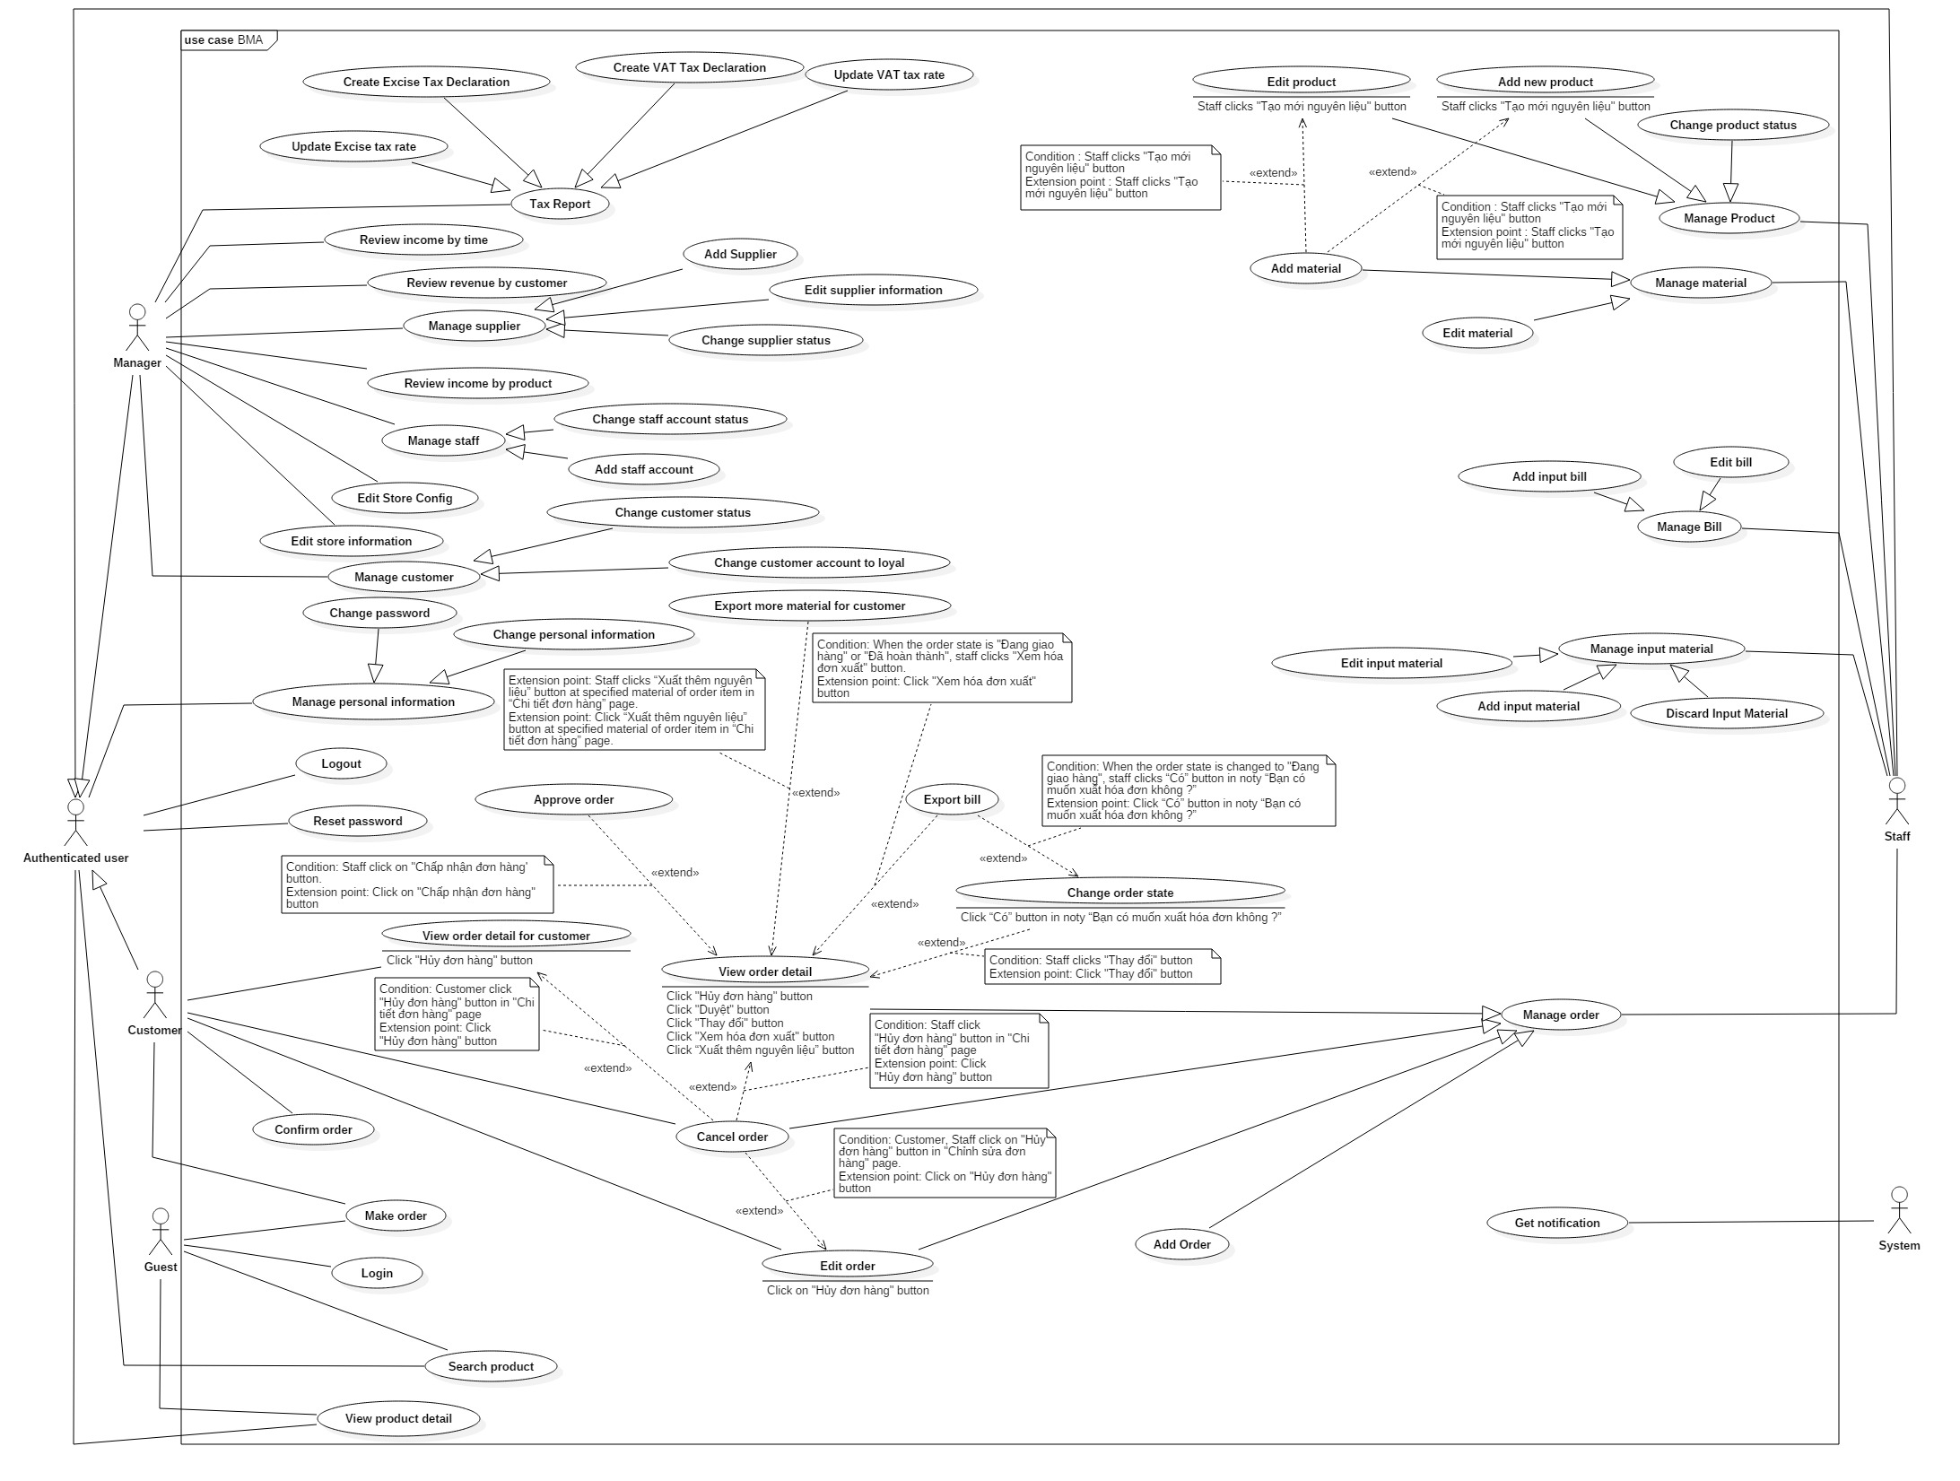

Figure 2: System Overview Use Case

## Conceptual Diagram

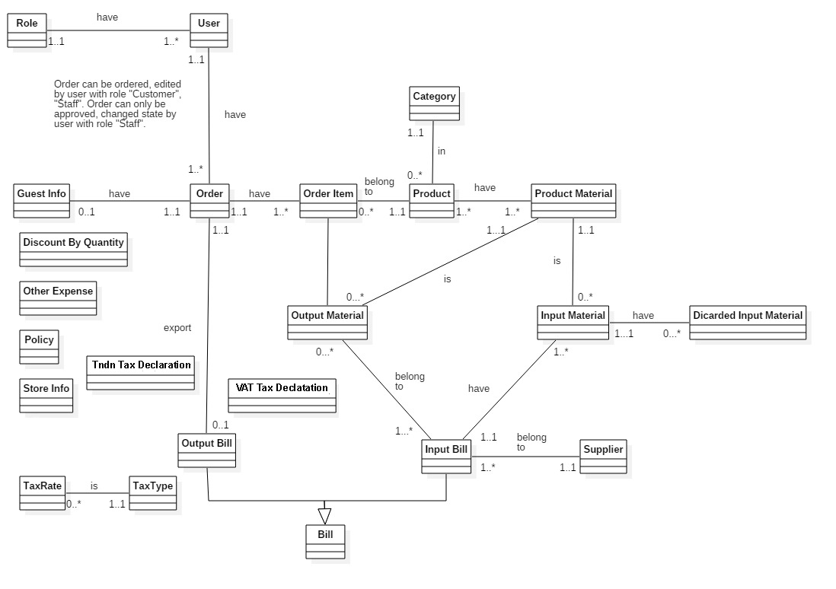

Figure 3: Conceptual Diagram

**Data Dictionary**

|  |  |
| --- | --- |
| Entity Data dictionary: describe all content of all entities | |
| Entity Name | **Description** |
| User | Abstract entity describes a user in system |
| Role | Describe role user in system |
| Order | Contain the order information. |
| Guest info | Contain guest information who have ordered the first time |
| Output bill | Contain output bill information |
| Input bill | Contain input bill information |
| Bill | Abstract entity describes a bill in system |
| Supplier | Contain supplier information. |
| Input material | Contain input material information |
| Output material | Contain total materials spend for order |
| Discard input material | Contain discard input material information |
| Order item | Contain order item information |
| Tax rate | Contain tax rate information |
| Tax type | Contain tax type information |
| Product | Contain product information |
| Category | Describe category of product |
| Product material | Contain product material information |
| Discount by quantity | Contain discount by quantity |
| Other expense | Contain other expense of store |
| Policy | Contain all of store configurations |
| Store info | Contain all of store information |
| VAT Tax declaration | Contain all of VAT tax declaration |
| Tndn Tax declaration | Contain all of Excise tax declaration |

## Algorithms

### Order State

The orders in BMA system is complex and can be managed differently during the operation. The state chart below describes all the state of a order.

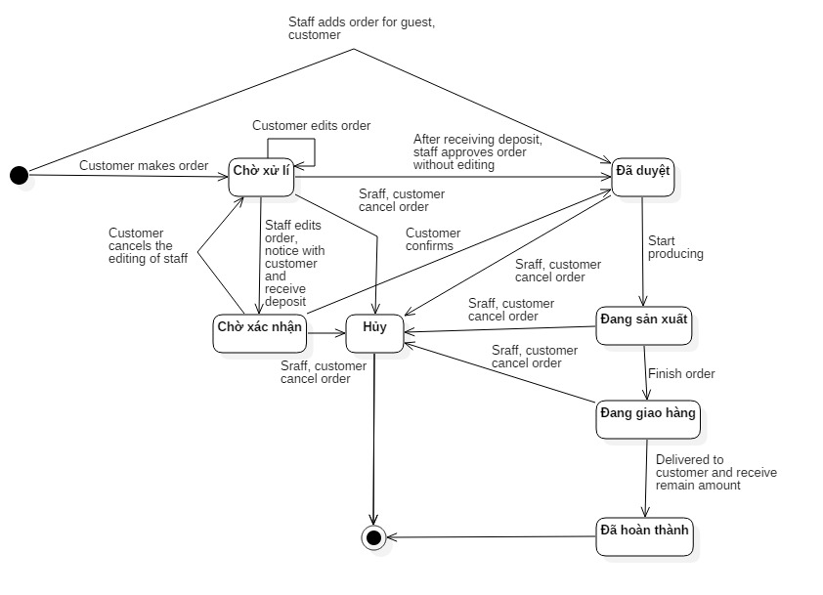

Figure 4: Order State Chart

|  |  |
| --- | --- |
| SStimulusion﷽﷽﷽﷽﷽> ERDquence numberecution bar em and database.tate | Description |
| Chờ xử lý | Order is made by customer and waiting for approve from the system. |
| Chờ xác nhận | Order is editted by staff and waiting for confirm from the customer. |
| Đã duyệt | Order is approved by staff or confirmed by customer. |
| Đang sản xuất | Order is producing. |
| Đang giao hàng | Order is delivering. |
| Đã hoàn thành | Order is finished after receiving money. |
| Hủy | Order is cancelled. |

Table 1: Contract State Dictionary

# Software Design Description

## System Architecture Design

|  |
| --- |
| HTTP Request (1)    Database  Web browser  Object Relational Mapping  (ORM)  (5)  **Annotation**  Call / Send  Dependency  Query / Update  HTTP Response (6)  (4)  (3)  View Model  Entity Framework 6.0  ADO.NET Data Provider  Select (2)  URL Routing  View  Business  Model  Controller |

Figure 5: System architecture design

## Component Diagram

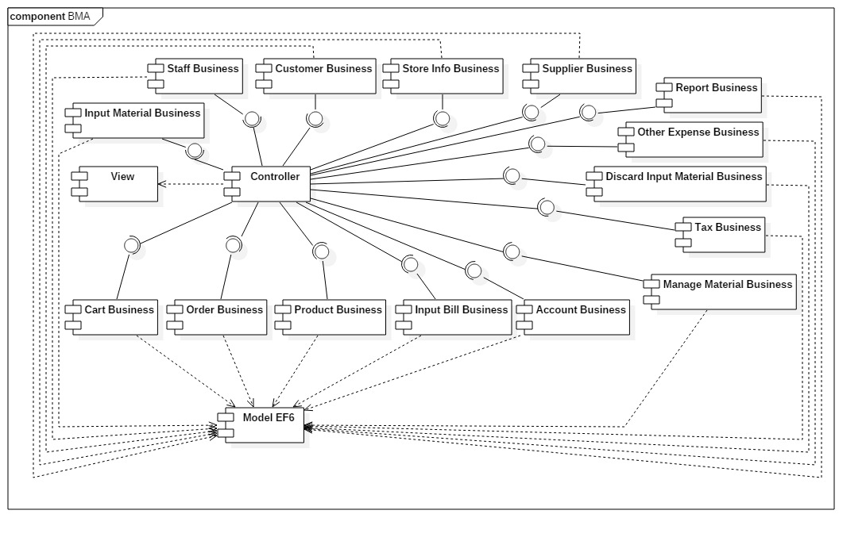

Figure 6 : Component Diagram

|  |  |
| --- | --- |
| Component Dictionary: Describes components | |
| View | Content all views of the system |
| Controller | Content all controllers of the system |
| Model EF6 | Entity Framework 6.0 mapping models |
| Cart Business | Business logic making the order for guest and customer |
| Order Business | Business logic processing the manage the order. |
| Product Business | Business logic processing of products |
| Input Bill Business | Business logic processing of input bill |
| Manage Material Business | Business logic processing of product material |
| Tax Business | Business logic processing of tax |
| Input Material Business | Business logic processing of input material |
| DiscardInputMaterialBusiness | Business logic processing of discarding input material |
| Other Expense Business | Business logic processing of other expense business |
| ReportBusiness | Business logic processing of statistic |
| Staff Business | Business logic processing of staff |
| Customer Business | Business logic processing of customer |
| Store Info Business | Business logic processing of store info |
| Supplier Business | Business logic processing of supplier |

Table 2: Component Dictionary

## Detailed Description

### Class Diagram

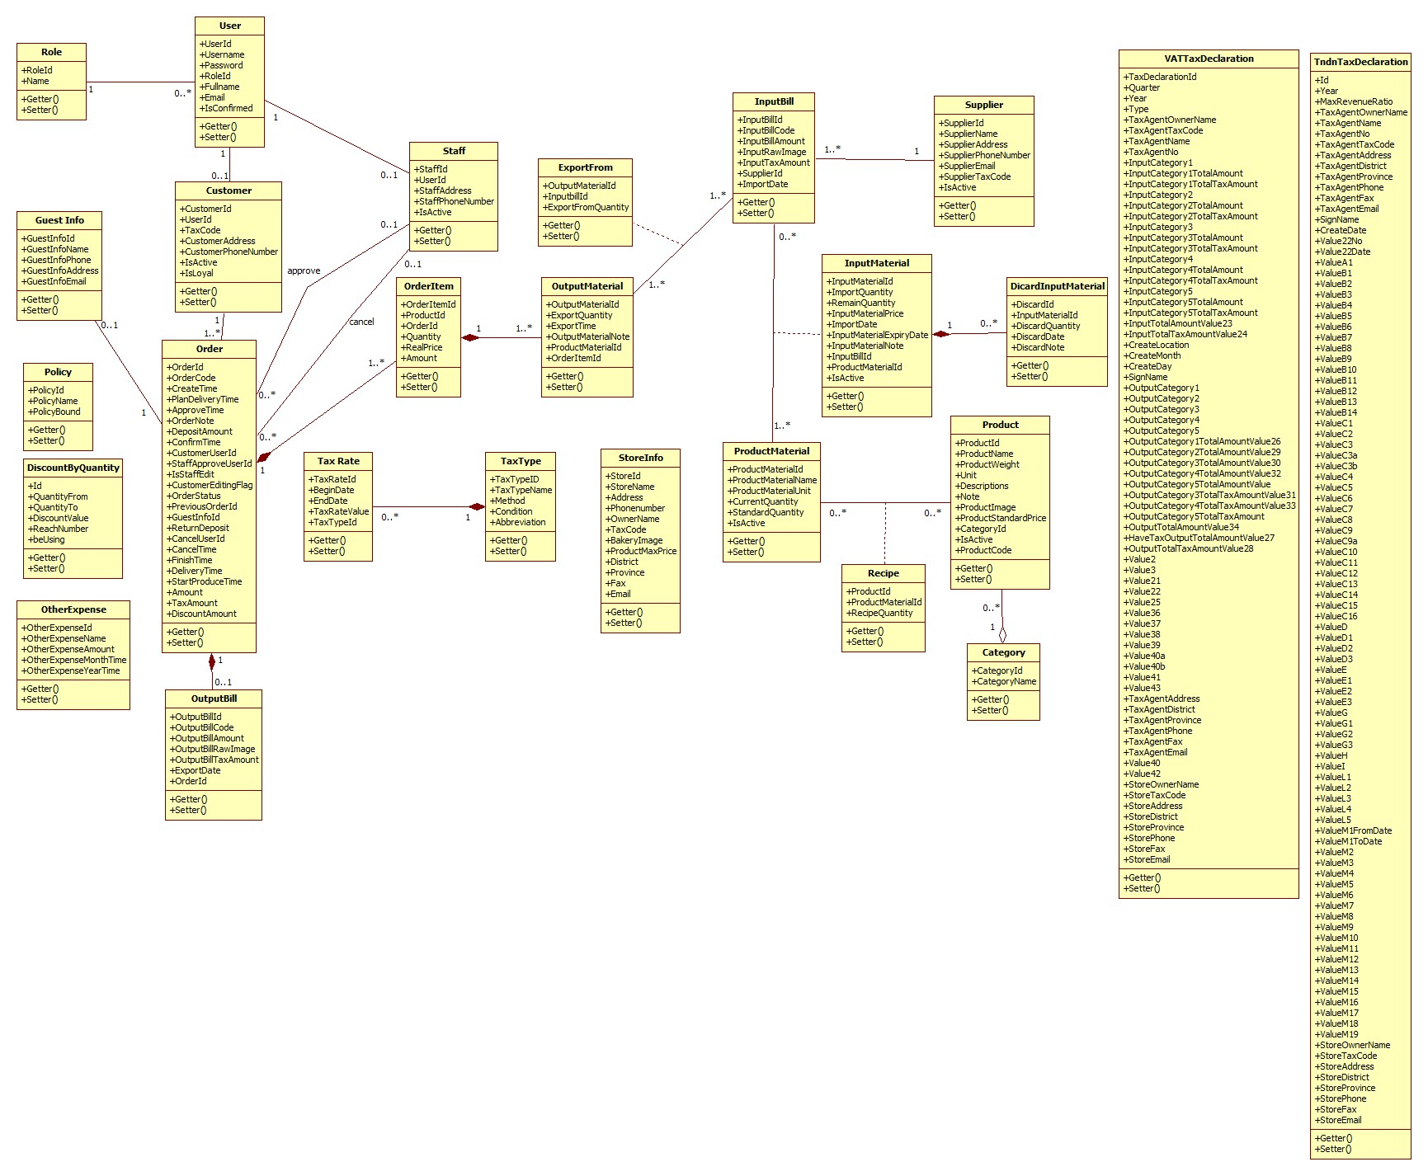

Figure 1 Class Diagram

### Interactive Diagram

##### Make order

**Summary**: This diagram shows the process of guest making new order

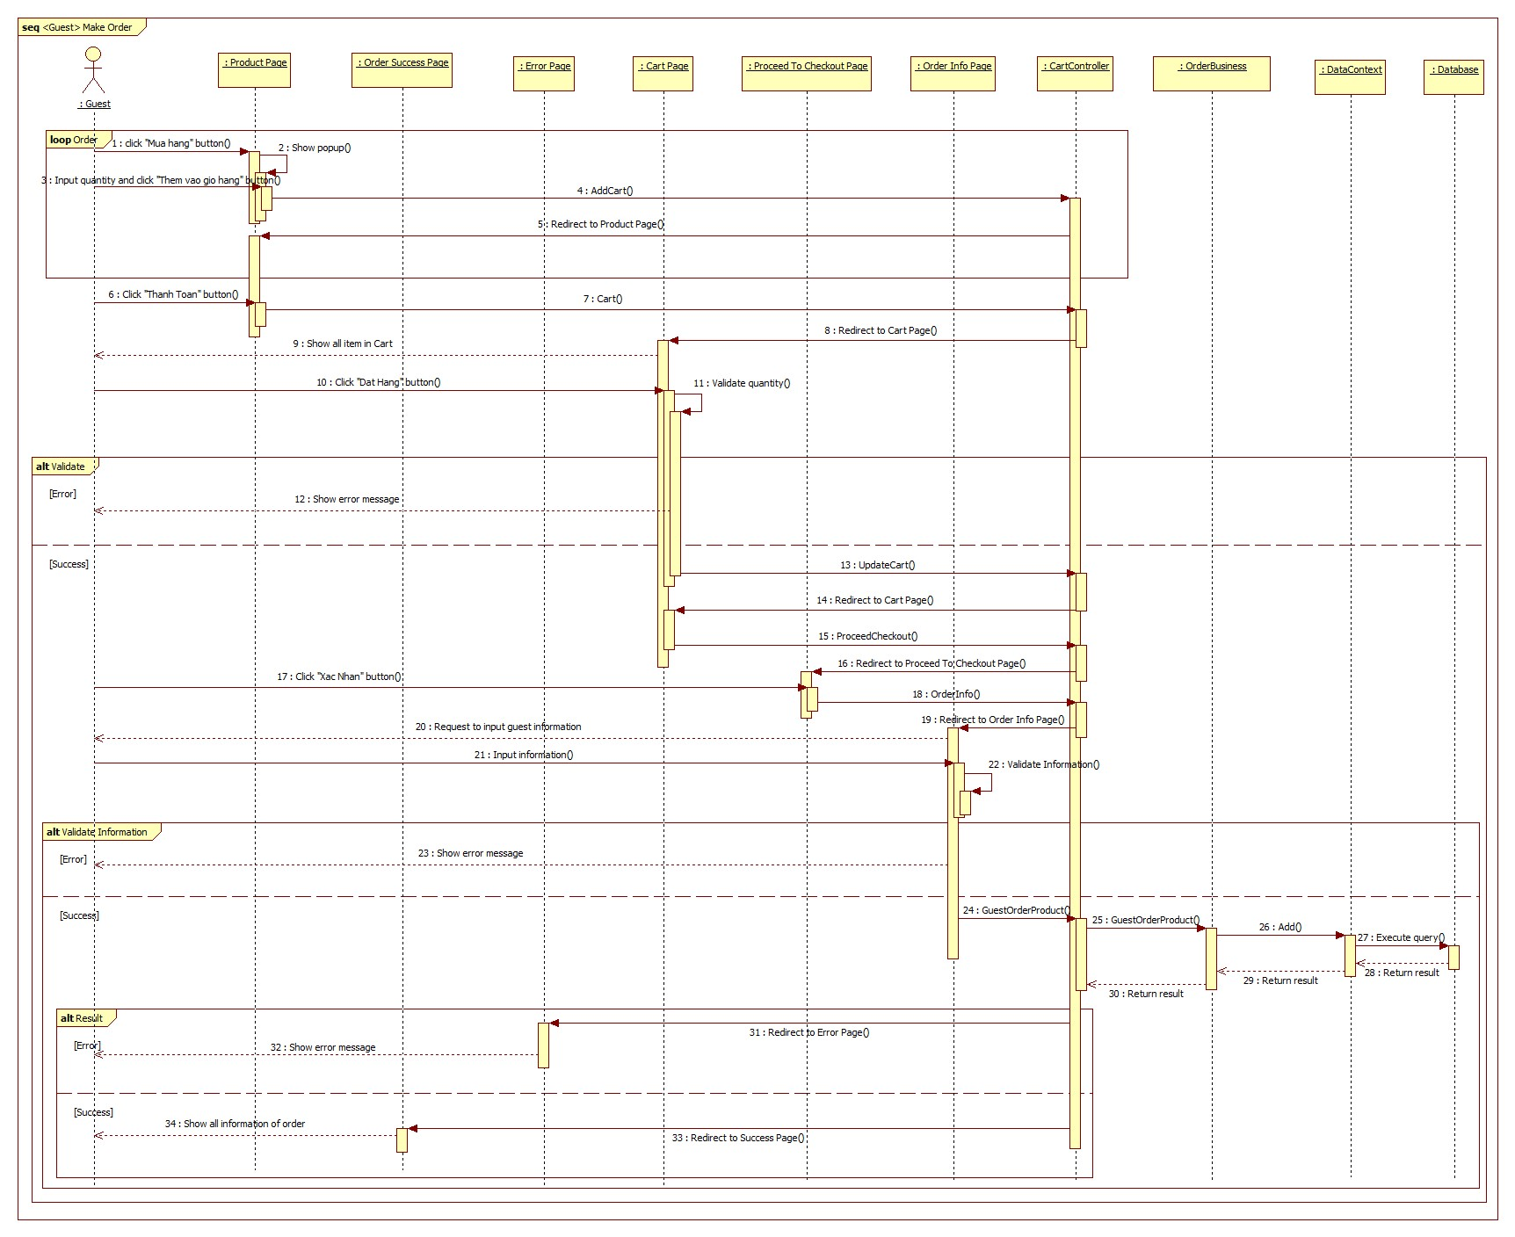

Figure 7 : Sequence diagram - <Guest> Make order

##### Edit order

**Summary**: This diagram shows process of staff edit the order.

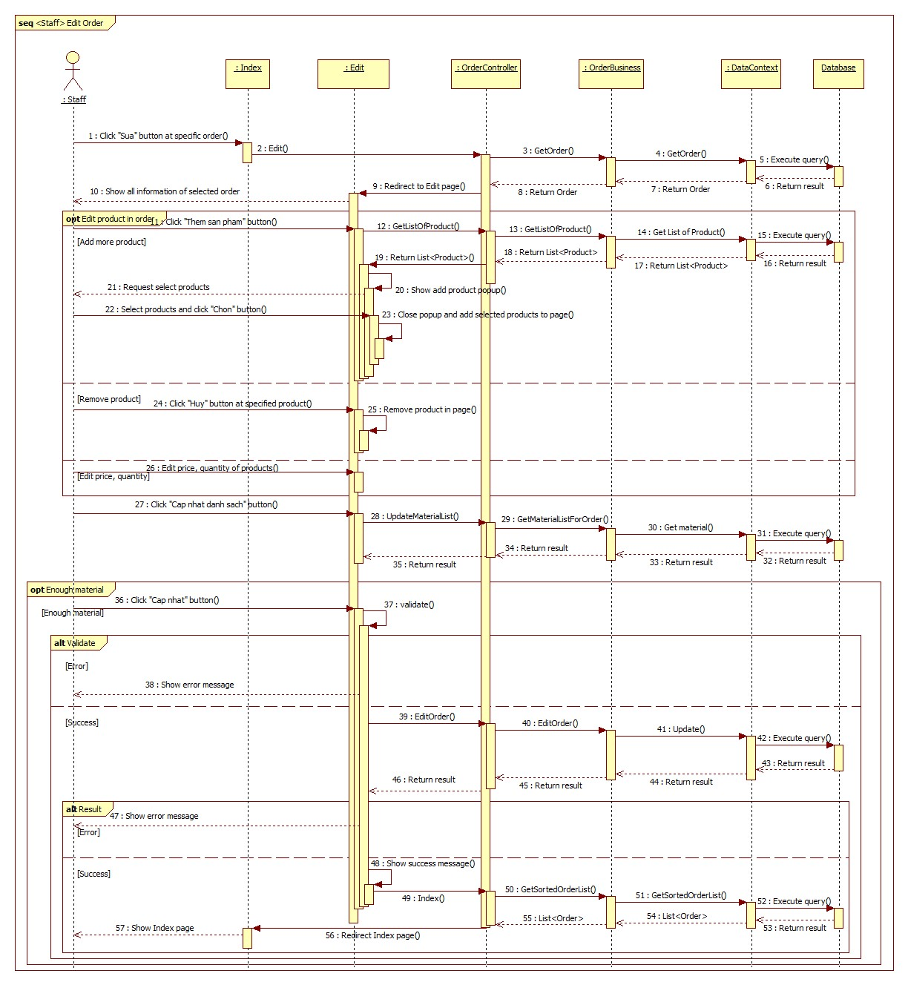

Figure 8 : Sequence diagram - <Staff> Edit order

##### Get notification

**Summary**: This diagram shows process of get notification

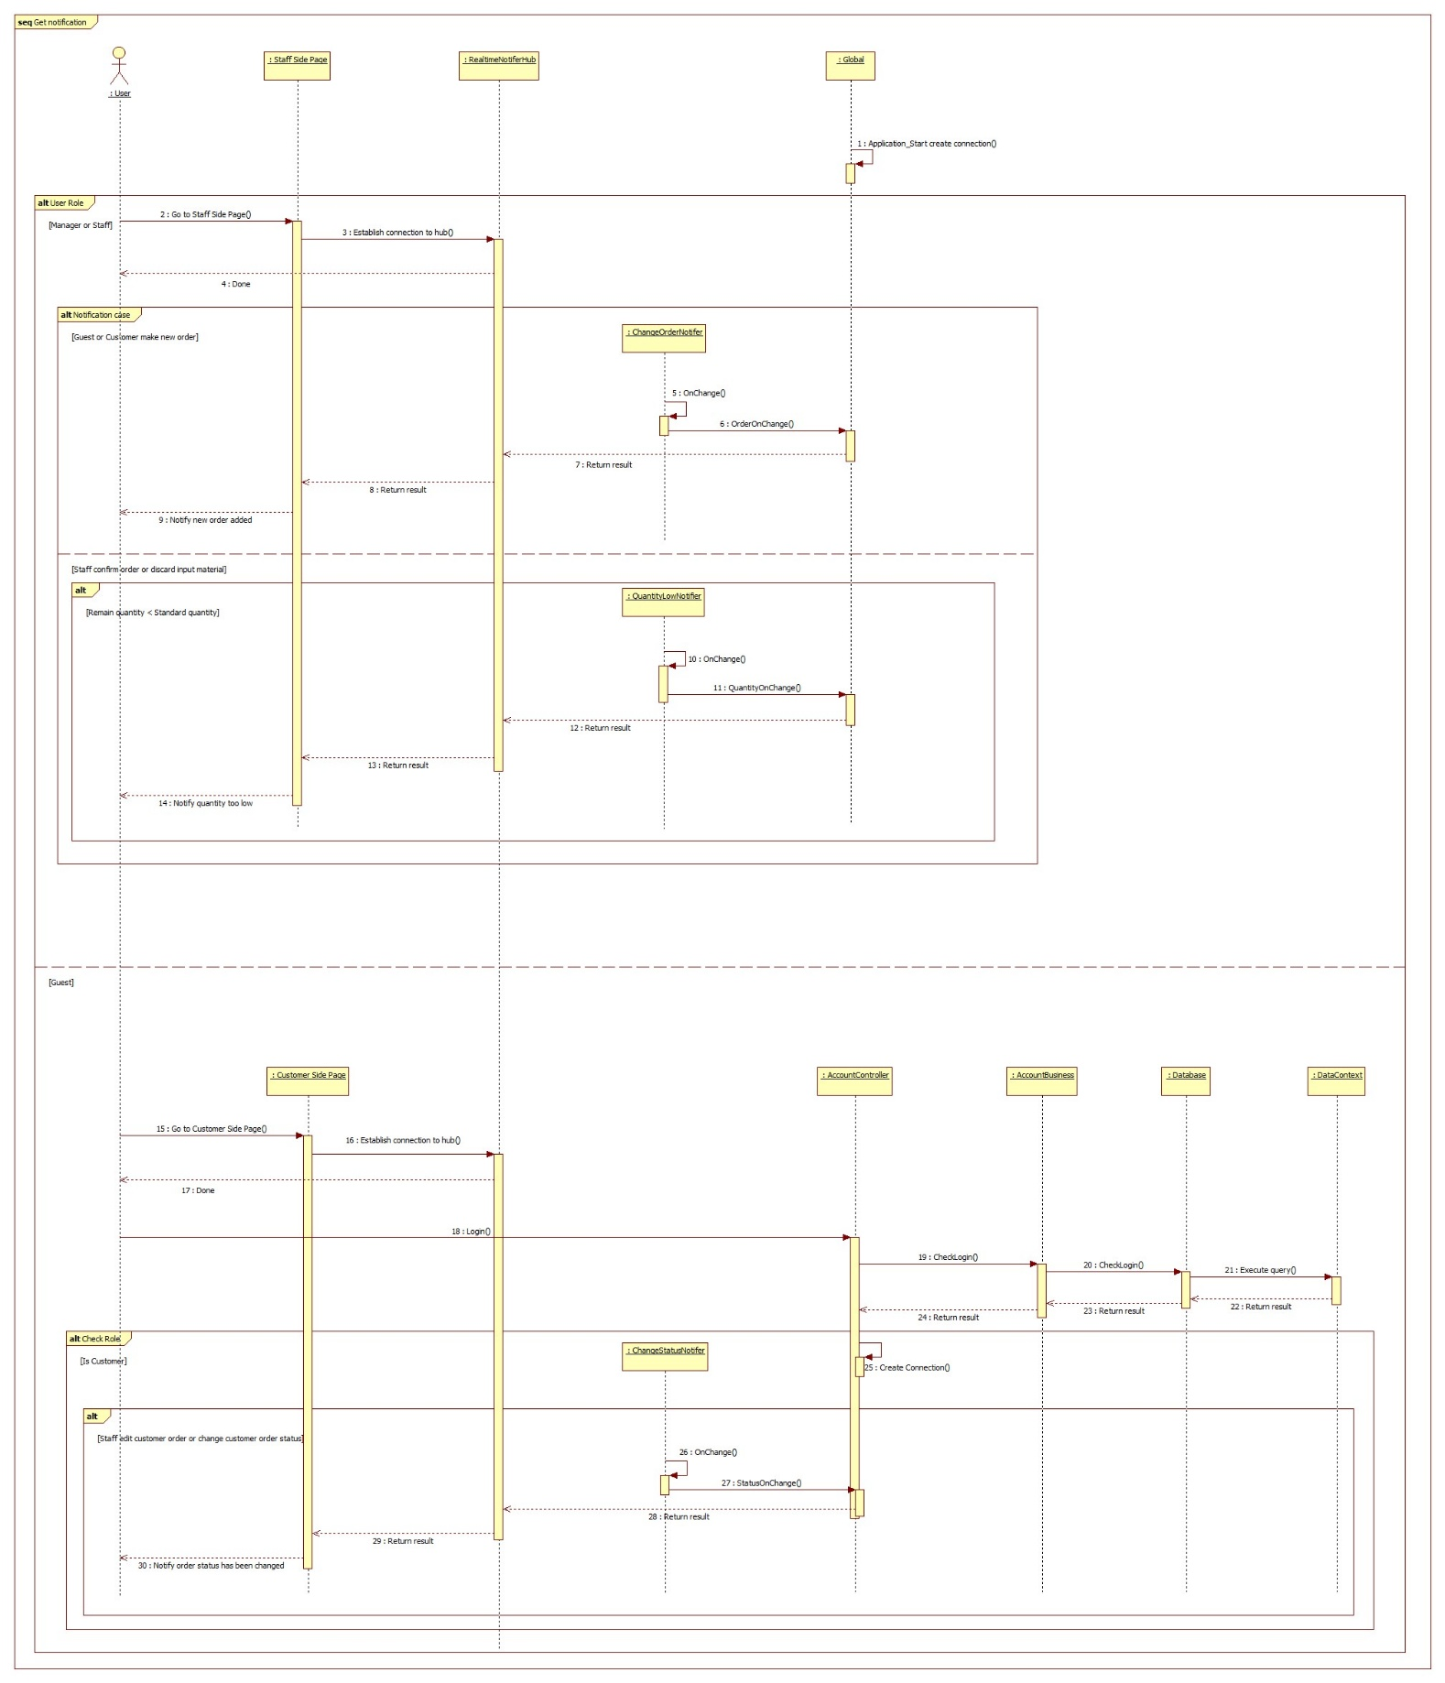

Figure 9 : Sequence diagram - <System> Get notification

## Database Design

### Entity relationship diagram

|  |  |
| --- | --- |
| Entity Data Dictionary: describe content of all entities | |
| **Entity name** | **Description** |
| Discount By Quantity | Describe all discounts by quantity in the system |
| Other Expense | Describe all other expenses in the system |
| StoreInfo | Describe all information of store in the system |
| Policy | Describe all policies in the system |
| Role | Describe all roles in the system |
| User | Describe all users in the system |
| Customer | Describe all customers in the system |
| Staff | Describe all staffs in the system |
| Guest Info | Describe all guest information in the system |
| Orders | Describe all orders in the system |
| Output Bill | Describe all output bills in the system |
| Order Item | Describe all order items of an order in the system |
| Category | Describe all categories in the system |
| Product | Describe all products in the system |
| Supplier | Describe all suppliers in the system |
| Input Bill | Describe all input bills in the system |
| Discarded Input Material | Describe all discard information of an input material in the system |
| Input Material | Describe all input materials in the system |
| Export From | Describe all relationship information between output material and input bill |
| Product Material | Describe all product materials in the system |
| Output Material | Describe all output materials of an order item in the system |
| Recipe | Describe all of materials of each product in the system |
| Tax Rate | Describe all tax rates in the system |
| Tax Type | Describe all tax types in the system |
| VAT Tax Declaration | Describe all information in VAT tax declaration |
| Tndn Tax Declaration | Describe all information in Excise tax declaration |

Table 3 : Entity dictionary

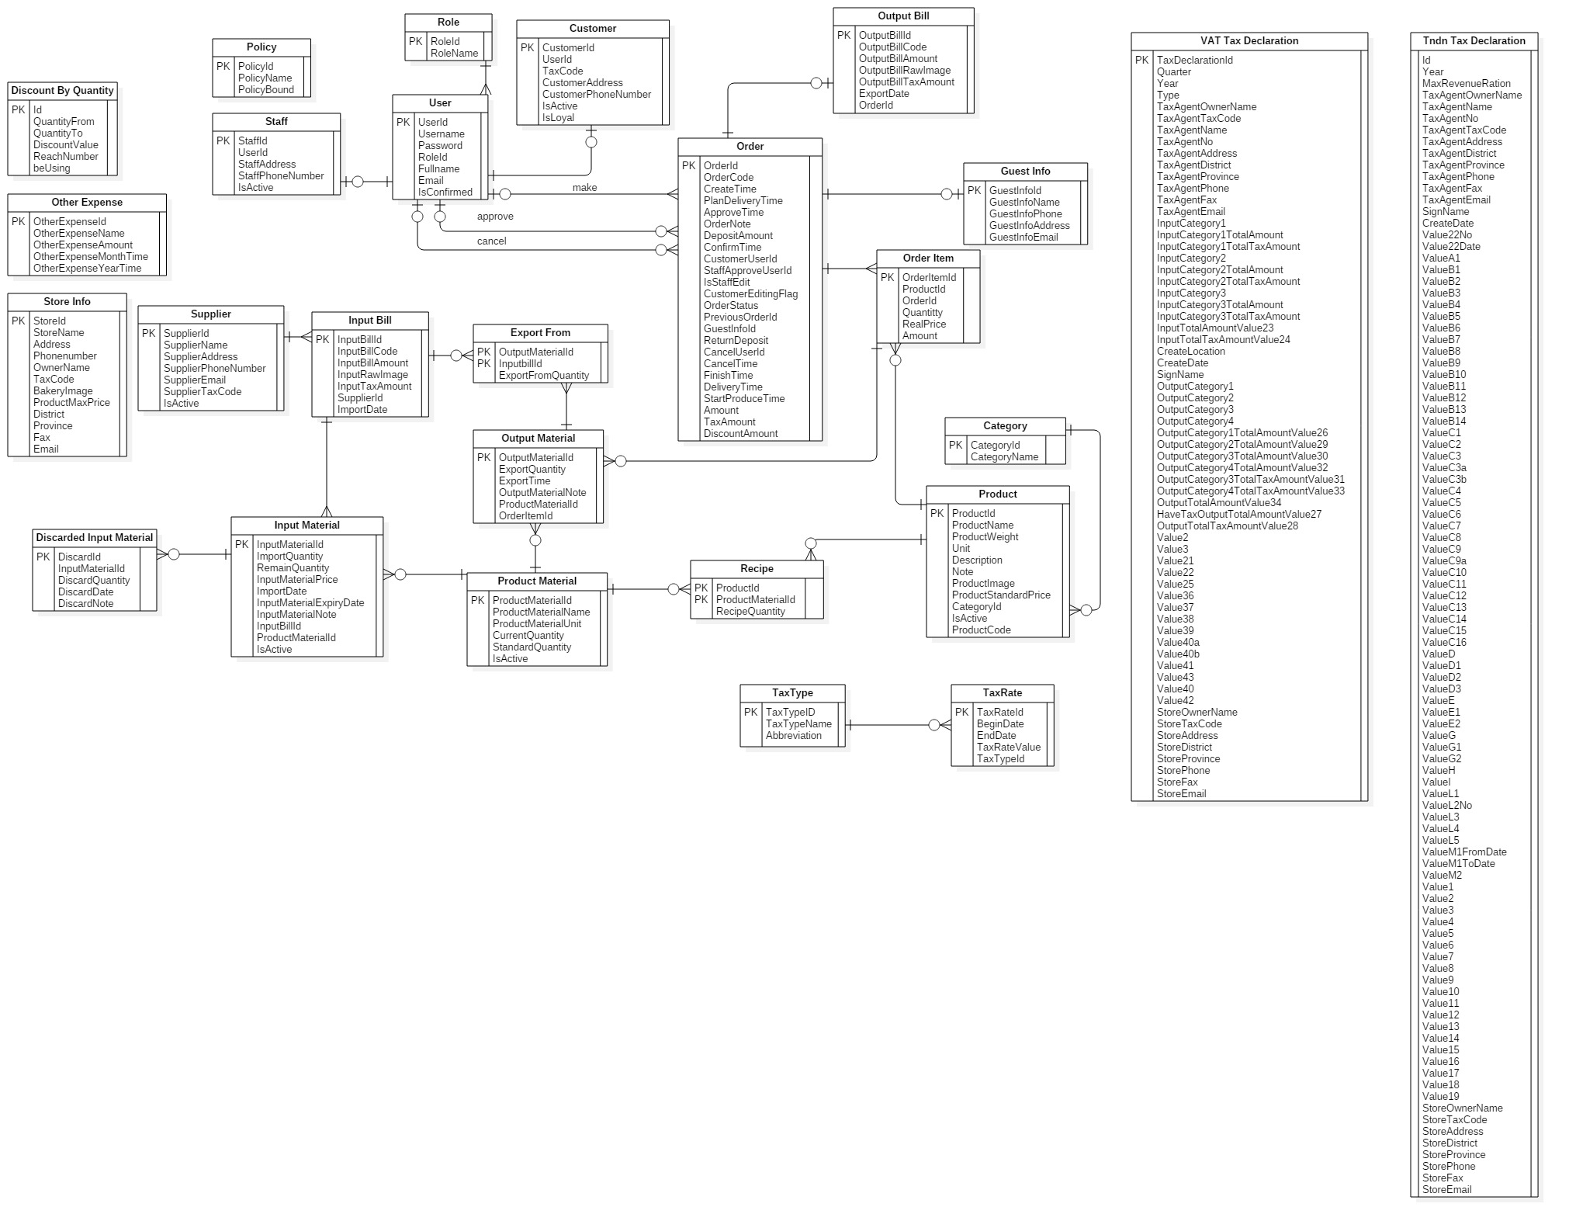

Figure 10 : Entity relationship diagram

### Physical Diagram

Figure 11:Physical Diagram

# Attachments

## Task sheet

|  |  |  |  |  |  |  |
| --- | --- | --- | --- | --- | --- | --- |
| **No.** | **Product Deliverables** | **Task** | **GiangHHT** | **ManhOT** | **VuongNQ** | **Size** |
| 1 | Report1 - Introduction | Project Information |  | **O** |  | 1 |
| Introduction |  |  | **O** | 1 |
| Current Situation |  |  | **O** | 1 |
| Problem Definition |  |  | **O** | 1 |
| **Proposed Solution** |  |  |  |  |
| Feature functions | **O** |  |  | 1 |
| Advantages and disadvantages | **O** |  |  | 1 |
| Functional Requirements |  | **O** |  | 1 |
| Roles and Responsibility |  | **O** |  | 1 |
| Review and merge document | **O** |  |  | 2 |
| 2 | Report2- Software Project Management Plan | **Problem Definition** |  |  |  |  |
| Name of this Capstone Project |  |  | **O** | 1 |
| Problem Abstract |  |  | **O** | 1 |
| **Project Overview** |  |  |  |  |
| Current Situation |  |  | **O** | 1 |
| The Proposed System |  | **O** |  | 1 |
| Boundaries of the System |  | **O** |  | 1 |
| Development Environment |  | **O** |  | 1 |
| Project organization | **O** |  |  | 1 |
| Project Management Plan |  | **O** |  | 1 |
| Coding Convention |  | **O** |  | 1 |
| Review and merge document | **O** |  |  | 2 |
| 3 | Report 3- Software Requirement Specification | User Requirement Specification |  |  | **O** | 2 |
| **System Requirement Specification** |  |  |  |  |
| External Interface Requirements |  |  | **O** | 1 |
| System Overview Use Case | **O** |  |  | 2 |
| **List of Use Case** |  |  |  |  |
| <Guest> Login |  | **O** |  | 1 |
| <Guest> Search product |  | **O** |  | 1 |
| <Guest> View product detail |  | **O** |  | 1 |
| <Guest> Make order |  | **O** |  | 1 |
| <Authenticated user> Logout |  | **O** |  | 1 |
| <Authenticated user> Search product |  | **O** |  | 1 |
| <Authenticated user> View product detail |  | **O** |  | 1 |
| <Authenticated user> Change personal information |  | **O** |  | 1 |
| <Authenticated user> Change password |  | **O** |  | 1 |
| <Authenticated user> Reset password |  | **O** |  | 1 |
| <System> Get notification |  | **O** |  | 1 |
| <Customer> Make order |  | **O** |  | 1 |
| <Customer> Edit order |  | **O** |  | 1 |
| <Customer> View order detail |  | **O** |  | 1 |
| <Customer> Cancel order |  | **O** |  | 1 |
| <Customer> Confirm order |  | **O** |  | 1 |
| <Staff> Add order | **O** |  |  | 1 |
| <Staff> Edit order | **O** |  |  | 1 |
| <Staff> View order detail | **O** |  |  | 1 |
| <Staff> Approve order | **O** |  |  | 1 |
| <Staff> Change order state | **O** |  |  | 1 |
| <Staff> Export bill | **O** |  |  | 1 |
| <Staff> Cancel order | **O** |  |  | 1 |
| <Staff> Export more material for order | **O** |  |  | 1 |
| <Staff> Add input material |  |  | **O** | 1 |
| <Staff> Edit input material |  |  | **O** | 1 |
| <Staff> Change input material state |  |  | **O** | 1 |
| <Staff> Add input bill |  |  | **O** | 1 |
| <Staff> Edit input bill |  |  | **O** | 1 |
| <Staff> Change material status |  | **O** |  | 1 |
| <Staff> Add material |  | **O** |  | 1 |
| <Staff> Edit material |  | **O** |  | 1 |
| <Staff> Add product |  | **O** |  | 1 |
| <Staff> Edit product |  | **O** |  | 1 |
| <Staff> Change product status |  | **O** |  | 1 |
| <Manager> Edit store information |  | **O** |  | 1 |
| <Manager> Edit store config |  | **O** |  | 1 |
| <Manager> Add new staff |  |  | **O** | 1 |
| <Manager> Change staff status |  |  | **O** | 1 |
| <Manager> Change customer status |  |  | **O** | 1 |
| <Manager> Change customer account to loyal |  |  | **O** | 1 |
| <Manager> Add new supplier |  |  | **O** | 1 |
| <Manager> Edit supplier information |  |  | **O** | 1 |
| <Manager> Change supplier status |  |  | **O** | 1 |
| <Manager> Update VAT Tax rate | **O** |  |  | 1 |
| <Manager> Update Excise tax rate | **O** |  |  | 1 |
| <Manager> Review income by time | **O** |  |  | 1 |
| <Manager> Review income by product | **O** |  |  | 1 |
| <Manager> Review income by customer | **O** |  |  | 1 |
| <Manager> Create VAT Tax Declacration | **O** |  |  | 1 |
| <Manager> Create Excise Tax Declacration | **O** |  |  | 1 |
| Software System Attribute | **O** |  |  | 1 |
| Conceptual Diagram | **O** |  |  | 1 |
| Review and merge document | **O** |  |  | 2 |
| 4 | Report 4- Software Design Description | System Architectural Design | **O** |  |  | 2 |
| Component Diagram | **O** |  |  | 1 |
| Class Diagram | **O** |  |  | 2 |
| Class Diagram Explanation |  | **O** |  | 1 |
| **Interactive Diagram** |  |  |  |  |
| <Guest> Make order |  | **O** |  | 1 |
| <Authenticated user> Change personal information |  | **O** |  | 1 |
| <Authenticated user> Change password |  | **O** |  | 1 |
| <Authenticated user> Reset password |  | **O** |  | 1 |
| <Authenticated user> Search product |  | **O** |  | 1 |
| <Authenticated user> View product detail |  | **O** |  | 1 |
| <System> Get notification |  | **O** |  | 1 |
| <Customer> Make order |  | **O** |  | 1 |
| <Customer> Confirm order |  | **O** |  | 1 |
| <Customer> Cancel order |  | **O** |  | 1 |
| <Customer> Edit order |  | **O** |  | 1 |
| <Staff> Approve order | **O** |  |  | 1 |
| <Staff> Add order | **O** |  |  | 1 |
| <Staff> Cancel order | **O** |  |  | 1 |
| <Staff> Edit order | **O** |  |  | 1 |
| <Staff> Change order status | **O** |  |  | 1 |
| <Staff> Export bill | **O** |  |  | 1 |
| <Staff> Export more material for order | **O** |  |  | 1 |
| <Staff> Add input material |  |  | **O** | 1 |
| <Staff> Edit input material |  |  | **O** | 1 |
| <Staff> Discard input material |  |  | **O** | 1 |
| <Staff> Add input bill |  |  | **O** | 1 |
| <Staff> Edit input bill |  |  | **O** | 1 |
| <Staff> Change material status |  | **O** |  | 1 |
| <Staff> Add material |  | **O** |  | 1 |
| <Staff> Edit material |  | **O** |  | 1 |
| <Staff> Add product |  | **O** |  | 1 |
| <Staff> Edit product |  | **O** |  | 1 |
| <Staff> Change product status |  | **O** |  | 1 |
| <Manager> Edit store information |  | **O** |  | 1 |
| <Manager> Edit store config |  | **O** |  | 1 |
| <Manager> Add new staff |  |  | **O** | 1 |
| <Manager> Change staff status |  |  | **O** | 1 |
| <Manager> Change customer status |  |  | **O** | 1 |
| <Manager> Change customer account to loyal |  |  | **O** | 1 |
| <Manager> Add new supplier |  |  | **O** | 1 |
| <Manager> Edit supplier information |  |  | **O** | 1 |
| <Manager> Change supplier status |  |  | **O** | 1 |
| <Manager> Update VAT Tax rate | **O** |  |  | 1 |
| <Manager> Update Excise tax rate | **O** |  |  | 1 |
| <Manager> Review income by time | **O** |  |  | 1 |
| <Manager> Review income by product | **O** |  |  | 1 |
| <Manager> Review income by customer | **O** |  |  | 1 |
| <Manager> Create VAT Tax Declacration | **O** |  |  | 1 |
| <Manager> Create Excise Tax Declacration | **O** |  |  | 1 |
| **Interface** |  |  |  |  |
| **Customer/Guest Interface Design** |  |  |  |  |
| Home page |  |  | **O** | 1 |
| User Login |  |  | **O** | 1 |
| Product page |  |  | **O** | 1 |
| Check cart |  |  | **O** | 1 |
| View information in cart |  |  | **O** | 1 |
| Confirm order |  |  | **O** | 1 |
| Add customer information to order |  |  | **O** | 1 |
| Change personal information |  |  | **O** | 1 |
| Change password |  |  | **O** | 1 |
| **Staff/Manager Interface Design** |  |  |  | 1 |
| View order list | **O** |  |  | 1 |
| Staff add product to order | **O** |  |  | 1 |
| Add customer to order | **O** |  |  | 1 |
| Checkout with new customer | **O** |  |  | 1 |
| Confirm order | **O** |  |  | 1 |
| View input bill list |  | **O** |  | 1 |
| Add new input bill |  | **O** |  | 1 |
| View input material list |  | **O** |  | 1 |
| View input material detail |  | **O** |  | 1 |
| Add new input material |  | **O** |  | 1 |
| Review income by time | **O** |  |  | 1 |
| Review income weekly detail | **O** |  |  | 1 |
| VAT Tax declaration - Applendix 1 | **O** |  |  | 1 |
| **Database design** |  |  |  |  |
| Entity relationship diagram | **O** |  |  | 2 |
| Entity dictionary |  | **O** |  | 1 |
| **Algorithms** |  |  |  |  |
| Order state | **O** |  |  | 2 |
| Review and merge document | **O** |  |  | 2 |
| 5 | Report 5 - Software Implementation and Test Document | **はじめに** |  |  | **O** |  |
| **データベース関係ダイアグラム** |  |  |  |  |
| ウェブアプリケーション物理的な ダイアグラム | **O** |  |  | 2 |
| ウェブアプリケーションデータ辞書 |  | **O** |  | 1 |
| **パフォーマンス対策** | **O** |  |  | 2 |
| **テスト計画** | **O** |  |  | 1 |
| **システムテストのテストケース** |  |  |  |  |
| **ウェブシステムのテストケース** |  |  |  |  |
| 「顧客」製品を注文すること |  |  | **O** | 1 |
| 「ゲスト」製品を注文すること |  |  | **O** | 1 |
| 「人員」送り状を造ること |  |  | **O** | 1 |
| ユーザログイン |  |  | **O** | 1 |
| 「人員」送り状を承認すること |  |  | **O** | 1 |
| 「人員」送り状の状態を変化すること |  |  | **O** | 1 |
| 「人員」入力原料を付加すること |  |  | **O** | 1 |
| 「人員」入力原料を捨てること |  |  | **O** | 1 |
| 6 | Report 6 - Software User's Manual | **インストレーションガイド** |  |  | **O** |  |
| **ユーザーガイド** |  | **O** |  | 2 |
| ログイン |  |  | **O** | 1 |
| 製品を注文すること |  |  | **O** | 1 |
| カートに製品を追加すること |  |  | **O** | 1 |
| かーとをチェックすること |  |  | **O** | 1 |
| カーとの精細 |  |  | **O** | 1 |
| 送り状を確認すること |  |  | **O** | 1 |
| 送り状に顧客の情報を充実すること |  |  | **O** | 1 |
| 送り状に顧客の情報を充実すること |  |  | **O** | 1 |
| 「人員」送り状を造ること |  |  | **O** | 1 |
| 送り状に顧客を追加すること |  |  | **O** | 1 |
| 新い顧客の口座で送り状をチェックアウト |  |  | **O** | 1 |
| 入力法案 リスク |  |  | **O** | 1 |
| 新入力法案を造ること |  |  | **O** | 1 |
| 入力原料 リスクを見る |  |  | **O** | 1 |
| 入力原料 の精細を見ること |  |  | **O** | 1 |
| 新入力原料を造ること |  |  | **O** | 1 |
| 7 | Authentication and Account | <Guest>Login |  | **O** |  | 1 |
| <Authenticated User>Logout |  | **O** |  | 1 |
| <Authenticated User>Edit own profile information |  | **O** |  | 1 |
| <Authenticated User> Reset password |  | **O** |  | 1 |
| <Authenticated User>Change password |  | **O** |  | 1 |
| 8 | Order Online | <Guest, Customer> Make order |  | **O** |  | 1 |
| <Guest, Customer> Search product in Order Online System |  | **O** |  | 1 |
| <Guest, Customer> View product detail in Order Online System |  | **O** |  | 1 |
| <Customer> Edit order |  | **O** |  | 1 |
| <Customer> Cancel order |  | **O** |  | 1 |
| <Customer> Confirm order |  | **O** |  | 1 |
| 9 | <Staff> Manage Product | List all of product |  | **O** |  | 1 |
| Add new product |  | **O** |  | 1 |
| Edit the product |  | **O** |  | 1 |
| View product detail in Manage System |  | **O** |  | 1 |
| Change product status |  | **O** |  | 1 |
| 10 | <Staff>Manage Order | List of order | **O** |  |  | 1 |
| View order detail | **O** |  |  | 1 |
| Edit order | **O** |  |  | 1 |
| Add order | **O** |  |  | 1 |
| Cancel order | **O** |  |  | 1 |
| Approve order | **O** |  |  | 1 |
| Change order status | **O** |  |  | 1 |
| List of shortage of material for order | **O** |  |  | 1 |
| Export Bill | **O** |  |  | 1 |
| Create customer account | **O** |  |  | 1 |
| 11 | <Staff>Manage Bill | Add input bill |  |  | **O** | 1 |
| Edit input bill |  |  | **O** | 1 |
| List all input bill |  |  | **O** | 1 |
| 12 | <Staff>Manage Input Material | Show input material list |  |  | **O** | 1 |
| Add discard for input material |  |  | **O** | 1 |
| Add new input material |  |  | **O** | 1 |
| Edit input material |  |  | **O** | 1 |
| 13 | <Staff>Manage Supplier | List all suppliers with name, address, phone |  |  | **O** | 1 |
| Change supplier status |  |  | **O** | 1 |
| Add supplier |  |  | **O** | 1 |
| Edit supplier |  |  | **O** | 1 |
| 14 | <Staff>Manage Product Material | Add product material |  | **O** |  | 1 |
| Edit product material |  | **O** |  | 1 |
| View product material detail |  | **O** |  | 1 |
| Change product material status |  | **O** |  | 1 |
| 15 | <Manager>Tax | Edit tax rate of VAT and Excise tax | **O** |  |  | 1 |
| Create VAT Tax Declaration | **O** |  |  | 2 |
| Create Excise Tax Declaration | **O** |  |  | 2 |
| 16 | <Manager>Statistic | Review income by time | **O** |  |  | 3 |
| Review income by good | **O** |  |  | 3 |
| Review revenue by customer | **O** |  |  | 3 |
| 17 | <Manager>Store information | Edit store information |  | **O** |  | 1 |
| Edit system config  - Min order quantity  - Discount price depend on quantity  - Max price for product |  | **O** |  | 2 |
| Set loyal for customer |  |  | **O** | 1 |
| 18 | <Manager>Manage Staff | List all staff |  |  | **O** | 1 |
| Change staff status |  |  | **O** | 1 |
| Add new staff |  |  | **O** | 1 |
| <Staff>Edit staff information |  |  | **O** | 1 |
| 19 | <Staff> Manage Customer | List all customer |  |  | **O** | 1 |
| Change customer status |  |  | **O** | 1 |
| 20 | <Manager>Manage Other Expense | List all of other expense | **O** |  |  | 1 |
| Add new other expense | **O** |  |  | 1 |
| Edit other expense | **O** |  |  | 1 |
| Delete other expense | **O** |  |  | 1 |
| 21 | <Manager> Manage Category |  |  | **O** |  | 2 |
| 22 | Notification | Notification to staff when there are new orders |  | **O** |  | 1 |
| Notification to customer when the order status is changed by staff |  | **O** |  | 1 |
| Notification to staff when the material quantity is below standard quantity |  | **O** |  | 1 |