Computational Analysis of Physical System
H. Altuğ Yıldırım
090100252
HW3

First Question:

from random import random
from pylab import plot,xlabel,ylabel,title,show
import time

k=input("How many points?")
n=0
k_vec=[]
pi_vec=[]
time_vec=[]
for i in range(1,k+1):
inside=0
starttime=time.clock()
n=10**i
for j in range(n):
x,y=random(),random()
if (x**2+y**2)**(0.5)<1: inside=inside+1
num_pi=4.0*(float(inside)/n)
elapsedtime=(time.clock() - starttime)
k_vec.append(i)
pi_vec.append(num_pi)
time_vec.append(elapsedtime)

xlabel('k')
ylabel('pi')
plot(k_vec,pi_vec)
title('Pi versus Iteration Number')
show()

xlabel('k')
ylabel('Time')
plot(k_vec,time_vec)
title('Each Iterations Time versus Iteration Number')
show()

Output:
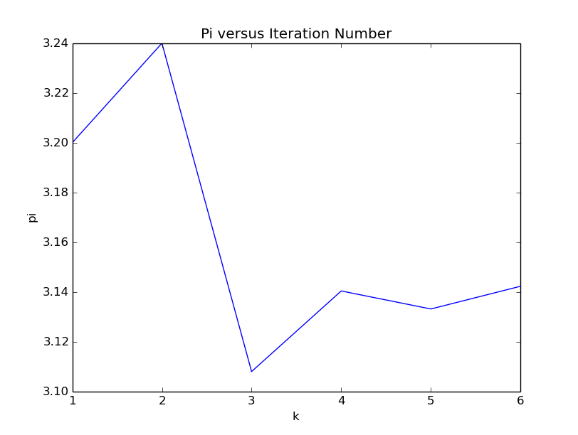
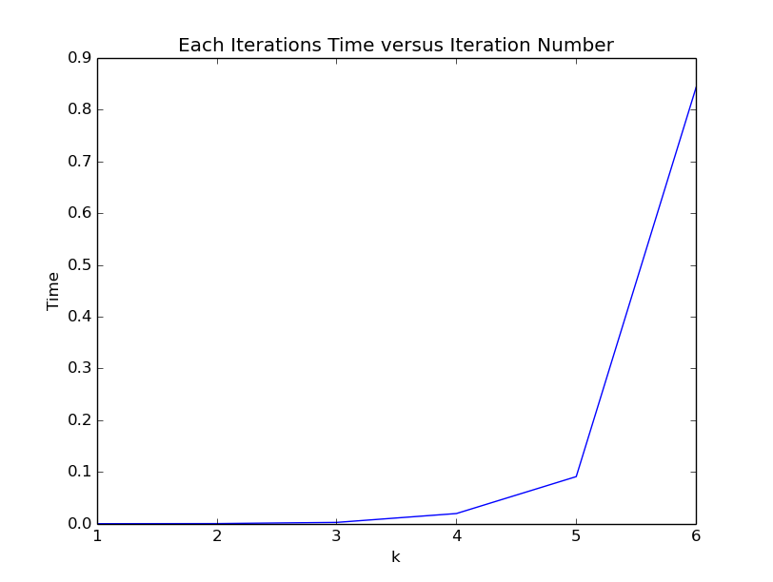

from random import *
sum=1
k=0
while sum!=0 :
k=k+1
dice=choice([-4,-3,-1,1,2,4])
sum=sum+dice
if k==1:
sum=sum-1
modw=k%2
if modw == 0:
print 'Brad Wins!'
else:
print 'Angelica Wins!'

