CS 255 System Design Document Template

UML Diagrams

UML Use Case Diagram

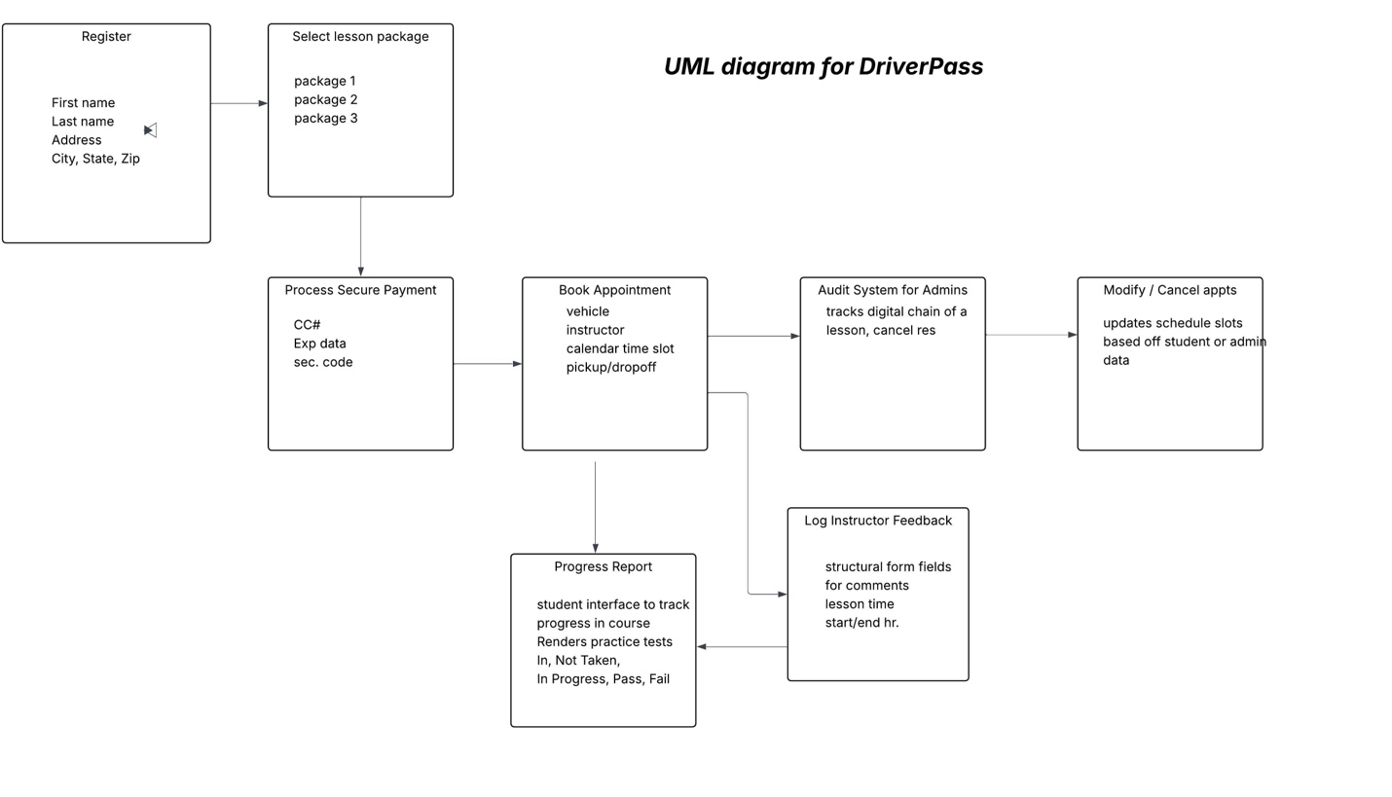

UML Activity Diagrams

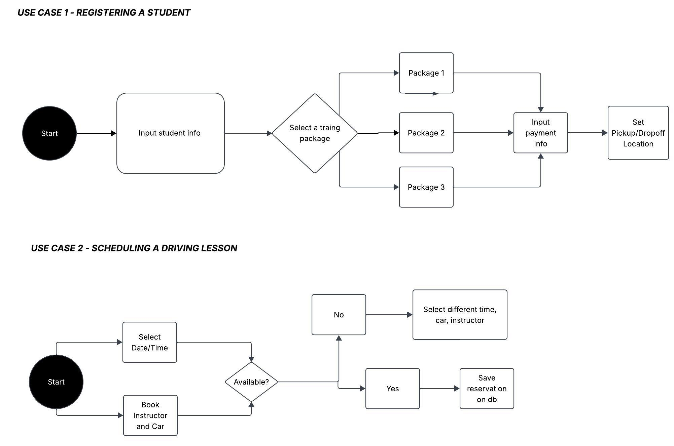

UML Sequence Diagram
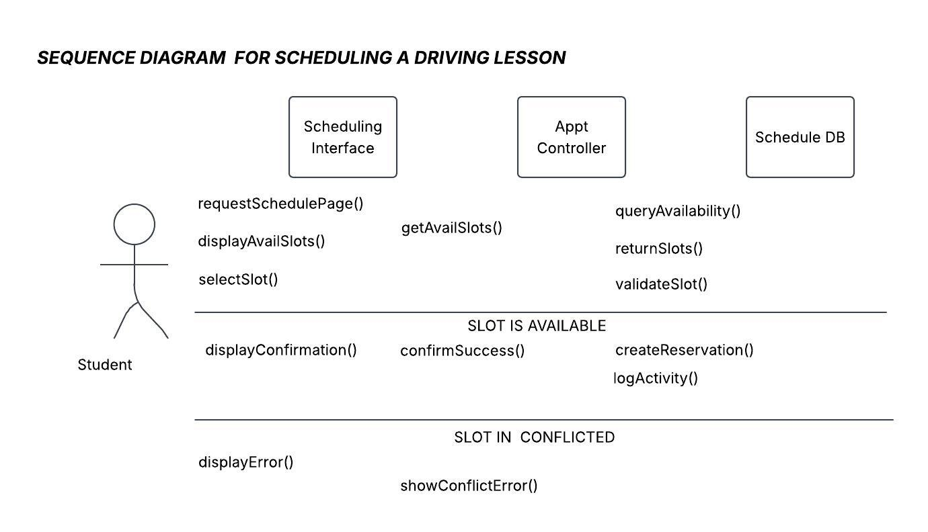

UML Class Diagram

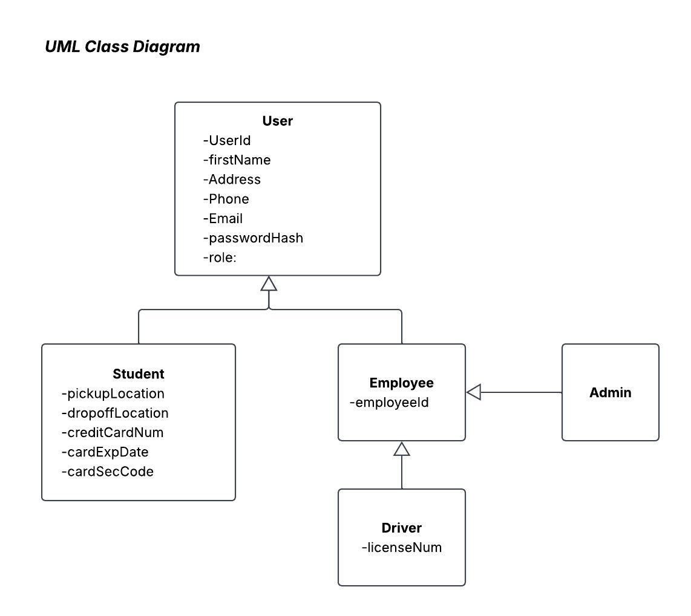

Technical Requirements

The DriverPass system is designed to be a cloud-based web application. It is designed to help students pass their driving tests and contain some core features: User registration, Booking lessons, Instructor giving feedback, Payment system, changing bookings. Other useful features are user-based access control differentiating site admins, instructors, and students. There is password security. The app is also linked to the DMV for test scheduling.

