
SX PRIME TM
Non-Petroleum-Based Prime Coat
Environment-Friendly and Cost-Effective Prime Coat
PARKING LOTS – STREETS – HIGHWAYS

SX PRIME ™ is an environmentally friendly alternative to asphalt prime coats. Invented at the University of Texas at Austin (UT Austin), SX PRIME™ offers the most cost-effective and
risk-free way to improve highways without sacrificing road durability, quality, or stability. SX PRIME™ is an easy-to-use polymer- based emulsion, and it requires no special equipment or handling procedures. In a series of tests, SX PRIME™ outperforms the most widely used alternatives, such as MC-30 and AEP — both of which emit volatile organic compounds (VOCs) and are at least partially prohibited for use in Ozone Nonattainment Areas, like crowded cities and metropolitan areas.


TxDOT APPLICATION OF SX PRIME ™

SX PRIME ™ IS TEST-PROVEN. In extensive trials coordinated by UT Austin and the Texas Department of Transportation (TxDot), SX PRIME™ prominently outperformed all known competitor products as a replacement for MC-30, an asphalt primer used worldwide. MC-30 is classified as a cutback asphalt and is heavily laden with kerosene, which is environmentally toxic. The Environmental Protection Agency (EPA) classifies cutback asphalt as a volatile organic compound (VOC), placing in a category of substances regulated by environmental agencies worldwide.
The leaching of kerosene into the ground and its evaporation atmosphere have polluted the environment for years. In addition to environmental concerns, MC-30 poses serious health risks to workers who are exposed directly to its vapors and potential flammability. Inhalation of asphalt fumes can cause dizziness, headaches, intoxication, and vomiting. These fumes also contain known carcinogens.
Extensive research has revealed that several other products, mostly asphalt emulsion-based, are suitable replacements for MC-30. However, none have proven to be as effective as MC-30—until the arrival of SX PRIME™.
SX PRIME ™ IS THE BEST REPLACMENT FOR MC-30. As shown by the following table, SX PRIME™ outperforms competitor products as a replacement for MC-30, and SX PRIME™ is much stronger than MC-30 and other alternatives.

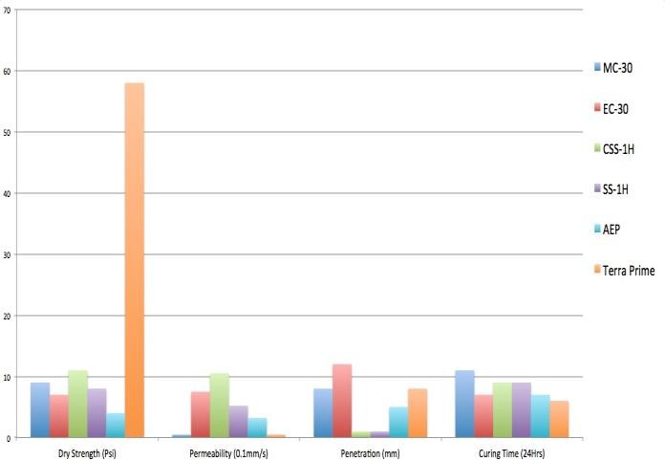
ORDERING AND RECEIVING SX PRIME™. SX
SX PRIME™ VS. COMPETITORS/MC-30
Prime™ is manufactured in Central Texas, USA. For most applications, the product is calculated at a rate of 0.1 gal/sq. yd. SX Prime™ can be ordered in any quantity and can be shipped worldwide.
For More Information, Contact:
SX SYSTEMS LTD, MEXICO
Miguel Leandro Guerra #181-B Colonia Centro C.P. 474700
TEL: 474-742-1030 y 474-742-1031

Copyright © 2014 SX Systems LTD, México All rights reserved.

