**FYS3410: Spring 2018**

**Module I**

**Practical assignments:**

1. Assume infinite one-dimensional (1D) NaCl lattice as shown in Fig.1 below.

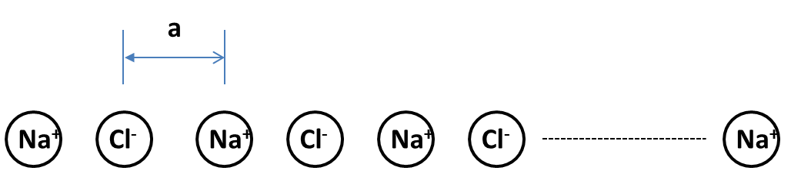

1. Choose the basis and the unit cell for this lattice;
2. Derive an analytical expression for the Madelung constant;
3. Assume this crystal to be of a finite size varying from 1 to 50 unit cells and plot the evolution of the Madelung constant as a function of the crystal size; analyze the trend for the corresponding cohesive energy evolution;
4. Is there a condition related to the repulsive/attractive force balance determining potential realization of such crystals? (Comment: no metaphysical or philosophical analysis is required; disregard any consideration of the substrate used; instead, assuming the Pauli repulsion to act similar to that as in 3D NaCl, i.e λ=1keV and ρ=0.32Å, try to calculate and plot/analyze the trend for the equilibrium separation between Na+ and Cl- ions as a function of the crystal size)
5. Consider hexagonal close-packed (hcp) crystal (e.g. see Figs 19-21 in Kitells’s book).
6. Calculate the number of atoms in the unit cell;

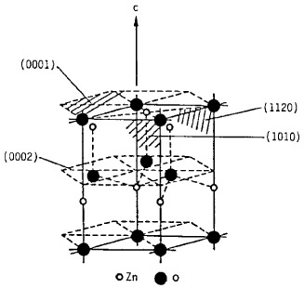

1. Calculate the characteristic c/a ratio;
2. Show that the packing density is 74%;
3. Deviations from the ideal hcp c/a ratio may be observed in some materials, e.g. in ZnO c/a =1.602. Taking into account alternating “shits” of Zn+ and O- ions building this hexagonal structure – conventionally called wurtize, see Fig.2 - try to elaborate what consequences such c/a deviation may result in.
4. Consider a cubic crystal and show that the distance between (hkl)-planes is given by:

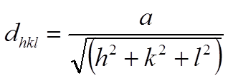

1. Consider specific planes in a triclinic crystal as shown in Fig.3 below. Vector *a3* is directed toward the reader. The origo is marked with a dark spot where *a1* and *a2* are originated.

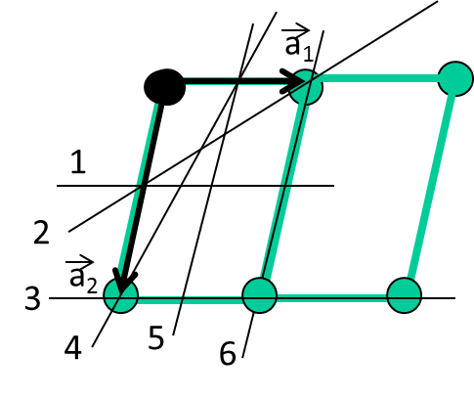

1. What are the Miller indices of the planes 1-6?
2. Make a drawing representing reciprocal lattice points corresponding to the planes in Fig.3;
3. Consider the reciprocal lattice vector *G* corresponding to the (010) planes in the drawing produced when solving problem (b) and an x-ray wave having wavevector *k.* Prove that diffraction is not taking place for any  *KG* <1/2∙ │G│ where *kG* is a projection of *k* vector on *G* direction.
4. Generalize the argument to the rest of the nearest to origo reciprocal points and introduce the Brillouin zone concept on the same graph.
5. Construct 3 first Brillouin zones for a 1D lattice, as well as for 2D and 3D simple cubic lattices.
6. What are limitations to observe crystallographic planes in a real x-ray experiment?
7. Point defects in crystals. Consider, in particular, vacancies.
8. Show that the minimum free energy in a crystal having N sites is reached only when a certain number of vacancies (n) are available.
9. Derive an expression for the equilibrium concentration of vacancies (CV ) as a function of temperature (T) and applied stress (σ).
10. Explain the roles of the activation energy and the activation volume.
11. Consider SiGe alloy. Si and Ge exhibit similar lattice structures, having, however, different lattice parameters, as illustrated in Fig.4 below.

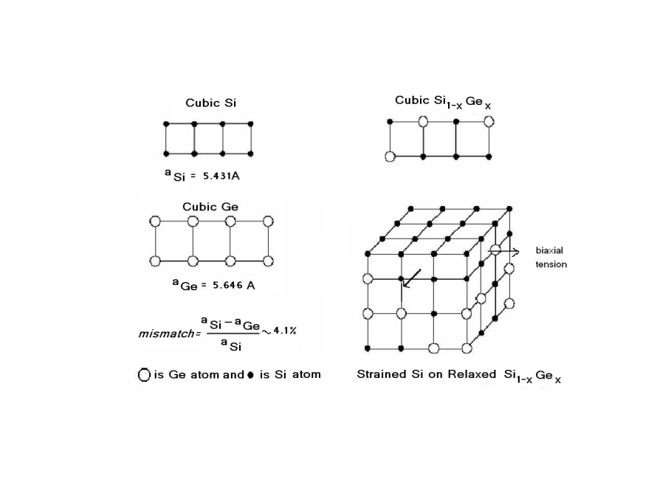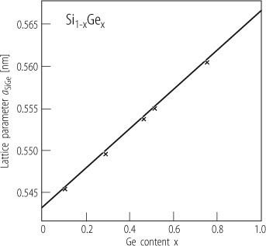

Note, a Si1-xGex film, say Si0.8Ge0.2 can be grown on a Si substrate so that the in-plane atomic arrangement in the film is matching that in the substrate, i.e. epitaxy is occurring. The film would then be biaxially compressed as illustrated in Fig.5 below.

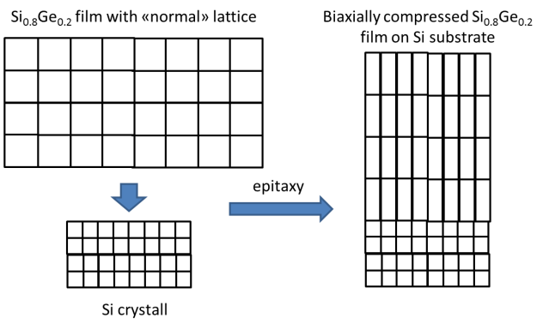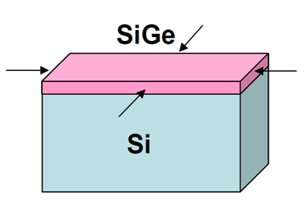

Fig 6 below represents Sb diffusion data in normal and biaxially compressed Si0.8Ge0.2.

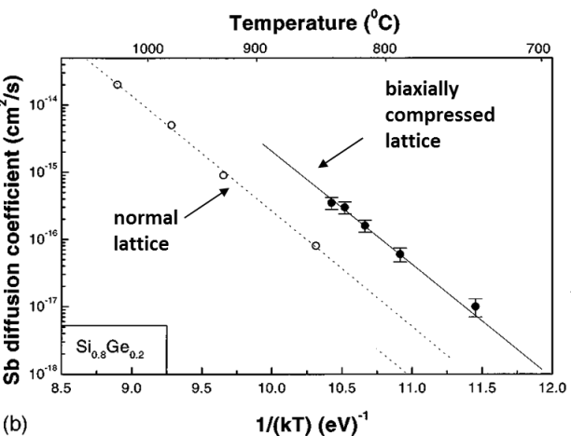

1. Estimate the stress occurring effectively in epitaxial Si0.8Ge0.2 film manufactured of Si (100) oriented substrate. Use 52GPa for the share modulus of elasticity (μ) and 0.28 for the Poisson ratio (ν).
2. Assume an x-ray diffraction measurement (λ=1.54Å) of Si and Si0.8Ge0.2 crystals as well as Si0.8Ge0.2/Si heterostructure. Consider (004) diffraction and make a qualitative drawing showing the diffraction pattern changes in these three samples.
3. Assuming that Sb diffuses via a vacancy mechanism, estimate the difference in vacancy concentrations in normal and strained Si0.8Ge0.2 (use the data in Fig.6).
4. Estimate the activation volume for Sb diffusion in Si0.8Ge0.2.

Note that the stress in a biaxially compressed film may be given as



Where fm(X) is the deformation due to the difference in the lattice parameters and X is the Ge fraction in Si1-XGeX alloy [Phys.Rev B 59, 7274(1999)].

9. An ideal gas consists of non-interacting point particles that move about in rapid and incessant fashion. Sketch the form of the pair distribution function g(r) for this ideal gas and discuss its features.

10.

(a) Draw the network structure of a borate glass.

(b) Explain how the addition of Na2O to B2O3 decreases viscosity of the glass melt.

(c) To raise the glass transition temperature of the borate glass, do you increase or decrease the cooling rate? Explain.

(d) Describe one surface treatment method by which you can strengthen a borate glass.