Halwaiwala Backend Microservices Documentation

1. Introduction
This document provides the backend architecture documentation for the Halwaiwala booking platform. The platform has three primary panels: Public Website (Customer), Halwai Dashboard, and Admin Panel. The backend follows a microservices-based architecture to ensure scalability, modularity, and maintainability.

2. Microservices Overview
Service | Responsibilities
Auth Service | Handles login/signup, roles (admin, halwai, customer), and JWT tokens.
Halwai Service | Manages halwai profiles, dishes, cuisines, events, and categories.
Enquiry Service | Stores customer enquiries in DB, integrates with WhatsApp API for notifications.
Payment Service (Future) | Payment gateway integration, commission tracking, payouts.
Notification Service (Optional) | Sends WhatsApp, SMS, and Email notifications (can be merged with Enquiry initially).

3. Panels to Services Mapping
Website (Customer): Auth Service, Halwai Service (browse), Enquiry Service (create enquiry).
Halwai Dashboard: Auth Service, Halwai Service (manage profile, events, dishes), Enquiry Service (view enquiries).
Admin Panel: Auth Service, Halwai Service (manage halwais/events/dishes), Enquiry Service (view all enquiries), Payment Service (future).

4. Microservice Architecture Graph
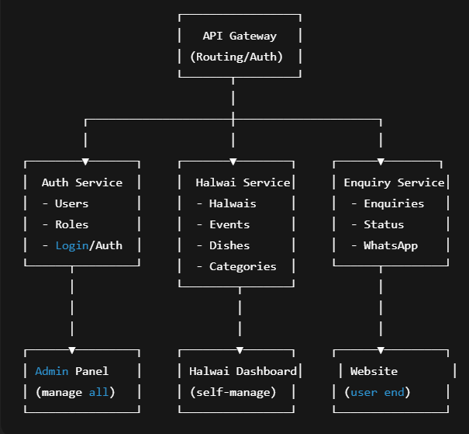

5. Example Flow (Enquiry)
1. Customer selects event, cuisine, dishes on Website.
2. Website → API Gateway → Enquiry Service.
3. Enquiry Service saves enquiry in DB and triggers WhatsApp notification.
4. Halwai Dashboard fetches enquiry details for that halwai.
5. Admin Panel can view/manage all enquiries.

6. Detailed Service Descriptions

6.1 Auth Service
The Auth Service is responsible for user authentication and authorization. It manages users with different roles: admin, halwai, and customers. It provides JWT tokens for secure communication between services and panels.

6.2 Halwai Service
The Halwai Service manages all halwai-related data. It supports CRUD operations for halwai profiles, dishes, cuisines, events, and categories. This service is consumed by both the Halwai Dashboard and the Admin Panel.

6.3 Enquiry Service
The Enquiry Service handles all customer enquiries. It stores enquiries in the database, associates them with halwais and events, and sends enquiry details to halwais via WhatsApp integration. The service allows admins to monitor enquiries and halwais to respond.

6.4 Payment Service (Future)
The Payment Service will manage payment gateway integration for bookings. It will handle commission calculation, settlement with halwais, and generate financial reports for the admin.

6.5 Notification Service (Optional)
The Notification Service will be responsible for sending communications like WhatsApp messages, emails, and SMS. Initially, WhatsApp notifications are handled within the Enquiry Service, but this can later be separated into a standalone service for scalability.

7. Internal Hierarchy of Halwai Backend
halwaiwala-backend/
│
├── gateway/ # API Gateway (entry point for all panels)
│ ├── src/
│ │ ├── middlewares/ # Auth checks, logging, rate limiting
│ │ ├── routes/ # Routes for admin/halwai/website
│ │ │ ├── admin.routes.ts
│ │ │ ├── halwai.routes.ts
│ │ │ └── website.routes.ts
│ │ ├── controllers/ # Gateway controllers if any aggregation
│ │ └── index.ts # Server entry
│ └── package.json
│
├── services/
│ ├── auth-service/
│ │ ├── src/
│ │ │ ├── controllers/ # login, signup, roles
│ │ │ ├── models/ # User model
│ │ │ ├── routes/ # /auth routes
│ │ │ ├── utils/ # token helpers, password hashing
│ │ │ ├── middlewares/ # auth validation middleware
│ │ │ └── config/ # db config, env
│ │ └── package.json
│ │
│ ├── halwai-service/
│ │ ├── src/
│ │ │ ├── controllers/ # halwai, dish, cuisine, event
│ │ │ │ ├── halwai.controller.ts
│ │ │ │ ├── dish.controller.ts
│ │ │ │ ├── cuisine.controller.ts
│ │ │ │ ├── event.controller.ts
│ │ │ │ └── eventCategory.controller.ts
│ │ │ ├── models/ # Halwai, Dish, Cuisine, Event, EventCategory
│ │ │ ├── routes/ # halwai.routes.ts, dish.routes.ts etc.
│ │ │ └── utils/ # validation, helpers
│ │ └── package.json
│ │
│ ├── enquiry-service/
│ │ ├── src/
│ │ │ ├── controllers/ # create, fetch enquiries
│ │ │ ├── models/ # Enquiry model
│ │ │ ├── routes/ # enquiry.routes.ts
│ │ │ └── utils/ # WhatsApp integration
│ │ └── package.json
│ │
│ ├── payment-service/ # (future)
│ │ ├── src/
│ │ │ ├── controllers/ # initiatePayment, settleCommission
│ │ │ ├── models/ # Transaction, Commission
│ │ │ └── routes/ # payment.routes.ts
│ │ └── package.json
│ │
│ └── notification-service/ # (optional, can be merged with Enquiry initially)
│ ├── src/
│ │ ├── controllers/ # sendEmail, sendSMS, sendWhatsApp
│ │ └── utils/ # notification templates
│ └── package.json
│
├── libs/ # Shared utilities/types
│ ├── middlewares/ # common middlewares
│ ├── validators/ # Joi/Zod validations
│ ├── utils/ # cloudinary, logging
│ ├── types/ # DTOs, interfaces
│ └── enums.ts
│
├── docker-compose.yml # Service orchestration
├── package.json
└── tsconfig.json

