**Abhijeet Kumar**

**201302197**

CSE471: Statistical Methods in AI

Assignment #1: K Nearest Neighbor Classifier

**DATASETS AND THEIR DESCRIPTIONS**

**IRIS DATA SET**

Number of Features :: 4

Number of Instances :: 150

Number of Classes :: 3

Class Distribution :: Equal (33.33% for each)

Attribute(Feature + Class) Information ::

1. sepal length in cm
2. sepal width in cm
3. petal length in cm
4. petal width in cm
5. class:
   1. Iris Setosa :: 1
   2. Iris Versicolour :: 2
   3. Iris Virginica :: 3

**POKER HAND DATA SET**

Number of Features :: 10

Number of Instances :: 25010

Number of Classes :: 10

Class Distribution ::

0:Nothing in hand,12493instances(49.95202%/50.117739%)

1: One pair, 10599 instances, (42.37905%/42.256903%)

2: Two pairs, 1206 instances, (4.82207% / 4.753902%)

3: Three of a kind, 513 instances, (2.05118%/2.112845%)

4: Straight, 93 instances, (0.37185% / 0.392465%)

5: Flush, 54 instances, (0.21591% / 0.19654%)

6: Full house, 36 instances, (0.14394% / 0.144058%)

7: Four of a kind, 6 instances, (0.02399% / 0.02401%)

8: Straight flush, 5 instances, (0.01999%/0.001385%)

9: Royal flush, 5 instances, (0.01999%/0.000154%)

Attribute (Feature + Class) Information ::

1. S1 “Suit of card #1”

Ordinal (1-4) representing {Hearts, Spades, Diamonds, Clubs}

1. C1 “Rank of card #1”

Numerical (1-13) representing (Ace, 2, 3, ... , Queen, King)

1. S2 “Suit of card #2”

Ordinal (1-4) representing {Hearts, Spades, Diamonds, Clubs}

1. C2 “Rank of card #2”

Numerical (1-13) representing (Ace, 2, 3, ... , Queen, King)

1. S3 “Suit of card #3”

Ordinal (1-4) representing {Hearts, Spades, Diamonds, Clubs}

1. C3 “Rank of card #3”

Numerical (1-13) representing (Ace, 2, 3, ... , Queen, King)

1. S4 “Suit of card #4”

Ordinal (1-4) representing {Hearts, Spades, Diamonds, Clubs}

1. C4 “Rank of card #4”

Numerical (1-13) representing (Ace, 2, 3, ... , Queen, King)

1. S5 “Suit of card #5”

Ordinal (1-4) representing {Hearts, Spades, Diamonds, Clubs}

1. C5 “Rank of card 5”

Numerical (1-13) representing (Ace, 2, 3, ... , Queen, King)

1. CLASS “Poker Hand”( NUMBERED FROM 0-9)

* Nothing in hand; not a recognized poker hand
* One pair; one pair of equal ranks within five cards
* Two pairs; two pairs of equal ranks within five cards
* Three of a kind; three equal ranks within five cards
* Straight; five cards, sequentially ranked with no gaps
* Flush; five cards with the same suit
* Full house; pair + different rank three of a kind
* Four of a kind; four equal ranks within five cards
* Straight flush; straight + flush
* Royal flush; {Ace, King, Queen, Jack, Ten} + flush

**TIC-TAC-TOE DATA SET (ENDGAME)**

Number of Features :: 9(positions on the the board)

Number of Instances :: 958

Number of Classes :: 3

Class Distribution :: Un-Equal

1:positive ::65.3%

2:negative ::24.7%

Attribute (Feature + Class) Information ::

(x=player x has taken, o=player o has taken, b=blank)

* top-left-square: {x,o,b}
* top-middle-square: {x,o,b}
* top-right-square: {x,o,b}
* middle-left-square: {x,o,b}
* middle-middle-square: {x,o,b}
* middle-right-square: {x,o,b}
* bottom-left-square: {x,o,b}
* bottom-middle-square: {x,o,b}
* bottom-right-square: {x,o,b}
* Class: {positive,negative}

**BALANCE SCALE WEIGHT AND DISTANCE DATA SET**

Number of Features :: 4

Number of Instances :: 625

Number of Classes :: 3

Class Distribution :: UnEqual

* Balanced :: 8%
* Left :: 46%
* Right :: 46%

Attribute(Feature + Class) Information ::

* Class Name: 3 (L, B, R)
* Left-Weight: 5 (1, 2, 3, 4, 5)
* Left-Distance: 5 (1, 2, 3, 4, 5)
* Right-Weight: 5 (1, 2, 3, 4, 5)
* Right-Distance: 5 (1, 2, 3, 4, 5)

**SPECIFICATIONS IN CODEBASE**

**DISTANCE FUNCTIONS**

* EULIDEAN
* MAHALANOBIS
* CITY-BLOCK
* SEUCLIDEAN

**TARGET FUNCTION**

* CONTINUOUS
* INVERSE DISTANCE

**KFOLD EVALUATIONS** :: 2-5

**K IN KNN** :: 1-5

**TIE BREAK** :: RANDOM

**WEIGHT FUNCTION** :: DEFAULT (All dimensions treated equally)

**KERNEL METHODS** :: NOT USED

**PLOTS**

**IRIS DATA (Euclidean distance function)**

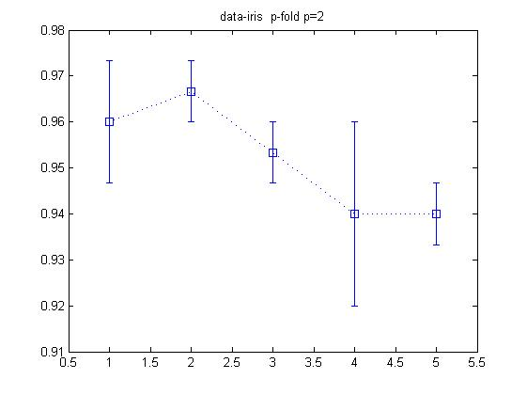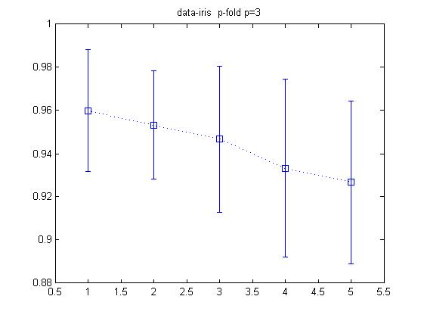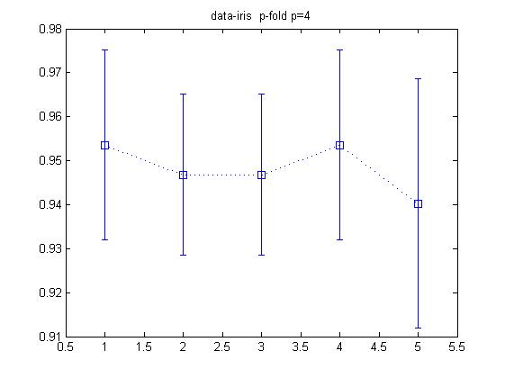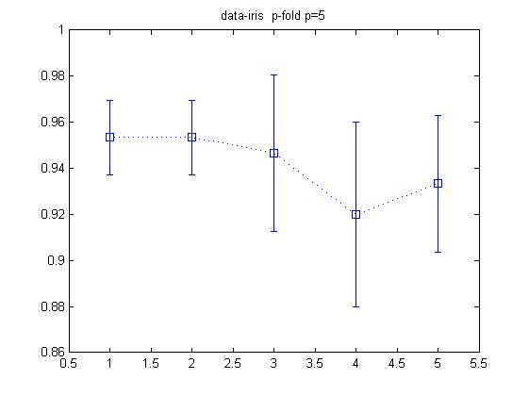

**POKER DATA (Seuclidian distance function)**

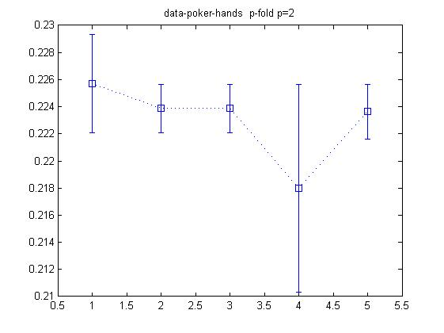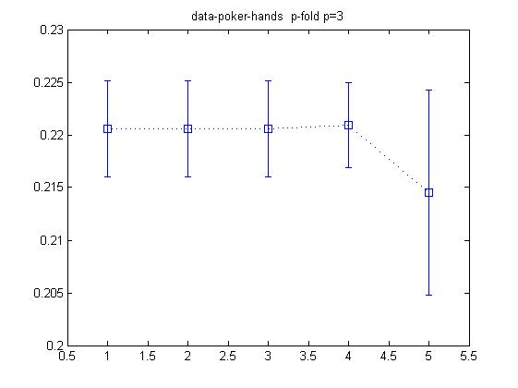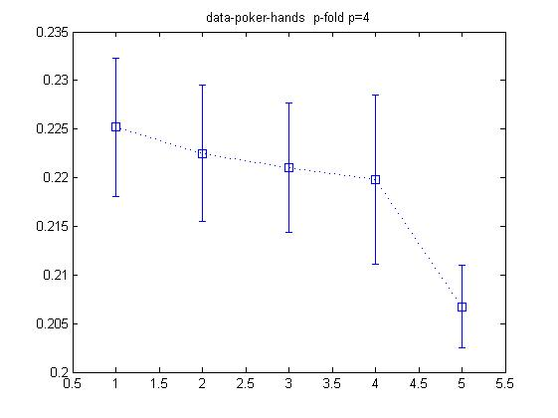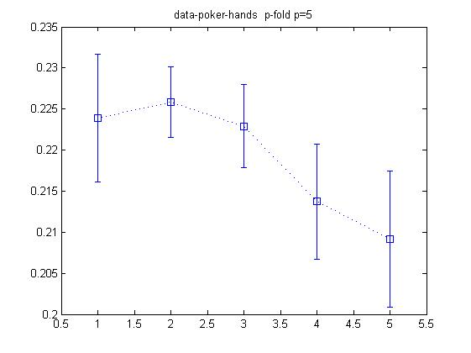

**TIC TAC TOE DATA (Mahalanobis Distance function)**

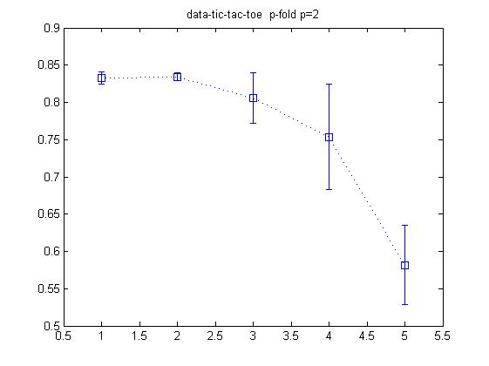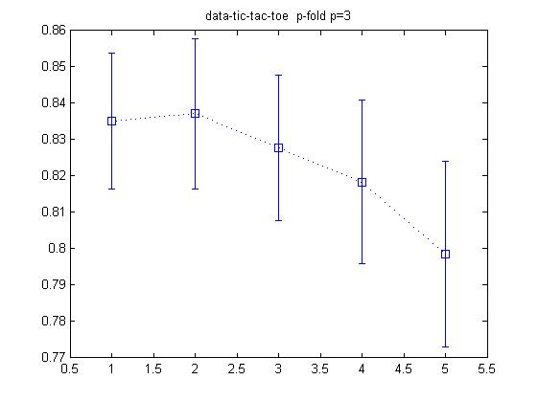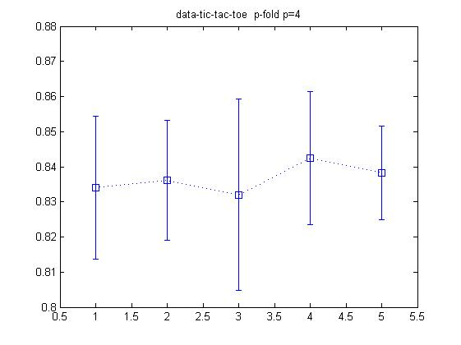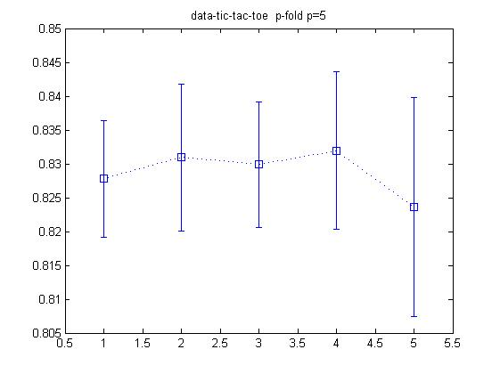

**BALABCE AND WEIGHT DATA (Euclidean Distance function)**

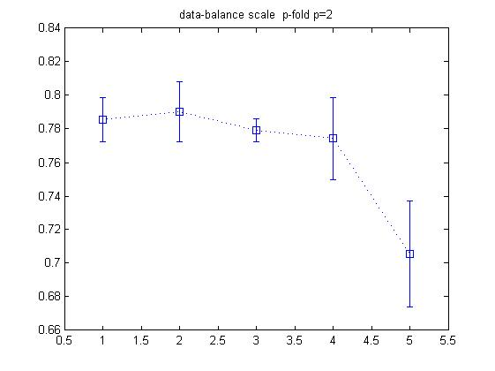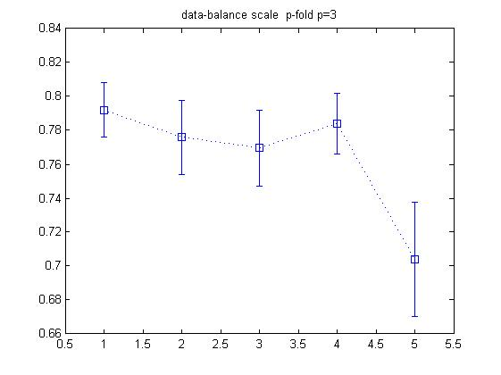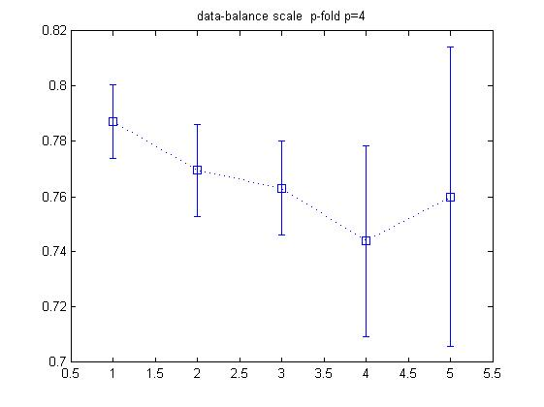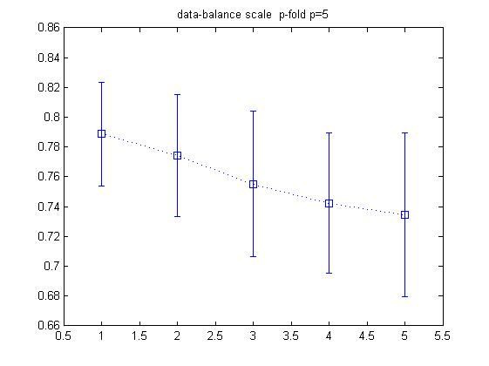

**RESULTS & SUMMARY**

**Distance Function and Variations**

Further table description ::

|  |  |  |  |  |  |
| --- | --- | --- | --- | --- | --- |
|  | K=1 | K=2 | K=3 | K=4 | K=5 |
| P=2 |  |  |  |  |  |
| P=3 |  |  |  |  |  |
| P=4 |  |  |  |  |  |
| P=5 |  |  |  |  |  |

**IRIS DATA**

City-block

0.9333 0.9267 0.9333 0.9200 0.9133

0.9600 0.9333 0.9400 0.9400 0.9400

0.9465 0.9532 0.9399 0.9465 0.9330

0.9400 0.9333 0.9133 0.9200 0.9200

Min :0.91333

Max :0.96

Average :0.93429

Euclidean

0.9600 0.9600 0.9600 0.9400 0.9200

0.9667 0.9667 0.9533 0.9467 0.9267

0.9600 0.9602 0.9401 0.9399 0.9397

0.9533 0.9467 0.9267 0.9133 0.9200

Min :0.91333

Max :0.96667

Average :0.94499

Mahalanobis

0.8400 0.8400 0.8400 0.7933 0.7933

0.8667 0.8800 0.8667 0.8533 0.7667

0.8860 0.8658 0.8793 0.8860 0.8062

0.9200 0.9067 0.8800 0.8600 0.8200

Min :0.76667

Max :0.92

Average :0.8525

Seuclidean

0.9267 0.9200 0.8667 0.8533 0.8333

0.9467 0.9400 0.9200 0.9067 0.8600

0.9403 0.9403 0.9068 0.9001 0.9001

0.9400 0.9400 0.9267 0.9333 0.9067

Min :0.83333

Max :0.94667

Average :0.91037

**TIC-TAC-TOE DATA**

City-block

0.7484 0.7370 0.7140 0.7599 0.7422

0.7192 0.7192 0.7140 0.7036 0.7192

0.7161 0.7161 0.7140 0.7067 0.7140

0.7045 0.7045 0.7035 0.6983 0.7274

Min :0.69828

Max :0.75992

Average :0.71909

Euclidean

0.7484 0.7443 0.7296 0.7338 0.7495

0.7202 0.7182 0.7182 0.7119 0.7265

0.7151 0.7151 0.7140 0.7098 0.7161

0.7088 0.7088 0.7067 0.7057 0.7151

Min :0.70568

Max :0.74948

Average :0.72079

Mahalanobis

0.8299 0.8330 0.8194 0.7651 0.8205

0.8372 0.8414 0.8340 0.8309 0.8152

0.8382 0.8392 0.8392 0.8382 0.8299

0.8361 0.8351 0.8330 0.8288 0.8351

Min :0.76514

Max :0.84135

Average :0.82897

Seuclidean

0.8006 0.7839 0.7704 0.7025 0.6096

0.7933 0.7881 0.7819 0.7537 0.6983

0.8069 0.8058 0.7828 0.7484 0.7233

0.7975 0.7964 0.7714 0.7494 0.7316

Min :0.6096

Max :0.80687

Average :0.7598

**POKER DATA**

City-block

0.2117 0.2154 0.2138 0.2102 0.2015

0.2124 0.2125 0.2179 0.2061 0.2092

0.2096 0.2350 0.2150 0.2157 0.2082

0.2095 0.2277 0.2147 0.2090 0.2033

Min :0.20148

Max :0.23503

Average :0.21292

Euclidean

0.2116 0.2129 0.2093 0.2082 0.2024

0.2081 0.2100 0.2100 0.2057 0.2030

0.2104 0.2124 0.2156 0.2099 0.2045

0.2088 0.2113 0.2117 0.2049 0.2054

Min :0.2024

Max :0.21559

Average :0.20879

Mahalanobis

0.2246 0.2264 0.2268 0.2190 0.2073

0.2240 0.2224 0.2184 0.2180 0.2146

0.2240 0.2254 0.2269 0.2231 0.2119

0.2259 0.2244 0.2242 0.2167 0.2144

Min :0.20732

Max :0.22687

Average :0.22092

Seuclidean

0.2237 0.2248 0.2262 0.2262 0.2262

0.2245 0.2250 0.2177 0.2159 0.2076

0.2246 0.2262 0.2255 0.2230 0.2162

0.2213 0.2205 0.2216 0.2156 0.2114

Min :0.2076

Max :0.22623

Average :0.22119

**BALANCE AND WEIGHT DATA**

City-block

0.7984 0.7744 0.7744 0.7024 0.6624

0.7904 0.7824 0.7824 0.7921 0.7488

0.7888 0.7776 0.7824 0.7664 0.7487

0.7840 0.7648 0.7648 0.7376 0.7312

Min :0.66241

Max :0.79841

Average :0.76273

Euclidean

0.7968 0.7760 0.7344 0.7104 0.6976

0.7744 0.7632 0.7552 0.7488 0.7087

0.7872 0.7712 0.7568 0.7696 0.7361

0.7824 0.7600 0.7584 0.7472 0.7088

Min :0.69761

Max :0.79683

Average :0.75217

Mahalanobis

0.7648 0.7648 0.7264 0.7216 0.7216

0.7712 0.7776 0.7744 0.7712 0.7455

0.7472 0.7505 0.7393 0.7553 0.7393

0.7760 0.7776 0.7600 0.7808 0.7408

Min :0.72159

Max :0.7808

Average :0.75528

Seuclidean

0.7744 0.7744 0.7296 0.7200 0.7200

0.7520 0.7680 0.7520 0.7072 0.7183

0.7665 0.7713 0.7681 0.7248 0.6960

0.7760 0.7744 0.7472 0.7872 0.7664

Min : 0.69604

Max : 0.7872

Average: 0.74969

**GENERAL**

* HIGHER K IN KNN MOVES AWAY FROM REALITY
* K FOLD EVALUATION :: PROVIDES MORE GENERIC RESULTS
* OVERFITTING TO THE PARTICULAR TRAINING DATA
* WRONG CHOICE OF DISTANCE FUNCTION MAY PROVE TO BE FUTILE
* HIGH CLASSIFICATION TIME
* FAST TRAINING

**DATA SPECIFIC**

**IRIS DATA**

* VERY GOOD RESULT WITH ALL DISTANCE FUNCTION
* SIMPLE DOMAIN
* DATA EQUALLY REPSENTED
* LINEAR SEPRABILITY OF ONE CLASS FROM TWO IN EUCLIDEAN SPACE IS KNOWN
* CITY-BLOCK AND EULIDEAN DISTANCE FUNCTIONS ARE THE BEST DISTANCE FUNCTIONS

**TIC-TAC-TOE DATA**

* GOOD RESULTS
* HARD TO CONVERT THE PROBLEM TO KNN AS DEFINNING DISTANCE BEWEEN TWO T’s WHERE T ={‘X’,’O’,B’} IS DIFFICULT
* USE OF DIFFERENT DISTANCE FUNCTIONS MAKES MUCH MORE SENSE HERE
* UNEQUAL DATA REPRSENTAION
* VARIATION IN RESLULTS WITH DIFFERENT DISTANCE FUNCTIONS
* MAHALANOBIS DISTANCE EASILY OUTPERFORMS OTHER FUNCTIONS
* COMPLEX TO UNDERSTAND AS SPACE DIVISION PROBLEM OR TO REALIZE LDF’s

**POKER DATA**

* RESULT IS BAD USING ANY TYPE OF DISTANCE FUNCTION
* A SINGLE HAND SUCH AS FULL HOUSE CAN HAS A LOT OF POSSIBLE CASES
* A LOT OF MATCHING TENDENCY(SIMILARITY) WITH OTHERS SUCH AS FOUR OF A KIND ,THREE OF A KIND TWO PAIRS
* ORIGINAL DATA IS BIGGER AND HERE ONLY A PART OF IT IS USED
* DATA IS HIGHLY UNEQUALLY REPRESENTED
* ALTHOUG ALL DISTANCE FUNCTION BEHAVE VERY POORLY SECLUDIAN SEEMS TO HAVE A LIITLE ADVANTAGE ON THE OTHERS

**BALANCE AND WEIGHT DATA**

* GOOD RESULTS
* SIMPLE PHYSICS PROBLEM
* HARD TO SEPRATE IN SIMPLE KERNEL SPACES(SEEMS INTUTIVE)
* ALL DISTANCE FUNCTIONS PERFORM EQUALLY WELL
* CLASS DISTRIBUTION IN ACTUAL DATA IS UNEQUAL BUT STILL REPRESTS THE DATA FINE ENOUGH

**CodeBase(Matlab)**

% main caller function for each data set

data_iris;

data_poker_hands;

data_tic_tac_toe;

data_balance_scale;

%iris data

%preprocessing

file_id=fopen('Iris.data.txt');

c=textscan(file_id,'%f %f %f %f %s','delimiter',',');

fclose(file_id);

data=zeros(150,4);

for i=1:4

data(:,i)=c{i};

end

results=c{5};

results ( find ((strcmp(results,'Iris-setosa'))==1))= mat2cell(['1']);

results ( find ((strcmp(results,'Iris-versicolor'))==1))= mat2cell(['2']);

results ( find ((strcmp(results,'Iris-virginica'))==1))= mat2cell(['3']);

results=str2num(cell2mat(results));

%results on - folfd knn using the custom myknn function

[mean,deviation]=myknn(data,results,5,5);

%draw plots

for i=1:4

figure

errorbar( mean(i,:) , deviation(i,:) , ':bs');

title (strcat('data-iris p-fold p=',num2str(i+1)) );

end

clear c data results

%poker hands data

%preprocessing

file_id=fopen('poker-hand-training-true.data.txt');

c=textscan(file_id,'%d %d %d %d %d %d %d %d %d %d %d','delimiter',',');

fclose(file_id);

data=zeros(25010,10);

for i=1:10

data(:,i)=c{i};

end

results=c{11};

%results on - folfd knn using the custom myknn function

[mean,deviation]=myknn(data,results,5,5);

%draw plots

for i=1:4

figure

errorbar( mean(i,:) , deviation(i,:) , ':bs');

title (strcat('data-poker-hands p-fold p=',num2str(i+1)) );

end

clear c data results

%tic-tac-toe data

%preprocessing

file_id=fopen('tic-tac-toe.data.txt');

c=textscan(file_id,'%c %c %c %c %c %c %c %c %c %s','delimiter',',');

fclose(file_id);

data=zeros(958,9);

for i=1:9

data(:,i)=c{i};

end

data ( data =='x')=1;

data ( data =='o')=2;

data ( data =='b')=3;

results=c{10};

results ( find ((strcmp(results,'positive'))==1))=mat2cell(['1']);

results ( find ((strcmp(results,'negative'))==1))=mat2cell(['2']);

results=str2num(cell2mat(results));

%results on - folfd knn using the custom myknn function

[mean,deviation]=myknn(data,results,5,5);

%draw plots

for i=1:4

figure

errorbar( mean(i,:) , deviation(i,:) , ':bs');

title (strcat('data-tic-tac-toe p-fold p=',num2str(i+1)) );

end

clear c data results

%balance scale data

%preprocessing

file_id=fopen('balance-scale.data.txt');

c=textscan(file_id,'%s %f %f %f %f','delimiter',',');

fclose(file_id);

data=zeros(625,4);

for i=1:4

data(:,i)=c{i+1};

end

results=c{1};

results ( find ((strcmp(results,'R'))==1))= mat2cell(['1']);

results ( find ((strcmp(results,'B'))==1))= mat2cell(['2']);

results ( find ((strcmp(results,'L'))==1))= mat2cell(['3']);

results=str2num(cell2mat(results));

%results on - folfd knn using the custom myknn function

[mean,deviation]=myknn(data,results,5,5);

%draw plots

for i=1:4

figure

errorbar( mean(i,:) , deviation(i,:) , ':bs');

title (strcat('data-balance scale p-fold p=',num2str(i+1)) );

end

clear c data results

%% p fold k-nn classification %%

%input %

%caution -- all inputs shold be of type double do the necessary pre-processing

%data - n*d matrix : n sample points , d dimensions of a sample point

%gt - n*1 mattrix : ground truth for each corresponding data point

% p_max - 2-p folds

% k_max - k-nearesrt

%output%

function [accuracy,deviation]=myknn(data,gt,k_max,p_max)

[n,d]=size(data);

accuracy=zeros(p_max,k_max);

deviation=zeros(p_max,k_max);

unique_gt=unique(gt);

%partition set via kfold - test and training :: data and gt

for i=2:p_max

c=cvpartition(n,'KFold',i);

observed_result=zeros(k_max,c.NumTestSets);

for j=1:c.NumTestSets

training_data = data ( find ( c.training(j) ) , : ) ;

test_data = data ( find ( c.test(j) ) , : ) ;

gt_training_data = gt ( find ( c.training(j) ) , : );

gt_testdata = gt ( find ( c.test(j) ) ,: );

% k_max minimum distances of each test point from all the training points

[distance,index]=pdist2(training_data,test_data,'euclidean','smallest',k_max);

index=index.';

distance=distance.';

prediction=gt_training_data(index);

% loop in k

for k=1:k_max

temp_prediction=prediction(:,1:k);

temp_distance=distance(:,1:k);

%normalizing the distances in each row

temp_distance=temp_distance./repmat( sum(temp_distance,2),1,k );

predict_mat=zeros(c.TestSize(j),size(unique_gt,1));

predict_mat2=zeros(c.TestSize(j),size(unique_gt,1));

% predict and compare results

for s=1:size(unique_gt,1)

%use normalized distance here

predict_mat(:,s)=histc(temp_prediction,unique_gt(s),2);

for t=1:c.TestSize(j)

r=find ( temp_prediction(t,:) == unique_gt(s) & temp_prediction(t,:) >=0 );

if size(r,2) ~= 0

predict_mat2(t,s)=sum ( temp_distance ( r ) ) /size(r,2);

else

predict_mat2(t,s)=Inf;

end

end

end

%predict_mat

%predict_mat2

%prediction based on

[max_val,final_predicted_k_result]=min(predict_mat2,[],2);

% metrics data storage%

correct_predicted=size(find(gt_testdata==final_predicted_k_result),1);

wrong_predicted=c.TestSize(j)-correct_predicted;

observed_result(k,j)=correct_predicted/c.TestSize(j);

clear temp_prediction temp_distance predict_mat predict_mat2 max_val final_predicted_k_result

end

clear training_data test_data gt_training_data gt_test_data index distance prediction

end

% observed_result

% metric calculation for ith fold %

accuracy(i,:) = mean(observed_result,2);

deviation(i,:)= std(observed_result,1,2);

end

accuracy = accuracy(2:p_max,:);

deviation = deviation(2:p_max,:);