HAMSIKA GOKAVARAPU
25BDS0067
7-7-26
10 python experiments, lab1
1.Odd or even
num= int(input("Enter a number:"))
if num % 2==0:
print(f"{num} is Even")
else:
print(f"{num} is Odd")
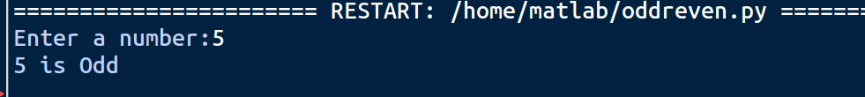
2.Calculator
a=float(input("Enter num1:"))
b=float(input("Enter num2:"))
op=input("Enter operator")

if op=='+':
print (a+b)
elif op=='-':
print (a-b)
elif op=='*':
print (a*b)
elif op=='/':
print (a/b)
else: print ("invalid")
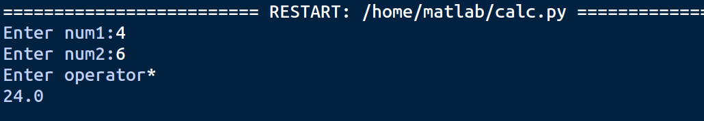

3.Factorial
num = int (input("Enter a number:"))
fact = 1
for i in range (1, num+1):
fact *=i
print(f"Factorial of {num} is {fact}")
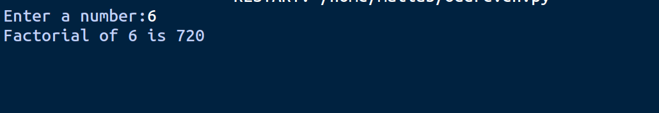
4.Fibbonaci
n = int(input("How many terms?"))
a,b=0,1
for _ in range (n):
print (a, end="")
a,b=b,a+b
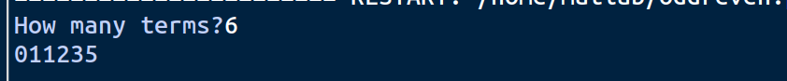
5.Prime Number Checker
num = int (input("Enter a no:"))
isprime = num >1
for i in range (2, int(num **0.5) + 1):
if num % i==0:
isprime=False
break
print(f"{num} is {'Prime' if isprime else 'Not Prime'}")
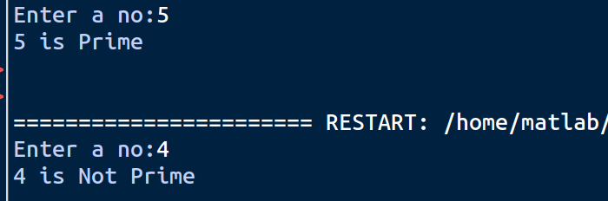

6.Pallindrome
s = input ("Enter a string:")
cleaned= s.lower().replace(" ","")
if cleaned == cleaned [::-1]:
print ("Pallindrome")
else:
print("Not a pallindrome")

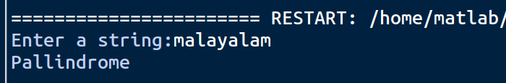
7.Sum of digits
num = int (input("Enter a number:"))
total = 0
temp = num
while temp>0:
total += temp % 10
temp //=10
print(f"Sum of digits : {total}")
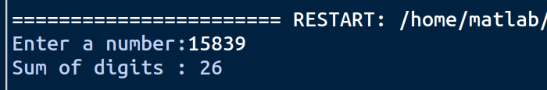
8.Simple interest calculator
p= float (input("Enter principal amount:"))
r= float (input("Enter Rate of interest:"))
t= float (input("Enter Time period:"))
interest = (prt)/100 print(interest)

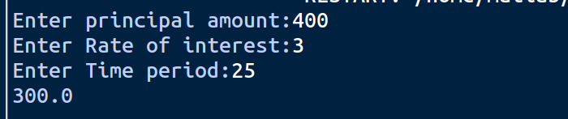

9.Reverse a number
num = int(input("Enter a number:"))
reversed_num = 0
temp = num
while temp >0:
reversed_num = reversed_num*10 + temp % 10
temp //=10
print(f"Reversed number:{reversed_num}")

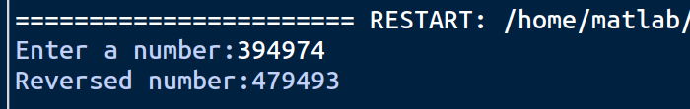

10.Armstrong Number checker
num= int(input("Enter a number:"))
temp = num
digits = len(str(num))
total=0
while temp > 0:
digit = temp % 10
total += digit ** digits
temp //= 10
print(f"{num} is {'an Armstrong number' if total == num else 'not an Armstrong number'}")
