# Vityarthi Delivery Agent – Assignment Report

## 1. Introduction

This report presents the implementation and evaluation of search-based planners (UCS, A*, Local Search) for a delivery agent navigating static and dynamic obstacles.

## 2. Algorithms

* **UCS**: guarantees optimal path, but slow.
* **A**\*: efficient using admissible heuristics.
* **Local Search**: hill climbing with random restarts, useful for dynamic replanning.

## 3. Experiments

We tested planners on the given maps using the simulation framework.

### 3.1 Results Table

| map | planner | path_found | path_cost | nodes_expanded | planning_time_ms | sim_steps | collisions |
| --- | --- | --- | --- | --- | --- | --- | --- |
| map_small.txt | UCS | True | 8 | 21 | 0.1885 | nan | nan |
| map_small.txt | A* | True | nan | nan | nan | 8 | 0 |
| map_small.txt | LocalSearch | True | nan | nan | nan | 8 | 0 |
| map_dynamic.txt | UCS | True | 9 | 33 | 0.3828 | nan | nan |
| map_dynamic.txt | A* | True | nan | nan | nan | 9 | 0 |
| map_dynamic.txt | LocalSearch | True | nan | nan | nan | 9 | 0 |

### 3.2 Plots

Steps vs Planner:

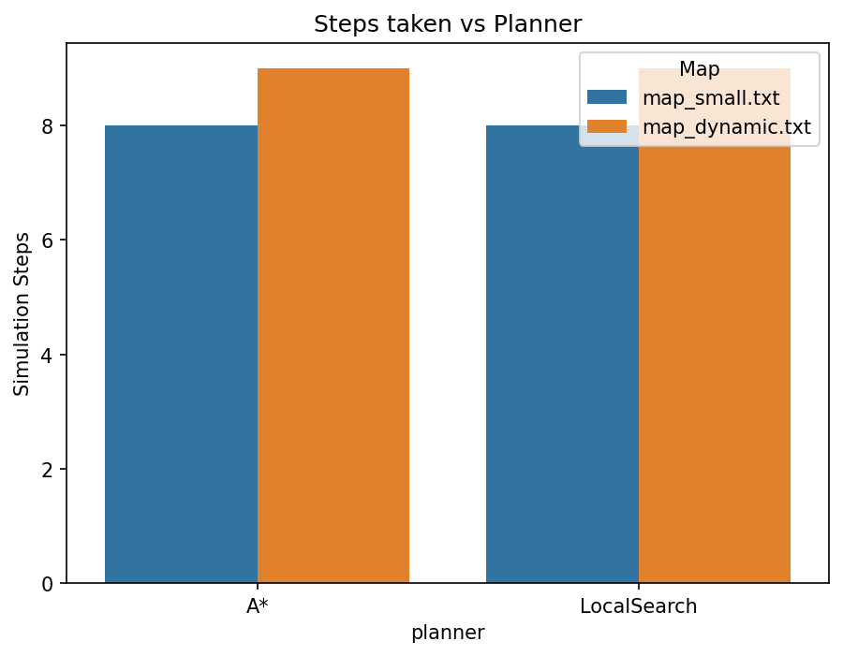

Steps vs Planner

Collisions vs Planner:

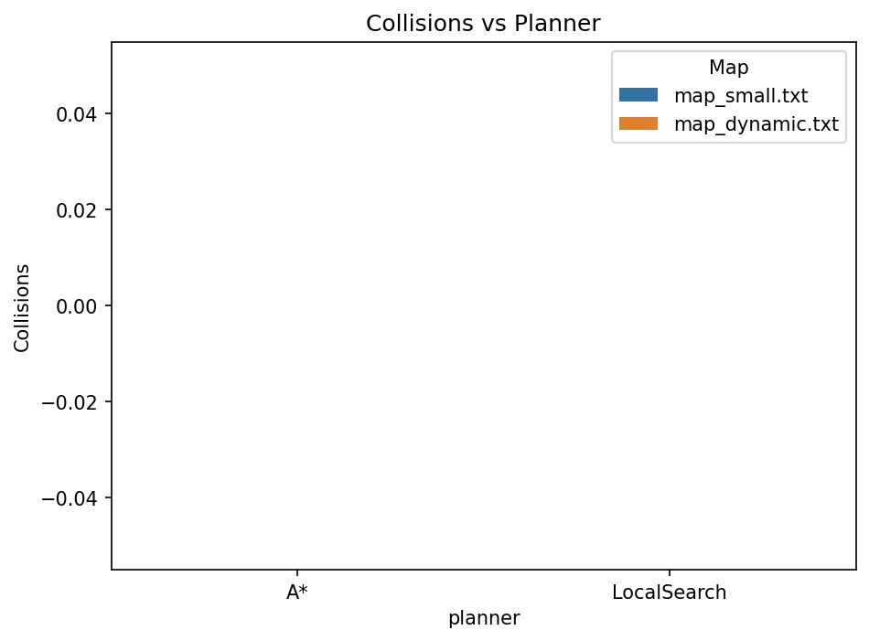

Collisions vs Planner

Planning Time vs Planner:

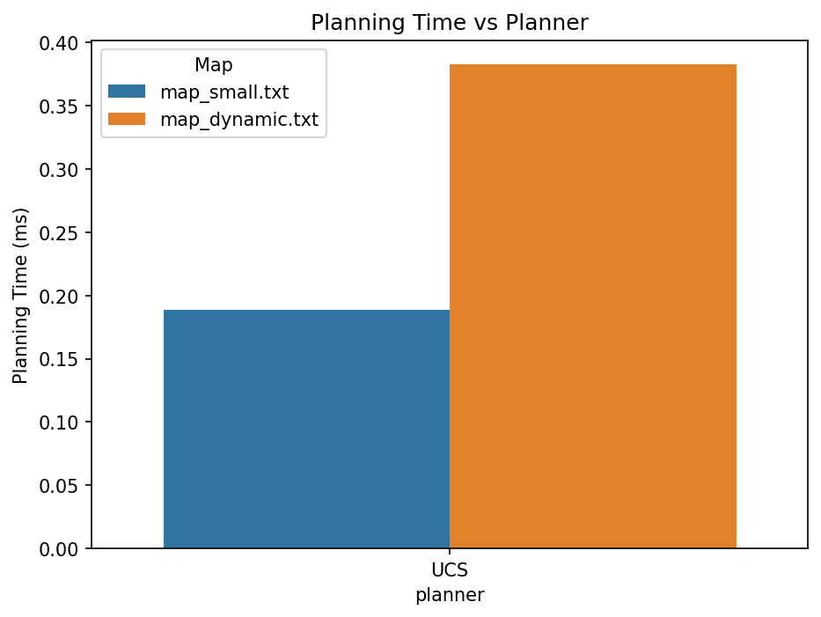

Planning Time vs Planner

## 4. Discussion

* **UCS** is correct but scales poorly.
* **A**\* balances speed and accuracy.
* **Local Search** replans quickly and adapts to dynamic maps.

## 5. Conclusion

A* is best for static maps, while Local Search helps in dynamic environments. Future work: multi-agent coordination, larger maps, advanced heuristics.