ChatGPT acquired 1 million users just 5 days after launching in November 2022. By comparison, it took Instagram approximately 2.5 months to reach 1 million downloads. And Netflix had to wait around 3.5 years to reach 1 million users.

ChatGPT, the popular chatbot from OpenAI, is estimated to have reached 100 million monthly active users in January, just two months after launch, making it the fastest-growing consumer application in history, according to a UBS study on Wednesday.

The report, citing data from analytics firm Similarweb, said an average of about 13 million unique visitors had used ChatGPT per day in January, more than double the levels of December.

"In 20 years following the internet space, we cannot recall a faster ramp in a consumer internet app," UBS analysts wrote in the note.

it took Instagram two and a half years to get to 100 million. TikTok got there in nine months. according to data from Sensor Tower.

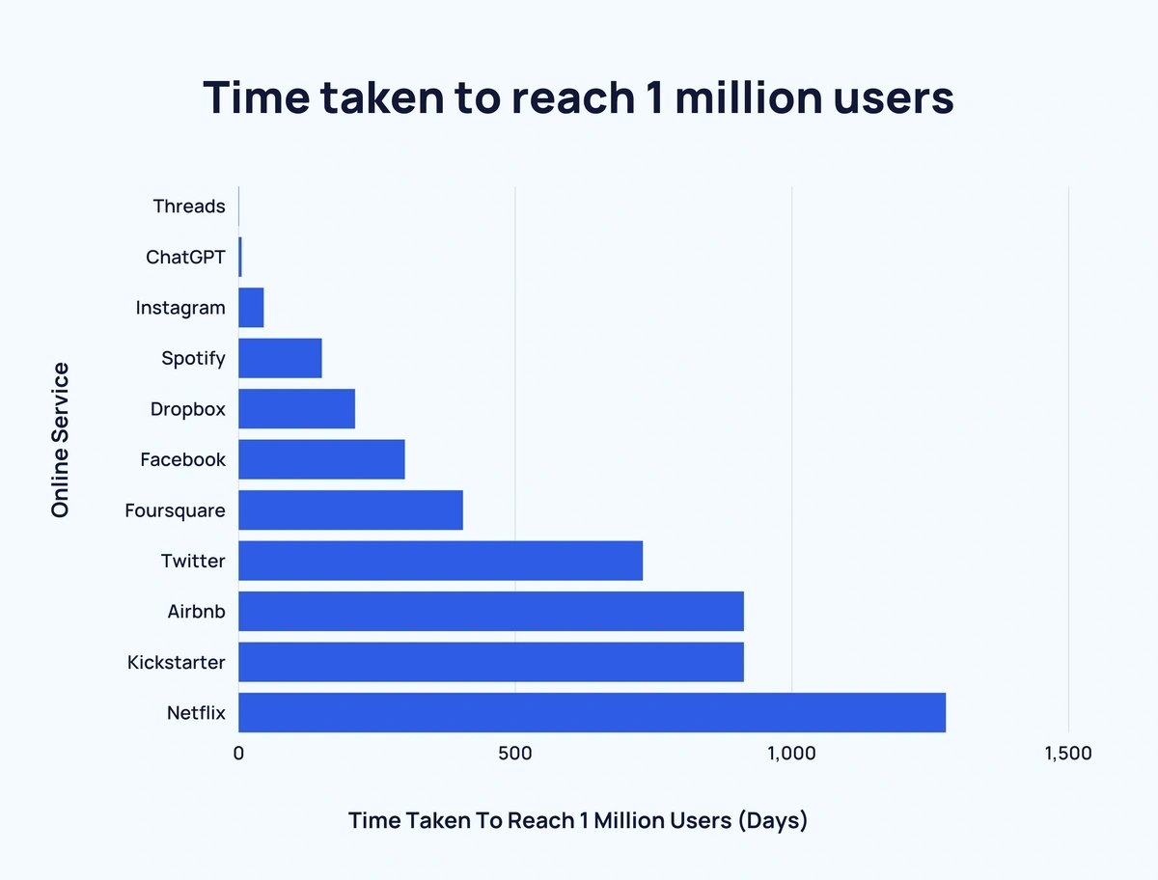

This made it the fastest-growing application in history until Threads took that crown in July 2023.It took 1 hour to reach 1 million users.

What is ChatGPT?

ChatGPT is a chatbot created by the San Francisco company OpenAI. Known as a generative AI, it responds to virtually any prompt you give it with startling speed and clarity. Whereas many chatbots only know how to respond to certain keywords or triggers, ChatGPT can respond to complex questions and spit out comprehensive, essay-length answers on virtually any topic.

ChatGPT is able to do this by running the Internet’s vast amounts of data through powerful neural networks: software loosely designed on neurons in the human brain. This technology has existed for several years. Yann LeCun, the chief AI scientist at Meta, recently argued that ChatGPT was “not particularly innovative” and relied largely on Google’s Transformer neural net technology unveiled in 2017.

“Most of us are pretty surprised” about the explosive popularity of ChatGPT, admits Margaret Mitchell, the chief ethics scientist at the AI company Hugging Face. “The technology wasn’t putting forth any sort of fundamental breakthroughs.”

But ChatGPT was the first major project to roll out such an AI for the public to use, play with, and break. Other companies like Google held theirs back due to the unpredictability of this new technology and the potential harms it could cause, like the spreading of misinformation or hate speech. OpenAI, meanwhile, chose to rush their product to market this fall in the face of potential looming competition, according to the New York Times.

While ChatGPT is underpinned by complex technology, its visual interface is incredibly intuitive: you simply enter text into a text box, just like you would on Google. This streamlined interface has allowed people of all ages and backgrounds to instantly engage with it. Another one of ChatGPT’s strengths is its flexibility. If you don’t like its response to your prompt, you can tweak your suggestion, and the AI will adjust accordingly.

New Research Papers by Open AI:

It mentions ,AI would critique another AI answers, to find bugs.In critiques comparison they found that AI was able to find a lot more bugs than human in a test.As shown in graph below

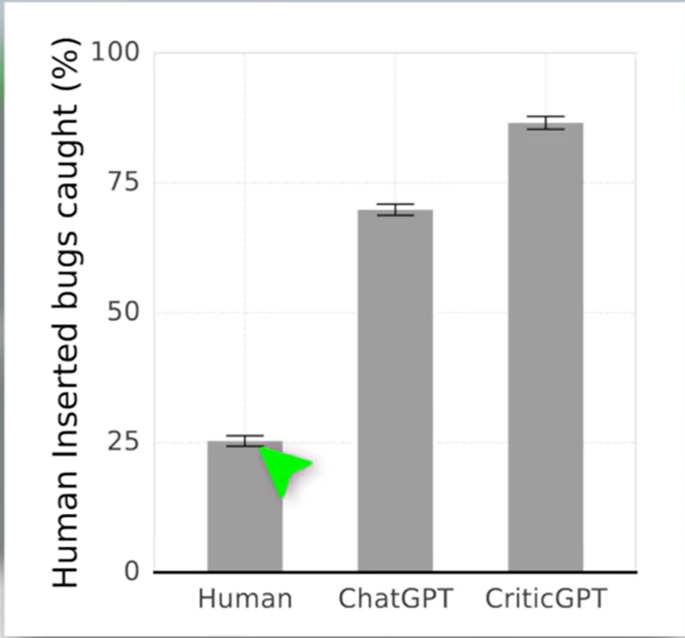

Also in comprehensiveness AI wins:

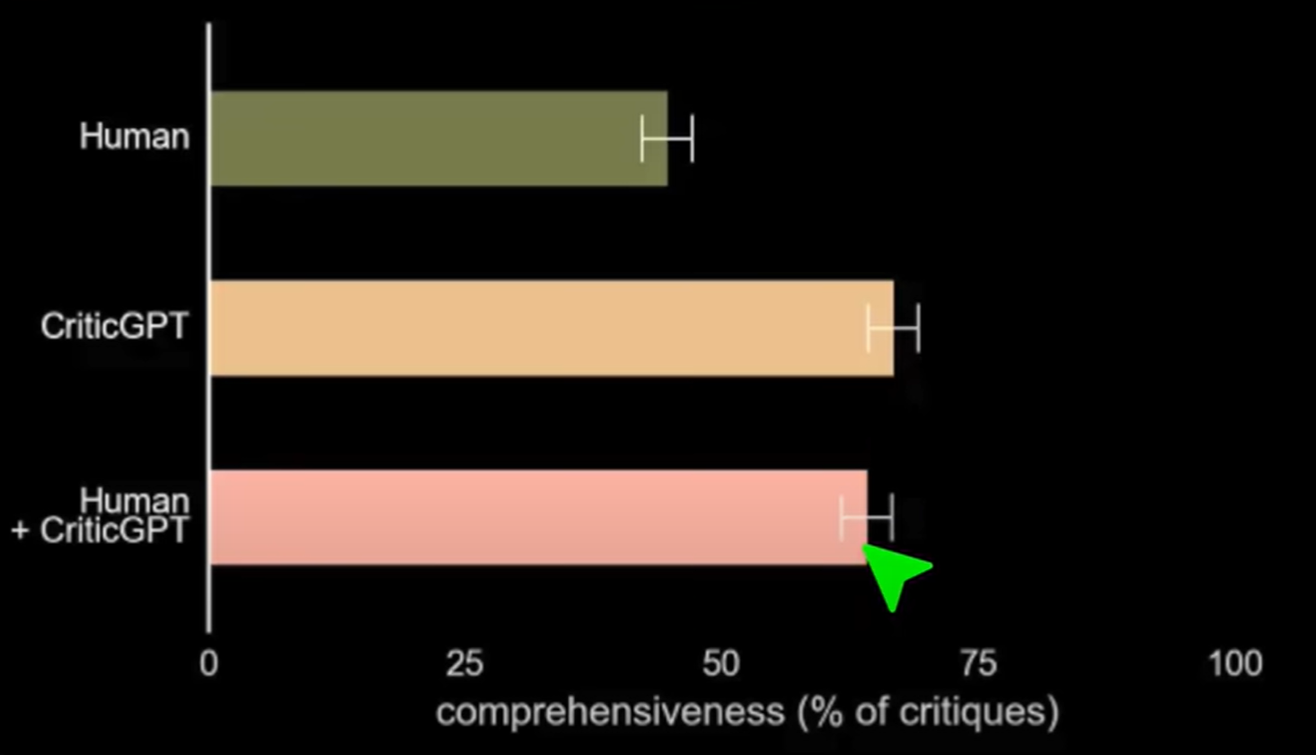

But there is an issue in AI that it hallucinates more than human:

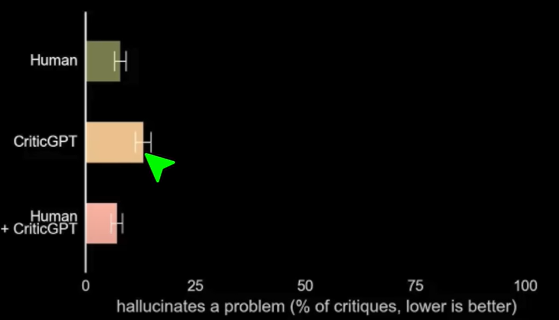

Limitations:

CriticGPT is trained on ChatGPT answers which are quiet short , it still hallucinates and still fails in solving complex problems.

# How Google uses AI into its products:

The past few years have seen huge breakthroughs in the use and application of artificial intelligence — and AI holds major promise for people around the world. AI already powers Google’s core products that help billions of people every day. Whether it’s asking for movie times, finding the nearest doctor or finding better routes home — our work in AI is centered on making everyday experiences more helpful.

We’ve been developing AI for more than two decades. Some of our most popular products at Google — like Lens and [Translate](https://blog.google/products/translate/24-new-languages/) — were built entirely using artificial intelligence technologies like optical character recognition and machine learning. And countless other Google products now have AI built into them, and are far better and more helpful to billions of people as a result.

Many of these improvements are possible thanks to our invention of [Transformer](https://ai.googleblog.com/2017/08/transformer-novel-neural-network.html) in 2017. Considered the grandparent of [modern language models](https://blog.google/technology/ai/understanding-the-world-through-language/), we’re now able to build AI language models (like [BERT](https://ai.googleblog.com/2018/11/open-sourcing-bert-state-of-art-pre.html), [PALM](https://ai.googleblog.com/2022/04/pathways-language-model-palm-scaling-to.html), [MUM](https://blog.google/products/search/introducing-mum/), and [LaMDA](https://blog.google/technology/ai/lamda/)) on top of this architecture that can do everything from solve complex math word problems, answer questions in new languages, and express their reasoning through words using [chain of thought](https://ai.googleblog.com/2022/05/language-models-perform-reasoning-via.html) prompting.

Here are nine ways we use AI, today, to make our products even more helpful.

1. **Search.** When Google was founded, most searches happened on computers in homes, computer labs or libraries. Twenty-five years later, AI is making it possible to search in new languages, with new inputs (like searching with your [camera](https://lens.google/), or even [humming a tune](https://blog.google/products/search/hum-to-search/)) and even multiple inputs at once. Thanks to [multisearch](https://blog.google/products/search/multisearch/), you can now search with images and text at the same time with the Google App. So next time you’re inspired by an interesting wallpaper pattern, you can just snap a photo and add text to find that pattern on a shirt.
2. **Maps.** The AI behind Google [Maps](https://blog.google/products/maps/google-maps-101-how-ai-helps-predict-traffic-and-determine-routes/) analyzes data to provide up-to-date information about traffic conditions and delays — sometimes helping you avoid a traffic jam altogether. It also automatically updates things like [business hours and speed limits](https://blog.google/products/maps/how-ai-and-imagery-build-self-updating-map/) so you can see the latest information about your world every single day.
3. **Pixel.** AI helps your Pixel phone instantly translate between 21 languages in chat, as well as facilitate a verbal conversation between 6 different languages in Interpreter Mode. It’s also what enables [Magic Eraser](https://blog.google/products/photos/magic-eraser/) to remove distractions from photos.
4. **Photos.** People take a lot of photos but an abundance of pics makes it easy for memories to get buried. So back in 2015, we developed AI in Google Photos to help you search for photos by [what’s in them](https://blog.google/products/photos/picture-this-fresh-approach-to-photos/). And more recently, we’ve used AI in Photos to help you revisit forgotten “[Memories](https://blog.google/products/photos/new-memories-features-look-back/).”
5. **YouTube.** YouTube uses AI to automatically generate captions for videos, making them more accessible to a wider audience, including those who are deaf or hard of hearing.
6. **Assistant.** Human beings speak like…human beings. For a long time, computers did not. The Natural Language Processing (NLP) AI technology developed for Assistant allows it to understand and respond in a way that mimics human communication — which allows it to parse the text of your question that tries to identify the meaning of your question. So AI is what enables your phone, your Home, your TV, or your car to understand what you mean by “[Hey Google, where's the closest dog park](https://blog.google/products/assistant/ask-a-techspert-assistant-questions/)” — and quickly get you directions.
7. **Gmail**. We’re all familiar with features like autocomplete and spell check, both of which are powered by AI. But if you’ve ever wondered why Gmail is less spammy than other email services — look to AI. Our spam-filtering capabilities are powered by AI, and they block nearly 10 million spam emails every minute — and prevent more than 99.9% of spam, phishing attempts and malware from reaching you.
8. **Ads.** Large and small businesses all over the world rely on Google Ads to find customers and grow their businesses, and we make that even easier with AI. As one example, through [Performance Max](https://blog.google/products/ads-commerce/performance-max/), advertisers simply tell us their campaign goals and share their creative assets, and AI will automatically produce and run a highly effective ad campaign across all of Google’s properties, to meet their budget. We’re also using AI to automatically [reformat landscape video ads](https://blog.google/products/ads-commerce/vertical-video-youtube/) into vertical or square ads, based on what someone is watching on YouTube.
9. **Cloud.** Lastly, while we’re very excited at the ways AI is improving our products — we’re equally excited to put the power of AI in other businesses’ hands, so they can transform the way they work and operate. Google Cloud has built AI into countless solutions that our customers can customize for their unique needs, such as DocAI for document processing, Contact Center AI for call center operations, Vertex Vision AI for video and image analysis, Translation Hub for translation in 100+ languages at scale, and many other exampaaa

# AI used by Youtube:

**Automatically remove objectionable content**

In the first quarter of 2019, 8.3 million videos were removed from YouTube, and 76% were automatically identified and flagged by AI classifiers. More than 70% of these were identified before there were any views by users. While the algorithms are not foolproof, they are combing through content much more quickly than if humans were trying to monitor the platform singlehandedly. In some cases, the algorithm pulled down newsworthy videos mistakenly seeing them as “violent extremism.” This is just one of the reasons Google has full-time human specialists employed to work with AI to address violative content

In the first quarter of 2020, 49.9% of the videos that were removed from youtube, had 0 views, 29.4% of videos had only 1–10 views and 22.7% of the videos had more than 10 views. AI is the one who made this possible. Among the removed videos, 1021380 videos belonged to United States, 826661 videos were from India, 484536 videos from Brazil and many other countries are there.

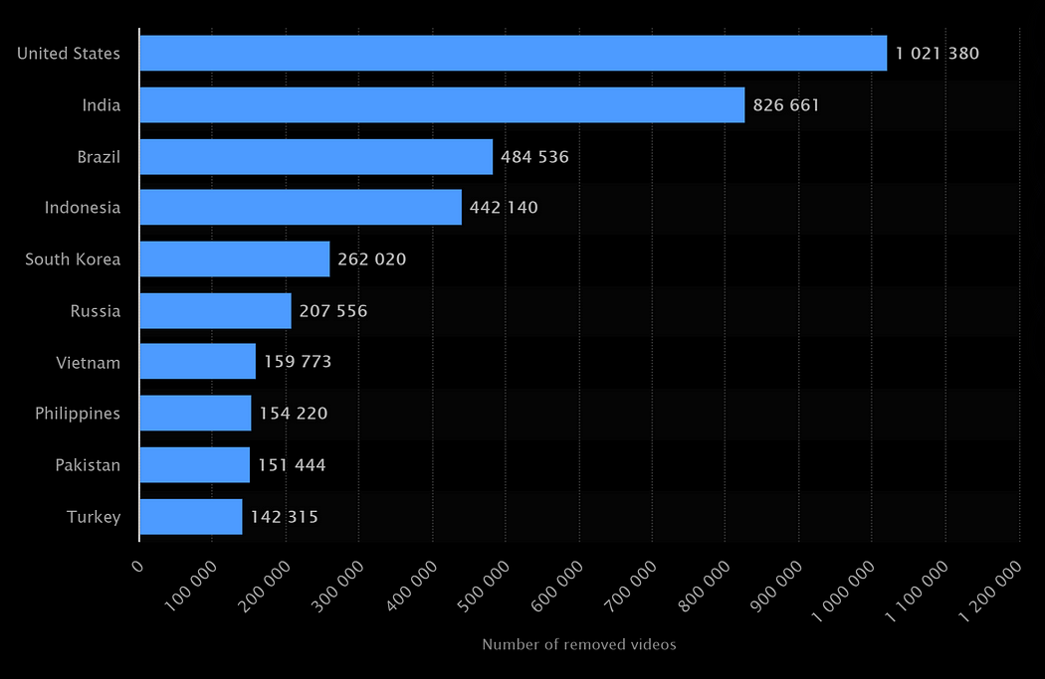

YouTube’s top priority is to protect its users from harmful content. In pursuit of that, the company invested in not only human specialists but the machine learning technology to support the effort. AI has contributed greatly to YouTube’s ability to quickly identify objectionable content. Before using artificial intelligence, only 8% of videos containing “violent extremism” were flagged and removed before ten views had occurred; but after machine learning was used, more than half of the videos removed had fewer than ten views.

# Pressure from brands:

One of the main drivers for YouTube’s diligence in removing objectionable content is the pressure from brands, agencies, and governments and the backlash that’s experienced if ads appear alongside offensive videos. When ads started appearing next to YouTube videos supporting racism and terrorism, Havas UK and other brands began pulling their advertising dollars. In response, YouTube deployed advanced machine learning and partnered with third-party companies to help provide transparency to advertising partners. Google is working with third-party companies to make sure YouTube content is safe for brands while also deploying advanced machine learning to better identify content that might be deemed offensive to

**Up Next - feature**

If you have ever used YouTube’s “Up Next” feature, you benefited from the platform’s artificial intelligence. Since the dataset on YouTube is constantly changing as its users upload hours of video every minute, the AI required to power its recommendation engine needed to be different than the recommendation engines of Netflix or Spotify. It had to be able to handle real-time recommendations while new data is constantly added by users. The solution they came up with is a two-part system. The first is candidate generation, where the algorithm assesses the YouTube history of the user. The second part is the ranking system that assigns a score to each video.

YouTube has one of the largest and most advanced recommendation systems in the industry. As one of the world’s leading websites, to satisfy its customers it must recommend relevant videos. YouTube is slightly different than other services that utilize recommendation systems(i.e Netflix, Spotify) because users upload thousands of hours of video to the platform every second. YouTube’s corpus is constantly changing, and they aren’t in control of the content being added. This creates the need for a robust model that can handle constant incoming data and will output quality recommendations in real time. The model below is the author’s response to this need.

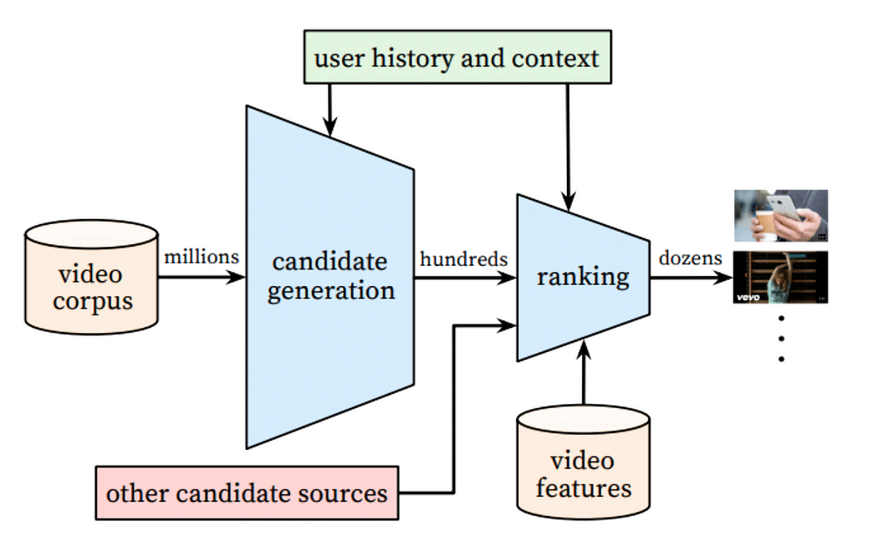

The Recommendation System’s Architecture

The recommendation system they designed has two stages. The first being a neural network for candidate generation and the latter for ranking.

viewers and advertisers.

# How Netflix Uses Personalize Recommendations:



Netflix is a widely loved streaming service, and it owes much of its popularity to its personalized content suggestions. Here is how it works in simple terms: Netflix employs artificial intelligence (AI) to keep an eye on what each users watches, what they like and what they rate highly. Then based on this information, it suggests other shows and movies that users are likely to find interesting. This personalized tough is a big reason why Netflix is such a hit!

In simple terms, you can think of Netflix’s AI as your personal T.V match maker. It understands, your viewing preferences and uses that knowledge to help you find movies and shows that you would love.

Netflix’s AI is pretty good at its job. In fact, back in 2016, Netflix CEO Reed Hastings mentioned that “[Over 75% of what people watch on Netflix is discovered through our recommendation system.”](https://www.businessinsider.com/netflixs-recommendation-engine-drives-75-of-viewership-2012-4)

Fast forward to 2020, Netflix revealed [that 80% of the content viewed on the platform comes from these personalized recommendations.](https://www.wired.co.uk/article/how-do-netflixs-algorithms-work-machine-learning-helps-to-predict-what-viewers-will-like)

**So how does Netflix’s AI work?**

Here’s a simplified overview:

* Netflix tracks what you watch, how long you watch it, and whether you finish it.
* Netflix then figures out what kinds of shows and movies you are into, like genres, theme, and actors you prefer.
* Netflix then rates each show and movies based on the factors like popularity, user ratings, and how well they match your taste.
* Netflix then uses this information to create a custom list of recommendations just for you.
* Netflix relies on advanced machine learning algorithms to analyze data and produce suggestions. These algorithms can spot patterns and trends in user actions that would be challenging for humans to detect.
* Netflix considers various factors when making recommendations, such as:
* What shows and movies have you watched in the past?
* How long did you watch them for?
* Did you finish them?
* What ratings have you given to shows and movies?
* What shows and movies have other users with similar preferences watched?
* How popular are different shows and movies?

***In simple terms, Netflix AI keeps getting smarter as you watch more content. It learns from your choices and becomes better at suggesting shows and movies that you’ll like.***

**What are the benefits of AI for Netflix and its users?**

There are many benefits of AI for Netflix and its users. For Netflix, AI boosts user engagement and keeps them from leaving the platform. When users regularly discover the content they love, they are more likely to stay. For users, AI makes it easy to find the content they enjoy and saves them time through scrolling through Netflix’s library.

**Advancing Artificial Intelligence at Facebook**

The world’s largest social networking platform has been using AI for years, and they continue to innovate to try to solve problems for users and make the experience even better. Here are a few of their recent innovations:

* **Detecting deepfakes** – Facebook has been working hard on detection models for deepfake content, and now they are speeding up their efforts. The company recently launched a [Deepfake Detection Challenge](https://ai.facebook.com/blog/deepfake-detection-challenge/) (DFDC), and the top-performing AI model in the challenge could detect artificial videos with 82.56% accuracy.
* **Instant translation** – Facebook is using applied machine learning to enable (and continually improve) automatic translation of specific posts within users’ news feeds.
* **Image recognition** – Although users have enjoyed Facebook’s image recognition features for a long time, the company continues to improve on the software so users can easily search through photos without having to rely on tags or surrounding text.
* **Helping visually impaired people** – With the help of AI and deep learning, Facebook engineers are creating “talking pictures” that speak the content of a photo out loud, so visually impaired users can have a better experience on the platform.
* **Preventing suicide** – The Facebook technology can look for signs of trouble in users’ posts and comments from friends, then generate alerts and help people in crisis.

**A Better VR Experience**

Facebook recognized the need for better technology to unlock the full potential of augmented reality (AR) and virtual reality (VR), so they created the [Oculus Quest](https://ai.facebook.com/blog/powered-by-ai-oculus-insight/), a 100% wire-free VR system.

Oculus Quest’s cutting-edge AI software calculates users’ positions and movements every millisecond, then translates those movements into VR. This new technology reduces or eliminates some of the problems associated with previous VR headsets, like visual stuttering, latency, jitter, and swimminess.