Day 1:
https://www.youtube.com/watch?v=vG824vBdYY8&ab_channel=CoderFoundry

Setting the main functionalities of the web app (what should it allow the user to do):

Concept: You have projects. A project is a collection of tickets. Tickets can be, requests, issues or bug reports etc.

Users can be assigned to projects. Users roles can be managed within a project. Tickets can be assigned to users.

-Log in
-Create projects
-Add users to projects
-Manage user roles to projects
-Post tickets to projects
-See tickets from projects
-Sort tickets by tags, priority etc
-Search tickets
-Close tickets
-Assign users to tickets
-Set deadlines for tickets
-Create new tags
-Comment under tickets

Layout of the software:

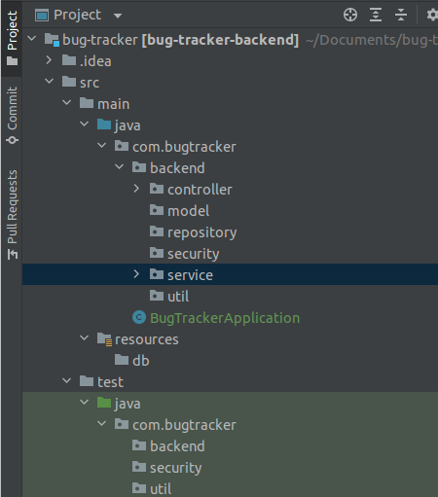

Controller --> This is where we will be mapping the URL addresses of the web service.
This is where we handle incoming requests by the client.
e.g.: get request from URL: domain/bug/{bugId}.

We could write a method that receives this request, understands the bugId variable, pulls the details of the bug from the database, formats it into an object(model) and returns the necessary data to the front end to be displayed.

The controller is the brain, this is where the logic takes place using the “tools/methods” we put in mainly [service].

Model --> This is where the classes which are going to be mapped to tables in the database go. As well as enums.

Repository --> Everything that requires communication with the database goes here. Such as queries. This is the access point to the database of the project.

Security --> All things related to Auth0, ignore for now

Service --> This is where methods that we will be using in controller go.
Example:
GetBug(@NoNull long bugId);
FindAllIssuesByGroup(@NoNull long Id);
So this is where methods for requests are built. Service communicates with the [repository] && [model] to either format and return data or edit/delete data on the database

Util --> Every other methods needed. Basically just generic stuff like a validation method for validating some input in service etc.

This is not final
General work flow
Client
Controller
Repository
Model
Service
Util
Model
Controller
View
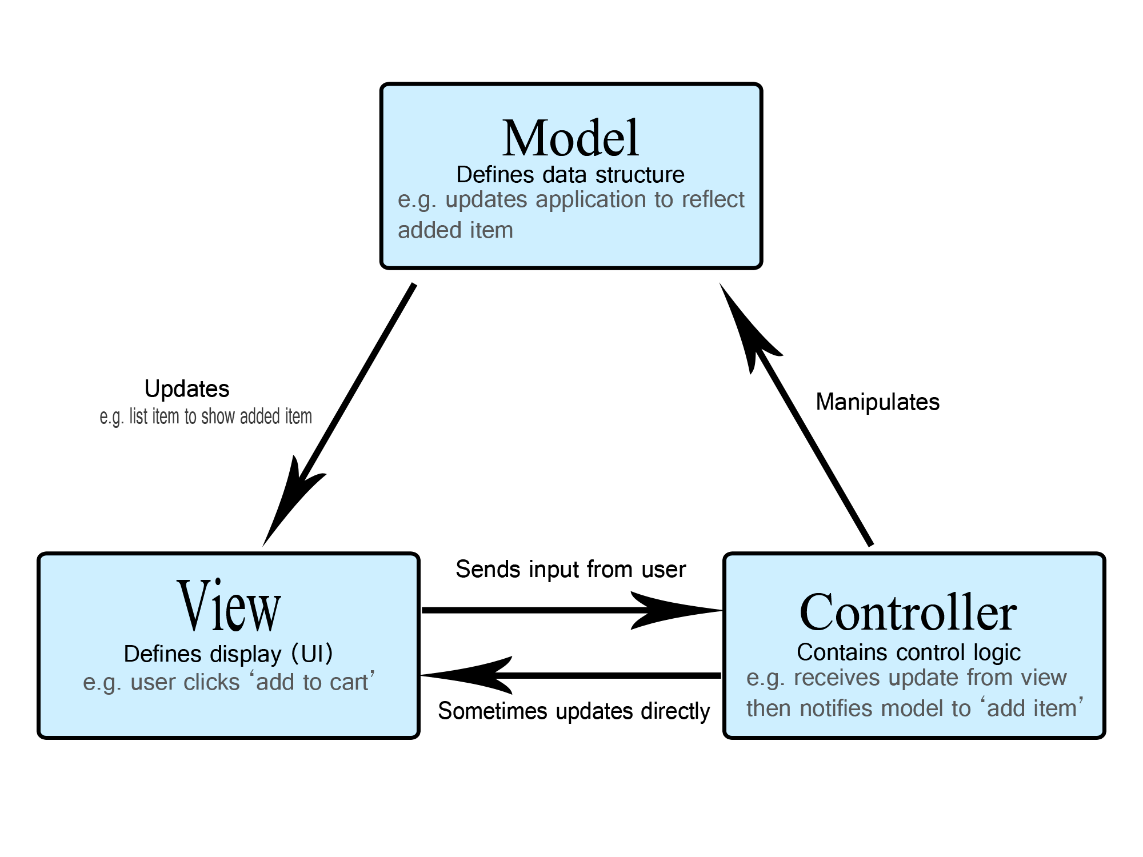

Database layout

What do we need?

-User table
-Roles table
-Project table
-Ticket table
-Comments table
-Priority table
-Tags table
-ticket history table
-attachments table

User table

userId | Name | Email | roleId | phoneNo
1 | Geri | something@gmai | foreignk | 077800

Roles table
roleId | roleName
1 | Admin

Project table
projectId | Name | Description | Open | Date started | priorityId | Picture(maybe)
1 | Web app | A cool app | bool

Ticket table
ticketId | projectId | submittedUser | title | description | created | assignedUser | toBeFinished | priorityId | Status | updated

Comment table
commentId | ticketId | userId | comment

User – role and project table (assigned role of user for each project)
userId | projectId | roleId

Priority table
priorityId | Name

Tag table
tagId | name

tag – ticket connecting table
tagId | ticketId

ticket history table
historyticketId | ticketId | property | old value | new value | Date changed

attachment table

attachmentId | ticketId | description | filePath

