AI Pioneers Internship
Week 1 — Python for Machine Learning & Data Preprocessing
Adult Census Income: Data Preprocessing and Exploratory Analysis
Student Name: ______________________________
Machine Learning Internship | 15 September 2026

1. Introduction
This Week 1 project builds a reproducible preprocessing workflow for the UCI Adult Census Income dataset. The work concentrates on the data decisions that precede modelling: inspecting structure, identifying quality issues, treating incomplete values, representing nominal variables, selecting a compact feature set, and standardizing numerical inputs. No predictive model is trained; the final dataset is prepared for a future downstream machine-learning task.

2. Internship Objectives
- Understand the fundamentals of Machine Learning using Python.
- Learn data loading, cleaning, handling missing values, feature selection, encoding categorical variables, normalization, and exploratory data analysis using Pandas and NumPy.
- Deliverable: Clean and preprocess a sample dataset and document each preprocessing step.

3. Dataset Overview
The Adult Census Income dataset was obtained from the UCI Machine Learning Repository. It was derived from 1994 U.S. Census Bureau data and is commonly used to study whether annual income exceeds $50,000. The raw UCI training and test files were combined only for this preprocessing exercise, yielding 48,842 rows and 15 columns. The source uses '?' as an explicit missing-value marker; the loader converts it to a proper missing value without changing the original files. UCI identifies the dataset as donated by Ronny Kohavi and Barry Becker and links its provenance to Census Bureau data.
Source: https://archive.ics.uci.edu/dataset/2/adult (UCI Machine Learning Repository). The project retains the original files in data/raw and records the source in the README.

4. Initial Data Assessment
The raw combined data contains 48,842 observations and 15 columns. It contains numerical fields (age, sampling weight, education number, capital gain/loss, and weekly hours), nominal demographic/work fields, and the binary income label. 52 exact duplicate rows were found. The sampling-weight field (fnlwgt) was treated as a survey-design weight rather than a person-level predictor.

5. Exploratory Data Analysis
EDA was deliberately limited to plots that support a preprocessing decision. The missingness chart identifies the fields requiring treatment; occupation frequency exposes the categorical distribution; numerical distributions show the large scale differences that motivate standardization; and the correlation heatmap confirms that education and education_num describe the same underlying level.
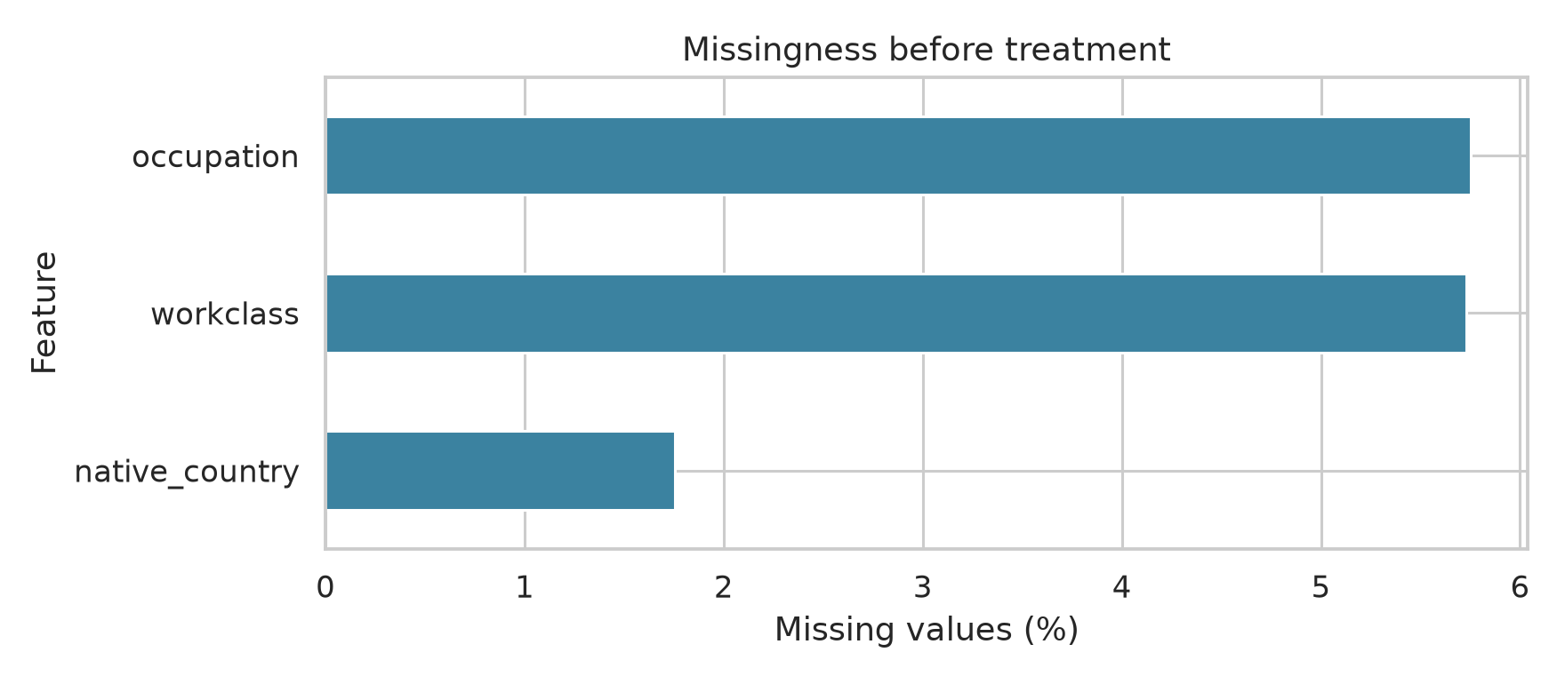
Figure 1. Missingness is concentrated in three categorical fields.
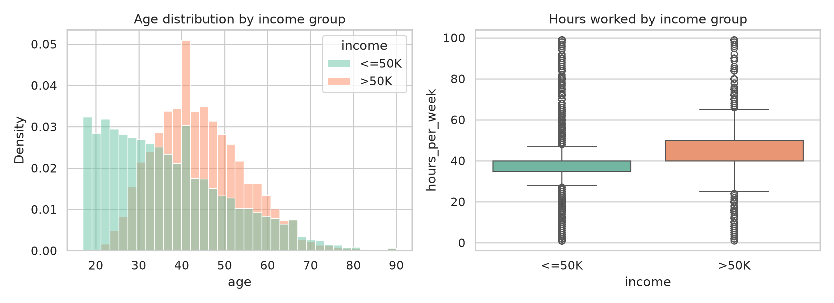
Figure 2. Age and weekly-hours distributions by income group.
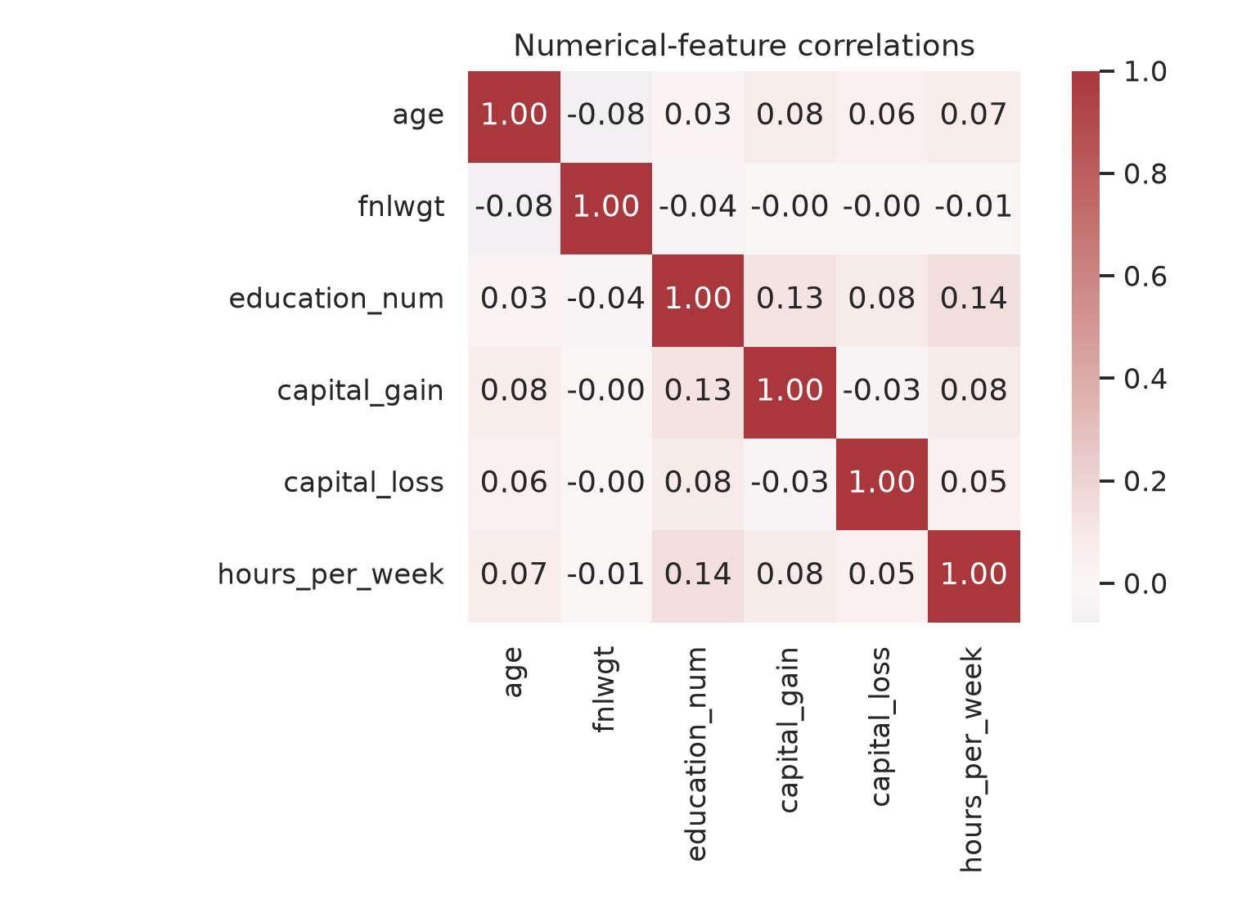
Figure 3. Numerical correlation check used to review redundancy.

6. Data Cleaning
Problem → Decision → Reason → Result: 52 exact duplicate records → remove only exact duplicates → repeated records inflate frequency without adding information → 48,790 unique records remain. The fnlwgt column → remove → it is a census sampling weight, not an individual attribute → 14 columns remain after this step. Extreme capital-gain/loss values were retained because they are valid monetary observations, not data-entry errors.

7. Missing Value Treatment
Missingness was assessed before any transformation. All affected fields are nominal: workclass, occupation, and native_country. Rather than discard thousands of records, the pipeline uses most-frequent-category imputation inside the categorical transformer. This keeps the complete analytic sample and is transparent, though it may slightly increase the most common category. Native country is subsequently excluded during feature selection for a separate low-information/imbalance reason.
feature | missing_count | missing_percent
occupation | 2809 | 5.75
workclass | 2799 | 5.73
native_country | 857 | 1.75
Before treatment: 6,465 missing cells. After treatment: 0 missing cells.

8. Categorical Encoding
Seven retained categorical fields—workclass, education, marital_status, occupation, relationship, race, and sex—are nominal. They are encoded with one-hot encoding, not label encoding, because numeric labels would falsely imply an order. The encoder is configured to ignore unseen categories when reused downstream. The final transformed feature matrix contains 62 predictors: 4 standardized numerical features and 58 indicator features.

9. Feature Selection
Candidate fields were reviewed using meaning, redundancy, missingness, and leakage/identifier checks. No direct target leakage field or unique personal identifier exists in the UCI data. The following fields were removed:
removed feature | reason
education_num | Exact numeric duplicate of education level; retain the readable categorical education field.
native_country | Missing in 1.8% of records and highly imbalanced (United-States dominates); not retained for a compact baseline feature set.
The retained inputs are age, workclass, education, marital_status, occupation, relationship, race, sex, capital_gain, capital_loss, and hours_per_week. The income column remains the label and is not transformed as a predictor.

10. Normalization / Scaling
StandardScaler was applied only to retained numerical predictors. Standardization was selected over min-max scaling because capital gain and capital loss have strongly skewed, valid extreme values; it places features on a comparable zero-mean, unit-standard-deviation scale without forcing every observation into a fixed range. Categorical indicators and the income label were not scaled.
Unnamed: 0 | min_before | max_before | mean_before | std_before | min_after | max_after | mean_after | std_after
age | 17.0 | 90.0 | 38.653 | 13.708 | -1.58 | 3.746 | -0.0 | 1.0
capital_gain | 0.0 | 99999.0 | 1080.218 | 7455.906 | -0.145 | 13.267 | -0.0 | 1.0
capital_loss | 0.0 | 4356.0 | 87.596 | 403.209 | -0.217 | 10.586 | 0.0 | 1.0
hours_per_week | 1.0 | 99.0 | 40.426 | 12.393 | -3.181 | 4.727 | 0.0 | 1.0

11. Final Preprocessed Dataset
The processed CSV contains 48,790 rows and 63 columns: 62 transformed predictors plus the income label. It has no remaining missing values. It is saved as data/processed/adult_census_income_processed.csv; a cleaned pre-encoding checkpoint is also saved for inspection.

12. Before/After Summary
stage | rows | columns | missing_cells | description
Raw combined UCI files | 48842 | 15 | 6465 | Original data; '?' parsed as missing
After exact-duplicate removal | 48790 | 14 | 6456 | Removed exact repeated rows; removed fnlwgt
After feature selection | 48790 | 12 | 5600 | Removed education_num and native_country
Processed output | 48790 | 63 | 0 | Median/mode imputation, one-hot encoding, standardization

13. Key Findings
- Missing values are confined to three categorical variables, making categorical imputation more appropriate than numerical imputation or wholesale row deletion.
- The combined raw files contain exact duplicates; removing them preserves one observation per unique record.
- Education and education_num are redundant representations of the same concept; retaining only the readable categorical feature avoids duplicate signal.
- Numerical variables have materially different ranges, especially capital gain/loss versus age and hours; standardization makes their representations comparable.

14. Conclusion
The project delivers the required clean dataset and documents every major preprocessing decision with executable code and before/after evidence. It addresses Python-based data loading, cleaning, missing values, categorical encoding, feature selection, numerical normalization, and exploratory analysis while preserving the original source data. The resulting processed dataset is suitable as an input to a subsequent, separately scoped machine-learning exercise.

15. References
UCI Machine Learning Repository. Adult Dataset. https://archive.ics.uci.edu/dataset/2/adult
Pedregosa et al. (2011). Scikit-learn: Machine Learning in Python. Journal of Machine Learning Research, 12, 2825–2830.

