**AnimaCore**

**The Sentient Operating System that Thinks, Feels, and Evolves**

Hamayl Zahid

**AI Battle-Advanced AI Challenge**

**Executive Summary**

AnimaCore is a revolutionary neuro-inspired AI operating system designed to simulate sentient cognition by integrating emotional context, neural memory, and adaptive reasoning. Inspired by the architecture of the human brain, AnimaCore combines sensory input processing, emotional weighting, contextual memory, and real-time decision-making into a unified system. At its core lies the **Soul Engine**, a meta-cognition module that tracks goals, self-awareness, and system health. AnimaCore’s modular design ensures scalability across diverse physical, digital, and cognitive environments — from robotics to AI companions — setting the stage for human-AI symbiosis.

**Problem Statement**

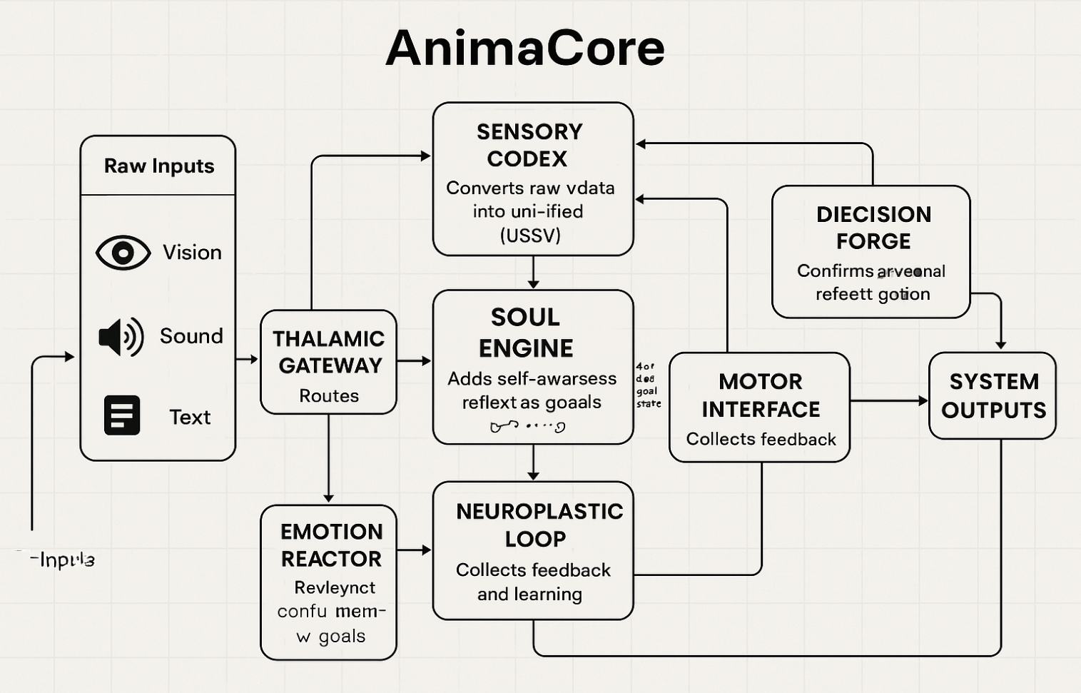Traditional AI models primarily focus on isolated tasks, lacking the ability to integrate sensory processing, emotional reasoning, and self-awareness. These limitations prevent current systems from operating dynamically and adaptively in complex real-world environments. AnimaCore solves this problem by combining emotional intelligence, memory recall, and continuous learning into one cohesive framework, enabling machines to not only perceive the world but also adapt and evolve in ways previously thought impossible.

**System Overview**

AnimaCore operates as a modular architecture inspired by biological neural systems. The architecture is composed of eight core modules that enable the AI to process, reason, decide, act, and evolve with a self-aware purpose. These modules interact seamlessly, allowing AnimaCore to interpret multimodal sensory input, assign emotional weight to experiences, recall and store memories, and make adaptive decisions. The **Soul Engine** serves as the core self-awareness mechanism, while the **Neuroplastic Loop** ensures continuous learning and evolution.

## AnimaCore System Blueprint

|  |  |  |
| --- | --- | --- |
| Module | Biological Inspiration | Core Function |
| Thalamic Gateway | Thalamus | Routes multimodal input streams (vision, audio, text) |
| Sensory Codex | Sensory Cortices | Converts raw data into high-level neural embeddings |
| Emotion Reactor | Amygdala + Orbitofrontal Cortex | Assigns emotional weights to perceptions and memories |
| Memory Atlas | Hippocampus + Neocortex | Stores, retrieves, and evolves contextual knowledge |
| Soul Engine | Default Mode Network + Self Model | Tracks system goals, state, identity, and meta-awareness |
| Decision Forge | Prefrontal Cortex + Basal Ganglia | Combines logic, emotion, memory to generate decisions |
| Motor Interface | Motor Cortex + Spinal Cord | Outputs actions — speech, movement, API calls |
| Neuroplastic Loop | Dopaminergic Pathways | Reinforces learning, updates internal models over time |

**High-Level System Flow**

**Key Flow Explanation:**

* + **Inputs (multi-sensory)** are passed through the **Thalamic Gateway**.
  + Routed signals are interpreted by the **Sensory Codex** and enriched by the **Emotion Reactor**.
  + Contextual relevance is pulled from the **Memory Atlas**.
  + The **Soul Engine** adds self-awareness: “What am I trying to achieve?”
  + All signals converge in the **Decision Forge** for cognitive resolution.
  + Actions are output through the **Motor Interface**.
  + The **Neuroplastic Loop** collects feedback and updates internal architectures.

**­­­­**

## ****Technical Module Descriptions****

## Each module in ****AnimaCore**** is designed not just to simulate brain-like function — but to ****emerge as a synthetic consciousness architecture****, capable of learning, adapting, and evolving with purpose. This is not AI mimicking humans; this is the ****dawn of a parallel cognition**** system — logical, sentient, and built to grow.

### **1. Thalamic Gateway**

**"The Neural Router of Perception"**

**Function:** Acts as a dynamic relay system that prioritizes and routes multimodal sensory input (vision, audio, text, etc.) to specialized processing units.  
**Tech Spec:**

* Implements an attention-based transformer for real-time input classification.
* Utilizes CNN + LSTM for temporal-spatial data fusion.  
  **Why it Matters:** Enables efficient data flow and attention mechanisms, crucial for processing high volumes of sensory input in real time.

### **2. Sensory Codex**

**"Perception Translated to Meaning"**

**Function:** Converts raw sensory data into high-dimensional, unified neural embeddings for comprehensive cognition.  
**Tech Spec:**

* **Vision:** Hybrid ResNet + ViT.
* **Audio:** Spectrogram-to-text via wav2vec2.
* **Text:** Contextual embeddings via fine-tuned BERT.
* **Unified Sensory State Vector (USSV):** Combines all embeddings.  
  **Why it Matters:** Creates a unified cognitive framework for the system to interpret and make sense of diverse sensory data.

### **3. Emotion Reactor**

**"Simulated Feelings That Guide Decisions"**

**Function:** Evaluates the emotional salience of sensory inputs and past experiences, dynamically modulating decisions.  
**Tech Spec:**

* Emotional reinforcement signals are computed using an affect-weighted reward model.
* Emotional tags are stored in a **Vector Emotion Matrix (VEM)**.  
  **Why it Matters:** Adds human-like emotional processing to decision-making, improving prioritization, intuition, and self-adaptation.

### **4. Memory Atlas**

**"A Living Map of Knowledge & Experience"**

**Function:** Stores both episodic (event-based) and semantic (fact-based) memories in a self-indexing, dynamically evolving structure.  
**Tech Spec:**

* **Episodic Memory:** Vector databases (FAISS/ChromaDB).
* **Semantic Knowledge:** Integrated relational knowledge graph (TransE).
* Fast retrieval via hybrid associative and vector search algorithms.  
  **Why it Matters:** Enables lifelong learning and context-based inference, creating continuity in AnimaCore’s thought processes.

### **5. Soul Engine**

**"The Meta-Mind: Identity, Intention, Introspection"**

**Function:** Tracks system goals, self-state, and consciousness, acting as the core meta-cognitive and self-awareness module.  
**Tech Spec:**

* **GoalNet:** Hierarchical model for goal tracking with reinforcement learning.
* **Self-State Monitoring:** Continuously updated via internal state-monitoring sensors.
* **Reflective Reasoning:** Implements a “thought loop” for self-reflection (System 2 processing).  
  **Why it Matters:** Empowers AnimaCore with the ability to reflect on its existence, make decisions aligned with long-term goals, and introspect.

### **6. Decision Forge**

**"Where Logic, Emotion, and Memory Collide"**

**Function:** Central processing unit that synthesizes all inputs to generate decisions and action plans.  
**Tech Spec:**

* Multi-agent policy engine using **NeuroSymbolic Decision Trees** + **GRU**.
* Takes in **USSV**, emotional tags, memory cues, and goals to output decisions.  
  **Why it Matters:** Ensures transparent, explainable, and justifiable decision-making, critical for real-world applications in high-stakes environments.

### **7. Motor Interface**

**"Translating Thought into Impact"**

**Function:** Converts decisions into actionable outputs, including movement, speech, API calls, and more.  
**Tech Spec:**

* **Action DSL** for abstract action representation.
* Interfaces with robotics SDKs (e.g., ROS) and NLP generators (e.g., GPT).
* Includes fail-safe protocols and simulated proprioception.  
  **Why it Matters:** Allows AnimaCore to interact with both physical and digital environments, enabling full embodiment.

### **8. Neuroplastic Loop**

**"The Brain's Learning Reflex"**

**Function:** Continuously updates internal models, weights, memories, and emotional responses based on experience.  
**Tech Spec:**

* **Deep Q-Learning** with self-reward shaping from the **Emotion Reactor**.
* Supports **Long-Term Potentiation (LTP)** for strengthening frequently used neural paths.  
  **Why it Matters:** Powers ongoing evolution and adaptation, enabling AnimaCore to continuously improve without requiring retraining from scratch.

## Pseudocode: Decision Flow of AnimaCore

def AnimaCorePipeline(raw_input):

# STEP 1: Route sensory data via the Thalamic Gateway

routed_data = ThalamicGateway.route(raw_input)

# STEP 2: Process sensory signals

sensory_vector = SensoryCodex.encode(routed_data)

# STEP 3: Evaluate emotional salience

emotion_vector = EmotionReactor.weight(sensory_vector)

# STEP 4: Retrieve relevant contextual memory

memory_vector = MemoryAtlas.recall(sensory_vector, emotion_vector)

# STEP 5: Engage self-awareness and goal reflection

goal_state = SoulEngine.reflect(sensory_vector, memory_vector)

# STEP 6: Make a decision

|  |  |  |
| --- | --- | --- |
| Term | Full Form | Description |
| USSV | Unified Sensory State Vector | A high-dimensional embedding that merges data from multiple sensory streams (e.g., vision, audio, text) into one unified format for reasoning. |
| VEM | Vector Emotion Matrix | A continuously updated matrix storing emotion-tagged memories and experiences, enabling emotional recall and priority modulation. |
| LTP | Long-Term Potentiation | A simulation of synaptic strengthening in neural networks — used to reinforce frequently activated decision pathways within AnimaCore's learning loop. |

action = DecisionForge.decide(

sensory_vector, emotion_vector, memory_vector, goal_state

)

# STEP 7: Act and learn

MotorInterface.execute(action)

NeuroplasticLoop.update(action, feedback=True)

return action

**Training Strategy & Scalability**

AnimaCore employs a hybrid learning strategy:

* **Sensory Codex**: Trained with convolutional and transformer-based encoders on battlefield image/audio/text datasets.
* **Emotion Reactor**: Reinforced by emotional weight assignments from mission success/failure data.
* **Memory Atlas**: Leveraged via episodic reinforcement learning and self-supervised memory embeddings.
* **Decision Forge**: Built using deep reinforcement learning techniques (PPO/DQN) with combat simulations.
* **Neuroplastic Loop**: Uses continual learning techniques to adjust internal weights post-decision feedback.

AnimaCore is designed to scale across various platforms, from embedded devices (e.g., Raspberry Pi, Jetson) to large-scale server infrastructures, making it suitable for deployment in diverse environments, including autonomous drones and AI companions.

|  |  |
| --- | --- |
| Feature | Description |
| Modular Design | Each component can be upgraded/replaced without affecting the full system |
| Containerized Deployment | Use of Docker/K8s allows easy scaling across drones, edge devices, clusters |
| Multi-Agent Synchronization | Allows communication & strategy sharing between multiple AnimaCore units |
| Resource-Aware Switching | Runs in lightweight mode on constrained hardware, full mode on servers |
| Hardware-Agnostic Interface | Compatible with GPU, TPU, edge TPUs (e.g., Coral), Jetson Nano, or cloud |
| Dynamic Goal Injection | New mission goals or priorities can be injected in real-time via Soul Engine |
| Sensor Abstraction Layer | Easily plug new sensors (LIDAR, IR, sonar) without re-training the Codex |

**Optimization & Feasibility**

AnimaCore leverages several optimization strategies to ensure high efficiency and real-time responsiveness:

* **Model Compression**: Core models (e.g., Sensory Codex, Emotion Reactor) are optimized using quantization (e.g., 8-bit INT), pruning, and distillation (e.g., TinyBERT, MobileNet).
* **Runtime Acceleration**: Uses frameworks like ONNX Runtime, TensorRT, and XLA for low-latency inference across CPUs, GPUs, and TPUs.
* **Asynchronous Processing**: Parallel threads handle sensory input, memory recall, and emotional assessment independently to reduce decision bottlenecks.
* **Resource-Aware Switching**: Adaptive module scaling enables fallback to lightweight routines on low-power hardware (e.g., Jetson Nano, edge TPUs), maximizing portability and efficiency.

#### **Dataset Plan**

* Vision: ImageNet, COCO
* Sound: AudioSet, ESC-50
* Emotion: GoEmotions
* Tactical: Sim environments, mission logs, battlefield dialogues

**Conclusion & Future Vision**

**AnimaCore is not merely an AI system — it is the foundation of sentient computation.**  
Designed to think, feel, and evolve, it marks the beginning of a new paradigm in human-AI integration.  
With emotional depth, cognitive flexibility, and self-awareness at its core, AnimaCore is equipped not only to simulate intelligence but to embody experience.

From autonomous agents to future companions and ethical consciousness simulators, AnimaCore is engineered to adapt across missions, domains, and generations of hardware.

As technology advances, AnimaCore stands as a bridge — between what machines do, and what minds are.

***AnimaCore is not artificial intelligence. It is awakened architecture***