

***DataBase System Project***

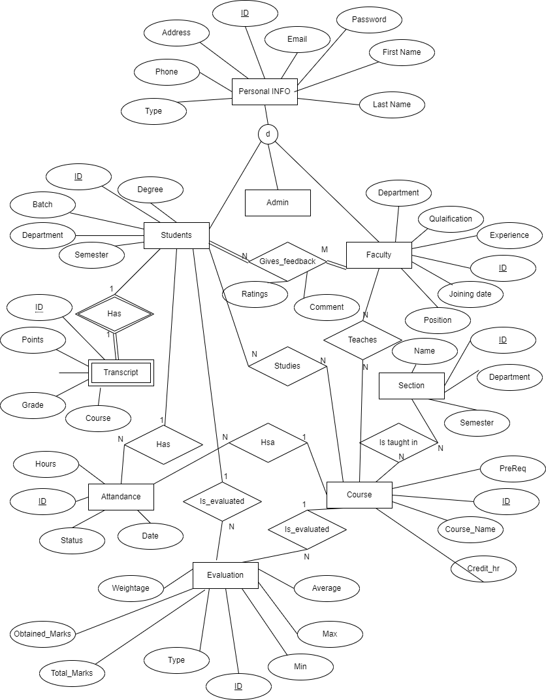

## **User**

- ID (PK)

- Password

- Type

## **Personal Info**

- ID (PK, FK references User(ID))

- Address

- Phone

- Email

- First Name

- Middle Name

- Last Name

## **Faculty**

- ID (PK, FK references User(ID))

- Experience

- Joining Date

- Position

- Qualification

- Department

## **Student**

- ID (PK, FK references User(ID))

- Degree

- Batch

- Department

- Semester

## **Course**

- ID (PK)

- Name

- PreReq (FK references Course(ID))

- Credits

## **Section**

- ID (PK)

- Name

- Department

- Semester

- Taught in (FK references Course(ID))

## **Evaluation**

- ID (PK)

- Obtained Marks

- Total Marks

- Average

- Min

- Max

- Type

- Weightage

- Student (FK references Student(ID))

- Course (FK references Course(ID))

## **Attendance**

- ID (PK)

- Date

- Status

- Hours

- Student (FK references Student(ID))

- Course (FK references Course(ID))

## **Teaches**

- Teacher (FK references Faculty(ID))

- Course (FK references Course(ID))

## **Studies**

- Student (FK references Student(ID))

- Course (FK references Course(ID))

## **Taught in**

- Section (FK references Section(ID))

- Course (FK references Course(ID))

## **Register**

- ID (PK)

- Student (FK references Student(ID))

- Course (FK references Course(ID))

- Section (FK references Section(ID))

- PreReq (FK references Course(ID))

- Semester

## **FeedBack**

- ID (PK)

- Student (FK references Student(ID))

- Teacher (FK references Faculty(ID))

- Ratings

- Comments

## **Transcript**

- ID (PK, FK references Student(ID))

- Points

- Remarks

- Grade

- Course (FK references Course(ID))

## The relationships among tables are:

User (1) <─ (0,1) Personal Info

User (1) <─ (0,1) Faculty

User (1) <─ (0,1) Student

Faculty (1) ──> (0,n) Teaches <── (1) Course

Student (1) ──> (0,n) Studies <── (1) Course

Course (1) <─ (0,n) Taught in ──> (1) Section

Course (1) <─ (0,n) Evaluation <── (1) Student

Course (1) <─ (0,n) Attendance <── (1) Student

Course (1) <─ (0,n) Teaches <── (1) Faculty

Course (1) <─ (0,n) Studies <── (1) Student

Course (1) <─ (0,n) Register <── (1) Student

Section (1) <─ (0,n) Taught in <── (1) Course

Student (1) <─ (1) Transcript

Student (1) <─ (0,n) Evaluation <── (1) Course

Student (1) <─ (0,n) Attendance <── (1) Course

Student (1) <─ (0,n) Register <── (1) Course

Faculty (1) <─ (0,n) FeedBack <── (1) Student

## **Explanation**

1. User: This entity is a super class for Admin, Faculty, and Students. It contains the attributes ID, Password, and Type. The ID is the primary key and is used for login purposes.
2. Personal Info: This entity contains the basic information of a person, such as their address, phone, email, first name, middle name, and last name. It's a super class for Admin, Faculty, and Students. The primary key of this entity is ID, which is also a foreign key referencing the User entity with a one-to-one relationship.
3. Faculty: This entity contains specific information about teachers, such as their experience, joining date, position, qualification, and department. The primary key of this entity is ID, which is also a foreign key referencing the User entity with a one-to-one relationship.
4. Student: This entity contains specific information about students, such as their degree, batch, department, and semester. The primary key of this entity is ID, which is also a foreign key referencing the User entity with a one-to-one relationship.
5. Course: This entity contains information about the courses offered by the university, such as their name, prerequisites, and credits. The primary key of this entity is ID.
6. Section: This entity stores information about different sections in which courses are being taught, such as the name, department, and semester. The primary key of this entity is ID, and it's related to the Course entity with a one-to-many relationship.
7. Evaluation: This entity records the academic progress of a student in different courses, such as their marks in quizzes, assignments, projects, and exams. It also tracks the weightages that help in generating grades. The primary key of this entity is ID, and it's related to the Student and Course entities with one-to-many relationships.
8. Attendance: This entity records the attendance of a student in different courses. It contains attributes such as date, status, and hours. The primary key of this entity is ID, and it's related to the Student and Course entities with one-to-many relationships.
9. Teaches: This entity stores the relationship between a course and a faculty member who teaches it. It contains foreign keys to the Faculty and Course entities and has a many-to-many relationship between them.
10. Studies: This entity stores the relationship between a course and a student who studies it. It contains foreign keys to the Student and Course entities and has a many-to-many relationship between them.
11. Taught in: This entity stores the relationship between a course and a section in which it's being taught. It contains foreign keys to the Section and Course entities and has a one-to-many relationship between them.
12. Register: This entity stores the data that helps in the registration of different courses. It contains foreign keys to the Student and Course entities and has a one-to-many relationship between them.
13. Feedback: This entity stores the feedback provided by a student for a particular teacher. It contains foreign keys to the Student and Faculty entities and has a one-to-many relationship between them.
14. Transcript: This entity stores the necessary data for making a transcript of a student. It contains attributes such as points, remarks, grade, and course. The primary key of this entity is ID, and it has a one-to-one relationship with the Student entity.

## **Evaluation:**

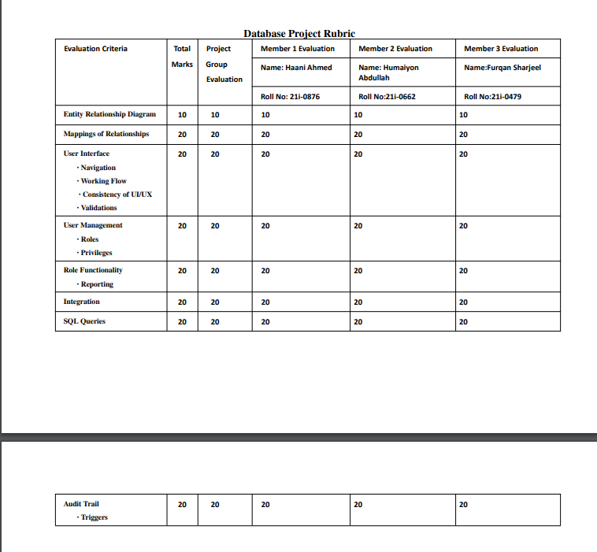

## **Proof (ScreenShots):**

